Module Name: BMSP4004
Generating Data & Business Analysis
Morgan Davies
Course Name and Number
Tutor: Dr Roisin Mullins
Due Date: 17/01/18

Contents
Introduction 3
The Role of a Business Analyst 3
The Well Being of Future Generations Wales Act 2015 3
Inspire 4
The rationale for the location 4
The Database created 5
Purpose of a database 8
Functions of a database 8
Database Design Lifecycle 8
Part 2 10
Data tools trends 10
Tools to capture data and information 11
Database tools 11
References 12

Introduction

The Carmarthen Business School are going to run a conference on rethinking business conference on a year by year basis. This will be crated from scratch as a new business conference venture. They will be assigning a business analyst to determine the most appropriate time of the year to run the sustainability based conference. The analyst will also be determining the long of the conference, the registration fee and all other fees to delegate, the best location to run the conference and ultimately it needs to be along the Wales costal path.

The Role of a Business Analyst
A business analysis is understanding what the businesses’ needs are, they will assess the business impact of the changes, capturing, analysing and documenting the requirements, supporting the communication and the delivery of requirements with relevant stakeholder. A good example of what a business analyst would do is “If you had a plot of land and wanted to build a house, we hope that you would first engage the services of an architect. The architect would ask you questions – what is your budget, what style of house, how many bedrooms, how much parking or garage space you need, etc. The architect would then draw up plans which they would agree with you before approaching builders to understand the cost of building the house. Once the build was underway the architect would monitor the build to make sure the house was built according to your needs.” ("Welsh Government|Well-being of Future Generations (Wales) Act 2015", 2018.)
A business analyst makes the lie easier for the business, they find the best possible way to benefit the business. It is important for the Carmarthen School to have a business analyst because they will find the best location that not only provides them with everything they need, they will also find the best price. The business analyst will investigate ideas and solve problems. The analyst will formulate all the options and recommend the best one.
“The analysis of the external environment should be an ongoing process for senior management, since the factors identified may provide insights into problems for the future or opportunities for new successes.” (Cadle, Paul & Turner, 2011)

The Well Being of Future Generations Wales Act 2015

The Future Well Being Act requires public bodies in Wales to think about the long term impact of their decisions, to get them to work better with people, communities and each other, and to prevent any persistent problems such as poverty, climate change and health inequalities. The well-being of future generation have seven main goals. This is a list of the seven goals: A prosperous Wales, A resilient Wales, A healthier Wales, A more equal Wales, A Wales of cohesive communities, A Wales of vibrant culture and Welsh language and a globally responsible Wales. ("Future Generations Act – Future Generations Commissioner for Wales", 2018)The ones that apply to the location venue chosen by the business analyst was the prosperous Wales and Wales of cohesive communities. Prosperous Wales wants to see an innovative, productive and low carbon society which recognises the limits of the global environment. Organisations should use resources efficiently and proportionately. This fits the location chosen by the business analyst because the Liberty Stadium has all the facilities needed for this conference and they are also looking to become more sustainable. They are looking to reduce their carbon footprint, so the analyst thought it would be the perfect place to have the conference. The liberty stadium also fits all the criteria for the Wales of cohesive communities. The Liberty Stadium is attractive, viable, safe and well- connected community. There are also four tunnels at each corner that enables a consistent flow of air throughout the stadium.

Inspire
“We are an environment think-tank, rooted in experience, with a clear commitment to promoting long-term sustainability through practical thought-leadership. We work on sustainability policy and practice for: Energy, Water supply and water management” (Sustainability First, 2018).
Inspire is a sustainability certificate that is backed up by the Welsh government, currently the only place you receive this certificate currently is from is the university of Trinity Saint David’s. This certificate will people that you are learning to be more sustainable and have the knowledge and understanding to back it up.

The rationale for the location

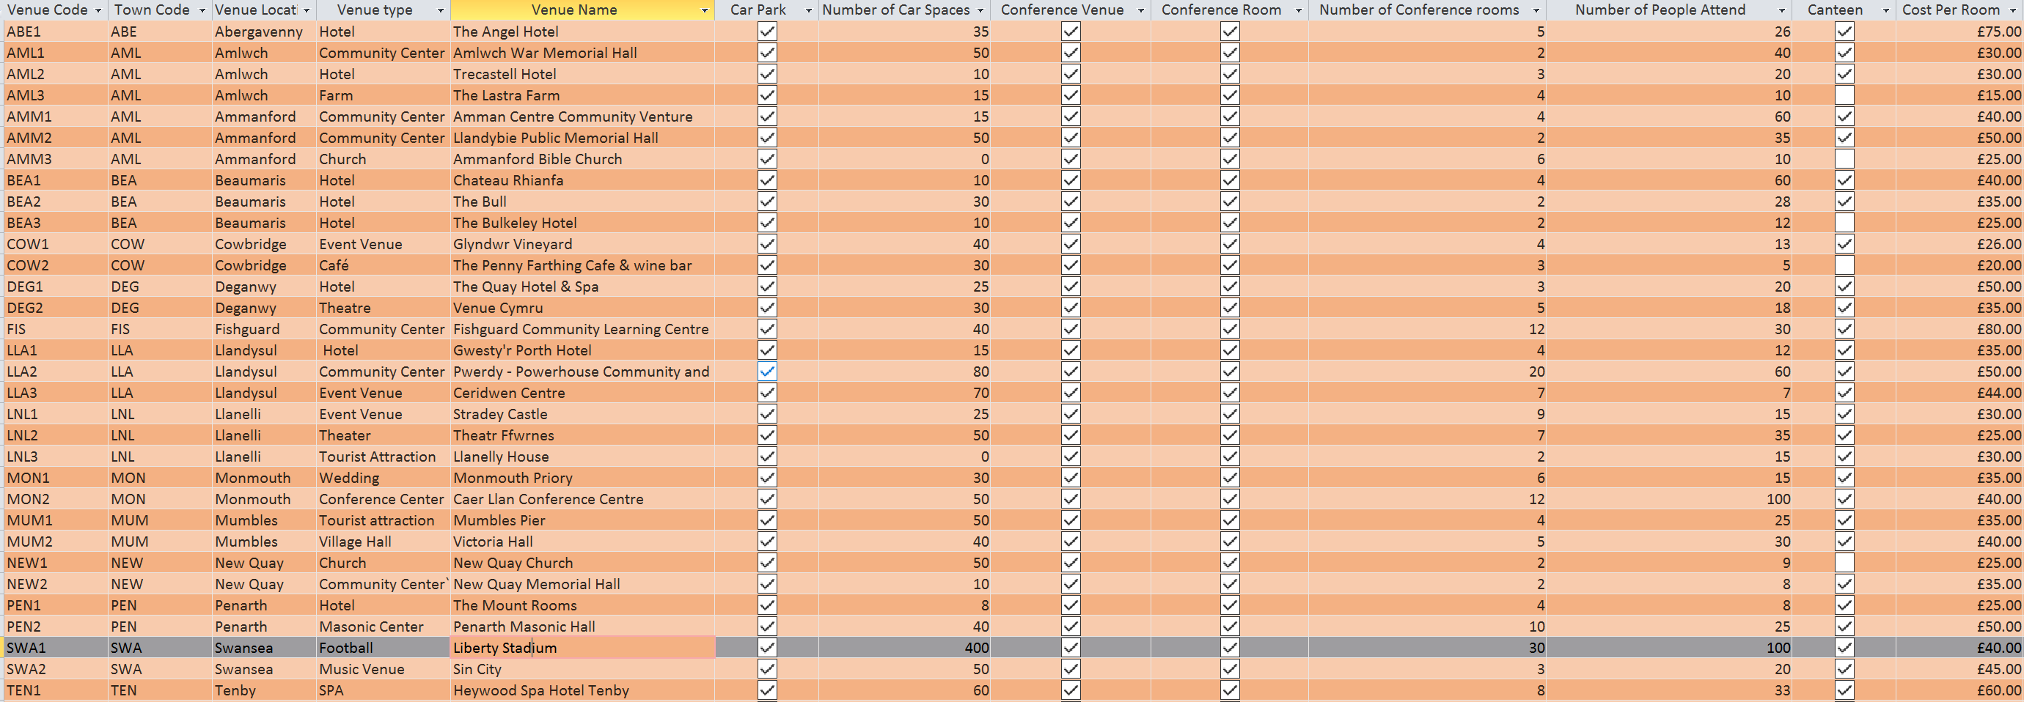

As you can see from the image above, the business analyst has created a database to the best location that fills all the needs of the delegates. The Liberty Stadium has the most parking spaces out of all the other venues and it also has free parking, most of the other venues charged for the parking. The Liberty has more than enough conference rooms available for the Carmarthen Business School. Once a room has booked book they do offer supplements for no extra cost. If the business school is looking for something more than supplements, they do have a canteen and other food facilities.

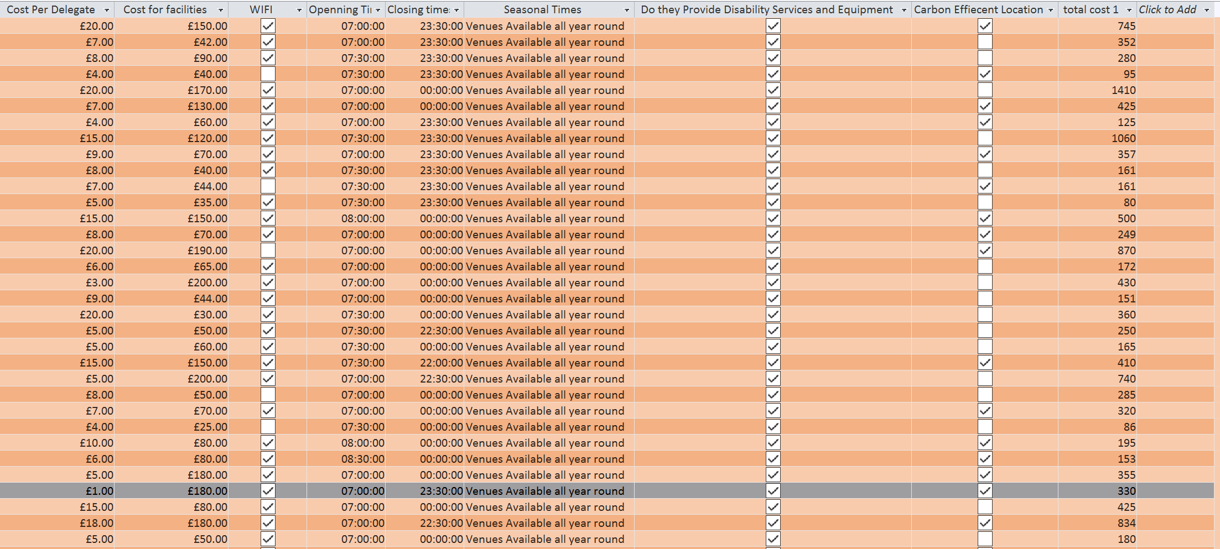

The Liberty Stadium is just under the average cost of all the venues. It may be a bit more expensive than some of the other venues, however, the cheaper ones didn’t have all the delegates’ needs. There were other that had other thigs but the Liberty ticked all the right boxes. The Liberty also provides services and equipment for anyone who may have a disability. There are plenty of recycle bins in the grounds and the stadium is kept in great condition. The date decided for the conference is the 5th of January because it’s the start of the New Year and it gives people time to prepare for it.
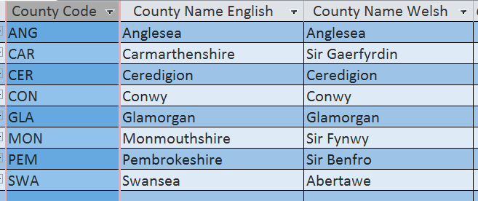
This is a table of the 8 chosen counties. These are the county that the analyst decided on. These are the entities in the table.

The Database created
A database, structures data that store organised information. Most of these database will contain more than on table. The table will often contain many different fields. A good example for this, a business database will often include tables for their products, financial records and their employees. All of the tables would have different fields that are relevant to the information that is stored in the table. ("Database Definition", 2018)
To explain the database, the first thing to do is explain the terminology. The entities of a database would be something about which we store data. For example a customer is an entity. Entities are not always tangible, (they are not always perceptible by touch) for example, an even like a concert would be an entity. The entities will have data to describe them. The terminology for this is called the attributes. An example of this: a customer is an entity is usually described by first name, contact number, last name, street and city. Once you have a basic entities in your database environment, you need to find out the relationships among between the entities. The three basic types of relationship are; one-to-one. One-to-many and many-to-many. The best way to describe a one-to-one relationship is at no time can a train station be related to more than one town and no town can be related to more than one train station. ` in a relational database, a one-to-many relationship is, for example, when a parent record in one table can potentially reference many child records in another table. The parent is not required to have child records, so the one-to-many relationship allows zero child records, one child record or multiple child records. The main thing to note is the child can not have more than one parent record. And ultimately the many-to-many relationship occur when there are multiple records on the table are associated with multiple records in another table, for example, the relationship between the customers and product: the customers can buy various products, and the products can be purchased by many customers. (Harrington, J. (2000).

Purpose and functions of a database management system

The purpose of a database is to optimize data management. The data can then be transformed into information. Organization use a large amount of data. A database management system a software tool allows you to organize your data in a database. There are three main elements: Physical database, database engine and database scheme. The physical database is the collection of files that contains data. The database engine is the software where you can access and modify the contents of your database. The database scheme is the specification of the logical structure of the data in the database. Roman Steven (2002)
The main functions of the database management system is to store data and relate data entry forms and many more. The database function can enable transformation of data. The database function keeps the data in consistent formats, this is called integrity. It also avoids data redundancy, this means avoiding duplication of data. There will be data security management such as access, privacy, backup and restoration.

Database Design Lifecycle

The main parts to the database design lifecycle is: planning, analysis, Maintenance, implementation and conceptual design. The planning and analysis would be the stage of the database system development lifecycle to be as efficient and effective as possible. The main this this will lock at is: the aims and objectives of the database system, the purpose of the database system, the supported tasks of the database system and the resources of the database system. For the implementation you will create a database using the tool access using the program SQL and VBA. There will be security provision, for example passwords. There will be general maintenance done automatically to access and the databases.
“A table typically has a column or combination of columns that contain values that uniquely identify each row in the table. This column, or columns, is called the primary key (PK) of the table and enforces the entity integrity of the table. Because primary key constraints guarantee unique data, they are frequently defined on an identity column.” (Teorey & Teorey, 1996)
“A foreign key (FK) is a column or combination of columns that is used to establish and enforce a link between the data in two tables to control the data that can be stored in the foreign key table. In a foreign key reference, a link is created between two tables when the column or columns that hold the primary key value for one table are referenced by the column or columns in another table. This column becomes a foreign key in the second table.” (Teorey & Teorey, 1996)

Part 2 Data tools, trends and Tools used to capture data and information

Globalisation has really taking over the world, with the advancements in technology, it has allowed businesses to use things like the internet to their advantage. A great example of this is, Facebook, Facebook has taken over most of the competition and they are using that to their advantages. They have link everything together, if one thing is searched that data is then stored that why when you search for something, adverts for that will pop up on your screen on Facebook, YouTube have also taken advantage of this. Businesses also use Facebook to advertise their business and they can use it to communicate. There are many tools you can use to capture data and information for example, you can use Microsoft Access for data. You can use Microsoft word record your findings and you can find information all on the internet. The benefits of using tools is it makes life easier for the business and everything can be done more efficiently. Business can store all there important document into the cloud like OneDrive or Dropbox. OneDrive will back up your work and you can access it from anywhere as long as it has connection. Technology is advancing all the time and if business do not do the same they will fall behind and most like be facing bankruptcy. An example of this is Myspace. Myspace was basically the old Facebook, however the Facebook designs and feature where a lot better, Myspace was not able to keep up with Facebook. In the service industry, they use data collection to dramatically improve their business performance. For example, Fleetmatics, they are a fleet management software company. They collect data at every stage of their client’s driver journey. It then reviews the data and reports the findings of the vehicle and field workers. With the data, they can improve the efficiency of their client’s operations. The way they can do this is by avoiding regular hold ups, or they can use it to see if there are any wear and tears that need maintenance ahead of times. This reduces the chances of any unexpected problems. (The Telegraph, 2018.) Without technology the massive company Amazon would not be around, Amazon relays on their online websites, the websites have a list of all their products and once the customer is ready they purchase the products online and they deliver the product to your door. Once you buy something on Amazon the software is program to suggest similar things you may need with your order. To summarise technology is becoming the way forward and it is important to keep an eye on all the trends and tools you can use to capture the data you need, so you can turn it into useful information to improve the efficiency of your business.

References

("Database Definition", 2018)
("Future Generations Act – Future Generations Commissioner for Wales", 2018)
(Sustainability First, 2018). About Us. Sustainabilityfirst.org.uk. Retrieved 17 January 2018
Cadle, J., Paul, D., & Turner, P. (2011). Business analysis techniques. Johanneshov: TPB.
Cadle, J., Turner, P., & Paul, D. (2010). Business analysis techniques. London [England]: British Computer Society.
Database Definition. (2018). Techterms.com. Retrieved 17 January 2018, from https://techterms.com/definition/database
Future Generations Act – Future Generations Commissioner for Wales. (2018). The Future Generations Commissioner for Wales. Retrieved 16 January 2018, from
Harrington, J. (2000). Object-oriented database design clearly explained. San Diego: Morgan Kaufmann.
https://study.com/academy/lesson/what-is-a-database-management-system-purpose-and-function.html
In-text: (Roman, 2002)
Pay, A. (2018). How to gather the right data for business operations. The Telegraph. Retrieved 17 January 2018, from http://www.telegraph.co.uk/connect/small-business/operations-and-logistics/how-to-gather-data-for-business-operations/
Primary and Foreign Key Constraints. (2017). Docs.microsoft.com. Retrieved 17 January 2018, from https://docs.microsoft.com/en-us/sql/relational-databases/tables/primary-and-foreign-key-constraints
Roman, S. (2002). Access database design and programming. Sebastopol [CA]: O'Reilly.
Teorey, T., & Teorey, T. (1996). Database modeling & design. San Francisco, Calif.: Morgan Kaufmann Publishers.
Welsh Government Well-being of Future Generations (Wales) Act 2015. (2018). Gov.wales. Retrieved 16 January 2018, from http://gov.wales/topics/people-and-communities/people/future-generations-act/?lang=en
What is a Database Management System? - Purpose and Function - Video & Lesson Transcript | Study.com. (2018). Study.com. Retrieved 17 January 2018, from
What is a Database Management System? - Purpose and Function - Video & Lesson Transcript | Study.com. (2018). Study.com. Retrieved 17 January 2018, from https://study.com/academy/lesson/what-is-a-database-management-system-purpose-and-function.html

Appendices


