

Academic Discipline of Social Justice and Inclusion
MArts/BA Humanistic Counselling Practice

Module: Practicum 1 (EHCH4005)

Assessment Component: One

Student Number: 1804911

Theorists Rogers and Egan

Carl Rogers and Gerard Egan both contributed works within the counselling field using different therapeutic approaches. I have been researching the theories of Carl Rodgers and Gerard Egan, comparing and contrasting them and investigating how both are used within the counselling field of today. I will be exploring how both could be established in therapeutic work with a client, how this may impact on a client and the counsellor and finding ways of keeping within the framework, when using both therapeutic approaches.
Carl Rodgers was known to go to a Union Theological Seminary to do some religious work, it was here he states he questioned the philosophy of life and his individual feelings. (Rogers. C, p8) He then went on to take courses in philosophy and began clinic work with children. He enjoyed the guidance work and began his work within psychology (Rogers. C, p9).
A Humanistic approach to therapy was where Carl Rogers and various other American psychologists founded their theories in the 1950’s (Saunders. P, p15) Humanistic Theorists believe that all human beings have the potential for growth and can achieve their own way of being. If the individual has the right conditions, it will enable them to work towards self- actualisation. (Saunders. P, 2002, p31). Self- actualisation, according to Maslow, is the need for growth. In the journal of humanistic counselling, everyone possesses the need for growth and self-actualisation (Gold. Joshua, M, Vol 52, Issue 2). Maslow (1943, 1954) structured these growth needs in a pyramid format and is illustrated in structures, the bottom being “Physical” i.e. a person having food, water and shelter; Security i.e. the need for safety, shelter and stability; Social i.e. the need to belong, be included and be loved; Ego i.e. the need for self- esteem, recognition and prestige. It is believed that if all these needs are being met then self-actualisation can happen and an individual has the ability to find ways of self-fulfilment (McLeod. S, 2018, Simply Psychology)
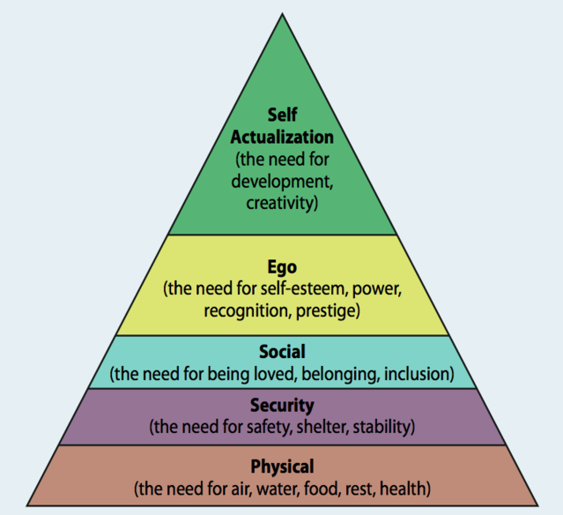
Above an Illustration of Maslow’s Hierarchy of needs (Burton. N, 2017, Psychology Today)
Within humanistic counselling, a counsellor is known to be able to find ways for a client to explore and solve their own struggles, experiences and needs, and can help with aiding in the self-actualisation process. (Saunders. P,2002, p31). Carl Rogers identified six conditions that are needed for therapeutic change and for the relationship to be successful for both the counsellor and the client, three of these conditions being labelled the “core” conditions. (Jones. R, 2012, p32). The core conditions are Empathy, Congruence and Unconditional Positive Regard. Another word for Congruence is genuineness. It is the ability of the counsellor to be self-aware of their own problems which may have a negative impact on the counsellor/ client relationship. Counsellors also need to be themselves by being honest and able to communicate who they are (Jones. R, 2012, p34).
Unconditional Positive Regard is another core condition where a client is able to feel that they are not being judged by the helper who is non-judgemental, warm in their approach and manner, compassionate to the client and aware of their potential (Jones. R, 2012, p34).
Empathy is known to be a distinguished feature within the core conditions. It allows a client to feel that they are being understood and may give the client an ability to freely express and explore themselves, the counsellor devoting their full attention towards the client and their personal experiences. Rogers felt that these core conditional approaches were the philosophy of being able to show every client and person respect, value and worth (McLeod. J, 2013, p178-179).
Gerard Egan studied and taught Philosophy. It was around this time he became interested in psychology and gained a PHD in clinical psychology. During his time teaching he began to think that external factors (a person’s environment, family life and life events) can have an effect on a person and that it was not likely that internal factors determined a person’s personality or behaviour. With this he developed a model known as “The Skilled Helper” (Saunders. P, 2002, p38). His model can be seen in three stages: the first stage being the story i.e. what is happening in a client’s life, what problems and struggles the client experiencing; stage two is the possibility stage, where a client is ready to make sense of their situation. An example could be missed out on opportunities and how a client could change and overcome them. Reaching the second stage for a client is believed to vary. Some clients will tell a great deal of their stories whereas some tell their stories over a period of counselling sessions. Stage three is the stage where client and counsellor work on how the client can get what they want and decide a plan of action. During this stage it is suggested that being able to guide a client and giving them steps to work towards will help better their opportunities and discover ways to overcome their problems (Egan. G, 2002, p32-33).
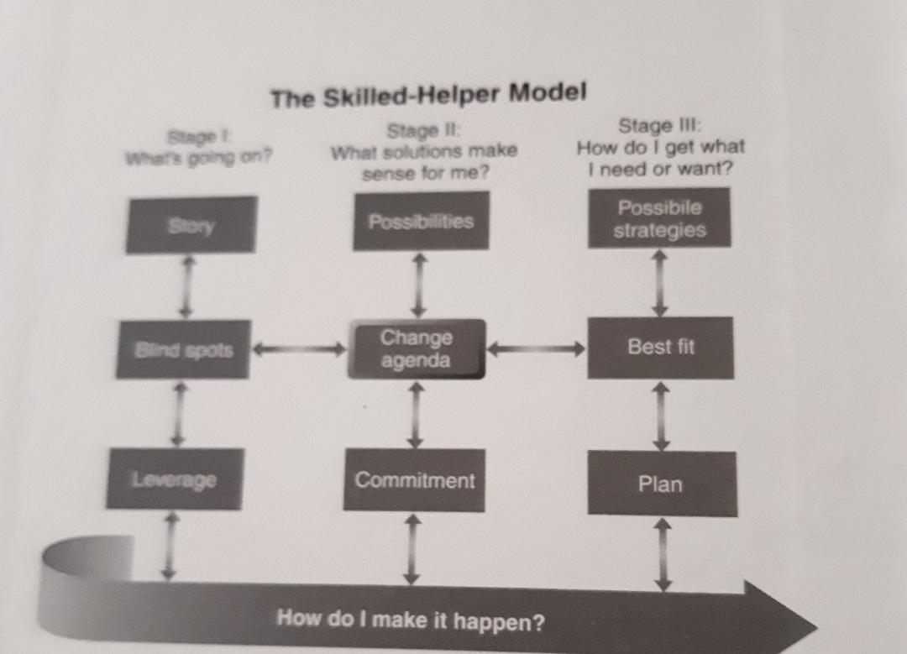
Above Egan’s Skilled Helper model (Egan. G, 2002)

Carl Rogers’s helping approach is very person centred and is an approach where the client is the expert, because clients have their own ability to find and solve their own problems. Being person centred, this is considered a better approach for achieving the most success in terms of the client’s wellbeing. It is a good motivation for clients to move towards self-fulfilment (Saunders. P,2002, p23). One view is that by exploring and describing the way a person is feeling a better understanding can be gained in the helping process (McLeod. J, 2013, p171-172).
Carl Rogers’s approach appears to be non-directive allowing a client to direct themselves, use their own wisdom. It seems to give a client the opportunity to find their own approach to better manage their therapeutic journey and healing process (Saunders. P, 2002, p22).
Gerard Egan’s approach is known as an “Integrative Approach”. It is very direct, and goal focused. Egan feels that people suffer with their own individual distress due to life experiences and health conditions. Using a single approach in helping someone will not benefit many clients. Making use of several approaches and applying them to suit the individual needs of clients would be best practice in assisting clients to overcome and solve a range of issues (Saunders. P,2002, p33).
Carl Rogers and Gerard Egan’s approaches do have similarities and when considering both approaches in detail, it is clear both are very much core condition based. When reading “The Skilled Helper” (Egan. G, 2002) it is evident that Gerard Egan values Carl Rogers’s work and has focused his own works around it. Gerard Egan mentions in his book about the nature of empathy and states that as a counsellor, having a deep understanding of empathy and being able to understand problems from the client’s point of view is essential in the healing process. Egan seems to surmise that having an emphatic understanding will help the counsellor to work on goals with the client whereas Rogers seems to allow the client to find their own goals rather than directing the client. Egan’s directional approach appears the most suitable for client needs (Egan. G, 2002, p76-77).
When considering how both Carl Rogers and Gerard Egan’s approaches to therapeutic work could help a counsellor assist a client in the healing process, it is clear that when looking at Maslow’s hierarchy of needs, all individuals from all different cultures require these core needs to be met in order to be able to reach self-actualisation (Maslow, 1943, 1954). Being able to assist a client in this process would take a great deal of listening and empathic skills in order to establish where a client is in their life and how best to support them.
Rogers’s approach appears very gentle, warm and humbling and seems not to be imposing any kind of authority or direction from the Counsellor. It could be viewed as a very self-empowering form of therapy as it is the client who is directing and managing ways to overcome their own problems. This approach may assist being able to work for many individuals but, taking into consideration that all problems vary from one another, this method may not work for all clients and maybe some goal setting and focus on supportive direction like Gerard Egan’s approaches could be of benefit to some clients and work best for them.
It is obvious that Egan has humanistic values within his approach whereas parts of Egan’s approach take away some of those humanistic values. The skills of being congruent, empathic and having unconditional positive regard seem to be the best approach to place at the centre of therapeutic work when considering the ethics built up around it. Individuals seem to highly value being treated under the core conditions and with this they may be able to work towards overcoming their problems and learn how to better manage them. It may give them the ability to feel self-worth, empowerment and aid in easing any distress the client maybe feeling.
If a humanistic approach is established it could make a client feel that they are being understood, not judged and at an equal level with a counsellor. It seems to be an ethical and more humane approach when working with clients. A humanistic based approach should always be considered as a base from which to work within different therapeutic frames. Using a first-person centred approach would only prove time consuming and stressful for both client and counsellor, as it may take a longer period for any benefits and results to appear evident from the sessions. Egan’s approach could be less time consuming for the client, with the therapeutic work focusing on certain problems. It is an easy therapeutic approach to adopt however, it may impact a client who is vulnerable. They may find it difficult to be set goals and have lots of direction given.
In conclusion, whether using Carl Rogers’s approach or Gerard Egan’s, being congruent with a client and insuring communication is clear in terms of what a client can expect from the counsellor would should be at the core when using either approaches in practice. Having good ethical guidelines like those of BACP to use as a guide when working with clients is essential to decrease any distress for clients that may not benefit from just one therapeutic approach. The counsellor needs to consider how best to refer them on to other services that could have a more suitable approach for them (BACP, 2018).

Theorists: Rogers and Egan – Reference List/Bibliography

- BACP (2018) Ethical Framework for Counselling Professionals Available at https://www.bacp.co.uk/events-and-resources/ethics-and-standards/ethical-framework-for-the-counselling-professions/ Accessed 30th November 2018

- Burton. N, (17th September, 2017), Maslows Hierarchy of Needs, Available at https://www.psychologytoday.com/gb/blog/hide-and-seek/201205/our-hierarchy-needs, Accessed on 29th November 2018

- Egan. G (2002) The Skilled Helper, Seventh Edition, Wadsworth Group, Brooks/Cole, p32-33-76-77

- Gold. J (October 2013) The Journal of Humanistic Counselling, Alexandria Vol. 52, Issue 2, Spirituality and Self-Actualization: Considerations for 21st-Century Counsellors p223-234

- Jones. R, (2012) Basic Counselling Skills A Helpers Manual SAGE Publications, p32, 34

- McLeod. J (2013) An Introduction to Counselling, Fifth Edition, Open University Press, p 171, 172, 178, 179,

- McLeod. S (2018), Maslow’s Hierarchy of Needs, Available at https://www.simplypsychology.org/maslow.html, Accessed on 29th November 2018

- Saunders. P (2004) First Steps in Counselling, Third Edition, PCCS BOOKS p15, 22, 23, 31, 33, 38,

- Rogers. C (1995) On Becoming a Person, Houghton Mifflin Company, New York, p 8,9

