University of Wales Trinity Saint David

Introduction to industry 4.0
Involving principles, practice, and current challenges of industry 4.0 technologies

Liam Hocking
MSc Industry 4.0 Advanced Manufacturing
Mahesh Kannath
24/03/2023

Abstract
To overview this assessment, I have written about the industry 4.0 improvements, challenges, and risks. How I can add this technology to a simple process within my facility.

Introduction
This assessment involves me understanding and learning the many factors of industry 4.0 and introducing them to the workplace. I have been asked to identify a single process within my facility and assess the current efficiency compared to those of industry 4.0. When walking in the cleanroom, along assembly line 6/7 I discovered a simple line process which could be automated involving the technology that industry 4.0. I will explain how this route could be safer, cost effective and increase production. I will also specify how I would go about draft a project and the way I would install this type of technology to the facility I currently work at.
The line operator must drill 4 screws at the same torque setting, when a product part enters his/her station. When the part has stopped at their station they place a screw onto the magnetic drill, and drill in order the four holes that the bracket is labelled on the station. Once their task is complete, they can press a button on the conveyor which sends the product to the next station.²

Aims & Objectives
My aim for this assessment is to assess my current facilities workflow efficiency with the line workers and build on how this can be improved. I will identify a possible idea to introduce Industry 4.0 ideologies with also eliminating additional hazardous factors caused by human error. Also, to assess ways in which maintenance on industry 4.0 machines are made safe to operate under.

Implementation Methodology
Looking at industry 4.0 technologies, I will need the machine implemented to operate at 3 different axes to be able to complete the task. The device will need to be taught what zones are available and where it is needed to pick up and place components. Torque settings will need to be specified within its program.
The type of robot I will plan to use for this task will be a cartesian robot as it has the potential for 3 degrees of freedom which is needed for this task. The tip of the robot will need a driver to perform the drilling/screw task. The load of the driver will need to be calibrated by a competent person to ensure the driver doesn’t ruin any products or effect the reliability of the product. The linear joints will allow the robot to move within the specified area (i.e. X, Y and Z axes). This area will need some barriers to ensure employees are out of the workspace that the machine will be operating in. Although a person may see where the machine’s operating space is, the robot will not sense if a person is in the path and cause a dangerous collision.
The cartesian robot’s specification for this installation will need to fit within an area of 1.25m² and be able to operate with 230VAC supplied from the local distribution board. The controller for the robot will also need to be accounted for to allow the machine to operate. Using services from “vention.io”¹ I can create the exact robot to this specification or even talk to an expert on the task I would like the robot to undertake and how to complete the project successfully. The barriers for the robot will also be a major part of the specification and can’t exceed the given space for that work area. After the robot CAD is fully designed and all instruments accounted for, this would be a great opportunity to get the work peer reviewed by another engineer to spot potential mistakes or other considerations that have not been accounted. For the installation process for the machine, I would need to consider that it would be more cost effective and efficient to allow a 3rd party company that specialises in robotic installations to fulfil this task.
Once installed, the robot will need to be programmed in sync with the existing hardware on the assembly line. Boundaries will also need to be considered so that the barriers or robot itself will no collide under operation. The conveyor and PLC’s will need to be altered as the timing of parts will change. The robot will be more consistent than a human operator so a suitable timer will need to be added to the conveyors program to allow the robot to complete the task. Overtime the driver on the robot may receive some fatigue causing the screws to no longer fit on the tip. A sensor after this drilling process will need to be considered to assess that all screws are in place. If screws have not been driven in the appropriate slots the sensor should alarm stopping the production and alerting any maintenance technicians to fit the issue. Emergency shut down procedures should also be implemented to the robot in case of unforeseen hazards while the production line is under operation. This will be done by adding an emergency stop button to the machine making it easily visible and accessible to the workforce if needed. The emergency button will cut all incoming power to the robot halting any operation.
General maintenance will need to be performed to ensure the production rate doesn’t suffer overtime and unplanned break downs don’t occur frequently costing the business a lot of money. To ensure maintenance is preformed to the correct standard, training courses will need to be provided from the company to upskill all relevant workers. Implementation of the skill set learnt will lead to the facility preforming optimally and scheduled maintenance will keep the efficiency of the production to the satisfactory rate.
Background research
One issue with the immense potential that industry 4.0 has is that it has the potential to displace human labour. As automation takes over jobs that humans once preformed it could lead to a lot of people being made redundant, leading to a lot of job losses. A possible mitigation strategy would be to re-skill the workforce and invest in training for them to be suitable for the current demands within the industry. With automation potentially taking over some workforces another issue could be the power consumption and possibly more waste product. To prevent pollution within the environment we could look to eco-friendly/green systems such as renewable energy sources to sustain the machines and develop a more efficient manufacturing process. This and recycling where possible will reduce the impact on the local environment. The last issue I can think of would be the data security of the assets. As the manufacturing process becomes more and more integrated, the risk of cyberattacks and data breaches also increases. Any sensitive data within the facility could be accessible if the security is breached so companies should invest in robust cybersecurity systems to prevent employees/customers information from being leaked. Ways to mitigate this include firewalls, encryption, intrusion detection system and white hat hacking/ frequent security audits.
Conclusions
To conclude this document, industry 4.0, processes and ideologies hold great potential to transform manufacturing and production. This of course has its challenges and risks that come with adopting new technology and companies should do their best to mitigate as many of these risks as possible. I think that, by taking these steps, industry 4.0 will be adopted, further developed, and built upon to improve the industry to greater standards than ever been possible before.
Recommendations
I recommend that this project should be scheduled appropriately to minimise downtime within the facility. Communication with the shopfloor will be crucial for the final stages of this project and free time for this installation will need to be discussed with the maintenance manager before this project is taken any further.

References:
- “ https://vention.io/?home“ a website to create robotic solutions to specifications needed.

2.Picture of drill station
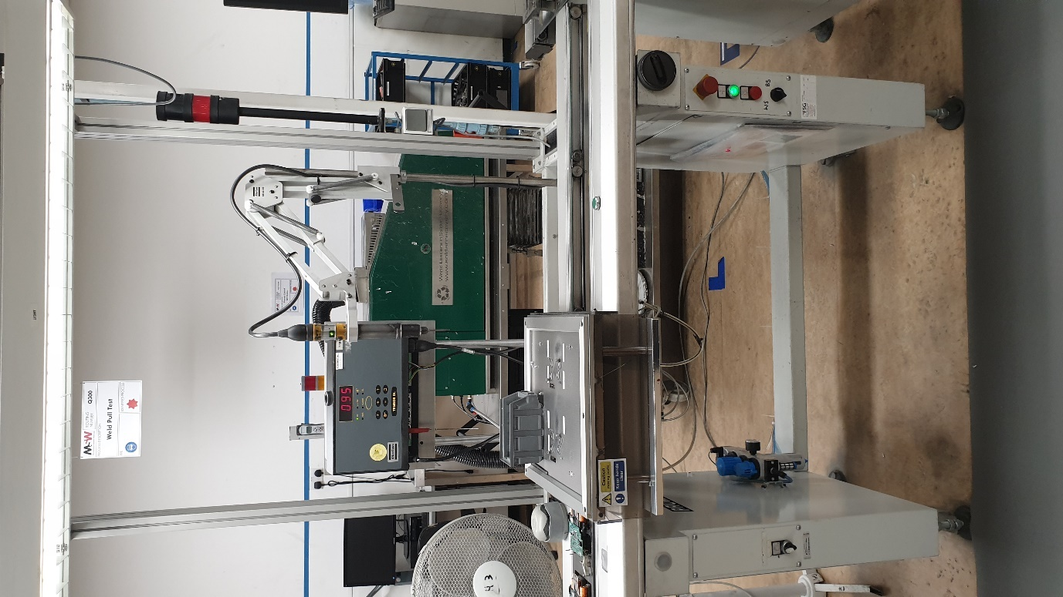

Close up of the drill station
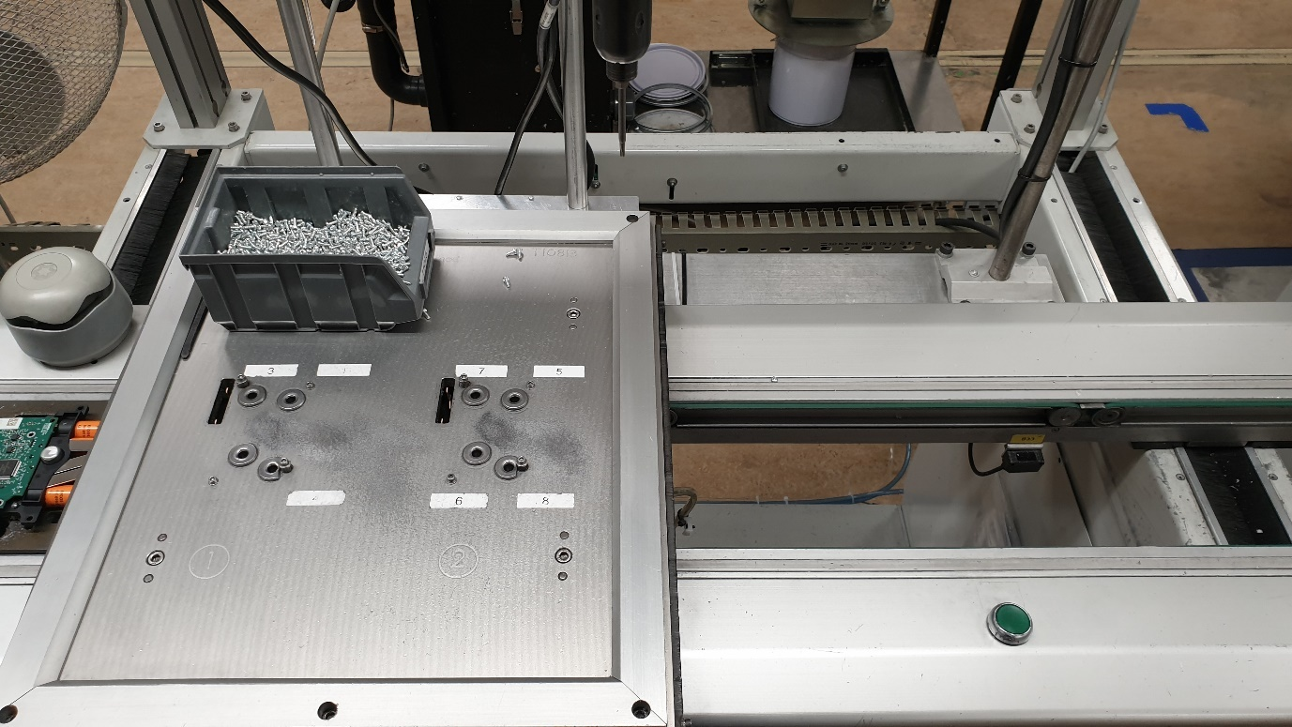
Picture of Product


