


ASSIGNMENT DETAILS AND FEEDBACK

SOUTH WEST WALES CENTRE OF TEACHER EDUCATION

Sections marked with * should be completed by module lead
Student name: | Rebecca Goss | Student number: | 1500225
Programme: | BA Primary Education with QTS
Module: * | Pedagogy in Practice 2 – Assessment for Learning | Module Level (4, 5, 6): | 6
Module code: * | ECAD6004/C | Contribution to Overall  Module Assessment (%): * | 50%
Module Lead:* | Mr T. Cox
Start date:* | 3/10/17 | Assignment No (x of x):* | 1 of 1
Submission deadline:* | 15/12/17 | Return date of provisional marks & written feedback:* | 26/1/18
Assignment Title:* | Critically evaluate your creativity and enterprise dispositions in terms of the Entrecomp frame work and how you might develop these to the next level and demonstrate progression.

Referencing: | In the main body of your submission you must give credit to authors on whose research your work is based. Append to your submission a reference list that indicates the books, articles, etc. that you have read or quoted in order to complete this assignment (e.g. for books: surname of author and initials, year of publication, title of book, edition, publisher: place of publication).
Submission: | All assignments must be submitted to Turnitin unless otherwise instructed by the Lecturer.  Note: the Turnitin version is the primary submission and acts as a receipt for the student. Late submission of the electronic version of the assignment will result in a late penalty. Penalties for late submission: Up to one week late, maximum 40%. Over one week late will be recorded as a non-submission. Late submission penalties may be lifted only with the approval of the Extenuating Circumstances Panel. | Date: | 15/12/17

Module lead to tick to indicate if a hard copy version of the assignment must be submitted.* | YES
 | NO | X

marking criteria and Student FEEDBACK
This section details the assessment criteria. The extent to which these are demonstrated by you determines your mark. The marks available for each criterion are shown. Lecturers will use the space provided to comment on the achievement of the task(s), including those areas in which you have performed well and areas that would benefit from development/improvement.
Common Assessment Criteria Applied | Marks available | Marks  awarded
1. Subject Knowledge and Understanding (which includes using research-informed literature and knowledge and understanding of the subject)  Extent of research and/or own reading, selection of credible sources, application of appropriate referencing conventions. Extent of knowledge and understanding of concepts and underlying principles associated with the discipline. | 30
2. Intellectual Skills (Analysis)  Analysis, evaluation and synthesis; logic, argument and judgement; analytical reflection; organisation of ideas and evidence | 30
3. Pedagogic and Professional Applications (Practical Application and Deployment)  Deployment of pedagogic methods, materials, tools and techniques; application of concepts; formulation of innovative and creative solutions to solve problems. Attributes in professional practice: individual and collaborative working | 30
4. Key Transferable Skills  Deployment of appropriate media; presentation and organisation. | 10

Assignment Mark (Assessment marks are subject to ratification at the Exam Board. These comments and marks are to give feedback on module work and are for guidance only until they are confirmed. ) | Late Submission Penalties (tick if appropriate) |  | %
 | Up to 1 week late | 40% Max | %
 | Over 1 week late | 0% | %

ASSESSMENT AND MARKING CRITERIA FOR ECAD5001/C ASSIGNMENT
Level 5 | Assessment Criteria Descriptors for BA Primary Education with QTS  This format emphasizes the holistic nature of judgements to be made by markers. Criteria weighting is adjusted for each module.
 | 0-39 (F) | 40-49 (P) | 50-59 (P) | 60-69 (P) | 70-79 (P) | 80-100 (P)
 | Poor / Weak F | Satisfactory 3rd | Good 2:2 | Very good 2:1 | Excellent 1st
Assessment Criteria | Poor, superficial, unsystematic, incomplete and/or inaccurate | Satisfactory understanding of main issues demonstrated | Good understanding demonstrated with some analysis | Very good understanding of basic principles and relevant evidence, with a coherent and logical argument | Thoughtful answer informed by wider reading, showing clarity of thought and personal insight | Outstanding answer, well written, highly structured and informed, showing striking personal insight and originality
Module Learning Outcomes matched to: | 0-11 | 12-14 | 15-17 | 18-20 | 21-23 | 24-30
Subject Knowledge and Understanding  (Conceptual)  (Reading) | Basic misunderstanding, misconceptions, misinterpretations and/or superficial knowledge in places | Outline knowledge of few key issues with evidence of understanding and application | Defined knowledge of some key issues and wider implications | Wider knowledge of most key issues, concepts and arguments | Clear understanding of the key issues under discussion with logical discussion | Excellent knowledge of key issues, concepts and arguments clearly discussed
Subject Knowledge and Understanding  (Conceptual)  (Reading) | Some inappropriate literature/material with limited reading range and lack of accuracy | Satisfactory range of reading drawn from the recommended list and other sources | Good range of reading drawn from the recommended list and other sources | Very good range of relevant literature from a variety of sources beyond recommended list | Evidence of well-considered thinking from a wide reading base using a variety of sources | Clear evidence of independent thinking informed by an excellent range of reading from a variety of sources
 | 0-11 | 12-14 | 15-17 | 18-20 | 21-23 | 24-30
Intellectual skills  (argument)  (presentation of findings/analysis)  (critical /reflective evaluation) | Argument is weak, little attempt to present differing viewpoints.  Generally too descriptive | The argument is beginning to be balanced with a growing awareness of other viewpoints | A balanced argument is presented while attempting to justify other viewpoints | A balanced argument is presented showing an understanding of different viewpoints and the reasoning behind them | A thoughtful argument is presented with appropriate consideration of viewpoints | A well- structured critical argument is presented with insightful consideration of viewpoints
 | Findings presented within incomplete descriptive framework and few or inaccurate conclusions are drawn | Findings are beginning to be presented in a developing framework with some analysis and reasonable conclusions | Findings are presented in a framework with some analysis and interpretation of data to form reasonable conclusions | Findings are presented in a framework with some analysis, interpretation and evaluation of data to form reasonable conclusions | Findings presented with some analysis and justified conclusions | Findings presented in a critical and analytical framework. Thoughtful conclusions, firmly based upon the evidence presented
 | Lack of evidence of evaluation and/or critical reflection | Evaluation and/or reflection are present but lacks depth | Good engagement with evaluation and reflection | Very good evidence of beginning to evaluate and critically reflect | Evidence of thoughtful critical engagement with evaluation and reflection | Effective and more in-depth critical engagement with evaluation and reflection
 | 0-11 | 12-14 | 15-17 | 18-20 | 21-23 | 24-30
Pedagogic and Professional applications  (linking theory to practice)  (professional reflection)  (ethical conduct where appropriate) | Superficial or lack of understanding of pedagogic and professional context(s) | Relates principles and concepts to underlying theoretical frameworks and approaches with respect to the pedagogic and professional context(s) | Identifies principles/ concepts underlying theoretical frameworks and begins to identify their strengths and weaknesses with respect to the pedagogic and professional context(s) | Evidence of the use of relevant research or developments to inform actions with respect to the pedagogic and professional context(s) | Clear evidence of integration of theory and practice with respect to the pedagogic and professional context(s) | Effective integration of theory and practice with respect to the pedagogic and professional context(s)
 | Little or no evidence of reflection | Reflection is evident | Evidence of good reflection | Beginning to critically reflect | Critical reflection is evident | Effective and in-depth logical and critical reflection is evident
 | Little or no awareness of ethical issues | Awareness of ethical issues | Awareness of ethical issues and able to discuss these in relation to personal beliefs and values | Ethical issues have been discussed showing an awareness of personal responsibility and professional codes of conduct | Ethical issues have been clearly discussed in the context of personal responsibility and professional codes of conduct | Ethical issues have been effectively addressed especially in the context of personal responsibility and professional codes of conduct
 | 0-3 | 4 | 5 | 6 | 7 | 8-10
Key/Transferable Skills  (Referencing techniques) | Weak presentation of written work | Satisfactory presentation of written work | Good presentation of written work | Very good presentation of written work | Effective presentation of written work | Outstanding presentation of written work
Key/Transferable Skills  (Referencing techniques) | A number of basic errors in spelling, punctuation or grammar | Some errors in spelling, punctuation or grammar | Few errors in spelling, punctuation or grammar | Very few errors in written language | Minor errors in written language | No errors in written language
Key/Transferable Skills  (Referencing techniques) | Weak structure with unclear writing style in parts | Satisfactory structure with a mostly coherent writing style | Good structure with a coherent writing style | Very good structure which supports the reader | Effective structure which supports the reader | Highly coherent and mature writing style which fully engages the reader
Key/Transferable Skills  (Referencing techniques) | Little or no use of protocols and conventions of Harvard referencing | Satisfactory use of Harvard referencing protocols and conventions | Good use of Harvard referencing protocols and conventions | Harvard system mainly used accurately, with some secondary sources | Harvard system used accurately including secondary sources | Harvard system used accurately, consistently and effectively with all sources

Student Self Evaluation Form
This section repeats in brief the common assessment criteria detailed on previous pages. The extent to which these are demonstrated by you determines your mark. Using these criteria, tick the box that best indicates the level of achievement you feel you have achieved with regard to each of them.

Common Assessment Criteria Applied | Level of Achievement
Common Assessment Criteria Applied | REFER |  | 3rd | 2:2 | 2:1 | 1st | 1st
 | OUTRIGHT FAIL | UNSATISFACTORY | SATISFACTORY | GOOD | VERY GOOD | EXCELLENT | EXCEPTIONAL
1. Subject Knowledge and Understanding (which includes using research-informed literature and knowledge and understanding of the subject) | 0-29% | 30-39% | 40-49% | 50-59% | 60-69% | 70-79% | 80-100%
 |  |  |  | ✓
2. Intellectual Skills (Analysis) | 0-29% | 30-39% | 40-49% | 50-59% | 60-69% | 70-79% | 80-100%
2. Intellectual Skills (Analysis) |  |  |  | ✓
3. Pedagogic and Professional Applications  (Practical Application and Deployment) | 0-29% | 30-39% | 40-49% | 50-59% | 60-69% | 70-79% | 80-100%
 |  |  |  | ✓
4. Key Transferable Skills | 0-29% | 30-39% | 40-49% | 50-59% | 60-69% | 70-79% | 80-100%
4. Key Transferable Skills |  |  |  | ✓
PLEASE COMMENT ON AREAS IN WHICH YOU FEEL THAT YOU HAVE PERFORMED WELL | PLEASE COMMENT ON AREAS you feel that you need TO DEVELOP
I think that I chose relevant competency areas and I think the evidence provided was strong.  I also made reference to many theorist and researchers in order to fully support my argument. | I feel as though academic writing is always something to develop within. I find this writing style difficult at times. Especially within this assignment as the use of I was allowed due to personal reflection.  I also think I need to improve on my constant use of one document. In this instance, the Entrecomp Competence Framework was the supporting document and again, I always seem to struggle making reference to this as I don’t want to lose the flow of my writing.

Student’s Name | Rebecca Goss | Date | 13.12.17
Student’s Signature | R.GOSS
Critically evaluate your creativity and enterprise dispositions in terms of the Entrecomp frame work and how you might develop these to the next level and demonstrate progression.

This assignment will begin with a discussion revolving around Creativity and Enterprise. Both of these terms will be defined, along with their importance in education, as well as the significance of practitioners being skilled within these two areas. After this, a brief overview of the Entrecomp Framework, Bacigalupo et al (2016) will be explained. In addition to three allocated competencies, that will be discussed and analysed in terms of my own personal abilities within them.

Creativity is a complex skill, due to its combination of many elements. Springer (2016) states that creativity can be defined as an adaptation of current thought processes, used within a different context for a new purpose, as well as the development of new ideas.
N.A.C.C.C.E (1999: 31-34) explains that there are four characteristics needed for a process of creativity. These are: Imagination, purpose, originality and judgement of value.
The importance of creativity in education withholds many benefits. Several authors communicate that creativity acts as a vital tool for deepening understanding, as it allows connections between subjects to be generated. (QCA, 2000; Wisemann, no date as cited in APPG, 2017) education should excite and fill pupils with motivation. Hayes (2009) communicates that unimaginative or uninspiring learning environments are present due to the elimination of creativity. To further this point, it is mentioned within the Foundation Phrase Framework, DCELLS (2008) that opportunities to enhance children’s creativity and imagination should be present throughout the curriculum. This shows that it is recognised by Welsh Government about the essential qualities that creativity withholds and can support the development of children in Wales.
On the other hand, creativity is a skill that can take a long period to develop. Rosso (2011:17) discusses that time-constraints heavily impact a flow of creativity due to the possibility of a long thought process when creative thinking and the limitation that it cannot be completed quickly. A final argument is presented by N.A.C.C.C.E (1999: 31-30) through the belief that many creative activities are undertaken by individuals in everyday life, that people are not aware of. If creativity can transpire naturally within a real-life context, it would be of high value to develop this skill further in education.
This then leads onto the importance of teachers being equipped with creative attributes and skills. Ball et al (2010) explains that due to the high demand of the government wanting creative people within careers to generate a thriving economy, teachers need to be able to fully support and utilise their own skills within creativity into education in order to successfully prepare children for their future prospects. As if their skills are not developed within this area then they are less likely to succeed.
In addition to creativity, enterprise education is also a current popular discussion topic.
Lowe et al (2006) defines enterprise as a personal development within individuals and the variety of goals they may have within their lives, that contain no similar measurement of success. It is also mentioned that; enterprising behaviour includes risk taking and addressing failures to take direction of their life. Young (2014:17) further explains a government initiative called ‘Ready Unlimited’ that supports teachers in creating learning experiences revolving around enterprise, to develop children’s knowledge and the ability to make connections with the real world.
The importance of enterprise in education is to confidently equip children with skills that they may possibly need within their lifetime. To further this, a high value of importance in regards to teachers possessing enterprise skills is present. Children need to have enterprise skills modelled in order for their understanding to increase, it is also important for educators to direct their pupils to effective learning which can only arise if they possess a high understanding of enterprise.

To conclude this section relating to creativity and enterprise in education. Donaldson (2015) communicates that both of these skills should be highlighted heavily within Welsh education as both skill sets are needed for children’s future. Which highlights the vital importance of their presence within education and the need for teachers to be competent in both areas.

To begin, the Entrecomp framework, Bacigalupo et al (2016) consists of fifteen competencies that are split into three sections known as: Into Action, resources and Ideas and opportunities. This framework Is described as a model of progression, that can be adapted by an individual to develop and enhance in particular competencies. There is no structure or specific rules to follow in order to advance within an area, general guidance is provided as each individual’s progression will be specific to themselves.
Despite these positives, challenging attributes of the framework are also present.
One major limitation considers the absence of critical assessment. This framework has not been administered into a real-life environment or context. This means, that many issues have not been discovered or addressed.
It should also be deliberated that enterprise and entrepreneurship are intertwined in this model. However, the definitions are entirely separate, this could cause confusion for the user.

For the purpose of this assignment, three competencies within the Entrecomp Framework Bacigalupo et al (2016) will be discussed and related to my personal reflection within each attribute. The selected competencies are: Creativity, Motivation & perseverance and Working with others.

The first competency to be addressed is creativity.
In terms of my personal creativity, I would place myself at a level of one within the ‘foundation’ ‘proficiency level’ Bacigalupo et al (2016: 18) Bacigalupo et al (2016) states level one as
‘focusing mainly on discovering your qualities, potential, interest and wishes. It also focuses on recognising different types of problems and needs that can be solved creatively, and on developing individual skills and attitudes’
(Bacigalupo et al 2016: 16)

A link is also present to Habits of Mind, Costa (2008:31) The eleventh habit ‘Creating, Imagining, Innovating” also discusses the ability of viewing from different perspectives and create solutions through creative thinking.
Nevertheless, a contrasting aspect is present. Within Habits of Mind, Costa (2008) as it discusses a create individual will accept criticism in order to succeed. This is not present within the Entrecomp Framework, Bacigalupo et al (2016) which arises the thought of the importance of criticism in creativity. Osborn (1953 as cited in Tanaka no date: 2344) suggests ‘If you try to criticize and create at the same time, you can’t turn either cold enough criticism or hot enough ideas’ this indicates that creativity and criticism negatively correspond with one another. Yet, De bono (1990) through the development of the Thinking Hats, promotes the idea of being critical when being creative. As each hat stands for a different method of thinking such as black hat thinking relating to caution when evaluating a proposal.

An example of evidence that supports the creativity skill level one presented, is through the completion of a lesson during PTE (See Appendix 1) It is evident within this lesson that resources had been provided. I had been encouraged to use this pre-fabricated lesson, as it had worked well on previous occasions.
To further develop my creativity skill to benefit myself as a practitioner, I need to begin to experiment. Level two is stated as ‘focusing on exploring different approaches to problems, concentrating on diversity and developing social skills and attitudes’ (Bacigalupo et al, 2016)
In order for myself to do this, I need to being analysing topics and discovering if they can be taught in a different way than they previously are. If it is determined that a new structure can be more efficient and beneficial way, then this should be undertaken instead of the usual routine. This is something I will focus on, especially during PTE.

The next competency to be discussed is Motivation and perseverance. which can be found within the Resources section of the Entrecomp Framework, Bacigalupo et al (2016: 18)
Gorman (2004) discusses that motivation encourages specific behaviour types when a target or goal is presented. Ryan et al (2000) explains that there are two types of motivation, Intrinsic and Extrinsic. Intrinsic motivation relates to an individual wanting to complete a goal for a personal fulfilment. Whereas extrinsic, revolves around completion for external rewards. Additionally, Oxford University Press (2017) define perseverance as ‘persistence in doing something despite difficulty or delay in success’ which is coherent with the term motivation.
Ormrod (2008 as cited in Lei 2010) explains that an intrinsically motivated individual is more likely to engage with tasks due to self-motivation, which results with an overall deeper understanding This also promotes the opinion that extrinsically motivated people possibly would have a lower overall learning experience. On the other hand, Emmer et al (1981 as cited in Lei 2010) is of the opinion that, the presence of an extrinsic reward, can stimulate involvement. Whereas more intrinsically motivated individuals possibly would not participate, due to lack of interest. However, Fowler (2014: 23) believes that a reward may instigate a response, yet it will not sustain for a long period of time. Once this appraisal or reward is completed, the extrinsic motivation is halted.
In relation to my own personal motivation and perseverance, it has been determined that I display a level 3, within intermediate ranking of progression and level of proficiency, which discusses the focal point of ‘critical thinking and on experimenting with creating value’ Bacigalupo et al (2016:16) A piece of evidence that supports my ranking of level 3, relates to the administration of enhanced provision (See Appendix 2)
During PTE last year, a discussion arose from staff members that there was very little time within the Christmas period to adapt the current role play area’s theme, with the new topic approaching. I have deep understanding about the importance of enhanced provisions especially within the Foundation Phase, which lead myself to implement the new role-play area for the children.
Within two hours various resources around the school had been collected, as well as the implementation of new materials. This presents an element of critical thinking, as it was determined that a variety of present resources were not suitable to the theme, meaning new ones had to be allocated.
The role-play area was not perfect and many with more time improvements can be made. However, as basic as it may be, I did not want to prevent an experience to the children, who ended up adoring the role-play area.
Additionally, during enterprise week a challenge was set to create a “What if?” scenario within a primary school and convince peers that your own idea was the best. This was based around the work of Sam Glucksberg (1964) developed further on an experiment called ‘the candle test’ in which two groups had been allocated, one presented with the financial reward for the fastest person to complete the challenge. During the “What If?” task it was told the winner would receive £125, however in a week’s time the idea had to be formed and presented. Immediately I found myself interested. Yet, when I thought about the possible ideas to suggest, I lost motivation. As I could not find a great idea quickly.
In order for myself to improve within motivation and perseverance, I need to find courage to work through times of difficulty. Bacigalupo et al (2016:16) states that ‘Level 4 focuses on turning ideas into action in ‘real life’ and on taking responsibility for this’. Even though the PTE example provided included a real context, I cannot take full responsibility as the decision of a theme was co-decided and I had support from staff. It is important for myself as a practitioner to create my own ideas, along with introducing them to staff and delegating responsibilities.

The final competency to be considered is working with others, this is allocated to the Into Action section, Bacigalupo et al (2016: 18)
The term working with others is an abbreviation from the word teamwork. Oxford University Press (2017) state this means ‘the combined action of a group”. This is also extremely important attribute within education and practitioners should have the ability to complete this well.
Tarricone et al (2002: 644) explained effective teamwork will result in many different advantages. One is the development of Interdependence. Which is understanding that in order to be successful, responsibilities need to be allocated to different team members, in order to reach a goal. On the other hand, Lencioni (2003) states that uniting trust can be difficult. As a team of successful individuals may find it hard not to lead a group and take a step back.
When analysing my own working with others competency using the Entrecomp Framework, Bacigalupo et al (2016: 18) the best fit ‘level of proficiency’ is ‘Foundation’ at a level one. Due to the identification of personal interests and abilities, as well as acknowledging a variety of issues that can develop my personal skills further through the implementation of creativity, present personal attributes and creating value within a team.
The evidence of myself being within this level, can be seen through evidence when on a school residential. (See Appendix 3)
The residential week was especially difficult to organise, due to the class being split into two groups who would alternate days to go to the activity centre. One of the first obstacles was room allocation, the number of children meant specific rooms had to be used, in which staff had to manoeuvre themselves around. However, the biggest issue was the possibility of unexpected weather. The activity centre provided two professionals in which children would experience activities such as rock climbing, yet it was communicated that in March, the weather cannot always be relied upon. If there was heavy rain the instructors would not attend, meaning as a team we had to create ideas for this possibility.
In order for myself to increase my ability to work within a team and progress to a higher level of two. I need to focus on generating multiple approaches to a problem. For example, even though many ideas for unexpected weather had been discussed, I had only put forward one idea. Which corresponds with the allocated level of one, due to my lack of different ideas surrounding one issue (Bacigalupo et al 2016: 16) this also presents my lack of useful service to the group. This needs to improve in order for myself to gain a higher level of teamwork.
Also, I think it would be of benefit to begin working on my ability to work with a wide range of people Bacigalupo et al (2016: 18). For example, when experiencing a residential I found it extremely hard to plan day activities with the instructors, due to our skill sets being within opposite areas, this is something I will work hard within, as it is extremely important to be able to communicate with a wide range of people within this profession.

On the whole, this assignment has included varied discussion about the importance of creativity and enterprise in education. It has been emphasised that due to the ever-growing demand of society, equipping children with both skill sets will enable them to fully succeed in their future paths, no matter their preference of career. Which further asserts the importance of my own skills within these areas, as a practitioner.
In relation to my own personal creative and enterprise dispositions, it can be determined through the use of the Entrecomp framework that I am placed within varying levels when considering my creativity, motivation and perseverance, as well as working with others. This has been secured by the provision of evidence, in addition to a very critical analysation of the determined level for my ability, in terms of the positives and negatives provided.
Yet, it has been concluded that it is extremely important for myself as a practitioner to enhance these areas to my fullest potential, in order to succeed. Future targets have also been incorporated within the three identified competencies that have been focused upon throughout this essay, that can further support in guiding myself to a higher level within creativity and enterprise dispositions which has been proved vital within current and future education.

References
All-Part Parliamentary Group on Arts, Health and Wellbeing (2017: 190) Creative Health: The Arts for Health and Wellbeing. [Online Article] Available at: http://www.artshealthandwellbeing.org.uk/appg-inquiry/Publications/Creative_Health_Inquiry_Report_2017.pdf [Accessed: 13.12.17]

Bacigalupo, M. Kampylis, P. Punie, Y., Van den Brande, G. (2016) EntreComp: The Entrepreneurship Competence Framework. Luxembourg: Publication Office of the European Union; EUR 27939 EN; doi: 10.2791/593884

Ball, L. Pollard, E. Stanley, N (2010) Creative graduates, Creative futures. Brighton: Creative Graduates Creative Futures Higher Education Partnership and the Institute for Employment Studies. [e-book] Available at: http://www.employment-studies.co.uk/system/files/resources/files/471.pdf [Accessed: 13.12.17]

Costa, A., Kallick, B. (2008) Learning and Leading with Habits of Mind, Virginia: ASCD.

De Bono, E. (no date) ‘The Journal for Quality and Participation’, Vol. 11. No.3 [Online] Available at: http://www.debonogroup.com/serious_creativity.php [Accessed on: 12.12.17]

Donaldson, G. (2015) Successful Futures. Cardiff: Welsh Government.

Fowler, S. (2014) Why Motivating People Doesn’t Work… and What Does San Francisco: Berrett-Koehler Publications. Available at:http://motivationbook.susanfowler.com/wp-content/thesis/skins/mobile-first/images/sample_chapter.pdf [Accessed: 13.12.17]

Gluckberg, S (1964) Functional fixedness: problem solution as a function of observing responses [Online Article] Available at https://link.springer.com/content/pdf/10.3758%2FBF03342819.pdf [Accessed: 13.12.17]

Gorman, P. (2004) Motivation and Emotion. London; New York: Routledge. Available at: https://www-dawsonera-com.ezproxy.uwtsd.ac.uk/readonline/9780203694978 [Accessed:13.12.17]

Hayes, D (2009) Learning and Teaching in Primary Schools. Exeter: Learning Matters [e-book] Available at: https://www-dawsonera-com.ezproxy.uwtsd.ac.uk/readonline/9781844458233 [Accessed:13.12.17]

Lei, , A, S (2010) ‘Motivation in education (Methods), ‘Journal of Instructional Psychology’. Vol. 37, June, pp. full text. Available at: http://www.freepatentsonline.com/article/Journal-Instructional-Psychology/231807635.html [Accessed: 13.12.17]

Lencioni, M, P. (2003) The Trouble with Teamwork [Online Article] Available at: http://www.hillconsultinggroup.org/assets/pdfs/articles/trouble-w-teamwork.pdf [Accessed: 13.12.17]

Lowe, R. Marriott, S (2006) Enterprise, Entrepreneurship and Innovation Concepts, Contexts and Commercialization. Oxford: Elsevier. [e-book] Available at: https://www-dawsonera-com.ezproxy.uwtsd.ac.uk/readonline/9780080492650 [Accessed: 10.12.17]

N.A.C.C.C.E. (1999) All our futures: creativity, culture and education, London: DfEE.

Oxford University Press (2017) ‘Perseverance’ Available at: https://en.oxforddictionaries.com/definition/perseverance [Accessed: 13.12.17]

Oxford University Press (2017) ‘Teamwork’ Available at: https://en.oxforddictionaries.com/definition/teamwork [Accessed: 13.12.17]

QCA (2000:116) Curriculum guidance for the foundation stage. London: Qualifications and Curriculum Authority [e-book] Available at: http://ictedusrv.cumbria.ac.uk/maths/pgdl/unit4/cgfs.pdf [Accessed: 12.12.17]
Rosso, D, B. (2011:16) Creativity and Constraint: Exploring the Role of Constraint in the Creative Processes of New Product and Technology Development Teams. [Online article] Available at: https://deepblue.lib.umich.edu/bitstream/handle/2027.42/89692/brosso_1.pdf?sequence=1 [Accessed: 13.12.17]
Ryan, M, R. Deci, L, E. (2000) ‘Intrinsic and Extrinsic Motivations: Classic Definitions and New Directions, ‘Contemporary Educational Psychology’, No.25, pp.54-67. [Online] Available at: https://mmrg.pbworks.com/f/Ryan,+Deci+00.pdf [Accessed: 13.12.17]

Springer (2016) Theory of Creativity. [Online Article] Available at: https://www.google.co.uk/url?sa=t&rct=j&q=&esrc=s&source=web&cd=3&ved=0ahUKEwjSrYGh6YLYAhULElAKHbtqBdMQFggzMAI&url=http%3A%2F%2Fwww.springer.com%2Fcda%2Fcontent%2Fdocument%2Fcda_downloaddocument%2F9783319192338-c2.pdf%3FSGWID%3D0-0-45-1517480-p177391509&usg=AOvVaw0bS9qcDSNjtkwNF7S43ohp [Accessed: 11.12.17]

Tanaka, Y. Sakmoto, Y. Sonehara, N. (no date) The Effects of Criticism on Creative Ideation [Online Article] Available at: https://mindmodeling.org/cogsci2015/papers/0403/paper0403.pdf [Accessed: 13.12.17]

Tarricone, P. Luca, J. (2002) Successful teamwork: A case study [Online Article] Available at: http://www.unice.fr/crookall-cours/teams/docs/team%20Successful%20teamwork.pdf [Accessed: 13.12.17]

Wales: Department for Children, Education, Lifelong Learning and Skills (2008) Framework for Children’s Learning for 3 to 7-year-olds in Wales. Cardiff: Welsh Assembly Government.
Young, L. (2014) Enterprise for All The Relevance Of Enterprise In Education. [Online Article] Available at: https://www.gov.uk/government/uploads/system/uploads/attachment_data/file/338749/EnterpriseforAll-lowres-200614.pdf [Accessed: 10.12.17]

1500225
Appendices
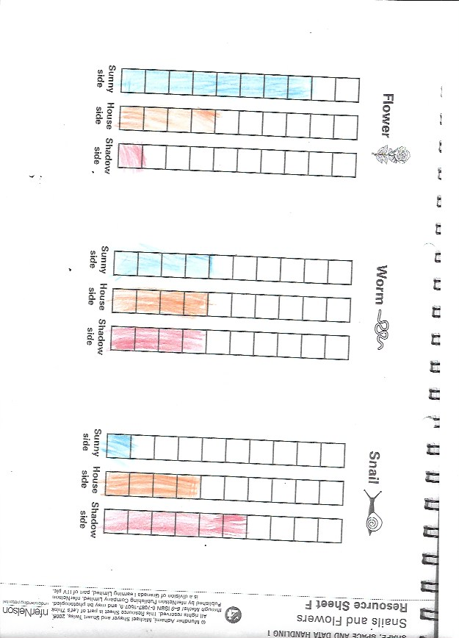
Appendix 1.
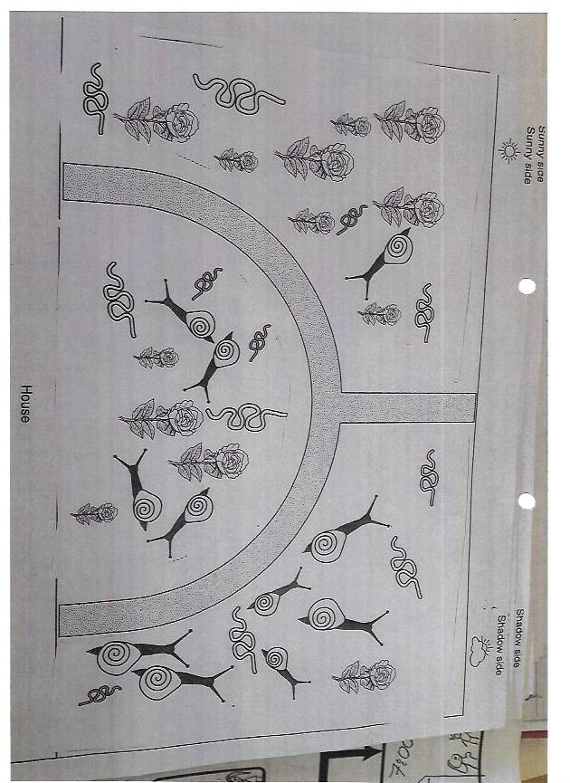
Pre-planned lesson example:
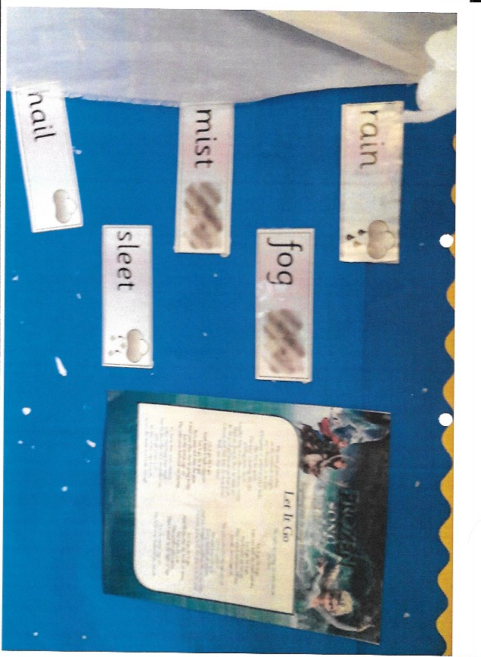
Appendix 2.
Enhanced provision example:

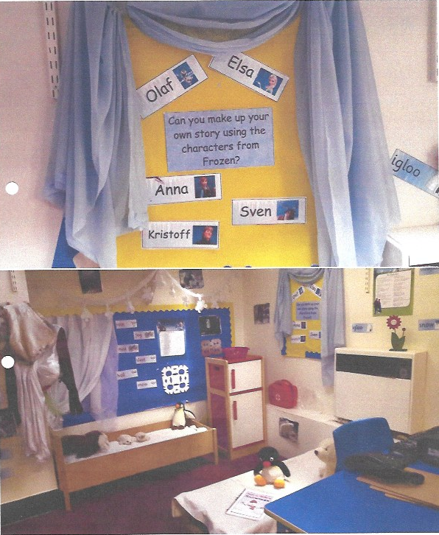
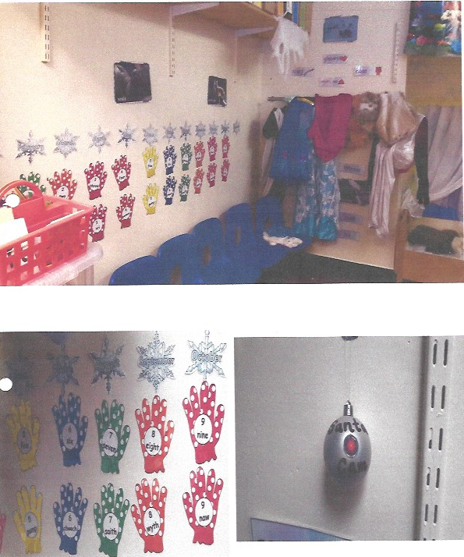

Appendix 3.
School residential evidence.

Model Casgliadau Adfyfyriol â Chymorth (ARC) (Model ‘Myfyrio a Newid’)

Assisted Reflective Conclusions (ARC) Model
Dyddiad/Date: 20.03.17
Digwyddiad critigol (Ffocws)/Critical incident (focus): Mathematics problem solving activity, Literacy cold write of a leaflet. (Monday)

Profiad/ Experience
Teimladau/  Feelings  “What are your feelings regarding the experience?” | Confident, after the residential I felt that I had built stronger relationships with the children. I was well prepared for both lessons and began to feel like a proper teacher as I taught two consecutive lessons, one after another.
Cofio a Deall/  Remember and Understand  “Can you list the aspects of the learning experience that went well?”  “What were the elements of the learning experience that were disappointing?” | My organisational skills, the mathematics activity required a lot of different resources. It was also very difficult to plan, as I had thoroughly checked through what I was going to say the children responded well to this and nobody received a red rag rating, almost all children were a green rating.  The literacy activity was also rather difficult as it was a cold write, meaning the children were not told a lot of information and had to individually create their own leaflets on how a plant grows. I used a good video stimulus which explained to children what a garden centre was, I also offered a lot of different leaflets for support.  As it was wet play all of the children had to stay in class. Their behaviour in the second lesson (literacy) was not an acceptable standard.
Gwerthuso a dadansoddi/  Evaluate and analyse  “What will you keep the same to ensure effective teaching and learning in the future?”  “What was the cause of the most important disappointing element?” | My organisation of the resources as well as the way I explained certain information in both of the lessons.  Wet play was the cause as the children had to stay indoors.
Casgliadau a chamau gweithredu/  Conclusions and actions  “What are your possible solutions to the disappointing issues identified?”  “What will you do next?” | Possibly getting the children out of the classroom and into the hall? However, this is dependent on how the school runs their wet plays.  Next, I will be planning other lessons that are not linked to this topic.
Y profiad newydd / Transformed experience

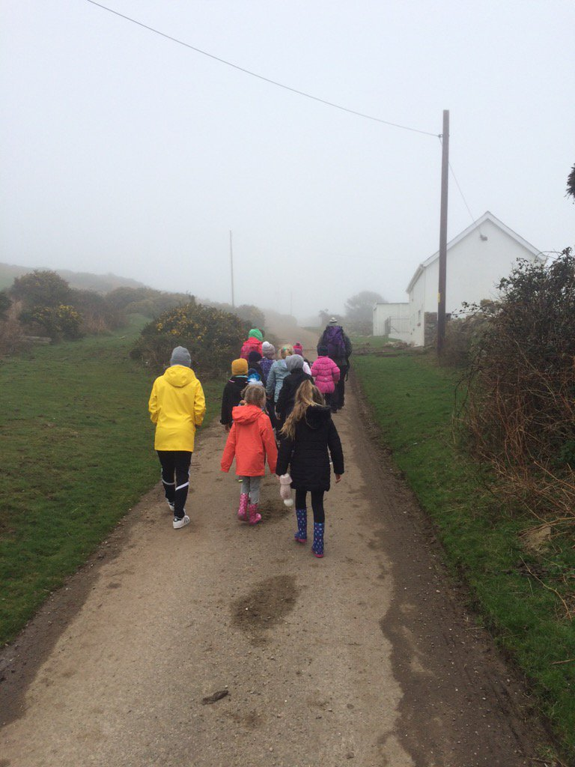
Me



