

LEVEL 4 ASSESSMENT SPECIFICATION

Student name: | Robert Brazier | Student ID number: | 2018693
Programme:
Module:
Module code: | ACDA4003 | Contribution to Overall Module Assessment (%): | 50%
Lecturer: | Sue Maw | Internal Verifier: | Gordon Dickers
Assignment Title: | Mathematics Fundamentals | Word count (or equivalent): | 2000 (equivalent)
Submission deadline: |  | Return date of provisional marks & written feedback:
Submission method: | All written assessments, where practical and possible, must be submitted via Turnitin unless otherwise instructed by the Lecturer. (Please DO NOT put this assessment specification into Turnitin or it will match many similarities with other students’ submissions.)  Alternative submission method (if applicable):  Late submission of the assessment will result in a late penalty mark. Penalties for late submission: Up to one week late, maximum mark of 40%. Over one week late, 0%. Only the Extenuating Circumstances Panel may approve a change to submission dates.
Academic honesty / referencing: | Academic honesty is required. In the main body of your submission you must give credit to authors on whose research and ideas your work is based. Append to your submission a reference list that indicates the books, articles, etc. that you have used, cited or quoted in order to complete this assessment.

Please photograph your work or use a stylus and submit in Moodle Assessment folder by 1.15pm on Thursday 14th May.
Please submit as one file if possible, for example by pasting photos under the questions in Word.
Module Learning Outcomes
(from module syllabus)
- Apply appropriate mathematical techniques to the solution of mathematical problems.

- Differentiate the following:
a)
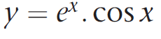
4 marks
b)
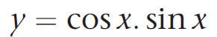
4 marks

c)
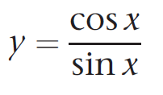
5 marks
d)
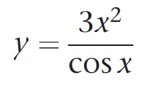
5 marks

Hint:
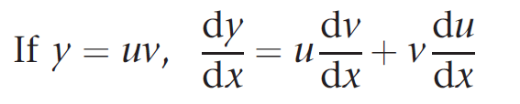
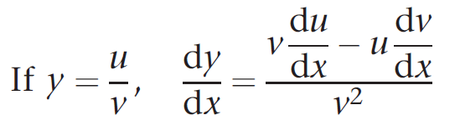

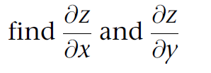
e)
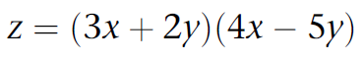
6 marks

f)
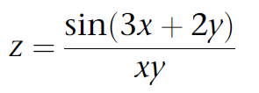
6 marks

- a)

10 marks
b)
Find the dot product and the cross product of the two vectors (6,8,0) and (12,9,0).
10 marks

- Complete the following complex number calculations:

a)
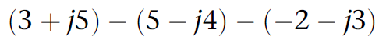
[3 marks]
b)
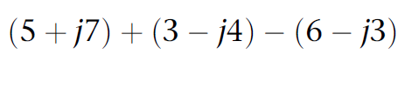
[3 marks]

c)

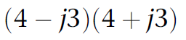
[4 marks]
d)
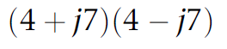
[4 marks]
e)

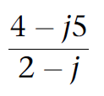
[8 marks]

f)
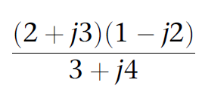
[8 marks]

4. Matrix $A= \left( \begin{matrix}4 & -4 \\ -7 & 1\end{matrix} \right)$ and $B= \left( \begin{matrix}3 & 1 \\ -1 & 2\end{matrix} \right)$

4a) A+B 2 Marks
4b) A-B 2 Marks
4c) AXB 4 Marks
4d) Determinate of A 3 Marks
4e) Adjoint of A 4 Mark
4f) Inverse of A 5 Marks



