


Data Security, Governance and Compliance (DSGC)

Tutorial 7

Wales Institute of Science and Art
Applied Computing
I.Q Building, Room 205
Swansea
SA1 8EW

INTRODUCTION AND OBJECTIVES OF THE Exercises
In the lecture, you learnt about the strategy options used to treat risk and be prepared to select from them when given background information. Evaluate control alternatives under the defence risk treatment strategy and formulate a cost–benefit analysis (CBA) using existing conceptual frameworks. Explain how to maintain and perpetuate controls. Describe popular methodologies used in the industry to manage risk.
Apply your understanding and knowledge from what you learnt in the lecture about the topic by answering the following:
Please read the following and then answer the questions as best as you can, your lecture notes, text book, library databases and/or the Internet can be used to answer the questions. – 30 mins
Once you have done that, discuss your answers with other members on your table – 10 mins
Be prepared to discuss and even present your findings to the rest of the class, upon the lecturer’s choice – 20 mins

Review Questions

- What is competitive advantage? How has it changed in the years since the IT industry began?

- What is competitive disadvantage? Why has it emerged as a factor?

- What are the five risk treatment strategies presented in this lecture?

- Describe the strategy of defense.

- Describe the strategy of transference.

- Describe the strategy of mitigation.

- Describe the strategy of acceptance.

- Describe the strategy of termination.

- Describe residual risk.

- What are the three common approaches to implement the defense risk treatment strategy?

- Describe how outsourcing can be used for risk transference.

- What conditions must be met to ensure that risk acceptance has been used properly?

- What is risk appetite? Explain why risk appetite varies from organization to organization.

- What is a cost-benefit analysis?

- What is the difference between intrinsic value and acquired value?

- What is single loss expectancy? What is annualized loss expectancy?

- What is the difference between benchmarking and baselining?

- What is the difference between organizational feasibility and operational feasibility?

- What is a qualitative risk assessment?

- How does Microsoft define “risk management”? What phases are used in its approach?

Exercises
These answers will vary
- Using the following table, calculate the SLE, ARO, and ALE for each threat category listed.

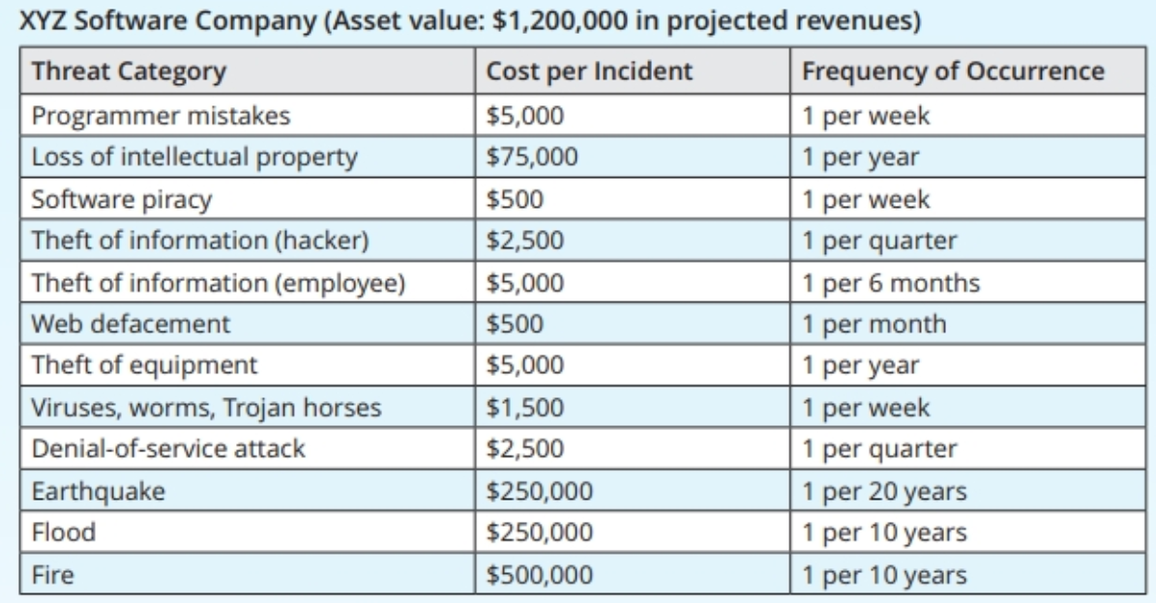

- How did the XYZ Software Company arrive at the values shown in the table that is included in Exercise 1? For each row in the table, describe the process of determining the cost per incident and the frequency of occurrence.

- How could we determine EF if there is no percentage given? Which method Frequency of Occurrence 1 per week 1 per year 1 per week 1 per quarter 1 per 6 months 1 per month 1 per year 1 per week 1 per quarter 1 per 20 years 1 per 10 years 1 per 10 years is easier for determining the SLE: a percentage of value lost or cost per incident?

- Assume a year has passed and XYZ has improved its security. Using the following table, calculate the SLE, ARO, and ALE for each threat category listed.
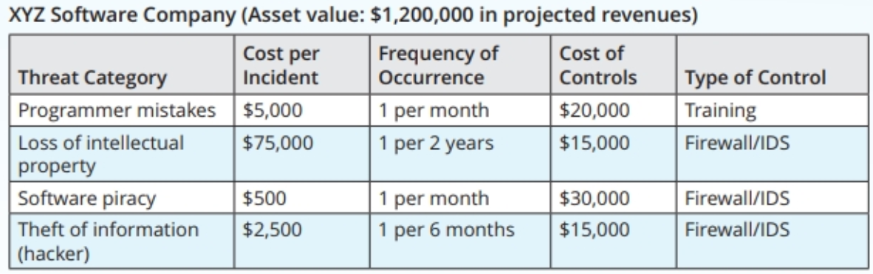
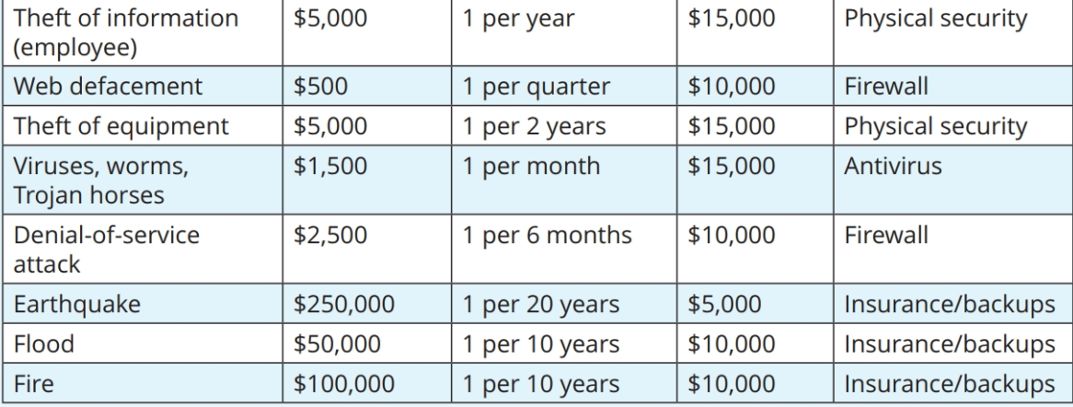

- Why have some values changed in the following columns: Cost per Incident and Frequency of Occurrence? How could a control affect one but not the other?

- Assume that the costs of controls presented in the table for Exercise 4 were unique costs directly associated with protecting against that threat. In other words, do not worry about overlapping costs between threats. Calculate the CBA for each control. Are they worth the costs listed?

- Using the Web, research the costs associated with the following items when implemented by a firm with 1,000 employees and 100 servers:
- Managed antivirus software (not open source) licenses for 500 workstations
- Cisco firewall (other than residential models from LinkSys)
- Tripwire host-based IDS for 10 servers
- Java programming continuing education training program for 10 employees
- Checkpoint Firewall solutions

Quick Quiz 1

- Which risk treatment strategy focuses on planning and preparation to reduce the damage caused by a realized incident or disaster?
  - Mitigation
  - Termination
  - Transference
  - Acceptance

- True or False: An example of using the transference risk treatment strategy would be to outsource the security of an asset to another organization.

- Which of the following is NOT one of the three types of plans included in a mitigation risk treatment strategy?
  - Incident response (IR) plan
  - Disaster recovery (DR) plan
  - Business continuity (BC) plan
  - Risk control plan (RC)

- When is the acceptance risk treatment strategy NOT an acceptable approach?
  - The cost of protecting an asset is more than the asset is worth
  - The asset consists of employee and / or customer information
  - The asset is considered expendable
  - The asset has relatively little risk

- Which risk treatment strategy approach can also be referred to as an avoidance strategy?
- Termination
- Acceptance
- Defense
- Transferal

Quick Quiz 2

- Which of the following can be calculated using the values from an ARO multiplied by the values from an SLE?
  - cost benefit analysis
  - asset valuation
  - annualized loss expectancy
  - operational feasibility

- True or False: Asset valuation is the process of assigning financial value or worth to each information asset.

- Operational feasibility, which refers to user acceptance and support, as well as management acceptance and support, is also known as which of the following?
  - organizational feasibility
  - behavioral feasibility
  - technical feasibility
  - political feasibility

- Which risk management technique relies on a group evaluating, rating, and ranking assets?
  - Delphi technique
  - OCTAVE methods
  - Microsoft’s technique
  - FAIR

- What is the easiest way to calculate the cost-benefit analysis (CBA)?
  - CBA = ALE(postcontrol) – ALE(precontrol) + ACS
  - CBA = ALE(postcontrol) – ALE(precontrol) – ACS
  - CBA = ACS(precontrol) – ALE(postcontrol) + ALE(precontrol)
  - CBA = ALE(precontrol) – ALE(postcontrol) – ACS

