Motorcycle technology
Name: Iriney Georgiev
Student number: 1900719
Course: Motorcycle engineering

Contents:
1 Introduction: 3
2 Center of gravity: 4
2.1 Manual procedure: 4
2.2 Data sheet: 4
2.3 Schematic diagram: 4
3 Maximum velocity: 5
3.1 Drag force: 5
3.1.1 Frontal area 5
3.2 Resistance due to gradient (Road Plane) 5
3.3 Calculations: 6
4 Analysis: 7
4.1 Honda Fireblade CBR1000RR,2005 7
4.2 BMW S1000RR,2018 7
5 Modern motorcycle geometry 8
5.1 Dakar motorcycle 8
KTM 450 Rally is a machine manufactured especially for Dakar. 8
5.2 Drag motorcycle 8
6 Concussions with recommendations: 9
7 References: 9

Introduction:
This investigation process is going to represent the following information:
- Geometry data of two different motorcycles
- Technical information for one of the motorbikes; finding maximum possible speed of the bike
- Microsoft excel sheets with calculations for a prove
- Handling characteristics for both machines in different dynamic situations
- Geometry data for two more motorcycles and compare how the geometry of each motorcycle relate to its handling characteristics and performance

Center of gravity:
The center of gravity is specific for each motorcycle. This is a variable which can be easily changed by rake angle, swing arm, suspension, etc. However, the rider’s weight has the most significant impact where the center of gravity falls.

Manual procedure:
If a workshop manual for a certain bike is not available, the given procedure should be done:
- First, the motorbike should be put on accurate scales which measures each wheel separately.
- Then the rear wheel has to be lifted by a stool and measure the bike again. The chair must be measured and weighted as well. This process can be repeated with a rider on the motorcycle for more data.
- The next stage is to determine the wheel base of both bikes. Using a center point dropping it from the middle of each wheel to the ground a mark can be drawn and measure it with a tape.
- The wheel radius can be taken with a ruler.
- For the rake angle a specific degree tool is needed. Placing it on the forks or triple clamp the rake angle can be determined.
- The last part is the offset which can be tricky. However, it is the distance between the center of the forks to the center where the triple clamp connects with the frame.

Data sheet:
Figure 1: Microsoft excel table showing data and calculations for center of gravity

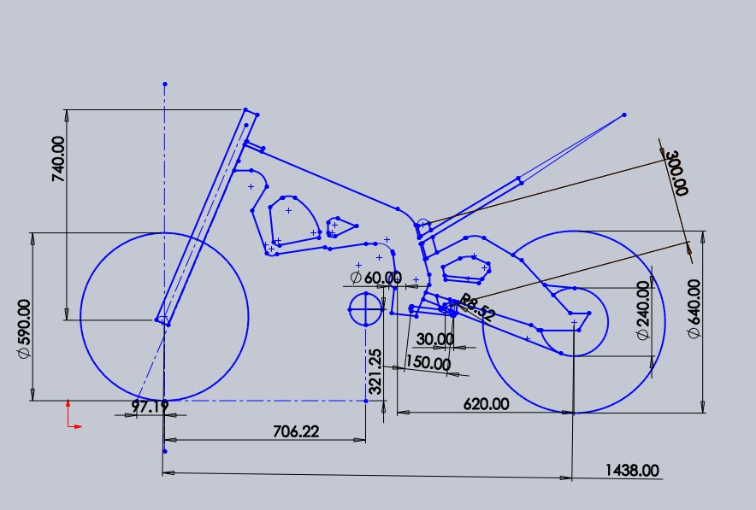
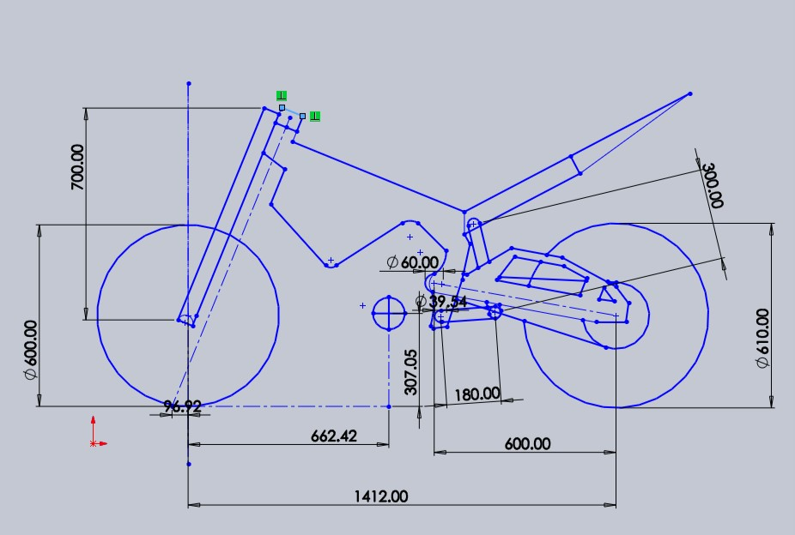
Schematic diagram:
Figure 2: A schematic diagram: Honda Fireblade CBR1000RR; (Georgiev)
Figure 3: A schematic diagram representing BMW S1000RR; (Georgiev)
The diagrams from above represents both motorcycles and their geometry data. Using the manual way of measuring the motorcycle a close approximation, how the motorcycle geometry looks like, can be produced. Both motorbikes are shown without the weight of the rider. However, the center of gravity is clearly marked, cycle with crossing lines. Using the data sheet from the previous midpoint when the rider weight is a factor the center of gravity moves to the front.

Maximum velocity:
Every bike has its own specifications. The easiest source to find certain information is the factory manual. In order to find the maximum velocity of the motorcycle hence gear ratios are needed. Gear calculator will be required to find out the maximum speed for each gear. However, these will be the perfect condition to reach this speed. There are external forces which would act over the motorbike until it reaches its maximum speed. (Bradley, 1996)

Drag force:
$$Fd=\frac{1}{2}q×Cd×A×v^{2}$$
Where: q is density of air, in this case it is a constant=1.167$kg/m^{3}$
Cd is the drag coefficient which depend from the surface
A ($m^{2}$) is the frontal area of the motorcycle
V is velocity in $m/s$

Frontal area
Finding the frontal area can be a challenge. A picture with a front view of the motorbike has to be taken. A few measurements from the bike should be takes such as height, mirrors distance, etc. All this information can be inserted into Solid Works. A program which can calculate the exact frontal area by plotting grids over the picture. Therefore, each square can be calculated and counted to find the exact frontal area.
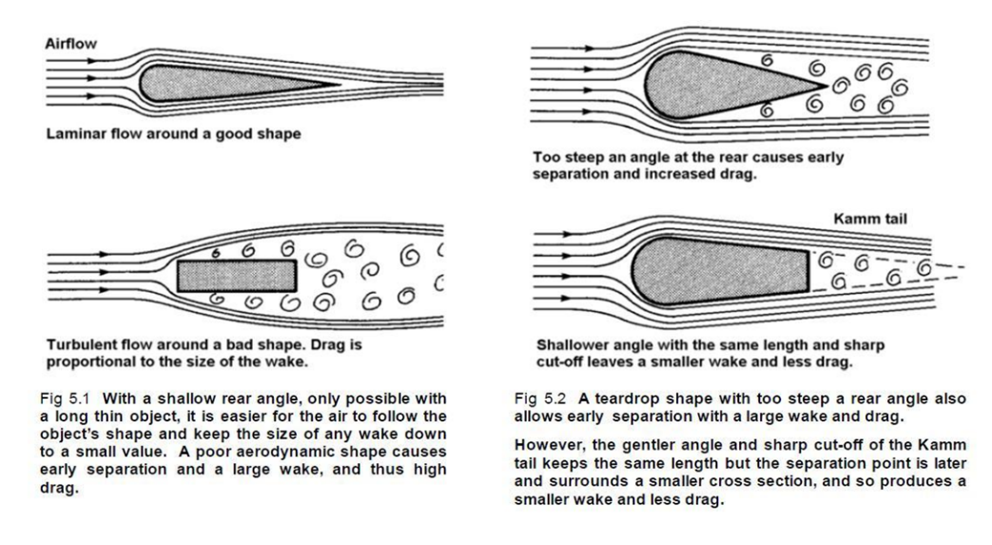
The frontal area plays a significant role in those calculation because of the aerodynamic resistance. Aerodynamic resistance can be explained as an object going through the air. It is known that the air has a mass of 1kg/m^3 hence energy is required to displace the air. Smaller frontal area less energy will be needed. The front of the bike can be in a streamlined shape which can reduce the energy as well. Using the formula from above with increasing the velocity more power is required to drive the object forward.
Figure 4: Airflow explanation; (Foale, 2002)
In order to increase the efficiency of the vehicle, while traveling through the air, the drag coefficient must be lowered hence less energy is lost displacing the air. (Foale, 2002)

Resistance due to gradient (Road Plane):
This investigation is under perfect conditions hence the road plane will be zero.

Calculations:
Figure 5: Power needed table/calculations
The Fireblede is chosen for this part of the investigation. Taking real data from the workshop manual the following information can be seen. (Ltd, 2010) The maximum force which the bike can produce is 1217.688N with a rider. In order to reach maximum speed of 286km/h on 6th gear the motorbike needs power of 171hp.
$$P=F×v$$
Using a liner motion formula, the required force is 1605.17N which means the motorbike is not powerful enough with a rider, rider’s weight is 95kg. With a lighter rider the motorcycle might reach its maximum speed. (Pearson Education, 1987)

Analysis:

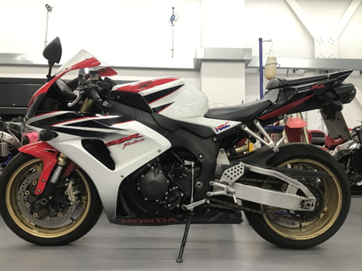
Honda Fireblade CBR1000RR,2005
Figure 6: Side view of Honda CBR1000RR; (Georgiev)
One really successful street bike during that time which can be ridden on a circuit as well. The characteristic of this bike allows the rider to feel comfortable on the road due to its specifications. The wheel base is quite short which allows the rider to lean the bike easily. However, its trail is in relation with the wheelbase in order to make the bike stable in the corners and on the straights. The handling is great because a steering damper is attached to the wheel. The model of the forks is “Upside Down” which increase the comfort and effect during the braking process. This bike is with the new for that time Pro-Link system, patent of Honda, which helps during the squat and anti-squat process.
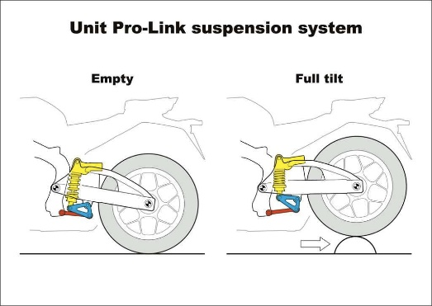
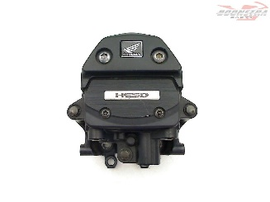
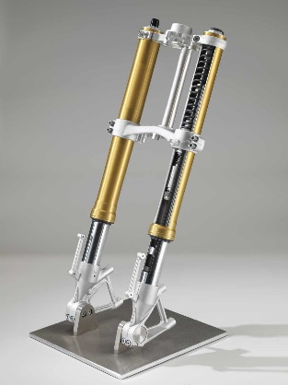
The center of gravity is clearly seen to the front, with the rider, which means the anti-wheelie can be prevent. The rider will be able easily to shift its body position and ride the bike smoothly.
Figure 7: Honda’s steering damper; (Ureterp, 2019)
Figure 8: Pro-link system image; (Inc, 2018)

Figure 9: An Upside Down fork example; (Ltd., 2017)

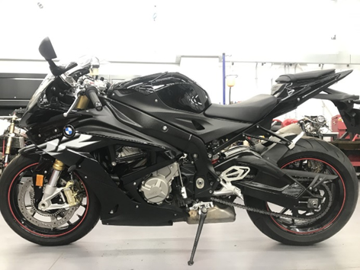
BMW S1000RR,2018
Figure 10: Side view of the BMW S1000RR; (Georgiev)
The idea is to show one modern bike from the last years. This bike is originally a road bike but it is supposed to be for track as well.
Electronics will have a huge effect over the performance of this bike. Its wheel base and rake angle is almost the same length as on the previous bike. Therefore, the bike will not have a huge difference during stability and comfort. However, a lot of other features are included such as anti-wheelie, shifter, mapping changes, traction control and others. All these elements will make the bike safer on the road. At the same time only from the electronics the bike can be set up for track which makes it more interesting and attractive.

Modern motorcycle geometry:

Dakar motorcycle

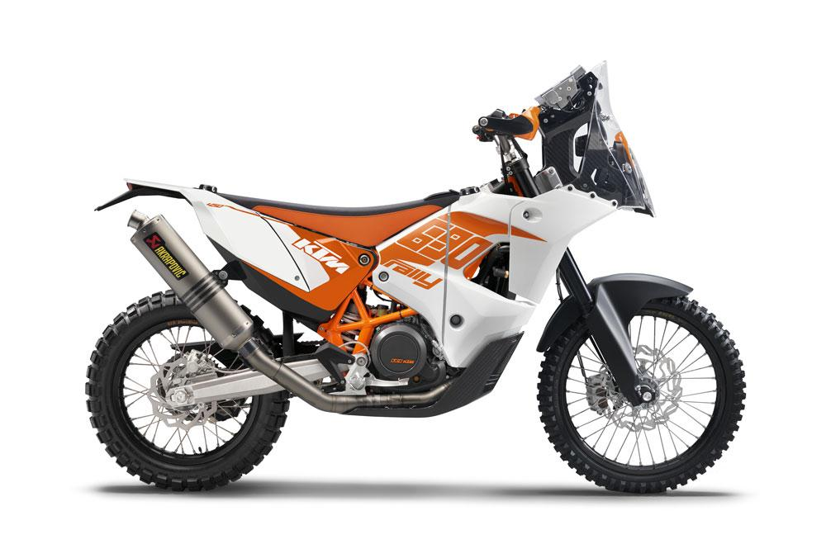
KTM 450 Rally is a machine manufactured especially for Dakar.
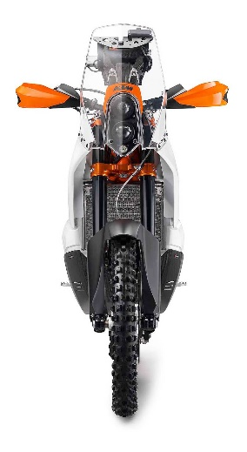
It is completely different from the road bike due to its application. It must travel long cross-roads for a period of time hence it must be easily ridden. First the motorcycle is really light as weight not to save rider’s energy. It has a long wheelbase in order to be stable in long straights. However, the front is small and the whole bike is tall but narrow. This plays a small role for the aerodynamics resistance, less air resistance, but more about the mobility of the bike. The tires are with large grip to have long endurance.
Figure 12: Front caption of KTM 450 Rally; (MCS, n.d.)
Figure 11: A classic Dakar motorcycle example; (MCS, n.d.)
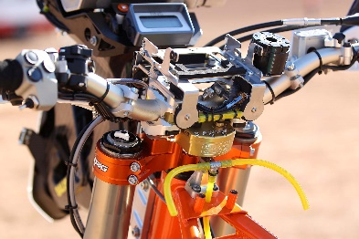
On this motorbike the rider stays in a stand position almost all the time. Therefore, its weight moves easily and the center of gravity changes as well. Fortunately, the suspension is on a high level and a lot correction can be made to ensure the comfort and stability. Electronics are also an important factor but they are more about precision setups.
Figure 13: Close look from the front suspension

Drag motorcycle
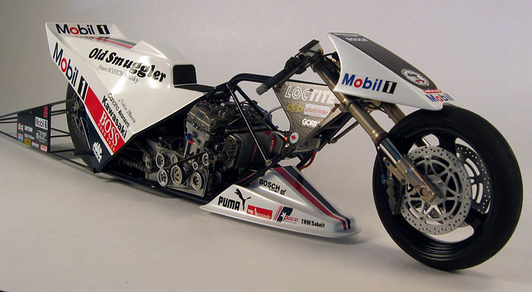
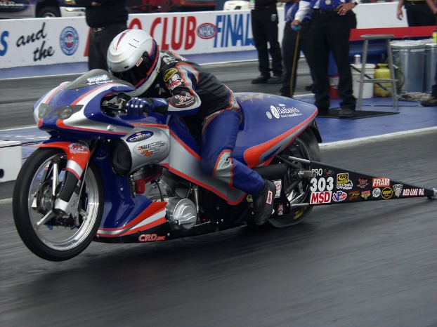
Figure 15: A professional drag racing motorcycle; (models, n.d.)
Figure 14: Drag motorcycle; (Baaklini, 2012)

The second type of modern motorcycle is a drag bike. All of them can be called prototypes. The main point is to have maximum speed for a short period of time. The biggest changes to produce a drag bike is to lower and shift forward the center of gravity. For this reason, the suspension become really low and the wheelbase must be as long as possible. The trail is calculated to make the bike as stable as possible on the straight. The fairings play important role here hence aerodynamic forces must be minimized. The front tire is rally small because the bike is not supposed to take corners. However, the rear tire has a huge diameter for a maximum grip which will provide advantage on the starting grid.

Concussions with recommendations:
Geometry of a motorbike varies due to its application. Depending for what the bike is used the center of gravity must be on place. From the research so far, a few simple ways of moving the center of gravity can be done:
- Wheelbase
- Rake angle
- Trial
- Fork length
- Triple clamp dimensions
- Seat height
- Shock and linkage system
- Swing arm length
- Gear ratios
- Rider weight

References:
Baaklini, J. (2012). Karanouh Motorsports organize first ever motorcycle drag race in Lebanon. Retrieved from biser3a: https://biser3a.com/motor-sports/karanouh-motorsports-organize-first-ever-motorcycle-drag-race-in-lebanon/
Bradley, J. (1996). The Racing Motorcycle. Broadland Leisure Publications.
Foale, T. (2002). Motorcycle Handling and Chassis Design. Tony Foale (2002).
Georgiev, I. (n.d.). Georgiev's own collection. Motorcycle Technology. Swansea.
Inc, 2. V. (2018). The Missing Linkage. Retrieved from motorcycle: https://www.motorcycle.com/ask-mo-anything/the-missing-linkage.html
Ltd, M. (2010). Honda CBR 1000 RR - Fireblade back 2005 forward. Retrieved from mbike: http://www.mbike.com/honda/cbr1000rr/2005
Ltd., A. M. (2017). Upside Down Fork vs. Conventional Telescopic Fork – The Differences & Pros. Retrieved from bigbike-rider: https://bigbike-rider.com/upside-down-fork-vs-conventional-telescopic-fork-the-differences-pros/?lang=en
MCS. (n.d.). KTM 450 Rally. Retrieved from motorcyclespecs: https://www.motorcyclespecs.co.za/model/ktm/ktm_450_rally%20%2011.htm
models, R. s. (n.d.). "Top Fuel" Drag Racing Motorcycle by Jimmy Canciano. Retrieved from racingscalemodels.blogspot: http://racingscalemodels.blogspot.com/2011/12/top-fuel-drag-racing-motorcycle-by.html
Pearson Education. (1987). Motor Vehicle Engineering Science. Longman Group UK Limited 1987.
Ureterp, B. P. (2019). Honda CBR 1000 RR Fireblade 2004-2005 (CBR1000RR SC57) Steering Damper. Retrieved from boonstraparts: https://www.boonstraparts.com/en/part/honda-cbr-1000-rr-fireblade-2004-2005-cbr1000rr-sc57-steering-damper-2004/000000187275

