ASSESSMENT

SOFTWARE APPLICATIONS FOR BUSINESS

MODULE NAME: SOFTWARE SOLUTIONS FOR BUSINESS
MODULE CODE: ACCA 4026_LON
LECTURER:MISS ANUM PARACHA
TRINITY SAINT DAVID UNIVERSITY OF LONDON (LONDON CAMPUS)

STUDENT ID: 2518293
STUDENT NAME: THOTAKURI SRIKANTH



Table of Contents

Main Body 2
Task 1 2
e-Commerce Website builders/software solutions 2
Task 2 2
Mind-map of Contemporary Software Applications 2
Task 3 3
Office Applications for Creating, Storing, Presenting, and Analysing Data 3
a. 3
b. 3
Task 4 3
Communication and Collaboration applications 3
a. 3
b. 4
Conclusion 4
References 4

Task 1:

- Shopify
Definition:Shopify is an online store that can hold more than 4 million other online stores around the world (Shopify, 2024). It was founded in 2006 and is a one-stop shop that lets businesses sell their goods through a variety of channels, such as the web, mobile devices, social media, and real-world stores. (Lunden, 2023).

Key Features:
Shopify Magic AI - Incorporated artificial intelligence that translates product descriptions into eight languages, creates email subject lines, and offers image editing functionalities. This is a free built-in feature that lets merchants make content without having to pay for it (Shopify, 2024).
Themes and Customization: There are more than 100 professional templates to choose from, and you can edit them with a drag-and-drop editor (Smith, 2023).
Multi-channel selling means talking to customers through social media, online stores like Amazon and eBay, and in-store point-of-sale systems (Laudon and Traver, 2021).
Shopify Payments fraud detection and chargeback coverage for processing payments (Shopify, 2024).
App Ecosystem: The Shopify App Store has more than 8,000 apps that can add features. (Crouch, 2022)

Benefits:
- Predictable Business Backend - According to industry analysts, nothing strange occurs at the checkout. Tax laws are enforced. Shipping code is sound (Crouch, 2022, p. 3). This uniformity is crucial in customer confidence assurance.
- Scalability - It is open to businesses of all sizes, from small to large (Smith, 2023).
- Support 24/7: phone, email, and chat support all day, every day (Shopify, 2024)
- SEO Optimization: Onboard SEO, which includes customizable meta tags, sitemaps, and clean URL structures (Chaffey and Ellis-Chadwick, 2019)
Limitations:
Transaction Fees: Extra fees for transactions that aren't processed through Shopify Payments (0.5% to 2% of the transaction amount). (Crouch, 2022)
Price: The entry level plans begin at $29/month with more advanced functionalities needing more expensive plans (Smith, 2023)
Learning Curve: It is easy to use but requires familiarity with Liquid (Shopify templating language) to make more customisation (Lunden, 2023) higher level.

2. Wix
Definition: Wix is a cloud-based web site creation software founded in 2006 and having over 260 million users worldwide (Wix, 2024). It incorporates the creation of websites and e-commerce facilities, which is particularly convenient to small business and entrepreneurs.
(Jones, 2023).

Key Features:
Wix AI Website Builder - AI that builds an entire webpage within minutes, asking users to answer basic questions about the type of business and design preferences (Wix, 2024).

950+ Templates - Huge collection of professionally made templates, many of which have hundreds of AI-generated sections (Wix, 2024)

Drag-and- drop editor - Visual editing is easy to use with intelligent grid alignment and fine control of positioning (Jones, 2023).

Integrated Marketing Tools- Works with Google Ads, Meta Ads, and TikTok Ads to improve search engine optimization (Chaffey and Ellis-Chadwick, 2019).
Wix Studio: How to manage websites with workflows and approvals (Wix, 2024)

Benefits:
- Ease of use - The site has been praised on its usability. Users observe that the site is user friendly even on the initial project where it takes the beginners through the process and enables them to create a site that looks professional. (Jones, 2023, p. 45).
- All-in-One Solution - Hosting, SSL certificates, CDN (Content Delivery Network), and domain registration (Wix, 2024) are included.
- Flexible Pricing - Free plan, and premium plans are offered between 17-159 per month (Wix, 2024)
- App Market - More than 500 apps and integrations that add features (Jones, 2023)

Limitations:
- Closed Ecosystem - Closed Ecosystem: It can be hard to change templates after a site is published, and many themes don't offer a lot of design options. (Jones, 2023, p. 47).
- Performance Problems - There are reports of performance problems with the site, where users complain that the editor and published websites are slow and freeze when editing (Smith, 2023, p. 112).
- Scalability Limits - It might be incompatible with large-scale e-commerce operations that have complex requirements (Laudon &Traver, 2021)
- Customers Support Issues - The most common complaint in reviews is that the company has frustrating billing and unhelpful customer service when the customers have issues (Crouch, 2022, p. 8).

Task 2:
What is Mind Mapping?
Definition:Mind mapping is a visual cognitive tool, a visual representation of ideas, concepts and information in a non-linear, radial manner around a central theme (Buzan, 2018). In contrast to the old-fashioned linear way of taking notes, mind maps are based on branches, colours, pictures and keywords that allow establishing hierarchic relations between ideas, simplify the complex information and make it easier to memorise. (Novak and Cañas, 2017).

A mind map possesses a simplistic structure that comprises of:
1. a hub containing the central topic or problem.
2. Key branches that display key categories or themes.
3. More detailed sub-topics, in secondary branches.
4. Pictures, icons and colours to enhance memory.
5. Benefits of Minding mapping in the Business Process.

1. Enhanced Brainstorming and Ideation

Mind mapping enhances creative thinking, in that, teams are able to develop and structure ideas without the constraints of linear systems. (Buzan, 2018). The visual representation evokes free association and allows the participants to realize associations that they would not otherwise have realized. Mind mapping has been discovered to produce more ideas, 15% more than with the use of traditional brainstorming techniques (Novak and Cañas, 2017).

2. Improved Project Planning and Management

Mind maps can be used in business activities to divide intricate projects into manageable tasks, distribute roles, and track the progress of the project by project managers (Project Management Institute, 2021). Its hierarchical character allows the teams to observe the political connections between tasks and anticipate the potential bottlenecks before their occurrence (Kerzner, 2019).

3. Enhanced Knowledge Management and Training

Organizations use mind maps to capture business processes, create training documents, and institutional knowledge (Novak and Cañas, 2017). The visual format is more efficient in the retention of information and the study has demonstrated that mind maps will memorize information in as good a way as 32 percent better than linear notes. (Buzan, 2018).

4. Decision Making and Strategic Planning.

Mind mapping is also an important tool used by senior management teams to plan their strategy as it enables them to view the opportunities and threats in the market and also their own strengths (Project Management Institute, 2021). The non-linear format promotes holistic thinking and is able to detect interdependencies between a variety of strategic initiatives.
(Kerzner, 2019).

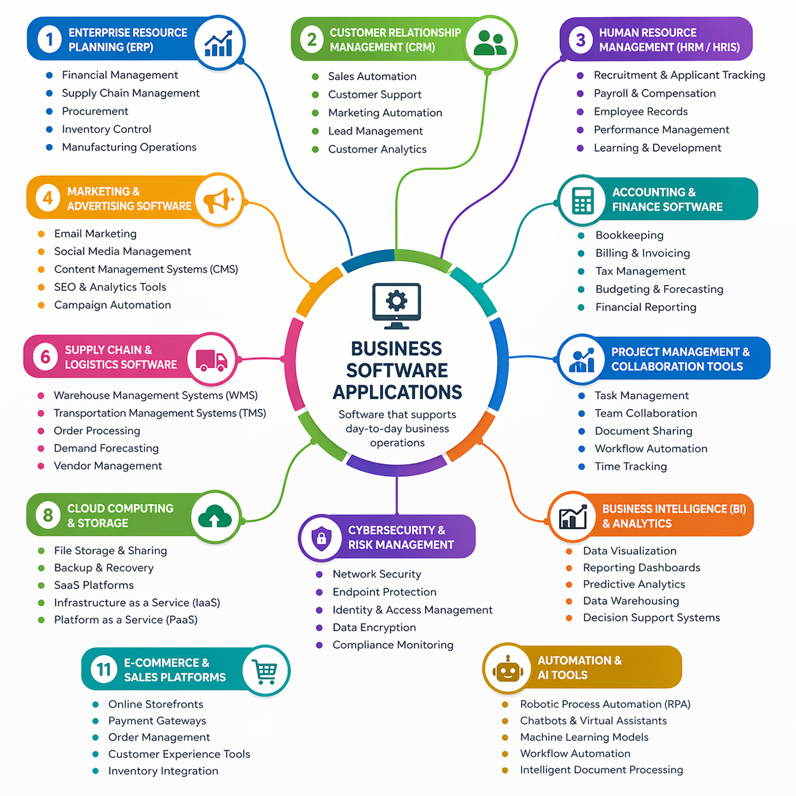

Task 3:
Office Software Solutions to Business
The Office suite has been the most popular office suite in business setups, and its applications are applied to support the primary business processes (Beskeen et al., 2020). We are going to consider four significant applications in this section, namely, MS Word, MS PowerPoint, MS Excel and MS Access.

Microsoft Word
Definition: Microsoft word is a word processing software that is used in the creation, editing, formatting, and sharing of text-based documents (Beskeen et al., 2020). It is the most common word processor that is used in business organisations worldwide.

Major Features:
Feature | Description
Document Formatting | Text styling, paragraph alignment, header/footer, column, and page layouts
Track Changes | Collaborative editing with visible markup of additions, deletions, and comments
Templates | Ready-made document templates for letters, reports, invoices, and brochures
Mail Merge | Automated personalised document creation based on data in contact databases
Proofreading Aids | Spell check, grammar check, thesaurus, and readability statistics
Collaboration | Real-time co-authoring with automatic OneDrive or SharePoint saving

Benefits:

1. Creation of professional papers - Generates quality and reliable papers that can be used in the process of communication with the clients and internal reporting (Shelly &Vermaat, 2019).
2. Teamwork efficiency - When several team members can look at the documents and edit them without confusion thanks to the possibility to track the changes and comment on them (Beskeen et al., 2020).
3. Integration - Integrates with other Microsoft 365 applications such as Excel, PowerPoint, and Outlook (Lambert, 2021)
4. Accessibility - It has an in-built accessibility checker to ensure that individuals with disabilities can read the documents (Microsoft, 2024).

Limitations:
1. Cost - Home users are not allowed to have a permanent license; they must pay to be subscribed to Microsoft 365 to utilize all the features (Lambert, 2021).
2. Compatibility Problems - When opening documents, they may not be compatible with other Word Processors. (e.g., Google Docs, LibreOffice) (Beskeen et al., 2020).
3. Complexity Advanced features are not easy to learn (Shelly &Vermaat, 2019).
4. Resource Intensive - May be slow using outdated hardware, particularly with large documents that include pictures and tables (Lambert, 2021)

Microsoft PowerPoint
Description: Microsoft PowerPoint allows you to create a meeting, training, conference, or sales pitch in the form of slide-based presentations.
(Beskeen et al., 2020).

Major Features:
Feature | Description
Slide Layouts | Pre-made slide templates like title, content, comparison, and image layout
Animations & Transitions | Movement effects for text and objects, and inter-slide motion
Presenter View | Displays the current slide, next slide, speaker notes, and timer to the presenter
Designer AI | Suggests ideas and designs automatically based on the content of the slides
Multimedia Integration | Add video, audio, charts, and interactive elements to slides
Team Presentations | Co-authoring and real-time commenting

Benefits:
1. Professional Visual Communication - This will be a chance to make beautiful presentations that will assist in better conveyance of the information(Reynolds, 2020)
2. Time Saving - AI-based Designer option and Templates are much faster to create a presentation(Microsoft, 2024).
3. Audience Interaction- The audience remains interactive with the multimedia, transitions and animation.(Beskeen et al., 2020)
4. Consistency - Master slides ensure that there is consistency in the branding of the presentation materials.(Lambert, 2021).

Limitations:
1. Excessive Animations Risk - Poorly designed presentations with excessive animation and text can demand the attention of the message, which is known as Death by PowerPoint (Reynolds, 2020, p. 45).
2. Linear Format - The linear thinking is promoted, and it may not be suitable to every content and audience (Beskeen et al., 2020).
3. File Size - Presentations that have integrated media can become very huge and difficult to share (Shelly &Vermaat, 2019).
4. Version Compatibility - The older versions of PowerPoint may not be compatible with new features or file formats (Lambert, 2021).

Microsoft Excel
Definition:Microsoft Excel is a spreadsheet application that is employed in data analysis, computation, financial modelling, charting, and reporting (Beskeen et al., 2020). The majority believe that it represents the most potent and versatile Microsoft Office business analytics.

Major Features:
Feature | Description
Formulas & Functions | Over 450 pre-built formulas including SUM, IF, VLOOKUP, INDEX-MATCH, financial formulas, and more
Pivot Tables | Cross-tabulation and data summarisation tool for large datasets
Charts & Graphs | Over 20 different chart types such as column, line, pie, bar, area, scatter, and waterfall
Conditional Formatting | Cell formatting based on certain criteria or rules
Data Validation | Limits the kind of data that can be entered into cells (drop-down menus, numbers, dates, etc.)
Goal Seek & What-If Analysis | Back-solves for input values to reach a target result and explores different scenarios
Power Query & Power Pivot | Data importing, manipulation, and modelling for large datasets
Benefits:

1. Powerful Data Analysis - Excel includes an in-built calculation engine that is capable of processing a large volume of data (millions of rows) without any problems and this is suitable with complex business analytics (Winston, 2022).
2. Flexibility - It may be used in simple lists and financial analytics along with statistical analysis, and also in dashboard building (Beskeen et al., 2020).
3. Industry Standard - It is practically a pre-requisite in a job in the business industry, which means that it can be utilized to share information (Lambert, 2021)
4. Automation & Programming - Automation and Programming: Automation and VBA (Visual Basic for Applications) can simplify things. (Winston, 2022).

Limitations:
1. Error Prone - The huge spreadsheets can be easily affected by errors in formulas, wrong references and inaccurate data (Beskeen et al., 2020)
2. Scalability Limitations - It is extremely slow and cannot work with very large datasets (over 1 million rows) (Winston, 2022)
3. Collaboration Problems - With the traditional version control, it would be problematic when multiple users are editing the same file, but now co-authoring has been improved (Lambert, 2021)
4. Not a True Database - Lacks data integrity attributes of good database systems (referential integrity, transaction logging) (Shelly &Vermaat, 2019)

Microsoft Access

Definition:Microsoft Access is a database management system (DBMS) that combines a graphical user interface and software development tools with the Microsoft Jet Database Engine (Beskeen et al., 2020). It is a database application in the development and administration of relational databases in small to medium business applications.

Major Features:
Feature | Description
Tables | Raw data stored in rows and columns where data is defined by a set of data types and validation rules
Queries | SQL-based or graphical data retrieval, filtering, and calculating queries on one or more tables
Forms | Data entry, data editing, and navigation forms
Reports | Summaries of data with grouping, sorting, and calculations with the ability to be printed or exported
Macros | Automate repetitive processes without the need to know how to program
VBA Integration | Complete automation and custom functionality using a programming language
Relationships | Create and enforce referential integrity amongst related tables

Benefits:

1. Simple Database Creation - Non-programmers can create useful databases without SQL programming code, enforcing data relationships and constraints (Beskeen et al., 2020)
2. Office integration - Imports/exports information in Excel, word and outlook (Lambert, 2021).
3. Rapid Application Development - Enables quick creation of forms and reports of business data management (Shelly &Vermaat, 2019)
4. Data Integrity - Determines data relations and data validation (Beskeen et al., 2020)

Limitations:
1. Poor Scalability - small or medium-sized datasets (typically less than 2GB in size and 255 users concurrently) (Microsoft, 2024)
2. Un-Web-Native Web-based deployment is limited in relation to modern cloud databases like SQL Server or MySQL (Lambert, 2021).
3. Single Platform - It can fully operate only on windows; it is partially compatible with Mac versions (Beskeen et al., 2020).
4. Obsolescence Risk - Microsoft has reduced its expenditure towards Access in favor of cloud providers like Power Apps (Winston, 2022)

Task 4:

Communication and Collaboration Uses.

4a: Analysis of Communication and Collaboration Tools.

Communication Application: Slack
Definition: Slack is a digital means to communicate with other teams. It sets chat rooms in channels, allows sending direct messages, and collaborates with thousands of business software products (Mankin, 2019). Slack was released in 2013 and has over 20 million daily active users, being one of the most popular business messaging apps. (Salesforce, 2024).

Key Features:
Feature | Description
Channels | Public and private conversation spaces by team, project, topic, and department
Direct Messages | Private messages between individuals and small groups
Huddles | Voice-first online meetings with screen sharing and instant captions
Threads | Organised replies to specific messages to keep discussions focused
File Sharing | Drag-and-drop file sharing with image, PDF, and Office file previews
Integrations | Connects with over 2,600 apps such as Google Drive, Trello, Zoom, and Salesforce
Search | Advanced search of conversations, files, and channels with filters
Workflow Builder | No-code automation of processes and approvals

Profits to Business Operations:
1. Reduced Email Count - Slack significantly reduces internal email and replies, with studies showing that internal email reduced by 48 percent with the adoption of Slack (Mankin, 2019).
2. The Organisation of Structured Communication - Channel based organisation will prevent the information silos and enable a new team member to see the past discussion (Rosenfeld, 2020)
3. Remote Work Enablement Slack has become a ubiquitous part of remote and hybrid workplaces, with industry observers remarking that the so-called digital water cooler is being used to keep the team culture intact even in the context of remote work (Mankin, 2019, p. 78).
4. Transparency - Public channels enhance the transparency of an organisation, reduce information hoarding and increase cross-functional awareness (Salesforce, 2024)

Limitations:
1. Notification Overload - Not configured, users can be overwhelmed with constant notifications, distracting them and reducing their productivity (Rosenfeld, 2020).
2. Information fragmentation - Slack might struggle to find crucial decisions that are easier to locate in the email and it is crucial to use pinned messages and saved items (Mankin, 2019).
3. Price - Free version is limited (90-day history of messages, 10 integrations); paid plans start at 8.75/user/month (Salesforce, 2024).
4. Always-On Expectation - Can make oneself stressed to reply on the spot and delete work and personal time (Rosenfeld, 2020)

Collaboration Application: Trello
Definition: Trello is a visual collaboration tool based on the Kanban methodology, whose features are based on boards, lists, and cards to organize projects and tasks (Businessolver, 2022). Trello is an app that is owned by Atlassian and was acquired in 2017, boasting over 50 million registered users worldwide (Atlassian, 2024).

Key Features:

Feature | Description
Boards | Visual containers representing projects, departments, or workflows
Lists | Columns representing stages of a workflow (e.g., To Do, In Progress, Done)
Cards | Individual tasks or items that move between lists
Labels | Colour-coded labels to sort cards by priority, type, or department
Due Dates & Calendar | Time tracking and calendar view to manage deadlines
Checklists | Sub-tasks within cards to break down complex work
Attachments | Files, images, and links attached directly to cards
Power-Ups | Integrations with Slack, Google Drive, Jira, and 200+ more apps
Butler Automation | No-code automation of repetitive tasks, rule-based actions, and scheduled commands

Conclusion:
- Use a range of software packages and applications to support day-to-day business operations.
- Create, present and communicate information clearly and effectively in a workplace setting.
- Office software (Word, Excel, PowerPoint) including mail merge, tables, spreadsheets.
- Databases and online collaboration tools like Teams, zoom etc for Business.
- Creating and managing PDFs, email communication, and privacy/ethics in computing.

References
Atlassian (2024) Trello: Features and pricing. Available at: https://www.atlassian.com/software/trello (Accessed: 23 April 2026).
Beskeen, D.W., Cram, C.M., Duffy, J. and Friedrichsen, L. (2020) Illustrated Microsoft Office 365 & Office 2019: Introductory. Boston: Cengage Learning.
Businessolver (2022) Collaboration tools in the modern workplace: A comparative analysis. London: Businessolver Publishing.
Buzan, T. (2018) Mind map mastery: The complete guide to learning and using the most powerful thinking tool in the universe. London: Watkins Publishing.
Chaffey, D. and Ellis-Chadwick, F. (2019) Digital marketing: Strategy, implementation and practice. 7th edn. Harlow: Pearson Education.
Crouch, A. (2022) E-commerce platforms compared: Shopify, Wix, and beyond. London: Digital Commerce Press.
Jones, M. (2023) Website builders for small business: A practical guide. Manchester: SME Publishing.
Kerzner, H. (2019) Project management: A systems approach to planning, scheduling, and controlling. 12th edn. Hoboken, NJ: John Wiley & Sons.
Lambert, J. (2021) Microsoft Office 365 step by step. Redmond, WA: Microsoft Press.
Laudon, K.C. and Laudon, J.P. (2020) Management information systems: Managing the digital firm. 16th edn. Harlow: Pearson Education.
Laudon, K.C. and Traver, C.G. (2021) E-commerce: Business, technology, society. 16th edn. Harlow: Pearson Education.
Lunden, I. (2023) 'Shopify's e-commerce dominance continues', TechCrunch, 15 March. Available at: https://techcrunch.com (Accessed: 23 April 2026).
Mankin, D. (2019) The future of work: How Slack and remote tools are changing business communication. Oxford: Oxford University Press.
Microsoft (2024) Microsoft 365 accessibility and features overview. Redmond, WA: Microsoft Corporation.
Novak, J.D. and Cañas, A.J. (2017) The theory underlying concept maps and how to construct and use them. Pensacola, FL: Institute for Human and Machine Cognition.
Project Management Institute (2021) A guide to the project management body of knowledge (PMBOK guide). 7th edn. Newtown Square, PA: Project Management Institute.
Reynolds, G. (2020) Presentation zen: Simple ideas on presentation design and delivery. 3rd edn. Berkeley, CA: New Riders.
Rosenfeld, J. (2020) Digital collaboration: Tools, tactics, and best practices. London: Kogan Page.
Salesforce (2024) Slack: Communication and collaboration for the modern workplace. Available at: https://slack.com (Accessed: 23 April 2026).
Shelly, G.B. and Vermaat, M.E. (2019) Discovering computers: Digital technology, data, and devices. Boston: Cengage Learning.
Shopify (2024) Shopify: The complete e-commerce platform. Available at: https://www.shopify.com (Accessed: 23 April 2026).
Smith, R. (2023) 'E-commerce platform comparison 2023: Shopify vs Wix vs Squarespace', Journal of Digital Commerce, 14(2), pp. 45-58.
Winston, W.L. (2022) Microsoft Excel data analysis and business modeling. 7th edn. Redmond, WA: Microsoft Press.
Wix (2024) Wix website builder: Features and pricing. Available at: https://www.wix.com (Accessed: 23 April 2026).

