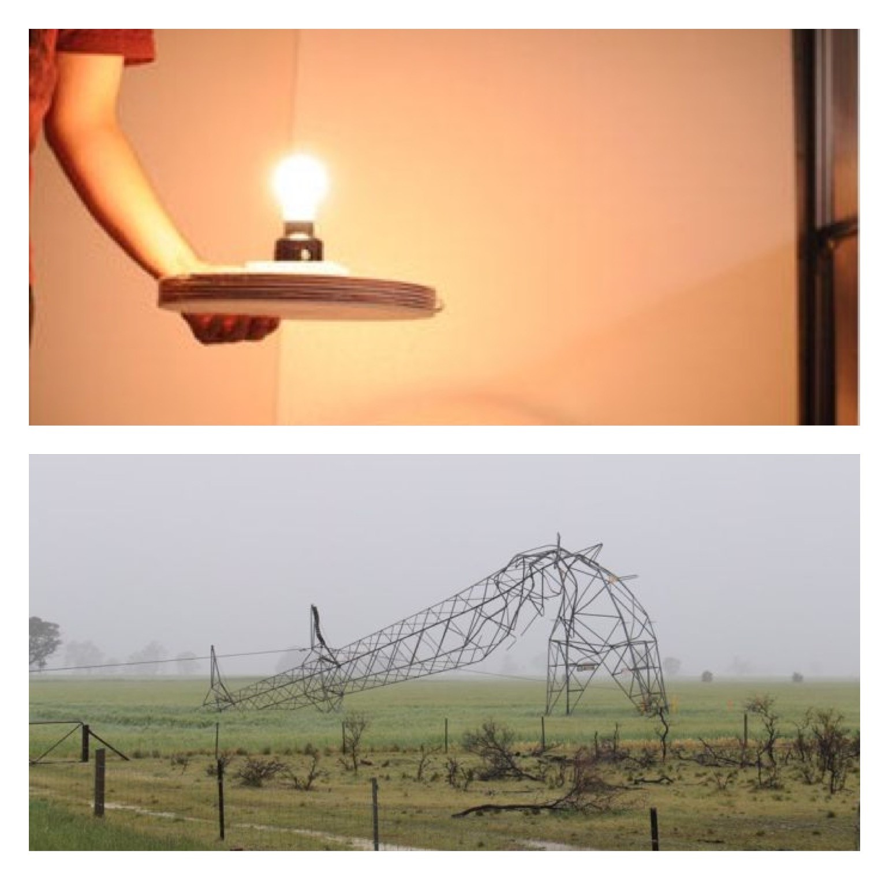 | Title: Disconnect 2 Connect

Table of Contents
Executive Summary………………………………………………………………………….1
Introduction………………………………………………………………………………......2
The Current Domestic Electrical Supply Network………………………………….…….….3
Is the National Grid Sustainable in the Long Term?................................................................4
A Conventional Domestic Electrical Installation…………………………………………….5
PVC – The ‘Poison’ Plastic……………………………………………………………….….6
Copper Sustainable, Recyclable, Available?............................................................................7
Connected to Grid not to Earth……………………………………………………………….8
A New Concept in Domestic Electrical Energy Provision…………………………………...9
Wireless Power Transfer…………………………………………………………………….10
Developing the Concept……………………………………………………………….…….11
Conclusion………………………………………………………………………………..….12
References…………………………………………………………………………………...13

1.Executive Summary
This report has been compiled to present an innovative alternative to the current UK domestic electrical supply provision. It will consider the environmental impact of existing house wiring methods and the long-term sustainability of the Nation Grid. It will also explore developing technologies and ‘off grid’ solutions.

2.Introduction
According to the Commission of the European Communities one of the critical challenges of the 21st Century is the reinvention of energy systems to a low carbon model (Commision of the European Communities, 2009). In the UK a key enabler to achieving this would be a reduction in electricity demand by reducing national annual consumption. According to Gov.UK data collected for the year 2018 there were 27,424,000 homes connected to the National Grid (Grid) each with an average annual consumption of 3,831 kilowatts per hour (KWh). As a nation the annual domestic consumption for 2018 was 105,880 Gigawatts per hour (GWh) (Department for Business, Energy & Industrial Strategy, 2019). When we consider that a Gigawatt is a unit of power which equals one billion watts it is evident that consumption rates are unsustainable and have been increasing year on year since 1970. This report will explore and present the case for a new concept in domestic electrical consumption.

3. The Current Domestic Electrical Supply Network
Following the end of the First World War the UK needed more reliable and affordable energy supplies. New and innovative methods were needed to accomplish this and in 1925 a committee chaired by Lord Weir made a proposal to develop a network which would connect a series of power stations up and down the British Isles. The network would be known as the ‘National Gridiron’ and would link only the more efficient power station in the country. Today it is known as the National Grid and has over 180 power stations supplying electricity to homes and businesses nationwide (National Grid, 2020). The standard network supply in the UK was 240 volts up until 2003 when the voltage was reduced to 230 volts in a move towards a uniform European standard of 220 volts. However, the standard varies across the electrified world with 240 volts being the maximum supply voltage to 100 volts as is the case in Japan (World Standards , 2020). The average UK home will draw power from the grid for every electrical device from kitchen appliances, power tools heating, home media and personal computers to charging equipment and lighting.

4. Is the National Grid Sustainable in the Long Term?
The development and expansion of the National Grid has evolved since its inception in 1925. From the early days of fossil fueled power stations to the arrival of nuclear energy and more recently wind, tide and solar energy has beckoned a cleaner, more sustainable means of generating electrical power for the National Grid. All these power stations feed the National Grid enough electrical energy to provide a 230-volt 50 hertz domestic power supply to 27,424,000 UK homes every day 365 days a year (Department for Business, Energy & Industrial Strategy, 2019). When the first electricity pylons were erected in the UK their impact on the landscape was, and still is significant. However modern society has almost become ‘blind’ to them accepting them as a necessary ‘inconvenience’. In the early years of the National Grid around 98% of power stations were fuelled by coal.
The mining of fossil fuel and initial erection of the pylons caused substantial damage to the natural landscape, water from rivers was polluted by the extraction of their waters to cool the power plants which consequently pumped heated water back into the water course harming plant and animal life in those areas. Poisonous gases and particles were released into the atmosphere affecting overall air quality (Button, 2014). Today’s power stations are cleaner and more efficient than those of our industrial past and with the UK Government committed to phasing out the last 5 coal fuelled power stations by 2025 (Department for Business,Energy & Industrial Strategy, 2018) the national grid is evolving into a more environmentally sustainable network .bringing electrical energy to households across the UK. Despite these transformative moves to generate cleaner energy the long-term future of a sustainable National Grid network is not certain. According to a 2016 research article published by the Institute of Mechanical Engineers 24% of the total Green House Gases (GHG’s) emitted in the UK are attributed to the electricity sector. Shifts in energy policy have also seen a focus more on affordability and security than moves to address climate change. Gas fired plants will be required to generate power for the National Grid once coal is phased out which will bring a new chapter in environmental challenges for the ensuing four decades. Following the depletion of natural gas combined heat and power plants would need to look towards increased use of biomass to fuel the National Grid (Hammond & O'Grady, 2017). Notwithstanding biomass being classed as a renewable energy, the burning of biomass does create GHG’s which will continue to contribute to global warming.
The infrastructure of the National Grid is also expensive to maintain, pylons and transmission cables of approximately 4000 miles carry electricity across large distances from generator to consumer. This process is inefficient as energy is lost covering such long distances.
Electrical demand has in recent years peaked to exceptional levels which are forecast to increase over the coming decades. To meet demand in the early years of the grid new a plant would be installed, however this is no longer a viable option due to the high cost of available fuels to power the generators. As demand has increased, capacity has stagnated resulting in the need to bring previously decommissioned, highly inefficient power plants back online to meet the increase in demand (The Current National Grid Energy Management, 2020) bringing into question the National Grid as a sustainable long term strategy for domestic electricity provision in the UK. A recent report published in the ‘I’ newspaper questions if the UK is prepared to cope with the surge in demand as it predicts an electric car “revolution” (Fig.1). A report published by the Electric Vehicle Energy Task Force, commissioned by the UK Government warns that “the National Grid will be unable to cope” with the increased demand if it is not managed effectively by industry leaders and government ministers (Merrick, 2020).

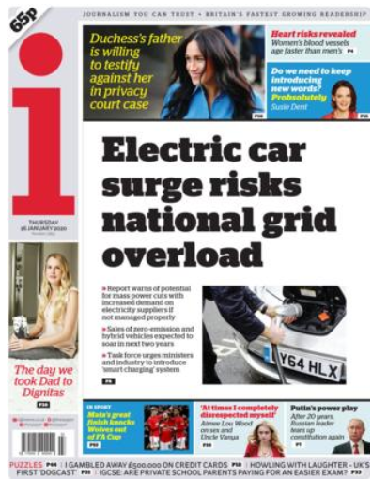
(Fig.1) (Merrick, 2020)

5. A Conventional Domestic Electrical Installation
A typical UK home will have wide-ranging electrical appliances and fixings occupying most, if not all rooms in the house. To provide a supply in each room a full electrical installation is required. For the purpose of this report a new house construction scenario will be used. The first phase of an installation involves the design of the installation, (Fig 2) this would normally be carried out be a qualified electrical engineer and would have to comply with British Standard 7671 (IET, 2020). Each, socket, lighting point, switch, television point, electric cooker etc. would be measured and marked. Cables manufactured from copper for the conductor and Polyvinyl Chloride (PVC) for the insulation. would then be run from the supply entry point into the building (consumer unit) to every electrical fixing in the building (Fig 3). Once the walls, ceilings, floors are fitted the electrical engineer would return and carry out the second phase of the installation. This would involve the fitting of the front component parts of the socket outlets, light fittings and any other electrical fixture that has had a cable run to it (Bates, 2012). The illustrations below provide an overview of a simple domestic installation including the numerous meters of cable required to service each point.

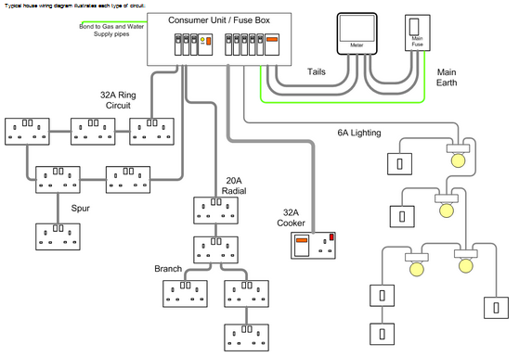
Fig. 2 (DIY wiki, 2019)

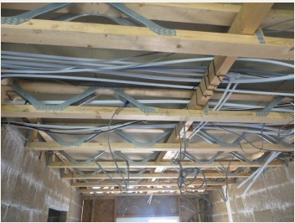
Fig.3 (DIY wiki, 2019)
6. PVC – The ‘Poison’ Plastic
Modern insulated electrical cables found in domestic and industrial installations are manufactured using Polyvinyl Chloride (PVC). These cables have been in use since the 1950’s when rubber insulation was withdrawn and have proved to be more practical than the previously used rubber insulation. As rubber is a naturally occurring compound its PVC successor can be produced to meet the demands of the industry.
However, there is an environmental consequence in the manufacture of PVC. Sometimes referred to as the ‘poison plastic’ PVC can and does release toxins into the environment. This can occur during manufacture, when it is burnt or as it breaks down in landfill sites (Markwell, 2019). According to The Environmental Protection Agency (EPA) “PVC is the most environmentally damaging plastic”. And that the toxins released during its manufacture, use and disposal are accumulating in the environment creating a chlorine-based chemical which can create serious health problems including cancer, hormone disruption and immune system damage. The water we drink, the air we breath and the food we eat is being contaminated by these toxins. PVC even fails to be a recyclable material due to the complex mix of additives that are used in its manufacture .(Enviromental Protection Agency, 2003) Moves to ban the use of PVC are currently not considered practical due to PVC being a so widely used in the industry and the lack of a practical alternative (Markwell, 2019). However advancing on from the progress made by a European Union incentive in 2010, a commitment has been made to address the environmental challenges of PVC production, use and disposal (Vinyl Plus, 2020). The Vinyl Plus programme continues to seek innovative ways to manage PVC which arguably could be to maintain and protect the PVC industry. In terms of the domestic electrical industry an alternative way to negate the use of cables would go some way to reducing PVC production.

7. Copper - Sustainable, Recyclable, Available?
Copper is used in the manufacture of electrical conductors and is a naturally occurring compound. However, there is an environmental impact which can stem from the mining of copper and some of the harmful chemicals that are produced during the smelting process. During the process sulphur dioxide is created in high quantities. When released into the environment it can produce acid rain which is harmful to the natural environment. Copper mining also contributes to loss of natural habitats due to deforestation and land degradation (Greenspec, 2020).
It is argued that copper is a finite resource and the period for extraction is coming to an end. The time of this exhaustion is unknown. However, copper is 100% recyclable, and with mining and recycling methods becoming increasingly efficient it can only be speculated on when demand outweighs supply. With world production at around 12 million tons per annum and with estimated reserves being at 300 million tons (Greenspec, 2020), theoretically the reserves could be exhausted by the year 2050. With only 2 million tons per annum being recycled it raises two important questions. The first is regarding the disposal of non-recycled waste copper and where is it being deposited? And secondly as with any natural resource what measures are in place in preparation for a globally depleted commodity? Some may argue that copper is a sustainable resource and that it is not expended as coal and natural gas are but if it does becomes a scarce metal it will become more valuable which could lead to a new age in energy poverty as cables to carry a supply to poorer communities are simply too expensive. According the United States Department of Energy (DOE) copper is fundamental component in the electrical industry and in the manufacture of electrical appliances. It may in time become a “limiting factor” in future renewable energy deployment (Centre for Sustainable Systems, 2017).

8. Connected to Grid not to Earth
Having presented a case for a new concept in home energy in terms of the demands on the National Grid, the environmental impact of cable manufacturing and the long-term sustainability of the current provision for a domestic electrical power supply other factors require equal consideration. The environmental impact of the service would require further analysis such as plastic switches, light fittings, other PVC components, the transport infrastructure to maintain the grid and the thousands of domestic electrical contractor vehicles providing a legally required qualified service (IET, 2020) to households up and down the country and the real environmental impact of nuclear fuel along with its added risk.
This whole scenario stems from the fact the UK mains operates on 230 volts. This level of voltage is required to enable the supply to travel across large distances from the power plants to each household, but why do we need to continue to consume this hazardous voltage in our homes? Some innovative models of eco-homes continue to be connected to the grid. To pursue a future connected to the grid where all the electrical energy we need is generated remotely there comes with it a certain disconnect from the natural world around us and the consequences of our need for convenience.

9. A New Concept in Domestic Electrical Energy Provision
In this age of technological growth an ever-increasing number of electrical devices operate on low voltages. This may not seem immediately apparent as many appliances have built in step down transformers to reduce the voltage and current to a level by which delicate circuitry can operate, internet routers, digital radios, laptops, home computers, charging equipment and many other devices are built to reduce the power supply available in UK homes.
A market in low voltage domestic electrical equipment is already emerging mainly driven by outdoor pursuits and camping, but the range of products is growing, televisions, kettles, lighting, fans and extractors. As a new and innovative concept of bringing electrical energy to modern homes would be driven by the construction industry. Each new built home would not be connected to the National Grid (off grid) and in the case of a terraced street, estate, cul- de -sac etc. a communal access point to the national Grid would remain as a means of contingency during the transitional period from grid to off grid nationally. The primary supply to each new property would be generated by solar / wind turbine or both. Instead of a conventional out of reach consumer unit full of circuit breakers there would be an accessible charging, storage and distribution point. This would store generated power in a series of battery packs for use when supply is low and for charging household devices.
There will be very limited or no internal conventional wiring as there will be a significant reduction in the need for a 230v supply. Each light fitting would be recyclable, low voltage and self-contained consisting of the illuminate, power source and fitted with Smart circuity. Each lighting point can be portable or fixed and supplied by a low voltage cable from the distribution point. All lighting will be controlled by a Smart device removing the need for wired light switches. Depending on the size of the property, each room will have a concealed low voltage independent power source which is either a re-chargeable battery pack or fed by the power source from the distribution point.

10. Wireless Power Transfer
Electromagnetic Power Transfer technology is still a developing science. Originally studied by Nikola Tesla in 1896 where he experimented with oscillating frequencies and how they could be matched to transfer energy from a transmitter to a receiver and converted back into an electric current (Bressan, 2019). In theory a means of transferring electricity from one point to another wirelessly in a domestic environment is a possibility. Smartphone charging pads operate by means of the same principles and are now commonly used
Voltage leakage and compensatory measures in terms of generating more power than is needed for the device to transmit the voltage seems to remain somewhat of a necessary trade off (Stielau & Covic, 2002). Conversely in his paper ‘Wireless Power Transfer by Means of Electromagnetic Radiation Within an Enclosed Space’ Robert A Moffatt refers to a test carried out by NASA in 1975 where a 30-Kilowatt power supply was transferred over a distance exceeding one mile. Using beamed microwaves, the efficiency of the transfer was over 50%. Technology has since moved forward and in his research, he concludes that enclosed spaces have the capacity to increase efficiency due to the reflective properties of the walls. This efficiency is improved as the distance is increased. The efficiency becomes independent of the location of the receiving device as the square area of the room becomes the antenna effectively absorbing the signal (Moffatt, 2016). The possibilities of such science could bring an end to all conventional methods of domestic electricity provision.

Developing the Concept
Before introducing this concept to possible collaborators, a name for the concept will create a focus for the team to identify with the project. For the purpose of this report the project is named Tech&Inno.2.
Listed below are some of the key planning points. This will be supported by a detailed business plan and project plan including a stakeholder analysis of target customers, investors, financiers and Tech&Inno.2 project team members. Tech&Inno.2 has adopted the mantra ‘Disconnect 2 Connect’. Tech&Inno.2 will make approaches to established eco-friendly housing developers with a view to installing a prototype system. As a concept Tech&Inno.2 will require further development and in collaboration with stakeholders and with successful investment Tech&Inno.2 will take the leap to the next curve by bringing this product to market.

- Target Customers – Housing Associations, Local Authorities, Property Developers
- Unique Value – Electrical Energy is an integral Part of the Home
- Key Solutions - Low Cost Installation, Low Energy Costs, Safer Sustainable Energy
- Routes to Customers – Networking – Collaboration – The Electrical Industry
- Financial Routes – Grants, Start-up Loan, Enterprise Allowance, Investors
- Initial Costs – Prototype Project Costs, Bring to Market Costs
- Key Metrics – Equipment Costs, Installation Hours, Installation Cost, Consumption Rates
- Key Performance Indicators (KPI’s) – Revenue, Profit Margin, Gross Margin,
- Tech&Inno.2 is established to make meaning not money

12. Conclusion
The developed world has become accustomed to the conveniences that advances in technology have brought. The research undertaken in this report has identified that the UK electrical infrastructure may not be sustainable in the long term. To explore and implement the possible alternatives will require a significant shift in consumer behaviours. Electricity in our homes has become an expected necessity, to push a switch and a room lights up has become the absolute norm, so much so that lighting is as much an aesthetic part of modern homes as it is practical. It would be unrealistic to assume that consumers would take a seismic shift in adopting a reduced level of service in their homes so a more sustainable long-term compromise must be achieved. For society to ‘Disconnect 2 Connect’ will require a certain ‘buy in’ from consumers and the electrical industry. To be ‘off grid’ needs to become fashionable and the product needs to be developed to achieve this. The electrical contacting industry’s role will change but it will not perish. Further development, conversions and during the period of transition will require experienced electrical contractors to implement. This concept takes a bold leap forward and opposes may factors we have come to accept as standard.
Tech&Inno.2 has a mission to take a step back to what it means to be of this earth Disconnect 2 Reconnect

13.References
Bates, C. (2012, November 26). Build Basics: Electrics. Retrieved from Buid It: https://www.self-build.co.uk
Bressan, D. (2019, July 10). How Nikola Tesla Planned To Use Earth For Wireless Power Transfer. Retrieved from Forbes: https://www.forbes.com
Button, K. (2014, August 5). The UK National Grid: Environmental Impacts, Consequences and Connectivity. Retrieved from The Power and the Water Connecting Pasts and Futures: https://powerwaterproject.net
Centre for Sustainable Systems. (2017). Critical Materials Factsheet. Michigan: University of Michigan.
Commision of the European Communities. (2009). Retrieved from Investing in the Development of Low Carbon Technologies: http://www.etipbioenergy.eu
Department for Business, Energy & Industrial Strategy. (2019, July 25). National Statistics - Energy Consumption in the UK. Retrieved from GOV,UK: https://www.gov.uk/government/statistics/energy-consumption-in-the-uk
Department for Business,Energy & Industrial Strategy. (2018). IMPLEMENTING THE END OF UNABATED COAL BY 2025 . Retrieved from UK.GOV: https://assets.publishing.service.gov.uk
DIY wiki. (2019, January 30). House Wiring for Beginners. Retrieved from DIY wiki: http://wiki.diyfaq.org.uk
Enviromental Protection Agency. (2003, August 18). PVC: The Poison Plastic. Washington DC, USA.
Greenspec. (2020). Copper production & environmental impact. Retrieved from Greenspec: http://www.greenspec.co.uk
Hammond, G. P., & O'Grady, A. (2017). The Potential Enviromental Consequences of Shifts in UK Energy Policy that Impact on Electricity Generation. Proceedings of the Institute of Mechanical Engineers, Part A: Journal of Power and Energy, 231,(6), 535-550.
IET. (2020, 01 17). The Institution of Engineering and Technology. Retrieved from The IET Wiring Regulations: https://electrical.theiet.org
Markwell, L. (2019). PVC insulated and sheathed cables in a domestic installation. Retrieved from Institutitution of Engineering and Technology: https://electrical.theiet.org
Merrick, J. (2020, 01 16). "The national grid is at risk of being overloaded". i News, p. 1.
Moffatt, R. A. (2016, November 23). WirelessPower Transfer by Means of Electromagnetic Radiation Within an Enclosed Space. Retrieved from Stanford University Department of Physics: https://arxiv.org/pdf/1611.07076.pdf
National Grid. (2020). National Grid History. Retrieved from nationalgrid.com: https://www.nationalgrid.com
Stielau, O. H., & Covic, G. A. (2002, August 6). Design of loosely coupled inductive power transfer systems. Retrieved from IEEE Xplore Digital Library: https://ieeexplore.ieee.org
The Current National Grid Energy Management. (2020). Retrieved from The Green Age: https://www.thegreenage.co.uk
Vinyl Plus. (2020). About Vinyl Plus. Retrieved from Vinyl Plus - Committed to Sustainabale Development: https://vinylplus.eu
Wilson, I. G. (2013). Historical daily gas and electrical energy flows through Great Britain's transmission networks and the decarbonisation of domestic heat. Energy Policy (Volume 61), 301-305.
World Standards . (2020, January 13). Plug, Socket and Voltage by Country. Retrieved from World Standards : https://www.worldstandards.eu

