
Operating Systems
Module Name: Computer Architecture & OS
Module Code: ACCA 4022
Student Name: Muhsin Aslam
Student ID: 2514783
Lecturer Name: Md Shantanu Islam

Contents
Introduction 4
Key functions of general Operating Systems 4
Task Management: 4
Application/Program Management: 6
File/Directory Management: 7
Device Management: 8
Security Management: 9
Use of Windows OS CLI commands 10
Example 1: 10
Example 2: 11
Example 3: 11
Example 4: 12
Example 5: 12
Example 6: 13
Example 7: 13
Example 8: 14
Example 9: 14
Example 10: 15
Use of Linux OS CLI commands 16
Example 1: 16
Example 2: 17
Example 3: 17
Example 4: 18
Example 5: 18
Example 6: 19
Example 7: 19
Example 8: 20
Example 9: 20
Example 10: 21
Use of Windows OS scripts 22
Example 1: 22
Example 2: 24
Use of Linux OS scripts 26
Example 1: 26
Example 2: 28
Conclusion 29
References 30
Appendices 31

Introduction

This report looks at the basic functions of operating systems and how they are used in everyday computing. It explains what operating systems do such as managing files, processes and system resources. The report also explores how command line tools are used in both Windows and Linux to carry out different tasks. In addition, it includes examples of simple scripts to show how tasks can be automated. Overall, this report is based on both research and practical activities that helped me to build a better understanding of how operating systems work in real life situations.

Key functions of general Operating Systems
Microsoft Windows, first launched in 1985 & has grown to be one of the most commonly used operating systems globally. Its significance lies in offering an intuitive, user friendly interface while supporting a wide range of applications. Additionally, Windows manages essential tasks such as handling files, memory, running processes and controlling hardware devices [1].

Task Management:
Task management is a key feature in Windows that lets the operating system monitor and control active programs and processes. This is demonstrated through the Task Manager which displays running applications and background processes along with their CPU, memory, disk and network usage. Task Manager helps users track system performance and identify programs that may be causing slowdowns. It also provides the option to terminate unresponsive tasks. Overall, this function supports system stability and ensures that resources are used effectively [2].
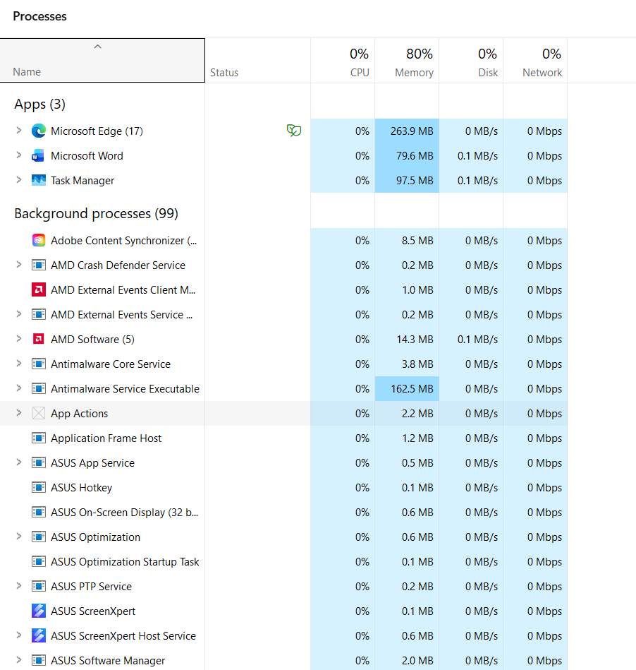
Figure 1: Task Manager

Application/Program Management:
Windows operating systems offer a centralised interface for managing all installed programs and applications. By accessing “Apps & Features” or searching “Add or Remove Programs,” users can see both system and third party software as illustrated in the screenshot [Fig. 2]. This interface enables users to uninstall, modify or repair applications helping to maintain system performance and free up storage space. Users can also sort and filter applications by size, installation date or drive location making it easier to manage software efficiently [3].

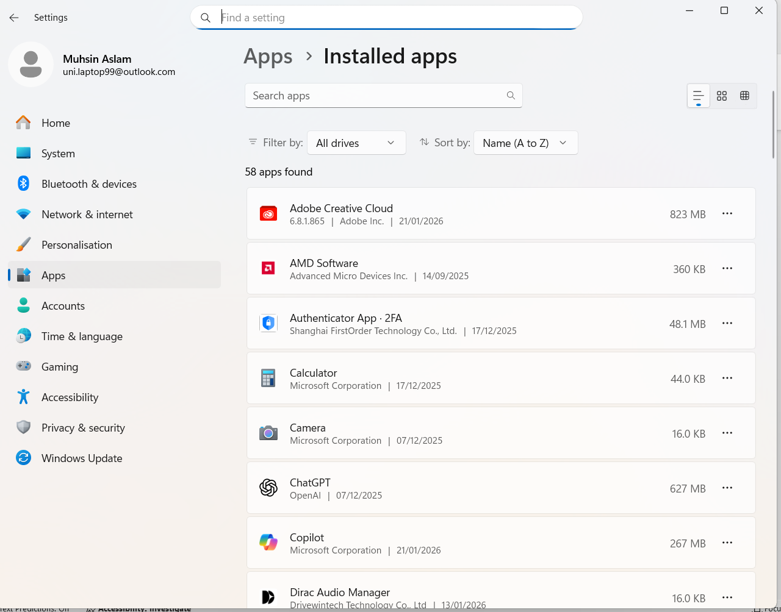
Figure 2: Apps & Features

File/Directory Management:
Windows makes it easier for users to manage files and folders using the File Explorer. Folders help organise related files so information can be found quickly as shown in the screenshot [Fig. 3]. Users can carry out tasks like creating, renaming, moving, copying or deleting files and folders. The system’s hierarchical layout allows smooth navigation between directories. Additional features such as search tools and file details support users in keeping their data organised and managing it more effectively [4].
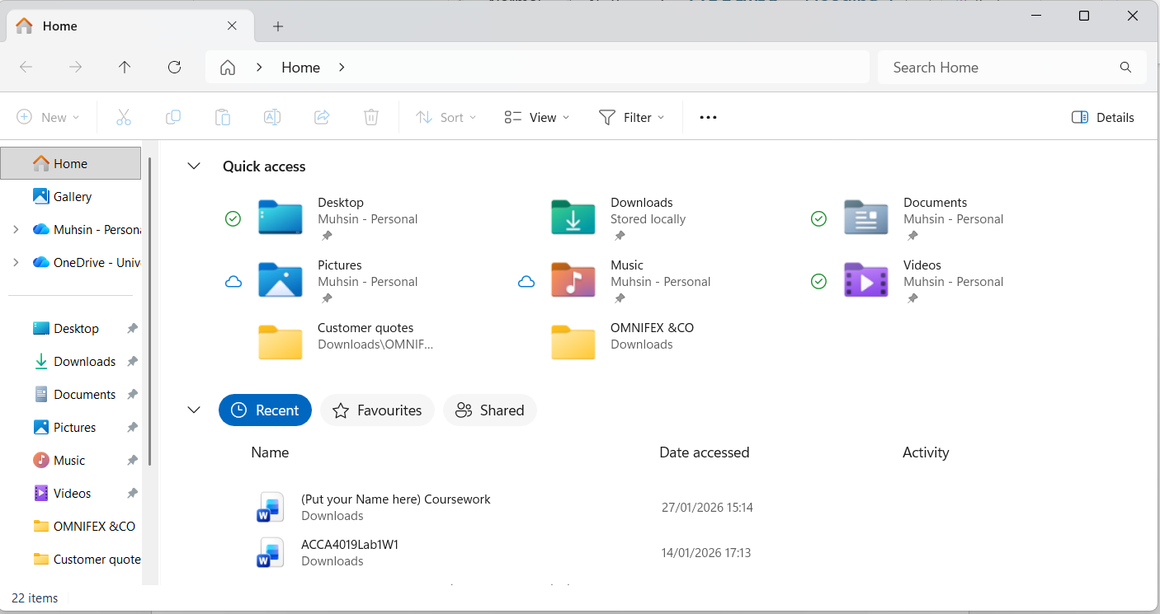
Figure 3: File Explorer

Device Management:
Device management in Windows lets users oversee and control the computer’s connected hardware. Using the Device Manager shown in the screenshot [Fig. 4], users can view components like processors, disk drives and network adapters. This tool allows drivers to be installed or updated, faulty devices to be disabled and hardware problems to be resolved. Proper management of devices ensures that hardware works correctly with the operating system which is vital for maintaining system stability and performance. Handling hardware resources is an essential function of modern operating systems as it allows software and physical devices to interact efficiently [5].
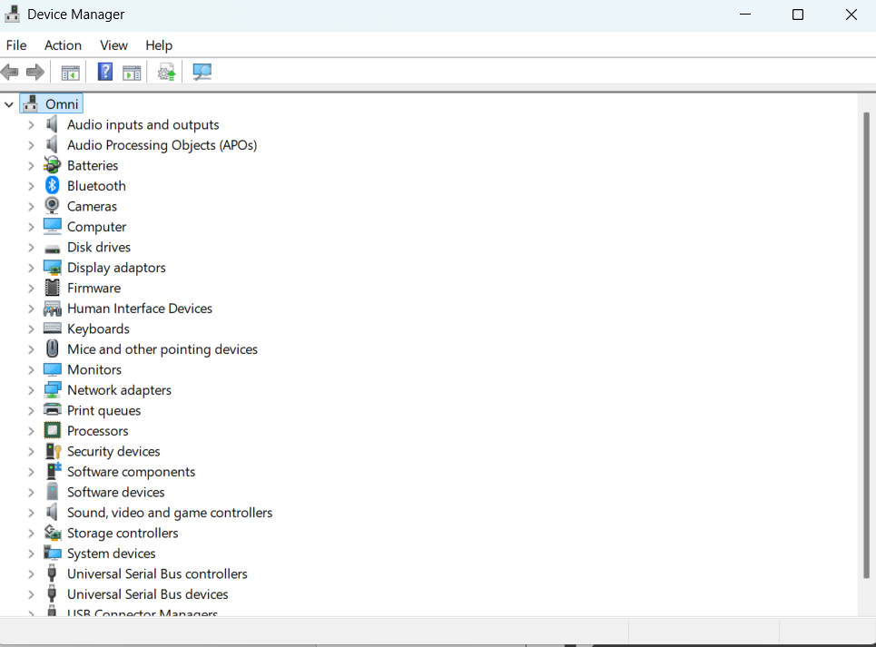
Figure 4: Device manager

Security Management:
Windows includes security management features to protect the system, user data and network resources from threats like malware or unauthorised access. The Windows Security dashboard shown in the screenshot [Fig. 5], gives users a central location to monitor virus and threat protection, firewall settings and account security. Through this interface users can run scans, adjust firewall rules and manage application permissions. Proper security management allows the operating system to detect and respond to threats promptly helping maintain system integrity and confidentiality. This highlights the wider role of operating systems in enforcing security measures and keeping digital environments safe [6].

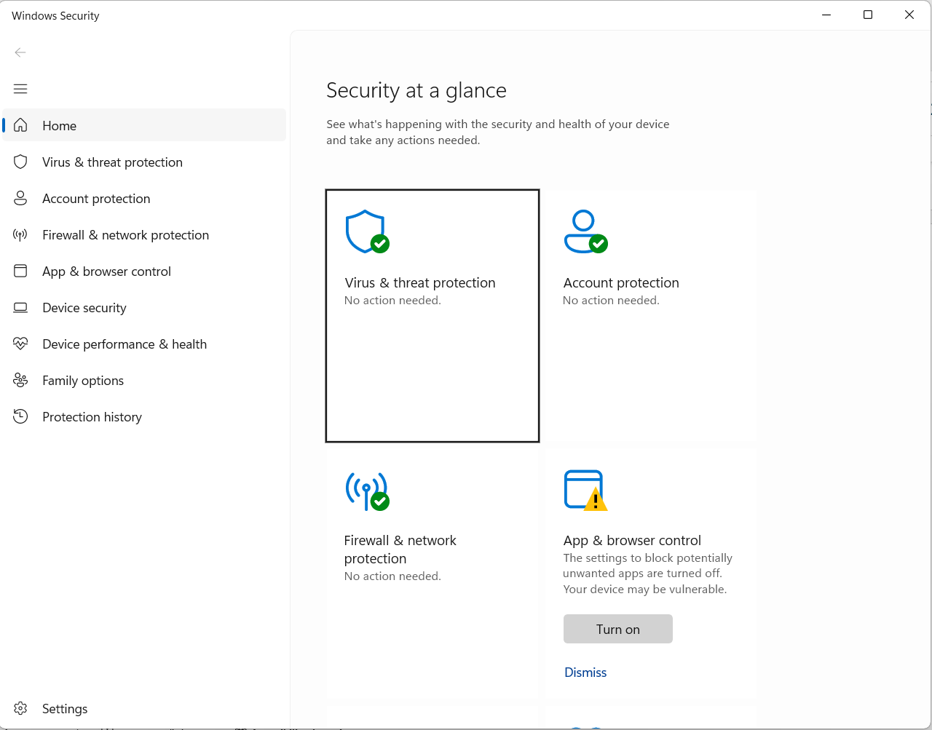
Figure 5: Security Manager

Use of Windows OS CLI commands
The Windows Command Line Interface lets users operate the system using text based commands. It is commonly used for tasks such as managing files, controlling running processes and configuring network settings helping to perform system operations more efficiently and automate routine administration [7].

Example 1:
The DIR command lists the contents of the current directory. The output shows folders and files in C:\Users\unilaptop, including names, dates and available disk space information.
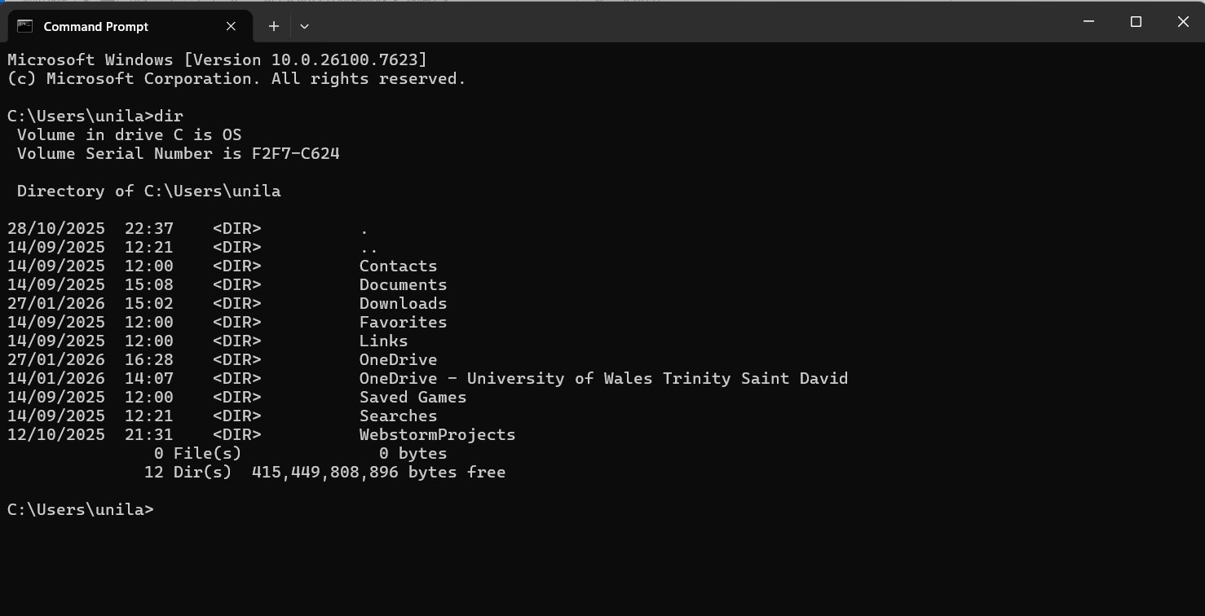
Figure 6: DIR Command

Example 2:
The CD command is used to change the current working directory. The output shows the directory path updating, indicating the system has successfully moved to the selected folder.
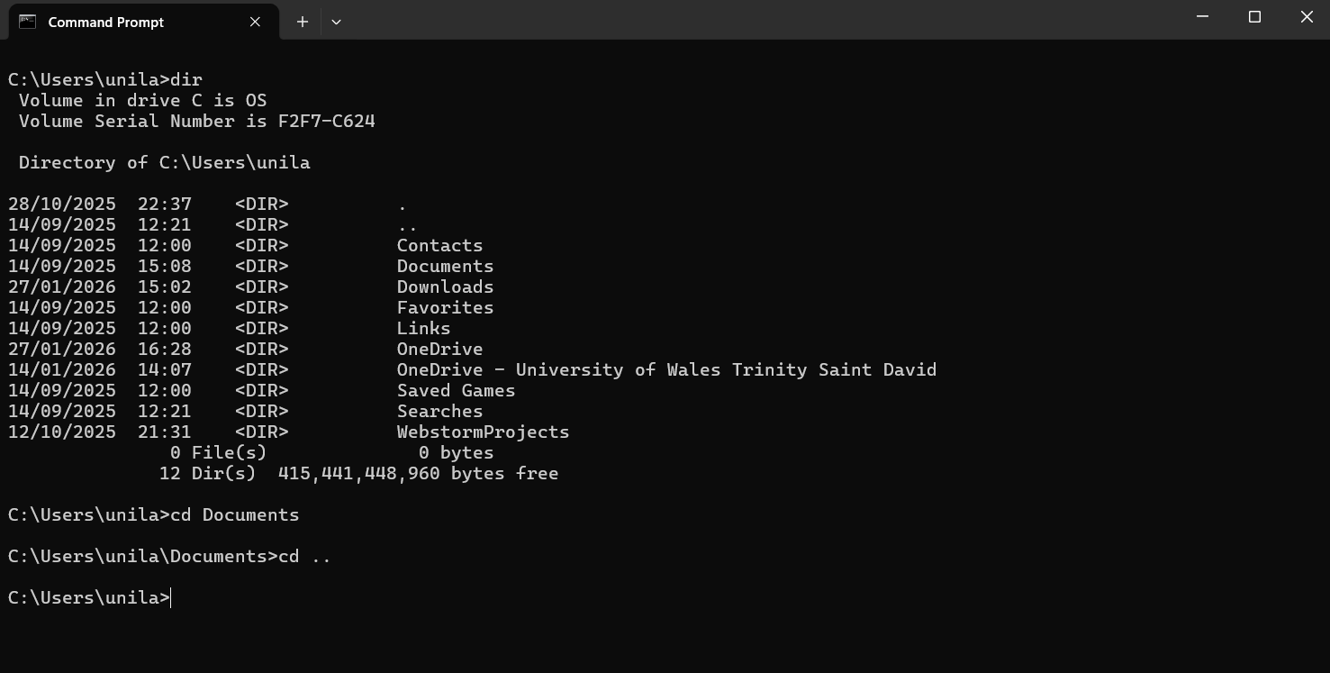
Figure 7: CD Command

Example 3:
The MKDIR command creates a new directory named in the current location. The DIR output confirms its creation by listing the new folder alongside existing directories.
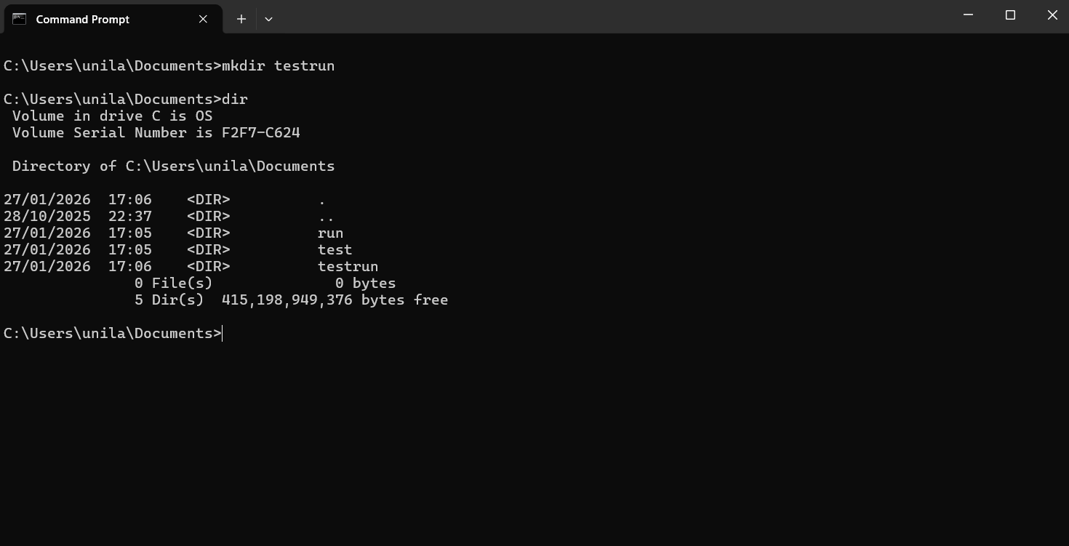
Figure 8: MKDIR Command

Example 4:
In this Command Prompt sequence, the user creates a directory using MKDIR. Then, RMDIR is used to simultaneously delete the run, test and testrun folders, which is confirmed by the final DIR listing showing they are gone.
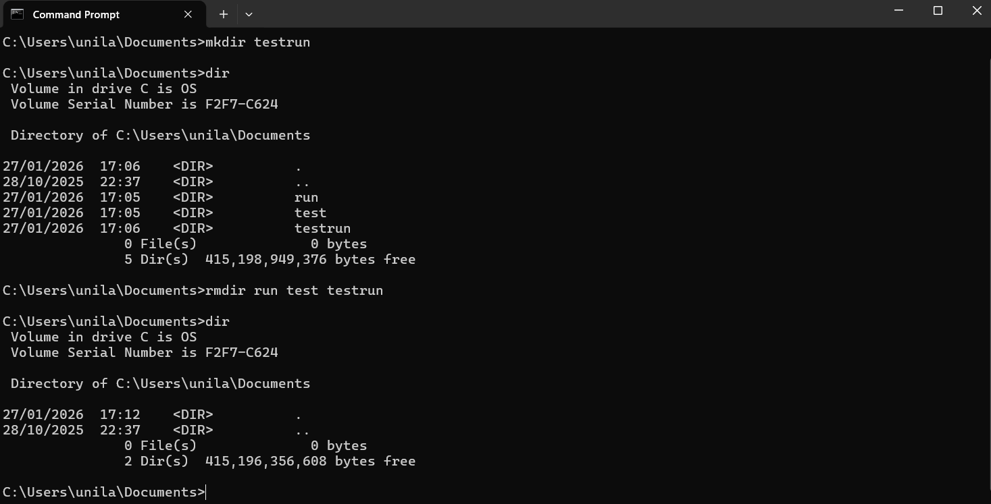
Figure 9: MKDIR & RMDIR Command

Example 5:
The ECHO command creates file.txt with the text new test inside. Typing the filename opens the text file in Notepad, as shown in the secondary window displaying the content.
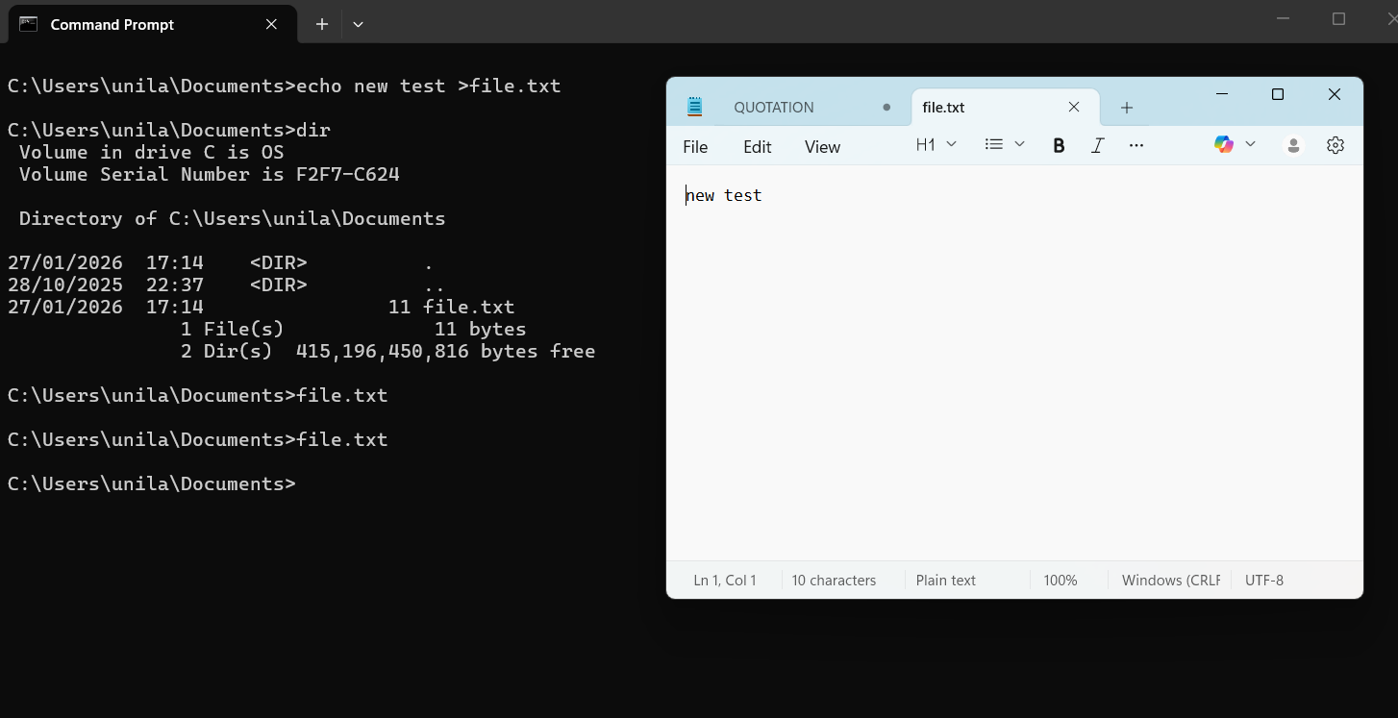
Figure 10: ECHO Command

Example 6:
The TRACKLIST command displays all currently running processes. The output includes the process name, PID and memory usage providing a snapshot of active applications and background system services.
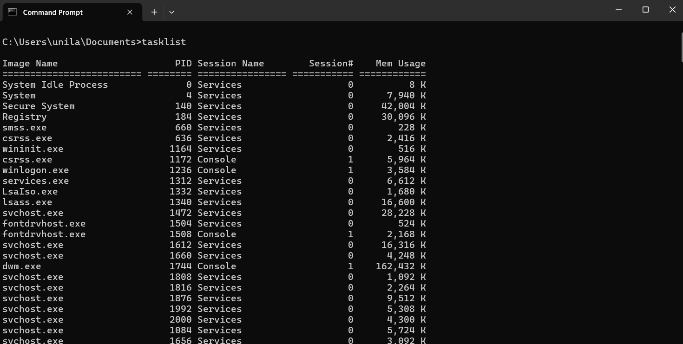
Figure 11: Tracklist Command

Example 7:
The SYSTEMINFO command generates a detailed report of the computer's configuration. The output lists essential hardware and software data. Including OS version, processor type, BIOS details and total physical memory.
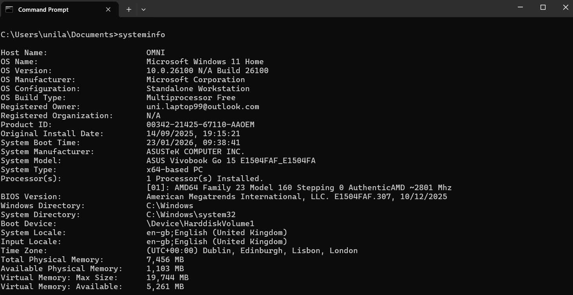
Figure 12: Systeminfo Command

Example 8:
The IPCONFIG/ALL command retrieves comprehensive network settings. The output details the hostname, physical MAC addresses and DHCP status for all network adapters which is vital for diagnosing connectivity issues.
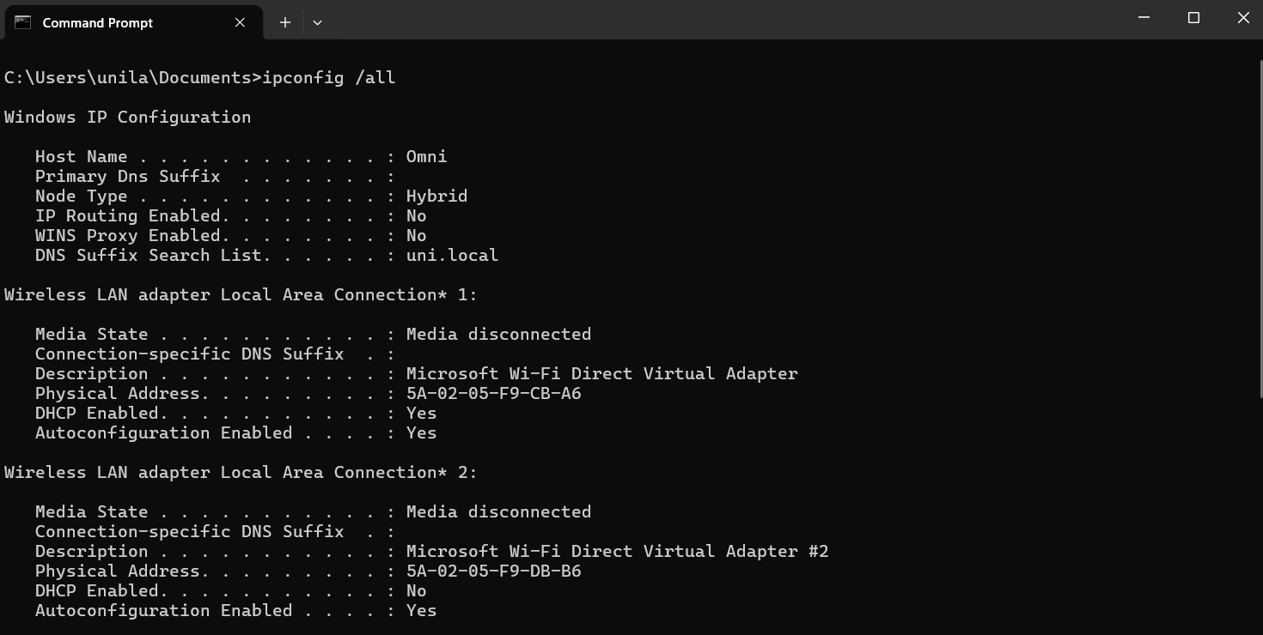
Figure 13: Ipconfig Command

Example 9:
The PING command tests the connection to Google's server. The output shows four successful replies, confirming the website is reachable with an average response time of 14 milliseconds.

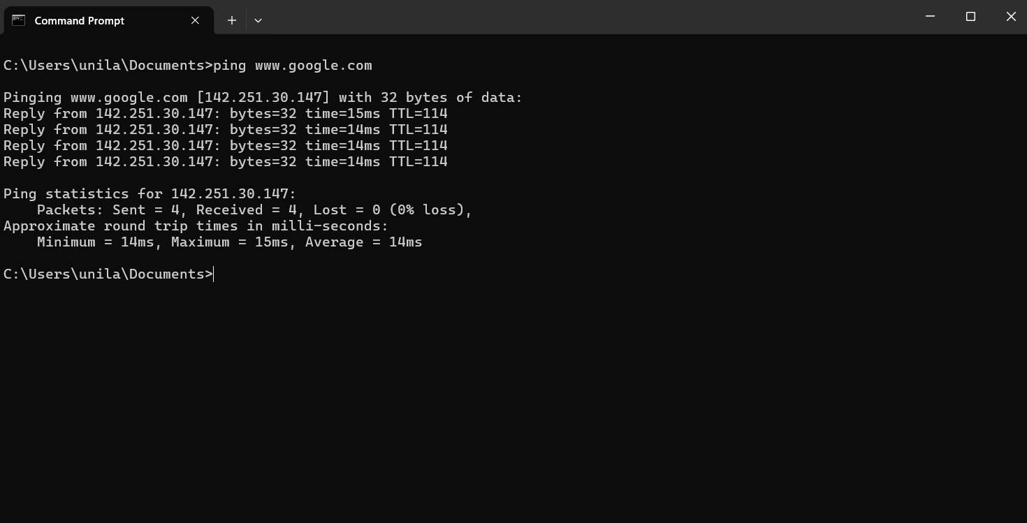
Figure 14: PING Command

Example 10:
The TRACERT command maps the path data takes to reach Google. The output lists each network hop and its response time, showing the journey through various routers to the destination.

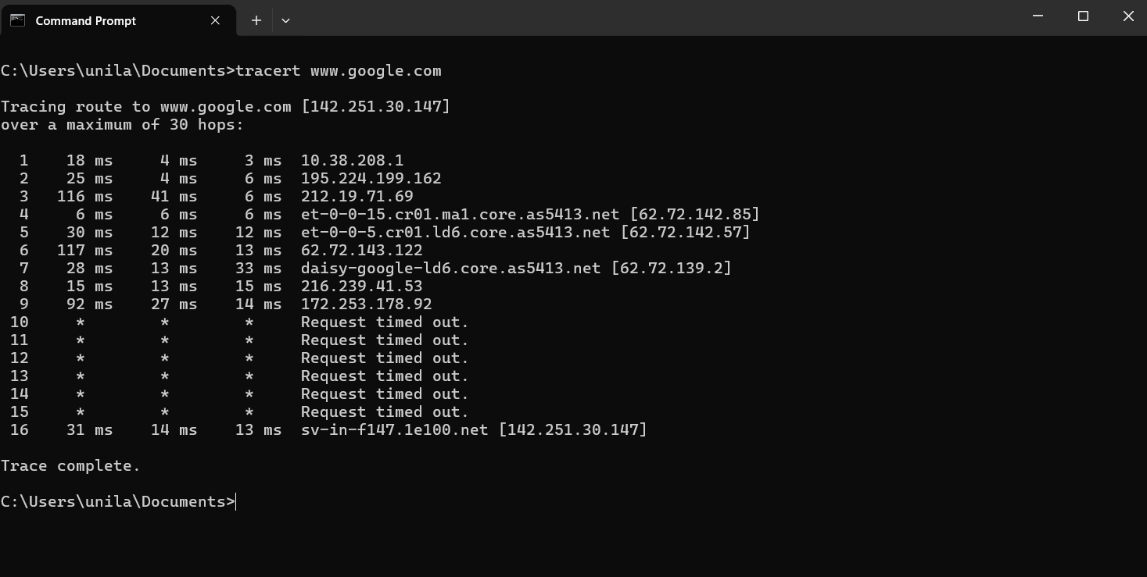
Figure 15: Tracert Command

Use of Linux OS CLI commands
The Linux Command Line Interface enables users to perform tasks like managing files, controlling processes and configuring system settings using text commands. Tools such as Bash allow scripting and automation, making system administration quicker, more flexible and better suited to modern computing needs [8].

Example 1:
The SU command switches the current user to another account typically the root user, after entering the correct password. The output provides a new session with the target user’s privileges.
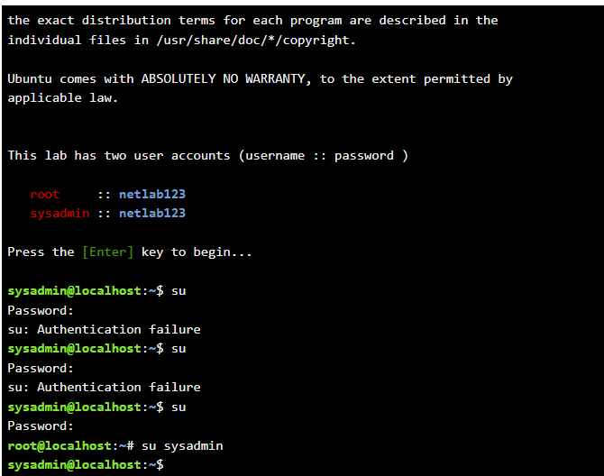
Figure 16: SU Command

Example 2:
The PWD command displays the present working directory,. Showing the full path of the current location in the file system. The output is a directory path indicating where the user is operating.
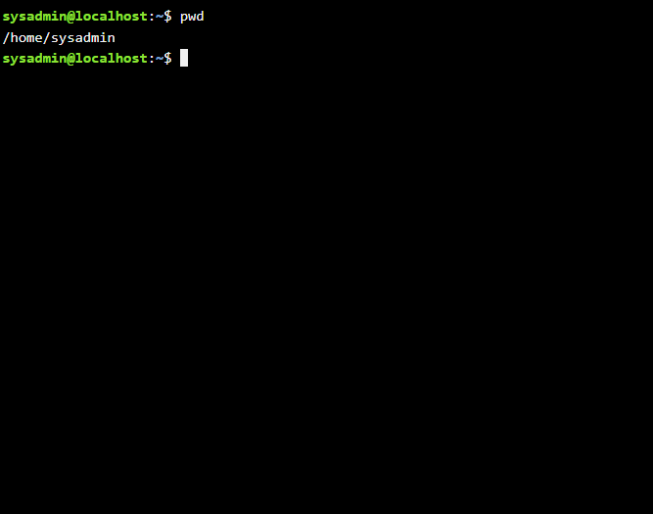
Figure 17: Pwd Command

Example 3:
The LS command lists directory contents, showing files and folders in the current location. Using -L provides detailed information, while -A displays hidden files. The output varies based on the options used.
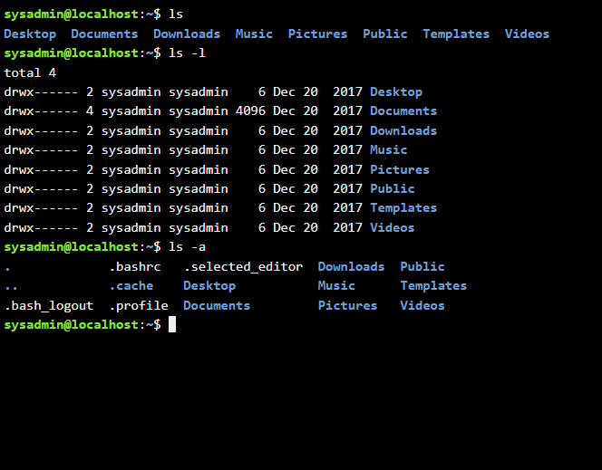
Figure 18: LS,-L & -A Command

Example 4:
The CD command is used to navigate between folders. For example, CD Desktop moves to the Desktop directory. The output shows no text but changes the current working location.
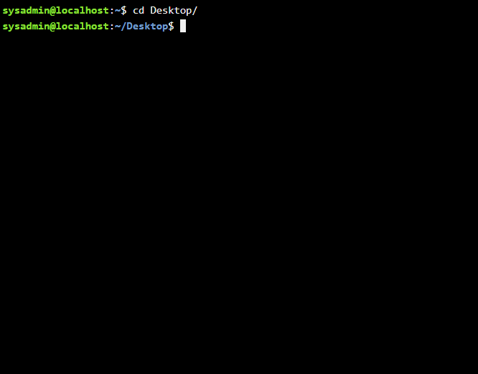
Figure 19: CD Command

Example 5:
The MKDIR command creates a new directory by specifying a folder name. For example, MKDIR new folder generates a directory. The output mainly shows no message but confirms creation if no errors occur.
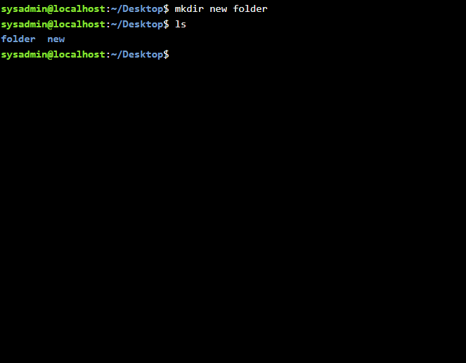
Figure 20: MKDIR Command

Example 6:
The RMDIR command removes an empty directory by specifying its name. For example, RMDIR foldername deletes the folder. The output usually shows nothing unless an error occurs, same as a non empty directory.
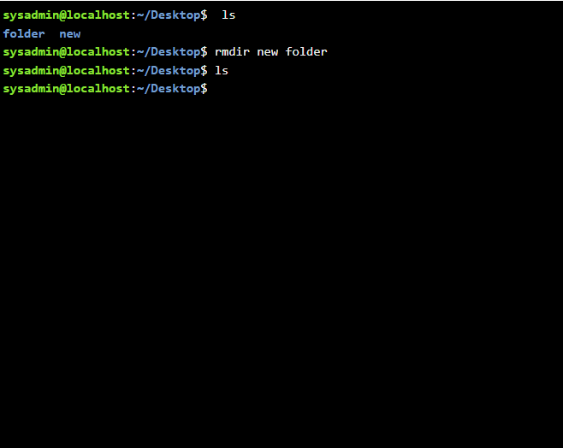
Figure 21: RMDIR Command

Example 7:
The TOUCH command creates a new empty file when followed by a filename, such as TOUCH ‘file.txt’. The output shows no message, but the file appears in the directory listing.
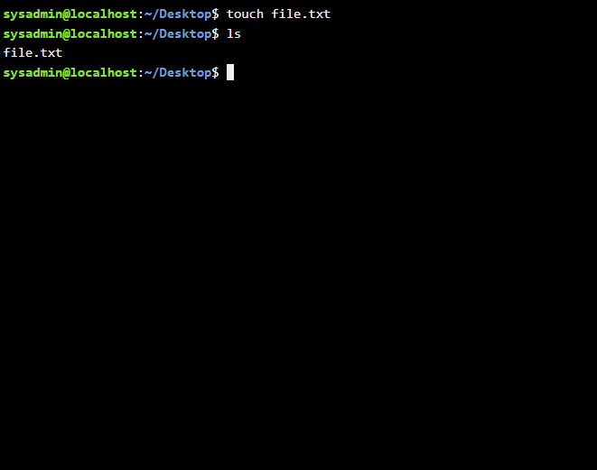
Figure 22: TOUCH Command

Example 8:
The ECHO command outputs text and with ‘>’, writes it into a file. The CAT command displays file contents. The output shows the written text when the file is viewed.
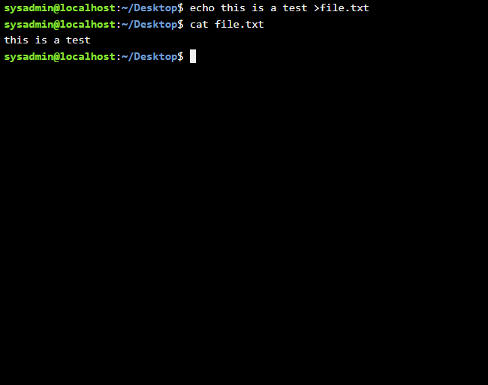
Figure 23: ECHO Command

Example 9:
The INCONFIG command displays network interface details, including IP address, subnet mask, etc. The output lists all active interfaces and their configuration helping manage and troubleshoot network connections.
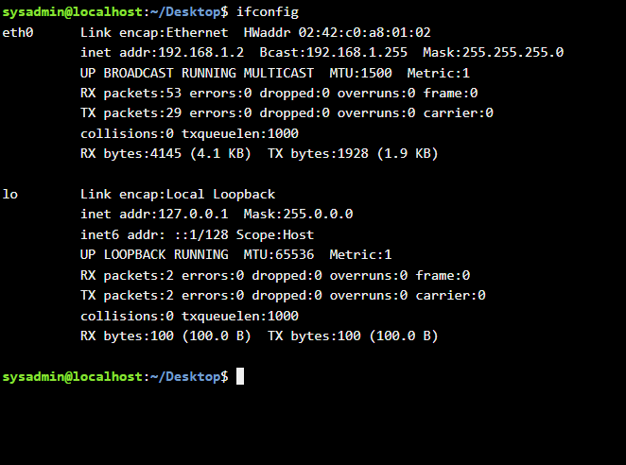
Figure 24: INCONFIG Command

Example 10:
The WHOAMI command displays the currently logged-in user. The date shows the system’s current time and date. RM filename deletes a specified file. The output confirms user identity, current time or file removal.

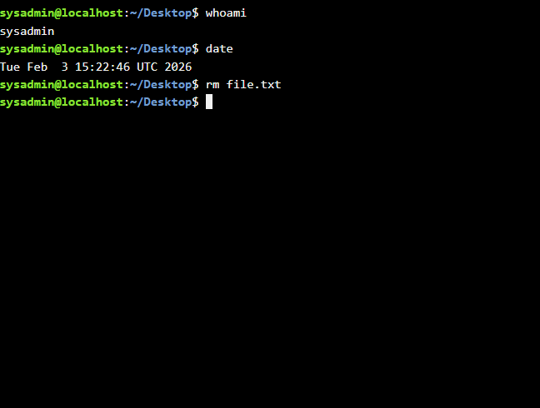
Figure 25: WHOAMI Command

Use of Windows OS scripts
Batch scripting in Windows allows repetitive tasks to be automated by running a series of commands saved in a “.bat file”. It can be used for tasks such as managing files, installing software and maintaining the system helping to increase efficiency and reduce the chance of human error in administration [9].

Example 1:
The @ECHO OFF command in a batch script disables the display of each command in the command prompt as it executes making the output cleaner. The ‘@’ symbol ensures that the echo off command itself is not displayed. This is very useful in scripts where you only want the results or messages to appear & not the underlying commands.
The PAUSE command temporarily halts the execution of the script and displays the message “Press any key to continue . . .” in the command prompt. This allows the user to read messages or see results before the window closes especially when running scripts by double clicking the .bat file.
When combined, @ECHO OFF and PAUSE produce a script that executes commands silently and waits for user input before exiting ensuring that the output can be reviewed without clutter from the command lines themselves.

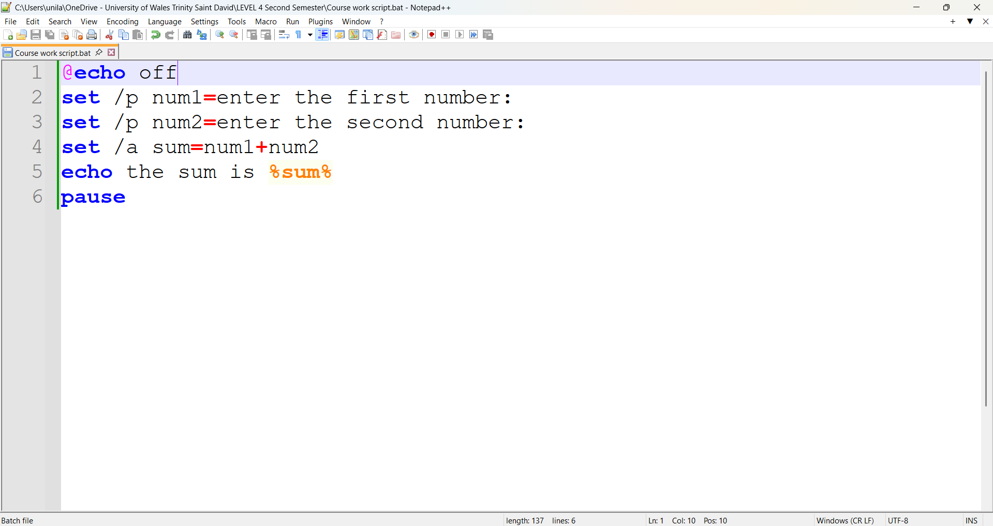
Figure 26: @echo off & Pause CODE/script
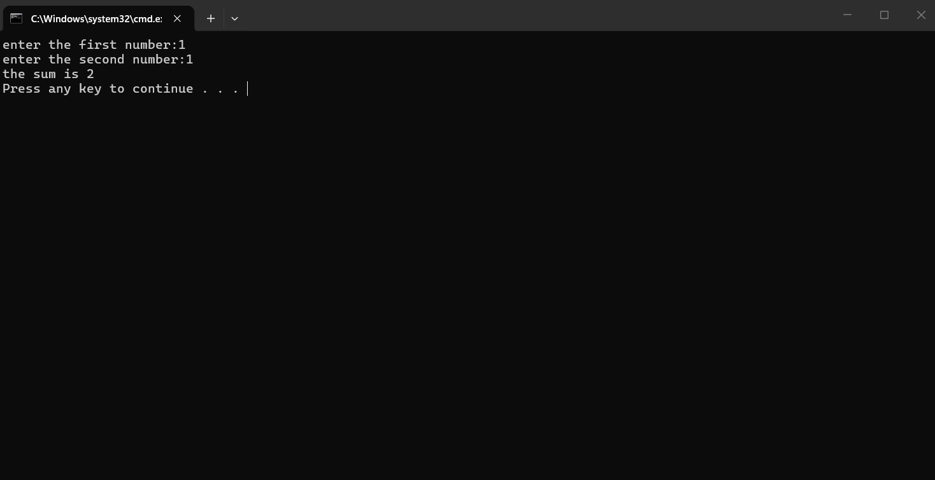
Figure 27: Output off the script

Example 2:
In a batch script, conditional statements allow the program to make decisions based on specific criteria. The IF command evaluates a condition and executes commands accordingly. For example, “IF %number% GEQ 18” checks whether the variable %number% is greater than or equal to 18 and if true executes the subsequent command. Similarly, LEQ checks if a value is less than or equal to a given number and EQU verifies equality.
The ELSE statement provides an alternative set of commands to execute if the IF condition is not met. This structure allows scripts to handle multiple scenarios dynamically. When the script runs, the output depends on the evaluated conditions, commands under true conditions execute and false conditions trigger the ELSE block. This makes batch scripts flexible for tasks like validating input, performing calculations or controlling program flow based on user defined values.

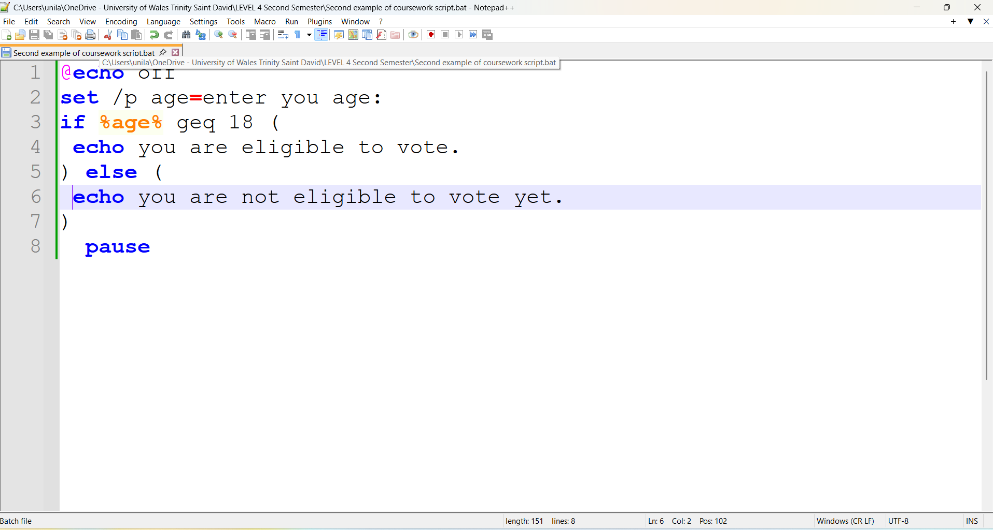
Figure 28: script for the age of voting
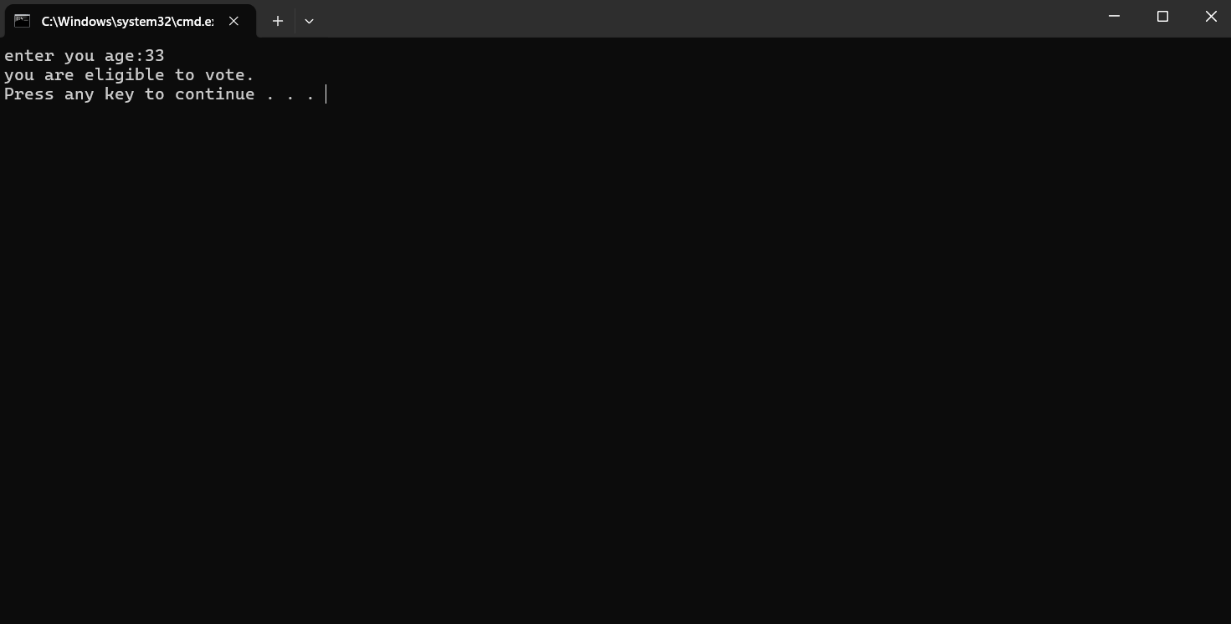
Figure 29: output of above script

Use of Linux OS scripts
Bash scripting in Linux allows users to automate tasks by running a sequence of commands in the Bash shell. It is useful for system administration, managing files, installing software and scheduling tasks helping to make processes more efficient and minimise human errors [10].

Example 1:
This Bash script demonstrates user input, arithmetic calculation and output in Linux. The command echo "enter the first number" prompts the user to type a value which is stored in the variable num1 using read num1. Similarly, echo "enter the second number" and read num2 store the second input in num2.
The script calculates the sum of these two numbers with “total=$((num1+num2))”. The final command echo "the sum is $total", displays the result on the terminal. When executed, the script first asks for the first number, waits for input then asks for the second number and finally outputs the total sum.

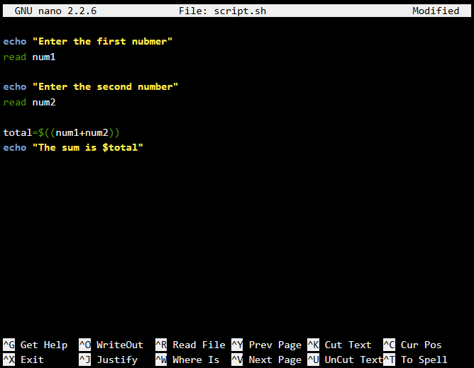
Figure 30: Editing the script in script.sh file
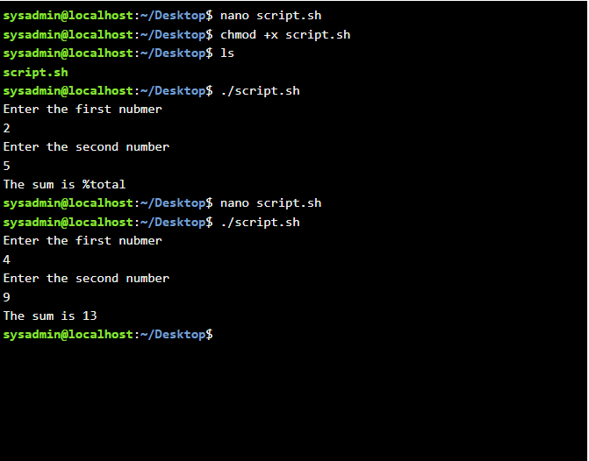
Figure 31: output of the sum

Example 2:
The LOOP.SH script demonstrates a basic for loop in Bash, which iterates a set number of times. The loop is defined as for ((i=1; i<=10; i++)), which initialises the variable i to 1, checks whether i is less than or equal to 10, and increments i by 1 after each iteration.
Within the loop, the command echo "$i" prints the current value of i to the terminal during each iteration. The DO and DONE keywords define the block of commands that are repeated for every value of i.
When executed with ./loop.sh, the script outputs the numbers 1 through 10, each on a separate line. This demonstrates how Bash loops can automate repetitive tasks efficiently such as generating sequences or processing multiple items in a system.

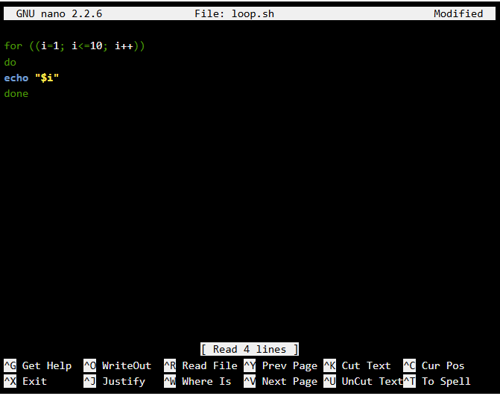
Figure 32: Loop.sh script
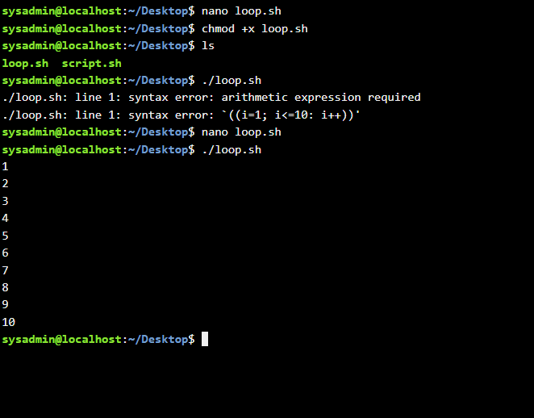
Figure 33: 1-10 generated

Conclusion
In this report, I explored the main functions of operating systems and how to use their command line interfaces. I worked with Windows and Linux commands, as well as batch and Bash scripts using examples like loops, conditionals and file management. These tasks helped me understand how scripting and CLI commands can automate tasks and make system navigation more efficient.

References
[1] A. Silberschatz, P. B. Galvin and G. Gagne, Operating System Concepts, 10th ed. Hoboken, NJ: Wiley, 2020.
[2] Microsoft, “Task Manager in Windows,” Microsoft Learn, 2023. [Online]. Available: https://learn.microsoft.com/en-us/windows/client-management/task-manager.
[3] Microsoft, Manage apps and features in Windows 11, Microsoft Docs, 2023. [Online]. Available: https://learn.microsoft.com/en-us/windows/application-management/apps-features
[4] A. Silberschatz, P. B. Galvin and G. Gagne, Operating System Concepts, 10th ed. Hoboken, NJ, USA: Wiley, 2018.
[5] M. Kerrisk, The Linux Programming Interface, updated online ed., 2021.
[6] S. Singh and N. Chatterjee, “Cybersecurity and cyberwar: What everyone needs to know,” Oxford University Press, 2021.
[7] M. Solomon and D. Ionescu, “Windows command-line administration and automation,” Journal of Systems and Software, vol. 170, 2021.
[8] M. G. Sobell, A Practical Guide to Linux Commands, Editors, and Shell Programming, 4th ed., Pearson, 2021.
[9] J. R. Levine, Windows Batch Scripting: Practical Automation for Administrators, 2nd ed., O’Reilly Media, 2020.
[10] M. G. Sobell, A Practical Guide to Linux Commands, Editors, and Shell Programming, 4th ed., Pearson, 2021.

Appendices
Online Course name:

Figure 34: Certificate of completion

