

Assessment 2

Student name:​ Adriana Dulceneya Ribeiro Silva
Student ID: ​2008480
Module name: Mental Disorders and Psychopathology​
Module code: BMHP6006
Lecturer name: Bianca Sanfilippo ​
Date: 5th January 2023

Table of Contents
Introduction 3
General Anxiety Disorder (GAD) 3
Schizophrenia 5
Autism 8
Conclusion 10

Introduction
Understanding the classification, diagnoses and treatment provisions of mental health issues is critical in delivering effective care. According to the International Classification of Diseases 2010 (ICD-10), General Anxiety Disorder (GAD), Schizophrenia and Autism are three different mental health disorders that impact human behaviour (ICD-WHO, 2010). This report provides a critical examination of each of these mental health issue to identify the causes, symptoms, and scope of rehabilitation. The classification, prevalence and recommendations provided by the National Institute for Health and Care Excellence (NICE) are also reviewed in this report.

General Anxiety Disorder (GAD)
General Anxiety Disorder (GAD) is marked as an excessive and exaggerated level of anxiety or worry about everyday life events with or without any obvious reason for it. People with GAD feel constantly anxious about a wide range of situations and are often in panic and fear, which has a further impact on their behaviour and life. The classification of GAD further falls into section 41.1 under Chapter five and within the group of “Neurotic, stress-related and somatoform disorders (F40-F48)” (ICD-WHO, 2022). The rate of GAD prevalence in the UK is found to range from 1.3 to 4.7% in elderly people, while a record increase in the illness is observed in both women and men aged between 18-24 years. Smaller increases in anxiety can also be observed among those from 25 to 44 years (Slee et al., 2021). The UK primary care has further noticed an increased incidence of anxiety symptoms from 6.2 per 1000 person years at risk in 2003 to 14.7 per 1000 person-years at risk in 2018 (Archer et al., 2022). It is also observed that GAD is the most frequently reported mental health diagnosis among employed people in the UK.
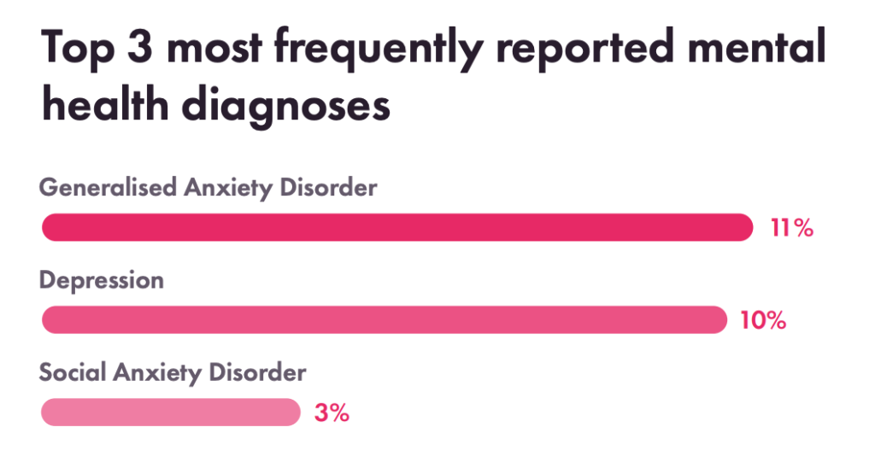
Figure 1: GAD diagnosis among employed people in the UK
Source: (Pindar, 2022)
Anxiety is caused by stress that develops over difficult experiences and due to anticipating poor outcomes. Going through significant life stress and trauma, especially when a person is young, also leads to anxiety disorders (Craske, et al., 2011). It must also be noted that anxiety disorder is also sometimes specific to people with certain personalities. Nonetheless, it is noted that GAD is also caused by a history of negative or traumatic life events and chronic physical or mental conditions.
The signs and symptoms include difficulty falling asleep, difficulty focusing, sweaty palms, and/or the inability to carry out social or professional obligations (Adwas, et al., 2019). Anxiety is characterised by various unfavourable emotions and emotional symptoms, such as an erratic mind, mood swings, and weariness that may be brought on by issues with nervous system regulation.
Individuals are diagnosed with GAD when their worrying habit persists for at least six months. For this diagnosis, a physician or mental health professional may undertake a physical examination like blood or urine tests to assess if anxiety is linked to any underlying medical condition. In contrast, the preliminary diagnosis involves initial assessments of behavioural or somatic symptoms by a GP who may make further referrals or undertake close examinations. In addition, an assessment may also involve reviewing past medical or life events, including the history of substance abuse. Furthermore, the Generalised Anxiety Disorder 7-Item (GAD-7) questionnaire is also used to screen and monitor patients (Munir & Takov, 2022).
Patients have been demonstrated to respond better to cognitive-behavioural therapies (CBT) than to medicine, and these effects also tend to remain longer (National Health Service, 2018). The main form of treatment for moderate to severe GAD is face-to-face CBT. According to studies, CBT for GAD improves the quality of life both during and after therapy by reducing anxiety and sadness (Hirsch, et al., 2019). Clinical studies of cognitive behavioural therapy have a beneficial impact on patients by lowering the primary symptoms of worry. CBT sessions were tough; thus, they might not have been appropriate for people with major mental health issues.
The GAD-7 assessment can help with primary care for people with GAD. Most of the risk that has been identified for GAD are developed from complex psychological, environmental, and social factors, and it's important to understand how they work together to understand how well rehabilitation works (Tambs, et al., 2010). The Generalized Anxiety Disorder Scale-7 (GAD-7) is a self-rated screening instrument consisting of 7 questions: feeling uneasy, anxious, and unable to quit worrying, over worrying, restlessness, irritability, and fear that something terrible will happen. Moreover, these questions are used to determine the severity of generalised anxiety disorder (GAD). The overall score on the GAD-7 scale ranges from 0 to 21. When it comes to anxiety, scores of 5, 10, and 15 correspond, respectively, to mild, moderate, and severe forms of the condition. If this tool scores are ten or higher, it indicates a need for further investigation (Johnson, et al., 2019). The GAD-7 scale is a diagnostic tool, and the treating medical professional will use it to determine the appropriate action.
Apart from the common treatments of GAD, it is recommended that mind-body techniques like meditation are applied to reduce anxiety. This may further involve the effective application of nutrition, herbal or aromatic therapy and exercise (McPherson & McPherson, 2013). Progressive muscle relaxation, biofeedback, music and art therapy, and visual imagery are likely to provide people with anxiety respite and an opportunity to relax. Care and treatment guidelines issued by the National Institute for Health and Care Excellence (NICE) are available to those 18 and older struggling with a generalised anxiety disorder (GAD). It has been found that building trusted relationships can be of great help in dealing with GAD. It is recommended in the principles to have a conversation with the patient about the many types of alternative therapies and to place the primary emphasis on jointly deciding what course of action to take. This encourages people to communicate about the worries they have. These guidelines ensure that the patient’s right to confidentiality is maintained throughout the treatment (NICE, 2011). The person with GAD and their family members will benefit from learning more about the disorder and how to deal with it. If the patient has a moderate learning disability, referrals to local support groups should also be made.

Schizophrenia
Schizophrenia is a serious mental health illness, a chronic brain disorder characterised by disruptive and illogical thought processes, perceptions, and emotional responsiveness. Schizophrenia is also defined as a condition in which a person loses touch with reality, which affects their behaviour and social interactions (Geekie & Read, 2009). Approximately 24 million people, or (0.32%) of the population, are affected by Schizophrenia. In contrast, the prevalence of Schizophrenia in the UK is over 685.000 people, constituting almost 1% of the population. It also accounts for 30% of the adult mental health expenditure by the NHS. Furthermore, only 13% of the people affected by Schizophrenia are working in the UK as of 2022 (Zacher, 2022).
Schizophrenia is classified as a mental and behavioural disorder under section F20 of ICD-10 chapter five. It is further segregated into eight distinctive forms: paranoid, hebephrenic, catatonic, undifferentiated, post-schizophrenic depression, residual, simple, and other unspecified forms of schizophrenia (ICD-WHO, 2010). While the exact cause of schizophrenia is still unknown, it is influenced by various physical, psychological, genetic, and environmental factors. A stressful and emotional life event is also often found to be a triggering factor for schizophrenia-related psychotic episodes. In this regard, S. Brown (2011) has noted that factors like neurodevelopmental issues, trauma, infections (especially in childhood), use or consumption of cannabis, and poor socio-economic condition are significant causes of the development of schizophrenia in adults. However, sleep disorders, endocrine diseases, malignancy, autoimmune diseases, sensory deprivation or impairment and nutritional deficiency are also found to be causes of psychosis and can therefore be causes of schizophrenia (Cardinal & Bullmore, 2011). The below table further shows that substance abuse, personality disorders and affective disorders are the most common last diagnoses for the first hospitalisation due to schizophrenia indicating these issues as causal factors.
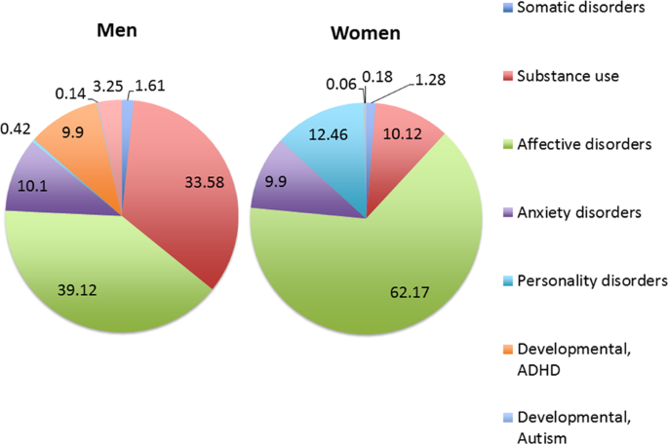
Figure 2: Last diagnosis before first hospitalisation for schizophrenia
Source: (Sommer, et al., 2020)
Psychosis is the primary symptom of schizophrenia, which may include hallucinations, delusions and altered reality, where a person believes, hears, sees, smells, or feels things which are not present (WHO, 2022). The signs of such mental illness could also be observed in how a person thinks or speaks, which tends to be disorganised. Individuals exhibiting such symptoms also display agitated behaviour, unusual postures, slow movements, and social withdrawal with a limited display of interest. Along with these, difficulties in memory, attention and problem-solving also concern symptoms of the illness. The diagnosis of the condition starts with evaluating the presenting complaints. It involves probing questions about psychosis and mood disorders and evaluating the symptoms. A general mental state examination is also required for this process (Cardinal & Bullmore, 2011). Therefore, different screenings and tests are necessary to accurately diagnose the disease, which may involve MRI, CT scan or other brain imaging assessment. While a physical examination is important to identify comorbid conditions or eliminate possibilities of other diseases, a psychiatric evaluation is most appropriate to diagnose the seriousness of the condition. Lastly, it is important that the service users are screened for and asked about their background, lifestyle and history of drug or alcohol abuse to provide an accurate diagnosis (Kelleher, et al., 2011).
Schizophrenia can therefore be treated through both pharmacological and non-pharmacological interventions. In this regard, using typical and atypical antipsychotic drugs is the most common medical treatment to target brain functions and reduce symptoms. The non-pharmacological treatments for schizophrenia-related psychosis usually involve a variety of talking therapies like Cognitive Behavioural Therapy (CBT), Family talking therapy, cognitive remediation, psychoeducation, as well as developing social and coping skills along with assertive community treatment (ACT) or case management (Stevović et al., 2022). In addition to this, patients are provided with Vitamin B supplements, amino acids, Omega-3 fatty acids, antioxidants, and melatonin, along with guidance on diet and physical activity to treat the symptoms (Talkspace, 2022). However, a combination of both pharmacological and non-pharmacological therapies is found to be beneficial in ensuring long-term recovery.
Measuring the rehabilitation and recovery of people with schizophrenia is difficult as only factors like quality of life, quality of treatment provided, and intrinsic motivation or productivity of the people could be assessed. The reduction in the rate of self-harm and substance abuse could also be measured. In this context, the Quality Indicator for Rehabilitative Care (QUIRC-SA) tool is most effective in assessing the quality of care as it is a standard toolkit used for reviewing the care of patients with long-term mental illnesses (Killaspy, et al., 2016). The National Institute for Health and Care Excellence (NICE) has provided various suggestions like smoking cessation and a healthy diet as important in preventing schizophrenia, while it is also suggested that effective monitoring of people taking antipsychotic medication is also required for proper recovery. NICE has further recommended evidence-based methods for the treatment and care of people with schizophrenia with the inclusion of factors like reducing stigma and discrimination to increase the uptake of healthcare support and seeking assistance (NICE, 2014).
Other recommendations for improving schizophrenia are found to be managing stress and helping people cope with stressful events. Conducting mindfulness activities, like yoga and spiritual therapy, may further help individuals express negative emotions (Green, et al., 2019). Considering the principle of care, it is further argued that the least restrictive treatment is provided to individuals. At the same time, attention is paid to obtaining consent and ensuring patient dignity, privacy, and empowerment.

Autism
Autism is also referred to as autism spectrum disorder, one of the most complicated health conditions, which is likely to deteriorate people's communication abilities and affect their behavioural outcomes of people thus, disrupting their daily lives.
As per the ICD-10 classification, it could be stated that autism spectrum disorder falls under F80-89 of pervasive and specific developmental disorders. In contrast, it is seen that the specific classification code of autism has been F84 under that of the pervasive developmental disorder. The classification also applies to autism, mainly associated with a medical condition and intellectual disabilities (ICD-10, 2022).
Autism is a common mental health issue found among children globally. According to the World Health Organisation, it is seen that 1 out of 100 children in the world is diagnosed with this condition. Along with that, the prevalence of autism among children is also higher among low and middle-income nations (WHO, 2022). However, the prevalence of autism is also high in the UK, as it is seen that 1 out of 57 children among the BME children in the country are at a higher risk of autism as compared to that the native white population. Also, it is seen that prevalence of autism is higher among boys as compared to that of girls in the UK, which is 2.8% and 0.65%, respectively (NCL, 2021).
The main causes of autism are mainly associated with genetic and non-genetic factors. In this context, it could be pointed out that autism is mainly caused due to genetic disorders, which are the fragile X syndrome or the Rett syndrome, where genetic changes increase the risk of the disorder, which affects brain development. In addition, environmental factors also play a prominent role, including the effect of medications, air pollutants, complications during pregnancy, and even viral infections that could increase the chances of autism among children (Inui, et al., 2017).
The signs of autism mostly include a lack of responses when people are called by their names or not smiling. Also, people show repetitive behaviours, including flapping hands, flicking their fingers, and rocking their bodies. This also includes getting very upset as well as avoiding eye contact. Also, children have problems achieving important milestones, and they face difficulty in verbal as well as non-verbal communication (Grodberg, et al., 2012).
The initial diagnosis mainly includes observing a child and reporting unnatural behaviour to the GP or the health visitor for children under 5. Also, it is important that the healthcare professional or special education needs (SEN) staff at school need to observe each of the children to detect signs of autism in them. The next step is ensuring autism assessment is carried out by autism specialists within an assessment team (NHS, 2022). The main purpose of the assessment is to identify the problems of the children while observing their interactions with other people. In this case, assessment tools called ADI-R (Autism Diagnostic Interview-Revised), DISCO (Diagnostic Interview for Social Communication Disorders), ADOS (Autism Diagnostic Observation Schedule) and 3Di (Developmental, Dimensional and Diagnostic Interview) are often used.
The current treatments for autism mainly seek to reduce the symptoms that interfere with daily functioning and quality of life. However, this disorder does not affect all people equally; thus, the treatment plan needs to be catered towards the needs and requirements of particular children (Schreibman, et al., 2015). Treatments may be offered in various venues, including those related to education, health, the community, or the home. In this sense, effective occupational treatment, physical therapy, speech and language therapy, and behavioural management techniques are crucial in assisting service users with autism. Behavioural therapies have been shown to improve reasoning and communication in autistic children, which is important for their overall development (Schreibman, et al., 2015). In this case, maintaining the Human Rights and Equality Act 2010 needs to be adopted to lower discrimination and stigmatisation. Apart from that, there are pharmacological interventions; antipsychotic medications, however, can potentially cause secondary unpleasant effects in autistic patients (D’Alò, et al., 2021).
The "Childhood Autistic Rating Scale" (CARS), a behaviour rating scale designed to evaluate the autism symptoms and the degree to which the affliction has been influencing the service user, is one of the important indicators of autism rehabilitation. The 14 categories of this scale, which examine autistic behaviours, have been used extensively to identify and diagnose autism. The 15th domain rates one's impression of autism. Scores between 30 and 36.5 suggest mild to moderate autism, scores between 37 and 60 indicate severe autism, and scores below 30 indicate non-autism (Chlebowski, et al., 2010). In addition to that, the Autism Diagnostic Observation Schedule-Generic (ADOS-G) is also used, which is a semi-structured standardised assessment for social interaction, communication as well as play and imaginative use of materials for the individuals who are suspected of having Autism (Lord, et al., 2000).
In order to improve autism, it is essential that complementary therapies are used, which allow for relieving the stresses and stimuli for the patients. Autism could be coped with life-challenging stressors, enabling individuals to access complementary therapies like yoga and mindfulness as well as medication (National Autistic Society, 2022). In addition, yoga is also seen to be effective as it increases awareness and coordination among children. Along with that, autism could also be improved with complementary therapies such as music therapies, chiropractic, craniosacral manipulation, and massage therapy (Hall & Riccio, 2012).
The ‘Autism: The Management and Support of Children and Young People’ was issued by the National Institute for Health and Care Excellence (NICE) Guidelines. According to the guidelines, it is made sure that autistic children and young people have access to medical care from qualified social workers and health care providers who have received training in treating autism. The NICE guideline for managing and treating autistic children and adolescents also covers psychosocial and pharmaceutical therapies (NICE, 2021). Patients with autism must exercise their rights and be encouraged to pursue the treatment pathway of their choice in accordance with the principles of care. Additionally, the care principles must be followed. In terms of maintaining the privacy, safety, and confidentiality of patients with autism

Conclusion
It is thus understood that mental health issues like GAD emerge from past experiences and trauma. It can be treated based on the NICE recommendation, while complementary therapies could also be used. Similar to this, schizophrenia is caused by a combined influence of various environmental factors and, therefore, can be treated based on both drug-based and talking therapies. It is essential to understand that autism there is a need for conducting autism assessment with the help of a diagnosis tic tool like DISCO and ADI-R. Also, current treatments like behavioural programmes and antipsychotic medicines could be effective.

References
Adwas, A. A., Jbireal, J. & Azab, A. E., 2019. Anxiety: Insights into Signs, Symptoms, Etiology, Pathophysiology, and Treatment. East African Scholars Journal of Medical Sciences, 2 (10).
Archer, C. et al., 2022. Trends in the recording of anxiety in UK primary care: a multi-method approach. Social Psychiatry and Psychiatric Epidemiology, July, Volume 57, p. 375–386.
Cardinal, R. N. & Bullmore, E. T., 2011. The Diagnosis of Psychosis. s.l.:Cambridge University Press.
Chlebowski, C., Green, J., Barton, M. & Fein, D., 2010. Using the childhood autism rating scale to diagnose autism spectrum disorders. Journal of autism and developmental disorders, 40(7), pp. 787-799.
CORC UK (2022) Generalised Anxiety Disorder Assessment (GAD-7).
Available at: https://www.corc.uk.net/outcome-experience-measures/generalised-anxiety-disorder-assessment-gad-7/ (Accessed: 11 December 2022].
Craske, M. et al., 2011. What is an anxiety disorder? Focus, July, 9(3), pp. 369-388.
D’Alò, G. et al., 2021. Impact of antipsychotics in children and adolescents with autism spectrum disorder: a systematic review and meta-analysis. Health and quality of life outcomes, 19(1), pp. 1-19.
Geekie, J. & Read, J., 2009. Making Sense of Madness: Contesting the Meaning of Schizophrenia. s.l.:Taylor & Francis.
Green, M., Horan, W. & Lee, J., 2019. Non-social and social cognition in schizophrenia: current evidence and future directions. World Psychiatry, 18(2), pp. 146-161.
Grodberg, D. et al., 2012. Brief report: the autism mental status examination: development of a brief autism-focused exam. Journal of Autism and Developmental Disorders, 42(3), pp. 455-459.
Hall, S. & Riccio, C., 2012. Complementary and alternative treatment use for autism spectrum disorders. Complementary Therapies in Clinical Practice, 18(3), pp. 159-163.
Hirsch, C. R., Beale, S., Grey, N. & Liness, S., 2019. Approaching Cognitive Behavior Therapy for Generalized Anxiety Disorder from A Cognitive Process Perspective. Front. Psychiatry.
ICD-10 (2022) ICD-10CM Diagnosis Code F84.0. Available at https://www.icd10data.com/ICD10CM/Codes/F01-F99/F80-F89/F84-/F84.0/ (Accessed: 17 December 2022).
ICD-WHO (2010) Chapter V: Mental and behavioural disorder (F00-F99). Available at: https://icd.who.int/browse10/2010/en#/F20-F29/ (Accessed: 17 December 2022).
ICD-WHO (2022) Neurotic Stress-Related and Somatoform disorder. Available at: https://icd.who.int/browse10/2010/en#/F41.1/ (Accessed: 23 December 2022).
Inui, T., Kumagaya, S. & Myowa-Yamakoshi, M., 2017. Neurodevelopmental hypothesis about the aetiology of autism spectrum disorders. Frontiers in human neuroscience, Volume 11, p. 354.
Johnson, S. U., Ulvenes, P. G., ktedalen, T. & Asle Hoffart1, 2., 2019. Psychometric Properties of the General Anxiety Disorder 7-Item (GAD-7) Scale in a Heterogeneous Psychiatric Sample. Front Psychol., 10(1713).
Kelleher, I., Harley, M., Murtagh, A. & Cannon, M., 2011. Are screening instruments valid for psychotic-like experiences? A validation study of screening questions for psychotic-like experiences using in-depth clinical interview. Schizophrenia Bulletin, 37(2), pp. 362-369.
Killaspy, H., White, S., Dowling, S. & Krotofil, J. M., 2016. Adaptation of the Quality Indicator for Rehabilitative Care (QuIRC) for use in mental health-supported accommodation services (QuIRC-SA). BMC Psychiatry, 16(1), pp. 1-8.
Lord, C. et al., 2000. The autism diagnostic observation schedule-generic: a standard measure of social and communication deficits associated with the spectrum of autism. J Autism Dev Disorder, Volume Jun;30(3), pp. 205-23.
McPherson, F. & McPherson, F., 2013. Treating generalised anxiety disorder using complementary and alternative medicine. Altern Ther Health Med, September-October, 19(5), pp. 45-50.
National Autistic Society (2022) Yoga as therapy. Available at: https://www.autism.org.uk/directory/y/yoga-as-therapy/ (Accessed: 23 December 2022).
NCL (2021) Autism rates increase. Available at: https://www.ncl.ac.uk/press/articles/archive/2021/03/autismratesincrease/ (Accessed: 24 December 2022).
National Health Service (2018) Overview - Generalised anxiety disorder in adults. Available at: https://www.nhs.uk/mental-health/conditions/generalised-anxiety disorder/overview/#:~:text=GAD%20is%20a%20common%20condition,ages%20of%2035%20to%2059/ (Accessed: 26 December 2022).
National Health Service (2022) How to get diagnosed. Available at: https://www.nhs.uk/conditions/autism/getting-diagnosed/how-to-get-diagnosed/ (Accessed: 26 December 2022).
NICE (2011) Generalised anxiety disorder and panic disorder in adults: management. Available at: https://www.nice.org.uk/guidance/cg113/ (Accessed: 27 December 2022).
NICE (2014) Psychosis and Schizophrenia in adults: National Clinical Guideline. Available at: https://www.nice.org.uk/guidance/cg178/evidence/full-guideline-490503565/ (Accessed: 27 December 2022).
NICE (2021) Autism Spectrum Disorder in under 19s: support and management. Available at: https://www.nice.org.uk/guidance/cg170/chapter/Key-priorities-for-implementation#pharmacological-interventions-for-behaviour-that-challenges/ (Accessed: 27 December 2022).
Pindar, J., (2022) Anxiety Statistics UK: 2022. Available at: https://championhealth.co.uk/insights/anxiety-statistics/ (Accessed: 27 December 2022).
Rutter, L. A. & Brown, T. A., 2018. Psychometric Properties of the Generalized Anxiety Disorder Scale-7 (GAD-7) in Outpatients with Anxiety and Mood Disorders. J Psychopathic Behav Assess., 39(1), p. 140–146.
S. Brown, A., 2011. The environment and susceptibility to schizophrenia. Progress in Neurobiology, January, 93(1), pp. 23-58.
Schreibman, L. et al., 2015. Naturalistic developmental behavioural interventions: Empirically validated treatments for autism spectrum disorder. Journal of autism and developmental disorders, 45(8), pp. 2411-2428.
Slee, A., Nazareth, I., Freemantle, N. & Horsfall, L., 2021. Trends in generalised anxiety disorders and symptoms in primary care: UK population-based cohort study. Br J Psychiatry, March, 218(3), pp. 158-164.
Sommer, I. E. et al., 2020. The clinical course of schizophrenia in women and men—a nationwide cohort study. npj Schizophrenia, 6(12), pp. 1-7.
Stevović, L. et al., 2022. Non-pharmacological interventions for schizophrenia - analysis of treatment guidelines and implementation in 12 Southeast European countries. Schizophrenia, 8(1), pp. 1-11.
Talkspace, (2022) 8 Complementary Natural Remedies for Schizophrenia.
Available at: https://www.talkspace.com/mental-health/conditions/schizophrenia/natural-alternative-treatments/ (Accessed: 28 December 2022).
Tambs, K., Czajkowsky, N., E. R. & M. C. N., 2010. Structure of genetic and environmental risk factors for dimensional representations of DSM–IV anxiety disorders. Br J Psychiatry., 135(4), p. 301–307.
World Health Organization (2022) Autism. Available at: https://www.who.int/news-room/fact-sheets/detail/autismspectrumdisorders#:~:text=It%20is%20estimated%20that%20worldwide,figures%20that%20are%20substantially%20higher/ (Accessed: 28 December 2022).
World Health Organisation (2022) Schizophrenia. Available at: https://www.who.int/news-room/fact-sheets/detail/schizophrenia/ (Accessed: 28 December 2022).
Zacher, J. M., (2022) UK National Schizophrenia Awareness Day 2022 - A Mental Illness in Need of Destigmatization. Available at: https://www.monsenso.com/uk-national-schizophrenia-awareness-day-2022-a-mental-illness-in-need-of-destigmatization/ (Accessed: 23 December 2022).

