
E-PORTFOLIO
MODULE : ECPS4018


AI Acknowledgement:

I acknowledge the use of OpenAI. https://www.openai.com/chatgpt
On the 28th and 30th of October look for articles using the following prompts:

1. Please find academic articles about the physical benefits of pet ownership and cite the sources in APA style.

2. Please find academic articles about the psychological benefits of pet ownership and cite the sources in APA style.

3. Please find academic articles about the social benefits of pet ownership and cite the sources in APA style.

4. Please find academic articles about the negative effects on physical health, mental health and the negative social factors of pet ownership and cite the sources in APA style.

5. I acknowledge the use of Grammarly (https://www.grammarly.com/)
on the 12th of November 2024 to check my work using the following prompt:
Please check the following text for overall structure, readability, grammar, spelling, and syntax, and check that my citations are correct using the APA referencing method.

Contents Page:
  - How does music make you feel?
300-word article summary p3-5

  - Study skills infographic p6-7

  - Essay Plan Library search p8-9

  - Library Summary of Sources p10

  - Essay Plan: Describe and discuss the psychological, social and physical benefits of owning a pet p10-13

  - Essay Reference List p14-15

1.1 How does music make you feel? (Article summary)

Zoe Nendick discusses the link between music and emotion (12 September 2022).
Why does music affect emotions and can music be happy or sad instinctively?
Certain scales chords or keys can sound cheerful, whilst others sound sombre eliciting an emotional response. Memories can also relate to certain songs reminding us of specific events or times. (Belfi et al., 2016). Our emotional response can be linked to our mood at the time. (e.g. Hunter et al., 2011). Listening to music is linked to certain reward areas in the brain causing pleasurable responses. (Blood & Zatorre, 2001),
Meyer discovered that the sequence of chords that create the structure of a piece of music alongside our expectations of the piece forms our emotional response (Meyers, 1956) Music-induced emotions arise as a result of the interaction between the listener, the music, and the situation at the time (Juslin, 2011), Personality type has been linked to how music makes us feel and whether we link music to past experiences.(Barrett et al, 2010).
Circumstances that may affect music-induced emotions; include your social situation and your surroundings at the time ( Egermann et al., 2011), and whether you have chosen the music yourself (Eerola & Vuoskoski, 2013). Concentration levels have also been shown to affect the listener's emotional state. (e.g. Sagha et al., 2015)

Streaming services have playlists available to choose from depending on your emotional state, to suit your mood at the time. Music has been shown to help release stress (Suda et al.,2008) and to have pain-relieving effects. (Finn & Fancourt, 2018). Background music affects our thoughts, emotions and behaviour.(Jain and Bagdare,2011).

Zoe studied a music degree, later converting to psychology due to her interest in music and its links to emotion and behaviour. She completed an MSc in Psychology and works with the London youth choirs.
Summary Reference
Nendick, Z. (2022, September 12). How does music make you feel? – The British Psychological Society. www.bps.org.https://www.bps.org.uk/psychologist/how-does-music-make-you-feel
References from article
Belfi, A. M., Karlan, B. R., & Tranel, D. (2016). Music evokes vivid autobiographical memories. Memory, 24(7), 979-989.
Blood, A. J., & Zatorre, R. J. (2001). Intensely pleasurable responses to music correlate with activity in brain regions implicated in reward and emotion. Proceedings of the National Academy of Sciences, 98(20), 11818-11823.
Egermann, H., Kopiez, R., & Reuter, C. (2011). Is there an effect of subliminal messages in music on choice behaviour? Journal of Articles in Support of the Null Hypothesis, 7(2), 1-34.
Eerola, T., & Vuoskoski, J. K. (2013). A review of music and emotion studies: Approaches, emotion models, and stimuli. Music Perception, 30(3), 307-340.
Finn, S., & Fancourt, D. (2018). The biological impact of listening to music in clinical and nonclinical settings: A systematic review. Progress in Brain Research, 237, 173-200.
Hunter, P. G., Schellenberg, E. G., & Schimmack, U. (2011). Feelings and perceptions of happiness and sadness induced by music: Similarities, differences, and mixed emotions. Psychology of Aesthetics, Creativity, and the Arts, 4(1), 47-56.
Jain, R., & Bagdare, S. (2011). Music and consumption experience: A review. International Journal of Retail & Distribution Management, 39(4), 289-302.
Juslin, P. N. (2011). Music and emotion: Seven questions, seven answers. Music and Arts in Action, 3(2), 1-27.
Meyer, L. B. (1956). Emotion and meaning in music. University of Chicago Press.
Sagha, Z., & Scherer, K. R. (2015). The role of attention in the emotional effects of music: A comparison of music and film. Psychomusicology: Music, Mind, and Brain, 25(1), 39-53.
Suda, M., Morimoto, K., Obata, A., Koizumi, H., & Maki, A. (2008). Emotional responses to music: Towards scientific perspectives on music therapy. NeuroReport, 19(1), 75-78.

1.2 Infographic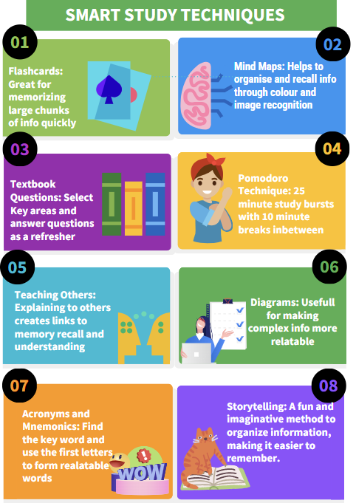

Infographic Reference



1.3 Essay Plan Library search

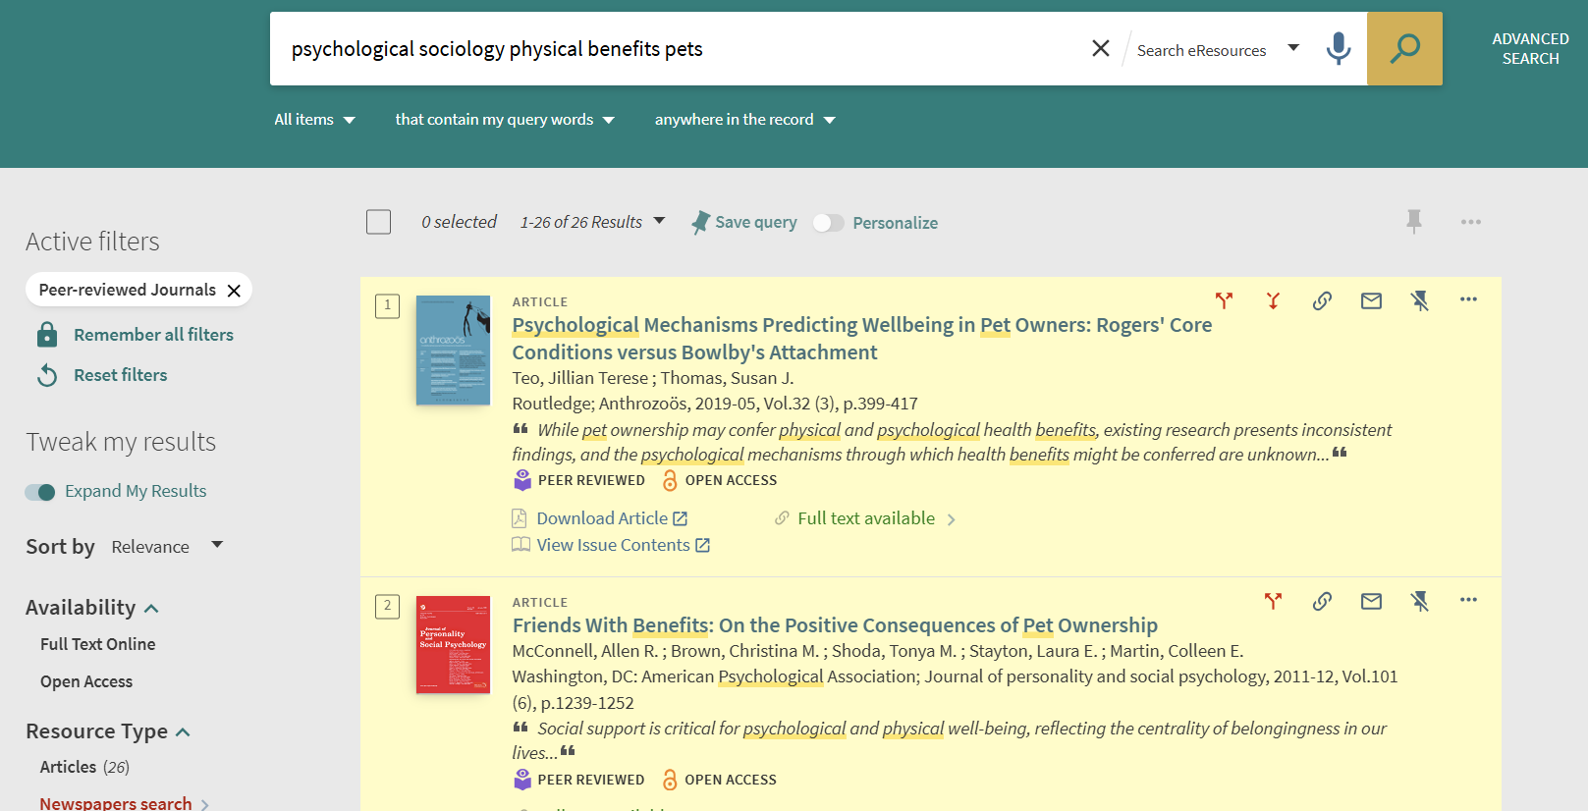

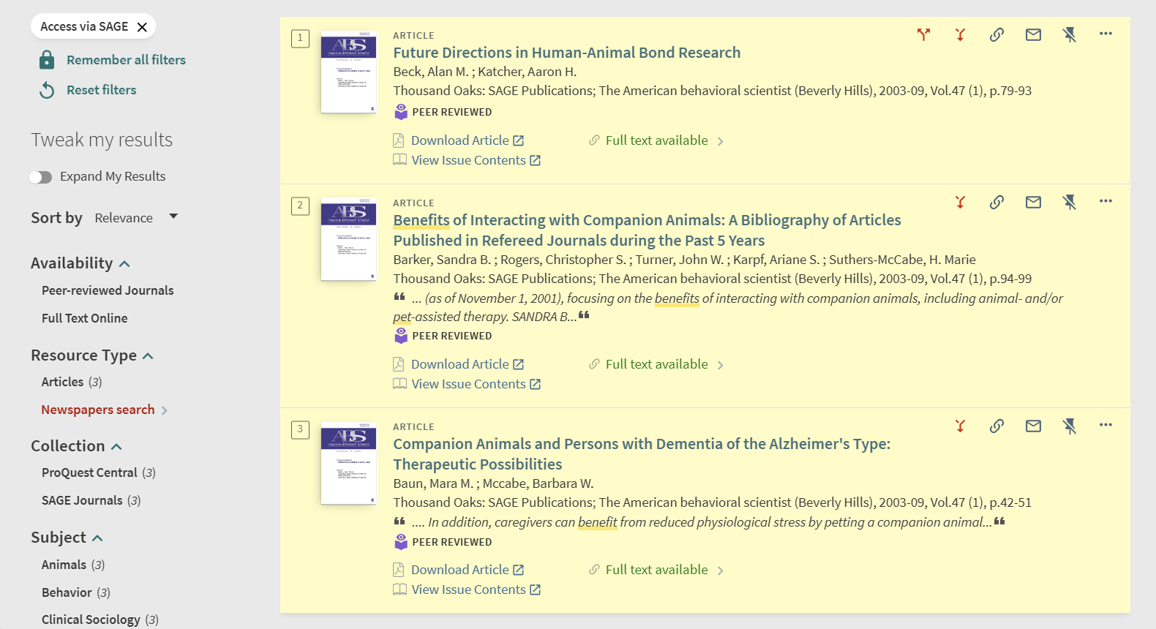

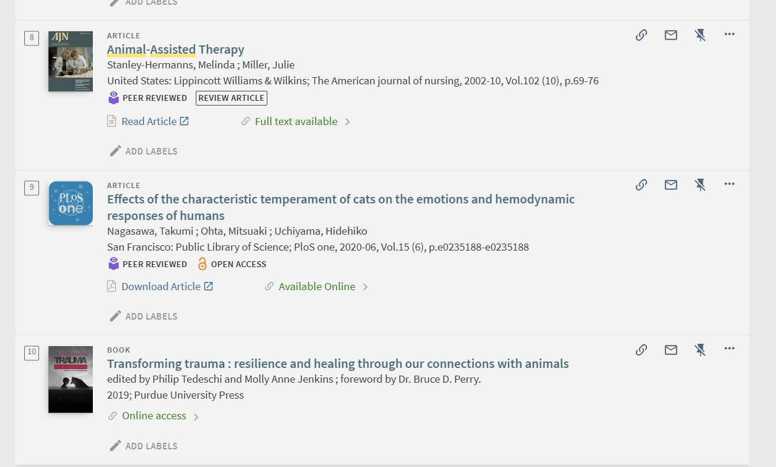

1.4 Library Summary of Sources
I found the library useful for finding books and articles for my essay plan. I ensured my sources were peer-reviewed, recent, relevant and of academic value. I also found equally valuable articles by using ChatGPT prompts. I particularly valued the sources on animal-assisted therapy and human-pet attachment theory. This is something I wish to pursue in the future as a veterinary nurse and mental health therapist.

1.5 Essay Plan

Describe and discuss the psychological, social and physical benefits of owning a pet.
Companion pet ownership has been shown to provide numerous psychological, physical and social benefits. (McConnell., et al 2011) Pets offer unconditional love, companionship, and physical and emotional support, which can significantly improve the well-being of their owners. (Scoresby et al., 2021) However, pet ownership also comes with its challenges, particularly when dealing with behavioural issues or the loss of a pet. (Zablan., et al 2024) This essay explores the various benefits and potential drawbacks of companion pet ownership.

Paragraph One
Companion pet ownership provides psychological benefits. Pets offer unconditional love, companionship, and emotional support to many people. (Mc Connel., et al 2011) They have been shown to reduce feelings of loneliness and depression. The bond between pets and their owners can be incredibly comforting, especially during tough times, and can add new meaning to life. (Scoresby., et al 2021) Stroking a pet has been shown to increase the release of serotonin and dopamine in the brain, leading to lower stress and anxiety levels and a reduction in depressive symptoms. (Purewal., et al 2019) Caring for a pet requires a daily routine, which can provide a sense of purpose. (Miller, 2020) This is particularly beneficial for individuals struggling with mental health issues, as it encourages regular activity, more social interactions, and a sense of responsibility.(Zablan., et al 2024) Pets are often used in therapy and as emotional support providers in schools, homes, and hospitals. (Miller, 2020)

Paragraph Two
Some studies suggest that individuals with insecure attachment styles may form stronger emotional bonds with pets, which can sometimes be linked to increased mental health issues, especially with the loss of a pet or caring for a sick or injured pet. (Teo & Thomas, 2019)The emotional and financial strain can be devastating, and the responsibilities of pet ownership can become an increased burden, especially when pets have behavioural issues such as aggression, excessive barking, destructiveness, or house soiling. (McNicholas., et al 2005) This can become unmanageably stressful, leading to an increase in mental health strain. (Scoresby., et al 2021)

Paragraph Three
Companion pet ownership provides physical benefits. Pets, especially dogs, require regular walks, which encourages owners to stay active. (Miller, 2020) Regular physical activity can increase exercise levels and help maintain a healthy weight. (Suttie, 2020) Pets can get owners more active and outdoors in nature, improving physical well-being. (McNicholas., et al 2005) This has been proven to improve mood by increasing dopamine and serotonin levels, lowering blood pressure, improving cardiovascular health, and boosting overall fitness. (Koskella, 2021) Thus decreasing anxiety and stress levels. Interacting with pets has been shown to lower cortisol levels, reducing anxiety and feelings of stress.(Zablan., et al 2024) Just the presence of a pet can provide comfort and physical wellness. Another positive factor in physical health is the enhancement of the immune system. (Suttie, 2020) Exposure to pets, especially during childhood, can strengthen the immune system and reduce the risk of allergies and asthma. Pets can introduce a variety of microbes into the home, which can help build a more robust immune system. (Scoresby., et al 2021)

Paragraph Four
Likewise, it should also be considered that the loss of a pet or caring for a sick or injured pet, the emotional and financial strain of owning a pet, and the responsibilities of pet ownership can become an increased burden, especially when pets have behavioural issues such as aggression, excessive barking, destructiveness, or house soiling. (McNicholas,2005)This can become unmanageable and stressful, leading to an increase in blood pressure and increased work on the heart, leading to poor heart health and a lowered immune system caused by stress, which could cause illness within the body's systems. (Koskela, 2024))

Paragraph Five
Companion pet ownership, especially that of dog owners, has many social benefits: encouraging the owners to get out and about, leading to more opportunities to meet new people. (Zablan, 2024)Dog parks, pet-friendly events, and walking routes are great places to meet other pet owners and talk about the pets, taking the pressure away from the owner and encouraging feelings of self-esteem. (Scoresby., et al 2021) Pets can act as social catalysts, helping their owners meet new people and reducing social isolation. (Koskela, 2024) Caring for a pet can enhance empathy and compassion, skills that are transferable to human relationships. Interacting with pets has been shown to improve communication skills, especially for children and individuals with social anxiety and special needs. (Teo & Thomas, 2019)

Paragraph Six
The negative effects of social interaction should also be mentioned. Pet owners with dogs with behavioural issues, for example, may become more isolated out of embarrassment or fear of their pets' behaviours, such as aggression, soiling, vocalization, or destructiveness.(Zablan., et al 2024) Pets can occasionally cause lifestyle restrictions, limiting the ability to travel or see relatives due to pet commitments or moving to pet-restricted housing. (Purewal., et al 2019)

Conclusion
In conclusion, companion pet ownership offers a range of psychological, physical, and social benefits. Pets can provide comfort, reduce stress, and encourage a more active lifestyle. (Miller, 2020) However, it is important to acknowledge the potential challenges, such as the emotional and financial strain of caring for a pet with behavioural issues or dealing with the loss of a pet.(Zablan., et al 2024) By understanding both the benefits and drawbacks, individuals can make informed decisions about pet ownership and ensure a positive experience for both themselves and their pets.

1.6 Reference List:
Koskela, A. (2024, November 8). Emotional bonding: How dog-owner heart rates sync during interaction. Neuroscience News. https://neurosciencenews.com/dog-human-heart-synch-27996/

Miller, L. B. (2020, October 26).The psychological and physical benefits of having a pet. Psychology Today. https://www.psychologytoday.com/us/blog/the-mind-body-connection/202010/the-psychological-and-physical-benefits-having-pet

McConnell, A. R., Brown, C. M., Shoda, T. M., Stayton, L. E., & Martin, C. E. (2011). Friends with benefits: On the positive consequences of pet ownership. Journal of Personality and Social Psychology, 101(6), 1239-1252. https://doi.org/10.1037/a0024506

McNicholas, J., Gilbey, A., Rennie, A., Ahmedzai, S., Dono, J., & Ormerod, E. (2005). Pet ownership and human health: A brief review of evidence and issues. BMJ, 331, 1252. https://doi.org/10.1136/bmj.331.7527.1252

Purewal, R., Christley, R., Kordas, K. et al. Socio-demographic factors associated with pet ownership amongst adolescents from a UK birth cohort. BMC Vet Res 15, 334 (2019). https://doi.org/10.1186/s12917-019-2063-x

Scoresby, K. J., Strand, E. B., Ng, Z., Brown, K. C., Stilz, C. R., Strobel, K., Barroso, C. S., & Souza, M. (2021). Pet ownership and quality of life: A systematic review of the literature. Veterinary Sciences, 8(12), 332. https://doi.org/10.3390/vetsci8120332

Suttie, J. (2020). The science-backed benefits of being a dog owner. Greater Good Science Centre. https://greatergood.berkeley.edu/article/item/the_science_backed_benefits_of_being_a_dog_owner

Teo, J. T., & Thomas, S. J. (2019). Psychological mechanisms predicting wellbeing in pet owners: Rogers' core conditions versus Bowlby's attachment. Anthrozoös, 32(3), 399-417. https://doi.org/10.1080/08927936.2019.1604417

Zablan, K., Melvin, G., & Hayley, A. (2024). Dog ownership, physical activity, loneliness and mental health: A comparison of older adult and younger adult companion animal owners. BMC Psychology, 12(618). https://doi.org/10.1186/s40359-024-02104-x

