Project Elizabeth Line
Review

Student Rosca Ana Diana (2020311)
Course: Project Management

University of Wales
Trinity Saint David

Date:16.01.2023

Table of Contents

1. Introduction……………………………………………………………..………………..3
2. The Elizabeth Line Crossrail Project-Success Factors………….……………... 4
3. The Elizabeth Line Project-Failures……………………………………………….8
4. Conclusion………………………………………………………………………………11
5.Bibliography…………………………………………………………………………….13

Introduction
One of the biggest projects to have ever been started in Europe, The Elizabeth Line Crossrail joins the East and West of London, and its aim is to offer transport facilities from Heathrow in and Maidenhead in the west to Abbey Wood and Shenfield in the Eastern parts of London. (Davies , et al., 2014)
As mentioned in the journal by Davies and colleagues, the rail line has a length of approximately 74 miles and will add an additional 10% to UK’s total system of underground railway coverage.
According to the estimations made so far, the railway is projected to simplify transportation for approximately 200 to 280 million people per annum. It is also estimated that the lifespan of the project is of 120 years, and this makes the venture one of the most significant endeavours that was ever done in United Kingdom. Upon completion, the railway will offer fast-link transport means from Heathrow Airport, to the centre of London city and the Wharf enterprise areas into the East.
The Project started in 2009, once the government approved the Crossrail Act in 2008, and it was projected to be totally operational in 2018, though it has been delayed several times due to a variety of reasons.
One major issue that delayed the project was related to train signalling system. The second major issue, came in 2019 and delayed the project even further as the World was facing a whole new variable, a situation never encountered in a mega project like this one: Covid-19 Pandemic. It is estimated that all the lines will be fully operational by mid-2023.
The scope of this paper is to critically evaluate The Elizabeth Line Crossrail and to determine whether the project is a success or a failure and to underline the lessons learned so far from it.
To properly determine the success of failure of the project we first need to recognise the scope and to better understand the project objectives. On the project initiation, the main scope was to reduce the overcrowding that existed on the existing railway system, to reduce congestion and to provide additional transportation facilities. (de Silva & Paris, 2014)
Considering it was a mega project, a construction in the centre of a huge city like London, mega populated, full of history and culture, the venture was handled with caution and the latest available technologies were used to reduce risks as much as possible. (Black, 2017) Several committees were formed and their aim was to conduct an assessment called Performance Assurance Assessment.
Its scope was to assess six vital delivery functions such as business-related benefits, support and adherence of health and safety measures, quality of the project, environmental issues, social sustainability effect and community relations.

2.The Elizabeth Line Crossrail Project-Success Factors

When we evaluate this project against three aspects like economical, environmental and social we can only draw the conclusion that the project is a definite success. This section of the reports will show the impact that The Elizabeth Line has when considering these three major deliverables.
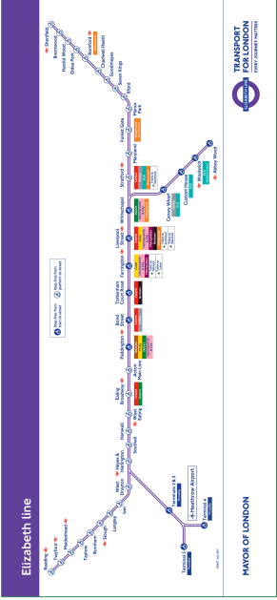
Fig1. Crossrail Route Map (Haylen, 2019)
In economical terms, The Elizabeth Line is expected to boost the UK economy significantly. According to an estimation, the project will generate more than £42 billions current net value in the next 60 years. According to Pollalis and Lappas, just in the first year after it was functional, The Elizabeth Line was estimated to add a benefit of £5.5 billion to the United Kingdom’s economy (Pollalis & Lappas, 2019).
Another big economical impact is that this project will help put London among the world’s most competitive cities because of its efficient means of transportations and reduced congestion. The construction of various new stations underground will facilitate multiple business opportunities for the surrounding areas.
According to estimations, the Project will be directly linked to the provision of over 90,00 households and close to 4.5 sq. feet of commercial spaces. Tens of thousands of jobs have been created so far just trough the enactment of this development helping the financial progress of the state and increasing the living criteria of London’s inhabitants. (Bennett, 2017)
Even though certain sectors will benefit more from the construction of the railway, the project will bring economic benefits to the entire country. Among the major beneficiaries of the project and the sectors that will directly be impacted we can mention the property developers in London and the immediate community around the capital. In the transport sector, another, major beneficiary will be the Heathrow Airport, which will be directly impacted by this project.
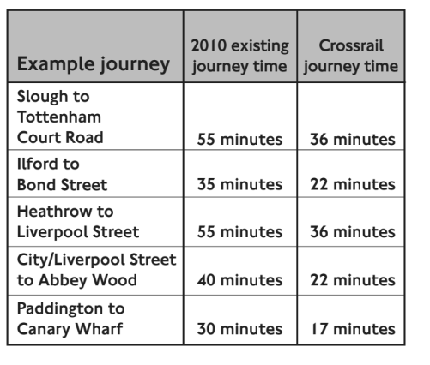
Fig.2 Crossrail Impact on travel Times (Crossrail Department for Transport , 2010)
According to Fraser, 2017, the business community will be highly impacted by the project because it will facilitate access into London. The retail industry will be a major beneficiary owed to the improved accessibility of people into the capital. Just about £2-3 billion will be immediately contributed by businesses opened because of the creation of the Elizabeth Line (Fraser, et al., 2017)
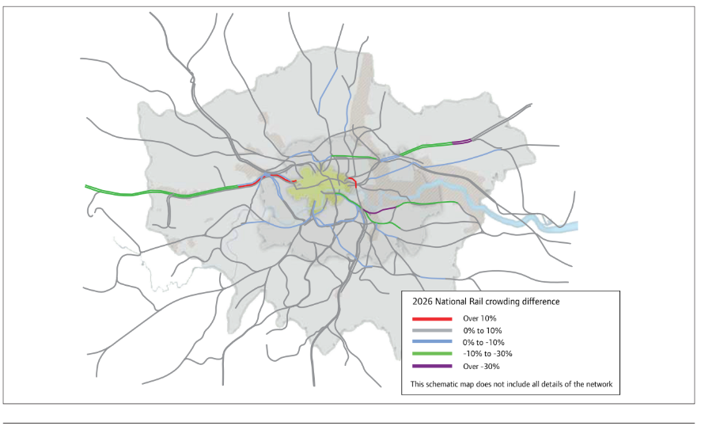
Fig.3 Railway Crowding Changes with Crossrail 2026 (Crossrail Department for Transport , 2010)
Because of this development, both the existing and the new, developing real-estate companies will reap the benefits from this project as the value of land is due to increase exponentially according to Loo and Colleagues. Among companies that already benefit from this development we can name Canary Wharf Group, which owns Canary Wharf Estates, Berkeley group who owns Arsenal state in Woolwich. They were the first to seize the opportunity by constructing the Canary Warf Station and donating £150 million to the Project. In exchange, the Canary Warf Croup was allowed to develop commercial and recreational facilities above the Canary Warf Station. (Loo, et al., 2018)
Another major beneficiary is and will be Heathrow Airport. Among the success factors of any airport, we can mention the public transport and transport accessibilities. Thanks to the Elizabeth Line Crossrail, Heathrow Airport will have a direct line with the City Centre of London. According to Estimations made by Buck in 2017, the operations in Heathrow Airport will increase significantly due to people having easy access to it. Heathrow Airport is one of the railway stakeholders as well with a contribution of £70 million towards the project.
Another major impact from the project that was predicted is the impact that Crossrail will have on jobs for the surrounding communities:

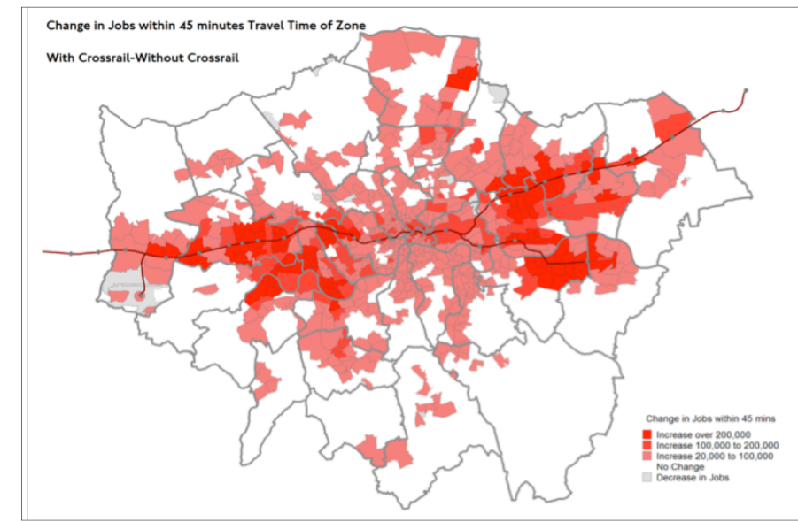
Fig.4 Crossrail Impact on access to jobs (Crossrail Department for Transport , 2010)

We can mention here also the huge environmental impact as an area of success for the Elizabeth Line Project. (Buck, 2017) Another aim of the project was to ensure a minimal disruption to the environment. Trough a concise management, over 99.7% of the excavated materials were reused (Pollalis & Lappas, 2019). As previously stated by Paris in a 2017 report, there is always a high possibility when undertaking a mega project to significantly reduce the air quality through emissions contributed by the emissions of types of machinery used. (Paris, et al., 2017) In this project because of the fact that state of the art technologies and machinery with emission control were used degradation of air was significantly reduced. Trough landscaping and green roofing initiatives, there was no significant loss of biodiversity. So far, the project has stayed on course, recovering over 91% of the biodiversity against 80% recovery the initial target. (Paris, et al., 2017)

3. The Elizabeth Line Crossrail Project-Failures
To be able to manage and so successfully implement a mega project like The Elizabeth line is a hugely complex task. Because of the Project’s complexity some of planned elements that mark the failures or challenges the project faced did not go according to plan. To better understand what go wrong with the Project and what areas could be managed differently or improved on a similar project we will discuss these aspects below.
Delayed completion.
Every project has an assigned time in which it should be completed and for the Elizabeth Line Project, the date it was supposed to be completed was December 2018. However, due to several factors this timeline could not be respected.

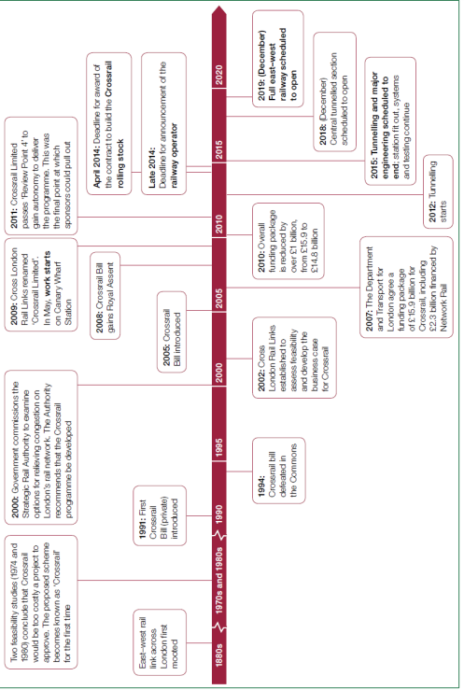
Fig.5 Crossrail timeline, including original opening schedule (Haylen, 2019)
One of the main factors that delayed the completion of the project was the incorporation of signaling systems that will support the functioning of trains. Incorporating these systems with the Crossrail system turned out to be more complicated than initially underestimated. Therefore, the corporation requested anadditional 18 months to fully integrate the signalling systems. (Barsam, et al., 2017). As a result dues to this new request the new completion date should have been mid-2020.
However, the end of 2019 brough in a new challenge, possibly the hardest one that a project of this avenue has ever faced. The beginning of year 2020 brought operations disturbances due to the Covid-19 Pandemic. Due to lockdowns and to all movement ceasing, the construction development was stopped as people were obliged to stay at home. This situation continued throughout the year of 2022 and part of 2021. (Garriban, et al., 2020) Not working within the normal programs due to social distancing brough further delays and the railway was partly put in use in 2022. It is estimated that by mid-2023 all stations of the Elizabeth Line will be fully operational.
Cost was another issue as the project had to be revised and several constraints on significant areas faces challenges. Due to those cost pressures the revised cost of the project was later adjusted to £17.6 billion, and it remains to be seen how much the final cost of the project would be when it is fully operational in 2023.

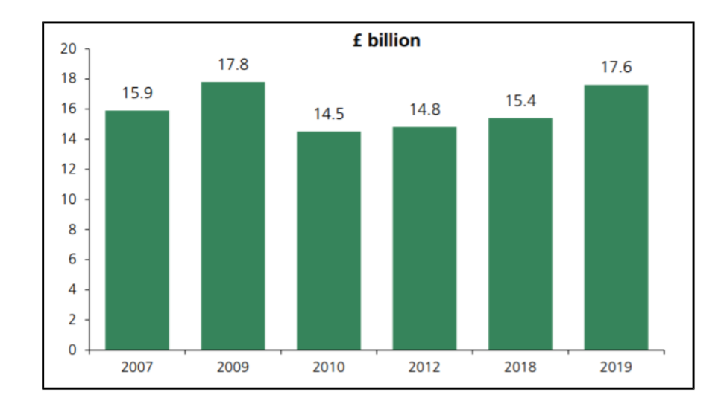
Fig.6 Changes in capital costs for constructing the Crossrail over time (Haylen, 2019)
Apart from these, there are cost issues that came from the delayed completion of the project. Garriban estimated that TfL suffered losses of more than £800 million pe year since 2019 when the project should have been completed. (Garriban, et al., 2020).
According to Masters, 2018, the procurement strategies of Crossrail are based on the New Engineering Contract Option C target-cost contracts wherein sharing risks and benefits incentivise efficiencies and good behaviours . This procurement model was based on the 2012 London Olympics, but we need to consider that it is one-off transactional nature. Taking this into account a long-term integrated procurement relationship could have been more suitable to this type of project. (Masters, 2018)
4. Conclusion
Taking all these factors into consideration it is safe to say that the project has been successful and that, the benefits of the Crossrail are clear, measurable and substantial and that indicates that transport projects designed primarily to relieve congestion of existing infrastructure and support future population and employment growth, generally meet or exceed their original demand forecasts. (Crossrail Department for Transport , 2010)
That success is based and series of various factors among which we can name the collaboration between sponsors and stakeholders and the management of the project and the communication it has with all the teams. Even though there have been several serious delays we must take into account the magnitude of the project, it’s cost, duration and size.
One of the most important and outstanding skills present in this project was the setting of targets and visions. Every deliverable had specific targets – for instance the targets in the environment impact managements. Those targets have been achieved and they set a great example and a lesson learned for future similar projects. (Pollalis & Lappas, 2019).
The success and some failures of megaprojects such as Elizabeth Line can offer us with further insight into how to manage and conduct futures programmes of this magnitude.
One recommendation that can be made for megaprojects is that is it necessary to provide an adequate time for a thorough thinking and analyses for a comprehensive execution strategy before developing a plan of this scale.
When planning the execution strategy, the project lifecycle must be assed so that it can allow time to accommodate changes that evolve along with completing phases of the programme over time.

As seen in Elizabeth Line Crossrail Project it is of a significant importance to set clear visions and values which are followed by decision making processes and behaviours according to those values.
Elizabeth Line Crossrail Project has proved just how important it is that every task follows the previously set values-the huge environmental impact the project obtain will definitely be taken into consideration and closely followed when managing future projects.

Bibliography
Barsam, J. M., Harris, D. & Hooper, A., 2017. Crossrail project: engineering design management on the Elizabeth line, London. Proceedings of the Institution of Civil Engineers-Civil Engineering, 170(5), pp. 15-20.
Bennett, S., 2017. Crossrail project to deliver London’s Elizabeth line: the parliamentary bill process. Proceedings of the Institution of Civil Engineers-Civil Engineering, 170(6), pp. 10-12.
Black, M., 2017. Crossrail project: managing geotechnical risk on London’s Elizabeth line.. Proceedings of the Institution of Civil Engineers-Civil Engineering, 170(5), pp. 23-27.
Buck, M., 2017. Crossrail project: finance, funding and value capture for London’s Elizabeth line. Proceedings of the Institution of Civil Engineers-Civil Engineering, Volume 170, pp. 15-19.
Crossrail Department for Transport , 2010. Crossrail Business Case-Summary Report, London: Crossrail Department for Transport.
Davies , A., MacAuley, s., DeBarro, T. & Thurston, M., 2014. Making innovation happen in a megaproject: London's Crossrail suburban railway system. Project Management , 45(6), pp. 25-35.
de Silva , M. & Paris, R., 2014. Building Crossrail-a holistic approach to sustainability. ICSI 2014: Creating Infrastructure for a Sustainable World, pp. 868-877.
Fraser, D., Haig, J., Heduan, M. & Limna, G., 2017. Crossrail project: logistics management strategy for the Elizabeth line, London. Proceedings of the Institution of Civil Engineers-Civil Engineering, 170(5), pp. 57-61.
Garriban, S. et al., 2020. London at a Crossroads-Back to the Future. [Online]
Available at: https://www.centreforlondon.org/publication/london-at-a-crossroads/
Haylen, A., 2019. Crossrail Elizabeth Line. [Online]
Available at: https://researchbriefings.files.parliament.uk/documents/SN00876/SN00876.pdf
[Accessed 04 January 2023].
Loo, B. P., Bryson, J. R., Song, M. & Harris, C., 2018. Risking multi-billion decisions on underground railways: Land value capture, differential rent and financialization in London and Hong Kong. Tunnelling and Underground Space Technology, Volume 81, pp. 404-410.
Masters, J., 2018. The lessons to learn from Crossrail's delays. [Online]
Available at: https://constructionmanagement.co.uk/lessons-learn-crossrails-delay/
[Accessed 04 January 2023].
Paris, R., Myatt, C. & de Silva, 2017. Crossrail project: environmental management during delivery of London’s Elizabeth line. Proceedings of the Institution of Civil Engineers-Civil Engineering, 170(6), pp. 49-52.
Pollalis, S. N. & Lappas, D., 2019. Crossrail-Elizabeth Line London, UK. pp. 1-16.

