University of Wales Trinity Saint David
School of Engineering
Law and the Workplace
Lauren Lloyd
2315243
Degree Apprenticeship in Logistics and Supply Chain Management
5th June 2025
Ethics and Law (ACMA5015)

Table of Figures
Figure 1: SONY Product Safety Warning (SONY, 2016) 9
Figure 2: Phase 1 Single Use Items Banned (FOR Cardiff Offices,2023) 10
Figure 3: Alternative to Single-Use Plastics (Welsh Goverment, 2023) 11

Table of Contents
1. Explain the process of forming a valid contract. Ensure that you support your answer with case law. [ 25 Marks] 4
2. With particular reference to the case of Black Horse Limited v Andrew Curtis (Bristol CC, 21 February 2024), discuss the extent to which the Consumer Rights Act 2015 is in need of reform to ensure that consumer rights are clear. [25 Marks] 6
3. With particular reference to section 5 and section 7 of the General Product Safety Regulations 2005, discuss the obligations of producers and how they apply to your current workplace. [ 25 Marks] 8
4. Explain ‘’ The Environmental Protection (Single-use Plastic Products) (Wales) Act 2023’’ and its effect on the workplace/supply chain. [25 Marks] 10
5. References 13

Explain the process of forming a valid contract. Ensure that you support your answer with case law. [ 25 Marks]
A key point to distinguish in forming a contract is whether an offer has been made or whether it is an invitation to treat. An offer is made with the intention to enter a legally binding contract if it is accepted, whereas an invitation to treat is an invitation for others to make an offer, and is not legally binding until that offer has been accepted (Bashir, et al., 2020). A key case surrounding invitation to treat is Gibson v Manchester City Council (1979).
An offer can be made to individuals, groups, or to the public which is seen in the case of Carlill v Carbolic Smoke Ball Co (1893). However, the certainty and terms of the offer must be clear to both parties for there to be a valid contract as seen in Scammell v Nephew LTD Ouston (1941). In addition to this, a contract can be either unilateral or bilateral (Suleymanli, 2023). Unilateral is where an offeror promises a benefit to the offeree in exchange for an act as seen in Lefkowitz v Great Minneapolis Surplus Store (1957). Whereas bilateral is where both parties make commitments to each other, as seen in Partridge v Crittenden (1968).
For agreement to happen, acceptance is needed and can be done verbally, written, through conduct, or through the postal rule, where acceptance takes place as soon as the letter is posted as seen in Adam V Lindsell (1818), regardless of if the other party never receives the reply. However, silence is not a form of acceptance as established in FeltHouse v Bindley (1862).
A key point within contracts is consideration, which refers to the exchange of something of value between the parties involved in the contract (Ahmad, 2025). Without consideration, a contract is not legally enforceable as seen in Dunlop Pneumatic Tyres co v Selfridge Co LTD (1915). An exception to this is Implied assumpit, which is where it is normal for people to pay for something so it would be reasonably expected as in Lampleigh V Brathwait (1615). Although consideration does not have to be economically adequate, consideration must be sufficient, highlighted in Chappell and Co v Nestle Co LTD (1960).
Intention is essential to form a contract. To stop people from being liable for things they never intended to be a contract, a business and family/ social intention rule was established (Gulati, 2011). An example of the family rule is in Balfour V Balfour (1919) where an agreement between a husband and wife was not legally enforceable due the familial relations therefore there is no intention to creating a legal relation, unlike in a business situation where the intent is there to create a legal relationship.
When you enter a contract, it is legally binding under nearly all circumstances. The exception to this is a contract is not enforceable if it has been entered into with someone that was under duress, misrepresentation, the contract was illegal, an extreme mistake, or if the party has a lack of capacity (Sainz, 2025). A case relating to lack of capacity is Nash V Inman (1908), where it was established that contracts with minors for non-essential items are unenforceable.
To conclude, there are many aspects to forming a valid contract, such as offer, acceptance, consideration, intent to create legal relations, and capacity.

2. With particular reference to the case of Black Horse Limited v Andrew Curtis (Bristol CC, 21 February 2024), discuss the extent to which the Consumer Rights Act 2015 is in need of reform to ensure that consumer rights are clear. [25 Marks]
The Consumer Rights Act 2015 sets out to protect consumers when buying physical goods, digital content and services to ensure that items businesses are selling are of satisfactory quality, are as described and are fit for purpose (Which?, 2024). But are the rights set out in the act truly clear for consumers?
In the case of Black Horse Limited v Andrew Curtis, 2024, Curtis continued to use a vehicle after he had rejected it while waiting for Black Horse to collect it. However, the company did not attempt to collect the car as there was no collection time agreed. This brings up the question of whether the Consumer Rights Act 2015 is clear as Curtis’s understanding of the law differed from what was upheld in court.
It would be a benefit to both consumers and businesses if the Consumer Rights Act was clarified further, specifically in relation to the language used in the act. When laws are written in a way that is easy to understand, and make use of current societal language, the understanding of what the act is portraying is increased (Legal Creatives, 2024). Furthermore, even lawyers frequently complain about contracts that are written in an overly complex manner and to prefer to read the explanatory notes accompanying the act, rather than the legislative text itself (Office of the Parliamentary Council, 2013). This shows how beneficial it could be if the Consumer Rights Act 2015 was reformed to use more simplified and current language, and a study showing the impact replacing complex words in contracts to their simpler alternative has showed boosted understanding and positive reactions (Justo & Recario, 2024). In opposition to this, amending the act so that it explains points more thoroughly could also be a downside as the act could become too oversimplified, which can create gaps in understanding (Lissack, 2026). This could mean that law that previously covered certain scenarios will be changed, resulting in exclusions, blind spots, and laws having to be updated regularly to cover more scenarios. An example of this is the Divorce Reform Act 1969, where for couples to go through divorce proceedings, they had to prove that their marriage was ‘irretrievably broken down’ - this was later reformed through the Divorce, Dissolution and Seperation Act 2020, as that phrase didn’t fully account for the complexities of reasoning behind why marriages can end (UK Government, 2022).
On the other hand, if the Consumer Rights Act was reformed, it could enable businesses to understand the law easier, therefore they would be able to comply with the legislation better. In addition to this, it would also ensure that consumers were clearer on what their rights are. For example, if it was explicitly and clearly stated in the legislation that if a date has not been agreed, there cannot be a failure to collect, it could have changed the outcome of Black Horse Limited v Andrew Curtis (2024) and other similar cases as the law would have been easy to understand.
In conclusion, the Consumer Rights Act 2015 could benefit both businesses and consumers if the language used and explanations were simplified. However, the right balance between more clarification and too much clarification needs to be found to ensure that it is not amended to the point of oversimplification.

3. With particular reference to section 5 and section 7 of the General Product Safety Regulations 2005, discuss the obligations of producers and how they apply to your current workplace. [ 25 Marks]
The General Product Safety Regulations 2005 ensures that consumer goods that are supplied into and within Great Britain are safe for use and puts the obligations onto producers to ensure that their products are safe. The act applies to products intended for use, and products that under reasonably foreseeable circumstances could be used by consumers (Office for Product Safety & Standards, 2024).
Section 5 of the act sets out that producers are not allowed to place an unsafe product on the market. Producers also shall not agree to supply, expose, or posses a product that is not safe (The National Archives, 2005). This applies to Sony as it places the responsibility onto Sony to ensure all products supplied are in a safe manner. This is checked at various points throughout the production process, notably through regular inspection points such as incoming parts quality inspection to ensure no faulty parts are used throughout the process, and also finished goods inspection, where the finished unit is checked by an experienced technician team to ensure the product is working and complies with all safety regulations. Sony also carefully considers the reliability and safety of the suppliers in use for all parts, but especially product safety critical items such as batteries. They do this through conducting rigorous and regular checks with suppliers, and only continuing work with suppliers that meet the regulatory requirements (SONY, 2024).
Section 7 puts further obligations onto the producers to provide consumers with information to enable them to assess and take precautions against any risks inherent in a product where such risks are not obvious without warnings. The producer must be informed of the risks that the product may possess and take appropriate action to avoid such risks. However, the presence of warnings does not exempt the producer from complying with other requirements of the regulations (The National Archives, 2005). Section 7 applies to Sony through requiring Sony to provide adequate information on the product and any risks that it may involve. This is evident in Sony products through instructions on how to use properly, and a list of cautions and warnings that come with every product, an example is seen in Figure 1.
Figure 1: SONY Product Safety Warning (SONY, 2016)
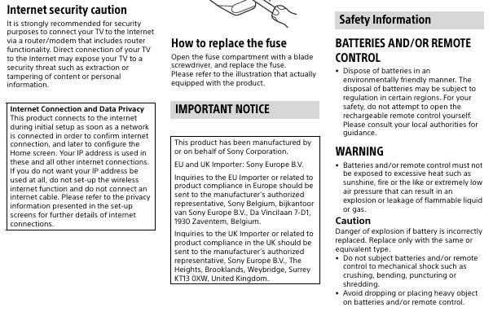
Traceability within Sony is also heavily linked to section 7 of the General Product Safety Act 2005, as each product produced is traceable through batch numbers. This enables Sony to comply with the act as if there is ever any need for recalling the products they can do so in a more controlled and visible manner. A time Sony had to use this was in 2016 where they had to recall computers due to a risk of batteries overheating due to a manufacturing issue – they were able to track affected units through serial numbers and communicate to consumers (SONY, 2016).
In addition to this, the section 7 has placed a legal responsibility onto Sony to ensure that products and machinery used within the workplace is safe and are not a risk to both employees, and any other visitors onsite.
To summarise, the General Product Safety Regulations 2005 has increased the obligations on producers to ensure only safe products are traded on the market and ensure consumers are provided with information on any risks the product may have.

4. Explain ‘’ The Environmental Protection (Single-use Plastic Products) (Wales) Act 2023’’ and its effect on the workplace/supply chain. [25 Marks]
The Environmental Protection (Single Use Plastics) Act 2023 places criminal responsibility onto business and organisations to stop the supply of certain single use plastics within Wales (Welsh Government, 2023). This is to reduce the reliance in Wales of single use plastics, as well as reducing the environmental impact. The impact single use plastics can have on the environment is devastating, with around 40% of single use plastics ending up in landfills, increasing pollution (Chen, et al., 2021). One of the aims of this act is to change this and move to a circular economy operation within Wales.
There are two phases to this act, the first phase began in October 2023 and banned certain single use products as seen in Figure 2 (FOR Cardiff Offices, 2023). However, there are exemptions to this such as straws can be supplied to those who declare they need one for health or disability reasons and it does not apply for business-to-business transactions.
Figure 2: Phase 1 Single Use Items Banned (FOR Cardiff Offices,2023)
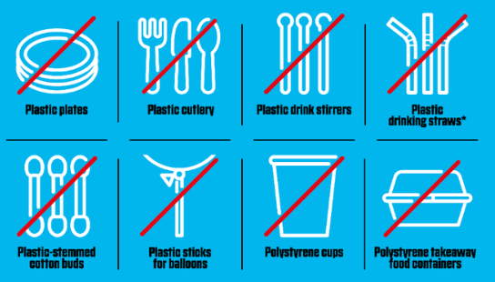
The second phase of the Act is aimed to be introduced in Spring 2026, and will further the restrictions to include carrier bags, polystyrene lids for cups and takeaway food containers, and oxo-degradable plastic products (Welsh Government, 2023). Similar, to the first phase of the act, there are some exemptions to this.
This Act has already had an impact on business within Sony, for example the cups previously supplied for use by the water fountains in the production hall were previously polystyrene. However, from October 2023 this has changed to now supplying paper cups, with a poster next to all water fountains to encourage people to bring their own re-usable water bottles to work and only use the paper cups as a last resort. In addition to this, the canteen in Sony now uses metal cutlery for dine in users which will then be washed and re-used, with the option of wooden cutlery for a take-out alternative, so no longer use plastic cutlery within Sony.
This act will impact supply chains within businesses as in preparation for phase two, businesses must consider implementing alternative products to ensure the stock levels of the items that are being banned are reduced so that when the ban comes in, they don’t have excess products that they cannot use. Though, if businesses do have excess stock, guidance encourages the business to speak to suppliers, the local council or trade association about recycling guidance. An example of alternative products businesses can look to implement is in Figure 2 (Welsh Government, 2023).
Figure 3: Alternative to Single-Use Plastics (Welsh Goverment, 2023)
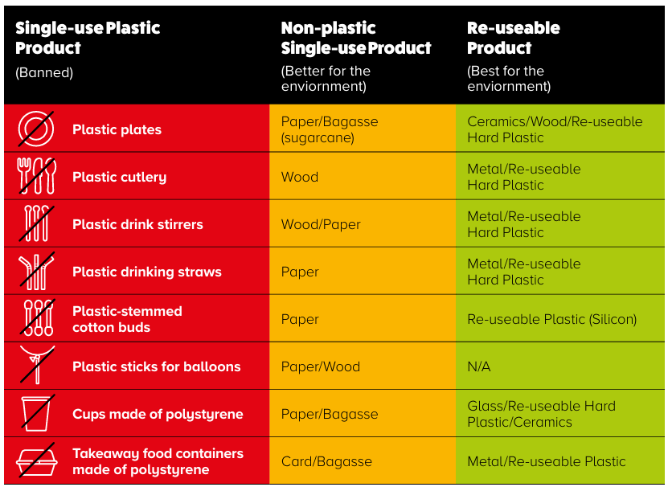
In addition to this, businesses outside of Wales must conduct research on the location of the consumers that they are supplying to, as if they supply single use plastics to consumers within Wales, that is a criminal offence.
To conclude, the Environmental Protection (Single-use Plastic Products) (Wales) Act 2023 has two phases, each aimed to stop the supply of various single use plastics into and within Wales, with the aim to encourage businesses to have a more circular economy and move away from the current throw away culture and will impact businesses and organisations who will have to substitute products in use for a more reusable alternative or could face criminal liability.

5. References
Adams V Lindsell 1 B & Ald 681 (1818).
Ahmad, H., 2025. What is Consideration in Contract Law in the UK?. [Online]
Available at: https://legalvision.co.uk/commercial-contracts/consideration-contracts/
[Accessed 28 May 2025].
Balfour V Balfour 2KB 571 (1919).
Bashir, S., Khan, F. S. & Khan, A. S., 2020. Invitation to Treat In Law Of Contract. International Review of Social Sciences, 8(7).
Carlill V Carbolic Smoke Ball Co 1 QB 256 (1893).
Chappell and Co v Nestle Co LTD AC 87 (1960).
Chen, Y., Kumar Awasthi, A. W. F., Tan, Q. & Li, J., 2021. Single-use plastics: Production, usage, disposal, and adverse impacts. Science of the Total Environment, Volume 752.
Divorce Reform Act c, 55 (1969).
Divorce, Dissolution and Seperation Act 2020 c.11 (2020).
Dunlop Pneumatic Tyre Co LTD v New Garage & Motor Co LTD UKHL 1, AC 79 (1915).
Felthouse V Bindley EWHC CP J35; 142 ER 1037 (1862).
FOR Cardiff Offices, 2023. Single-use plastic ban in Wales from 30th October. [Online]
Available at: https://www.forcardiff.com/sustainability-hub/single-use-plastic-ban-in-wales-from-30th-october/#:~:text=This%20law%20will%20ban%20the%20sale%20or%20supply,existing%20stock%20and%20to%20buy%20or%20make%20alternatives.
[Accessed 30 May 2025].
Gibson V Manchester City Council (1979) UKHL 6 (1979).
Gulati, B., 2011. 'Intention to Create Legal Relations'. A Contractual Necessity or An Illsory Concept. Beijing Law Review.
Justo, J. M. & Recario, R. N. C., 2024. Text Simplification System for Legal Contract Review. Advances in Information and Communication, pp. 105-123.
Lampleigh v Brathwait EWHC KB J17 (1615).
Lefkowitz v Great Minneapolis Surplus Store 86 N.W.2d 689, 251 Minn. 188 (1957).
Legal Creatives, 2024. Rethinking Legalese. [Online]
Available at: https://www.legalcreatives.com/blog/rethinking-legalese-why-complex-language-doesn-t-mean-better-law
[Accessed 29 May 2025].
Lissack, M., 2026. Don't Be Addicted: The Oft-Overlooked Dangers of Simplification. The Journal of Design, Economics, and Innovation, 2(1), pp. 29-45.
Martínez, E., Mollica, F. & Gibson, E., 2023. Even lawyers do not like legalese. Proceedings of the National Academy of Sciences.
Nash V Inman 2 KB 1 (1908).
Office for Product Safety & Standards, 2024. General Product Safety Regulations 2005. [Online]
Available at: https://www.gov.uk/government/publications/general-product-safety-regulations-2005/general-product-safety-regulations-2005-great-britain#obligations-of-producers-and-distributors
[Accessed 29 May 2025].
Office of the Parliamentary Council, 2013. When Laws Become Too Complex, s.l.: Cabinet Office.
Partridge v Crittenden 1 WLR 1204 (1968).
Sainz, B., 2025. Lack of Capacity in Contract Law. [Online]
[Accessed 5 June 2025].
Scammell v Nephew LTD Ouston 1 AC 251 (1941).
SONY, 2016. Important notification about battery pack VGP-BPS26 in VAIO Personal Computers. [Online]
Available at: https://www.sony.com/electronics/support/serial-number-checker/17
[Accessed 1 June 2025].
SONY, 2024. Sustainability Report, s.l.: Sony.
Suleymanli, O., 2023. Basic Terms for Conclusion and Entry into Force of Contracts. SCIENTIFIC WORK International scientific journal, 17(4), pp. 81-87.
The National Archives, 2005. The General Product Safety Regulations 2005. [Online]
Available at: https://www.legislation.gov.uk/uksi/2005/1803/contents
[Accessed 1 June 2025].
UK Government, 2022. 'Blame Game' ends as no fault divorce comes into force. [Online]
[Accessed 5 June 2025].
Welsh Government, 2023. Statutory guidance for bans and restrictions on single-use plastic in Wales. [Online]
Available at: https://www.gov.wales/sites/default/files/publications/2023-11/single-use-plastic-statutory-guidance.pdf
[Accessed 4 June 2025].
Welsh Government, 2023. The Environmental Protection (Single-use Plastic Products) (Wales) Act 2023. [Online]
Available at: https://www.gov.wales/environmental-protection-single-use-plastic-products-wales-act#:~:text=The%20Environmental%20Protection%20%28Single-use%20Plastic%20Products%29%20%28Wales%29%20Act,to%20consumers%20in%20Wales%2C%20unless%20an%20exemption%20applies.
[Accessed 1 June 2025].
Which?, 2024. Consumer Rights Act 2015. [Online]
Available at: https://www.which.co.uk/consumer-rights/regulation/consumer-rights-act-aKJYx8n5KiSl
[Accessed 25 May 25].

