PRODUCTS | WEEKLY SALES
 | MONDAY | TUESDAY | WEDNESDAY | THURSDAY | FRIDAY | SATURDAY | SUNDAY
LATTE | 6 | 7 | 5 | 9 | 8 | 5 | 2
CAPUCCINO | 5 | 6 | 6 | 8 | 7 | 4 | 2
AMERICANO | 4 | 3 | 6 | 5 | 5 | 3 | 2
TEA | 5 | 4 | 6 | 7 | 6 | 3 | 2
HOT CHOCOLATE | 3 | 2 | 2 | 4 | 3 | 2 | 3

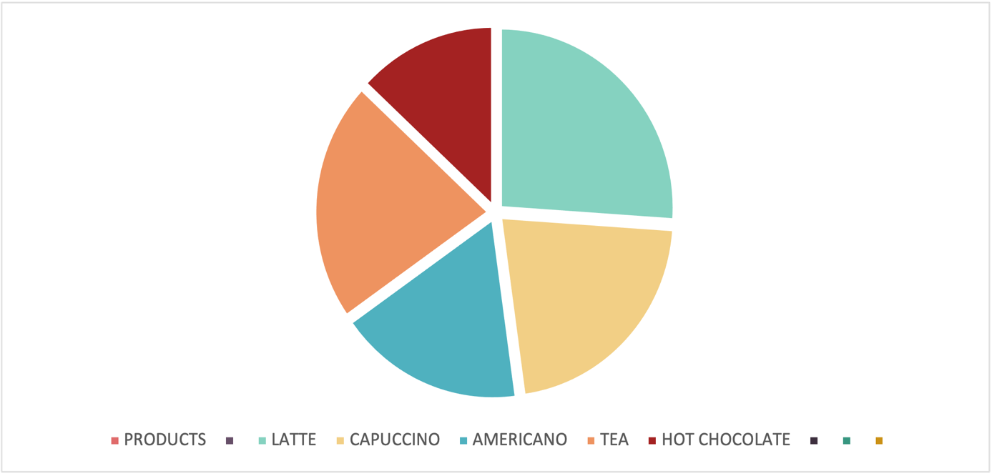
In this task of week 2, we must choose a scenario to create a task for week 2, I choose the coffee shop, because you. need to create a table chart to show which coffee is with high and lower sales. Searching tools which more fit to create this task, I choose Microsoft Excel, because it's the perfect tool to help you creating the table chart as it's giving you all the necessary tools to choose which table chart you need to use. However, I developed creating table chart using the perfect tools and platform and I can use this skills in my future job or business.

