Silverstone cancellation: Sunday’s order of events

motogp.com give you a chronological rundown that led to the cancellation of the British GP

For the first time since 1980 at the Salzburgring, MotoGP™ organisers were forced to cancel a Grand Prix after heavy rain fall left the newly surfaced Silverstone circuit unfit to race on. But what happened throughout the day until a final decision was reached?

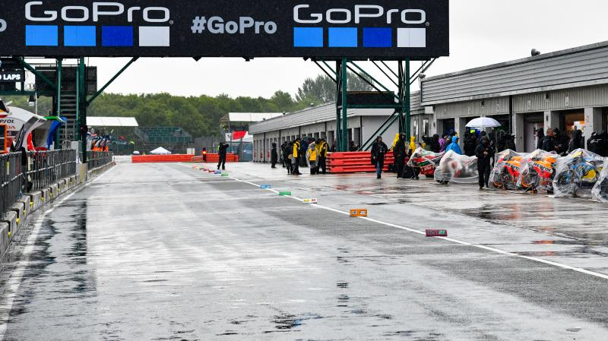
GoPro British Grand Prix is cancelled 26/08/2018
After a long day of rain on asphalt that refused to drain, Race Direction took the difficult decision to cancel the race at Silverstone
09:20
Maverick Viñales (Movistar Yamaha MotoGP) goes quickest in a dry morning Warm Up, shortly before the rain started to fall at Silverstone

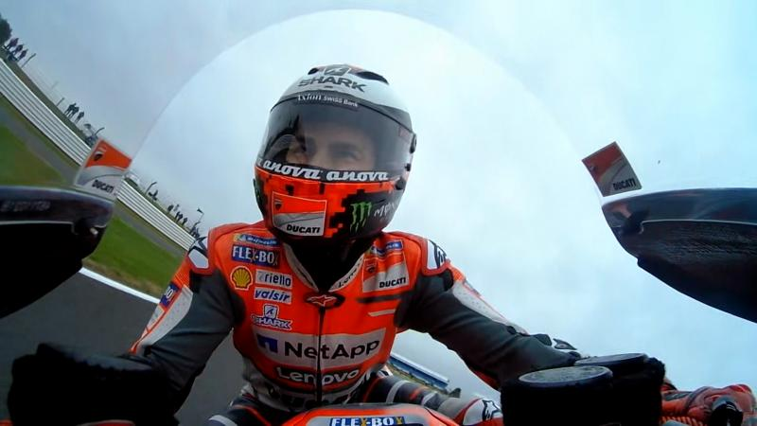
British GP: MotoGP™ Warm Up 26/08/2018
The full Warm Up session for the MotoGP™ grid as they prepare to go racing for round 12 of the World Championship
11:20
Revised start time of 11:30 delayed due to poor track conditions, with the MotoGP™ riders heading off the grid after completing a couple of sighting laps.
12:00
A meeting between IRTA officials, MotoGP™ teams and Dorna to take place at 12:30 local time.
12:30
After discussions, confirmation that racing on Monday will not be an option.
13:15
Race Direction confirm they will check the track conditions. If safe, pit lane will open at 13:40 for 10 minutes, before a potential race start at 14:00.
13:30
Race start delayed until further notice.
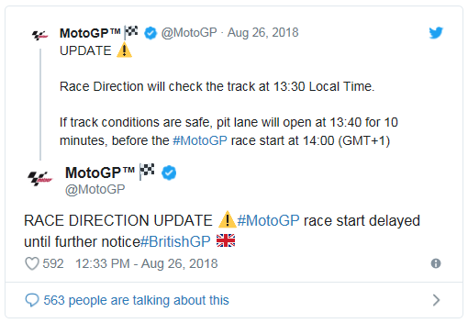
13:50
Race Direction to check the track again at 15:00, subject to weather forecast, with a 16:00 race start for MotoGP™.
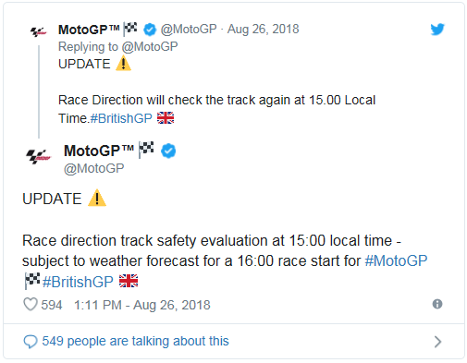

15:10
If rain has stopped by the latest 16.00 local time, all three races will go ahead starting with MotoGP™, with races being completed by 19.30.
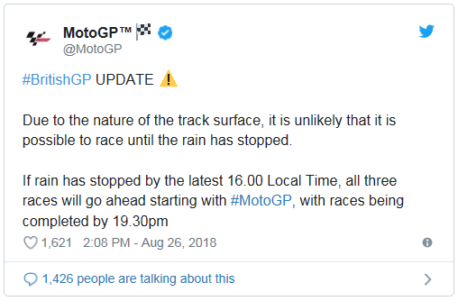
15:20
Pending a track inspection, pit lane will open at 16:30 for a 16:50 race start.
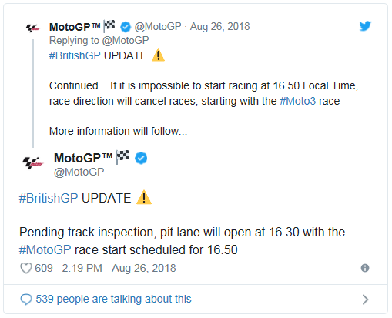
16:00
British GP cancelled.
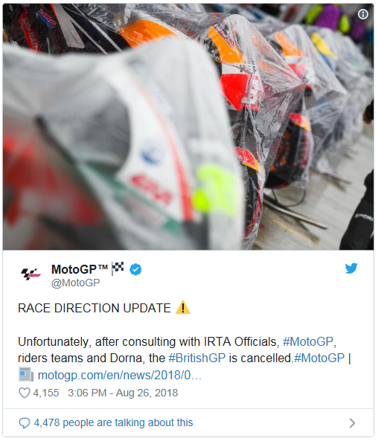

Silverstone surface to blame for British GP cancellation

Mike Webb, Loris Capirossi and Fanco Uncini held a Press Conference to discuss the reasons behind the decision
After lengthy delays, the decision was finally made to cancel the 2018 GoPro British Grand Prix at Silverstone with the heavy rain failing to drain from the track surface, with the premier class riders and Race Direction deeming it unsafe for any races to take place on Sunday.
“It was obvious the track conditions weren’t safe. After a consultation with the riders we delayed the start to see if conditions would improve,” said Race Director Mike Webb. “We have reached the point where even though the rain is getting less, the circuit is still not in a condition where we can safely run races. So, we’ve taken the very difficult and regrettable decision to cancel.”

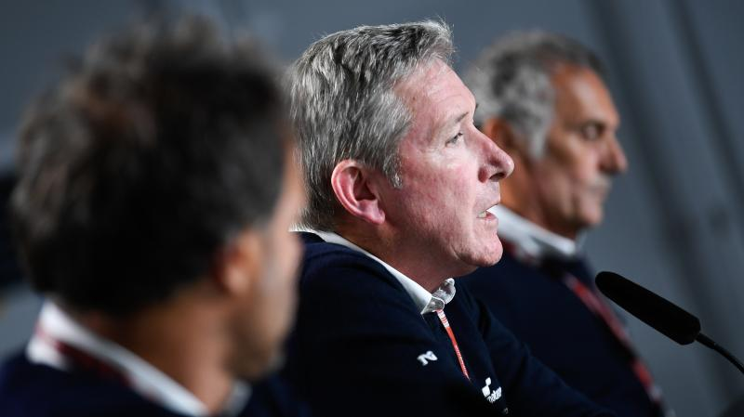
Mike Webb explains the problems at Silverstone 26/08/2018
The MotoGP™ Race Director, along with Loris Capirossi and Franco Uncini explain the reasons for cancelling the races
Webb continued, saying the decision is directly down the track surface, having raced in similar Silverstone conditions before in recent years: “We’ve had a number of years here in very wet conditions recently with the old surface and been able to run races. This year, with the new surface, it’s the first time we’ve encountered quite so much standing water in critical places on the track,” he explained. “Yes, it’s a direct result of the track surface, I must say from the circuit point of view, the staff have done an unbelievable effort over the whole weekend, not just today, but an enormous effort to make the track safe. Until the last minute that was still working but unfortunately, we couldn’t battle nature.”
Webb was then asked what discussions will be taking place with Silverstone in order to stop this from happening again, with the question raised as to whether Silverstone can host a MotoGP™ race if this is to happen in the future: “We obviously want to have a British GP, the climate of the area means we’ve got to expect rain and the surface has to be able to handle it. They’ve done an enormous job over this weekend to try and improve things, which they have, but the nature of the surface means we’ve reached this point.”
Grand Prix Safety Officer Franco Uncini shed some more light on the situation, revealing Silverstone are looking for an investigation to take place to reveal the exact cause of the issues faced this weekend: “We had a discussion yesterday (Saturday) about the improvement of the asphalt. They are looking for an investigation that will take around six weeks, to let us know what really was the problem. We will wait to see the outcome… but for sure they will need a new asphalt.”
Uncini continues, saying when he originally came to view the new asphalt, it was in very good condition. So when did the surface deteriorate? “It was confirmed by Cal Crutchlow, who did a test on a bike one month later, he said it was perfect. But then, we discovered during the Formula One that the circuit was bumpy. So, it was a degrade from March to July. That was the situation of the tarmac, I don’t know what happened, they (Silverstone) will make a deep study.”

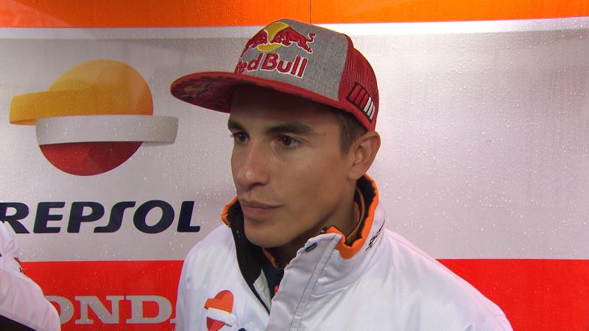
Marquez: "We wanted to race but safety comes first" 26/08/2018
After the race was cancelled we spoke to the Championship leader to get his feelings after long but race-less day at Silverstone
MotoGP™ Safety Advisor Loris Capirossi explained how the riders came to the decision in a meeting with IRTA: “We did a meeting today to understand the idea of the riders and they saw already that when we tried to start the race the first time, they said the standing water on the track is a lot everywhere.
“This is why we postponed the race. Me and Franco made a lot of checks every half an hour to see if the situation was better but always, even with very little rain, didn’t improve. This is why we spoke with the riders and they said for sure it isn’t the right time to do the race today, the track conditions were really dangerous, especially for aquaplaning… this is why we decide all together, but especially the riders, the surface problem (was too much) and we decided to not race.”
In the light of some riders apparently not turning up to the meeting, Capirossi added: “We were missing a couple of riders, the decision was nearly unanimous from the riders to say the conditions were unsafe to do the race. Sure, we say to everybody to come, a couple of riders don’t come but their decisions don’t come… we listened to all the riders there.”
(motoGP.com, 2019)

Official Statement: Cancellation of GoPro British MotoGP™ Grand Prix at Silverstone
26 Aug 2018

Statement from Silverstone Managing Director Stuart Pringle regarding the cancellation of today’s GoPro British MotoGP™ Grand Prix at Silverstone
“Firstly and most importantly I would like to apologise to all of the race fans for the most trying and foulest of days at Silverstone. I am truly sorry this has happened. If I had known fans would have to wait for six hours in these conditions with this outcome, I would have taken the decision to cancel the event at midday.
“We were willing to cancel the meeting much earlier but I was assured by Dorna that the teams were willing to race if conditions improved.
“I’m very conscious of the amount of money people have spent on this event. We will be contacting all customers next week to explain what we are doing about the cancellation of this event.
“Nobody is more disappointed by the outcome of today than me and the incredibly hard-working team at Silverstone, who have done everything in their power to try and ensure the race could happen.
“It was not our decision to cancel the racing. This was a sporting matter not under Silverstone control and was a decision made by the riders and Dorna, along with the Safety Commission and Race Direction.
“A plan was made at midday today in consultation with Dorna and Race Direction. We looked closely at the weather predictions provided by the Met Office with whom we were in regular contact all afternoon. The further delay this afternoon was due to the forecast of the rain subsiding, however the final decision was made without our knowledge or input. We kept the decision to race open in good faith, however this was taken out of our hands.
“All the work we have done here to make Silverstone a better place for motorcycle racing has been done with the best of intentions. We will be making further investigations into this matter immediately after the Bank Holiday to understand whether our newly resurfaced track played a part in today’s inability to stage races.
“We will be reviewing all the data we have on the track and gathering more, and together with the contractor, Aggregate Industries, a full investigation will be carried out.
“Once again my sincere personal apologies for today’s events. Can I also extend my thanks and gratitude to all of the marshals, medics, security, catering, track and everyone else working on the event this weekend for their extremely hard work and dedication in trying to keep this event open.”
(Silverstone.co.uk, 2019)

