

Active Aero Wing for the Tesla

Group Design Project (ACHA5014)

Callum Clement (2400570)
Mikel Olaberria (2416696)
Oscar Davis (2410215)

Table of Contents
Introduction 4
Aerodynamic Simulation – Mikel Olaberria (2416696): 5
Aerofoil Research: 5
Aerofoil Sim: 6
Initial wing testing results: 12
Conclusion to testing: 12
Full Scale wing simulation: 13
Car Model Simulation: 15
Lap Time Simulation: 17
Simulation Conclusion: 18
Simulation limitations: 18
Mechatronics and Control Systems – Callum Clement (2400570) 20
Component Selection 20
Creating the RC Filter 22
0.1µF 50V Capacitor 23
2.2µF 50V Capacitor 24
33µF Capacitor 25
Simulink Code Basic Input 26
Simulink Code 1 Data Input 26
Simulink Code 3 Data Inputs 27
Simulink Code 3 Data Inputs Advanced 28
Simulink Code 3 Inputs Adjusted 29
Simulink Code Final 30
Mechatronics 31
If I was to take this further 32
Mount Design – Oscar Davis (2410215) 47
Introduction: 47
Mount Material: 47
Mount Design 1: 47
Mount Design 2: 49
Initial Testing 50
Further testing and improvements 52
Final Mount Testing 57
Final Designs 59
Final Wing Design 61
Fixtures: 62
Part List: 62
Conclusion 64
References: 65

Introduction:
The group project consists of making an active-aero wing which will react and change its angle depending on the data which is given to it. The group members will each be given different jobs to complete to make sure the project comes together. This includes, programming, designing, control systems, research, vehicle simulation and final specs. The wing will work by using an Arduino, which the group will programmed in MATLAB Simulink to change the angle of the wing depending on the value of the data inputted. By creating a model, aerodynamic tests can be done on it using a wind tunnel and SolidWorks simulations. These tests will allow the group to calculate the effects of the wing such as downforce and drag. The group work has been assigned as such:

Team leader: Mikel
Simulation: Mikel
Control Systems: Callum
Algorithm Selection: Callum
Mount and Materials: Oscar
Final Specifications: Group

Aerodynamic Simulation:
The aim of the simulation was to gather and compare data of aerodynamic performance from a number of different wings and configurations, which would be used for an active-aero wing. The simulation was used to calculate values such as drag, downforce, lift and lap time comparisons depending on wing configuration. For the simulation, I used SolidWorks Computational Fluid Dynamics (Dassault Systèmes, 2024) to measure and compare drag and downforce for multiple wing designs at varying angles. This data was then used in Optimum lap, which allowed for visualisation of the changes aerodynamic forces would have on the Lap times around Brands Hatch circuit. The wing designs were modelled in SolidWorks making small scale models for early testing, before making a full scale model for the chosen design, and testing it with a full scale tesla model to as accurately measure the aerodynamic effects.
When setting up the SolidWorks CFD (Dassault Systèmes, 2024), it was important that the baseline parameters for the tests where equal for every wing allowing for a fair comparison. Therefore, the CFD parameters used were 60mph inlet speed and an air density of 1.225 kg/m^3. These parameters were kept constants for all aerodynamic testing. By doing this simulation and testing, I aim to build an understanding to the effect of aerodynamic drag and downforce on performance, allowing me to make accurate decision for a final group wing design.

Aerofoil Research:
For the wing profile, three NACA aerofoils were chosen for initial testing using CFD. The chosen wing profiles include the NACA 6412 (Korf, 2023), NACA Eppler 420 (Korf, 2023) and the NACA MSHB (Korf, 2023).
NACA 6412:
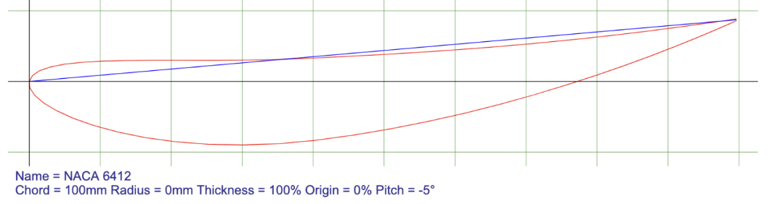
Figure 5.1
NACA Eppler 420:
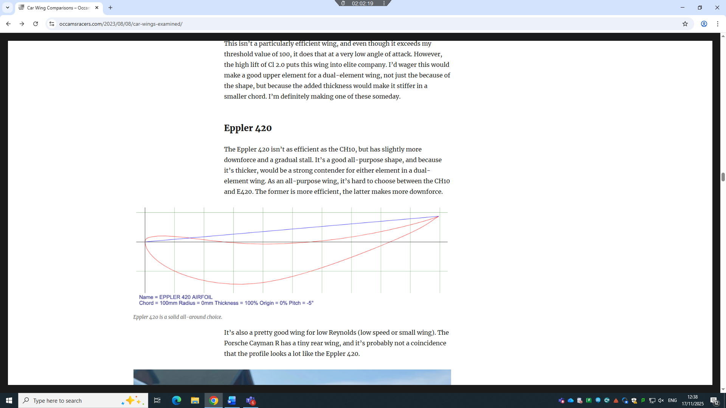
Figure 5.2
NACA MSHB:
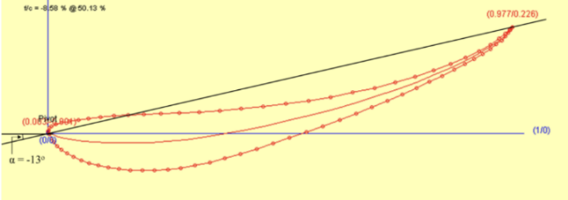
Figure 5.3
The NACA 6412 was chosen for it balance between drag and downforce and has also been used as a wing in other motorsport applications. The NACA Eppler 420, was chosen for its medium downforce properties. The NACA MSHB was chosen for its high downforce, which was higher than both previous wings.

Aerofoil Sim:
NACA 6412:
0 degree wing testing:
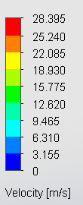
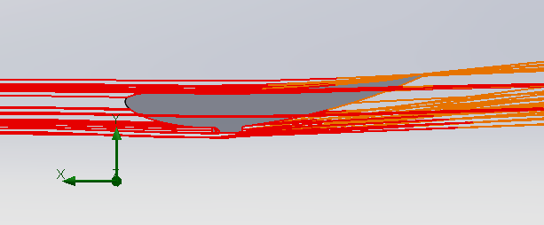
Figure 6.1
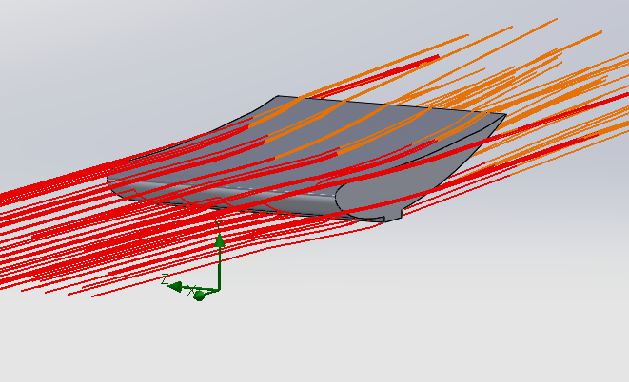
Figure 6.2
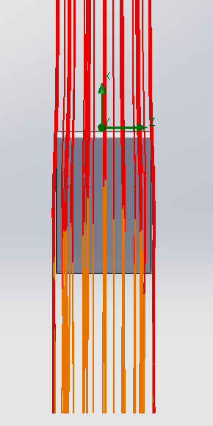
Figure 6.3

CFD Force Results:
The CFD simulation of the NACA 6412 at 0 degrees recorded a drag force of -0.098 N and a downforce of -0.497 N. These results show that at this angle the wing produces low downforce for minimal drag, which is the expected results of the wing in a 0 degree flat configuration.

NACA 6412:
45 degree wing testing:
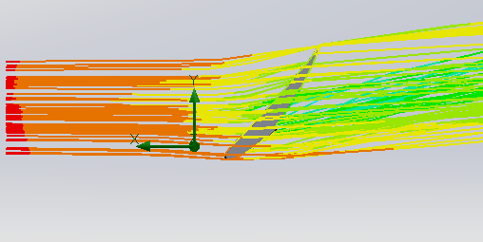
Figure 7.1
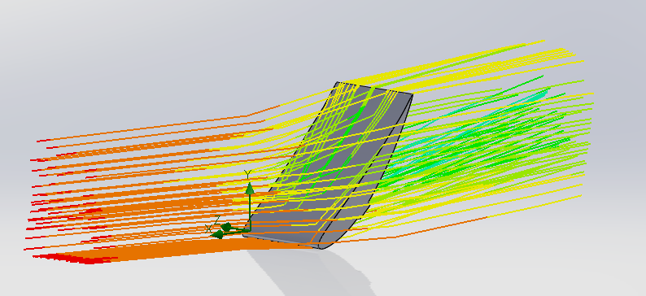
Figure 7.2
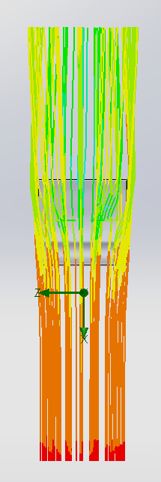
Figure 7.3

CFD Force Results:
The CFD simulation of the NACA 6412 at 45 degrees recorded a drag force of – 1.229N and a downforce of – 1.167N. These results show that at this angle the wing produces moderate downforce for high drag, which is the expected results of the wing in a 45 degree raised configuration.

NACA Eppler 420:
0 degree wing testing:

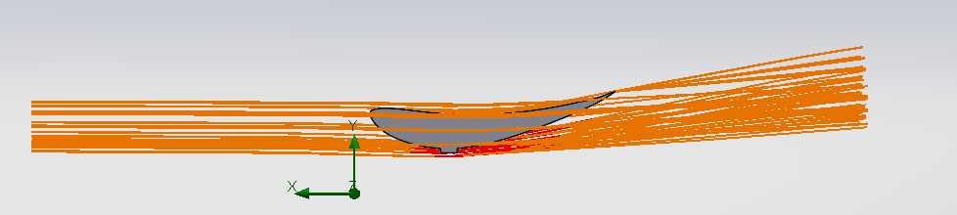
Figure 8.1
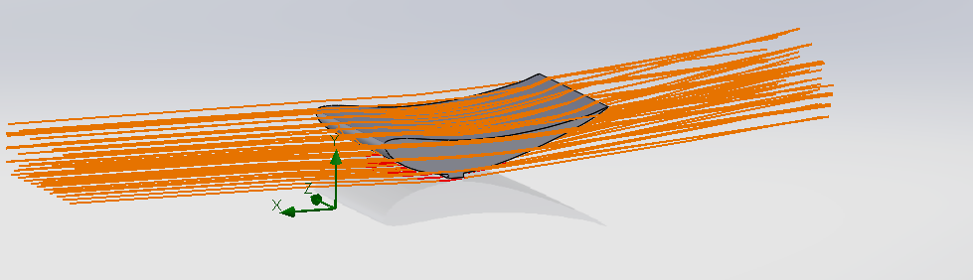
Figure 8.2
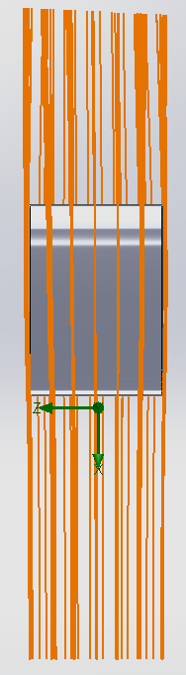
Figure 8.3

CFD Force Results:
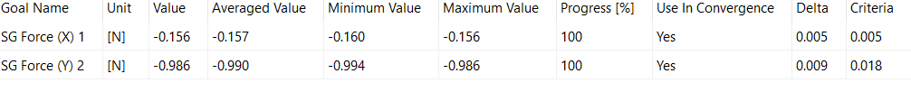
The CFD simulation of the NACA Eppler 420 at 0 degrees recorded a drag force of – 0.159N and a downforce of – 0.986N. These results show that at this angle the wing produces moderate downforce for low drag, which is the expected results of the wing in a 0 degree flat configuration.

NACA Eppler 420:
45 degree wing testing:

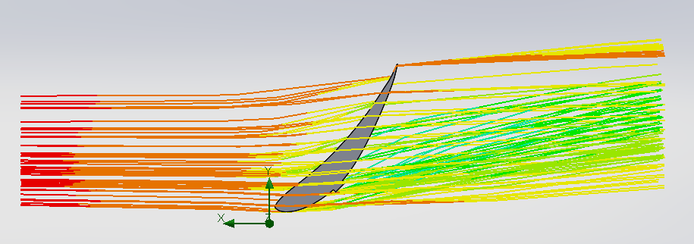
Figure 9.1
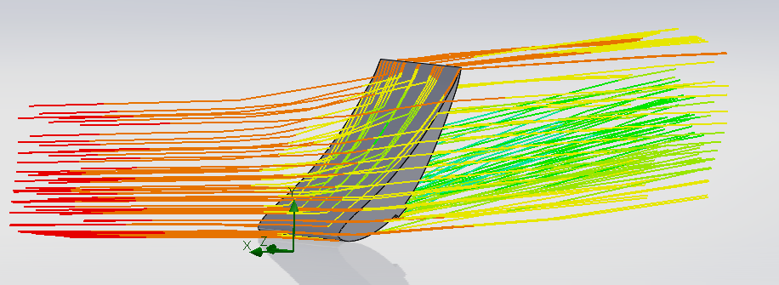
Figure 9.2
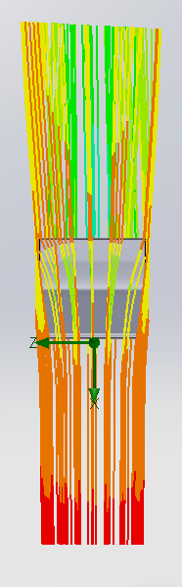
Figure 9.3

CFD Force Results:
The CFD simulation of the NACA Eppler 420 at 45 degrees recorded a drag force of – 1.167N and a downforce of – 1.181N. These results show that at this angle the wing produces almost even downforce to drag, which is unexpected results as downforce was much greater than drag at a 0 degree test.
NACA MSHB:
0 degree wing testing:

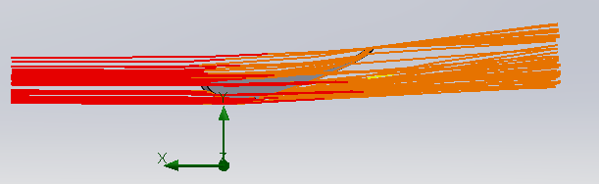
Figure 10.1
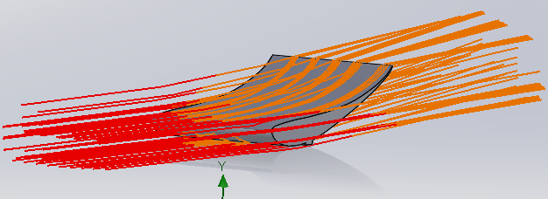
Figure 10.2
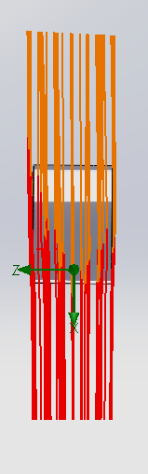
Figure 10.3

CFD Force Results:
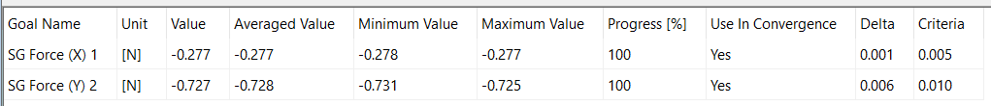
The CFD simulation of the NACA MSHD at 0 degrees recorded a drag force of – 0.277N and a downforce of – 0.727N. These results show that at this angle the wing produces high downforce to low drag, which is an expected results for a wing at 0 degrees.

NACA MSHB:
45 degree wing testing:

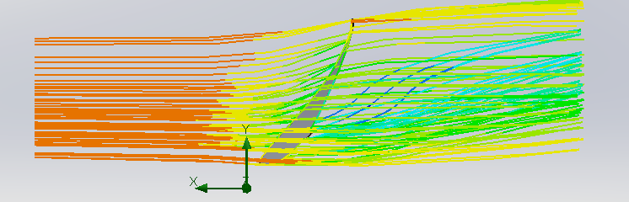
Figure 11.1
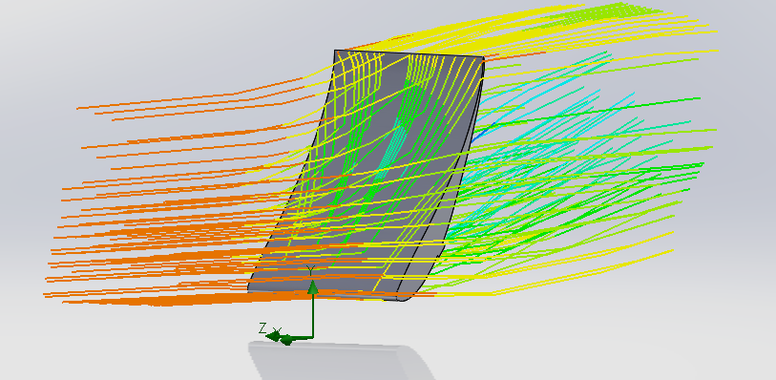
Figure 11.2
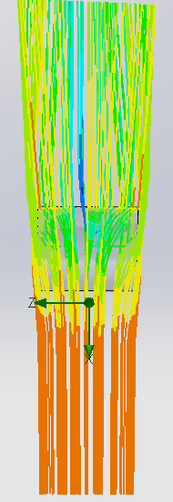
Figure 11.3

CFD Force Results:
The CFD simulation of the NACA MSHD at 45 degrees recorded a drag force of – 1.643N and a downforce of – 1.251N. These results show that at this angle the wing produces higher drag than downforce, which is an unexpected and unwanted properties.

Initial wing testing results:

Wing Profile | Drag at 0° (N) | Downforce at 0° (N) | D/DF Ratio at 0° | Drag at 45° (N) | Downforce at 45° (N) | D/DF Ratio at 45° | Final Ration
NACA 6412 | 0.098 | 0.497 | 1:5.07 | 1.229 | 1.167 | 1:0.95 | 1:2.72
NACA Eppler | 0.156 | 0.986 | 1:6.32 | 1.167 | 1.181 | 1:1.01 | 1:3.98
NACA MSHD | 0.277 | 0.727 | 1:2.63 | 1.643 | 1.251 | 1:0.76 | 1:1.91

Figure 12.1

Conclusion to testing:
To find the best wing profile three were tested, the NACA 6412, NACA Eppler and NACA MSHD. Each wing was tested at 0 degrees which represents normal driving and 45 degrees which represents heavy braking. The drag and downforce of each wing was recorded and compared.
The NACA 6412 at 0 degrees produced 0.497 N of downforce and 0.098 N of drag. Although the drag is the lowest of the three it also produced the least downforce. At 45 degrees it produced 1.167 N of downforce and 1.229 N of drag which is an acceptable result but not the best.
The NACA MSHD at 0 degrees produced 0.727 N of downforce and 0.277 N of drag which is better than the 6412 but not as good as the Eppler. At 45 degrees it produced the highest drag of all three at 1.643 N but only 1.251 N of downforce meaning the drag was higher than the downforce which is not what you want during braking.
The NACA Eppler gave the best results out of the three. At 0 degrees it produced 0.986 N of downforce and 0.156 N of drag which is almost double the downforce of the 6412 with only a small increase in drag. At 45 degrees it produced 1.181 N of downforce and 1.167 N of drag which are very similar to each other showing it works well as an airbrake whilst still producing good downforce.
Because of this the NACA Eppler is the best choice out of the three wings tested.

Full Scale wing simulation:
After running test on all small scale wings, the NACA Eppler was the wing with best properties and was therefor chosen as the wing for the project. For further data, a full scale model of the wing was made, for further CFD testing:
NACA Eppler 0 degrees:
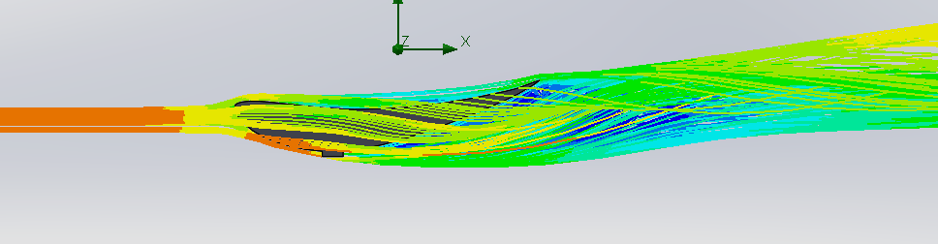
Figure 13.1
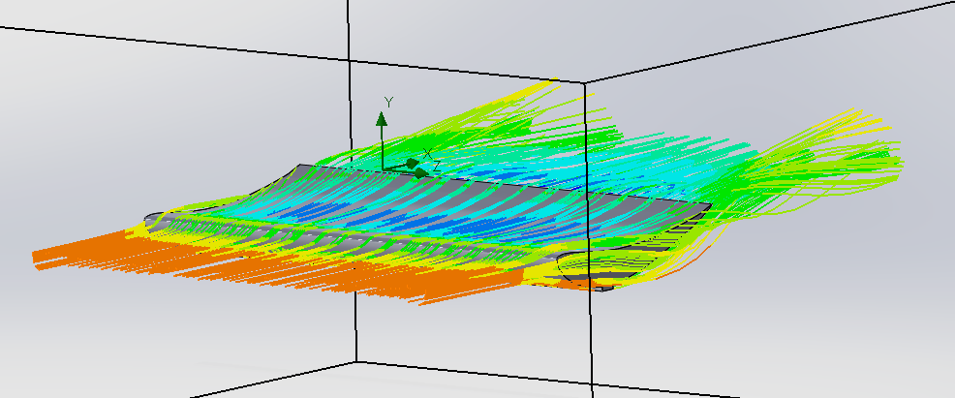
Figure 13.2
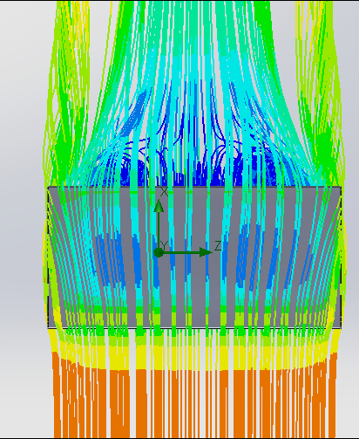
Figure 13.3

CFD Force Results:
The CFD simulation of the full scale NACA Eppler 420 at 0 degrees recorded a drag force of 155.355N and a downforce of – 124.248N. These are substantial values, which I expect to make a difference on the lap times of the vehicle.
NACA Eppler at 45 degrees:

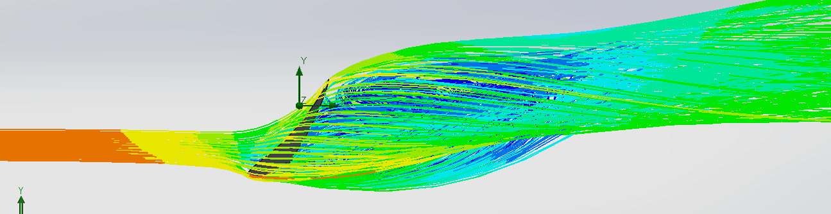
Figure 14.1
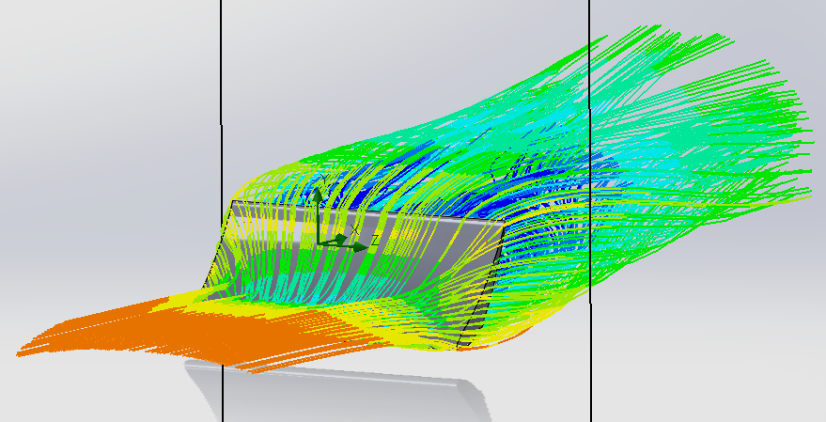
Figure 14.2
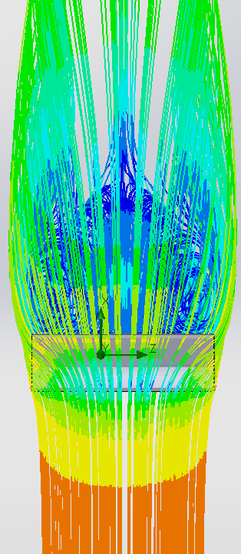
Figure 14.3
CFD Force Results:
The CFD simulation of the full scale NACA Eppler 420 at 45 degrees recorded a drag force of 836.751N and a downforce of – 885.176N. These values tell us that the drag and downforce produced by the wing is almost equal. This is good as the wing was designed to act as both a wing but also an airbrake.

Car Model Simulation:
No Wing:
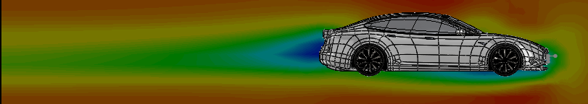
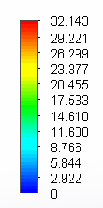
Figure 15.1
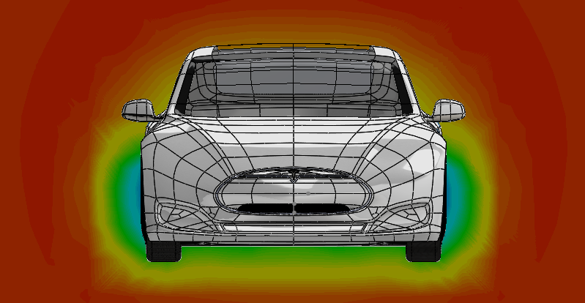
Figure 15.2

CFD Force Results:
The CFD simulation of the full scale Tesla Vehicle recorded a drag force of 437.640N and a downforce of – 36.355N. These values tell us that the model is generating very high drag in comparison to the downforce it is making. The downforce is only -36.355N, meaning that it is almost creating lift. When the wing is included, we hope to potentially reduce drag but most importantly to increase the downforce being generated.

Full scale NACA Eppler 420 at 0 degrees:
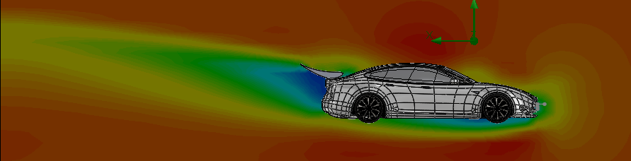
Figure 16.1

CFD Force Results:

The CFD simulation of the full scale Tesla Vehicle with NACA Eppler 420 at 0 degrees recorded a drag force of 597.967N and a downforce of – 635.891N. These values tell us that the model is now generating more downforce than it is drag. Though drag has increased by 1.366 times, the downforce has increased by 17.49 times when the wing is included.

Full scale NACA Eppler 420 at 30 degrees:
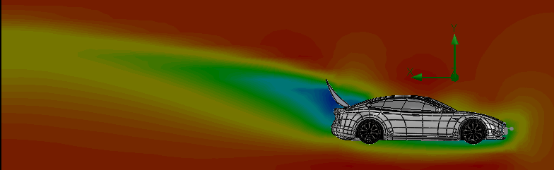
Figure 16.2

CFD Force Results:
The CFD simulation of the full scale Tesla Vehicle with NACA Eppler 420 at 30 degrees recorded a drag force of 1131.342N and a downforce of – 1077.926N. These values tell us that when the wing is deployed, the model is now generating slightly more drag than downforce. This time, the drag has increased by 1.89 times, while the downforce has increased by 1.695 times. This current data will definitely impact the car performance and must therefore be used in lap simulation to find the change it will have on performance.

Lap Time Simulation:
LAP time testing: To compare lap times for the tesla, Optimum lap (Optimum, 2024) was used as it allowed for custom vehicle parameters which could be modified, allowing for different configurations to be easily tested and compared.
For testing, no electric vehicles were an option to use, and therefore the engine and gearbox configuration was taken from the vehicle database in optimum lap. The vehicle chosen was the Porsche 911 Carrera with modified Mass, drag, downforce and frontal area, to fit the Tesla’s requirements.
Circuit and braking parameters:
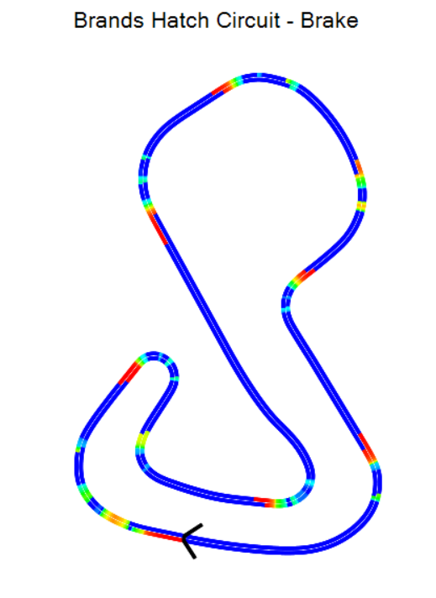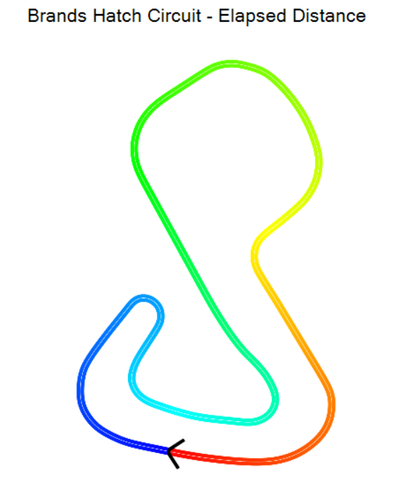
Figure 17.1 Figure 17.2
Using data from both 0 degree lap times and 30 degree lap time to make an estimated lap time for active aero. This was done by using data from the 0 degree wing if it was less than 50% braking, and data from the 30 degree wing if it was more than 50% braking.
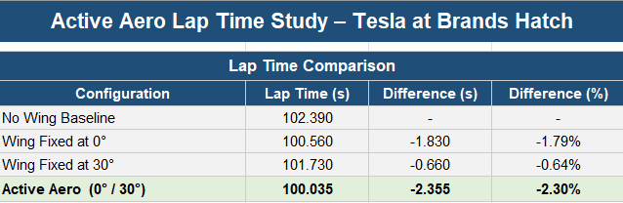
Figure 17.3
The table above compares lap times at Brands Hatch Circuit for four configurations of the Tesla. The first configuration was the baseline model of tesla with no wing. The second configuration was the tesla with the wing at 0 degrees. The third configuration was the tesla with the wing at 30 degrees, and the third configuration was a sum off both winged data depending on whether the car was breaking or not.
The baseline car with no wing recorded a lap time of 102.390 seconds. Fitting a fixed wing at 0° reduced this by 1.830 seconds due to lower aerodynamic drag on the straights. A fixed wing at 30° provided less improvement at 0.660 seconds faster than the 0 degree wing, as the downforce benefit in corners was offset by the increased drag on the straights. The active aero configuration, which deploys the wing to 30° under braking and returns to 0° when accelerating, achieved the fastest lap time of 100.035 seconds. This was a 2.355 second improvement over the baseline. This shows that an active aerodynamic wing is a good way to improve time around a circuit in comparison to fixed wing configurations.

Simulation Conclusion:
As part of simulation I used CFD to calculate aerodynamic forces at 60mph that would act upon 3 different wings at different configurations. For each wing, two tests were conducted, changing the wing angle from 0 degrees for acceleration and 30 degrees for braking. When comparing the changes in forces, all wing showed an increase in downforce at 30 degrees, while also increasing the drag. These results are what the team was looking for, as the wing design was going to be used to create downforce, but also act as an airbrake helping the car slow down faster and be more competitive. When comparing the results from the initial tests, both downforce and drag at both angles were considered, resulting in creating a table to compare the ratio of drag to downforce. The ratios calculated were: 1:1.27 for NACA 6412, 1:3.98 for NACA Eppler 420 and 1:1.91 for NACA MSHD. As a result, the Eppler wing was chosen as it had the best ratios for both 0 degree wing and 30 degree wing.
When running lap simulations, the active aero setup ended up being the quickest overall at 100.035 seconds, which was 2.355 seconds faster than the baseline car with no wing at 102.390 seconds. The wing sits flat at 0° for most of the lap to keep drag low, then raises to 30° under braking to generate downforce and act as an air brake. This turned out to be more effective than either fixed wing setup on its own — the 0° wing did 100.560 seconds, and the 30° wing did 101.730 seconds.
The 30° wing was actually slower than the 0° wing despite producing much more downforce. The reason for this is that Brands Hatch has a lot of corners and short straights, so the extra drag from the raised wing was killing the top speed more than the downforce was helping in the corners. This made it a good track to test the active aero concept on, because the wing could deploy exactly when it was needed in the braking zones without dragging the car down everywhere else on the lap.
Taking all four results together, it is clear that no single fixed angle can match what the active system achieves, since it is essentially getting the best out of both setups depending on what the car needs at that point on the track.

Simulation limitations:
One limitation of the simulation is that the active aero lap time is only an estimate because Optimum Lap cannot actually change the wing position throughout the lap. To get around this, data from both the 0° and 30° simulations were combined manually, using the 30° data in the braking zones and the 0° data everywhere else. This works as a reasonable approximation but in reality, the car transition times and effects between the two positions would differ which the simulation cannot capture.
Another limitation is that the engine data had to be taken from a Porsche 911 rather than using the Tesla's electric motor data. This was done as Optimum Lap does not have a way to model an electric powertrain. This means the absolute lap time are not an accurate representation of what a real Tesla would do, however since all four configurations used the same engine data the differences between them should still be valid for comparison purposes.
Overall, the simulation testing shows that using an active aero wing can benefit lap times in a vehicle in comparison to a fixed wing or no wing setup. This was shown by running 2.355 seconds faster than the baseline model with no wing. Further studies could be done by testing many angles for the wing to find the most optimal values for the application. Furthermore, using finer meshes and more detailed CFD would help to increase the accuracy of the results.

Mechatronics and Control Systems – Callum Clement (2400570)

To create an active aero system the main part is designing the code and deciding on the mechatronics for the wing. The requirements we have for the system is to receive vehicle data and for it to adapt the wing angle based on that data, the goal is to allow for a minimum of 3 data inputs to change the wing angle. Model in loop testing is a process in which physical testing processes are substituted for mathematical models to see if the software will function appropriately and use the given inputs to reach the desired output.(Model-in-the-Loop Testing, A. R. Plummer)
MIL is used to reduce cost and can be more efficient; MIL is often used for aerodynamic processes for automotive applications which is why it is a process we went through with our project.
Track data for the Tesla was gathered with the data collected each second it includes all vehicle data required such as acceleration, speed, braking force, and steering angle, some of which will be used to change the wing angle. The data is then imported into a MATLAB code which then can select variables, this can be sent to an Arduino which will use those variables to control a component.

Component Selection

Selection of components was very dependent on the capabilities and advantages of one over another. The Arduino that was used is an Arduino Uno Rev 3 which is a very widely used and available board which allows for up to analogue 6 inputs which could be used to adjust wing angle but only 3 of these inputs would be used.
The Arduino would be used in conjunction with Simulink designed by MATLAB due to the high compatibility of the software and the simplicity of being able to design a useable model for our application.
The actuator selection was a more difficult task as there were many possible candidates. Some options that were considered are stepper motors, servo motors or linear actuators. With the prototype model it was not as vital as for deciding for the final wing but implementing our desired actuator early on would allow for us to keep it integrated throughout.
Important aspects to consider include the size, cost, speed and force capabilities. Any choice made would need to have the speed and torque capabilities that we require of it, in motorsport situations we want the wing to travel to its desired position within 500ms, it allows for effective aerodynamic advantage especially with the use of an airbrake as any longer would be a greater distance the vehicle has travelled.
Electric linear actuators are a good compact option which can be found for quite cheap as a basic model and have a high force output, the speed however lets the actuator down with them being quite slow across their travel with higher force actuators only travelling approximately 15mm/s, additionally they require a linear potentiometer to track the distance travelled which increases the cost of the component.
Stepper motors are another option, the internals of the motor are split up into “steps”, many stepper motors have 200 steps internally for a full 360-degree rotation, meaning each step is 1.8 degree compromising on accuracy. The accuracy of the stepper motor can be combatted with a gearbox to reduce the rotational distance per step, but this would increase cost and size. Stepper motors on their own are cheap and relatively small with strong holding torque during low speeds. At high speeds the torque reduces and can skip steps internally if the force overcomes the motor’s ability which would not be suitable for what we need as we need to maintain the torque while the wing responds quickly.
Servo motors were our final option that we investigated. Servos are typically split into 2 different types, standard servos with limited rotational range about 180-degrees or continuous rotational range servos that can rotate the full 360. Servo motors have a built-in potentiometer and control circuit which measures the current motor position from a change in resistance from the potentiometer. The motor size is relatively small and compact, while they are slightly more expensive than stepper motors, they make up for that in the high-speed response and their high output torque being the perfect candidate for our project.

Creating the RC Filter

To control our motor, we are required to convert our PWM signal into a analogue signal which can be read by the Arduino and used to set motor angles when specific conditions are met, to do this we need an RC low pass filter. On the Arduino Uno there are 6 PWM pins, pins 3, 9, 10 and 11 have a PWM frequency of 490Hz where pins 5 and 6 have a frequency of 980Hz. We will be using one of the 490Hz pins as we want to reduce the frequency to create a smoother analogue output and better response time for this instance, we have used a 10Kohm resistor to reduce the frequency to 49Hz.
To determine the capacitor size, it tends to be a large amount of trial an error with an oscilloscope to find the appropriate amount of smoothing without creating too much of a delay in the signal.

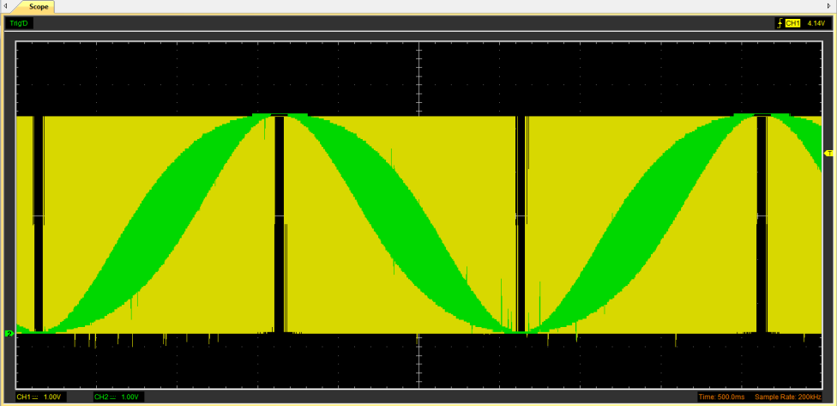
0.1µF 50V Capacitor

The above image is a screenshot from a Hantek oscilloscope showing the results of a 0.1µF 50V capacitor being used. The green section would be the outputted analogue signal, and the yellow section is the raw unfiltered PWM signal. It is clear that the green line is thicker in sections which is excessive noise in the output signal, this noise is a result of a capacitor which is too small. Excess noise within the signal can cause the motor to glitch randomly so it is important that the noise is removed. The analogue signal is also going past the limits of the PWM signal meaning we would not be able to use the full 5V required.
The peak of the analogue signal aligns with the centre of the PWM signal meaning that there is no lag with the capacitor used.

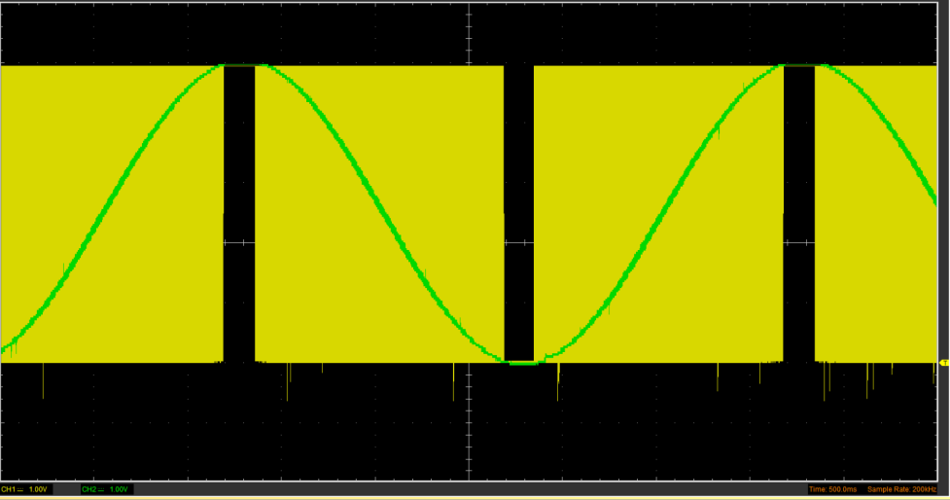
2.2µF 50V Capacitor

The capacitor used for this signal is a 2.2µF capacitor. The analogue signal is much thinner due to the reduced noise which gives us a much cleaner output signal. The peak of the analogue signal stops with the top of the PWM signal meaning we will be using all 5V from the signal. There is a very slight delay in the analogue signal as it does not perfectly line up in the middle of the PWM signal, but the delay is negligible.
This is the capacitor that we had decided to use for our system as it has an acceptable amount of noise and delay for our use case.

33µF Capacitor
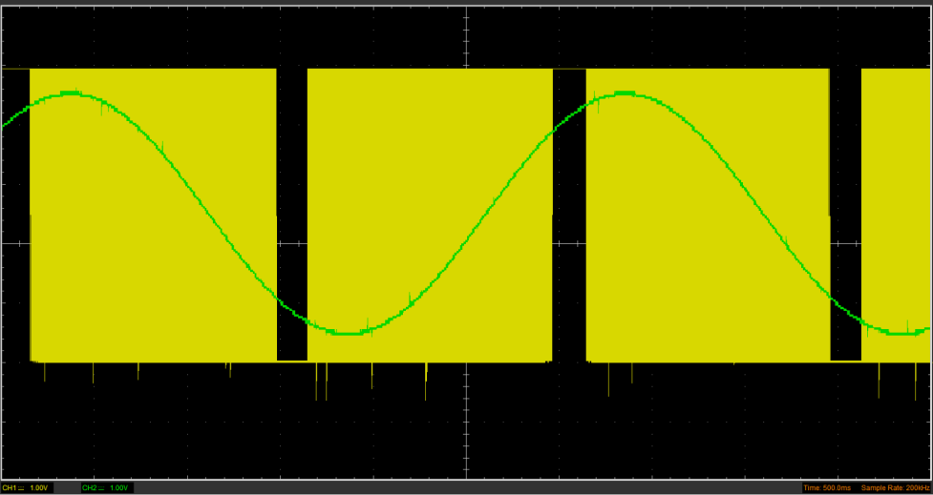
This last image shows the issues with over sizing with the capacitor and why it is important to choose the correct size. The above is a system with a 33µF capacitor, there is a very large reduction in noise but there is also a reduction in the amplitude of the signal, where the peaks do no longer reach the top of the PWM signal so you would be outputting closer to 4V than the full 5V.
There is also a very considerable amount of lag with this choice of capacitor where that the analogue signal reaches the peak far after the PWM cycle.

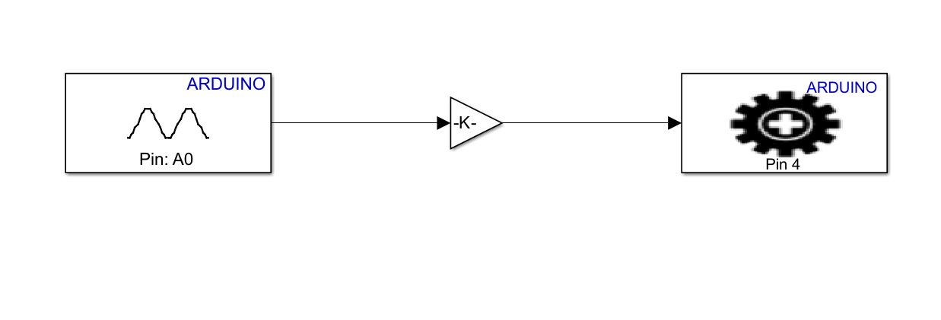
Simulink Code Basic Input
The above screenshot is a very simple Simulink code I created which uses an analogue input, gain block and a simple servo write. With this code I had tested it with a potentiometer to understand its effect on the servo positioning.
Analogue inputs are in a range from 0 to 1023 so they cannot be used directly into the servo motor and need to be adjusted so that the analogue values correspond to an angle for the motor to turn to.
We are using a motor with 180 degrees of rotation so we need to translate this 0 to 1023 range into an angular value where 1023 would be 180 degrees or 511.5 would be 90 degrees etc. This is done with the use of a gain block and it makes it very simple all that is required is to set the gain value to “180/1023” which then creates an angular value for each analogue value which is then output to the servo motor.

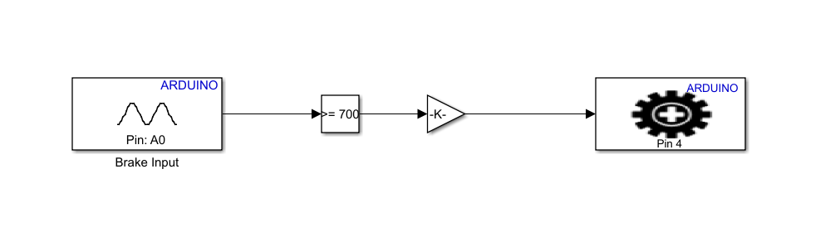
Simulink Code 1 Data Input
This basic code above was the first interpretation of actual vehicle data being interpreted to output a desired wing angle. This uses one extra block compared to the simple code above which is a “compare to constant” block. This block compares any incoming value to the set value within the block and for our use case compares if the value input is greater or equal to the value within the block.
We wanted our wing to active as an airbrake only under heavy braking conditions and we studied our data and concluded that we wanted the airbrake to activate at around 70%. This means that it is not going to be activating all the time but will become activated when it is needed.

Simulink Code 3 Data Inputs
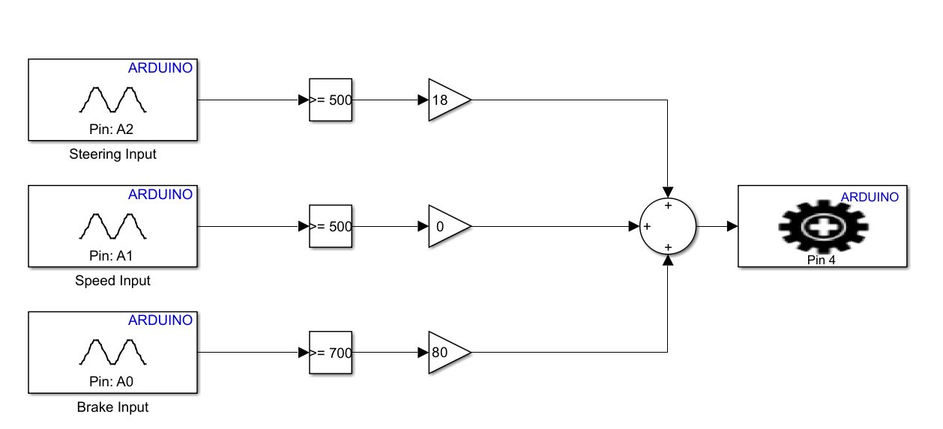
After getting the servo to respond to braking data I wanted to try incorporating some other types of data which were speed and input. This code above had each data type labelled on the analogue inputs with their own variables and angular outputs going into a sum block and out to the servo motor. This had its advantages where it would allow different data types to be used to adjust wing angle but it wouldn’t only use 1 of those if the conditions were met it would combine the angles, which for braking and speed was okay as both those conditions are not typically met at the same time but if it was the braking angle would be the final result.
The concern from this is if there is heavy braking while cornering which would have the brake input take over and result in the airbrake still being active when higher downforce would be ideal than increased drag.

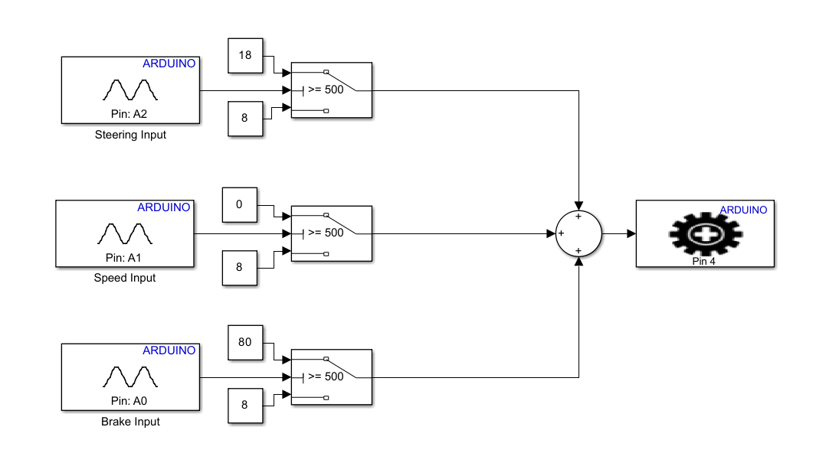
Simulink Code 3 Data Inputs Advanced
This is a continuation from my last code using switch blocks instead of gain and compare to constant blocks. This allows me to set a resting angle for the wing and adjust the wing based on the input data. With switch blocks if the input value does not reach the threshold it uses the below value which is the wings resting angle of 8 degrees.
The angle values were chosen based on research completed with drag and downforce values. When the threshold for steering is met the wing raised to 18 degrees providing a higher level of downforce to allow for better cornering. When the speed threshold is met the wing reduces its angle down to 0 degrees to reduce the drag to allow for speed to be increased. Finally, the brake input which when it reaches the threshold raises to an angle of 80 degrees which after research found to be the best angle to increase drag without compromising on stability.

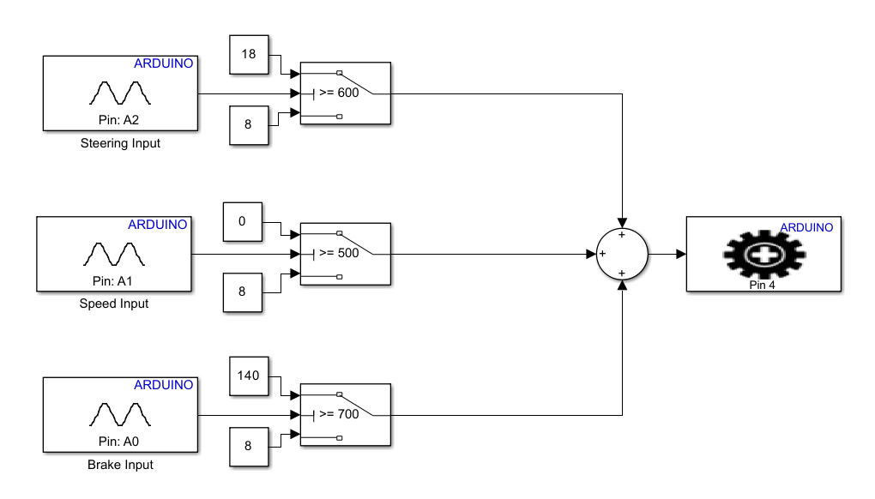
Simulink Code 3 Inputs Adjusted
The thresholds for the inputs were adjusted such as the braking which was incorrectly at 500 as well as the angle to compensate for the difference between servo angle and actual wing angle after testing. The threshold for steering input was also increased to stop the wing responding to this input prematurely.

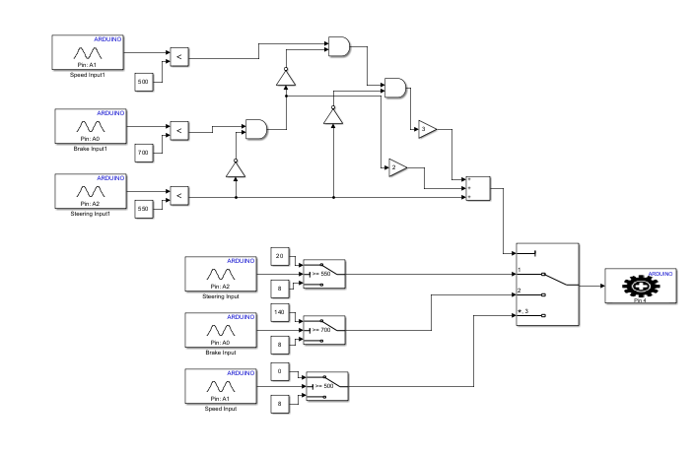
Simulink Code Final
For my final code I had needed to make a priority system for the code to allow for the output to be individually activated rather than being mixed. This was created with help from MATLAB guides with and or not gates which only allows speed to be output if both of the other conditions are not met. The code was developed with inspiration from other codes which require the same result which helped me gain a better understanding of how it all worked.

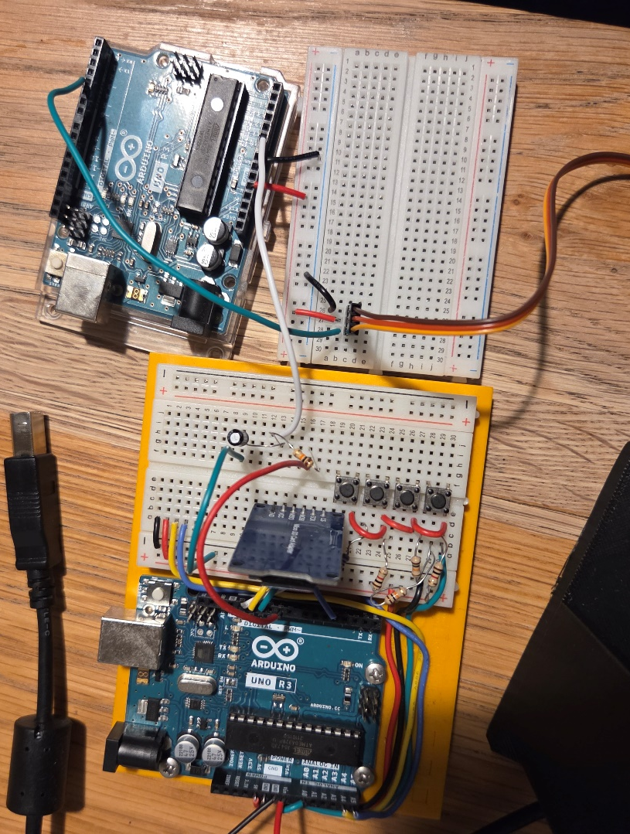
Mechatronics

The above image shows the Arduino setup with the sender board delivering the data to the other Arduino which interprets this data and provides the angle outputs for our wing. This image is of the Arduino prior to the change of the additional inputs from the signal sender board but the finished product involves 3 wires outputting from the sender going through RC filters and being input into the analogue input of the other Arduino Uno.

If I was to take this further

If I had another attempt at this project with more time to improve, I would clean up the whole mechatronics setup for a cleaner setup combined as the current is just connected the two with wires being unstable and unappealing to look at.
I would also look into PID systems as when creating this it had appeared a few times and I would be interested in implementing it into my coding to provide a smoother and more precise output of my coding.
I am happy with the end result, the essential function of my section with the control and mechatronics works as expected and allows for adaptation of the wing angle. This project was a big challenge but something I feel I have learnt along the way.

Materials – Oscar Davis (2410215)
Introduction:
It is one of my roles within the group to decide what material should be used for the wing and wing mount. I shall do this by researching what materials are commonly used in the motorsport idustry and find the most approprite materials for componets requirements. I will test materials using SolidWorks FEA and valide my research.

Aluminium:
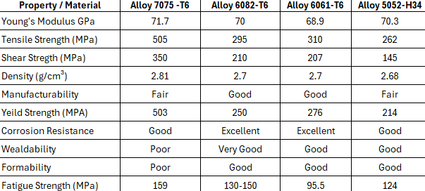
Figure 1.1

Alumiunium is an ideal choice for this project. Commonly used in the motrosprt industy, aluminium offers low density, high durability and corrsoion resistance.
Alloys: 7075, 6068, 6061 and 5052 offer key properties for spoiler and mount construction. They offer high fatigue stregth and stiffness (6068 Fatigue Stength = 130 - 150MPa), while also having high yield strengths (7075 Tensile Stregth = 505 MPa) meaning the material can bend and move without defroming. This is ideal as a spoiler and mount must be able to with stand high amounts of force (Subramanian et al., 2023) for prolonged periods of time.

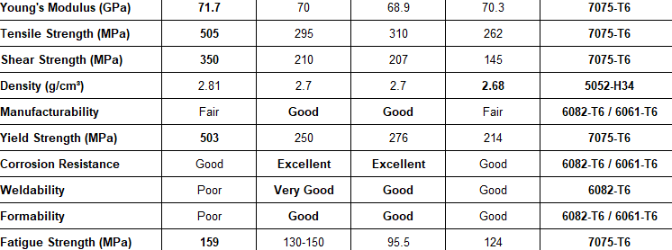
Figure 1.2

Looking at the results, it is shown that alloy 7075 has the most useful properties for this application. However from a cost (Mingtai Aluminium, 2021) and worability perspective alloy 6061 (Aluminumsheet.net, 2025) is far better suited. Although 7075 has higher stiffness and strength, 6061 is only marginally lower while also having a lower density a superior corrosion resistance. While 7075 excells in many of the desired properties it also lacks in other areas such as weldability and formabilty meaning to use the material would likley bring more negative impacts than positive. 6061 is more versitile and offers many key propeties that overall will allow for a better outcome. This therefore makes Aluminium Alloy 6061 the most appropriote of the alloys selected to use to manufactire a spoiler and mount.

Carbon Fibre:

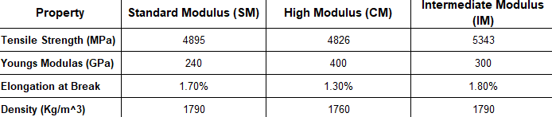
Figure 1.3

Crabon fibre is widely reguarded as one of the best materials used in the motortsport industy, it offers incredible stregth and stiff while being very lightweight and durable. The specific types of carbno fibre chosen are used commonly for within Formula 1 for a varyity of componets
These specific types offer a higher strgth (Intermediate Modululs Tensile Strength = 5343 MPa) and stiffness than most materials (High Modulus Youngs Moduls = 400 GPa) meaning a spoiler and mount made from these materials could withstand much greater forces for longer amounts of time without ay risk of deformtion.

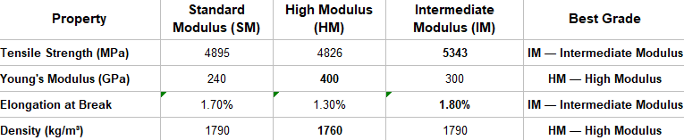
Figure 1.4

When compared, High Modulus and Intermediate Modulus have greater properties for the application. High Modulus has a slightly lower desnity and a greater stiffness. Intermediate Modulus has a higher Tensile strength and a Elongation at Break percentage meaning the material can withstand more strength without breaking or defroming.
However when factoring in workability (Rock West Composites, 2023) and cost (Toray Composite Materials America, 2025), Standard Modulus can be seen as a more balanced option. Despite having a lower tensile strength and youngs modulus, it still has incredible capabilities when compared to aluminium or titanium while being a better fibre to manufacture and produce.

Carbon Fibre Confuguration:

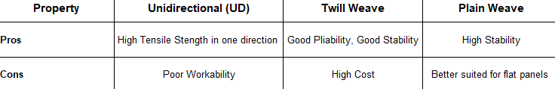
Figure 1.5

Carbon fibre is made in different configurtion to produce dfferent proepties for specific outcomes. These are some of the most common configuations used in the motorsport industy. Each have ideal properties for certain applications but also have drawbacks that can effect other aspects of material selection such as cost and manufacturability.

Figure 1.6

Despite higher cost, Twill weave is ideal option as from a structural perspectiev it, it is easier to produce more complex profiles, such as curves and different features on spoilers, while also having high strength and stability.

Titanium:

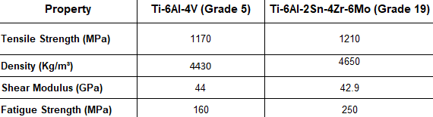
Figure 1.7

Alothough titanium is less commonly used it also has a remarkable proepties when compared to similarly used used materials such as aluminium. Having a much larger tensile stregth (Grade 5 = 1170MPa, Grade 19 = 1210 MPa). Titanium however is far more expensive than similar materials (Fang et al., 2018) and less workbable. Grade 5 and 19 titanium both very strong materials however with excellent corrosion resiatnce, Grade 5 being the prefered materials due to its higher stiffness and better workabilty (Navstar Steel, 2025; Baker Industries, 2025).

FEA Validation Testing:
To justify to the selection of materials for the wing and the mount, I ran my own tests on the materials using SolidWorks FEA.
I did this by using the Analytical Beam Deflection Calculations to calculate the real-world maximum deflection of the most suitable materials: Alloy 7075, Alloy 6061, Carbon Fibre Standard Modulus and Titanium Grade 5. After getting values I then proceeded to run my own tests on FEA in order to validate the real-world results to the test calculated results.
I used the same constants as the equation; beam dimensions, force applied, force acting point, and point of fixture but changed the young’s modulus for each material.

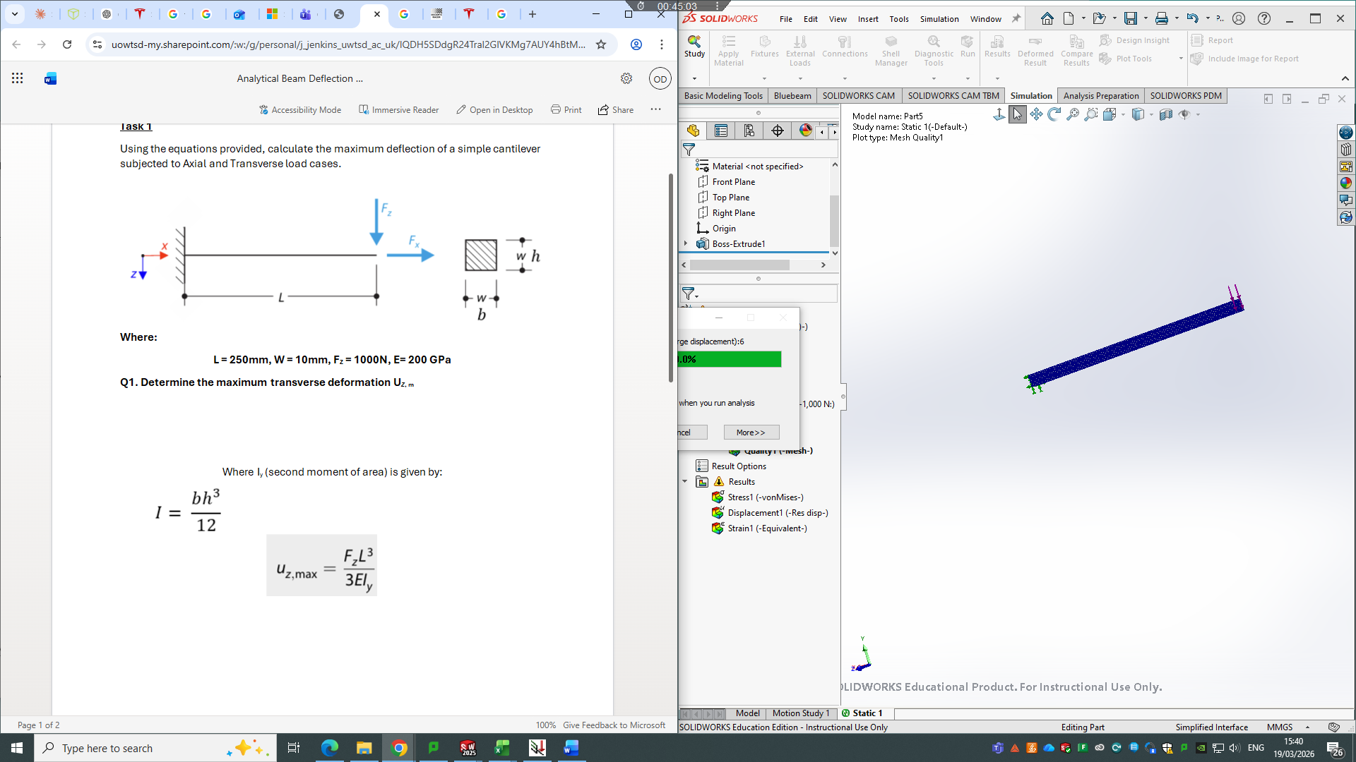
Figure 1.8
Figure 1.9

(Analytical Beam Deflection Calculations, no date)

The test results vary slightly, especially for Alloy 7075, Alloy 6061, and Titanium Grade 5. The main cause of this is due to the difference in young’s modulus values. The real-world calculations used researched values found from reliable sources, whereas the FEA tests used default values on the SolidWorks data base.
The difference in young’s modulus value was narrow but made a significant difference in end results. For Titanium, the difference in young’s modulus was too great a difference of 9GPa and is therefore not accurate enough to test further with wing and mounts models.
To make the tests more accurate, I adjusted the mesh on the simulation to get as close as possible to the real-world results. The data found was still very accurate compared to the real-world calculations and therefore material model testing will give reliable values.

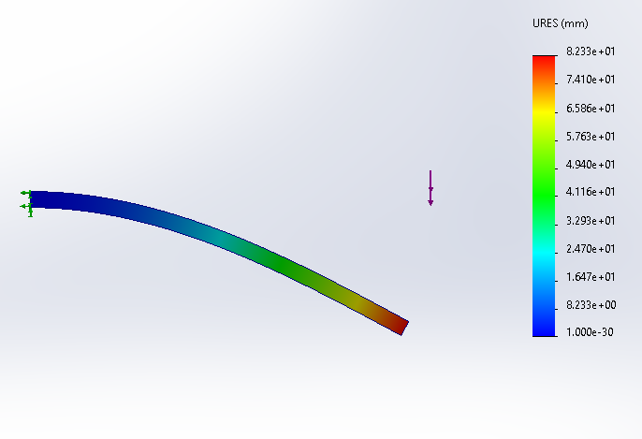
Figure 1.10

Aluminium Alloy 6061:

Youngs Modulus (GPa): 68.9
Tested Youngs Modulus (GPa): 69
Calculated URES (mm): 90.71
Tested URES (mm): 82.23

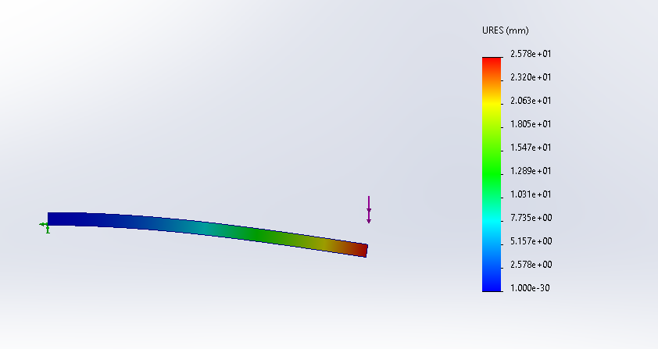
Figure 1.11

Carbon Fibre Standard Modulus:
Youngs Modulus (GPa): 240
Tested Youngs Modulus (GPa): 240 (Custom Material)
Calculated URES (mm): 26.04
Tested URES (mm): 25.78

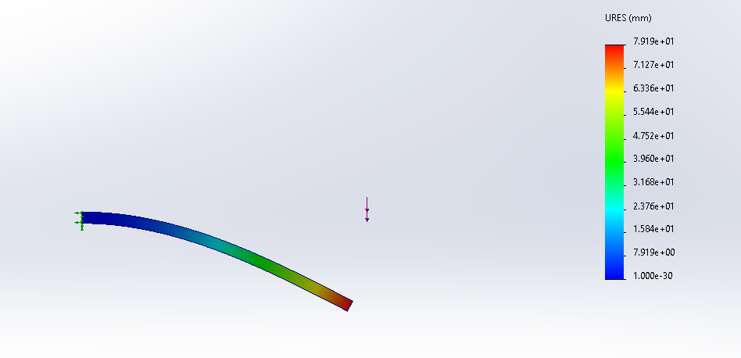
Figure 1.12

Aluminium Alloy 7075:
Youngs Modulus (GPa): 71.7
Tested Youngs Modulus (GPa): 72
Calculated URES (mm): 79.19
Tested URES (mm): 87.17

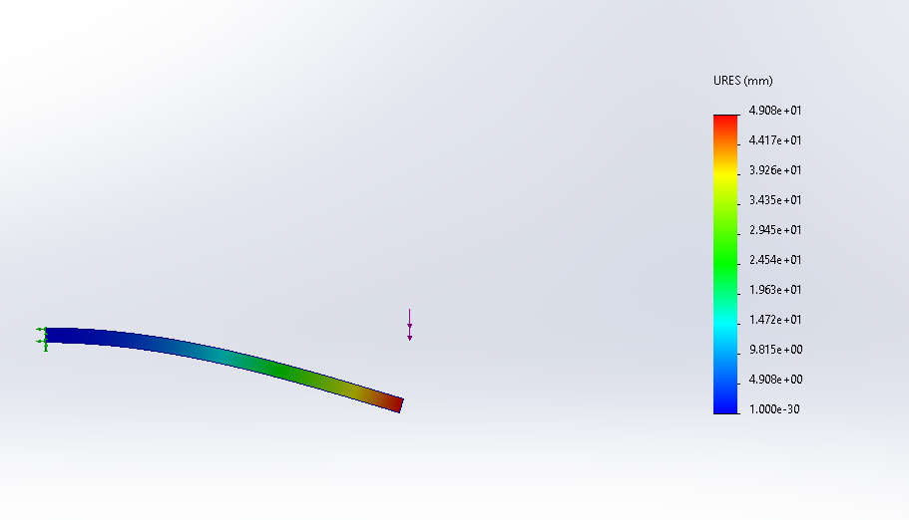
Figure 1.13

Titanium Alloy 6 Al:
Youngs Modulus (GPa): 114
Tested Youngs Modulus (GPa): 123
Calculated URES (mm): 54.82
Tested URES (mm): 49.08

Spoiler Material
Because Alloy 7075, Alloy 6061 and Carbon Fibre Standard Modulus are validated to give reliable data, I tested the wing profile with the different materials see how they acted under 15000N of force.

Force Applied: 15000N
Aluminium Alloy 6061:
URES(mm) = 2.017*10^-2
Von Mises (N/m^2) = 9.364*10^5
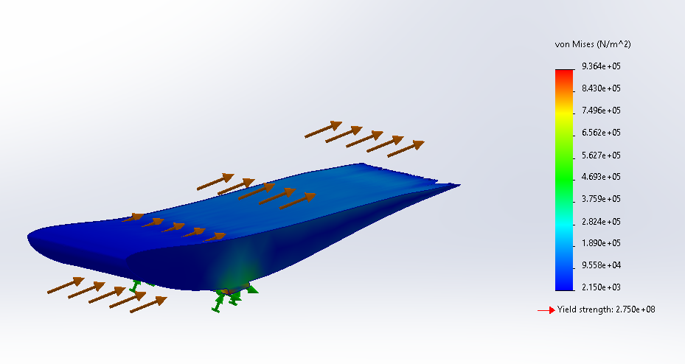
Yield Strength = 2.750*10^8
Figure 1.14

Aluminium Alloy 7075:

URES(mm) = 2.154*10^-2
Von Mises (N/m^2) = 1.110*10^6
Yield Strength = 5.050*10^8
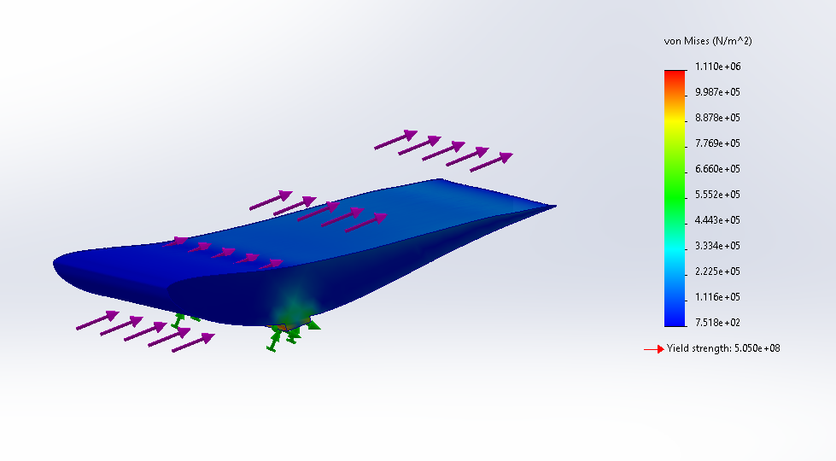
Figure 1.15

Carbon Fibre Standard Modulus:
URES(mm) = 6.593*10^-3
Von Mises (N/m^2) = 1.141*10^6
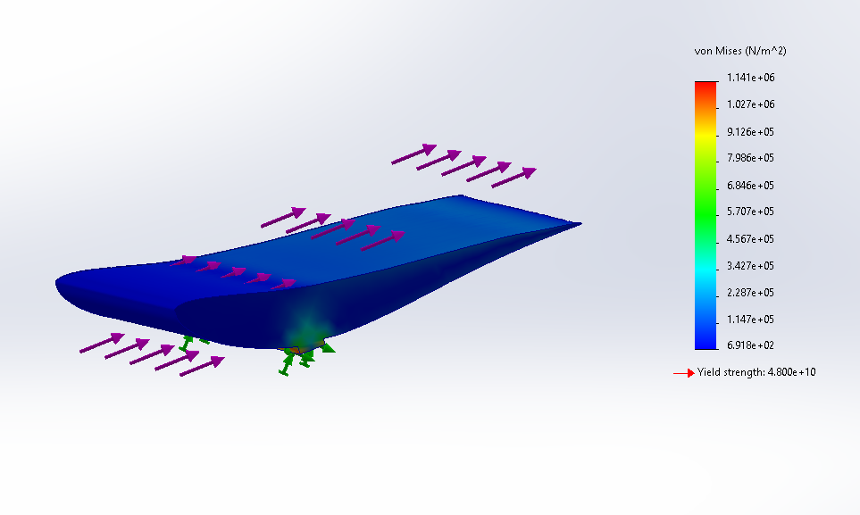
Yield Strength = 4.800*10^10
Figure 1.16
Based on these results, Carbon Fibre has the lowest max displacements of 0.006593mm, a Von mises value of 1.141 MPa and a Yield Strength of 48000 MPa. This gives a safety factor (Yield / Von Mises) of 42067 making it the ideal material for the wing.
The FOS for the wing must be 1.25 however the actual value was calculated, instead a much 15000N of force was applied to the wings, this is over double the amount a F1 wing would experience at top speed (350km/h+ = approximately 7300N) (Occam's Racer, 2021). Being used on a Tesla, the wing will never experience a force this great so therefore the wings FOS is validated.

However, based on other factors such as workability, cost, and durability the most effective material is Alloy 6061which is overall more cost effective, weldable, corrosion resistant and still incredibly strong.

Oscar: Mount

Mount Design – Oscar Davis (2410215)

Introduction:

It is my role within the group to design a suitable wing mount for the wing; this will be done by researching existing wing designs and experimenting with my own ideas backed by scientific and calculated validation to reach the best possible outcome.

Mount Material:

Force Applied: 15000N

Mount Design 1:
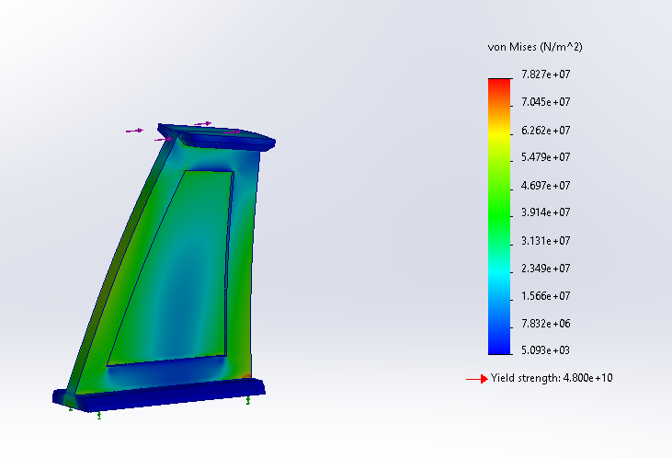
Figure 1.17

Mount 1 Results:

Aluminium Alloy 6061:
URES(mm) = 3.459*10^1
Von Mises (N/m^2) = 7.754*10^7
Yield Strength = 2.750*10^8

Aluminium Alloy 7075:
URES(mm) = 3.315*10^-1
Von Mises (N/m^2) = 7.754*10^7
Yield Strength = 5.050*10^8

Carbon Fibre Standard Modulus:
URES(mm) = 9.30*10^-2
Von Mises (N/m^2) = 7.827*10^7
Yield Strength = 4.800*10^10

Based on these results Carbon Fibre is the best overall option. Even when factoring in workability, cost and durability, the structural safety and stiffness is far superior to aluminium. The trade-off however is the much greater cost and difficulty of manufacturing, but the wings mounts will perform considerably better when made and is worth the sacrifice of cost and workability.

Force Applied: 15000N

Mount Design 2:

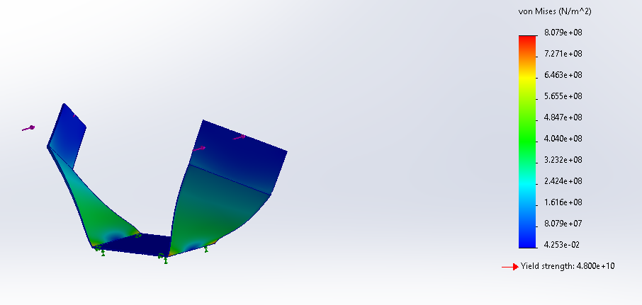
Figure 1.18

Mount 2 Results:

Aluminium Alloy 6061:
URES (mm) = 1.626*10^2
Von Mises (N/m^2) = 8.071*10^8
Yield Strength = 2.750*10^8

Aluminium Alloy 7075:
URES (mm) = 1.558*10^2
Von Mises (N/m^2) = 8.071*10^8
Yield Strength = 5.050*10^8

Carbon Fibre Standard Modulus:
URES (mm) = 4.596*10^1
Von Mises (N/m^2) = 8.079*10^8
Yield Strength = 4.8*10^10

After a second test with a different design, it is clear that carbon fibre is the best overall option, it performs the best under force and has the least deformation. These are critical properties for wing mounts as any movement in the part could cause major issues in the wing’s performance.
Movement of the mount compromises the wings profile (Subramanian et al., 2023), effects balance and handling of the car (Springer Nature, 2017) and can cause mounting tools such as bolts and fasteners to fatigue (Chai et al., 2021).

Initial Testing
Force Applied: 15000N

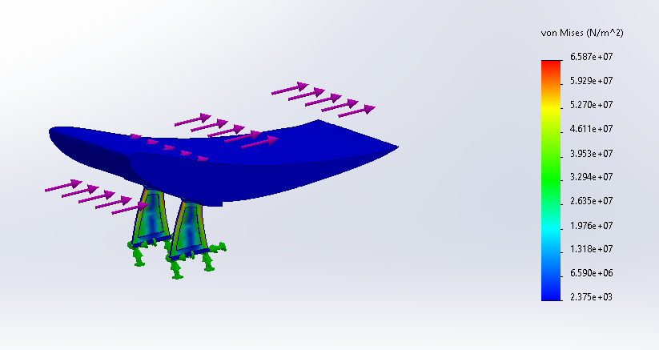
Mount 1:
Figure 1.19

URES (mm): 8.842*10^-1
Von Mises (N/m^2): 6.587*10^7

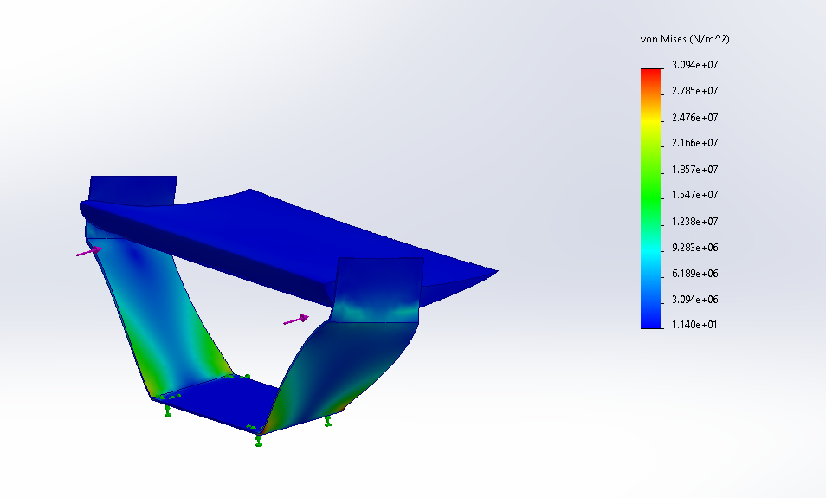
Mount 2:
Figure 1.20

URES (mm): 3.582*10^-1
Von Mises (N/m^2): 3.094*10^7

Initial Testing
Force Applied: 15000N
Mount 1:
Figure 1.21

URES (mm): 8.842*10^-1
Von Mises (N/m^2): 6.587*10^7

Mount 2:
Figure 1.22

URES (mm): 3.582*10^-1
Von Mises (N/m^2): 3.094*10^

Further testing and improvements
After the initial test for the first mount design, I redesign the wing to be stronger and lighter, which would allow the mounts to be made with less material as they would not need to take as much force. To do this I hollowed out the wing to 2mm and added end plates to either side.
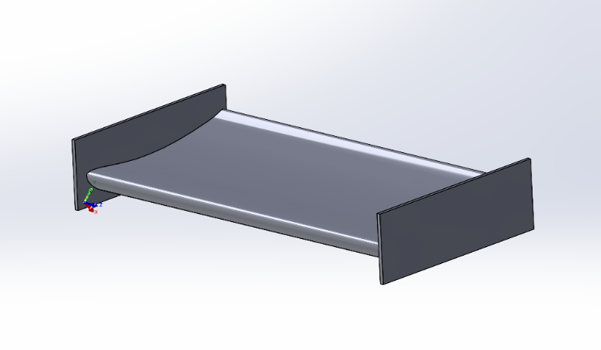
Figure 1.23
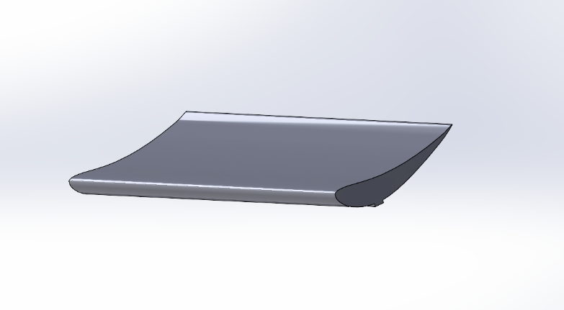
Figure 1.24

Mount 1:

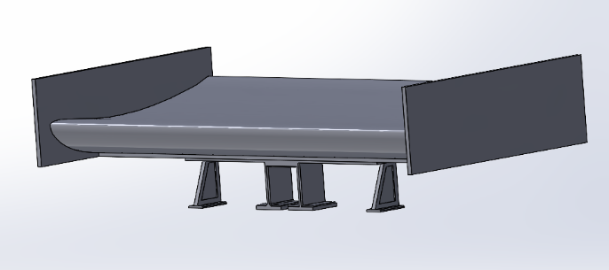
Figure 1.25

This new design included additional square struts in the centre. Using square struts instead of triangular to increase strength at the front of the mount, reducing movement backwards. The under-mount design is structurally very simple and easy to manufacture (The Answer is 27, 2020).

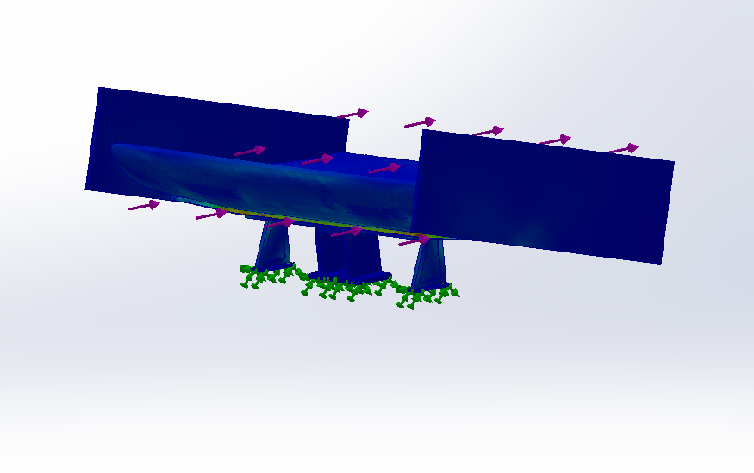

Figure 1.26

Results with 15000N applied:
Von mises (N/m^2) = 4.56 * 10^8

This was successful as the Von mises value lowered compared to previous tests.

To reduce the wing moving when under force, I elongated the mount for more surface area and stability. I then changed the wing to have a larger base to fit onto the mount and have less flexibility.

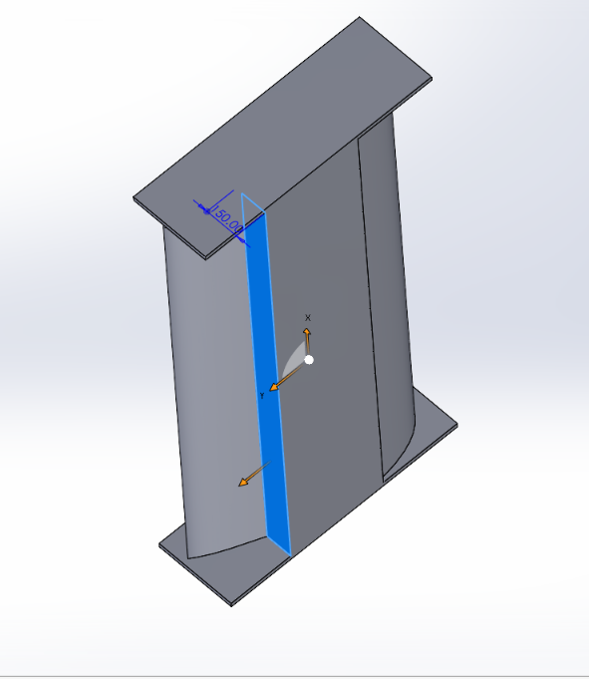
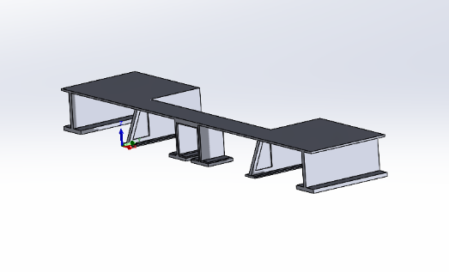
Figure 1.27
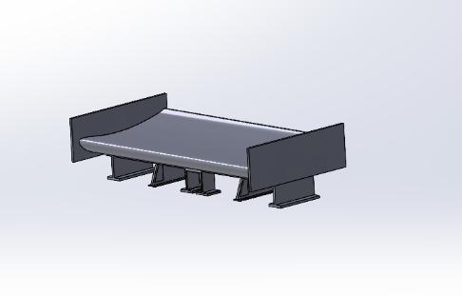

Figure 1.28

Mount 2:
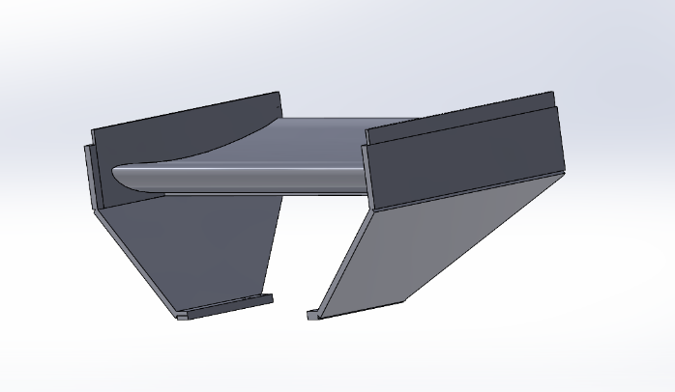
Figure 1.29
Using the improving wing design, I changed the second mount to have material towards the back of the wing to reduce flex.

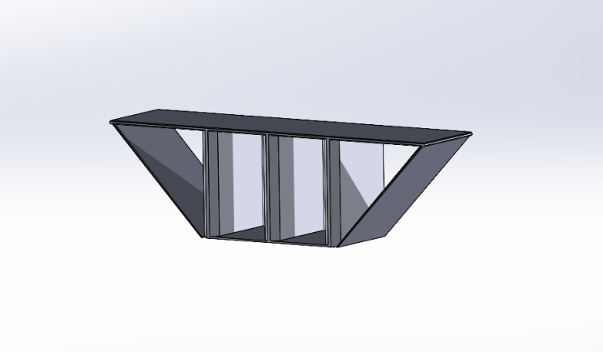
I then improved this further for more rigidity by adding support beams in the centre of the wing, mounted across the width of the wing. Using a side mounted design allows the wing to have multi – directional structural stability and reduce movement (Design Judges, 2025).
Figure 1.30

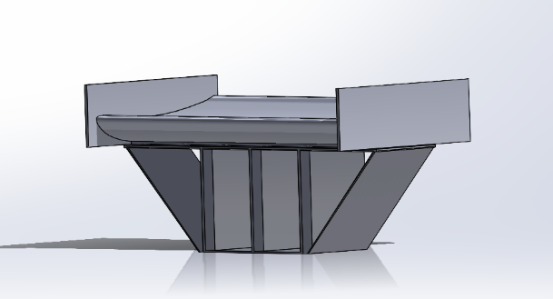

Figure 1.31

Final Mount Testing

Unfortunately, the carbon fibre material needed to test the following models was not available on this device, so the mount and wing are both simulated with 6061. However, this material is weaker and still performs well proving that if carbon fibre were used it would perform better.
Mount 1:

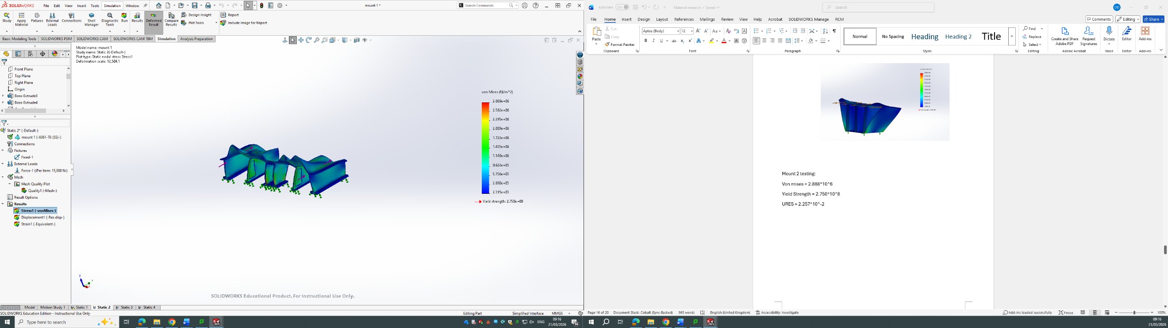
Force = 10000N
Figure 1.32
Von mises (N/m^2) = 2.869*10^6
Yield strength = 2.750*10^8
URES (mm) = 1.815*10^-2

Figure 1.33
Force = 15000N
Von mises (N/m^2) = 2.869*10^6
Yield strength = 2.750*10^8
URES (mm) = 1.815*10^-2

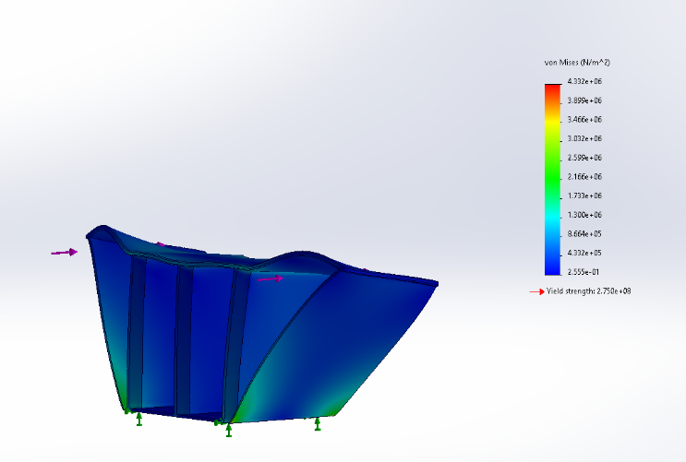
Mount 2:
Figure 1.34

Force = 10000N
Von mises (N/m^2) = 4.332*10^6
Yield strength = 2.750*10^8
URES (mm) = 3.385 * 10^-2

Figure 1.35

Force = 15000N
Von mises (N/m^2) = 4.332*10^6
Yield strength = 2.750*10^8
URES (mm) = 3.385 * 10^-2

Compare improvements:
Mount 1 has a lower URES meaning there is less movement within the structure.

FOS = Yield Strength / Von Mises Stress
Mount 1 = 2.75 *10^8 / 2.869 *10^6 = 95.9
Mount 2 = 2.75 * 10^8 / 4.332 *10^6 = 63.5

Mount 1 has a higher FOS and a lower URES, it therefore the superior design.

Final Designs
Mount 1:
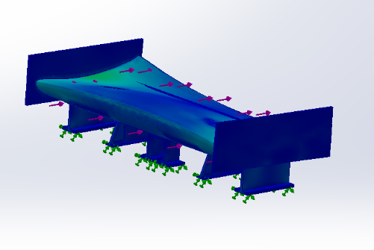
Figure 1.36

2mm Shell:
Force 10000N
URES (mm) = 0.1992 * 10^-1
Von Mises (N/m^2) = 1.043 + 07
Yield strength = 2.750*10^8

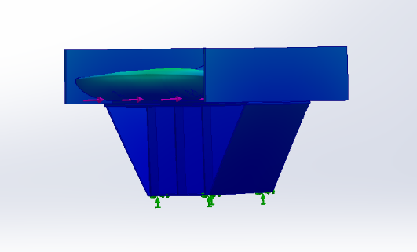
Mount 2:
Figure 1.37

Force = 10000N
Von Mises (N/m^2) 5.210*10^7
Yield Strength = 2.750*10^8
URES (mm) = 2.955*10^-1
Because the von mises values are lower than the yield strength values the elastic limit of the materials are not met, meaning the structures will not permanently deform under the force applied.

Comparing the data shows that Mount 1 has a lower URES as well as a higher safety factor. Mount 1 is therefore superior and will be used for the final design.

Final Wing Design
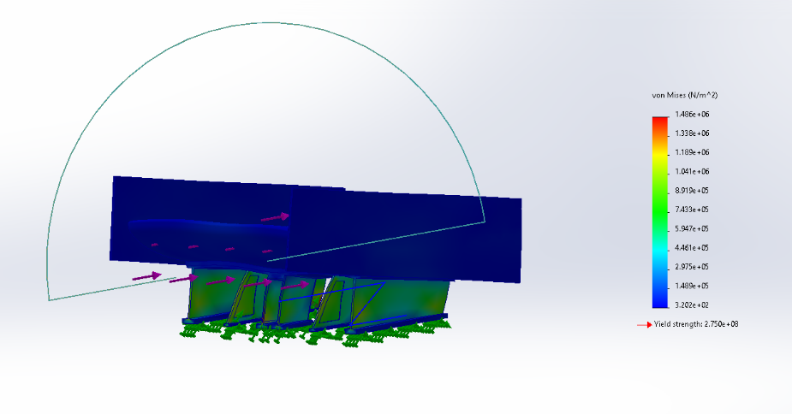
Figure 1.38

This wing is hollowed with 50mm walls instead of 2mm. this makes the wing itself deform less while also being lighter than the original design.

Force = 10000N
Von Mises (N/m^2) = 1.486 *10^6
URES (mm) = 0.0113

The Carbon Fibre needed for the actual model test was unavailable at the time of simulation so instead I simulated the model using Alloy 6061. This is a weaker material with less stiffness that the selected carbon fibre and comfortably accomplished a low URES and an FOS value over 1.4 when compared to a Formula 1 car’s maximum down force.

Fixtures:
Grade 8 bolts will be used to attach the mount to the car; the bolts will be drilled through the cars boot with an 8mm drill bit. There will be threaded screw holes on the base of the mount. The bolts can then be fed through mount and into the boot lid. Grade 8 hardened flat washers (The Nutty Company, 2025) can then be places over the bolts to spread the load of the force. To complete the fixture grade 8 hex nuts (Albany County Fasteners, 2024) can be used to tighten the bolts in place and secure the mount. The holes can be drilled used a solid carbide drill bit (Elevated Materials, 2023)

Using these parts will guarantee that the mount will stay secured, the max load the bolts will need to tolerate is approximately 10000N. Having this many bolts will have a combined maximum load well over this value (Engineering Toolbox, 2025).

This type of attachment is ideal as it is very simple with very low risk of error. As well as this it is low cost as it requires few tools and pieces of equipment to complete and can be done very quickly.

Part List:

- 20 x Grade 8 Bolts (13mm Thread Diameter)

- 20 x Grade 8 Hardened Flat Washers (13mm)

- 20 x Grade 8 Hex Nuts (13mm)

To conclude this section, the end design mount and wing met the criteria for a functional mounting system within a dependable safety factor with validated functionality. I could’ve this section by finding the corrected material data on the test simulation to give more exact results.

Conclusion

This project provided us with a great opportunity to investigate and explore the fundamental pieces of aerodynamics and allow for us to design and develop and active aerodynamic wing system. The design displayed the benefits of the varying downforce and drag for improving performance and lap times. The wing functions as designed to interpret vehicle data and make adjustments to the wing angle to compensate such as the airbrake which from testing increased the drag which would help slow the vehicle.
This project also gave the opportunity to gain a better understanding of actuators, aerodynamics, coding software and model design. Unfortunately, it is clear that there are areas that could be better focused on and improved upon if the time was there, such as our prototype design and coding which could have been improved upon but also the simulations to see the true effects of our active aero system.
With additional time our final design could have been improved to a much more effective and smoother running active aero system and if this topic is attempted by our group again, we believe we can provide a result we are much happier with.
Overall, the project was a success which allowed us to see the possibilities of what active aero can do and its benefits in real motorsport situations.

References:
Aalco - Ferrous and Non-Ferrous Metals Stockist (2020a) 'Aluminium: specifications, properties, classifications and classes', AZoM. Available at: https://www.azom.com/article.aspx?ArticleID=2863 (Accessed: 11 March 2026).
Aalco - Ferrous and Non-Ferrous Metals Stockist (2020b) 'Aluminium alloys — aluminium 6082 properties, fabrication and applications', AZoM. Available at: https://www.azom.com/article.aspx?ArticleID=2813 (Accessed: 11 March 2026).
Aerocom Metals Limited (no date) Aluminium alloy 5052. Available at: https://aerocommetals.co.uk/featured-inventory/aluminium-alloy-5052/ (Accessed: 12 March 2026).
Albany County Fasteners (2024) Nut and washer specifications — sizes, types and applications. Available at: https://www.albanycountyfasteners.com/fasteners-101-nuts-washers-information (Accessed: 22 March 2026).
Aluminumsheet.net (2025) Aluminium 6061-T6 price per kg. Available at: https://www.aluminumsheet.net/aluminium-6061-t6-price-per-kg (Accessed: 22 March 2026).
Anon. (no date) Analytical beam deflection calculations. Unpublished document.
AZoM (no date a) 'Aluminium/aluminum 5052 alloy', AZoM. Available at: https://www.azom.com/article.aspx?ArticleID=6626 (Accessed: 12 March 2026).
AZoM (no date b) 'Aluminium/aluminum 6061 alloy (UNS A96061)', AZoM. Available at: https://www.azom.com/article.aspx?ArticleID=6636 (Accessed: 11 March 2026).
Chai, Y. et al. (2021) 'Aeroelastic analysis and flutter control of wings and panels: a review', International Journal of Mechanical System Dynamics, vol. 1, no. 1, pp. 5–28. Available at: https://onlinelibrary.wiley.com/doi/10.1002/msd2.12015 (Accessed: 22 March 2026).
Cook, A. (2023) 'Unidirectional vs twill carbon in wrapped carbon tubes: cosmetic or functional?', Goodwinds.com, 2 November. Available at: https://goodwinds.com/unidirectional-vs-twill-carbon-in-wrapped-carbon-tubes-cosmetic-or-functional/ (Accessed: 20 March 2026).
Dassault Systèmes (2024) SOLIDWORKS [Software]. Vélizy-Villacoublay: Dassault Systèmes. Available at: https://www.solidworks.com
Dassault Systèmes (2024) SOLIDWORKS Flow Simulation [Software]. Vélizy-Villacoublay: Dassault Systèmes. Available at: https://www.solidworks.com/product/solidworks-flow-simulation
Design Judges (2025) Aero placement and mounting. Available at: https://www.designjudges.com/articles/aero-placement-and-mounting (Accessed: 22 March 2026).
E-Foru Chemical (no date) 6068 aluminum alloy. Available at: https://www.eforu-chemical.com/aluminium-metal-and-alloys/6068-aluminum-alloy,aluminum-6068-alloy,e-foru.html (Accessed: 12 March 2026).
Engineering Toolbox (2025) Metric bolts — minimum ultimate tensile and proof loads. Available at: https://www.engineeringtoolbox.com/metric-bolts-minimum-ultimate-tensile-proof-loads-d_2026.html (Accessed: 22 March 2026).
Fang, Z.Z. et al. (2018) 'Powder metallurgy of titanium — past, present, and future', International Materials Reviews. Available at: https://www.tandfonline.com/doi/full/10.1080/09506608.2017.1366003 (Accessed: 22 March 2026).
Janocha, H. (ed.) (2004) 'Actuators'. Available at: https://doi.org/10.1007/978-3-662-05587-8.
Kern, T.A. et al. (2023) 'Actuator Design', pp. 309–429. Available at: https://doi.org/10.1007/978-3-031-04536-3_9.
Korf, M. (2023) Car Wing Comparisons [Online]. Occam's Racer. Available at: https://occamsracers.com/2023/08/08/car-wings-examined/
Kurniawan, A. (ed.) (no date) Getting Started with Matlab Simulink and Arduino. Available at: https://books.google.co.uk/books?hl=en&lr=&id=HGmVAgAAQBAJ&oi=fnd&pg=PT7&dq=arduino+matlab&ots=Rj4XX_CFCx&sig=IvyO8QkDJA40-vz6bON6MfmAQeU#v=onepage&q&f=false (Accessed: 22 March 2026).
MatWeb (no date a) Aluminum 5052-H34. Available at: https://www.matweb.com/search/DataSheet.aspx?MatGUID=8644ac88ccb647869449d6ff6ddfbaed (Accessed: 12 March 2026).
MatWeb (no date b) Aluminum 6082-T6. Available at: https://www.matweb.com/search/datasheet.aspx?MatGUID=fad29be6e64d4e95a241690f1f6e1eb7 (Accessed: 11 March 2026).
Mingtai Aluminium (2021) Aluminum 7075 price per kg. Available at: https://www.mt-aluminum.com/aluminum-7075-price-per-kg.html (Accessed: 22 March 2026).
Miyaji, K. et al. (2017) 'Passive variable rear-wing aerodynamics of an open-wheel racing car', Automotive and Engine Technology, vol. 2, pp. 107–117. Available at: https://link.springer.com/article/10.1007/s41104-017-0021-9 (Accessed: 22 March 2026).
Navstar Steel (2025) Titanium Grade 5 sheet. Available at: https://www.navstarsteel.com/titanium-grade-5-sheet.html (Accessed: 22 March 2026).
Occam's Racer (2021) How to calculate wing downforce. Available at: https://occamsracers.com/2021/02/05/calculating-wing-downforce/ (Accessed: 22 March 2026).
Olliges, R. (2019) 'Carbon fiber weaves: what they are and why to use them', Elevated Materials, 17 January. Available at: https://www.elevatedmaterials.com/carbon-fiber-weaves-what-they-are-and-why-to-use-them/ (Accessed: 20 March 2026).
Optimum (2024) Optimum Lap [Software]. Denver: Optimum. Available at: https://optimumg.com/product/optimumlap/
Plummer, A.R. (2006) 'Model-in-the-loop testing', Proceedings of the Institution of Mechanical Engineers. Part I: Journal of Systems and Control Engineering, 220(3), pp. 183–199. Available at: https://doi.org/10.1243/09596518JSCE207
Rock West Composites (2023) Carbon fiber grades: it's all about tensile modulus. Available at: https://www.rockwestcomposites.com/carbon-fiber-grades-its-all-about-tensile-modulus.html (Accessed: 22 March 2026).
ScienceDirect (2026) Carbon fiber properties. Elsevier. Available at: https://www.sciencedirect.com/topics/materials-science/carbon-fiber-properties (Accessed: 20 March 2026).
Smiths Metal Centres (2023) 6082 aluminium technical datasheet. Available at: https://www.smithmetal.com/pdf/aluminium/6xxx/6082.pdf (Accessed: 11 March 2026).
Su, M.N., Young, B. and Gardner, L. (2016) 'Deformation-based design of aluminium alloy beams', Engineering Structures, 121, pp. 170–180. Available at: https://doi.org/10.1016/j.engstruct.2016.04.021 (Accessed: 20 March 2026).
Subramanian, K. et al. (2023) 'Numerical simulation study of drag and downforce on the rear wing of F1 cars', Advances in Computer Science Research, vol. 99, pp. 632–645. Available at: https://www.atlantis-press.com/article/125978896.pdf (Accessed: 22 March 2026).
The Answer is 27 (2020) Aerodynamics of rear wing mountings. Available at: https://theansweris27.com/aerodynamics-of-rear-wing-mountings/ (Accessed: 22 March 2026).
The Nutty Company (2025) Grade 8 SAE flat washers. Available at: https://www.nutty.com/washers/grade-8-sae-flat-washers/ (Accessed: 22 March 2026).
Thyssenkrupp Materials (UK) Ltd (no date) 7075 aluminium vs 6061 aluminium. Available at: https://www.thyssenkrupp-materials.co.uk/technical-knowledge-hub/7075-aluminium-vs-6061-aluminium (Accessed: 11 March 2026).
Toray Composite Materials America (2025) Standard, intermediate and high modulus carbon fiber. Available at: https://www.toraycma.com/products/carbon-fiber/ (Accessed: 22 March 2026).
What is a Servo Motor and How it Works (no date). Jameco. Available at: https://www.jameco.com/Jameco/workshop/Howitworks/how-servo-motors-work.html (Accessed: 22 March 2026).
Xometry (2025) All about 6082 aluminum alloy. Available at: https://www.xometry.com/resources/materials/6082-aluminum-alloy/ (Accessed: 11 March 2026).

