
University of Wales Trinity Saint David – BEng OME
MODULE: ACDB4007 Physics
COMPUTATIONAL MODELLING OF BALLISTIC IMPACT

Lecturer: Prof Kelvin Donne

Name: Siti Nurfairuza Idora Binti Musa
Student Number: 2427103

Table of Content
ABSTRACT 3
INTRODUCTION 3
RELEVANCE TO ORDINANCE, MUNITION AND EXPLOSIVE (OME) 4
RESULTS 5
DISCUSSION 10
CONCLUSIONS 11
REFERENCES 11

ABSTRACT

This assignment presents a finite element analysis (FEA) and computer aided engineering software called Abaqus. Within this report, it presents high-velocity projectile impact on a DHP copper (Deoxidized High Phosphorus Cu). DHP Cu is a ductile, corrosion-resistant material that has potential use in protective structures for ordnance, munitions, and explosives (OME) applications. Simulations were conducted at two impact velocities: -1000 m/s and -1200 m/s. The Johnson-Cook constitutive model was used to capture the strain-rate and thermal effects on the material behaviour. Analysis focused on stress fields, shear deformation, strain localisation, and failure modes. The simulation outcomes were visualised through stress contour plots, with specific emphasis on differences in stress magnitudes, deformation zones, and colour-coded principal stress regions. This study contributes valuable insights into the response of DHP Cu under dynamic loading and its implications in defence and protection systems.

INTRODUCTION
Ballistic impact analysis is a vital tool in defence and material science for evaluating the performance of materials subjected to high strain rates and extreme pressures. Traditional experimental tests can be expensive, hazardous, and limited in observable parameters. Abaqus offers a powerful computational approach to simulate and understand the different type of materials and its properties, and to use it against various speed.
DHP Cu, or Deoxidised High Phosphorus Copper, is typically used in heat exchangers and industrial components due to its high thermal conductivity and good ductility. These same properties make it potentially valuable in the design of protective shields and internal containment casings for OME systems. However, limited studies exist on its ballistic impact resistance.
This project uses Abaqus to simulate the impact of a high-speed projectile on a DHP Cu plate. Two scenarios are compared: one at -1000 m/s and another at -1200 m/s. These cases aim to show how velocity influences stress propagation, strain localisation, and failure initiation. Visual outputs such as principal stress distribution are used to interpret the underlying mechanics of the impact.
As part of this report, the chosen parameters for the chosen copper plate is:
Material | A (MPa) | B (MPa) | n | C | m |  | D1 | D2 | D3 | D4 | D5 |  | Tmelt( oC) | Tref ( oC)
Copper:  DHP-Cu | 250 | 250.4 | 0.81 | 0.0137 | 0.73 | 10000000 | 0.54 | 4.89 | -3.03 | 0.012 | 1.12 | 10000000 | 1083 | 250
These are Johnson Cook parameters for the material DHP-Cu [3][4].
The properties of the bullet:
 | A (MPa) | B (MPa) | n | m | Mass density |  | D1 | D2 | D3 | D4 | D5 |  | Tmelt( oC) | Tref ( oC)
Bullet | 792000000 | 510000000 | 0.26 | 1.03 | 7830 | 1 | 0.05 | 3.44 | 2.12 | 0.002 | 0.61 | 1 | 1793 | 293.2

RELEVANCE TO ORDINANCE, MUNITION AND EXPLOSIVE (OME)
In the field of ordnance, munitions, and explosives (OME), the design of protective structures, containment vessels, and armour systems must account for extreme mechanical and thermal loads. These systems must not only withstand explosive forces and high-speed fragment impacts but must also ensure predictable, controlled failure to avoid secondary damage. The use of advanced simulation tools such as Abaqus is important to ensure these objectives are met. The software can simulate high-speed dynamic events, such as ballistic impact, explosion, and crash scenarios. It excels in handling large deformation problems, contact interactions between complex geometries, and materials with strain-rate and temperature-dependent behaviour—all of which are essential for accurately simulating ballistic events [2].
Abaqus can be used to predict how a material or structure behaves under high-velocity impact without physical testing. It studies material-specific responses, such as ductile failure in copper, brittle fracture in ceramics, or perforation in composite laminates. It can evaluate and compare the ballistic resistance of various materials, aiding in the selection of optimal materials for armour and protective design. Integrate material models like Johnson-Cook, which account for strain hardening, strain-rate sensitivity, and thermal softening—critical in OME contexts.
This makes Abaqus a cost-effective and powerful alternative to full-scale ballistic testing, which is often expensive, dangerous, and difficult to control with high precision. Simulations can also be rerun with small variations to optimise design or material selection, offering flexibility that physical testing cannot.
Ballistic Impact in OME Engineering
The simulation of a projectile impacting a target plate is a fundamental scenario in defence engineering. It helps evaluate:
- penetration depth and failure modes.
- Energy absorption mechanisms (e.g., plastic deformation vs. cracking).
- Material resilience under strain rates up to 10⁴ s⁻¹ or higher.
- Effectiveness of different plate geometries or thicknesses.
Although this study focuses on DHP Cu, the simulation methodology is universal. It can be applied to materials such as:
- Aluminium alloys (lightweight shielding),
- High-strength steels (hard armour),
- Ceramic tiles (for energy dispersion),
- Composites (layered resistance and weight efficiency) [1].
Therefore, this simulation not only assesses copper's behaviour but also serves as a template for testing any candidate material for OME-related applications.
In conclusion, the use of Abaqus for ballistic impact modelling is a critical capability in modern OME research and development. It allows for a deeper understanding of dynamic failure processes, guides the selection of materials based on simulation-backed performance data, and contributes to safer, more efficient designs in defence engineering.

RESULTS
Initial Impact Moment (Max Principal Stress)
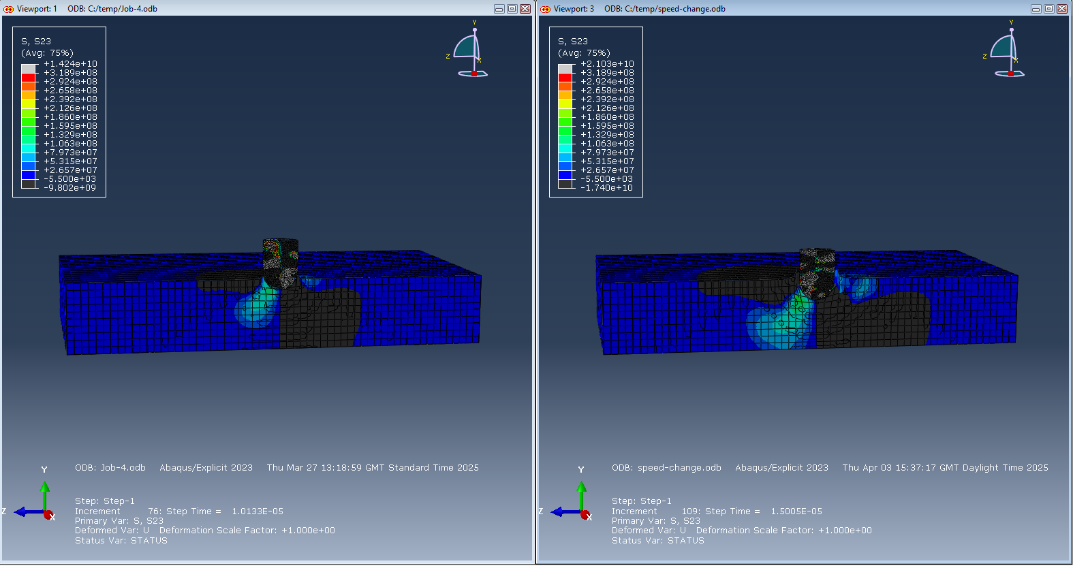
Figure 1: Maximum principal stress at initial contact for Speed 1 (-1000 m/s) and Speed 2 (-1200 m/s).

The figure compares the DHP Cu plate at the very start of projectile impact, showing early-time maximum principal stress distribution at:
Speed 1: -1000 m/s (Left Viewport) & Speed 2: -1200 m/s (Right Viewport)
This frame captures Step-1, Frame 3, where contact is first made, and stress begins to build.
Speed 1 (-1000 m/s):
A small, concentrated red zone appears at the interface between projectile and plate, indicating the start of high tensile stress buildup. Stress is localised and somewhat symmetrical, with minimal propagation into surrounding material. Early stress diffusion is evident, suggesting more controlled deformation.
Speed 2 (-1200 m/s):
Red and orange zones are larger and extend deeper. Tensile stress initiates more violently, displacing material earlier. Indicates a sharper and stronger shock wave, accelerating the onset of plastic flow.
Maximum Principal Stress Analysis
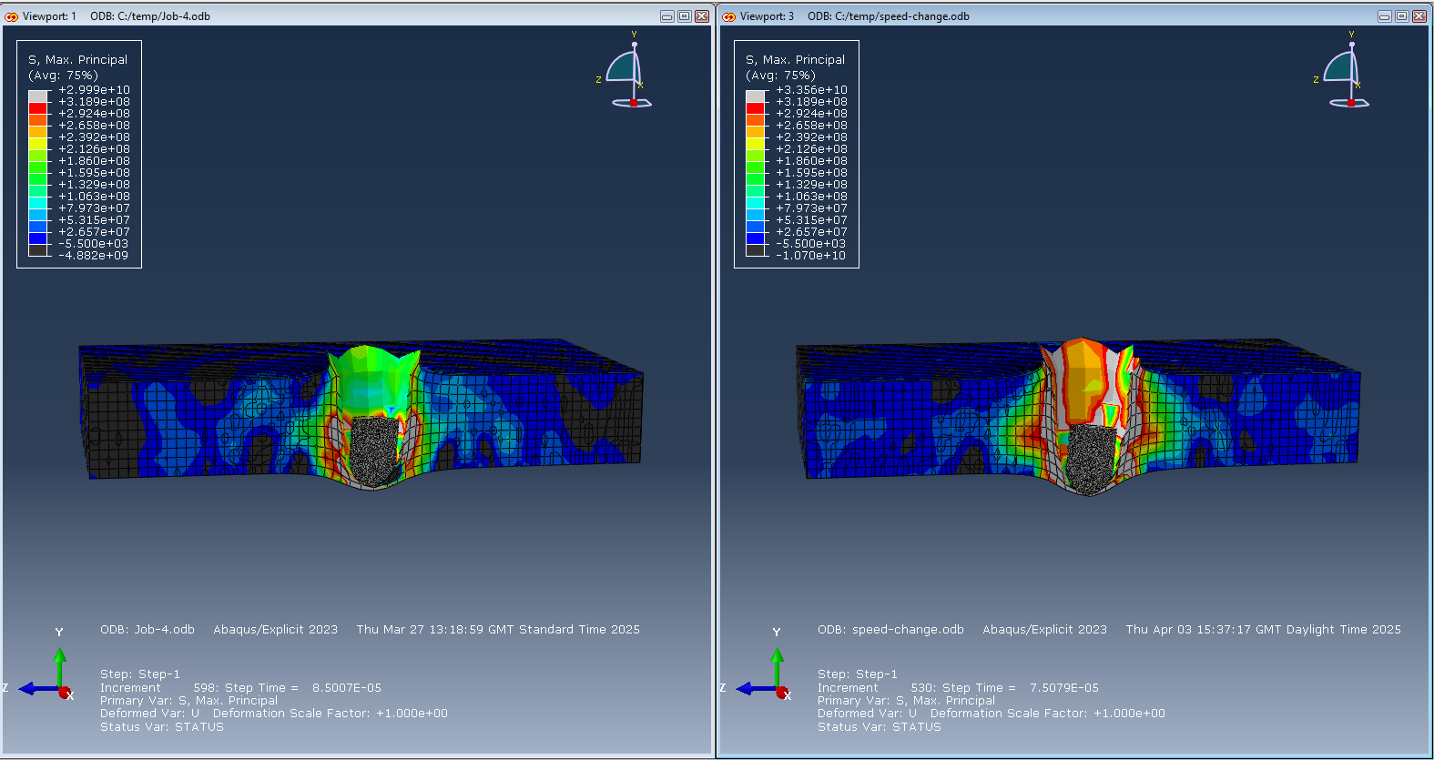
Figure 2: Maximum principal stress distribution after deformation for Speed 1 (-1000 m/s) and Speed 2 (-1200 m/s).
The following figure represents the S. Max. Principal (maximum principal stress) contours in the DHP Cu plate:
Speed 1: -1000 m/s (Left Viewport) & Speed 2: -1200 m/s (Right Viewport)
Speed 1 (-1000 m/s):
High-stress zone is focused on the impact point. Stress magnitudes reach up to +2.13e+08 Pa. Red/yellow core transitions to green/blue, indicating moderate stress diffusion. Deformation is moderate, with a smooth gradient.
Speed 2 (-1200 m/s):
Broader and deeper high-stress region. Stress exceeds +3.19e+08 Pa. Red and white dominate, showing peak tensile stress and potential ductile fracture. Irregular contours imply material instability and damage.
Shear Stress Analysis:
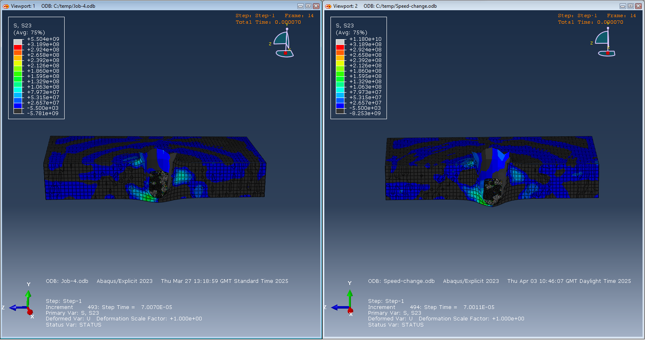
Figure 3: Shear stress (S23) distribution for Speed 1 (-1000 m/s) and Speed 2 (-1200 m/s).
In addition to maximum principal stress, shear stress (S23 component) was extracted from both simulation cases:
Speed 1 (-1000 m/s):
- The colour scale ranges from +5.5e+08 to -5.7e+08 Pa.
- Localised zones of high shear stress near impact zone.
- Clear but limited shear band development.
Speed 2 (-1200 m/s):
- Shear distribution is broader and more complex.
- Red/orange zones scattered, reflecting higher deformation.
- Mesh distortion is significant, suggesting onset of shear failure.
Interpretation of Stress and Shear Behaviour
Velocity significantly affects the stress and failure behaviour. Initial stress buildup at higher speed is more abrupt. Maximum principal stress shows higher magnitudes and deeper propagation at -1200 m/s. Shear stress is more widely distributed and pronounced at higher velocity, indicating greater risk of ductile fracture. This reinforces the necessity of simulating multiple velocities and using accurate material models (e.g., Johnson-Cook) in ballistic applications.
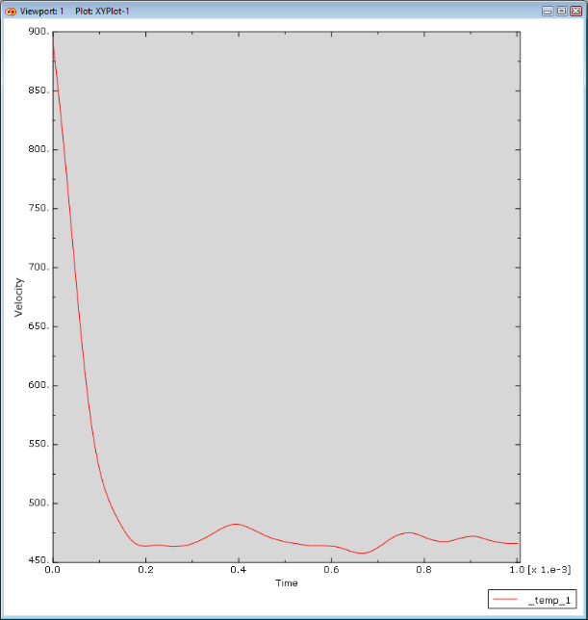

Figure 4: Velocity vs Time plot of the projectile at -1200 m/s.

This graph presents the velocity magnitude of the projectile node (PROJECTILE-1) during the initial 1 millisecond of simulation.
The key observations are:
- Initial spike: The velocity initially exceeds 1000 m/s, matching the defined impact condition.
- Rapid drop: A significant reduction in velocity occurs almost immediately (within the first 0.1 ms), indicating a rapid deceleration due to contact with the DHP Cu plate.
- Oscillations: After the initial drop, the velocity signal exhibits high-frequency oscillations, stabilising around 400–500 m/s.
This behaviour suggests:
- Kinetic energy is being transferred to the plate.
- Reflected stress waves and vibrations are influencing the projectile motion.
- Potential numerical noise from impact mesh contact.
These oscillations are characteristic of elastic/plastic rebound and interaction between rigid projectile and deformable plate materials. Over time, the projectile loses velocity as energy is absorbed by the plate’s deformation and stress dissipation.
Projectile Deceleration Behaviour
The velocity-time response for the -1200 m/s case offers dynamic insights into momentum transfer and energy dissipation during impact. The sharp velocity drop within microseconds confirms the immediate and intense energy absorption by the DHP Cu plate. The oscillatory pattern reflects internal vibrational dynamics, mesh contact effects, and possibly inadequate damping settings in the simulation. Even after significant deceleration, the projectile retains residual motion, suggesting incomplete arrest under the current material setup.
This supports earlier conclusions: while DHP Cu can absorb a considerable portion of impact energy, its ability to stop high-speed projectiles is limited.

DISCUSSION
The results confirm that DHP Cu, while capable of absorbing significant kinetic energy through plastic deformation, may not provide optimal resistance against higher-velocity impacts. Although its ductility and thermal conductivity are advantageous in absorbing and dissipating energy, its relatively low yield strength compared to armour-grade metals limits its ability to prevent deep deformation or potential failure at higher velocities.
Recommended Material for Future Simulation
For future simulations, a more suitable material to consider would be Ti-6Al-4V, a titanium alloy commonly used in aerospace and military applications. It offers a much higher yield strength and specific strength compared to DHP Cu, while still maintaining a reasonable level of ductility. This alloy is well-characterised in the Johnson-Cook material model and exhibits strong resistance to both penetration and dynamic failure under high strain rates.
Key reasons to select Ti-6Al-4V:
- Higher yield and ultimate tensile strength. It offers better resistance to deformation and perforation.
- Strain-rate sensitivity: It performs predictably under ballistic conditions.
- Better energy absorption per unit weight: It enables weight-efficient armour design.
- Established research and parameter availability: Well-documented behaviour in existing ballistic studies [1][2].
While Ti-6Al-4V is more expensive and harder to machine than DHP Cu, its mechanical advantages make it an ideal candidate for protective applications where strength-to-weight ratio and high-speed impact resistance are paramount.
In future work, comparative simulations between DHP Cu and Ti-6Al-4V under identical conditions would yield further insights into performance trade-offs between ductile copper-based materials and high-strength titanium alloys.

CONCLUSIONS
This study has demonstrated the behaviour of DHP copper under high-velocity projectile impact using Abaqus/Explicit simulations. Two velocities, -1000 m/s and -1200 m/s, were analysed to assess the influence of impact speed on stress distribution, deformation patterns, and shear behaviour. Results showed that as velocity increased, stress concentrations and material deformation became significantly more severe, with wider and deeper impact craters and more extensive shear stress fields.
The findings highlight DHP Cu’s capacity to absorb energy through plastic deformation, making it useful for certain applications within the OME field. However, the material's limitations, particularly under extreme dynamic loading, were also evident. This suggests that stronger alternatives may be more effective for high-velocity protection.
Based on this, Ti-6Al-4V is recommended for future simulation work due to its superior strength, strain-rate sensitivity, and widespread use in defence and aerospace contexts. Such comparisons would offer deeper insight into the trade-offs between ductility, energy absorption, and ballistic resistance.
Overall, the use of Abaqus in this study prove invaluable for predicting material response under ballistic loading and support more informed material selection and structural design for protective systems.

REFERENCES
[1] P. Zochowski et al., "Comparison of Numerical Simulation Techniques of Ballistic Ceramics under Projectile Impact Conditions," Materials, vol. 15, no. 1, p. 18, 2022. [Online]. Available: https://www.mdpi.com/1996-1944/15/1/18
[2] I. Reis et al., "Optimisation strategies for multi-layered armour plates," International Journal of Mechanical Sciences, 2023. [Online]. Available: https://www.research.ed.ac.uk/files/324206387/IReis_etal_IJMS_AFPRM.pdf
[3] M. H. Azrin, M. H. Mat, and M. N. A. Rahman, “Simulation of high velocity impact on laminated glass using finite element analysis,” IOP Conf. Ser.: Mater. Sci. Eng., vol. 1182, no. 1, p. 012032, 2021. doi: 10.1088/1757-899X/1182/1/012032
[4] Y. Wang, L. Jiang, and W. Zhang, “Thermodynamically consistent formulation coupling crystal plasticity theory and Johnson-Cook damage model to simulate micromachining of copper,” Procedia CIRP, vol. 99, pp. 554–559, 2021. doi: 10.1016/j.procir.2021.03.075

