Submission 2
Contents Page
1) Provisional Research Question 1
2) Literature Review 1
2.1) Basements in London 2
2.2) Dangers from Equipment and Hazardous Materials 2
2.3) Dangers of different Geology/Working conditions 2
2.4) Legislation 3
2.5) Tunnelling in the London Underground 3
3) Other References/Sources of Information 5

Provisional Research Question
How can Health and Safety be improved when tunnelling or excavating below ground?

Literature Review
What is known about the topic?

Throughout the project, I want to gain a good understanding for Health and Safety when working below ground and further my knowledge within the area. Additionally, I would like to propose ideas for how I believe the sector can be improved to minimise the chance of injury occurring on site. I will also touch on the differences between tunnelling and basement construction, as there might be some similarities between the two.

The project will help for future employment, as I can show that I have existing knowledge within a niche area, where others might not. Furthermore, Health and Safety is becoming the main focus of the Construction industry and without it, there would be significantly more injuries and deaths. Therefore, it is imperative that everyone working in the industry has a very good understanding of what is safe and unsafe on site.

Basements in London
The topic is niche within the sector and is very job specific. Some individuals will have plenty of experience, whereas others won’t experience this type of construction throughout their career. Excavation underground is very common in places such as London, where land is incredibly expensive, therefore, it tends to be cheaper to utilise as much as possible by digging multiple stories underground. [1] The Evening Standard wrote an article in 2015 stating that “Dozens of basements being excavated under homes in central London are potential death traps for the workers digging them out, according to a shocking report from health and safety officials”. It states that “almost half of the 107 sites seen in an unannounced inspection blitz of building sites earlier this month were in breach of health and safety rules”. This is an unacceptable number of sites not following the legislation in place when constructing these basements. There should be a significant punishment for those involved and check-ups for improvements in working standards throughout all the companies mentioned. This would protect the workers and decrease the number of incidents occurring within the sector.

Dangers from Equipment and Hazardous Materials
When constructing underground there are many dangers that must be considered to ensure that works can be carried out safely throughout the project. Things such as traffic and machinery in a dark dusty environment can make it difficult to see and manoeuvre in tight spaces. Additionally, hazardous materials must be kept in a safe location and checked often to prevent serious issues. Fumes from equipment must be transferred out of the tunnel to prevent Carbon Monoxide poisoning and allow workers to carry out jobs safely. This is why multiple reliable ventilation systems are required to ensure that workers have a consistent oxygen source whilst underground. [2] The government document states multiple key hazards to watch out for when working below ground or tunnelling.

Dangers of different Geology/Working conditions
Another consideration is the structure of the tunnel in terms of supports, spalling, collapse, different geology etc. This is crucial, as if there are soft ground conditions, then extra consideration must be taken to support this. Additionally, there is a higher risk of collapse occurring. [3] This happened in 1960 in Lebanon whilst constructing the Awali Tunnel. “A huge flow of water and sand filled over 2 miles of the bore and more than doubled construction time to eight years for its 10-mile length”. This would have had serious economic effects and delays to the project. Furthermore, the incredible danger that can occur if there is a serious collapse and workers are stuck in the tunnel.

Legislation
The topic within question is an ongoing concerning issue of how much safety is required to mitigate risk, whilst ensuring that the project can be completed within a sufficient period of time. [4] The BS 6164:2019 is the main Code of practice when it comes to Health and Safety when tunnelling within the United Kingdom. It considers the majority of aspects, however, is not a standalone piece of legislation and depends significantly on other standards. These are continuously being updated and adapted to suit current circumstances and developments in technology. For example, recently there has been a change in technology such as “the use of high pressure compressed air techniques for cutterhead interventions”. This ensures that material and water in the chamber is supported preventing inflow. Additionally, the size of shafts has been considerably increased to ensure the safety of workers in confined spaces.

Tunnelling in the London Underground
Tunnelling tends to be even more expensive, as these tend to be deeper than basement construction and therefore, equipment and resources have to be transported underground. [5] For example, tube “platform depth can vary from 15-25m below the surface”. The Victoria, Jubilee and Bakerloo lines in London run below sea level. [6] As can be seen below, the routes all dip below the sea level and with issues such as rising sea level, this is only going to get worse. [7] This means workers must be incredibly careful to avoid flooding or tunnel collapse when working in such an environment as it can happen so quickly, especially with London’s ever rising tides of the Thames.

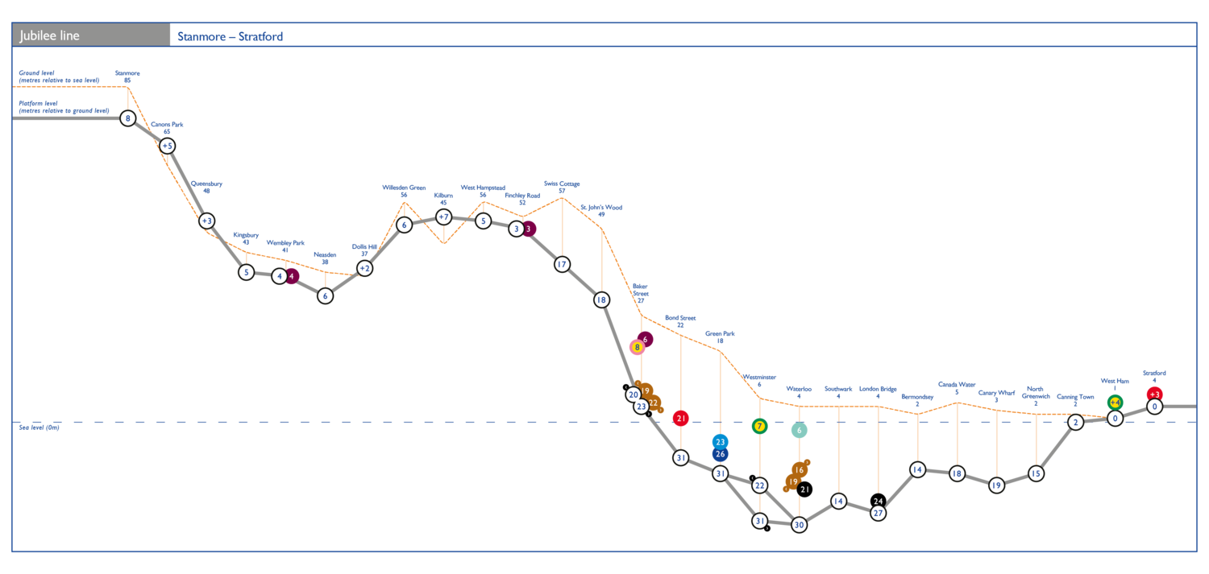
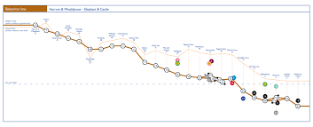
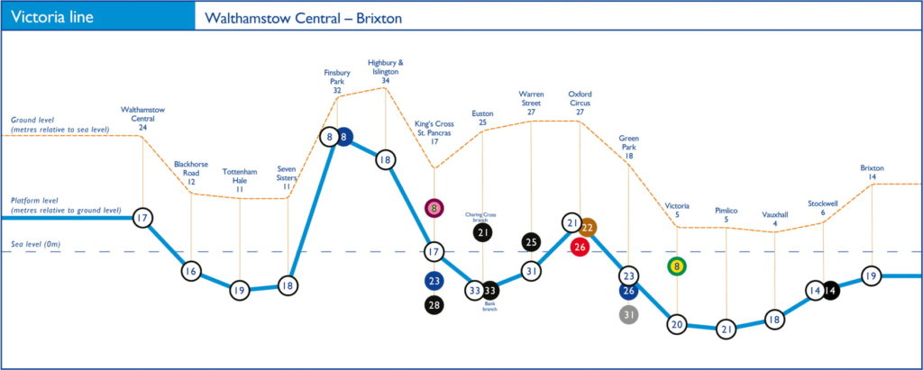

Other References/Sources of Information
[1] Bar-Hillel, M. Prynn, J. (2015). Basement dig ‘death traps’: workers’ lives at risk on building sites under London Homes. Evening Standard. Available from:
https://www.standard.co.uk/news/london/basement-dig-death-traps-workers-lives-at-risk-due-to-unsafe-building-under-london-homes-10145141.html
[2] CFRA. (2020). Generic Risk Assessments Rescues from tunnels and underground structures. Department for Communities & Local Government. Available from:
https://assets.publishing.service.gov.uk/government/uploads/system/uploads/attachment_data/file/877045/GRA_2-7_tunnels_archived.pdf
[3] Lane, K. (2022). Tunnelling techniques. Britannica. Available from:
https://www.britannica.com/technology/tunnel/Tunneling-techniques
[4] Lamont, D. (2019). Health and safety in tunnelling in the construction industry. United Kingdom: British Standards. Available from: https://memberportal.bsigroup.com/public/2019/december/health-and-safety-in-tunnelling-in-the-construction-industry/
[5] Massinas, S. (2019). Designing a Tunnel. Intechopen. Available from:
https://www.intechopen.com/chapters/70605
[6] Silva, D. (2018). London Underground Tube Lines. Dansilva. Available from:
https://www.dansilva.co.uk/down-underground
[7] Martinez, M. (2018). The challenge of tunnelling under the Thames. Ferrovial blog. Available from:
https://blog.ferrovial.com/en/2018/09/tunnelling-under-the-thames/

