University Of Wales Trinity Saint David

Wales Institution of Science and Art

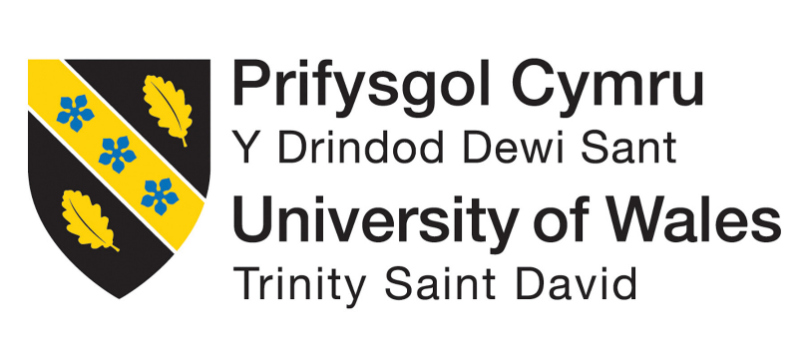

Reflective Project Report

Group Project (ACMA5009)

Kenyon Dale Montana
2123458
May 2024

Abstract

This report will explore extensively, Riversimple’s success in fulfilling their role within the Milford Haven: Energy Kingdom Project (MH: EK). The company’s methods of initial business management opportunity were studied, with them having successfully outlined the viability of the project through SWOT and PESTEL analysis. Their change management programme for the project was also discussed, with the company successfully implementing changes under the guidance of Kotter’s 8-Step Change Management Model. Moreover, their leadership structure was deemed appropriate for the company, using Fielder’s Contingency Theory to highlight how due to the small but uniquely specialised staff, there was not one appropriate leader for the differing tasks.
Riversimple desired outcomes and ambitions from the project were outlined and how they successfully achieved these goals. Immense changes to their workflow and management was required and necessary, having developed a streamline workflow of managing engineering issues and technicians’ progress with fast tracking the development of the fleet. Determining and isolating the essential changes aided in ensuring that the entirety of the Beta fleet was completely ready to undergo public trials. Changes in services such as the development of the service team proved vital in ensuring the client to company relationships remained streamlined. Enormous development in software further aided in data collection and serviceability of the car, providing early warning of when components needed service or underperforming. One of their largest goals to gain from the project was real world data of the fleet, which was gathered extensively, and an immense end of project report was published by the governing body of the project. This emphasised the viability of a hydrogen powered community especially in the automotive sector, an indicator towards Riverimple’s success throughout the project.

Contents
University Of Wales Trinity Saint David 1
Abstract 2
Contents 3
1. Introduction 4
2. Analysis Timeline 5
3. Methodology 6
3.1 Aims & Objectives 6
3.12 Aims 6
3.13 Objectives 6
3.14 Rationales. 6
4. Management Analysis 8
4.1 Assessment of Riversimple’s Initial Business Opportunity Analysis 8
4.2 Change Management Assessment. 10
4.21 Step 1: Creating a Sense of Urgency 11
4.22 Step 2: Creating a Guided Coalition 11
4.23 Step 3: Building a Vision and Strategy 11
4.24 Step 4: Communicating the Change Vision 11
4.25 Step 5: Empowering Broad -Based Change Step 6: Generating Short Term Wins 12
4.26 Step 6: Generating Short Term Wins. 12
4.27 Step 7: Generating Short Term Wins. 12
4.28 Step 8: Anchoring New Approach in Culture 12
5. Leadership and Management 14
6. Riversimple’s Desired Outcomes from the MH: EK Project 17
6.1 Management and Workflow. 17
6.2 Telematics and Vehicle Response. 18
6.3 Service. 18
6.4 Real World Data 19
7. Conclusions 20
8. Bibliography 21

Introduction

This report will be evaluating Riversimple’s effectiveness in providing their services in aiding with the Milford Haven: Energy Kingdom Project (MH: EK). MH: EK is a project undertaken by the Pembrokeshire County Council focusing on initialising with small steps, large-scale decarbonisation within their county (Pembrokeshire Council, 2021). This covers an abundance of differing sectors from home electricity, heating, and even transport. Riversimple played a quintessential role within the project, providing the council with their fleet of hydrogen powered vehicles, the Rasa, and the complementary services around it. Riversimple is a company in Mid Wales, pioneering zero emission vehicles through their hydrogen powered cars and systematic approach to negating the automotive industry’s impact upon the environment. Their approach simply does not start and end with innovative and sustainable technology, but to carry this belief in their business model and their corporate governance. Their passion towards their ambition is highly evident in their mission statement, “To pursue, systematically, the elimination of the environmental impact of personal transport.” (Riversimple, n.d).
This reflective report will evaluate the management of Riversimple’s vehicle readiness within the project and in succeeding with their own desired outcomes from the project. Riversimple’s predominant ambitions within this project was to gain real world data on their vehicles and provide their services effortlessly. The main goals of this initiative for Riversimple were to gather real-world data about their cars and easily offer their services. MH: EK was the company's first trial launch in which the cars were to be fully removed from their control for an extended period—a first for Riversimple. With the project with Pembrokeshire Council being the first trial being remotely supported by Riversimple, it forced a great deal of vital changes within the company and aided heavily in understanding the plethora of hinderances in providing the service or in vehicle readiness.

Analysis Timeline

Methodology

Outlining the aims and objectives from this analysis will provide a valuable indicator towards its success. Being able to set and understand goals greatly increases the likelihood of the task being fulfilled due to increased motivation (Locke & Latham, 2002). It is therefore vital that the goals are clear and realistic, hence why the aims and objectives from this assessment will be organised in the fashion of aims, objectives, and rationales. These aims and objectives outline the purpose of the report and the chosen methods used to analyse Riversimple’s success throughout the project.

3.1 Aims & Objectives

3.12 Aims
- Assess Riversimple’s implementation of change.
- Analyse Riversimple’s leadership and management throughout the project
- Determine how successfully Riversimple accomplished their desired outcomes.

Objectives
1i. Examination on the company’s initial business opportunity analysis.
1ii. Assess against models of change management, Riversimple’s management of change.
2i. Determine which structure of leadership and management the company follow.
2ii. Analyse said model, both pros and cons.
3i. Outline the company’s desired outcomes from the MH: EK project.
3ii. Verify how successfully these desired outcomes were achieved.

Rationales.
- Within this set of objectives, research regarding models of change management will be studied. A singular change management methodology will be selected from the vast number of models (such as Lewin’s, McKinsey, Kotter’s, etc) and will be used to consider whether Riversimple’s implementation of change was effective. Furthermore, the initial assessment of the business opportunity will also be analysed. Their methods of opportunity analysis (such as SWOT or PESTEL) will be scrutinised and if needed, improvements or even different methods of analysis will be suggested.

- The company’s leadership and management structure will undergo evaluation as the second set of objectives of the investigation. Firstly, research is required into the differing models of company leadership structures to determine under which structure Riversimple categorises into. This will aid heavily in understanding whether Riversimple are managing under the appropriate model of leadership or whether revision is needed. Advantages and disadvantages of said leadership model will then be investigated which can aid in revealing flaws of the leadership and further understand how it can be improved.

- Riversimple’s goals and desired outcomes from the MH: EK project will be examined, determining the effectiveness of their goal setting against research methodologies. Success of the project and how well they achieved these desired outcomes will be further dissected and will indicate their overall success of their management.

Management Analysis

4.1 Assessment of Riversimple’s Initial Business Opportunity Analysis

A company's transition from its current state to a desired future or objective is referred to as change. Different team members or organisation members may view change differently—some favourably, while others may view it unfavourably. Mullins (2019) states that resistance to organisational change is a common occurrence and can have both good and negative effects on the change's success. Individuals or entire organisations may be resistant to change for a variety of reasons. These may include self-interest on the part of the individual or the possibility that the change in behaviour is an attempt to escape security and habit. Mullins went on to say that the success of the transformation was determined by the way it was managed and the roles that individuals played within the teams (Mullins, 2019). As such, an analysis of Riversimple's management strategies is essential.
The MH: EK project's completion presented the chance for the shift. It was discovered after the Pembrokeshire County Council contacted the business, which prompted a SWOT and PESTLE analysis of the business opportunity to determine the project's viability.

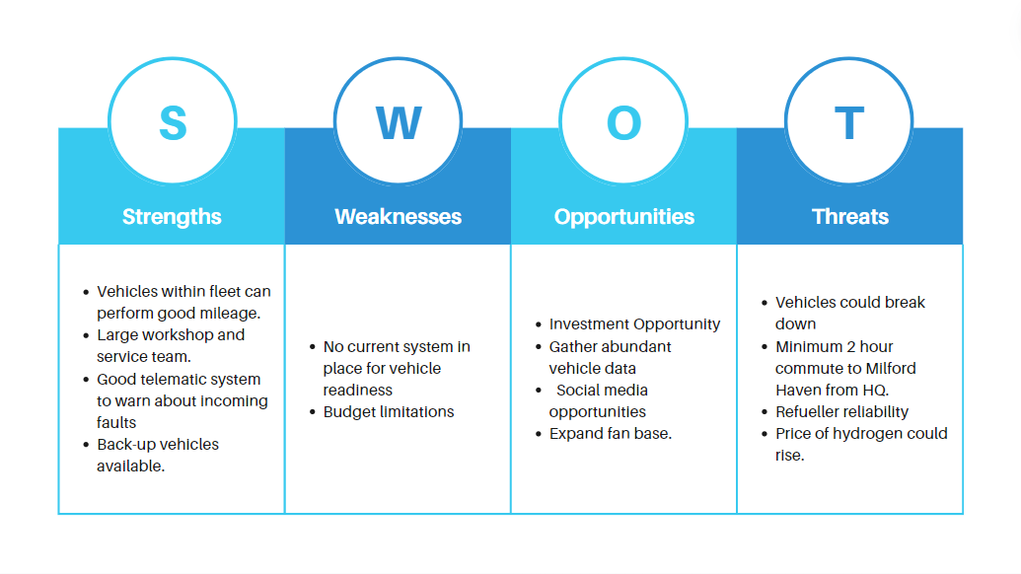
Figure 1 - Riversimple MH: EK Project SWOT Analysis
A basic initial SWOT analysis of the key aspects to be taken into account for the MH: EK project is shown in Figure 1. A SWOT analysis is a quick and efficient planning approach that illustrates the topic's advantages, disadvantages, opportunities, and strengths (Haan, 2024). As demonstrated in Figure 1, all the data is easily represented in a very readable way, making it highly presentable in front of sizable groups and helping to streamline the project's primary objectives. When analysis points are assigned a rating weight and hierarchy, SWOT analysis can also be pushed further to be driven by numbers (Jenco & Lisa, 2018).
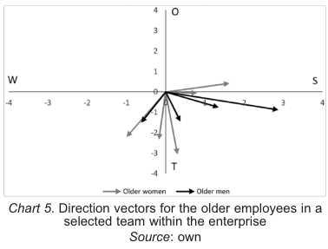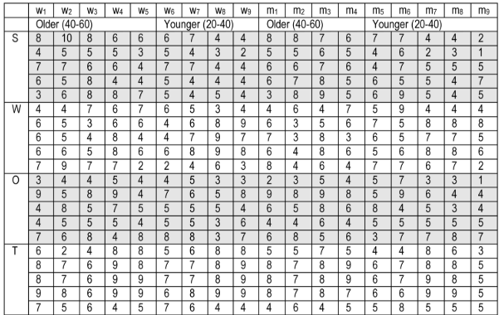
Figure 2- SWOT Analysis Table and Graph with Numeric Data (Jenco & Lisa, 2018).
Figure 2 shows how a SWOT analysis can be expanded upon to a great extent. This illustrates how this type of analysis may be very affordable and straightforward while still having the ability to significantly influence strategy direction. It can also be as simple as a box structure or as complicated as data-driven graphs due to its great flexibility. The SWOT analysis used by River Simple is particularly helpful in identifying and emphasising the project's primary concerns. It considers the chances it can take advantage of while also being aware of its biggest risks. Nevertheless, they need to add another analysis technique, which they have already done using PESTEL.
However, as Figure 1 illustrates, the SWOT analysis is frequently applied in its most basic form, which may not be the most efficient way to classify the many variables that may need to be taken into account. Sorting the various points, like in a PESTEL analysis, can give us further guidance on how to approach the problems more skilfully. For instance, using a PESTEL study to address every topic, from politics to law, would provide a more methodical and disciplined approach to working than using a SWOT analysis. Additionally, in order for the process to be as effective, it must be repeated frequently, which would be laborious and not the best use of labour and time (Haan, 2024).

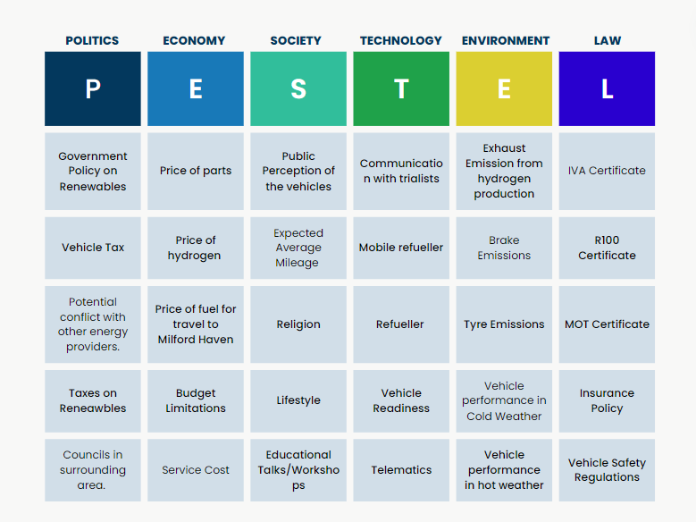
Figure 3 - Riversimple MHEK Project PESTEL Analysis
The first PESTEL study completed by Riversimple with reference to the MH: EK handover is shown in Figure 3. The PESTEL analysis is very helpful in classifying the variables under consideration, as was previously described. Additionally flexible, this type of study may be used to analyse more specialised issues like a separate PESTLE analysis on the vehicle or even the service being rendered, as well as more general themes like the MH: EK handover. Additionally, businesses can maintain compliance with the various regulations and politics surrounding the project by regularly updating their PESTEL analyses (Frue, 2016). In Riversimple's example, the politics and law section of the analysis makes evident the multiple laws, taxes, and certifications that must be complied with to be in compliance with all the laws, providing customers with a safer experience and reducing the likelihood of fines and penalties. Like SWOT, this analysis technique is low-cost, straightforward, and efficient. Their application of a PESTEL study is obviously very beneficial and crucial.
It is a very time-consuming way of analysis, even if it is quite straightforward. Every argument presented in every table section needs to be carefully considered. Additionally, this approach does not address internal issues as well as it addresses external factors (Frue, 2016). While it is crucial to take into account the elements beyond the company's control, internal factors have the potential to significantly impede the advancement of its change initiative.

4.2 Change Management Assessment.

Kotter's Eight Step Change Model will be used to examine whether the measures performed were the most successful in applying the change in order to scrutinise the efficacy of Riversimple's handover. Kotter's Eight Step Change Model is a management approach that encourages employees to swiftly adopt new advancements, technologies, and changes in order to spur companies to embrace change and innovation (Jain, 2019).

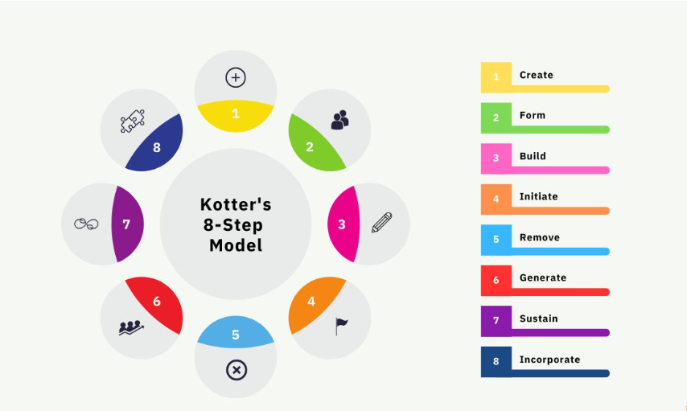
Figure 4 - Kotter's 8-Step Model (Jain, 2019)

The eight phases of the change management framework are shown in Figure 4. Effective change management requires careful consideration of every stage in the model.

4.21 Step 1: Creating a Sense of Urgency

According to Kotter (2008), a hazardous degree of complacency and an extreme lack of urgency are the main causes of the 70% failure rate of change management endeavours. He makes it extremely apparent that the effectiveness of a shift depends greatly on this initial phase. Creating a feeling of urgency was comparatively straightforward for Riversimple because of their tiny but incredibly committed crew. In order to provide prompt client assistance and vehicle preparedness, specific teams were created. To add to the urgency, deadlines and lofty objectives were established. Riversimple, who had never tested their automobiles before, was excited to go through the process. This removes the obstacle that arises when employees are unmotivated to put up with the difficulty of change (Ansari and Bell 2009).#

4.22 Step 2: Creating a Guided Coalition

In this phase of the plan, a group with the power and knowledge to spearhead the change must be formed. These people inside the group are often supervisors and leaders who help spread the word about the change throughout the company by educating and supporting the remaining employees (Jain 2019). With their founder spearheading the shift, a project manager ingraining the values in the workforce, and a workshop manager assisting in making sure the cars met their technical milestones ahead of schedule, Riversimple was able to effectively execute this through its organisational structure.

4.23 Step 3: Building a Vision and Strategy

During this phase, the change's goal must be outlined precisely, and a sensible plan needs to be developed. Top management must provide the overarching vision, while individuals like Riversimple's project manager build the logical framework for organising tactics (Ramasamy & Ramaswamy, 2017). Focus sprints were designed to accelerate the development of vehicles and focused on problems that would make an automobile unsuitable for testing. These had aggressive deadlines as well. In order to monitor progress, agile management techniques were also applied, such as the usage of kanban boards and regular morning meetings.

4.24 Step 4: Communicating the Change Vision

Effectively communicating the change's vision is the model's fourth stage. This covers every employee, custodian, investor, and member of the organisation in the case of Riversimple. It is crucial to have clear communication since conflicting instructions from upper management can easily impede the implementation of change (Kotter, 1996). Given the small and cohesive team at Riversimple, this was less of a problem. Precautions were implemented, including calling a planned meeting to go over the specifics of the transfer to the MH: EK project. This reduced investor and labour uncertainty and made the process of implementing the change go more smoothly.

4.25 Step 5: Empowering Broad -Based Change Step 6: Generating Short Term Wins

This model section emphasises that workers who bear the responsibility of effectively implementing change are endowed with the authority to undertake pertinent actions. According to Ramasamy and Ramaswamy (2017), institutional impediments, a lack of necessary abilities, and managers who aren't always amenable to activities meant to carry out the change are the key obstacles to this. To address a portion of these obstacles, Riversimple actively trains its employees. An obvious bottleneck in the manufacturing line, for instance, was the fact that only one worker was competent and able to fit the piping for the hydrogen systems. This was fixed when four more workshop team members completed the training and were certified to do tasks that had previously only been performed by one employee. In addition, Riversimple had a monthly corporate culture day when a guest firm helped to develop the existing strong company culture. This encouraged casual conversations with the CEO, who was already very forthcoming.

4.26 Step 6: Generating Short Term Wins.

The creation and celebration of short-term victories is vital for raising spirits and, consequently, for the advancement of change. According to Pollack J. and Pollack R. (2014), many participants believed that the change was stagnating because they had forgotten about the modifications that had previously been effectively enacted. When Riversimple was going through handover readiness for the MH: EK project, this was kind of obvious. Even though the short-term goals were explicit, observable, and closely tied, as recommended by Kotter (1996), they were frequently ignored in favour of the next objective. Given the extremely tight deadline, the business may have used materialistic rewards like gift cards or other items to thank the staff for their short-term successes.

4.27 Step 7: Generating Short Term Wins.

The extended period of time between deployment and effective acceptance is addressed in this step of the model (Jain, 2019). Similar to the previous step, this one also tackles complacency, which is the first major obstacle to change. Jain continues by discussing the need for additional funding for staff change management training in order to fully implement the reforms. Riversimple may have profited from ongoing education and growth in the area of change management, but they did not receive this extra training. Not that they didn't keep most, if not all, of the modifications made during the MH: EK experiment.

4.28 Step 8: Anchoring New Approach in Culture

New, passed-down practices that originated in the implemented stage are found in the final stage. This might include redefining goals, documenting new procedures, and revising the workflow (Ramasamy & Ramaswamy 2017). A good outcome in this last phase suggests that the transformation was effective. When Riversimple's MH: EK testing concluded, this became very clear. The process utilised to resolve technical problems and prepare vehicles for trials is now fully standard in the development of the vehicle, much like the sprint runs for vehicle trial preparation. Because of the lessons learned during the MH: EK testing, the service model has also been significantly simplified. In fact, all of the lessons learned were applied to the ongoing beta trials in Abergavenny.
This model of change management is immensely useful, with plentiful amounts of corporations considering it to be standard practise. It is extremely simple to implement with plentiful amounts of studies towards it, not to mention the numerous books Kotter himself has written on the matter. This provides companies with extensive material to aid and guide them through change management projects. In addition, the model emphasises on the contribution and acceptability of multiple parties within the organisation such as the employees by forming guided coalitions for the success of the initiative.
On the other hand, the model does come with some disadvantages. Firstly, the model is strict and rigid, perhaps not suiting some situations of change that are more complex and unique. Kotter’s eight step model also does not consider the affects of change towards the parties involved. Large organisational changes often lead to anxiety, fear, or loss as Kotter himself stated. This can highly affect the morale, performance, and output of the entire company. Similarly, the model lacks to highlight how organisations should communicate how the implementations benefit the staff themselves. This links with the previous point of anxiety and would instead promote the change as appealing and desirable. Furthermore, this can fast track transitions as the staff would want to undergo this change and not feel as if they have to.

Leadership and Management

Since each employee at Riversimple specialises in a different area and the company is quite small, the management structure is highly flat and lacks a formal hierarchy. As a result, Fielder's Contingency Theory is the ideal paradigm to operate under for the organisation. This approach is predicated on the idea that there isn't a single best kind of leadership; rather, the best kind of leadership depends on the circumstances and job at hand (Asana 2022). A leader's position on the Least Preferred Coworker (LPC) scale is shown by the model. This rating system is based on how much you really or negatively value your least favourite coworker. Higher scores indicate a greater interpersonal orientation, whereas lower scores indicate a task orientation. According to Fielder (1967), positional authority, leader-employee relations, and task structure all influence how advantageous a situation is.

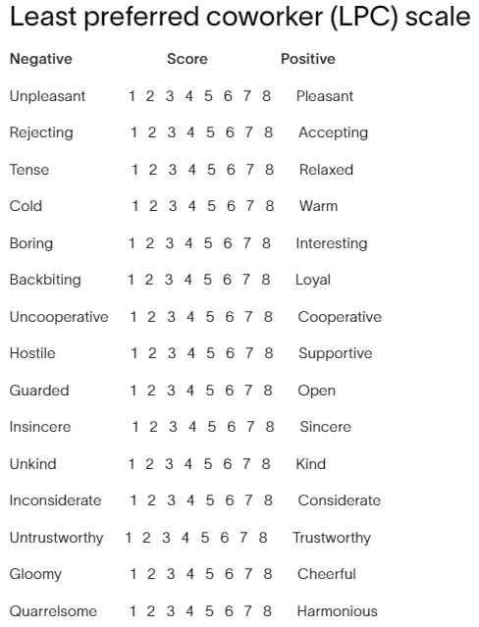
Figure 5 - LPC Scale Questionnaire (Asana 2022).

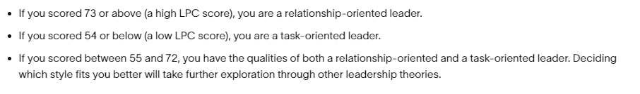
Figure 6 - LCP Self-Assessment Scoring (Asana 2022)

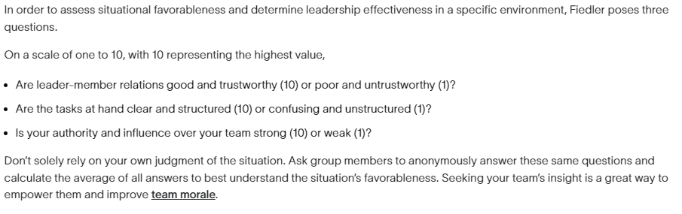
Figure 7- Situation Scoring (Asana 2022).

Figure 4 demonstrates the first test that potential leaders must undertake. As mentioned beforehand, this stage is under the basis of how you perceive your least preferred coworker under differing variables under a scale of 1 being the most negative and 8 being the most positive. Figure 6 highlights the scoring system and what it represents. High scores above seventy-three are considered as relationship-oriented leaders, whereas lower scores of fifty-four and below are considered to be task-oriented leaders. Scores in-between these two categories are stated to be a mixture of traits from both task and relationship-oriented leaders.
Figure 7 is the last of the questionnaires, where Fielder poses three questions towards the subject concerning their relationship with the members of the task, structure of the task, and authority over the members of the task. These are ranked within a scale of one to ten with one being most negative and ten being the most positive.

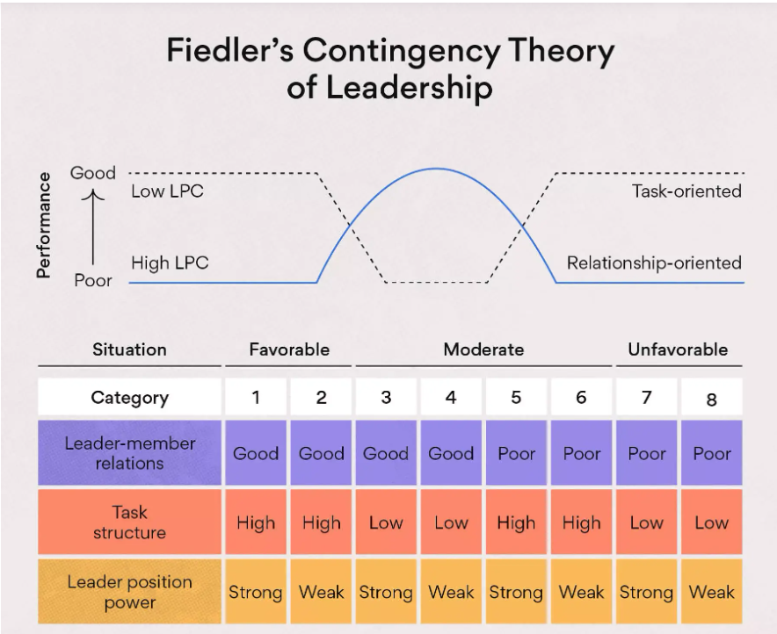
Figure 8 - Table and Graph for Leadership Type Best Fit (Asana 2022).

The scenarios where certain ranking LCP leaders are more advantageous than others are shown in Figure 6. While high LPC members are more advantageous for projects that are somewhat favourable, task-oriented leaders are better suited to handle the extremes of least and most favourable.
As was previously said, Riversimple greatly benefits from this leadership approach because the organisation lacks a fixed or formal management structure. This makes it possible to assign the proper unique leader to each unique assignment. Fielder's concept is applicable given the wide range of difficulties that need different levels of knowledge due to their distinct natures. However, there are a number of notable problems with the current paradigm. First off, if a leader receives a score between 55 and 72 in the median area, Fielder (1996) does not offer any helpful insight into the kind of leader they could be. He offers no direction and leaves things up for interpretation. The problem with self-evaluation is that an individual's response to these questions could not be totally truthful or consistent with their mood. A person's perception of their least preferred might differ greatly. It's possible that the least liked coworker is someone who genuinely discomforts everyone else at work.
For the time being, this approach functions well at Riversimple because of the team's size and the makeup of the workforce, which includes the fact that most employees are closely related and have strong bonds. This also includes the fact that the team consists of specialised individuals in their own unique field. However, the team's size will undoubtedly grow significantly as the business gets closer to production scale, and the level of closeness among team members will decline. This makes it necessary to adopt a more organised leadership model—perhaps a systems or classical approach.

Riversimple’s Desired Outcomes from the MH: EK Project

As the concluding indicator towards Riversimple's success within the MH: EK project, their actual performance towards their desired outcomes will now be analysed. Riversimple sought to provide the project with reliable vehicles, effortless service, and to gain real world data from their vehicles. As mentioned before, this was the company’s first public trial, and quintessential changes were forced to occur for the trial’s success. This section of the report will outline the variables that the company succeeded, failed, and improved to accomplish their desired outcomes from the project.

6.1 Management and Workflow.

During the initial conceiving of the MH: EK Project, the fleet of Rasa’s were far from complete in terms of trial ready. The vehicles being the beta fleet, details that were very minute to larger scale details left the fleet unprepared for a trial. This was due to the focus of the company in general development of hydrogen cars as a whole and small details such as cupholders were not necessarily considered until the opportunity of a public trial was presented. Larger and more vital aspects such as reliability and efficiency were also further enhanced. Upon preparations for the trials and handover, the company amassed a large backlog of engineering, management, and service issues.
The first step towards resolving this were the changes in workflow and management. “Design sprints” were organised where specific issues that would hinder or prevent a car being deemed suitable for trial were isolated and became priority. The use of engineering issue management software was imperative to organising this. A tool called Jira was used where an engineering issue would undergo an extensive number of thorough stages until completion.

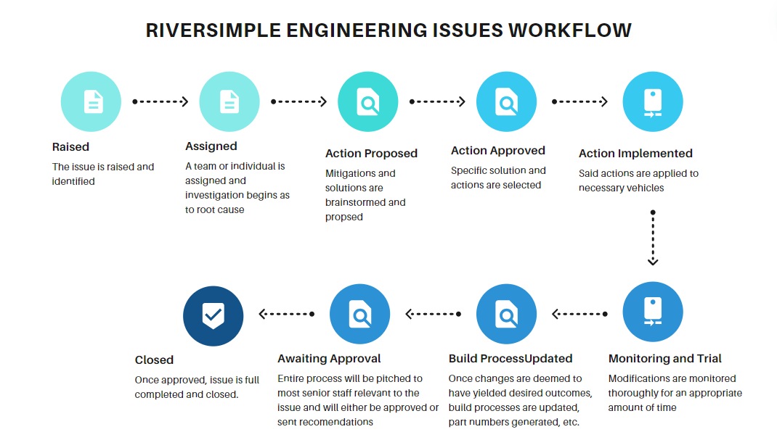
Figure 9 - Riversimple Engineering Issues Workflow
Figure 9 depicts this workflow and highlights the carefully conducted stages an issue undergoes to pass completion. This then feeds from the engineering team to the actions of the technicians. Within the workshop, different agile management tactics were also deployed such as the use of a KANBAN board. This was a table on a board that tracked the progress of different modifications within the vehicles of the fleet.
As the fleet approached trial readiness, a handover approval sheet was to be reviewed. This was a new process developed for the trial where four variables were graded using a traffic light system. Said variables consisted of programme management, vehicle engineering, build quality, and service. These variables were graded as green being trial ready, red being not suitable for trial, and amber as suitable for trial but with mitigations or plans for resolution in a following service. A comprehensive report was also written for each of these variables per car.

6.2 Telematics and Vehicle Response.

Live data sourcing and telematics of the fleet developed rigorously throughout the duration of the project. Initially, the telematic data was organised using excel sheets which had to be filled out by and engineer. This then evolved immensely, with the company developing two vital pieces of software to streamline this process. The first of which was called journey summariser and tracked the vehicle’s location at all times, displaying it on a map with geological information and status of the main components such as fuel cell voltage, motor temperature, etc. Alongside this, a graph-plotting software allowed for all the components in the vehicle’s data to be viewed at any given second of a journey. This allowed for analysis on general performance on the vehicles and more importantly, to be able to detect if a component was underperforming or nearing a failure. This allowed for a service to be scheduled way before a component were to occur.
In addition, the vehicle’s software made significant progress in terms of failure response. Previously, the vehicle’s programmed response to certain component failures would be to shut off completely to avoid further damage (extremely rare situation and only occurred a few times). Revision to the software resolved this, where instead of shutting down, the vehicle would turn off the perpetrating component and determine other which other components are at risk. This then allowed for the vehicle to function as normal with hinderance to performance, allowing the driver to safely pull over.

6.3 Service.

Service throughout the project streamlined drastically. The company struggled initially in certain aspects of service but quickly resolved them. For example, the first scheduled service was an immense failure, Riversimple sought to provide a software update to one of the vehicles and provide their first out of their fortnightly services. The designated technician team were unable to complete the majority of this due to lack of communication between the engineers and the technicians where the incorrect tooling was taken to the service, preventing them to update the software. With Milford Haven being a two-hour commute, it was not possible to make the journey just for the tooling. Furthermore, the technician team were provided with the incorrect meet-up location due to the lack of communication to the client. They waited for over an hour upon arrival as they could not get hold of the client and the schedules were incorrect.
To resolve all these issues, a dedicated service team was organised, which constantly received updates from clients and organised thoroughly the service sessions. A training session was arranged for new trialists where they would be taught how to operate all aspects of the vehicle. This included a pack that informed them of all the different warning symbols the car could flag and what the appropriate and safest way to respond is.

6.4 Real World Data

In terms of data collection, this saw great success. With the advanced telematics and logging of different logistics, the company alongside the Pembrokeshire county council have published an extensive 107 page report on the project. In sections of this report, the viability, efficiency, and costs of hydrogen vehicles were compared to diesel vehicles. Plentiful information was sourced and highlighted the potential future of hydrogen vehicles. The general performance of the Rasa was also published, a great deal of information that was released to the public for the first time such as vehicle range.
Outside of technical data, the company received plentiful feed back on other aspects of the car. With a large and diverse range of trialists, recommendations on ergonomics, drive feel, aesthetics, and even small quality of life changes such as storage was abundant.

Conclusions

In Conclusion, Riversimple were immensely successful in preparation and throughout the MH: EK project. The company evaluated the viability of their business opportunity thoroughly using the PESTEL and SWOT analysis, having considered a great number of external factors that could come into play. This proved useful as multiple of these discussed threats occurred during the trial but mitigations were already set in place (such as a pre-scheduled service for when a component is underperforming). On the other hand, they lacked to consider the internal factors that could have had larger impact on the company such as staff morale.
Upon analysis of their change management strategies and leadership, it was seen that their implementation of change was highly effective. This is made abundantly clear with the fact that all the new processes, technologies, and service advancements are still in used and are being applied and further developed in their current public trials in Abergavenny. Moreover, their leadership structure deemed highly suitable for the nature of the company highlighting their flexibility and adaptability to the plethora of tasks. But as mentioned beforehand, this will have to be revised as the company continues to expand.
The company’s intrinsic goals from the project were also met, having streamlined their services as the project developed. Although, these problems concerning communication could have been resolved much earlier within the vehicle readiness stage instead of having to resolve it after the project began. Real world data was also harvested from the trial where the data from day to day has influenced how the vehicle is being developed as well al providing fundamental data to the viability of a hydrogen ecosystem versus standard vehicles, presented in the end of project report by Pembrokeshire County Council. Operations within Riversimple evolved tremendously throughout the course of MH: EK which has clearly boosted their progress towards their final ambition, “to pursue systematically, the elimination of the environmental impact of personal transport." (Riversimple, n.d).

Bibliography

Ansari, S. and Bell, J. (2009). Five Easy Pieces: a Case Study of Cost Management as Organizational Change. [online] Journal of Accounting & Organizational Change. Available at: https://www.emerald.com/insight/content/doi/10.1108/18325910910963418/full/html [Accessed 25 Apr. 2024].
Asana (2022). Fiedler’s Contingency Theory: Why Leadership Isn’t Uniform. [online] Asana. Available at: https://asana.com/resources/fiedlers-contingency-theory [Accessed 4 May 2024].
Fiedler, F.E. (1967). A theory of leadership effectiveness. New York: Mcgraw-Hill.
Flinsch-Rodriguez, P. (2023). Contingency Management Theory FAQ. [online] business.com. Available at: https://www.business.com/articles/contingency-management-theory/ [Accessed 5 May 2024].
Frue, K. (2016). The Advantages of PESTLE Analysis. [online] PESTLE Analysis. Available at: https://pestleanalysis.com/advantages-of-pestle-analysis/ [Accessed 23 Apr. 2024].
Frue, K. (2018). 6 frustrating disadvantages of PESTLE analysis. [online] PESTLE Analysis. Available at: https://pestleanalysis.com/disadvantages-of-pestle-analysis/ [Accessed 24 Apr. 2024].
Haan, S. (2024). SWOT Analysis. [online] CIPD. Available at: https://www.cipd.org/uk/knowledge/factsheets/swot-analysis-factsheet/ [Accessed 22 Apr. 2024].
Jain, M. (2019). How to Apply Kotter’s 8-Step Change Model (2022). [online] The Whatfix Blog | Drive Digital Adoption. Available at: https://whatfix.com/blog/kotters-8-step-change-model/#:~:text=Kotter [Accessed 24 Apr. 2024].
Jenco, M. and Lysa, L. (2018). Evaluation of a Work Team Strategy by Using the SWOT Analysis. [online] Research Gate, pp.39–44. Available at: https://www.researchgate.net/publication/330913034_Synthesis_of_Magnesium_Based_Nano-composites [Accessed 22 Apr. 2024].
Kotter, J.P. (1996). Leading Change. Boston, Mass.: Harvard Business School Press.
Kotter, J.P. (2008). A Sense of Urgency. [online] Boston, Mass.: Harvard Business Press. Available at: https://books.google.co.uk/books?hl=en&lr=&id=xCAD8ashi_UC&oi=fnd&pg=PR3&ots=W0KlmYVsoc&sig=fP3t4VhiUX8gQRzmvt21kWiv070&redir_esc=y#v=onepage&q&f=false [Accessed 25 Apr. 2024].
Locke, E.A. & Latham, G.P., 2002. Building a practically useful theory of goal setting and task motivation: A 35-year odyssey. American Psychologist, 57(9), pp.705-717.
MindTools (2023). Fiedler’s Contingency Model. [online] www.mindtools.com. Available at: https://www.mindtools.com/ayfk2dg/fiedlers-contingency-model [Accessed 5 May 2024].
Mullins, L.J. (2019). Organisational Behaviour in the Workplace. 12th ed. Harlow: Pearson.
Pollack, J. and Pollack, R. (2014). Using Kotter’s Eight Stage Process to Manage an Organisational Change Program: Presentation and Practice. [online] Link Springer. JISC Springer Compact. Available at: https://link.springer.com/article/10.1007/s11213-014-9317-0#citeas [Accessed 1 May 2024].
Ramasamy, R. and Ramaswamy, G. (2017). A Critical Analysis of John P. Kotter’s Change Management Framework. [online] ResearchGate. Available at: https://www.researchgate.net/publication/318481875_A_critical_analysis_of_John_P_Kotter [Accessed 27 Apr. 2024].
www.pembrokeshire.gov.uk. (2021). Milford Haven: Energy Kingdom. [online] Available at: https://www.pembrokeshire.gov.uk/mh2-energy-kingdom/mh2-demonstrators [Accessed 20 Apr. 2024].
www.riversimple.com. (n.d.). Riversimple UK Based Hydrogen Fuel Cell Eco Car Company. [online] Available at: https://www.riversimple.com/ [Accessed 22 Apr. 2024].

