Software Engineering Design & Testing
Aleksandr Badger
University of Wales, Trinity Saint David
Swansea, Wales
2308404@student.uwtsd.ac.uk

Table of Contents
Introduction 3
1. Evaluation and Reflection of the Design & Development experience 4
1.1 Introduction to the Design Process 4
1.2 The Team Design Process 4
1.3 Strengths of the CRC Approach 4
1.4 Weaknesses of the CRC Approach 5
1.5 Evaluation of the Overall Design 5
2. User Stories and User Story Map 6
2.1 Introduction to User Stories 6
2.2 User Story Map Structure 6
2.3 Selected User Stories with Acceptance Criteria and Benefit Discussion 6
Story 1 6
Story 2 7
Story 3 8
2.4 Admin User Stories 8
3. CRC Card Design and Evaluation 9
3.1 The CRC Card Technique 9
3.2 Evaluation of the CRC Cards Produced 9
3.3 Do the CRC Cards Reflect the Acceptance Criteria? 10
3.4 Sufficiency for Implementation and Testing 10
4. Software Testing Evaluation 12
4.1 The Importance of Software Testing 12
4.2 Black Box Testing 12
4.3 White Box Testing 12
4.4 Differences shown by example 13
4.5 Testable Code 13
5. Application Tests and Unit Testing Investigation 15
5.1 Overview 15
Test 1: Valid ship placement - Black box 15
Test 2: Drop bomb used on a ship - Black box 15
Test 3: Internal state of _dropBombUsed after use - White box 16
5.2 Unit Testing 16
References 18
Appendix 20

Introduction
This assignment evaluates the design produced during the tutorial sessions, our experience producing the design and its strength and weaknesses. It also covers user stories, including a user story map and the benefit of the individual stories.
It further covers CRC cards, their design, implementation and reflection compared to acceptance criteria. This assignment also evaluates the importance of software testing, including white and black box testing and the importance of testable code, alongside the main principles of unit testing and its application in reference to previous tests completed.

Evaluation and Reflection of the Design & Development experience

Introduction to the Design Process
This assignment is focused on the scenario, where we are designing the software model for a web-based version of Battleship, including two rule changes: a special action, the bomb drop and a counter-manoeuvre mechanic. The design was developed collaboratively in a group using Class-Responsibility-Collaborator (CRC) cards, alongside a class diagram and a sequence diagram. This section evaluates that design process, reflects on the strengths and weaknesses of the approach, and considers the collaborative experience.

The Team Design Process
The design was produced through team-based exercises during tutorials. Working together in these groups required us to make decisions about which class was responsible for certain actions, an example of this is whether the Game class or the Player class is responsible for checking victory conditions. We decided that placing checkIfWinner() on the Game class made more sense, as this would also check various other states of the game, also considering the potential scenario of two Ai’s playing the game (although this should be an impossible scenario). Furthermore, the game class holds the global state needed to evaluate whether all opponent ships have been sunk, whereas an individual Player object has only a local view of the board.
Beck and Cunningham, who introduced the CRC technique, argued that its primary value lies not in the documentation it produces but in the role-playing discussions it generates between team members [1]. This was evident in practice, as assigning responsibilities to cards made design decisions much easier and lowered the need for future changes. This also allowed us to change responsibility from one card to another without the need to update documentation every time.
However, collaborative design also introduced issues. Some cards, such as Game and Admin, contain detailed responsibilities, while others were left underdeveloped, such as Notification and Counter_Manoeuvre and their responsibilities would require further explanation before a developer could implement them. This is a risk of informal design methods, where Ambler states that lightweight modelling techniques trade a rigid framework for speed, and that the “resulting artefacts often require a consolidation pass before they can reliably guide implementation “[2]. The consolidation role was somewhat fulfilled by the class diagram, which added operations, return types, and attributes that the CRC cards did not capture.

Strengths of the CRC Approach
CRC cards an accessible and inexpensive tools for software design, as they require no specialist tools, originally using colourful sticky notes, whereas online collaborative tools such as Miro now exist. For an assignment of this scope, CRC cards are a great starting point. The cards produced a clear deconstruction of the system into nine classes: Player, Board, Game, Ship, Bomb, Admin, AI_Player, Counter_Manoeuvre, and Notification. This deconstruction allows for even non-technical people to understand the game operates and how it is designed.
The collaborator relationships on each card also show how cards may have various dependencies. Counter_Manoeuvre, for example, lists Player, Ship, and Board as collaborators, immediately showing that implementing this feature requires changes across three classes. Showing this at the design stage rather than during implementation is a benefit of the approach.
Wirfs-Brock and McKean argue that responsibility driven design encourages designers to think about the obligations of each object before becoming considering the implementation details [3]. This was reflected within our group as discussions were focused on what each class needed to do and who it needed to collaborate with, rather than on how methods would be programmed.

Weaknesses of the CRC Approach
CRC cards describe what a class does, but not what data it holds, which became apparent when the class diagrams were produced. Multiple attributes, including _dropBombUsed and _counterUsed on Player were implied from the responsibility names rather than being directly visible on the cards. If we had only used CRC cards, these attributes might have been missed or implemented incorrectly.
The cards also do not show method signatures or data types. While class diagrams added this, they were created after the CRC cards rather than during it. Completing the work in this order meant that some design decisions recorded on the cards had to be reinterpreted when formalised in UML, creating some small inconsistencies over the diagrams.
Fowler states out that UML class diagrams serve a complementary function to informal design cards, where CRC cards capture intent and collaboration and class diagrams capture structure and contract [4]. The combination of both in this assignment was appropriate, however we could have used them more appropriately to help cover each other’s weaknesses.

Evaluation of the Overall Design
The class segregation is coherent with sound reasoning, while the collaborator relationships are mostly consistent with the sequence diagrams, and the special game mechanics added in the scenario are represented as separate classes rather than being a part of Player or Game. This is a good decision as isolating these mechanics makes them independently testable and easier to modify if the rules change, also following OOP practices.
The sequence diagram adds value by showing the flow of an attack turn and then branching the logic for special actions. However, it does not cover all scenarios. Edge cases such as a counter-manoeuvre being triggered during a drop bomb attack, or what happens when a player attempts to use a special action they have already used, are not represented. These gaps would need to be addressed before the design could be considered implementation ready.

User Stories and User Story Map

Introduction to User Stories
User stories is a technique originating in Extreme Programming and widely adopted in agile software development. Cohn defines a user story as a short, simple description of a feature told from the perspective of the person who wants the new capability. An example of how this would typically look is, as a “role”, I want “goal”, so that “benefit” [5].
In this assignment, user stories were produced collaboratively during tutorials and organised across the following user roles, Player/User and Admin. The stories were further grouped by priority, with a defined Minimum Viable Product (MVP), a Walking Skeleton, and a set of extended features.

User Story Map Structure
A user story map, as described by Patton, organises stories across two axes, the horizontal axis shows the user journey from left to right, and the vertical axis shows the priority from top to bottom [6]. The top row contains user activities, the second row contains user tasks, and the rows beneath contain the individual stories, with the highest priority stories sitting closest to the top.
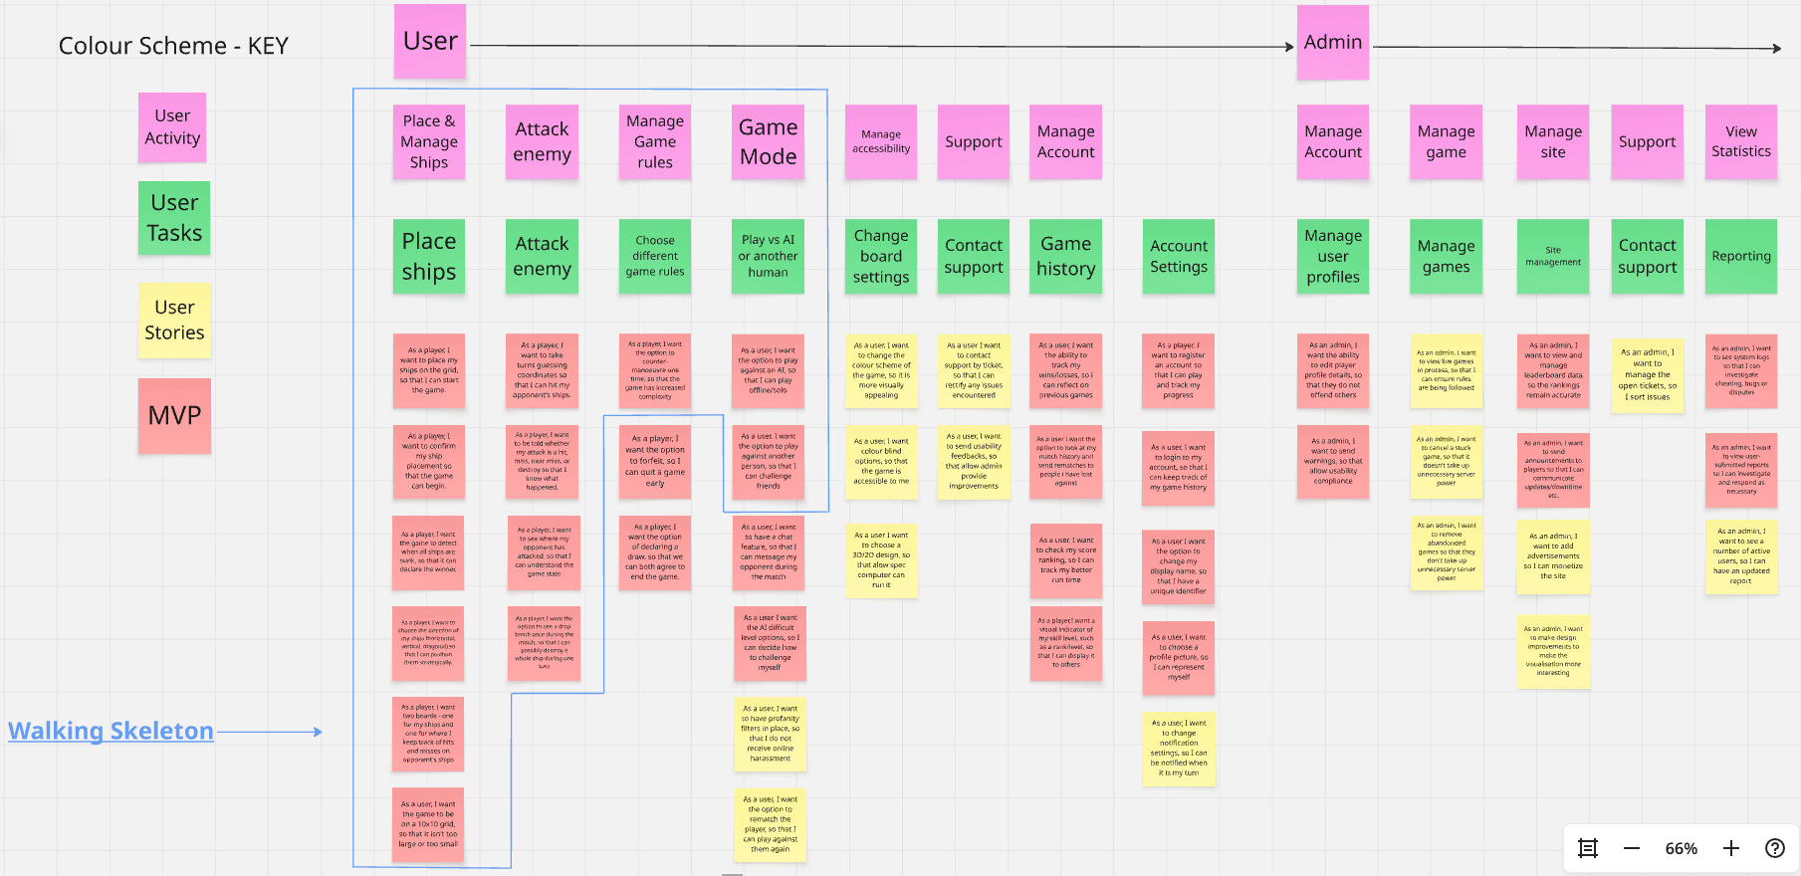
Figure 1: User Story Map

Selected User Stories with Acceptance Criteria and Benefit Discussion
The following stories have been selected from the MVP and Walking Skeleton layers as the most critical to the game. For each user story, acceptance criteria are provided for what they should have been defined as during the design phase.
Story 1
As a player, I want to place my ships on the grid so that I can start the game.
Acceptance criteria:
- The player is presented with a 10x10 grid before the game begins
- The player can place five ships: Carrier (5), Battleship (4), Cruiser (3), Submarine (3), Destroyer (2)
- Ships can be placed horizontally, vertically, or diagonally
- Ships cannot overlap
- The player must confirm placement before the game begins
- The system rejects placement that would extend a ship outside the grid boundary
This story represents the entry point to the game, as without it, no other gameplay story is possible. The benefit is not just that the game can start, but that the player can choose their positioning from the beginning of the game. Secondly, if placement is not validated correctly, this causes a domino effect of consequences such as incorrect hit detection and ships appearing in invalid positions. Therefore, this story also establishes the most important pre-condition for testing the rest of the system.

Story 2
As a player, I want to be told whether my attack is a hit, miss, near miss, or destroy so that I know what happened.
Acceptance criteria:
- When a player submits a coordinate, the system checks it against the opponent's ship positions
- If the coordinate contains no ship part, the result is reported as "miss"
- If the coordinate contains a ship part and the drop bomb was not used, the result is reported as "hit"
- If the drop bomb was used and the coordinate contains any part of a ship, the entire ship is marked as destroyed and the result is reported as "destroy"
- If the opponent uses a counter-manoeuvre in response, the ship moves one square and the result is reported as "near miss"
- The result is displayed clearly to both players
This user story is the core feedback loop of the game. Feedback is one of the fundamental principles of usable systems [7] and without clear feedback after each attack, the player cannot build a mental model of the game state, cannot make informed decisions about future moves and cannot verify that the special mechanics are functioning as expected. The four outcomes, hit, miss, near miss, and destroy, are also the primary outputs that testing must verify. Each outcome maps directly to a testable condition, making this story particularly important for the test design of this assignment.

Story 3
As a player, I want the option to use a drop bomb once during the match so that I can possibly destroy a whole ship in one turn.
Acceptance criteria:
- Each player has one drop bomb available at the start of the game
- The drop bomb option is only available if it has not already been used
- When the drop bomb is used on a coordinate containing any part of a ship, the entire ship is marked as destroyed
- When the drop bomb is used on an empty coordinate, it is reported as a miss and the drop bomb is still consumed
- The system updates _dropBombUsed to true after use regardless of outcome
- The opponent is notified that a drop bomb was used
The drop bomb introduces more risk and strategic depth, as a player who uses it well can drastically change the game state in a single turn. The benefit is not purely mechanical, as the existence of a one-time use special action increases active thought and creates tense moments during the game session. From a software engineering perspective, this story is also significant as the _dropBombUsed boolean on the Player class must be correctly initialised, updated, and checked, and this logic must be robust against edge cases such as attempting to use the bomb a second time, which makes it a high priority candidate for unit testing.

Admin User Stories
The admin stories show a separate set of concerns focused on platform control, where stories such as "As an admin, I want to view live games in process so that I can ensure rules are being followed" and "As an admin, I want to manage open tickets so I can sort issues" show that the system is also a managed platform. The benefit of these stories is that they enable the platform to remain fair, functional, and trustworthy for its user base. The Admin CRC card reflects this by including responsibilities such as banPlayers(), checkReportTickets(), and viewGames(), each of which corresponds to a specific admin story.

CRC Card Design and Evaluation

The CRC Card Technique
CRC cards were introduced by Beck and Cunningham in 1989 as a teaching tool for object-oriented design [1]. Each card represents a single class and records three things, the name of the class, its responsibilities, which are the things it knows and does, and its collaborators, which are the other classes it must interact with to fulfil those responsibilities. Cards are typically post it notes, and the design session involves team members physically handling and discussing them.
Wirfs-Brock and McKean describe CRC cards as a tool for responsibility driven design, an approach that treats objects as entities with defined purposes to the rest of the system rather than as just data containers [3]. This structure is useful because it moves the designer's focus from data structures and towards behaviour.

Evaluation of the CRC Cards Produced
Player lists responsibilities including registering and signing in, placing ships, attacking, using special actions, forfeiting, and declaring a draw. These responsibilities map directly to user stories in the MVP layer. One weakness is that the card does not distinguish between responsibilities that belong to the Player as a game actor and responsibilities that belong to the Player as a registered user of the platform, such as signing in. In a more refined design these might be separated into a Player class and a User or Account class.
Board holds the responsibilities for representing the 10x10 grid, storing ship placements, and storing hits and misses, these are accurate and necessary for the game to function. However, the card does not record the genBoard() or hitOrMiss() methods that appear in the class diagram, nor does it record the grid dimensions as attributes. This shows the structural gap between CRC cards and the class diagrams as we noted in the first section.
Game is the most fully developed card, as its responsibilities cover controlling the game session, managing turns, enforcing rules, evaluating victory conditions, managing AI players, and presenting outcomes, which map clearly to the methods in the class diagram. The class diagram suggests Game also interacts with Ship indirectly through Board.
Ship records responsibilities for representing an individual ship, storing its name and size. The card does not record any responsibility for tracking which squares of the ship have been hit, as this has been recorded by the board. The class diagram also addresses this through the _shipsPos array, but the logic for tracking damage at the ship level is not in this class.
Bomb records responsibilities for marking a hit or miss, blowing up part of a ship, and dropping into the sea. The difference between a standard hit and a drop bomb destroy is not stated, however the class diagram adds the explode() method with a type parameter, which helps address this.
Admin is responsible for controlling user accounts, producing statistics, updating/maintaining the game, viewing live games, checking report tickets, banning players and it is mapped directly to admin user stories and to the methods listed in the class diagram.
AI_Player records responsibilities for placing ships, attacking, using special actions, declining forfeit and draw requests. This is a reasonable set of responsibilities that mirrors Player without the user account management functions. AI_Player could also potentially inherit from Player, a design decision that is not addressed in either the CRC cards or the class diagram.
Counter_Manoeuvre records responsibilities as a one-time use mechanic that allows the player to move a ship on one axis. The collaborators are Player, Ship, and Board, however, the card does not display the logic required to ensure the new ship position does not overlap another ship or extend outside the grid boundary, as is stated by the acceptance criteria. This is the clearest example in the design of a gap between what the user stories require and what the CRC cards show.

Do the CRC Cards Reflect the Acceptance Criteria?
They partially reflect the acceptance criteria due a number of reasons, such as the cards capturing the responsibilities of each class accurately enough to help framework an initial class decomposition, and the collaborator lists are consistent with the sequence diagram and class diagram that we created. However, they do not capture the conditional logic, validation rules, or edge cases from the acceptance criteria.
There are a few issues worth mentioning. First, the counter-manoeuvre card does not record the requirement that the new ship position must be validated against the board before the move is accepted. The Bomb card also does not clearly describe the difference between a standard attack and a drop bomb attack or record the requirement that the drop bomb is used regardless of whether it lands on a ship. These reflect the limitations of the technique.
Fowler states, design artefacts at this level of abstraction are intended to guide thinking rather than to fully specify behaviour [4]. CRC cards are most effective when used as a starting point and to supplement them with more detailed artefacts, which is what the class diagram and sequence diagram did here.

Sufficiency for Implementation and Testing
CRC cards are not enough on their own to enable implementation or testing. A developer working only from the cards would have enough information to identify the classes and a few of their responsibilities, but would lack the method signatures, attribute definitions, and conditional logic needed to write working code. Furthermore, a quality tester using only the cards would be able to identify major functional areas to test but would not have enough information to write specific test cases.
The class diagram and sequence diagram help address the implementation gap, whereas specific test cases are derived from the acceptance criteria rather than from the CRC cards directly. This reinforces the argument that acceptance criteria should be produced alongside user stories and before CRC cards are finalised, so that the cards can be compared against them during the design process rather than after it.

Software Testing Evaluation

The Importance of Software Testing
Software testing is the process of evaluating a system or component to determine whether it satisfies specified requirements and to identify issues before the software reaches the users. Myers, Sandler, and Badgett define testing as the process of executing a program with the intent of finding errors [8]. The end goal of testing is not to show that the software works but to find conditions where it does not.
The importance of testing in software engineering is crucial, shown by the National Institute of Standards and Technology estimated that software defects cost the US approximately $59.5 billion per year, and that improved testing capabilities could remove a third of that cost [9]. Despite the figure being somewhat dated, it establishes a case for treating testing as a necessity. Humble and Farley argue that continuous testing is one of the key differences between high performing development companies and those who are not [10].

Black Box Testing
Black box testing, also known as behavioural testing, evaluates the functionality of software without having access to its code. Tests are derived from the specification, in this case the user stories and acceptance criteria, by providing inputs and observing outputs [11].
The primary advantage of black box testing is that it is independent of implementation, as black box test written against an acceptance criterion will remain valid even if the underlying code is different, provided the external behaviour does not change. The primary disadvantage is that black box testing cannot guarantee coverage of every potential path, as a tester working only from the specification may not be aware of any edge cases that only become visible when the internal logic is known.
Techniques commonly used in black box testing include equivalence partitioning, where the input space is divided into classes that are expected to produce the same behaviour, and boundary value analysis, where inputs at the edges of valid ranges are tested because defects are more likely to occur there [11].

White Box Testing
White box testing, also referred to as structural or glass box testing, derives test cases from knowledge of the internal structure of the code. The tester uses the source code to identify execution paths, branches, and conditions, and designs tests to exercise each one [12]. Coverage metrics such as statement coverage, branch coverage, and path coverage are used to measure how thoroughly the tests exercise the code.
The primary advantage of white box testing is precision, as a tester with access to the source code can identify conditions that would never be anticipated from the specification alone, such as an uninitialised variable, an off-by-one error in a loop, or a branch that is never reached. The primary disadvantage is that white box testing is directly related to the implementation and if the code is ever refactored, the tests may need to be rewritten even if the external behaviour is unchanged.
Pressman and Maxim note that neither black box nor white box testing alone is sufficient, as black box testing validates that the system does what the specification says, while white box testing validates that the code does what the developer intended [12]. A comprehensive testing strategy uses both, as they can then test almost every possible case and can solve each other’s weaknesses.

Differences shown by example
The difference between the two approaches can be shown by exploring the drop bomb mechanic below:
A black box test for this feature would be written like this. Assuming a player has not used their drop bomb, when they select the drop bomb action and target a coordinate containing part of an opponent's ship, then the system should report destroy, mark the entire ship as destroyed, and prevent the player from using the drop bomb again. The tester does not need to know whether _dropBombUsed is a boolean on the Player class, or how the explode() method on the Bomb class is implemented. They only need to observe the output and compare it to the acceptance criterion.
A white box test for the same feature would instead examine the explode() method directly, where the tester would inspect the code to identify the branch that handles a drop bomb hit c compared to a standard hit, verify that _dropBombUsed is set to true before the method returns, and check that the method handles the case where the targeted coordinate is empty, consuming the bomb without destroying a ship. These are conditions that the black box test might not cover if the specification does not explicitly describe certain edge cases.
This example shows how the two approaches complement each other, where black box tests confirm that the feature behaves correctly from the user's perspective, while white box tests confirm that the implementation handles all internal branches correctly, including those the user would never directly see.

Testable Code
Testable code refers to code that is structured in a way that makes it easy to write effective automated tests for it. Meszaros identifies several characteristics of testable code, including small, single-purpose methods, minimal dependencies between classes, and the avoidance of hidden state or global variables [13]. Code that does not abide by these principles is difficult to test in isolation as a test cannot exercise one part of the system without triggering side effects in another.
For this assignment, testable code is a concern for a few reasons. For example, the Game class carries a large number of responsibilities, such as controlling turns, enforcing rules, managing AI players, and evaluating victory conditions and a class with this many responsibilities is harder to test than one with a single, well-defined purpose. Therefore, if checkIfWinner() is linked to the turn management logic inside the same class, it cannot be tested in isolation without simulating an entire game session. The solution to fix this is to refactor checkIfWinner() into a method that takes the state of the board as a parameter and then returns a Boolean, as this would make it independently testable with a simple unit test.
Freeman and Pryce argue that writing tests before writing code, which is known as test-driven development, naturally produces more testable code because the developer is forced to think about how the code will be called before deciding how it will be implemented [14]. Applying this to Battleships would have encouraged a design where methods such as hitOrMiss(), checkIfWinner(), and explode() were each small, independently callable, and free of side effects.

Application Tests and Unit Testing Investigation

Overview
The following tests are derived from the acceptance criteria and from the class and sequence diagrams produced during the design phase. Each test is either a black box or a white box and described using four components, pre-conditions, inputs, expected outputs, and a description of what the test is trying to show and how it works. The tests cover the core gameplay mechanics, including the special actions introduced in the amended rules, as these represent the highest risk areas in the design.

Test 1: Valid ship placement - Black box
The game session has been initialised, player is on the ship placement screen, no ships have been placed yet and the board is a 10x10 grid.
The player places the Carrier (length 5) horizontally starting at coordinate (A,1), occupying (A,1) through to (A,5).
The expected output should be that the carrier is displayed on the board at the specified coordinates and no error is produced, so the player can continue placing the remaining four ships.
This test verifies that placeShips() on the Board class correctly accepts and stores a valid ship position. It uses a straightforward horizontal placement well within the grid boundaries so that no validation logic is triggered where it should not be. This is a positive test, confirming that the happy path works correctly, and it is a pre-condition for every other test in this suite since all subsequent tests assume both players have completed valid placements.

Test 2: Drop bomb used on a ship - Black box
In this scenario both players have completed ship placement and it is Player 1's turn, they have not used their drop bomb, meaning _dropBombUsed is false. Player 2 has the Destroyer occupying coordinates (C,3) and (C,4).
Player 1 selects the drop bomb action and targets coordinate (C,3).
The system reports "destroy". Both squares of Player 2's Destroyer, (C,3) and (C,4), are marked as destroyed on both boards. Player 1's drop bomb is marked as used and the option is no longer available for the rest of the game and Player 2's turn starts.
This test verifies the behaviour of the drop bomb mechanic as it confirms three things, that when the bomb lands on any square of a ship the entire ship is destroyed regardless of its length, that the result is correctly reported as "destroy" rather than "hit", and that _dropBombUsed is set to true on the Player object following the action. This test directly uses the explode() method on the Bomb class as well as the one time use constraint managed by useDropBombs() on the Player class. It is one of the highest priority tests because the drop bomb mechanic failure here would significantly affect the fairness of the game.

Test 3: Internal state of _dropBombUsed after use - White box
A Player object has been instantiated directly in the test environment with _dropBombUsed initialised to false and a Bomb object has been instantiated, no full game session is required.
useDropBombs() is called on the Player object with a valid target coordinate then method is called a second time with the same coordinate.
The expected outcome after the first call is _dropBombUsed is true and the method returns true, confirming the action was executed, then the second call returns false and no bomb action is executed.
As this is a white box test, it directly instantiates the Player class, calls useDropBombs(), and inserts an internal value of _dropBombUsed, this tests the branching logic inside useDropBombs(). The method must check _dropBombUsed before proceeding, execute the bomb if the flag is false, set the flag to true, and return false on any later calls. Testing this in isolation makes the test faster, more reliable, and easier to diagnose when it fails, since any failure points directly to the state management logic in the Player class rather than to any other part of the system.

Unit Testing
Unit testing is the practice of testing individual methods or classes in isolation from the rest of the system, without relying on external dependencies [13]. The main principles of unit testing are that tests should be fast, isolated, repeatable, self-validating, and written close to the time the code is produced. These properties are sometimes referred to as the FIRST principles of unit testing, a framework that helps distinguish structured unit tests from broader integration or end-to-end tests [13].
The first principles are as follows, tests should be “fast”, meaning they execute quickly enough to be run frequently without disrupting the development workflow, they should be “isolated”, meaning each test is independent and the outcome of one test does not affect another. They should be “repeatable”, producing the same result every time under the same conditions regardless of environment, they should be “self-validating”, producing a clear pass or fail result without requiring manual inspection and finally, they should be “timely”, written close to the code they test and ideally before it, in accordance with test-driven development practices [13]. These matter because unit tests that don’t follow them become unreliable, for example, a test that depends on the outcome of another test produces inconsistent results that are difficult to diagnose, which defeats the purpose of having the test at all.
Considering how these principles could be applied to the white box tests, we can look at the useDropBombs() method on the Player class and specifically check whether _dropBombUsed is correctly set to true after the method is called, and whether a second call is correctly rejected. Applying unit testing principles, this test should instantiate the Player class directly with _dropBombUsed set to false, call useDropBombs() with a target coordinate and assert the value of _dropBombUsed and then return value of the method.
The Bomb class should be isolated so that the test exercises only the state management logic inside Player rather than the explosion logic inside Bomb, as this satisfies the isolated and self-validating principles. When the test fails, the cause is due to the branching logic in useDropBombs() rather than a collaborating class.
A unit test could equally be applied to the hitOrMiss() method on the Board class. The test would set up a known board state by calling placeShips() to place the Destroyer at (C,3) and (C,4), then call hitOrMiss() with coordinate (C,3) and assert that the return value indicates a hit and that the internal grid state has been updated. Unlike the Player test, this would allow Board to interact with Ship directly rather than isolating it, because the interaction between those two classes is part of what the test needs to verify. Meszaros describes the different stytles, the first as a solitary unit test and the second as a sociable unit test, both of which are valid depending on what is being tested [13].
The current design of the Game class, which holds responsibilities for turn management, rule enforcement, AI management, and victory detection simultaneously, would require significant changes before it could be unit tested effectively. Moving checkIfWinner() into a method that accepts board state as a parameter and returns a boolean would be a improvement that would make it independently testable without simulating a full game session.

References
[1] K. Beck and W. Cunningham, "A laboratory for teaching object-oriented thinking," in Proc. ACM SIGPLAN Conf. Object-Oriented Programming, Systems, Languages and Applications (OOPSLA), New Orleans, LA, USA, 1989, pp. 1–6. Available: https://dl.acm.org/doi/10.1145/74877.74879
[2] S. W. Ambler, Agile Modeling: Effective Practices for Extreme Programming and the Unified Process. New York, NY, USA: Wiley, 2002.
[3] R. Wirfs-Brock and A. McKean, Object Design: Roles, Responsibilities, and Collaborations. Boston, MA, USA: Addison-Wesley, 2002.
[4] M. Fowler, UML Distilled: A Brief Guide to the Standard Object Modeling Language, 3rd ed. Boston, MA, USA: Addison-Wesley, 2003.
[5] M. Cohn, User Stories Applied: For Agile Software Development. Boston, MA, USA: Addison-Wesley, 2004.
[6] J. Patton and P. Economy, User Story Mapping: Discover the Whole Story, Build the Right Product. Sebastopol, CA, USA: O'Reilly Media, 2014.
[7] D. A. Norman, The Design of Everyday Things, revised ed. New York, NY, USA: Basic Books, 2013.
[8] G. J. Myers, C. Sandler, and T. Badgett, The Art of Software Testing, 3rd ed. Hoboken, NJ, USA: Wiley, 2011.
[9] National Institute of Standards and Technology, "The economic impacts of inadequate infrastructure for software testing," NIST Planning Report 02-3, Gaithersburg, MD, USA, 2002. Available: https://www.nist.gov/system/files/documents/director/planning/report02-3.pdf
[10] J. Humble and D. Farley, Continuous Delivery: Reliable Software Releases through Build, Test, and Deployment Automation. Boston, MA, USA: Addison-Wesley, 2010. Available: https://continuousdelivery.com/
[11] B. Beizer, Black-Box Testing: Techniques for Functional Testing of Software and Systems. New York, NY, USA: Wiley, 1995.
[12] R. Pressman and B. Maxim, Software Engineering: A Practitioner's Approach, 8th ed. New York, NY, USA: McGraw-Hill, 2014. Available: https://www.mheducation.com/highered/product/software-engineering-practitioner-s-approach-pressman-maxim/M9780078022128.html
[13] G. Meszaros, xUnit Test Patterns: Refactoring Test Code. Boston, MA, USA: Addison-Wesley, 2007. Available: https://xunitpatterns.com/
[14] S. Freeman and N. Pryce, Growing Object-Oriented Software, Guided by Tests. Boston, MA, USA: Addison-Wesley, 2009. Available: https://www.growing-object-oriented-software.com/

Appendix
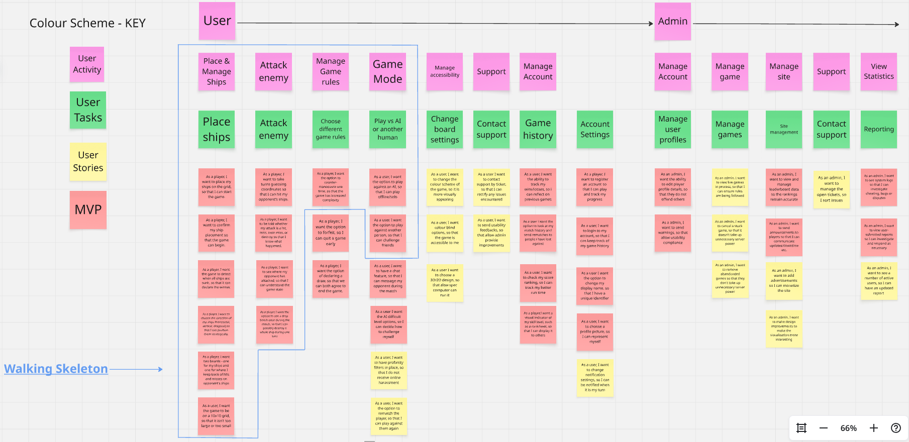
Figure 2: User Stories
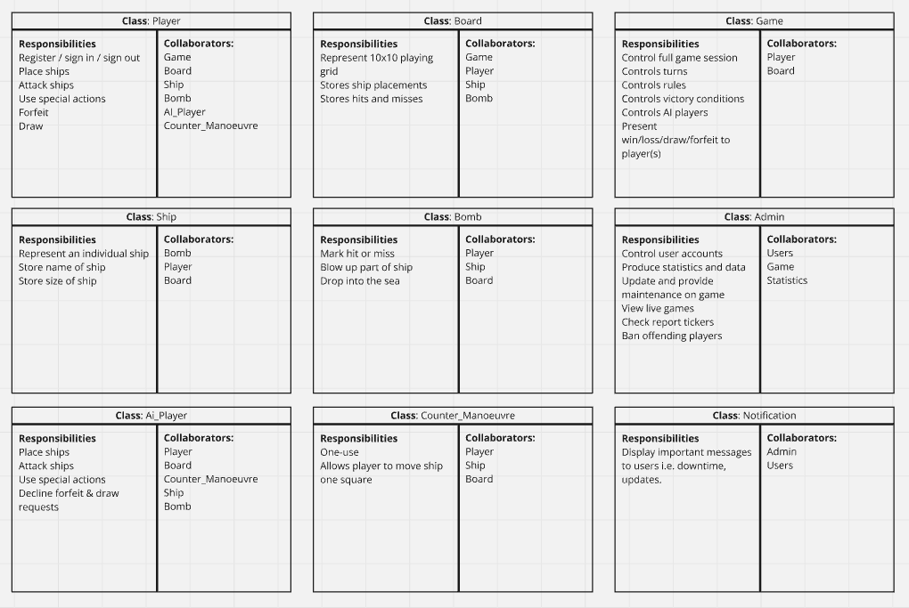
Figure 3: CRC Cards
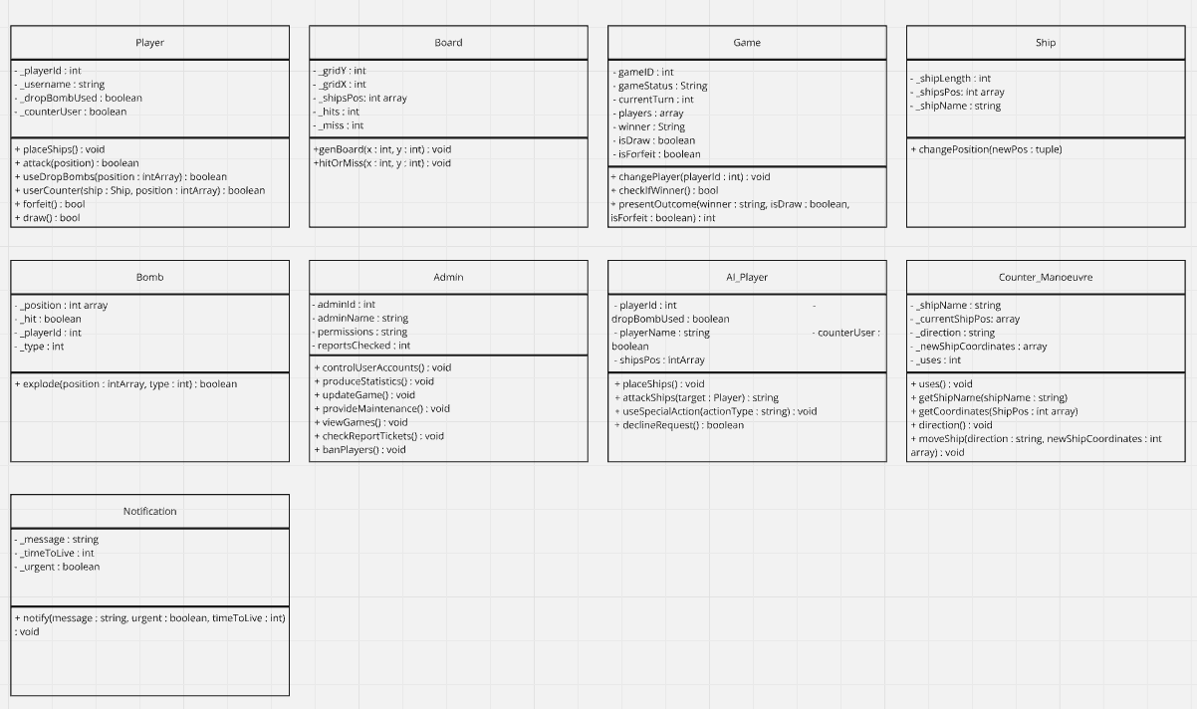
Figure 4: Class Diagrams
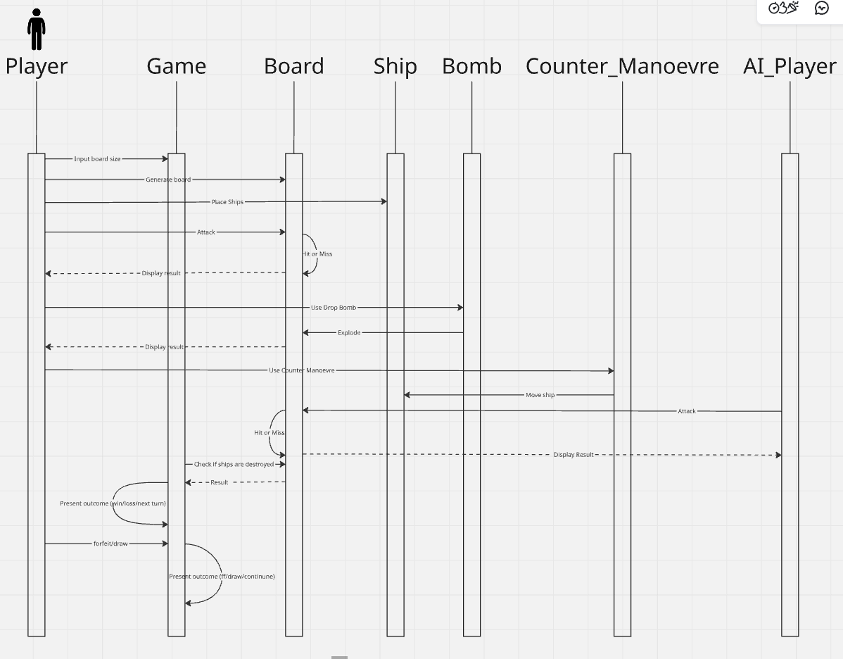
Figure 5: Sequence Diagram

