Manufacturing Systems and Simulation Assignment
Introduction of HDVF-EL75 Holder Assembly to Production
Taylor Durban – July 2024

Executive Summary
Sony UK Technology Centre have produced the HDVF-EL75 product for many years but the recent introduction of the first part of this assembly, known as the HDVF-EL75 ‘Holder’ means that the current production processes need to be evaluated to see how this introduction should be fitted in.
Taking advantage of the Arena Software to build and simulate production processes to measure their effectiveness, alongside the research and methodologies outlined in the Lean, Agile, JIT (just in time) and Six-Sigma principles, recommendations have been made for how this should be introduced.
It has been recommended to run this as an additional step in the production process and to use an additional operator and a new assembly station to ensure that the sales demands can be met and to make sure that the production team are able to stay agile should unexpected orders be placed.
With considerations for how much longer the product will be made for, inventory costs, and supply chain volatility it has been recommended to find new UK/European vendors for generic and machined components whilst maintaining the Japanese suppliers for the main chassis and body work parts to avoid the risks and costs involved in developing new tooling and needing to go back through the materials testing phase.

Table of Contents
Introduction 4
Lean and Six Sigma Theory 6
Analysis 8
Process and Production Layout 8
Suppliers and Inventory Control 10
Recommendations 11
Process and Production Layout 11
Suppliers and Inventory Control 12
Conclusion 13
References 14
Bibliography 14

Introduction
Sony in Pencoed is the only manufacturing facility of Sony products outside of Asia, focusing on the professional broadcasting camera system range. This includes broadcasting cameras, the system control systems as well as the Viewfinder equipment that supports camera operators with capturing the highest quality footage.
A current project is focused on the introduction of a sub-assembly build for one of the Viewfinder systems – HDVF-EL75, specifically the Holder part of this product. Previously this sub-assembly was purchased from a Sony manufacturing facility in Kosai, Japan. The decision was made to move this to the Pencoed facility as the Kosai facility only supply Pencoed and are currently planning to merge with another Sony manufacturing plant.
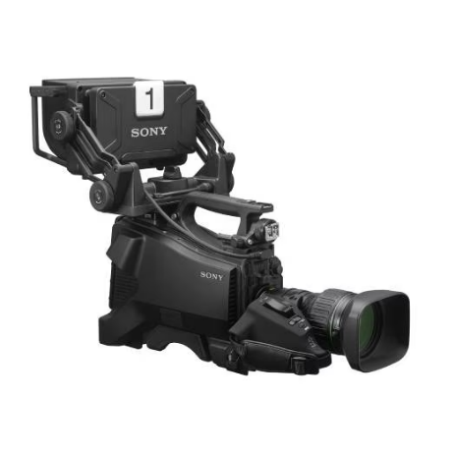
Figure 1 – Sony FZ90 Camera with an HDVF-EL75 Unit Attached (circled in red)
The sub-assembly of the HDVF-EL75 is shown in figure 2 below; this is the part of the build that is being transferred to Pencoed.
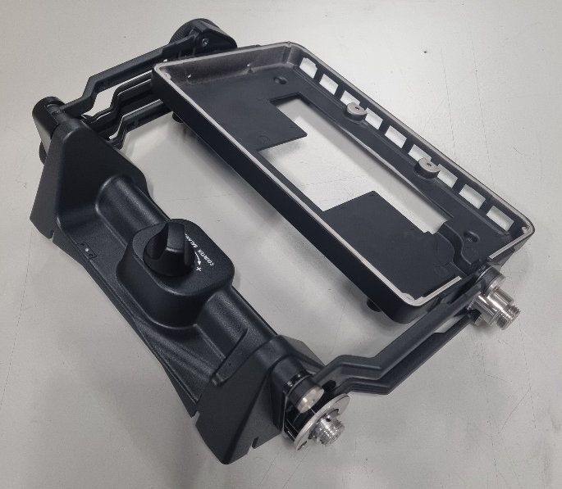
Figure 2 – HDVF-EL75 Holder Sub-Assembly
Before receiving the equipment from the Kosai factory, the HDVF-EL75 production area layout was evaluated. Based on knowledge of what is involved in the Holder sub-assembly (from videos, operation standards and visits to the Kosai factory) and the time it takes to build the sub-assembly compared to the final assembly it was known that there would be many considerations on how this should be introduced. Reviewing Sony Pencoed sales of the HDVF-EL75 model over the past 6 months the demand for this product averages at around 30 units per week, with one weeks downtime every 5th week. One of the biggest factors was that this product only has another 24 months of production before being superseded, therefore the amount of time and money spent on the set up of this needs to be considered.
Other parts of the process also need to be evaluated, for example the initial part of the build is quite fiddly and can easily cause issues later in the build. This part of the build requires the assembly of two brass worm gears into a stainless-steel frame, if done incorrectly the steel frame causes the gears to bind – especially when tested in the heat chamber (used to replicate the product being used in a hot country).
Other factors make this project different to many others. As the product is already well into its lifespan and with the sub-assembly always being made by Kosai, many of the smaller, simple parts, such as screws, were previously bought from Japanese companies. With this moving to Pencoed sourcing these parts from Japan may cause huge risks.

Lean and Six Sigma Theory
Lean and Six-Sigma methodologies were first brought around by Motorola in 1980’s (Slack, N. Et Al. 2012, p444). During this time there was a global focus on quality improvement, with the development of the Japanese principles such as Kaizen; that continuous small changes to improve quality and output are a better objective than introducing one large change. Considering that not every change can be a success, completing actions in small increments allows for changes to be reverted if they are unsuccessful. Whereas if one change is made, how do you evaluate what parts were positive and what was negative. The principle is that these small, incremental changes are never completed, as no system or process can be considered perfect. There is always an improvement that can be made, no matter how small. Bicheno, J and Holweg, M (2009, p16).
Alternatively, Motorolas Six-Sigma concept focuses on reducing variation to achieve their objective of “total customer satisfaction”, the belief was that customer satisfaction is achieved through on-time delivery, zero defects and high product quality. The name Six Sigma deviated from the quality aim that the specification range of services and products should be within ±6 the standard deviation (Slack, N. Et Al. 2012, p446).
Often discussed alongside Six-Sigma, Bicheno, J and Holweg, M (2009, p2) explain how Lean has evolved from just being a set of tools, such as the 5s strategy, Kanban and SMED to more of an underlying culture. Modern approaches to Lean aim at changing the mindsets within an organisation so that everyday behaviours are reflected in the objective of “doing more with less”.
Slack, N. Et Al (2012, p444) continue to discuss how Six-Sigma, in a similar way to Lean, focuses on the control of making improvements. The DMAIC cycle is known to be a key part of the Six-Sigma methodology; Define the problem/situation, Measure the data that is available, Analyse the data, make Improvements based on the information that has been collected and analysed. Finally, Control and Check that the changes have been successful and make sure they become the new standard way of working.

Sometimes considered an opposing principle to Lean is Agile, similarly this also more of a mindset as opposed to a set practice (Slack, N. Et Al. 2012, p374), although they emphasise different objectives Lean and Agile work together to show the benefits in developing processes that encompass the Lean methodology of efficient flow, with effective supply chain management and low inventory, meanwhile, also utilising the ideas within the Agile practices; ensuring that processes are adaptable.
It should be considered which of these mindsets should be prioritised for a given situation, but awareness of both systems is important in finding the balance. When demand varies a lot then it is likely that an Agile system may be a higher priority – but for processes with consistent demand a process developed around the Lean principles will likely prove higher value.
Muller, M (2011, p215) discussed how in a perfect world businesses are able follow the Lean principles, buying the perfect amount of raw material for their process/product and achieving a stable sales forecast with minimal inventory. This Lean, JIT (just in time) approach to inventory is highly desirable with companies always setting objectives to lower operating costs and raise profits, however, the JIT approach can cause single point of failures, where whole manufacturing process can be put to stop due to supply chain difficulties or new sales denied due to long lead times.
Muller M (2011, p216-225) discusses the adoption of Lean and JIT principles and how these have influenced the globalisation of the supply chain. With organisations now chasing the lowest materials costs very often supply chains spread worldwide, although this may reduce material costs it does open difficulties in supplying small quantities, with most suppliers looking for regular, large quantity orders to make shipping costs worthwhile. This very often results in higher order volumes and increased inventory, higher still once lead times for materials are considered when they need to be shipped worldwide. This works against the some of the Lean methodology of reducing the number of suppliers and gaining more control of supply chains.

Analysis

Process and Production Layout
First looking at the production layout; the previous layout worked well for the final assembly, however, if the sub-assembly is going to be built in the same area, then it will need to be re-arranged.
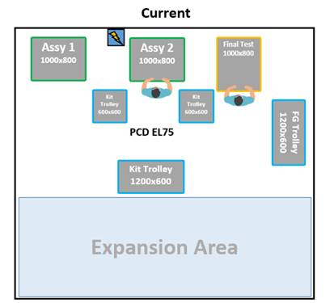
Figure 4 – HDVF-EL75 Old Production Layout
For all Sony broadcast business every product is built to order, previously once the production job is created all the required parts are called from the warehouse (including the Holder sub-assembly that was previously bought from Kosai). With the introduction of the first half of this built there needs to be consideration for the two possible options; should this remain as 2 separate jobs with the Holder sub-assembly being built in batches and then set to one side, allowing for the final assembly jobs to run as they currently do. Or should the process be updated to now allow for the extra space and time needed to complete the sub-assembly and the final assembly in one job.
To evaluate this the Arena Software package was used to build two simplified models and measure which process may be better – building in 2 job batches or adapting the process to include the sub-assembly.
As seen in the model below (Figure 5) this shows the build in batches style.
Figure 5 – Building in Batches Style of Production
Figure 6 (below) shows the alternative method of adding the Holder assembly to the current process.
Figure 6 – Continuous Flow Production Style
With each of these production styles set up with the same data, it would be easy to run the software and just decide based on the time taken to run a job of 10 units. However, as discussed by Bicheno, J and Holweg, M (2009, p12) the Lean principles highlight that looking at the whole value stream and aiming for perfection are what creates value. Hence it is important to consider what process will provide the most adaptability to meet customer orders and produce products with the highest quality. To consider this the software was run with some variations and the production times measured for completing 10 pieces using each variation. These variations were capped by the limited production space available for this build (6m x4m) and the limited budget available.
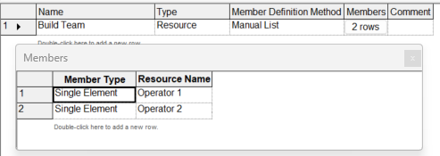
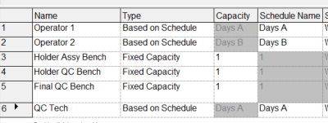
To make this data as accurate as possible, all the same assembly and QC timings were used, some of this data is from the Sony Pencoed Production and Engineering teams and the remainer was requested from the Kosai Engineering team. Assembly benches are always capped at one operator per bench. Also, operators were set onto A and B shifts, as they would be in the production plan, this will help to highlight whether there will be any benefits in running this with an additional operator or not.

Figure 7 – Resource List from Arena Figure 8 – Operators Set up in a Build Team

Setting up a build team allows for the Arena software to allocate tasks to whichever operator is available at that time, taking into consideration which work benches are available and if anyone is on break - as it would be in a real production environment.
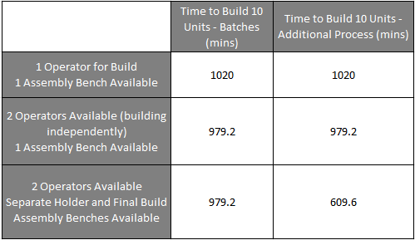
Figure 9 – Table of Build Timings
Looking at the data displayed in the table above it can clearly be recognised than adding an additional operator is not good value for money unless a secondary assembly bench is also built, and productions runs a continuous flow style process. If a batch style process is chosen, then there is no need for a second operator or an additional build station as the benefits are minimal and would not show a good return on the extra investment.

Suppliers and Inventory Control
Considering the approximate 30 pieces per week demand, 1 week downtime every 5 weeks and 2 more years of production it can be calculated that around 2650 more units will be completed. For a mass production product this is relatively low numbers and so this needs to be considered if any changes to the supply chain are made.
Currently with all parts arriving from Japanese vendors there is much more inventory onsite than what would typically be acceptable. Higher inventory increases storage costs and could result in purchasing unrequired material to not run low, however, moving to UK/European suppliers may be inefficient due to the costs involved with setting up new suppliers.

Recommendations

Process and Production Layout
Based on information gathered using the Arena Process Software and the sales requirements for this product it would be recommended that this Holder sub-assembly is added into the process and not set up as a separate build. It is also recommended that two operators are assigned to this build and that an additional assembly bench is set up for the Holder sub-assembly part.
By doing this the overall time taken to build and QC 10 units is reduced by 40.6%. Despite the cost of adding an operator essentially doubling the assembly labour cost for this product, the increased adaptability to meet order demands quickly and cover sickness/holidays means that this would be the recommended process.
The reduced build time is also reflected in a large increase in the maximum capacity per week for this product – using the data is can quickly be calculated that for 1 operator and 1 assembly bench the maximum capacity per week is only 24, whilst for 2 operators with 2 assembly benches the maximum capacity is 40 per week. Considering the average demand of 30 units per week (unachievable with just one operator working regular day shifts) this shows to be the most viable option without needing to look at running mornings/evening shifts, constantly run at maximum capacity, run through the downtime weeks to get ahead of schedule or regularly request overtime to satisfy sales demands, working the team this hard will also likely negatively affect the build quality as well as moral. With two operators the production and planning team have more adaptability and the opportunity to utilise the operators on other builds once the weeks sales have been achieved.
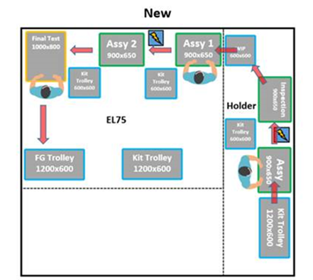
Figure 10 – The Old Production Layout Compared to the New Production Layout.
Figure 10 (above) shows a suggested new production layout. This takes into consideration the kitting trolleys and WIP tables between benches. (Note: ‘Assy’ refers to the Holder bench, ‘Assy 1’ is Final assembly, ‘Assy 2’ refers to a software update bench which is part of the QC Final test).
Building this Holder assembly in this way follows more Lean principles, reducing the complexity of creating jobs and reducing the number of storage locations in the warehouse. Instead, once the sub-assembly is built it is stored temporarily on the WIP trolley in production until the second operator uses it for the final assembly.
Taking considerations from Motorolas Lean principles and focusing on making sure that no defects make it to market, with the goal of complete customer satisfaction, additional QC check points will need to be added to the process. This means that the ‘Holder’ unit cannot be processed through the system unless it has been scanned and ‘passed’ each step by the build operator – who must scan their ID badge to use the system. This helps to ensure that every unit has time taken to build and goes through the necessary QC checks before moving to the next stage. The final QC set-up and testing step will remain in place as well.

Suppliers and Inventory Control
To address this without increasing risk too much it would be advised to find UK based vendors for generic components such as fasteners and for components that are currently machined (such as the brass gear worms). It is likely that UK suppliers would be able to produce and supply these at similar costs, with reduced lead times, lowering the inventory required to keep the system agile and instead allowing for Lean principles to be adopted. For parts that are specific for this product, such as the chassis and screen framework; these are made from a magnesium alloy and so it would be inefficient to try and move production to the UK/Europe due to the high costs involved in creating die cast tooling on top of the time that would be needed to trial the new parts to make sure that customer quality is not effected. For these components it would be recommended to maintain the existing supplier for the remainder of the product life to reduce any risks.

Conclusion
Evaluating the current production process used for building the HDVF-EL75 product, with considerations for how much longer this product will be manufactured, it has been suggested that based on data from the Arena Software package that setting up a process that includes this new build as part of the same job, using two operators, with two assembly benches – one for each assembly stage – is the most effective way to achieve the 30 units per week average demand without sacrificing quality.
To try and keep inventory volume low it would also be advisable to find new UK/European vendors for generic components as well as components that are machined. For the chassis and other cast components it would be better value for money in keeping the Japanese vendors and adjusting to maintain slightly higher inventory volume to keep the system agile.

References
Bicheno, J. and Holweg, M (2009) The Lean Toolbox. 4th edition. Buckingham: PICSIE Books.
Muller, M (2011) Essentials of Inventory Management. 2nd edition. New York: AMACOM.
Slack, N. Et Al (2012) Operations and Process Management. 3rd edition. Essex: Pearson Education Limited.

Images:
Figure 1 – Sony FZ90 Camera with an HDVF-EL75 Unit Attached. https://pro.sony/en_CZ/products/4k-and-hd-camera-systems/hxc-fz90
Figure 2 – HDVF-EL75 Holder Sub-Assembly. Image Taken from Sony Pencoed Engineering Trials.
Figure 4 – HDVF-EL75 Old Production Layout. Layout from the Sony Pencoed Engineering Team.
Figure 5 – Building in Batches Style of Production. Created from Rockwell Arena Process Software.
Figure 6 – Continuous Flow Production Style. Created from Rockwell Arena Process Software.
Figure 7 – Resource List from Arena. Created from Rockwell Arena Process Software.
Figure 8 – Operators Set up in a Build Team. Created from Rockwell Arena Process Software.
Figure 9 – Table of Build Timings. Timings from the Arena Software.
Figure 10 – The Old Production Layout Compared to the New Production Layout.

Bibliography
Bicheno, J. and Holweg, M (2009) The Lean Toolbox. 4th edition. Buckingham: PICSIE Books.
Muller, M (2011) Essentials of Inventory Management. 2nd edition. New York: AMACOM.
Slack, N. Et Al (2012) Operations and Process Management. 3rd edition. Essex: Pearson Education Limited.
Tetteh, E. and Chapman, H (2018) Lean Six Sigma for Optimal System Performance in Manufacturing and Service Organisations. Hershey, PA: IGI Global.

