Chloe Howell
Securing Successful Study Skills Assessment

Presentation Video Link
https://uowtsd.sharepoint.com/teams/ECES4012SecuringSuccessfulStudySkills-SwanseaCohort_GRP-ChloeHowell/Shared%20Documents/Recordings/New%20channel%20meeting-20231025_102120-Meeting%20Recording.mp4?web=1

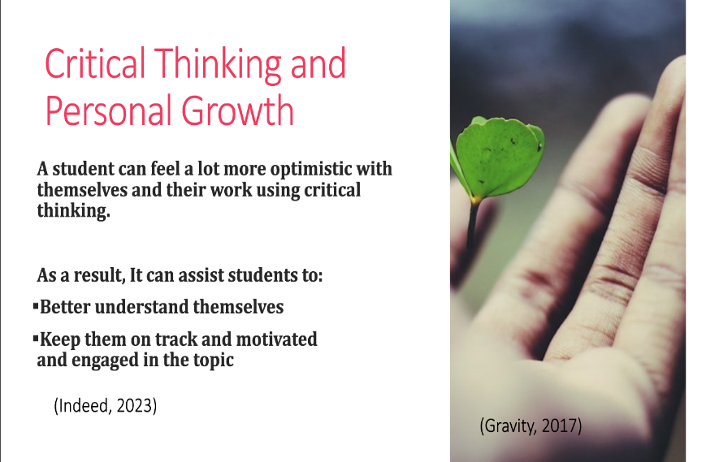
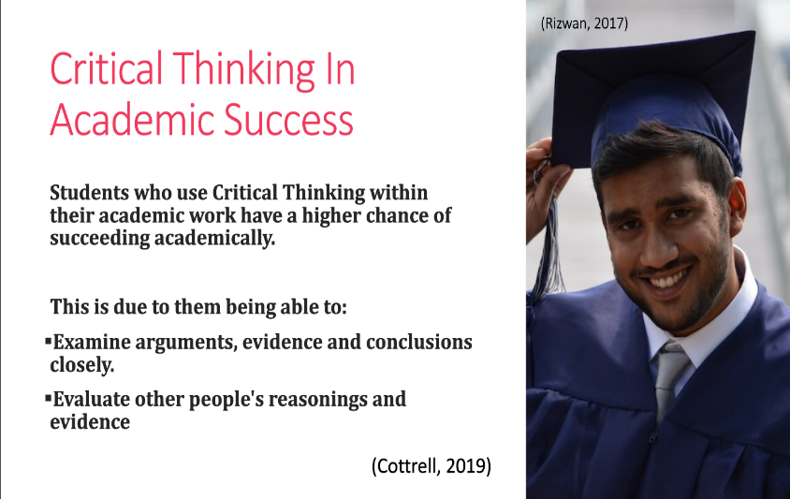
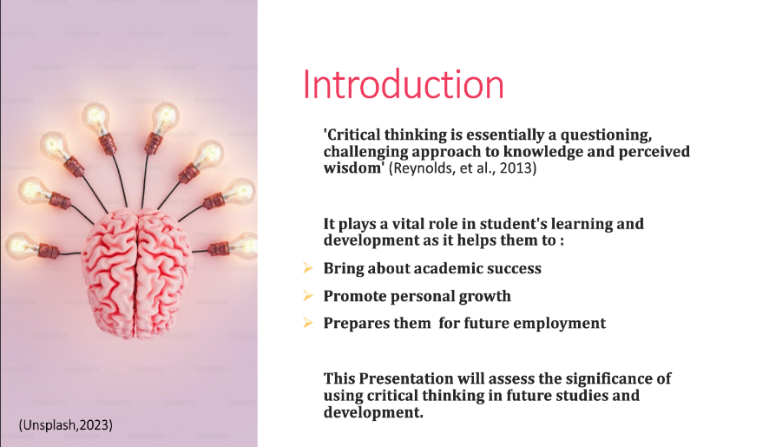
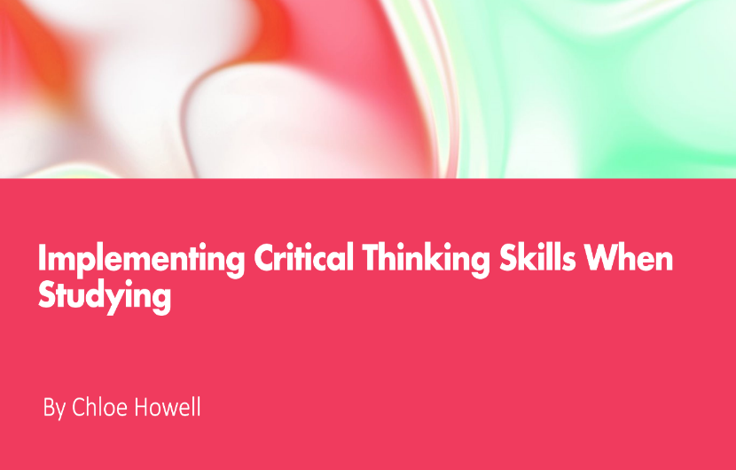
Presentation screenshots – Critical Thinking
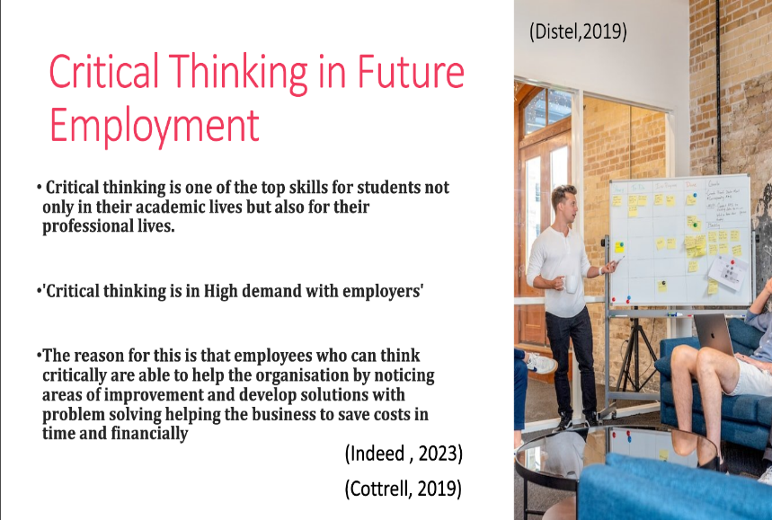

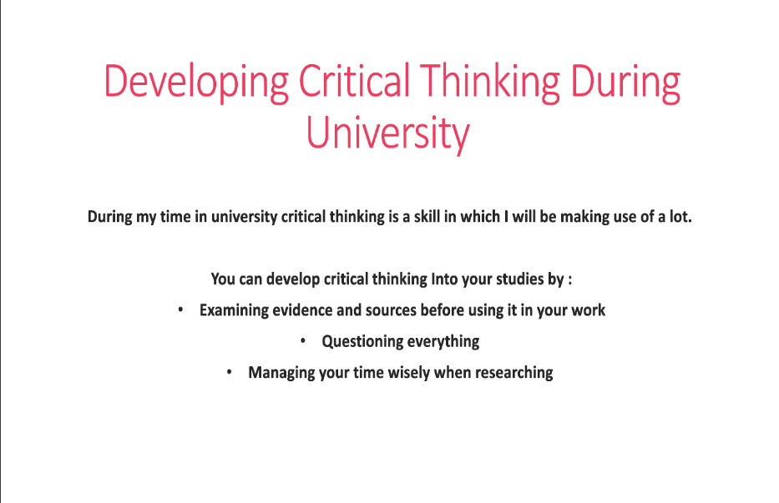
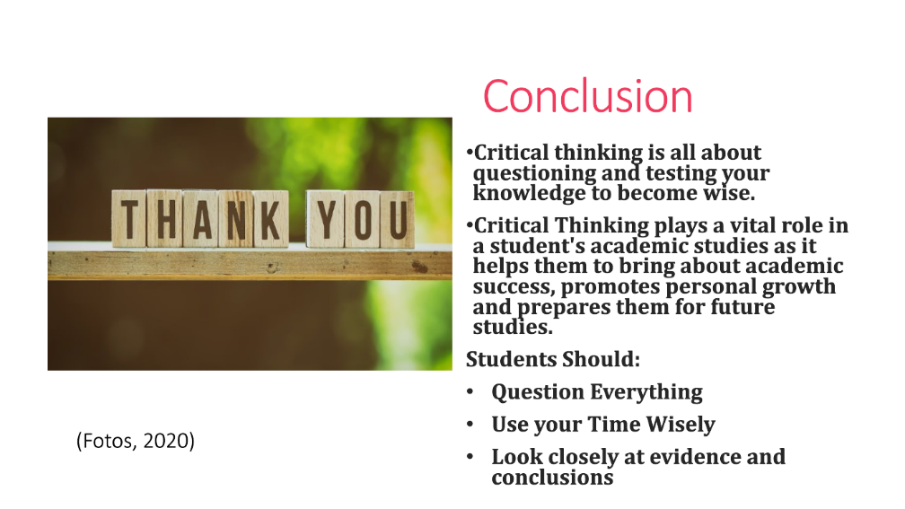
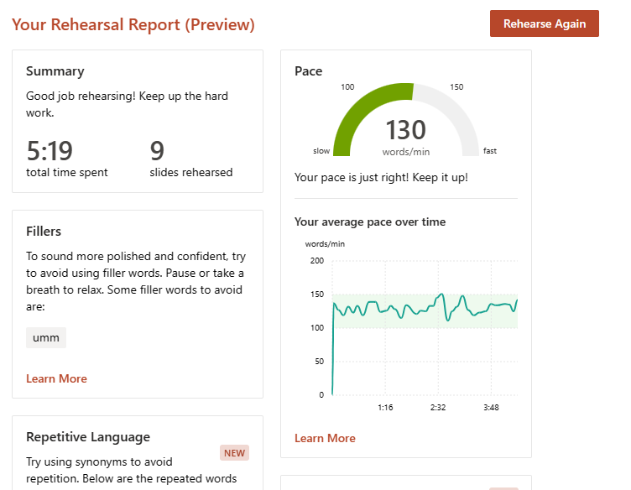
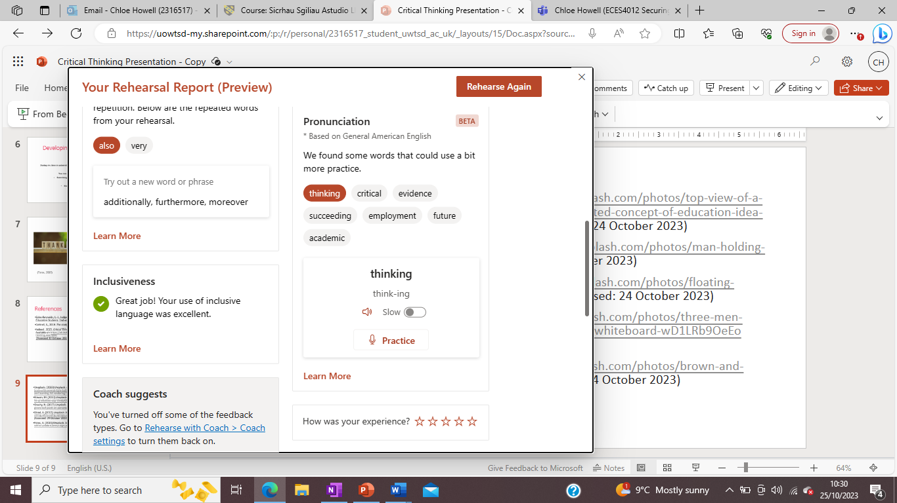
Rehearsal Report
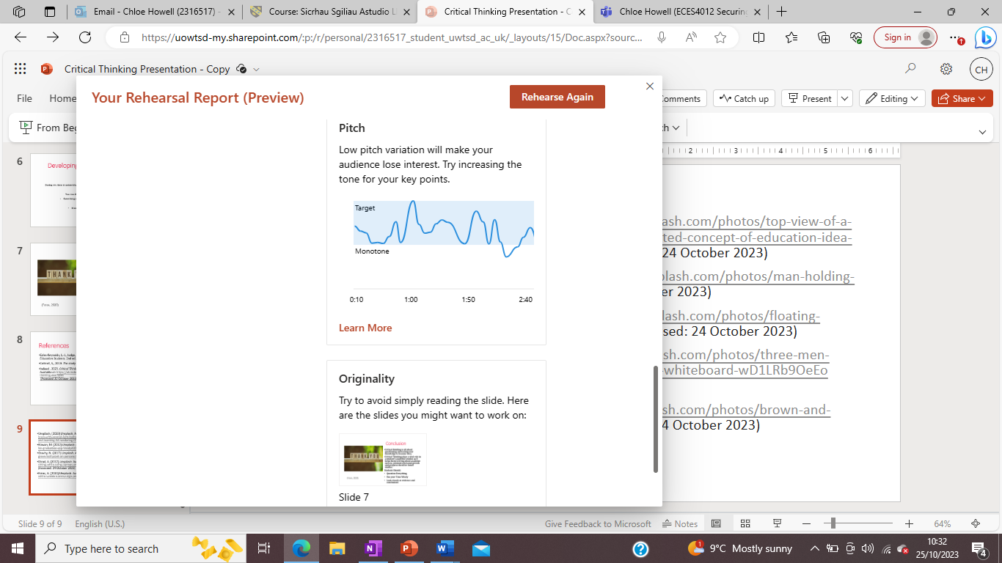

Reflective Piece
Introduction
My first assignment included a five-minute presentation on a chosen study skill where we had to talk about why this skill is important to ourselves and our studies. To begin, I wanted to choose a skill I was familiar with such as time management but as I explored the other skills options, I decided to challenge myself and go with critical thinking. At first, I felt anxious as I didn’t know a lot about critical thinking and wanted to ensure I had plenty of time to research around the topic and gain a clearer understanding when it came to doing my presentation.
Main Reflective Points
During my research into the topic, I felt I put a lot of pressure on myself to find as much information as possible in order to fulfil the expected 5 minute presentation time. I believe my research method worked effectively for myself when gathering the information and retaining information. However, I feel that if I had used more time to take a deeper look in to what I was researching this could have benefitted me to present with more confidence and flow to my presentation which (Lanning, 2023) states ‘In fact, in-depth research can actually help delivery. Thorough research can lead to an organized, flowing, and confidently delivered speech.’
Despite the worry I had when it came to learning about the topic, I stayed committed and motivated to pursue my chosen skill. This went well as I managed my research by staying organised and created mind maps to help me gather information on the topic to build my understanding around the topic. This benefitted me when it came to structuring my presentation and finding the information as struggle to retain information when I note take. As found by (Byrnes, 2010), ’Mind mapping increases learning and retention by up to 95% over conventional notetaking’. Therefore, by completing this I assignment I was able to discover that mind mapping is more effective for me.
The biggest weakness for myself during this assignment was my nerves. I don’t believe I delivered my presentation or explained myself clearly. My nerves affected my delivery, and I stumbled on what to say which caused me to use filler words, such as ‘umm’ as communicated by Presenter Coach. My feedback from Presenter Coach also informed me that I should take a break to relax as I was rushing through the presentation. ‘Excessive use of fillers in scientific presentations can reduce the credibility of the speaker as well as impair the comprehension of the speaker’s message by the audience.’ Explained by (Seals & McKinley E. Coppock, 2022). This proves that the use of filler words can affect a presenters message across to the audience.
Another weakness was the many distractions I faced doing it at home. This was because I would often have interruptions and background noise as I live in a very busy household, and it is difficult to find a time and place at home to complete this presentation in a quiet environment. I feel this also impacted my presentation as I felt on edge of others hearing me or background noise distracting me and knocked my confidence when recording. I think next time when it comes to a recorded piece, I need to make use of the university rooms or organise with the household a day and time where I can record this without distractions. I think this will then help me focus and increase my confidence.
In addition to the other feedback mentioned above, Presenter Coach advised me to increase my tone when it came to delivering my key points. I believe I was confident to start off with but as I got deeper into my slides my nerves effected my speech. This then had an impact on my tone and how I was presenting. If I had presented this in front of a group, having a lowered tone throughout the presentation, I would have lost the audience interest. Hence, my message to them about critical thinking would have been less impactful. As said by (Ros & Johnson, 2016), ‘This will come from the ability to make your voice resonate, as a resonant voice is more pleasing on the ear and can make you sound more confident’. If I was to do this presentation again, I would make sure my tone is consistent throughout to ensure the audience stays engaged throughout.
One of the challenges I came across when doing the presentation to begin with was figuring out how to use presenter coach for the first time and setting up teams to record this. The first few attempts of my recordings were of me trying to make sure I had everything set up and if I was recording it correctly. Each time I set the recording up, I felt I was more focused on if the camera was on which then my nerves would take over and I struggled to focus and remember everything I had just practiced. I would then feel the stress of each slide before they appeared and struggled to not read off each slide. Therefore, I felt I didn’t expand on what I was talking about other than what was on the slide.
Conclusion
To sum up, I believe my presentation could have gone better. I am content with structuring a presentation and how to research around a topic and build on my knowledge, but it is clear to myself that in future presentations I need to be more confident in my ability. I need to allow more time for more research and develop a clearer understanding which can help with my delivery. The targets I set myself for future presentations would be to manage my time wisely when researching and allowing myself time to get as much practice as I can before recording the presentation. Another target for myself would be to ensure I organise a quiet room and time when recording to minimise any interruptions. These targets will help with my delivery, confidence and tone of my presentation so that I can effectively deliver my message across to my audience and prove my understanding and knowledge.

References
Byrnes, C., 2010. Mind Mapping. [Online]
Available at: https://www.pmi.org/learning/library/mind-mapping-advantage-think-creatively-6554
[Accessed 28 October 2023].
Lanning, M., 2023. Research helps your speaking. [Online]
Available at: https://www.whitman.edu/academics/majors-and-minors/rhetoric-writing-and-public-discourse/public-speaking-resources/research-helps-your-speaking#:~:text=In%20fact%2C%20in%2Ddepth%20research,moves%20along%20in%20their%20studying.
[Accessed 26 October 2023].
Ros & Johnson, N., 2016. How to improve your voice for presentations. [Online]
Available at: https://www.britishcouncil.org/voices-magazine/how-improve-your-voice-presentations#:~:text=use%20our%20voice%3F-,When%20we%20make%20a%20presentation%20or%20speak%20to%20a%20large,make%20you%20sound%20more%20confident.
[Accessed 28 October 2023].
Seals, D. R. & McKinley E. Coppock, 2022. Advances in Physiology Education. [Online]
Available at: https://journals.physiology.org/doi/full/10.1152/advan.00110.2022
[Accessed 27 October 2023].

