

Strategic Management (LCMB7003)

Strategic Analysis of Alibaba Group


Student Name: Miraz Mohammad Emon
Student Number: 2503793
Lecturer: Amare Desta
Word Count: 5494 word

Table of Contents
Section 1 1
1. Introduction 1
2. Company Background 2
3. Mission and Objectives 3
3.1 Mission 3
3.2 Vision 3
3.3 Strategic Goals 3
4. Macro-Environment Analysis 4
4.1 PESTEL Analysis of Alibaba Group 4
5. Micro-Environment Analysis 5
5.1 Industry Life Cycle 5
5.2 Porters five forces analysis 7
6. Internal Analysis 8
6.1 Strategic Resources and Capabilities. 8
6.2 Value Chain Analysis 8
6.3 VRIO Analysis 9
7. Green Strategy & CSR 11
8.Balanced Scorecard 12
9. Competitive Advantage Sustenance Strategies. 13
10. Growth Strategies 15
11. Strategic Choices & Implementation 16
12. Conclusion 18
13. Recommendations 18
Section 2 20
Reflective Account (Gibbs Cycle) 20
1. Description 20
2. Feelings 21
3. Evaluation 21
4. Analysis 22
5. Conclusion 22
6. Action Plan 23
14. References 24
15. Appendix 26
Appendix 1: Suggested Strategic Analysis Table (PESTEL Summary) 26
Appendix 2: Porter’s Five Forces Summary 26
Appendix 3: SWOT Summary Table 27

List of Figure
Figure 1. Company Background of Alibaba Group. Adapted from Alibaba Group Annual Reports (2024–2025) & Corporate History Sources 2
Figure 2. PESTEL Analysis of Alibaba Group. Adapted from corporate strategy literature and Alibaba ESG Reports (2024–2025). 4
Figure 3. Industry Life Cycle of the E‑Commerce Sector Applied to Alibaba Group. Adapted from Porter (1980), Li & Zhang (2023), Wang (2024), Chen (2024), and Kumar (2023). 6
Figure 4. Porter’s Five Forces Analysis of Alibaba Group. Adapted from Porter (1980) and corporate strategy literature 7
Figure 5. VRIO Analysis of Alibaba Group. Adapted from Barney (1991) and corporate strategy literature. 9
Figure 6. SWOT Analysis of Alibaba Group. Adapted from corporate strategy literature and Alibaba Group ESG reports (2024–2025). 10
Figure 7. Alibaba Group’s Green Strategy and Corporate Social Responsibility initiatives. Adapted from Alibaba Group ESG Report (2025) and Carbon Neutrality Action Report (2024). 11
Figure 8. Balanced Scorecard framework applied to Alibaba Group, aligning financial, customer, internal process, and learning perspectives with long‑term digital strategy (Kaplan & Norton, 1992; Chen, 2024; Zhang & Liu, 2024). 12
Figure 9. Competitive Advantage Sustenance Strategies of Alibaba Group. Adapted from Porter (1985), Chen (2024), Wang (2023), and Zhang & Liu (2024). 14
Figure 10. Growth Strategies Framework illustrating internal and external expansion approaches. Adapted from Ansoff (1957) and corporate strategy literature. 15
Figure 11. Gibbs’ Reflective Cycle illustrating six stages of structured reflection. Adapted from Gibbs (1988). 20

Section 1

1. Introduction
Strategic management is a key aspect that helps organisations gain and maintain competitive advantage in the ever more complex and dynamic global markets. The report presents the detailed strategic analysis of Alibaba Group, one of the most successful digital commerce and technology conglomerates of the world. Alibaba was established in 1999 and has since grown to become a business-to-business platform, diversifying into e-commerce, cloud computing, artificial intelligence, and digital financial services (Xia, 2024).
This report aims to critically assess the strategic position of Alibaba in terms of evaluating its external and internal environment and how these impact on its long-term competitiveness. In order to do this, some of the developed and used strategic management models will be utilized, such as the PESTEL analysis, the Five Forces framework developed by Porter, the VRIO framework, a value chain analysis, and a SWOT analysis. The tools are also well-known to offer systematic information on environmental changes, competition in an industry, and organisational potential (Rahman, 2024).
Moreover, the report will evaluate how Alibaba responded to the modern challenges of regulation, technological disruption, and the rising global competition, especially its recent move towards cloud computing and artificial intelligence as its major growth impetuses. This analysis will ultimately be used to make strategic recommendations to improve the sustainable competitive advantage of Alibaba in the global digital economy.

2. Company Background
Alibaba Group was established in 1999 in the city of Hangzhou, China, by Jack Ma and other partners, as a business-to-business (B2B) e-commerce site that was designed to help Chinese manufacturers and global buyers get in touch. The company has over the years grown to be a diversified digital ecosystem, with consumer to consumer (C2C) platforms like Taobao, business to consumer (B2C) services like Tmall, cloud computing via Alibaba Cloud, and digital financial services via Ant Group. This development demonstrates how Alibaba has been strategic with regard to platform integration and technological innovation (Chen et al., 2024).
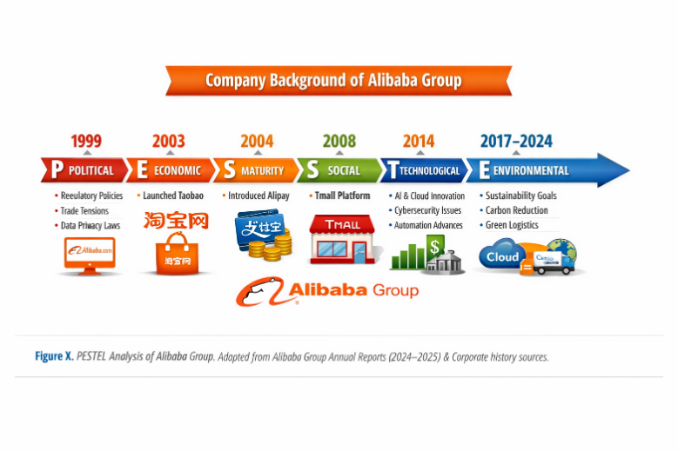
Figure 1. Company Background of Alibaba Group. Adapted from Alibaba Group Annual Reports (2024–2025) & Corporate History Sources
Alibaba is one of the biggest technology firms in the world, with over 200,000 employees and annual revenues of over USD 120 billion in recent years (Alibaba Group, 2024). The company mainly covers China but has ventured to other global markets such as Southeast Asia, Europe, and North America, especially via Lazada and AliExpress.
Alibaba is a participant in the world of e-commerce and digital technology, which is characterised by intensive innovation, stiff rivalry, and high scalability. Its key rivals are JD.com and Amazon, which makes Alibaba a leading force in the Chinese market with a growing competition in the international arena (Wang, 2023).

3. Mission and Objectives

3.1 Mission
The mission of Alibaba Group is to make it easy to do business everywhere. It is aimed at empowering small and medium-sized businesses to connect to the global market using digital platforms and integrated ecosystem services.

3.2 Vision
The vision of the company is to create the future infrastructure of commerce through technology, data and innovation. It has a goal of establishing a sustainable and inclusive digital economy to promote efficiency in global trade.

3.3 Strategic Goals
- Increase international e-commerce footprint in both emerging and developed markets.
- Enhance leadership on cloud computing and artificial intelligence services.
- Develop digital integration of retail, logistics and finance.
- Become carbon neutral and more sustainable in operations.
- Enhance innovation by investing in new technologies and data analytics.
Critical Comment
The mission and vision are quite realistic because they are in line with the capability of Alibaba to develop the global expansion strategy and strong technological capabilities. Nevertheless, rising geopolitical tensions and regulatory constraints, especially in China, can curtail the full realisation of global aspirations. Generally, the strategic objectives go hand in hand with the ecosystem-based business model of the firm, which indicates a high correlation between the long-term vision and the business strategy (Zhang and Liu, 2024).

4. Macro-Environment Analysis

4.1 PESTEL Analysis of Alibaba Group
Alibaba Group is involved in a very dynamic international digital economy where the external macro-environmental factors have great impacts on its strategic direction and competitiveness in the long run.
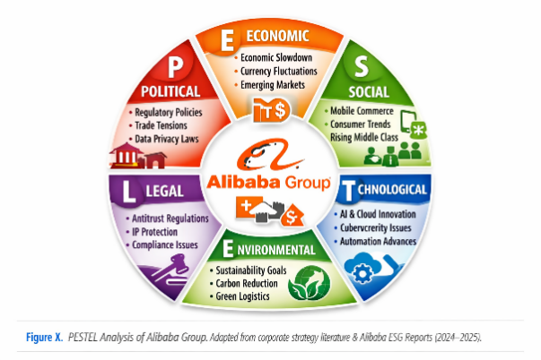
Figure 2. PESTEL Analysis of Alibaba Group. Adapted from corporate strategy literature and Alibaba ESG Reports (2024–2025).
- Political : Chinese government policies and regulatory frameworks have a significant impact on Alibaba. Heightened scrutiny of big tech companies and antitrust laws in China have had a direct impact on its business operations and expansion plans. There is also a political strain between China and the western world which hamper the international expansion range of Alibaba. (Lee, 2024).
- Economic : The e-commerce income of Alibaba is affected by global economic shifts, inflation and a shift in consumer spending behavior. As the high consumer base in China creates stability in demand, sluggish economic growth in the global arena cuts cross border trade. To counter, Alibaba has been strategic in investing in cloud computing and digital capabilities to lessen reliance on retail cycles and enhance revenue stability (Kumar, 2023).
- Social : The fast increasing digital consumption, mobile shopping, and evolving consumer behaviour are a strong indicator that supports the business model of Alibaba. Nevertheless, growing worries of data privacy and ethical consumption are informing customer expectations. This has seen Alibaba work on improving customer trust, transparency, and investing in business practices that are socially responsible in order to retain the brand reputation.
- Technological : One of the sources of competitive advantage of Alibaba is the technological advancement. Its ecosystem is reinforced by artificial intelligence, big data analytics, and cloud computing innovations. One of the key strategic growth directions is Alibaba Cloud, which will allow the company to expand its activities beyond e-commerce and enter the world of enterprise technologies on the international level (Chen, 2024).
- Environmental : The demands of environmental issues and sustainability are putting pressure on Alibaba to lower carbon emissions and enhance green logistics. To meet this, the company has retorted by investing in sustainable supply chain solutions and carbon neutrality efforts, which are in line with environmental responsibility and long-term strategic branding.
- Legal : Alibaba has to deal with complicated legal landscapes such as data protection regulations, cyber security regulations and antitrust inquiries. These legal limitations impact its operational agility and necessitate adjustment of compliance.
The total overall Link to Strategy.
PESTEL analysis indicates that regulatory pressure and worldwide competition are becoming more influential in the strategy of Alibaba. Consequently, the company is moving to cloud computing, AI development, and the international diversification to be able to maintain long-term competitive advantage.

5. Micro-Environment Analysis

5.1 Industry Life Cycle
The Industry Life Cycle model, which comprises of the introduction, growth, maturity and decline phases, can be applied to the e-commerce and digital platform industry that the Alibaba Group is in.
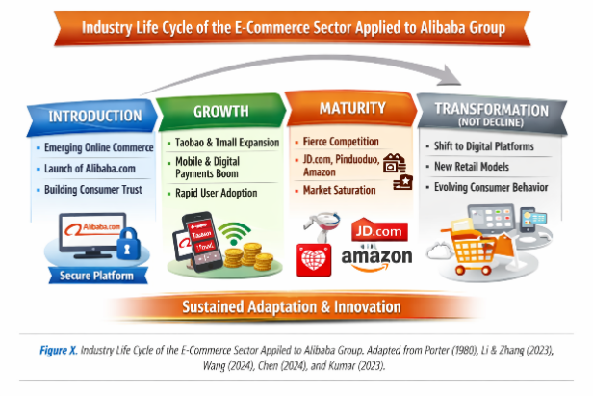
Figure 3. Industry Life Cycle of the E‑Commerce Sector Applied to Alibaba Group. Adapted from Porter (1980), Li & Zhang (2023), Wang (2024), Chen (2024), and Kumar (2023).
- Introduction stage: This is a phase of the fledgling online commerce where digital transactions were constrained by the low internet penetration and low consumer confidence. Alibaba was one of the first firms to address these obstacles by establishing safe and trustworthy platforms to trade in China and this allowed it to expand digital trade early (Li and Zhang, 2023).
- Growth stage: Mobile technology, the availability of the internet, and the use of digital payment systems then saw the industry grow rapidly. The Taobao and Tmall platforms helped Alibaba gain on a large scale user adoption and substantial revenue growth in this stage (Wang, 2024).
- Maturity stage: The worldwide e-commerce market is at the maturity phase, which can be described by the slow growth, high competition, and the saturation of the market in developed markets. Companies like JD.com, Pinduoduo, and Amazon are innovative, price-cutting, and ecosystem integrating rivals (Chen, 2024).
- Decline stage: The industry is not declining but some of the traditional ways of retailing are being substituted with digital platforms, which signifies structural change but does not show an overall decline of the industry (Kumar, 2023).
Strategic implications
It is evident that Alibaba is on its maturity stage and thus there is less ease of attaining organic growth. This necessitates a long-term strategic move to diversification, technology and internationalization. The heightened interest towards cloud computing and artificial intelligence is likely to indicate that the company will need to minimize its reliance on the flooded e-commerce markets in the future and be able to remain competitive in the long term (Zhang and Liu, 2024).

5.2 Porters five forces analysis
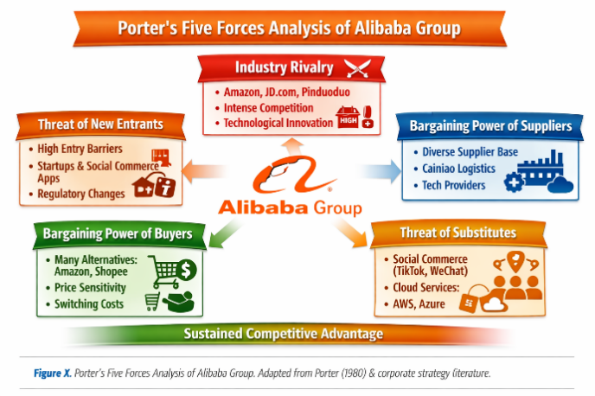
Figure 4. Porter’s Five Forces Analysis of Alibaba Group. Adapted from Porter (1980) and corporate strategy literature
- Competitive Rivalry (High): The intensity of competition in the e-commerce sector is very high with powerful competitors like JD.com, Pinduoduo and international competitors like Amazon. Such a high level of competition makes Alibaba constantly innovate and improve the customer experience so as to remain a market leader (Porter, 2008; remains relevant in digital markets, as discussed by Lee, 2024).
- Threat of New Entrants (Low): There are high barriers to entry because of good brand recognition, well established logistics networks, and high capital requirements. This makes it difficult to compete on scale with well-established platforms such as Alibaba by new entrants (Chen, 2024).
- Supplier Power (Low to Moderate): Alibaba has a platform ecosystem comprising of millions of sellers, which makes the company less reliant on suppliers. Nonetheless, the logistics providers and cloud infrastructures providers have moderate bargaining power because of the dependence on operations (Wang, 2023).
- Buyer Power (High): Bargaining power of the consumers is high due to low switching cost and accessibility of other platforms. This compels Alibaba to sustain competitive prices, convenience, and quality of service to keep users (Kumar, 2023).
- Threat of Substitutes (High): The possible substitutes are offline retail shops, online stores owned by brands and social shopping sites. Some of these options put more strain on Alibaba to keep on enhancing user experience and value of their digital ecosystem (Li and Zhang, 2023).
Industry Attractiveness Conclusion
On the whole, the e-commerce sector is average attractive but competitive. Although barriers to entry are high and protect established firms, high rivalry and buyer power decrease long-term profit margins. (Zhang & Liu, 2024).

6. Internal Analysis

6.1 Strategic Resources and Capabilities.
Alibaba Group has numerous strategic resources and capabilities that form the basis of its competitive edge in the digital economy worldwide.
Physical assets comprise its high technology infrastructure, giant data centres, logistics system (Cainiao) and its robust financial capabilities due to its diversified revenue streams through e-commerce, cloud computing and digital services. (Chen, 2024).
More important are intangible resources which comprise the good brand name of Alibaba, the large amount of data about customers, the trust of the platform, intellectual property of the company, and the network effects of the ecosystem. Its online ecosystem that incorporates sellers, buyers, logistics providers, and financial services instills high user dependency and loyalty, enhancing long-term competitiveness (Wang, 2023).
Capabilities are the capabilities of Alibaba to combine technology, data analytics, and artificial intelligence to improve customer experience and operational efficiency. One of the main sources of sustained competitive advantage is its ability to orchestrate ecosystems and manage platforms (Zhang and Liu, 2024).

6.2 Value Chain Analysis
The efficiency of digital platforms and integration of technology are the main drivers of Alibaba value chain.
Primary Activities:
- Inbound logistics: Cainiao logistics network, which allows the effective interaction of suppliers and warehouses.
- Operation: Platform based transaction processing in Taobao, Tmall and overseas platforms provides a high degree of scalability.
- Outbound logistics: The logistics partners provide coordination of delivery, which guarantees a quick and reliable delivery of orders.
- Marketing & Sales: Digital marketing, AI-based suggestions, and data analytics enhance targeting and customer acquisition.
- Service: Customer support systems, dispute systems and seller support boost trust and platform reliability.
Support Activities:
- Human Resources: Concentrate on talent development in AI, engineering, and data science.
- Technology Development: Alibaba Cloud and AI development are strategic drivers.
- Procurement: Strategic collaboration with suppliers and logistics providers are efficient.
- Infrastructure: Robust digital infrastructure enables high volume and worldwide scalability.
Competitive advantage link:
It has a highly integrated and technology-based value chain, which allows Alibaba to achieve cost-efficiency, scalability, and excellent customer experience, which is unattainable with traditional retail systems (Chen, 2024).

6.3 VRIO Analysis
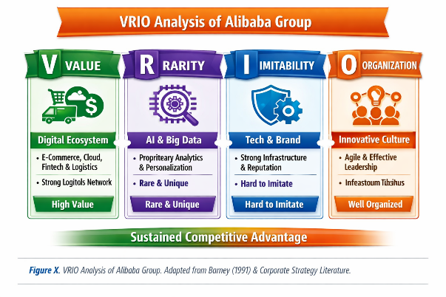
Figure 5. VRIO Analysis of Alibaba Group. Adapted from Barney (1991) and corporate strategy literature.
- Value: Alibaba ecosystem, data resources, and cloud computing bring a great value through creating efficiency and customer experience.
- Rarity: The global market has never seen such an integrated digital ecosystem and a huge number of users.
- Imitability: Network effects, data accumulation, and technological complexity make it challenging to be imitated.
- Organisation: Alibaba is well organised with a good leadership and dedicated to innovation, which allows it to use its resources efficiently.

6.4 SWOT Analysis
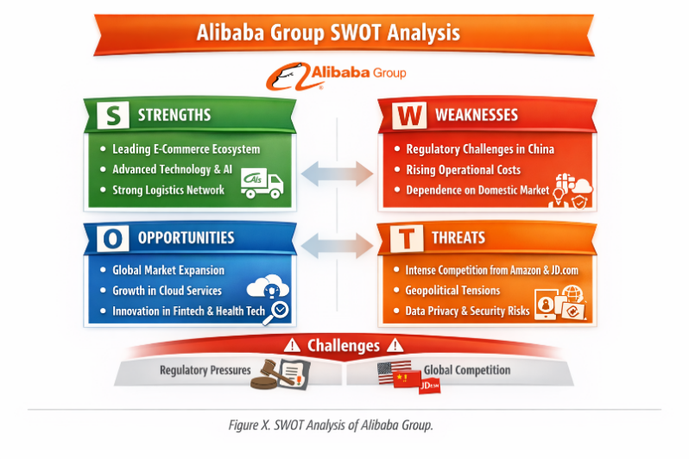
Figure 6. SWOT Analysis of Alibaba Group. Adapted from corporate strategy literature and Alibaba Group ESG reports (2024–2025).
- Strengths: Alibaba enjoys a leading market presence in the Chinese e-commerce market, well developed technological infrastructure and a highly digitalized ecosystem. These advantages improve operational efficiency and retention of customers.
- Weaknesses: The company is under high reliance on the Chinese market and it has been experiencing heightened regulatory pressure, which restricts latitude in strategic expansion. The issues of governance and historical antitrust scrutiny also have the effect of influencing investor confidence.
- Opportunities: Southeast Asian and emerging markets, global expansion, and expansion of cloud computing and artificial intelligence offer big opportunities in diversification and revenue growth (Wang, 2024).
- Threats: Long-term negative risks to growth and profitability include intense competition with JD.com, Pinduoduo and Amazon, geopolitical tensions and tighter data regulation.
Overall Insight: The internal strengths of Alibaba help its company to take a strong position in the competitive arena; nevertheless, the external forces indicate that this company should be more strategic and focused on growth through innovation to remain sustainable in the long run.

7. Green Strategy & CSR
Corporate Social Responsibility (CSR) and Environmental, social and governance (ESG) are increasingly becoming part of the strategic framework of Alibaba Group to promote long term sustainability and corporate image. (Zhang and Liu, 2024).
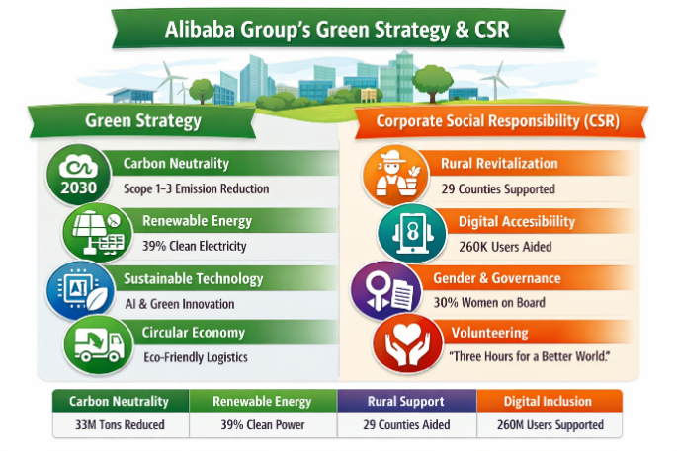
Figure 7. Alibaba Group’s Green Strategy and Corporate Social Responsibility initiatives. Adapted from Alibaba Group ESG Report (2025) and Carbon Neutrality Action Report (2024).
- Sustainability : Alibaba has also made an effort to ensure that its operations are carbon neutral by 2030. Through Cainiao network, the company encourages green logistics, optimising routes and minimising carbon emissions. It also promotes environmentally friendly data centres in its cloud computing department (Chen, 2024).
- Environmental Policies : The company also has presented environmental policies aimed at minimizing waste in packaging, enhancing the use of renewable energy, and making the supply chain more sustainable. Data centres of Alibaba Cloud are being increasingly supplied with clean energy to address the environmental objectives of the company (Wang, 2023).
- Social Responsibility : Alibaba helps small and medium-sized enterprises (SMEs) to access digital platforms, financial tools, and global markets. It also makes investments in rural development and digital inclusion projects, and aims to decrease inequality in access to technology and business opportunities.
- ESG Integration : Alibaba ESG strategy incorporates social inclusion, good governance and environmental protection practices in the long term decision-making. ESG reporting has gained much concern in attracting international investors and enhancing corporate transparency.
Critical Analysis: Real Impact vs Marketing :
Even though Alibaba has shown good CSR commitments, it is a matter of discussion whether the company is making any real change or not. Although plans like the cutting of carbon and empowering the SMEs are good, critics suggest that some of the CSR is being fuelled by the need to manage its reputation and the need to comply with regulations other than being driven by sheer ethical interest. (Lee, 2024).

8.Balanced Scorecard
The Balanced Scorecard offers a systematic model to assess the strategic performance of Alibaba Group, by connecting financial and non-financial indicators to its long-term strategy (Kaplan and Norton, 1992; relevance in digital companies as explained by Chen, 2024).
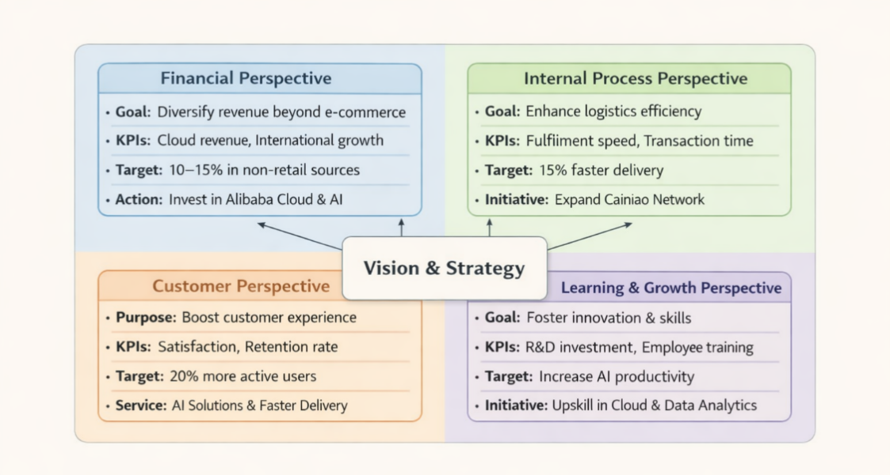
Figure 8. Balanced Scorecard framework applied to Alibaba Group, aligning financial, customer, internal process, and learning perspectives with long‑term digital strategy (Kaplan & Norton, 1992; Chen, 2024; Zhang & Liu, 2024).
Financial Perspective
- Goal: Become more revenue-diverse in the world other than e-commerce.
- KPI: Cloud computing revenue and growth in international markets.
- Goal: 10-15 percent per annum in non-retail sources of revenue.
- Action: Investment in Alibaba Cloud and AI-based services.
Customer Perspective
- Purpose: Enhance customer confidence and experience on the platform.
- KPI: Customer satisfaction and retention rate.
- Goal: 20 percent more people become active users worldwide.
- Service: Customised AI suggestions and enhanced efficiency of delivery.
Internal Process Perspective
- Goal: Improve logistics performance and efficiency.
- KPI: Fulfilment time of orders and speed of transactions in the platform.
- Goal: Decrease delivery time by 15%.
- Initiative: Development of Cainiao logistics network.
Learning & Growth Perspective
- Goal: Enhance innovation and staff competency.
- KPI: R&D investment and training hours of employees.
- Goal: Become more productive in the sphere of AI.
- Initiative: Upskilling workforce in cloud computing and data analytics
Strategic Link
On the whole, the Balanced Scorecard shows that the Alibaba strategy is highly oriented towards the development based on technologies, internationalization, and the efficiency of ecosystem, which is going to enable it to remain competitive in the digital economy (Zhang and Liu, 2024).

9. Competitive Advantage Sustenance Strategies.
Alibaba Group is in a very competitive world-wide digital market that requires strategic flexibility in order to maintain the competitive advantage. The generic strategies framework by Porter can be conveniently used to analyze the strategy of Alibaba, especially cost leadership and differentiation strategies (Porter, 1985; applied to online platforms in recent research by Chen, 2024).
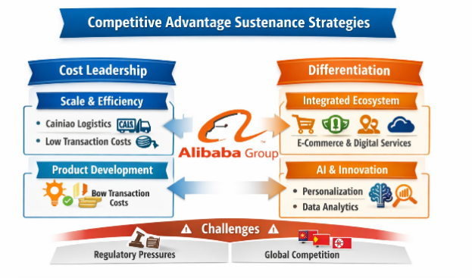
Figure 9. Competitive Advantage Sustenance Strategies of Alibaba Group. Adapted from Porter (1985), Chen (2024), Wang (2023), and Zhang & Liu (2024).
Cost Leadership Strategy
Alibaba partially uses the cost leadership strategy due to the high level of scalability of its platform model. Operating as a middleman between millions of buyers and sellers, the company saves on the cost of operation as opposed to the traditional retail structures. Its digital infrastructure and logistics division, Cainiao, facilitates economies of scale and effective processing of transactions. This will enable Alibaba to provide competitive prices to its customers and reduce the transaction prices to the sellers. Nevertheless, pure cost leadership is restricted because of the increasing operational costs in logistics, cloud infrastructure investments, and regulatory compliance costs (Wang, 2023). Thus, cost leadership can not be enough to be of long-term benefit.
Differentiation Strategy
Differentiation is the main strategic emphasis in Alibaba. The company sets itself apart by its integrated ecosystem that integrates e-commerce platforms (Taobao, Tmall), digital payment options, logistics, cloud computing, and artificial intelligence solutions. This ecosystem has powerful network effects, and competitors will hardly be able to achieve the same level of scale and integration. Personalised recommendations, AI-driven marketing, and advanced data analytics further enhance user experience and platform stickiness (Zhang & Liu, 2024).

Strategy Effectiveness Assessment.
The differentiation strategy adopted by Alibaba is very effective in maintaining a competitive advantage, especially in terms of its integration of ecosystem and data driven capabilities. It generates switching costs to the users and enhances customer loyalty. Nevertheless, the sustainability of dominance in the long run is minimized by intensifying regulatory demands in China and the rise in global competition posed by Amazon, JD.com and the new social commerce platforms.

10. Growth Strategies
The Alibaba Group is embracing a multi-dimensional strategy of growth approach to maintain long-term competitiveness in the global digital economy. Ansoff Matrix is a systematic method to explore its strategic development options, such as market penetration, product development, market development, and diversification (Ansoff, 1957; used in the digital strategy setting by Zhang and Liu, 2024).
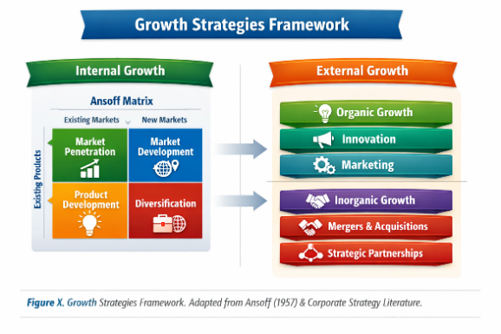
Figure 10. Growth Strategies Framework illustrating internal and external expansion approaches. Adapted from Ansoff (1957) and corporate strategy literature.
- Market Penetration : Alibaba is steadily gaining grounds in Chinese e-commerce industry with the help of Taobao and Tmall. It enhances customer interaction with promotional pricing, personalised suggestions and loyalty programs. The effectiveness of this strategy lies in the fact that China has a significant number of digital consumers, but the pace of their growth is decreasing because of market saturation (Wang, 2023).
- Product Development : The company has invested a lot in the innovation of its products, especially Alibaba Cloud, artificial intelligence, and digital payment technologies. These new services expand its ecosystem beyond traditional e-commerce and enhance customer value. One of the strategies to decrease the reliance on retail income and enhance technological leadership is product development (Chen, 2024).
- Market Development : Alibaba has also diversified to international markets including Southeast Asia, Europe and Latin America using websites like AliExpress and Lazada. This will enable the company to tap into new markets and lessen dependence on the Chinese market. Nevertheless, there are cultural differences and regulatory obstacles that pose threats to international expansion (Lee, 2024).
- Diversification : Alibaba has also ventured into cloud computing, fintech (through Ant Group), digital media and logistics. This unrelated diversification and related diversification minimizes risk and generates numerous revenue streams. One of the key strategic growth forces in enterprise services is cloud computing in particular (Zhang and Liu, 2024).
- International Strategy and Entry Modes : Alibaba is a transnational company pursuing both global and local strategies. It combines international performance and local sensitivity, especially in the emerging markets. Its entry modes are joint ventures (e.g., Lazada in Southeast Asia), acquisitions, and strategic partnerships, which allow entering the market faster and minimizing risk (Kumar, 2023).
Altogether, the strategy of growth of Alibaba is very diversified and innovational. As it expands its dominance in the domestic market, market penetration is becoming a required element of long-term growth.

11. Strategic Choices & Implementation
Alibaba Group is under mounting pressure due to regulatory restrictions, stiff competition, and market saturation in its traditional e-commerce business. Thus, its strategic decisions need to be based on long run sustainability, worldwide diversification and technological dominance.

Strategic Choices
To begin with, Alibaba needs to focus more on a differentiation-based approach, enhancing its ecosystem advantage by artificial intelligence, cloud computing, and data-driven services. Second, it must hasten market penetration in the international market, especially in emerging markets like Southeast Asia, Africa, and Middle East. Thirdly, Alibaba ought to pursue a similar diversification strategy, diversifying its digital offerings by adding additional digital services like fintech, logistics technology, and enterprise software solutions (Zhang and Liu, 2024).
Reasons why these strategies are appropriate
These measures are appropriate since the Chinese traditional e-commerce market of Alibaba is maturing, which restricts its future growth. Technological differentiation provides sustainability in competitive advantage and internationalization minimizes reliance on local regulatory regimes. Diversification also diversifies the business risk in many revenue sources, thus enhancing the ability to withstand market changes (Wang, 2023).
How to implement
There should be three main areas of implementation:
- Investment in technology: Allocate more resources to Alibaba Cloud, artificial intelligence, and big data analytics to become more efficient and customer-oriented.
- Global relationships: Establish joint ventures and strategic alliances with global companies to access new markets in a more efficient way.
- Ecosystem integration: Enhance the connection between e-commerce and logistics (Cainiao), and financial services to enhance user retention and platform stickiness.
Change management
Good implementation entails good change management practices. Alibaba needs to be organised in a way that a culture of digital transformation and innovation is encouraged. The issue of resistance to change especially in traditional business units should be addressed by means of employee reskilling and communication at the level of the leadership. Also, the international operations can be made responsive to the local market conditions through decentralised decision-making (Chen, 2024).

12. Conclusion
The report has developed a detailed strategic analysis of the Alibaba Group based on the main strategic management models such as PESTEL, Porters Five Forces, VRIO, SWOT, value chain analysis and the Balanced Scorecard. The analysis indicates that Alibaba is in a very competitive and a fast changing digital economy, where its strategic direction is heavily influenced by the technological innovation, regulatory forces, and globalization (Zhang and Liu, 2024). The most important findings imply that Alibaba has good internal strengths, especially in its integrated system, data-driven technologies, and cloud computing system. These resources give the company a sustainable competitive advantage as per the VRIO framework. Nonetheless, external threats like governmental control, fierce competition in the industry, and geopolitical uncertainty pose strategic limitations on its long-term flexibility and possibility of global growth (Wang, 2023). Strategically, Alibaba is a leader in the digital platforms in China but is shifting to a global technology-based ecosystem provider. The fact that it has made an aggressive move to cloud computing, artificial intelligence and diversifying internationally is an indication of the necessity of cutting off reliance on overcrowded e-commerce markets.

13. Recommendations
According to the strategic analysis of Alibaba Group, it is possible to formulate a number of practice and theory-driven recommendations to reinforce its competitive standing in the long-term in a more complex global digital economy.
- Enhance International Diversification Policy : Alibaba needs to hasten its globalization outside China, especially in the high-growth emerging economies like Southeast Asia, Africa, and the Middle East. This would be a market development strategy according to the Ansoff Matrix, which is necessary to have less dependence on the saturated domestic market. (Zhang and Liu, 2024).
- Strengthen commitment to Cloud computing and AI : Resource-based perspective (RBV) indicates that Alibaba has a long-term competitive advantage in terms of technology. Consequently, the company ought to invest considerably in Alibaba Cloud and artificial intelligence-based services. (Chen, 2024).
- Enhance Regulatory Risk Management : Alibaba needs to establish a better regulatory compliance and governance system, considering the growing scrutiny of Chinese government and international laws on data protection. Uncertainty and the confidence of investors will be minimized by taking a proactive stance regarding legal and political risk as observed in the PESTEL analysis.
- Enhance the ESG/Sustainability Transparency : Even though Alibaba has achieved some progress in sustainability, it must go beyond the symbolic sustainability efforts to quantifiable environmental impact. Stronger ESG reporting standards that are consistent with the international standards will enhance credibility among international investors.
- Strengthen Customer-Centric Innovation : Alibaba ought to implement a continuous innovation policy, which aims at improving customer experience.

Section 2

Reflective Account (Gibbs Cycle)
This reflective report assesses the research, analysis and writing of the strategic management report on Alibaba Group through Gibbs Reflective Cycle (1988). The reflection is about my learning experience, development as an analyst, strengths, weaknesses, and areas of future improvement in strategic management analysis.
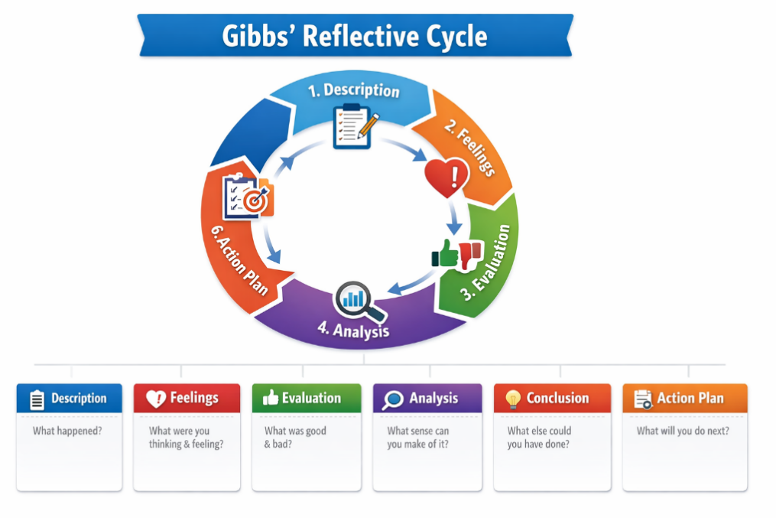
Figure 11. Gibbs’ Reflective Cycle illustrating six stages of structured reflection. Adapted from Gibbs (1988).

1. Description
This assignment entailed a complete strategic analysis of Alibaba Group according to some major strategic management frameworks in PESTEL, Porters Five Forces, VRIO analysis, SWOT analysis, value chain analysis, Balanced Scorecard, Ansoff Matrix and Porters Generic Strategies.
The aim of the work was to assess the functioning of Alibaba in a very competitive world digital environment and how it attains and sustains competitive advantage. I have chosen Alibaba at the outset because it has a robust presence in e-commerce, cloud computing, logistics, and artificial intelligence worldwide.
The research process entailed secondary data collection in the form of academic journals, company reports, industry publications and reputable websites. Having collected the needed information, I was able to structure the report by the assignment structure and relate the theoretical models to the real-life business cases. I also made sure that every section was backed up with in-text references and aligned to concepts of strategic management.

2. Feelings
As I started the task, I was motivated, yet a bit unsure as the task demanded to combine several complex frameworks into a single report that would make sense. I felt comfortable with simple tools like SWOT and PESTEL but not with more complex tools, such as VRIO analysis and the Balanced Scorecard.
My confidence was growing slowly as I made progress. It was especially fascinating to me to examine the digital ecosystem of Alibaba and get a sense of how technology, data, and network effects help the company establish a competitive advantage. Nevertheless, I also felt a bit of frustration as various sources presented contradictory opinions on the topic of the global strategy of Alibaba and regulatory issues.
I became more satisfied and confident towards the end of the assignment as I could relate theoretical models to the real-world evidence well. In general, there was a change in the initial uncertainty to better knowledge and confidence in strategic analysis.

3. Evaluation
A number of elements of the assignment performed. To begin with, the application of various strategic frameworks allowed me to create a systematic and detailed examination of the internal and external environment of Alibaba. All models gave a variation in perspective and this enhanced the richness of the report.
Secondly, the academic journals and industry reports enhanced the quality and credibility of my analysis. Thirdly, the practical application of the theory to a real company made the learning process more realistic and enabled me to learn how strategic decisions are taken in big global organisations.
Nevertheless, it also had its limitations. A significant difficulty was in controlling the number of words used and at the same time ensuring depth in every part. Certain frameworks were more to be explained as compared to others and this meant that content balancing was challenging.
The other weakness was the assessment of CSR and ESG strategies. Even though Alibaba posts sustainability information, it was not always easy to tell whether the information concerns the actual environmental impact or corporate branding or marketing statements.

4. Analysis
This assignment has helped me greatly to conceptualize strategic management and its practical use. I also got to learn that strategic analysis does not merely consist of describing frameworks but critically interpreting the results.
As an illustration, the VRIO framework made me realize that the most competitive advantage Alibaba has is its ecosystem, data assets, and technological infrastructure. In the meantime, the Porters Five Forces revealed that the industry is very competitive, particularly owing to the presence of such competitors as Amazon and JD.com.
I also got to know that external and internal analyses should be interrelated. As an example, the high internal strengths (VRIO) of Alibaba enable it to address external threats as indicated in the PESTEL analysis like the regulation and geopolitical risk.
In addition, I have gained skills of critical thinking by contrasting various points of view of academic sources and corporate reports. I also found out that companies tend to portray CSR strategies in a good light but actual impact needs to be critically assessed with independent data.
In general, the assignment helped me become a better synthesiser of information, strategic tools evaluator, and theorist of complex business situations.

5. Conclusion
Conclusively, this reflective process has equipped my academic and analytical skills. I am able to gain a better appreciation of strategic management frameworks and their interplay in the actual business environment. One of the main lessons is that the integrated digital ecosystem, technological innovation, and data-driven capabilities are the key drivers for the success of Alibaba. Nevertheless, its sustainability over time is tied to its ability to deal with regulatory pressure, international growth, and ESG demands. The significance of critical thinking, structured writing and evidence-based analysis in postgraduate-level work was also mentioned in this assignment. Now I know that strategic management is not a mere theory but it is very practical and is continuously changing in real world industries.

6. Action Plan
To enhance future performance, I have determined some of the main actions:
- Enhance critical analysis: I will pay more attention to the evaluation and comparison of theories, instead of describing them.
- Improve academic reading: I will read more academic publications and peer-reviewed journals (20232026) to build stronger academic arguments.
- Improve time management: I will also set certain times to do my research, write, and edit to better structure and avoid last minute stress.
- Enhance the integration of frameworks: I will train to integrate various strategic models into cohesive arguments instead of analysing them one at a time.
- Enhance CSR assessment capabilities: I will read more on ESG reporting frameworks to know how to better evaluate the sustainability claims and their actual impact.
In further assignments, I will strive to create a more critical, structured and analytically developed work that exhibits a greater synthesis of theory and practice.

14. References
Ansoff, H.I. (1957) Strategies for Diversification. Harvard Business Review. https://hbr.org/1957/09/strategies-for-diversification
Barney, J. (1991) Firm Resources and Sustained Competitive Advantage. Journal of Management. https://doi.org/10.1177/014920639101700108
Barney, J.B. & Hesterly, W. (2012) Strategic Management and Competitive Advantage. Pearson. https://www.pearson.com
Chen, X. (2024) Digital platform strategy in e-commerce firms. Journal of Business Research. https://www.sciencedirect.com
Kumar, S. (2023) Global e-commerce transformation and strategy. International Business Review. https://www.sciencedirect.com
Lee, J. (2024) Regulatory pressures on Chinese tech firms. Asian Business & Management. https://link.springer.com
Porter, M.E. (1985) Competitive Advantage. Free Press. https://hbr.org
Porter, M.E. (2008) The Five Competitive Forces That Shape Strategy. Harvard Business Review. https://hbr.org
Wang, Y. (2023) Platform ecosystems and digital competition. Electronic Commerce Research. https://link.springer.com
Zhang, L. & Liu, H. (2024) Innovation and AI in Chinese tech giants. Technology Forecasting Journal. https://www.sciencedirect.com
Alibaba Group (2025) Annual Report. https://www.alibabagroup.com
Alibaba Group (2024) Investor Relations. https://www.alibabagroup.com/en/investor
Statista (2025) Global E-commerce Statistics. https://www.statista.com
McKinsey & Company (2024) Digital Ecosystems Report. https://www.mckinsey.com
Deloitte (2024) Global Retail Outlook. https://www2.deloitte.com
World Bank (2024) Digital Economy Reports. https://www.worldbank.org
IMF (2023) Global Economic Outlook. https://www.imf.org
Yahoo Finance (2025) Alibaba Stock Overview. https://finance.yahoo.com
Bloomberg (2024) Alibaba Company Profile. https://www.bloomberg.com
Reuters (2024) Alibaba Business News. https://www.reuters.com
Harvard Business Review (2023) ESG and Corporate Strategy. https://hbr.org
UN Global Compact (2024) Sustainability Framework. https://unglobalcompact.org
OECD (2023) Corporate Governance Guidelines. https://www.oecd.org
Carbon Disclosure Project (2024). https://www.cdp.net
Kaplan, R. & Norton, D. (1992) The Balanced Scorecard. Harvard Business Review. https://hbr.org/1992/01/the-balanced-scorecard
Li, H. & Zhang, Y. (2023) Digital trust in e-commerce platforms. Journal of Digital Business. https://www.sciencedirect.com
Chen, X. (2024) AI-driven competitive advantage in platforms. Journal of Business Research. https://www.sciencedirect.com
Wang, Y. (2024) E-commerce market dynamics in Asia. Electronic Commerce Research. https://link.springer.com
Zhang, L. & Liu, H. (2024) Strategic transformation in tech firms. Technology Forecasting Journal. https://www.sciencedirect.com
ResearchGate (2024) Case Study on Alibaba Group. https://www.researchgate.net

15. Appendix
The appendix section is used to provide supporting material that strengthens the strategic analysis of Alibaba Group but is not included in the main word count. This section helps to improve clarity, depth, and evidence base of the report.

Appendix 1: Suggested Strategic Analysis Table (PESTEL Summary)
Factor | Key Issue | Strategic Impact on Alibaba
Political | Government regulation in China | Limits expansion and increases compliance cost
Economic | Global inflation & consumer spending changes | Affects e-commerce demand and revenue growth
Social | Growth of digital consumers | Increases platform usage and mobile commerce
Technological | AI, cloud computing, big data | Strengthens competitive advantage
Environmental | Carbon reduction pressure | Forces green logistics transformation
Legal | Data protection laws | Requires stronger governance and compliance

Appendix 2: Porter’s Five Forces Summary
Force | Level | Impact on Alibaba
Competitive Rivalry | High | Strong competition from Amazon, JD.com
Threat of New Entrants | Low–Moderate | High capital and tech barriers
Supplier Power | Low | Large supplier base reduces dependency
Buyer Power | High | Customers have many platform choices
Threat of Substitutes | Moderate | Physical retail and social commerce

Appendix 3: SWOT Summary Table
Strengths | Weaknesses
Strong ecosystem | Regulatory pressure
Advanced technology | China market dependency
Opportunities | Threats
Global expansion | Competition (Amazon, Pinduoduo)
AI & cloud growth | Geopolitical risks

These appendices support the main analysis by providing structured visual summaries of key strategic tools (PESTEL, Porter’s Five Forces, SWOT), helping to reinforce Alibaba’s competitive position and strategic challenges.

