Project Management Plan
For
Building a new Hostel
Assignment Part 1

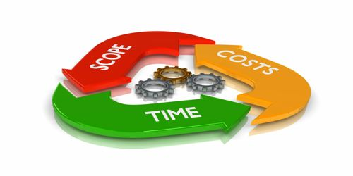
QS Study (2021)

Student Name | Deon Rose Lobban
Student ID | 1919079
Module name | Managing Projects in the workplace
Module Code | BMSW5104_Birm
Lecturers Name | Daminab Pokubo


Adobe stock (2022)

Knights' Constructions

132 Birmingham Middleway
Moseley Road B12 0DG
Tel: 0121 796 4321
E-mail: Knights’ Constructions@hotmail.co.uk

Introduction

The purpose of this report is to provide a structured project management plan for the development of student hostels on behalf of the University of Wales Trinity and Saint David (UWTSD). It will also critically explain the outline of the project, including details of the relevant stakeholders, student’s needs, funding, cost, work breakdown structure, risk assessment and the relevant business tools needed to help bring the project to fruition.

Knights' Constructions has been contracted to manage the construction of six hostel blocks
to help ease the increasing influx of students in England and traveling from abroad requiring living accommodation. The hostels will be located on the Bristol Rd, Birmingham City Centre, within walking distance of the University, city library, local shops, bus stops, train station, coach stations, and the new Birmingham phase one metro line. The involved stakeholders of the built properties will be impressed with the unique design of the buildings which will be comfortable and pleasant to look at, helping to bringing a sound investment for the future.
Knights' Constructions will deliver and construct six spacious student hostel blocks, each consisting of three levels. On each floor there will be twelve single rooms, (1 per student) with ensuite bathroom, a communal room, breakfast bar and kitchen, appropriate storage facilities complete with fixture and fittings. The hostels will house 36 students per block, providing students with the finest away from home living experience possible as seen below.
Projected hostel diagram of each level
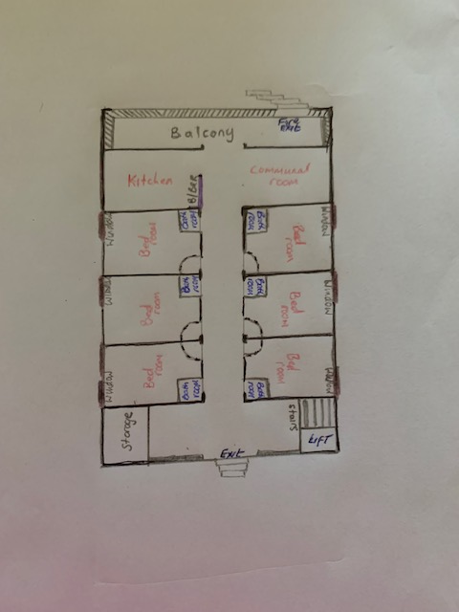
Table of contents

Introduction......………………………………………...………3

Knights’ Constructions.......……………………………………5

Project outline - Quad chart.………………...……....…………6-7

Pestle analysis...………………………...……………………...7

Funding…………...………………...……………………....….8

Stakeholders’ analysis………...........….……………………….8

Stakeholders’ analysis power tool………………....…………...8

Stakeholders’ involvement……….……………………9

Work breakdown structure……………........………….………10

(WBS) Management building team……………………….…10

Materials………………………………………………….……11

Gantt chart…………...………………………………………...12

Risk assessment.….……………………………………………12-13

Health and safety………………………………………………13

Sustainability...………………………………………………...13

Conclusion………………….………………………………….14

References …………………………………………………….15-16

Appendices………………………………………………….…17

Knights' Constructions

Knights’ Constructions is a family run business with over 20 years' experience in building large and small projects throughout the UK. All staff are highly qualified and have a professional approach to their field of work, achieving positive results with customers after every project undertaken.

Knights’ Constructions will collaborate closely with University of Wales Trinity and Saint David to develop a summary that will carefully examine and push the boundaries of what is possible. The company is inventive and uses a creative, fresh, modern approach, making the most of all available space, scenery, lighting, and available budget, while focusing on energy efficiency and eco-friendly items and materials; it thrives constantly to build aesthetically pleasing well-built accommodations that exceed the customer desires and expectations.

Project Outline - Quad Chart
The phrase Quad Chart derives from the word Quadrant Analysis Chart. It was developed initially as a management tool to help improve the budgeting and planning system alongside other documents, paperwork, or power point, thus outlining and improving the focusing on the structure of the project by breaking it down into 4 manageable sections. Each section has its own individual title and gives a bird’s eye view of important information relating to the subject, as well as the objectives and measure of success for the customer or client. The quad chart is a productive management tool in assisting Knights’ Constructions in the planning of all projects. It helps to summarise and put ideas into perspective as seen below.

Knights’ Constructions
Building a better future for students
Aims/Objectives  - To design, build/construct student blocks for the UWTSD.  - To provide comfortable living accommodations, appropriate for students to reside while studying.  - To provide a quality first class serve. | Stakeholders  - UWTSD  - Knights’ Constructions  - The public  - Students/union  - City council
Desired end-result  - Satisfied clients.  - Happy students.  - Strong, safe building.  - Clean and liveable living quarters.  - Accessible buildings/carparks.  - Environmentally friendly. | Measures of success  - Recommendations.  - Satisfied Customers.  - Projects completed on time.  - Successful Completion of Projects.

“The basic purpose of initiating a project is to accomplish specific goals. The reason for organising the task has a project is the focus on the responsibility and authority for the attainment of the goal on an individual or small group” (Meredith, Shafer and Mantel, 2017, p9).
Pestle analysis
Knights’ Constructions used the Pestle to scan the framework of the project from a political, economic, social, technological, legal, and environmental point, highlighting details which may affect the building of the project and possible productivity impacting on the stakeholders and their positions.
“PESTLE is a strategic planning tool used to evaluate the impact of political, economic, social, technological, environmental, and legal factors might have on a project.” (Rastogi and Trivedi, 2016, p3).

Pestle analysis for UWTSD student hostel blocks
Political | Economic | Social | Technological | Legal | Environmental
Covid 19 sick staff.  The Ukraine war could affect the building of the project if there are any political Russians involved in the financial side of the business.  Residential construction,  Traffic laws,  Waste management system update. | Landfill disposal,  Illegal dumping,  Landfill tipping fees | Lack of recycling knowledge. | Reduced time at recycling plants, Lack of recycling sites around the country. | Reduced regulations.  Product waste, excess dirty and recycled. | Illegal dumping, hazardous substances.

Funding
UWTSD will be the major stakeholders investing heavily throughout the project to be able to meet the demands for student accommodations. Start-up costs, and all expected expenditure has been negotiated, and agreed with UWTSD and will be provided by the university. Any additional costs or requirements will be discussed as and when required.
Upon completion and inspection of the end project UWTSD will retain complete ownership of the six hostel blocks and will not be seeking any outside investors or additional stakeholders or funding. “The implementation of construction projects of the municipal economy requires adequate investment and financial support” (Fedorova et al., 2018, p2).

Stakeholder Analysis

Knights’ Constructions employed a Stakeholder Analysis tool to help determine which stakeholders are the most important as it is imperative to know who the influential stakeholders are, and the most powerful in order to prioritize and communicate effectively.

Stakeholders Analysis power tool - UWTSD
Stakeholders | Project power | interests | project Influence | RISK and assumptions
UWTSD | high | to receive 6 student hostels | important | full funding provider, all resources,
knights' CONSTRUCTIONS | high | Complete objective, goals, deliverables | important | Providing all resources materials
council | high | health and safety | important | regulations, permits planning requirements,
students | low | affordable accommodations | minimal | Cost
general public | low | Noise, rowdy teenagers | minimal | Anti-social behaviour

“Stakeholder analysis typically refers to the range of techniques or tools to identify and understand the needs and expectations of major interests inside and outside the project environment.” (Smith, 2000).

Stakeholders’ Involvement
The stakeholders are central to the project's purpose, playing a crucial role, with or without financial commitment, which can have a significant impact on the project internally and externally, weighing heavily on decision-making and activities if made to feel undervalued.

Knights’ Constructions encourage a positive relationship with the stakeholders, expressing a clear view of each stakeholder's position and what is expected of them, gaining the respect and trust of the stakeholders by keeping them engaged, incorporating strong principles within the agreed contracts as listed below.
- Communicating regularly
- Involvement in the planning
- A representative will be provided on behalf of the stakeholders
- Newsletters/e-mails to keep in formed.
- Showing respect and honesty
- Share information regardless of whether it is negative or positive
- Show compassion and understanding

There are four categories of stakeholders: users, providers, influences, and governance (UPIG) within the hierarchy system. The relevant stakeholders are listed below and numbered according to influence, impact, and interests within the building of the project:
- UWTSD = Important – full investors
- Knights’ Constructions = Important - managing & constructing project
- City council = Important - public safety, pipelines, surrounding businesses, health care.
- Students – Interest
- The public - Interest
“Influence indicates a stakeholder’s relative power over and within a project. A stakeholder with high influence would control key decisions within the project and have strong ability to facilitate implementation of project tasks and cause others to take action.”
Project management institute (Smith, 2000).

Work Breakdown Structure (WBS)
The work breakdown structure is a hierarchical planned network of scheduled tasks divided into single project deliverables, allowing a better forecast of the project and what needs to be done facilitating manageability. Each deliverable can be sub-divided depending on project requirements. These smaller tasks are known as sub-tasks.
“The WBS has been considered as the standardised method to hierarchically subdivide a project into its sub-parts aiming to reduce project complexity.” (Hartmann et al., 2012; Smith, 2010 cited in Sutrinsa, Ramanayaka and Goulding, 2018).
Knights’ Constructions designs, manufactures, assembles, and installs all products & materials, which also allow for extension conversions. After several meetings with the Architectural designers, construction team, stakeholders, and health & safety, a proposal was initiated to develop 6 student hostels which will be constructed from the Knights flatpack building range within the Birmingham area; the team breakdown and planning is as follows:

(WBS) Management Building Team

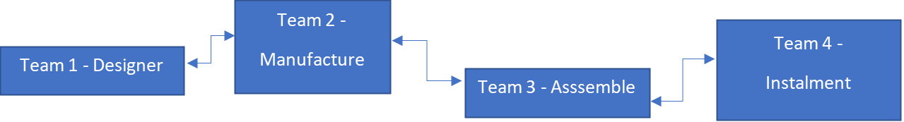
Knights’ Constructions (2022)
Team 1
Architectural designers create a three-dimensional outlook of the plan, including structural measurements of the required materials.
Team 2
The manufacturing team cut to size materials following measurements from team 1.
Team 3
All measurements and parts are double checked for accuracy, flat packed ready for the assembly team, delivered to the site ready for installation.
Team 4
The appointed site manager will have 3D plans of the structure, measurements, and all
relevant information to begin construction.
“Previous studies have focused on automating the planning aspect by associating individual components with schedule information. However, large construction projects usually consist of thousands of components.” (Ibrahim et al., 2009).
Materials
Knights’ Constructions flatpack building material system.
Framework: versatile transportable light weight steel, 35 to 40 years life span.
Wall panels: weatherproof, fire resistant hard plasterboard plastic covered Formica complex, including curved construction.
Roofing system: extra strong, safe, durable, long-life high-performance reinforced fiberglass, life span 20-30 years. The rapid evolution of Industry 4.0 technologies is impacting construction, changing the way building components and buildings are constructed. (Ginigaddara et al., 2021, p2)

Knights’ Constructions flat pack system prides themselves in knowing that they can erect a strong, sturdy hostel block in less than half the time of a normal building made of brick, allowing for a more cost-effective faster build, ready for the coming September.
Building materials are available in a range of landscape colours. Global factors may affect the quality and cost of raw materials, which may fluctuate depending on availability. Every attempt will be made to maintain customer satisfaction.

Gantt Chart

Knights’ Constructions used the Gantt chart to plan the schedules. It also highlights project tasks, predicted deadlines, timelines, showed the progression and resources needed to help the project run more efficiently. Incorporating the Gantt chart helped saving time and money.
“Gantt charts are simple to understand and easy to construct and are powerful visual tools for managing projects.” (Kumar, 2005)
Gantt Chart
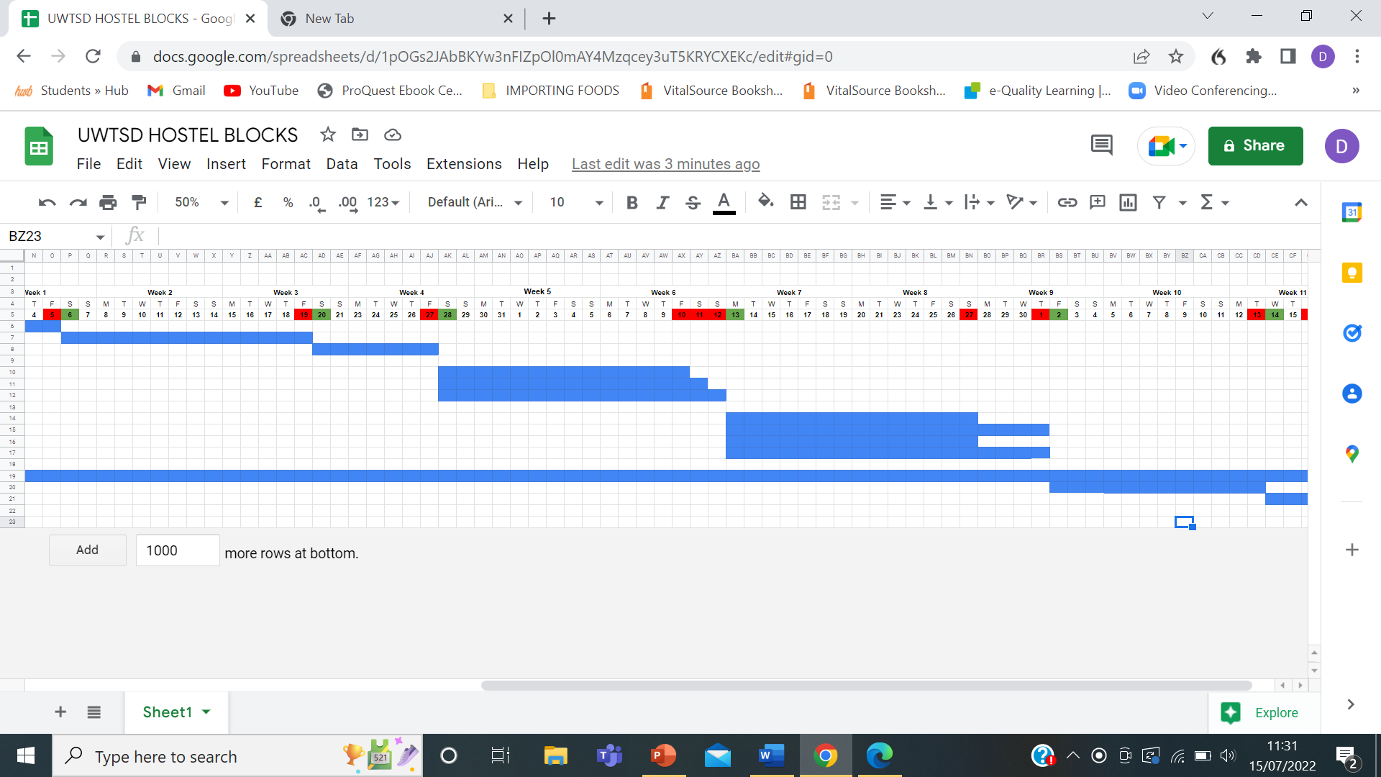
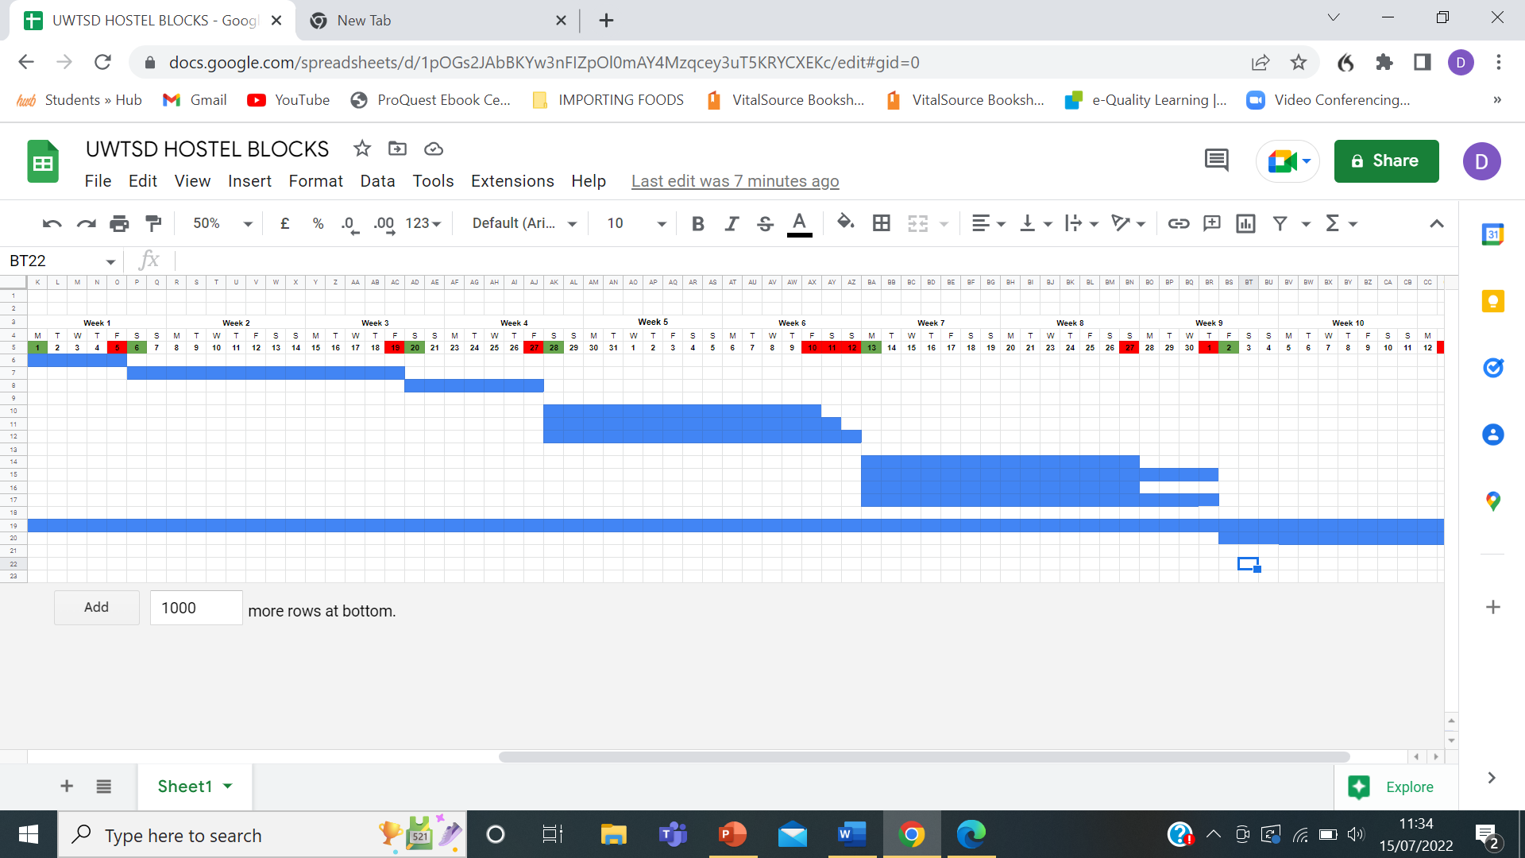
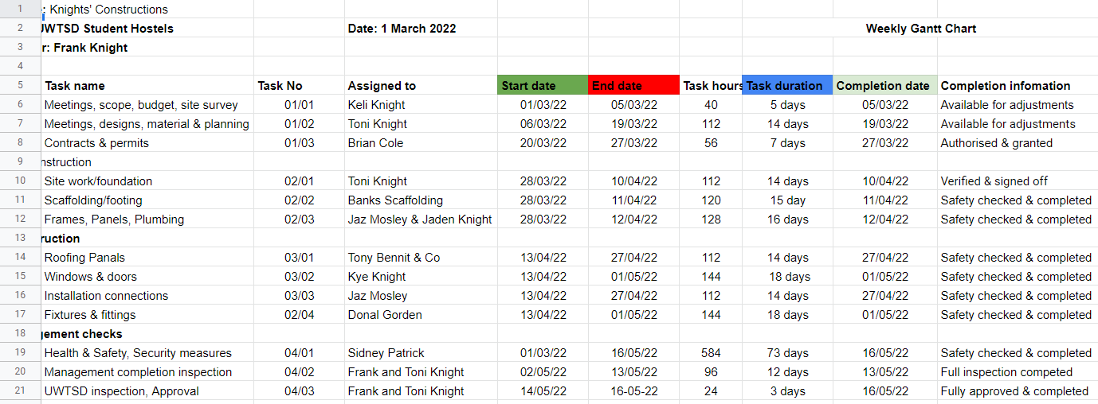

Risk assessments
Risk assessments are essential in all businesses helping to identify hazards and determine the possibility of accidents which may occur during the building of the project to help protect employees etc and to avoid liability. Knights’ Construction have a highly qualified risk assessment team who focus on the possible risk factors within each project employing measures to minimise and mitigate all eventualities. “The risk management process in construction is extreme and important. Risk measure includes risk level determination of each objective and the risk analysis estimation by applying various approaches and technology.” (Zavadskas, Turskis and Tamošaitiene, 2010, p3).

Potential Risk is unpredictable and can be unavoidable if not assessed and monitored. The Risk Assessment Method Statement (RAMS) helps with communication to all involved, providing information bringing forth recommendations and possible solutions to help reduce any viable risky situations within and around Knights’ Constructions sites, which is monitored on a 24hrs basis to cover risk and health & safety. Risk can also be measured by following and maintaining procedures.
- Training staff
- Constantly improve working standards
- Encourage consciousness in safety
- Use correct equipment
- Wear protective clothing
- Liability insurance
- Adjure to safety rules and regulations
- Signposts
The RAMS tool Risk assessment helps to measure risk as seen below

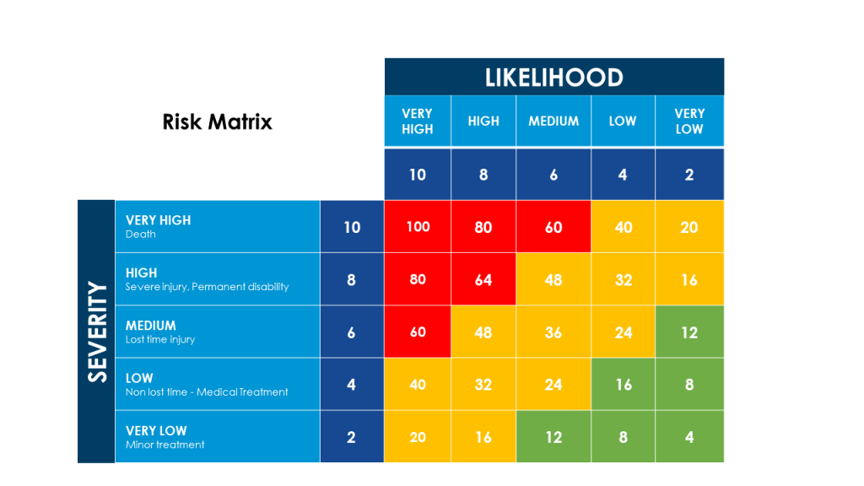
Safeti (2022)
Health and Safety
Health & safety and possible risk factors walk hand in hand as they conjoin each other when it comes to the safety of all involved. It is imperative within the project to keep the workers safe, and again make sure the right equipment is used correctly, wearing the correct attire in conjunction to the said job and applying to rules and regulations.
“UK Health and Safety Executive’s (HSE) mission is to ensure that the risks to health and safety of workers are properly controlled.” (Hughes and Ferrett, 2012, p25).
“Health and safety arrangements
5.— (1) Every employer shall make and give effect to such arrangements as are appropriate, having regard to the nature of his activities and the size of his undertaking, for the effective planning, organisation, control, monitoring and review of the preventive and protective measures.
(2) Where the employer employs five or more employees, he shall record the arrangements referred to in paragraph (1).” (The Management of work health and safety regulations, 1999)

Sustainability
Knights’ Construction aspires to the highest level of sustainability by being energy efficient, using recyclable materials, minimum water, zero waste and pollution, engaging with stakeholders in being supportive and adding long term sustainability to the project, focusing on quality, low prices, and successful future ventures.

Conclusion
In conclusion to this project management plan report, Knights’ Construction has demonstrated how it intends to manage the construction of six student hostel blocks for the UWTSD, factoring in the importance of the stakeholders and their positions, funding, student needs and convenient location.
Expressing over 20 years' experience in building large and small projects throughout the UK, Knights’ Constructions knowledge and understanding of what is needed during the student years will provide the ideal accommodation using Knights’ Constructions flatpack system, enabling the student blocks to be erected in less than half the time of a normal building made of brick and mortar.
The stakeholders of the built properties will not be disappointed, as the buildings will be unique, comfortable, and pleasant to look at, bringing a sound investment for the future.

References:
Fedorova, I.J.E., Muzalev, S.V., Frygin, A.V., Shalneva, M.S. and Khanova, L.M., 2018. Efficient funding strategy for investment and construction projects of municipal economy: study of characteristics. International journal of civil engineering and technology, 9(9), pp.1945-1951. Available at:
https://scholar.google.com/scholar?hl=en&as_sdt=0%2C5&q=private+construction+funding&oq=construction+funding

Ginigaddara, B., Perera, S., Feng, Y. and Rahnamayiezekavat, P., 2021. (p2) Development of an Offsite Construction Typology: A Delphi Study. Buildings, 12(1), p.20.
https://scholar.google.com/scholar?hl=en&as_sdt=0%2C5&q=the+advantages+of+using+construction+flatpack+&btnG=

Hughes, P. and Ferrett, E., (2012) Introduction to health and safety in construction. 4th edition. Routledge: London. Available at: https://scholar.google.com/scholar?hl=en&as_sdt=0%2C5&q=health+and+safety+in+construction&oq=health+and+safety

Ibrahim, Y.M., Kaka, A., Aouad, G. and Kagioglou, M., 2009. Framework for a generic work breakdown structure for building projects. Construction Innovation.
https://scholar.google.com/scholar?hl=en&as_sdt=0%2C5&q=work+breakdown+structure+construction&oq=work+break

Kumar, P.P., 2005. Effective use of Gantt chart for managing large scale projects. Cost engineering, 47(7), p.14.
https://scholar.google.com/scholar?hl=en&as_sdt=0%2C5&q=gantt+chart+project+construction+&oq=

Legislations.gov.uk (1999) Management of Health and Safety at Work Regulations 1999 (online) available at: https://www.legislation.gov.uk/uksi/1999/3242/regulation/5/made

Meredith, J.R., Shafer, S.M. and Mantel Jr, S.J., 2017. Project management: a strategic managerial approach. John Wiley & Sons. Available at:
https://scholar.google.com/scholar?hl=en&as_sdt=0%2C5&q=quad+charts+software+project+management&oq=business+quad+chart

Rastogi, N.I.T.A.N.K. and Trivedi, M.K., p3, (2016) PESTLE technique–a tool to identify external risks in construction projects. International Research Journal of Engineering and Technology (IRJET), 3(1), pp.384-388.
https://scholar.google.com/scholar?hl=en&as_sdt=0%2C5&q=pestle+analysisi+for+construction&btnG=
Smartsheet Contributor Diana Ramos January 26, 2021 https://www.smartsheet.com/content/construction-work-breakdown-structure
Smith, L. W. (2000). Stakeholder analysis: a pivotal practice of successful projects. Paper presented at Project Management Institute Annual Seminars & Symposium, Houston, TX. Newtown Square, PA: Project Management Institute.
https://www.pmi.org/learning/library/stakeholder-analysis-pivotal-practice-projects-8905

Sutrisna, M., Ramanayaka, C.D. and Goulding, J.S., 2018. (p4) Developing work breakdown structure matrix for managing offsite construction projects. Architectural engineering and design management, 14(5), pp.381-397.
https://scholar.google.com/scholar?hl=en&as_sdt=0%2C5&q=work+breakdown+structure+construction&oq=work+break
https://nrl.northumbria.ac.uk/id/eprint/34442/1/Goulding%20et%20al%20-%20Developing%20work%20breakdown%20structure%20matrix%20for%20managing%20offsite%20construction%20projects%20AAM.pdf

Zavadskas, E.K., Turskis, Z. and Tamošaitiene, J., 2010. Risk assessment of construction projects. Journal of civil engineering and management, 16(1), pp.33-46.
https://scholar.google.com/scholar?hl=en&as_sdt=0%2C5&q=risk+assessment+in+construction&btnG=

Appendices:
Adobe stock (2022) https://stock.adobe.com/uk/search/images?k=chess+knight

QS Study (2021) https://qsstudy.com/fundamental-purposes-control-project-management/

Safeti (2022)
https://safeti.com/downloads/risk-assessment-templates/

