
UWTSD
Tensile Report
Engineering Science ACHA4002
Niall Hindmarch
2316600
08/12/2024

Contents
Introduction 3
Experimental Procedure 3
Results 5
Analysis 8
Conclusion 12
Evaluation 12
Further work 12
References 13

Introduction
This report will detail the procedure of using a ‘Tensile Tester Kit ES6’ to measure the tensile/yield stress in aluminium, plastic, steel and alloy. Throughout this report there will be graphs that back up the results and images of the kit as well as materials that were used.
The use for this test is to determine the strength of the material properties, this is essential as the wrong material could lead to a decrease in performance as well as hindering the safety of the individuals in the vehicle. Furthermore, there are many structural parts in a vehicle that needs to withstand different loads within their lifespan, this experiment guarantees that the part can handle the stress without any complications. Although each material is bound to break within time, this experiment can determine how the material reacts after a long period of stress, it also gives engineers an idea of when the part needs to be renewed as well as the lifespan of this given part.
Although it has its primary purpose of being able to withstand stress for safety reasons, it also provides aid for environmental reasons as well, this is shown through the weight of the vehicle. As engineers now primarily use aluminium, magnesium and other composite materials, it makes the vehicle substantially lighter which then improves the fuel economy and meets the strict standards that is set. This helps engineers to evolve in their ways of making vehicles that meet the safety and emission standards as they get stricter through the years.

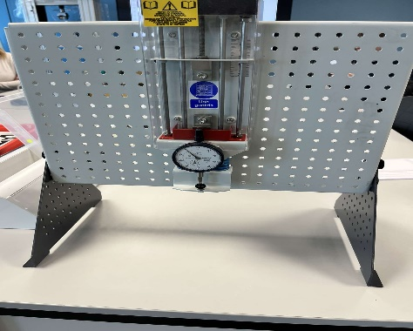
Experimental procedure

Figure 1 Tensile ES6 Kit
In figure 1, it shows an ES6 kit, with this kit an individual can use it to determine the strength of various common materials by adding an axial force with gradual increase of loads. At the beginning of the experiment, it is important to turn the force control clockwise with care until the dial starts to show a slight bit of movement, with this you can then turn the outer frame of the indicator until it reaches the value of zero.
Before placing the material into the tensile test kit, ensure that the length and cross section is measured as the individual can then compare the size of the material once finalizing the experiment.
For safety requirements, it is essential that the safety guard is fitted before the test of the material as it could cause harm to the individual.
Once it is fitted within the tensile tester, the individual can then proceed with the experiment, it is important to note that each turn is 1mm and to proceed with patience to get the most accurate results.

When rotating the nut clockwise slowly with patience, rotate in 0.2mm steps until reaching 5mm then increase the rotation to 1mm until reaching 10mm, if the material isn’t broken then continue in 10mm rotations until reaching 60mm. It is important to write the results down as you go along with each rotation.
To check the difference in length, push both ends together and then measure the material. Once the results are collected from each material, the individual can then convert the results from the dial into force values as well as finding the extension value by deducting the dial indicator results from the loaded nut rotations. In doing so, the individual can then calculate the results into stress and strain terms.
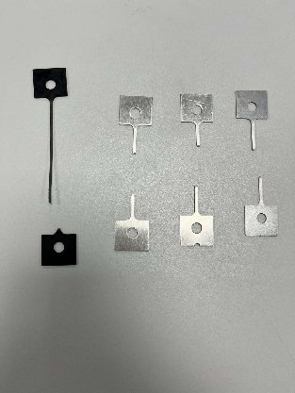
Figure 2, materials after testing
As shown in figure 2, the materials used were pushed to their limits for us to calculate the yield and tensile strength/stress. From this it is possible to find the results for the stress and nominal strain applied to the materials.

Results
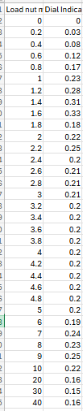
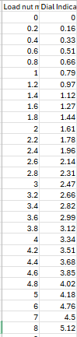
Figure 3 PVC

Figure 4 Duralumin

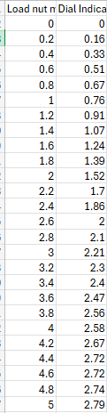
Figure 5 Aluminium
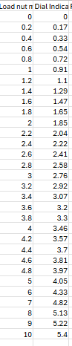
Figure 6 Steel

Analysis
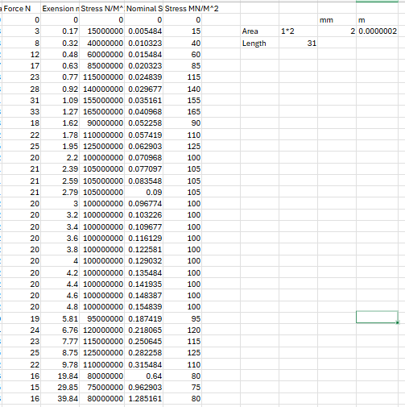
Figure 7, graph detailing the force, stress and nominal strain to the PVC
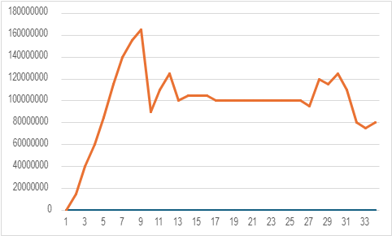
In figure 7, it details the stress as well as nominal strain within the PVC (plastic), this is also shown in Figure 2 as the finished result from the experiment. The data shows that the stress increased at the beginning with the numbers fluctuating midway and peaked at 140 n/m^2. It stayed at 100 consistently until it dropped down to which then finalized the results. This aligned with our expectations as plastic is more stretchable when applied force, as it wasn’t cold in the room when participating the experiment, it was feasible to stretch and get the most out of the material in the experiment. See below in ‘figure 8’ the stress against the extension.

Figure 8 stress against extension (extension on x-axis)
The graph above shows that the stress peaks at the beginning and drops down significantly and does not reach the peak again but more so stay between ‘120MN/m and 80MN/m’.
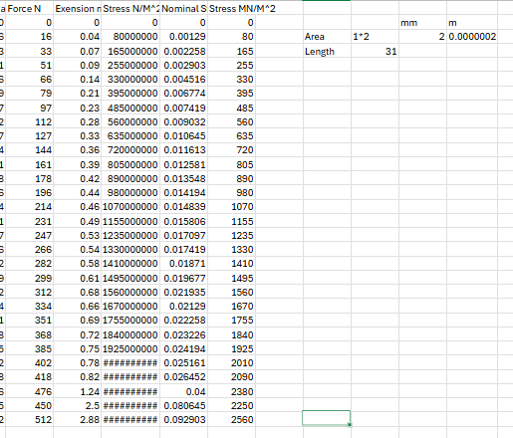

Figure 9, showing duralumin stress against nominal strain
In figure 9 it shows how duralumin handles the stress in the tensile test, as it states within the results it reaches a very large number, however, the nominal strain stays quite low. Although the nominal strain is low, the force applied to this material is substantially large and made the duralumin extend to 2.88mm. See below how the stress goes against the nominal strain.
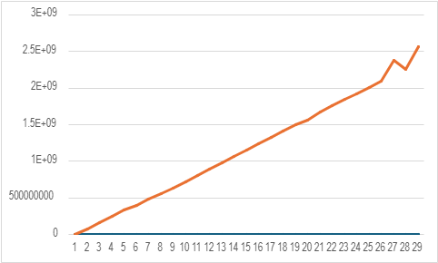
Figure 10, duralumin stress against nominal strain in a graph
As it shows above in ‘figure 10’ it shows that the stress gradually increased at a smooth pace until reaching the breaking point.

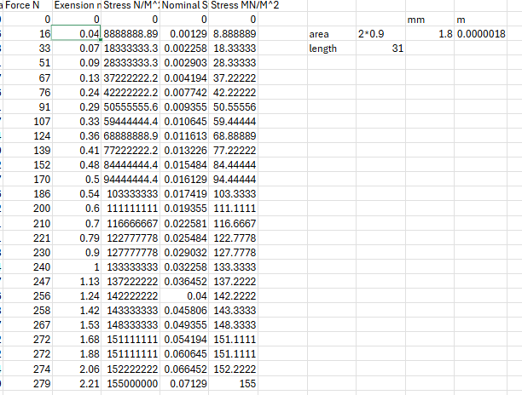
Figure 11 results of the aluminium in the tensile test
In figure 11, it represents the results of the aluminium in the tensile test, it shows the large amount of stress it can handle, and it clearly shows why aluminium is used so regularly today.
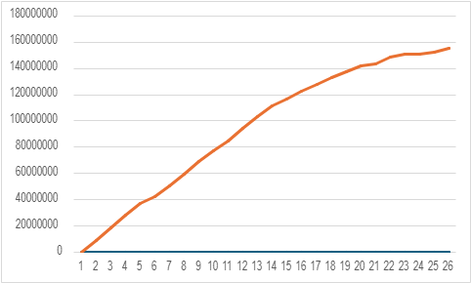
Figure 12 of the stress in aluminium against the nominal strain
In figure 12 it shows a gradual increase in stress against the nominal strain, it also provides insights into how it responds to the stress/strain by showing the point of failure and how it extends. This helped the participants in the experiment to understand and analyse the behaviour and effects.

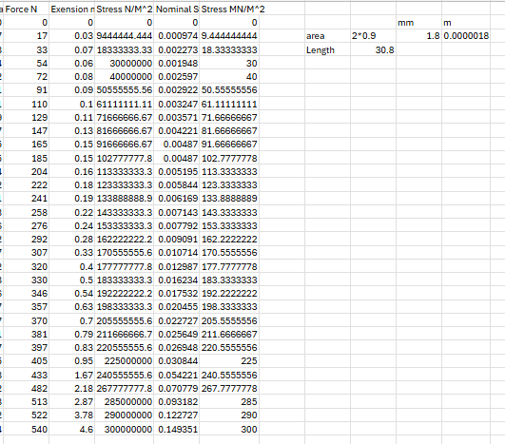
Figure 13 shows the results of steel in the tensile test
Figure 13 shows the results of steel in the tensile test and how it fares against stress and nominal strain. It is clear that steel showed the most strength against these masses and forces given the results, reaching an astonishing 300MN/M^2 as well as 0.14351 in nominal strain.
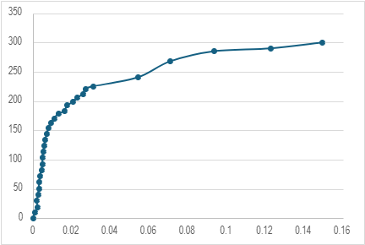
Figure 14 of stress in MN/M against nominal strain
In figure 14 it represents the stress against the nominal strain, It shows and quick increase in stress at the beginning and spaces out towards the end. As it shows the significant rise in stress it shows its stiffness within this material which then outlines Young’s Modulus theory, and as it slows down in stress it shows how it switches from elastic to plastic behaviour.
This helped the participants gain insight into the properties of this material and how steel can be tested within a tensile experiment.

Conclusion
In conclusion, the experiment went as expected as the participants within the experiment compared it to researched results, in February 2018 Sokoine University submitted a detailed study on tensile testing of steel, with these results the group could conduct the experiment with a guide to what the results should be (1).
It is clear to see that steel could handle the most stress and had the most elastic strain, however, PVC shows the most plastic behaviour.

Evaluation
To limit the areas of fault, we ensured that all windows was closed within the room so there wasn’t a cool breeze, ensuring that it is room temperature so we can get the most out of the experiment. Whilst a participant was rotating the lock, another participant was at eye level to watch every twinge in the diameter, once there was a rotation, the participant shouted out the measurement whilst another participant written down the results.
To further make sure that the measurements were correct the group each measured the extension from before and after the tensile test. This made us more confident in getting the correct answer as well as limit any abnormal answers.

Further work
If given unlimited time and resources to do this experiment, it’d be best to acquire a laser cutting tool to make a precise shape so there are smooth edges and minimise effects of the geometry in the test. The best equipment to use for the test would be a highly accurate and precise tensile machine, a servo hydraulic tensile machine would fit the purpose as it controls the strain rate by tweaking the load and displacement (2). To capture the results simultaneously, a high-speed camera is crucial to observe the experiment as more strain/loads are added to the specimen, it’d also be more in depth if there was a 3D imagery of the experiment live in action, to capture all angles.
In automotive, the stress varies from time to time as it could be light strain and heavy strain which could result in a vehicle crash so it would be optimal to engage with a series of intervals with different strain rates. Once the experiment is completed, for post-test analysis, it’d be useful to have a high resolution fractography, for which it scans electrons, this examines the surface with high magnification. In doing so, you can then analyse the failure mechanisms as well as ductility (3).

References
- Sokoine University of Agriculture, Tensile Test Technical Report, Feb 2018 https://www.slideshare.net/slideshow/tensile-test-report-89414455/89414455#3
- Construction and Building materials, Hansong Wu, 2023 https://www.sciencedirect.com/science/article/abs/pii/S0950061822038016
- Materials Science and Materials Engineering, S. Ramakrishna, Z.-M. Huang, 2016 https://www.sciencedirect.com/referencework/9780128035818/materials-science-and-materials-engineering

