Synthesize a Solution to a Potential Real-Life Scenario
  - Jacob Hopkins (2003836)
  - Networks and Cyber Security Essentials ACCA4024
  - School of Applied Computing
  - Wales Institute of Science and Art

Abstract
The paper documents the vulnerabilities and potential threats to Che-Si’s wide area network and explores the various mitigations available to help reduce the threats haunting the business. A strategy is presented on the ideal actions to be taken to improve the security of the network whilst maintaining productivity and performance.

Table of Contents
Contents
Abstract 2
Table of Contents 3
Introduction 4
Related Work / Review of Literature 4
Networks and its Types 4
Threats and Attacks 4
Mitigation 5
Design and Implementation 6
Weak Points / Vulnerabilities 6
Introduce Demonstration Design 6
Implementation^{[7]} 6
Outcome 9
Mitigation Strategies and Recommendation 9
Importance of Policies and Training 9
Digital Signature and Data Encryption Methods 9
Recommendations 9
Conclusion 10
References / Bibliography 10
Appendices 11

Introduction
Networks have been a key element in our technological advancements over the last sixty years. To put it simply a network is the communication between interconnected devices, this can be within a group or system. There are various types of networks that can be established based on components and characteristics they possess. It is important that these components come equipped with standard protocols from their manufacturers, as to allow for the sending and receiving of data over networks to communicate. An example of these standards includes the IEEE 802.3 standard for ethernet.
These complex networks are a necessity to almost every individual around the globe, handling and sending unimaginable amounts of data every second. Among these incredible collections of data are often confidential and private information such as personal details, credentials or documents. It is incredibly important that networks can protect information being transferred between its devices, limiting the potential for unauthorised access and the theft of private data.
Throughout this report I will be reviewing the security and structure of Che-Si’s network, analysing its policies discussing potential ways that could help improve the security of Che-Si’s construction company and its employees.

Related Work / Review of Literature

Networks and its Types
As previously discussed, networks can be divided into various types and identified based on characteristics they hold. Some of these characteristics include the components and devices connected to the network, the size or geographical area they cover, or even how devices are connected and communicate to each other over the network. In relation to Che-Si’s business, the world-wide network in place for staff and clients is a wide-area-network (WAN). This network type is commonly used for larger geographical scales such as across countries and even continents. As mentioned in the brief, Che-Si’s network policies allow for staff, clients and vendors to connect and access the network from any location using any device. Based on how the network can be accessed anywhere, including homes, we can expect many personal devices such as mobile phones, tablets and desktops to be the portal into the business’ network for many authorised individuals. Microsoft found in their research that “67%” ^{[5]} of people use their personal devices within the workplace today.

Threats and Attacks
With these policies in place for Che-Si’s network, there are numerous potential threats and attacks that could target the construction business’ and partners data.
A man-in-the-middle attacks (MitM) are an ever-present cyber-attack we could expect to affect the WAN. According to IBM, 35% of targeted exploitation attacks were man in the middle attacks ^{[1]} . This is where intruders place themselves in between an ongoing data transaction between two-parties. Once in place, the intruder can filter through the transferred data and steal whatever they believe to be valuable. A MitM attack could be expected on unsecure Wi-Fi networks such as free public Wi-Fi, but also on secured networks if intruders have obtained unauthorised access.
Phishing is another common cyber-attack we could expect to target Che-Si’s network, this is where fraudulent communications through methods such as email attempt to steal sensitive data like login credentials from users. Phishing is an “extremely lucrative criminal business” ^{[2]} that occurs worldwide daily. According to Cisco, there are an estimated “150 million phishing emails…sent each day” ^{[2]}, which could very easily target Che-Si’s network, employees, clients and vendors.
One more threat we could anticipate targeting Che-Si’s network would be malware. This malicious software could flood the network in various ways including those threats previously mentioned. According to the SANS Institute “95% of all attacks on enterprise networks are the result of successful spear phishing.” ^{[3]} Malware can come in many different forms that can hold up the network and can cause many unwanted disruptions to Che-Si’s business.

Mitigation
To help tackle the rising threats and dangers haunting networks globally, many methods, policies and tools have been created to mitigate their effects. Some of these methods can help with the previously mentioned threats that could affect Che-Si’s network.
To help prevent attackers from performing a man-in-the-middle attack over a network we could use a virtual private network, otherwise known as a VPN. These advanced tools can establish a secure virtual connection between devices and uses a key-based encryption to secure all data passing through the tunnel, including IP addresses. In the case that an attacker makes its way into the virtual tunnel, the encryption acts as an additional layer of security as the attacker will not be able to decipher the data being transferred. In recent years, the use of VPNs has grown considerably, with Statista reporting a growth of around “165%” ^{[4]} in users from 2017 to 2018.
Unlike MitM attacks, there are no favourable tools to help mitigate phishing. Businesses such as Che-Si’s can help combat the threat of phishing by providing up to date information/training and software for their employees, clients and vendors. This information could document the approaches and structures many attackers follow to deceive their targets, allowing those to identify a potential phishing attack and mitigate it.
To mitigate the effects of malware on a network such as Che-Si’s, keeping regular backups of important data and information to return to in the case of a malware attack such as ransomware is very helpful. If it is necessary to wipe all data on a network to eliminate a threat, we will have a backup to fall back on and restore the network with, mitigating the damage dealt by the malware. As mentioned in the given scenario, Che-Si’s business network already makes use of cloud storage facilities to house data for users to access. This cloud storage can be used to also create and hold backups of the network to help in this situation. Additional methods of mitigating malware include filtering files types over the network, blocking certain websites, actively monitor and inspect information over the network, and block malicious code by using digital signatures.

Design and Implementation

Weak Points / Vulnerabilities
Upon first glimpse, Che-Si’s network has some noticeable weak points that can easily be exploited by attackers with the right skills. A lot of these vulnerabilities come as a result of the existing policies in place for the construction companies’ network allowing for staff, clients and vendors to access the network from any location using any device. These policies allow for individuals to access the network even over unsecure connections without important protective measures such as encryption. In that situation many threats, such as man-in-the-middle attacks, could intercept the transferring data and capture sensitive information that could lead to further complications for Che-Si and their business. Additionally, with staff, clients and vendors allowed to use personal devices for network access, there is an increased possibility of unauthorised individuals accessing the network through authorised users. Whether a personal device is left unaccompanied or is even lost, Che-Si’s network could potentially be at risk.

Introduce Demonstration Design ^{[7]}
To help understand the vulnerabilities of the network I will demonstrate one of the potential attacks that could be conducted and explain the damage it could do to Che-Si’s business. The attack in this example will be a man-in-the-middle attack, more specifically over a secure network that an attacker has gained access to. The attack will be simulated using a virtual machine running Linux Ubuntu. The OS will make use of several tools to help with the attack. For intercepting packages from victims, we will use arpspoof, this command line utility will allow us to intercept the packets on a switched LAN. We will also be using arpspoof to intercept packets from the router our devices are connected to. For additional insight into what our victim is doing we will make use of driftnet, this program listens to internet traffic and collects images from TCP and displays for us to see what the victim is viewing. The final tool we will make use of is urlsnarf, this command line tool will sniff HTTP requests from our victim. With these tools our simulation will be able not only follow our target over the internet, but also capture and access information sent over their connection which could lead to unimaginable damage Che-Si’s network if confidential information from the network is captured.

Implementation ^{[7]}
The first step for conducting this attack would be to quire the network interface name and router IP within the Ubuntu virtual system, we can find this information within the connection information menu as seen below.
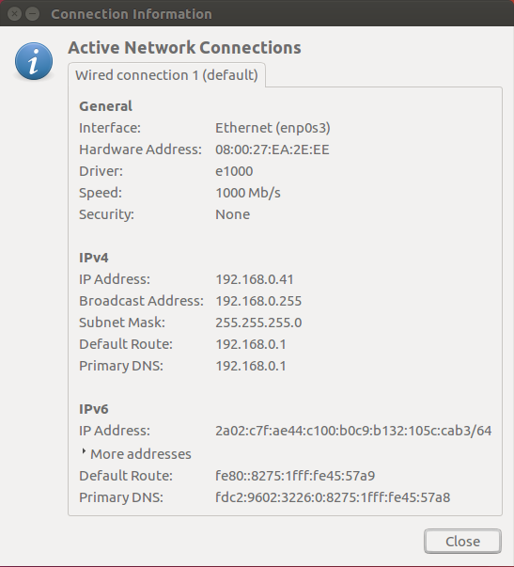
Next, we will need the IP address of the victim’s address. In this example we will just gather the address from the machine directly.
For this attack to work we will need to make sure packet forwarding is enabled on our Linux machine to relay the packets being set to and from our victims’ device from the router. To do this we will use the command:
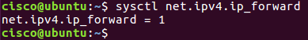
Here we can see we have port forwarding enabled based on the return message from the terminal.
Using arpspoof now, we will input the necessary code to intercept the packets from our victim.
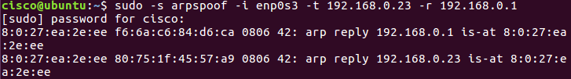
Here we can see our Linux machine sniffing packets being sent from our victim’s device.
We will also need to intercept the packets being sent from our router to our victim’s device so that we are able to reroute the traffic to not raise any concern for the victim. To do this we will still be using arpspoof using the following command:
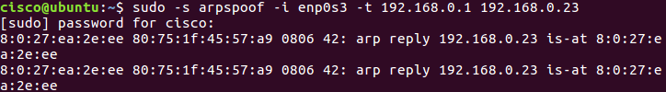
To help us get a better view towards what is going happening on our victim’s device we can use driftnet to acquire a picture of their activity with the following code:
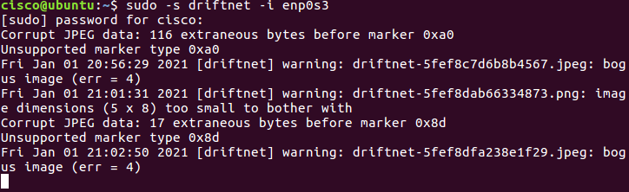
Driftnet uses this information to capture and display the following image, in this image we can see the site visited by:
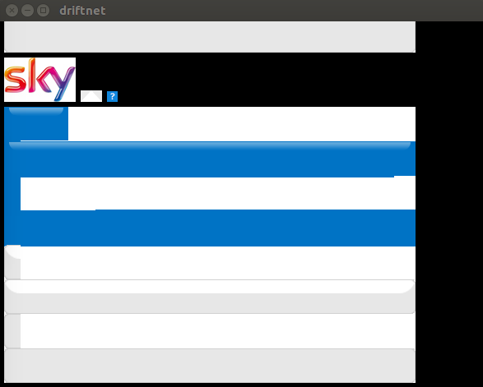
Finally, using urlsnarf we can capture the requests from our victim to view which site they are viewing:
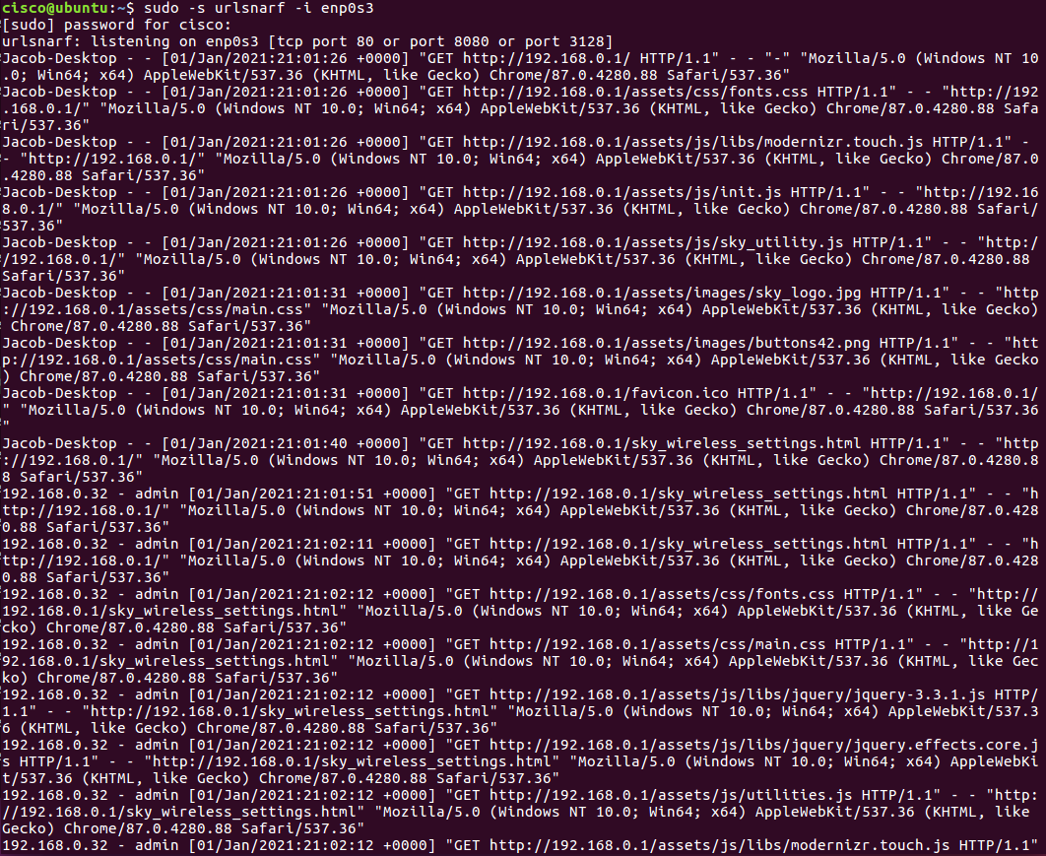
This large screenshot may seem confusing, but it holds crucial information for the attacker to use against their victim.

Outcome
From this simulated attack, an attacker has been able to capture, analyse and redirect packets from a target’s device within a network. Using minimal tools and experience with Linux software, the targets’ data had been stolen and potentially abused. This exact scenario could very well take place but with Che-Si’s business as the target. Whether it be a member of staff, client or vendor, anyone with access to the Che-Si network is a potential threat and gateway for unauthorised individuals.
To help with mitigating the potential threat of a man-in-the-middle attack there is one advisable solution. Using a virtual private network, or a VPN, we can create a secure tunnel between devices that will encrypt and protect the data being transferred to and across Che-Si’s network. The private networks will help reduce the potential of attackers accessing data packets over both wireless and wired connections, whilst also securing the data packets with encryption.

Mitigation Strategies and Recommendations

Digital Signature and Data Encryption Methods
To help with ensuring the credibility and security of online data, digital signatures are used. Acting as a form of verification of authenticity and integrity to anyone receiving or utilising data, this encryption method is incredibly important and widely used across the internet. This method of encryption can be adopted by Che-Si to help enhance the level of security across their wide area network, acting to ensure the reliability and quality of data sent between users. In addition to digital signatures, there are two main methods of encryption that could be used to help secure and protect data over the network, these methods are symmetric and asymmetric. Often referred to as private-key encryption, symmetric encryption makes use of pre-shared keys to encrypt and decrypt data. Some common encryption methods that use symmetrical algorithms include 3DES, IDEA and AES. Asymmetric encryption, or public-key encryption, uses two different keys for both encryption and decryption of data. The use of two different keys allows for a more secure encryption in comparison to symmetric encryption methods, however it does come at the cost of encrypting and decrypting the data compared to symmetric. These methods of encryption can be used to build mitigation strategies such as the VPN to encrypt the data transferred across the internet.

Recommendations
In all, Che-Si’s existing policies fail to enforce or provide any guidance towards how both members and associates of the business can protect their data and the integrity of Che-Si. We have been able to identify numerous weak points within the network and demonstrated the affects they could have on Che-Si business if exploited. The dangers include the potential compromise of the wide-area-network in addition to confidential data from Che-Si being accessed by unauthorised individuals. The ideal solution to these issues would be to create a comprehensive list of updated policies that enforce a more secure use of the network for uses.
Please see Appendix A for more information on the kind of policies that could be implemented for the network.

Conclusion
Although Che-Si’s network is up-to date with the “latest technologies” ensuring for the most effective level of operations, the policies that manage its users fail to bring uniformity and encourage unwanted events that could disrupt the network. With the identified mitigations, we can help reduce the potential damage that could occur from the threats towards the network whilst maintaining productivity and performance. Using the dissected implementation, we can understand the extremity of the networks’ threats and devise the most suitable solution to our problem. In all, a new written policy that incorporates more security policies to help monitor and manage devices and users connecting to the network, as well as the data being transferred is necessary for Che-Si.

References / Bibliography
[1] “IBM X-Force Threat Intelligence Index 2018”, IBM Security, New York, 2018. [Online] Available: https://www.justinholman.com/wp-content/uploads/2019/03/Threat-Intelligence-2018-IBM-X-Force.pdf [Accessed Jan. 8, 2021].
[2] Cisco Systems, “What is Phishing?”, Cisco. [Online] Available: https://www.cisco.com/c/en/us/products/security/email-security/what-is-phishing.html [Accessed Dec. 29, 2020].
[3] Cisco Systems, “Click with Caution: Tackling Phishing Threats”, Cisco. [Online] Available: https://www.cisco.com/c/dam/en/us/products/collateral/security/email-security/phishing-program-infographic.pdf [Accessed Dec. 30, 2020].
[4] Statista, “Size of the virtual private network (VPN) market worldwide from 2016 to 2022”, Statista, Mar. 2017, [Online] Available: https://www.statista.com/statistics/542817/worldwide-virtual-private-network-market/ [Accessed Jan. 8, 2021].
[5] J. Jones, “BYOD-is it Good, Bad or Ugly from the User Viewpoint?”, Microsoft, Jul. 26 2012. [Online]. Available: https://www.microsoft.com/security/blog/2012/07/26/byod-is-it-good-bad-or-ugly-from-the-user-viewpoint/ [Accessed Jan. 8, 2021].
[6] M. Gasior, “Following Policies and Procedures and Why It’s Important”, PowerDMS, May. 2, 2018. [Online]. Available: https://www.powerdms.com/blog/following-policies-and-procedures-why-its-important/#:~:text=Policies%20and%20procedures%20are%20an,making%2C%20and%20streamline%20internal%20processes. [Accessed Jan. 8, 2021].
[7] C. Delgado, “How to perform a Man-in-the-middle (MitM) attack with Kali Linux”, ourcodeworld, Mar. 25, 2017. [Online]. Available: https://ourcodeworld.com/articles/read/422/how-to-perform-a-man-in-the-middle-mitm-attack-with-kali-linux [Accessed Jan. 8, 2021].
[8] C. Paquet, “Network Security Concepts and Policies”, Cisco Press, Feb. 5, 2013. [Online]. Available: https://www.ciscopress.com/articles/article.asp?p=1998559&seqNum=3 [Accessed Jan. 8, 2021].

Appendices
  - Appendix A ^{[8]}
Technical Policies
Security staff members use the technical policies in the conduct of their daily security responsibilities. These policies are more detailed than the governing policy and are system or issue specific (for example, router security issues or physical security issues). These policies are essentially security handbooks that describe what the security staff does, but not how the security staff performs its functions.
The following are typical policy categories for technical policies:
- General policies
  - Acceptable use policy (AUP): Defines the acceptable use of equipment and computing services, and the appropriate security measures that employees should take to protect the corporate resources and proprietary information.
  - Account access request policy: Formalizes the account and access request process within the organization. Users and system administrators who bypass the standard processes for account and access requests may cause legal action against the organization.
  - Acquisition assessment policy: Defines the responsibilities regarding corporate acquisitions and defines the minimum requirements that the information security group must complete for an acquisition assessment.
  - Audit policy: Use to conduct audits and risk assessments to ensure integrity of information and resources, investigate incidents, ensure conformance to security policies, or monitor user and system activity where appropriate.
  - Information sensitivity policy: Defines the requirements for classifying and securing information in a manner appropriate to its sensitivity level.
  - Password policy: Defines the standards for creating, protecting, and changing strong passwords.
  - Risk-assessment policy: Defines the requirements and provides the authority for the information security team to identify, assess, and remediate risks to the information infrastructure that is associated with conducting business.
  - Global web server policy: Defines the standards that are required by all web hosts.
- Email policies
  - Automatically forwarded email policy: Documents the policy restricting automatic email forwarding to an external destination without prior approval from the appropriate manager or director.
  - Email policy: Defines the standards to prevent tarnishing the public image of the organization.
  - Spam policy: The AUP covers spam.
- Remote-access policies
  - Dial-in access policy: Defines the appropriate dial-in access and its use by authorized personnel.
  - Remote-access policy: Defines the standards for connecting to the organization network from any host or network external to the organization.
  - VPN security policy: Defines the requirements for remote-access IP Security (IPsec) or Layer 2 Tunneling Protocol (L2TP) VPN connections to the organization network.
- Personal device and phone policies
  - Analog and ISDN line policy: Defines the standards to use analog and ISDN lines for sending and receiving faxes and for connection to computers.
  - Personal communication device policy: Defines the information security’s requirements for personal communication devices, such as voicemail, smartphones, tablets, and so on.
- Network policies
  - Extranet policy: Defines the requirement that third-party organizations that need access to the organization networks must sign a third-party connection agreement.
  - Minimum requirements for network access policy: Defines the standards and requirements for any device that requires connectivity to the internal network.
  - Network access standards: Defines the standards for secure physical port access for all wired and wireless network data ports.
  - Router and switch security policy: Defines the minimal security configuration standards for routers and switches inside a company production network or used in a production capacity.
  - Server security policy: Defines the minimal security configuration standards for servers inside a company production network or used in a production capacity.
- Wireless communication policy: Defines standards for wireless systems that are used to connect to the organization networks.
Security Policy Roles and Responsibilities
In any organization, it is senior management, such as the CEO, that is always ultimately responsible for everything. Typically, senior management only oversees the development of a security policy. The creation and maintenance of a security policy is usually delegated to the people in charge of IT or security operations.
Sometimes the senior security or IT management personnel, such as the chief security officer (CSO), the chief information officer (CIO), or the chief information security officer (CISO), will have the expertise to create the policy, sometimes they will delegate it, and sometimes it will be a bit of both strategies. But the senior security person is always intimately involved in the development and maintenance of security policy. Guidelines can provide a framework for policy decision making.
Senior security staff is often consulted for input on a proposed policy project. They might even be responsible for the development and maintenance of portions of the policy. It is more likely that senior staff will be responsible for the development of standards and procedures.
Everyone else who is involved in the security policy has the duty to abide by it. Many policy statements will include language that refers to a potential loss of employment for violation of the policy. IT staff and end users alike are responsible to know the policy and follow it.

