
2026
Samandra Corpas Pereira (2544439)
Course: Digital Skills Lecturer: Charles Oham ModuleLCLM4002
12/08/2026
Digital Portfolio & Reflection

My Digital Life Skills -DS3
1-My life skills portfolio shows the important skills I have developed through my work, studies and daily life.
I have improved my communication skills, and I can communicate bit more clearly with my colleagues and lecturers, I also feel more confident to solve problems and solutions when challenges happen at work or during my studies. I have developed a good -time management and organisational skills because I balance my full- time job and the university and family responsibilities and organising my tasks documents, appointments and deadline. Now I can use Word, Excel, PowerPoint, University Moodle and online research tools more confidently and independently.
Working with classmates has also helped me develop teamwork skills. We support each other, shares and work together to achieve our goals.
2-What skills you used.
In this project, I use a range of important skills that I have develop through my work experience. Using communication skills to collaborate with my classmates.
I also used time management, organisation and problem solving.

3- What tools you can use well now
I can use PowerPoint to create presentation using templates and clear bullet points.
I can use the university library to find reliable information for my assignments.
I can also record videos and audio and use Moodle to access learning materials and submit my assessment.
4- what was hard at the start
At the beginning, I found it quite challenging to use computers and some digital tools because they were not part of my life.
I also found it difficult to organise my files and find my documents. However with practice and support from my lecturer I have become more confident and organised.

5- What you can now do alone
I can manage to complete my homework independently using different digital tools.
I can submit my assessments on Moodle and write professional reports and emails.
I also feel more confident organizing my work and completing tasks by myself.

Bullet Points vs Unstructured Text
I learnt that clear bullet points make a presentation look more professional than messy. Help me to understand the audience quicky identify the main ideas and make the information easier to read.
In contrast, messy text can look cluttered, made the slide harder to follow, and reduce the impact of the message.
Skills developed:
- Organising information clearly.
- Enhancing visual communication.

Please see the continued image on the next slide
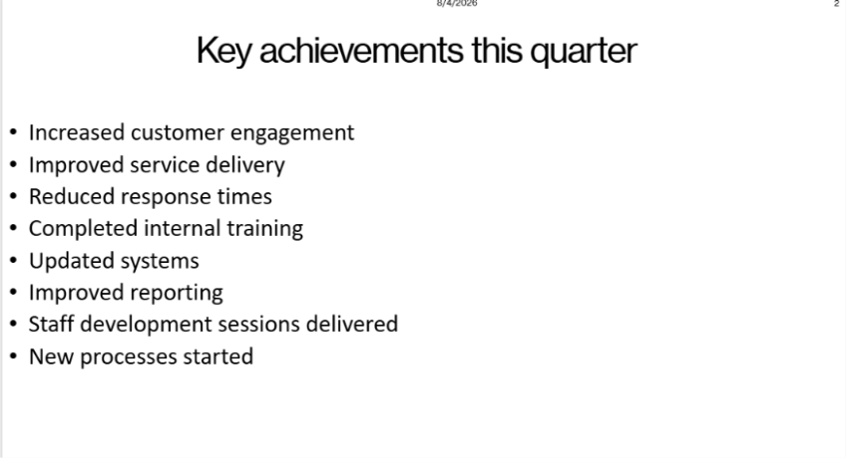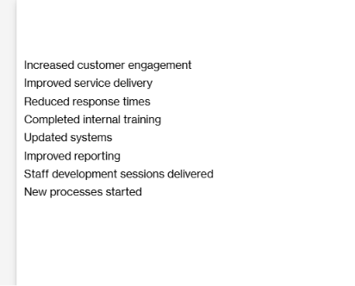

Adapting Communication for Different Audiences.
Through this activity in class I learnt how to adapt my email tone depending on who I am writing to. Language that is suitable for customers, managers and colleagues.
Using the correct tone helps the message sound more professional, respectful and appropriate. This activity leads to better communication and creates a positive impression in the workplace.
Based on my text I used communication skill, specifically in Audience awareness, Tone, adaptation and professionalism.
- Professional email Communication & Tone.
- Professional writing: Apologies, Clarification and Request.
- Digital Communication Skills: Tone and Formality.
- Adapting Tone for different Audience, Customers, Colleague and Managers.

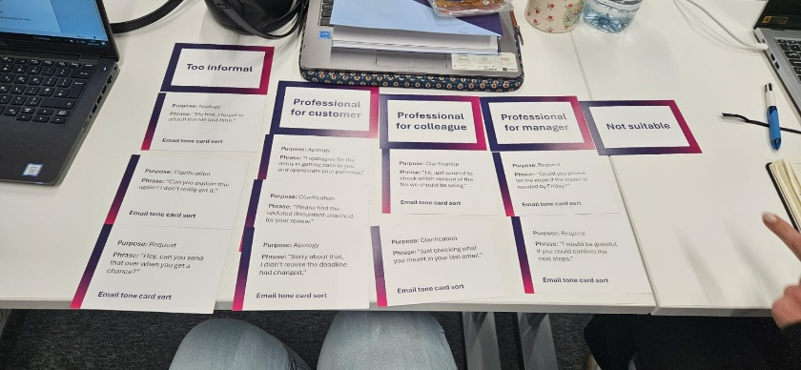

Human Judgement vs AI Liability
I understanding that human judgment is essential for responsible and decision -making.
I must be the original author of my ideas and decide what goes into my final work.
- Human must take full responsibility.
- Human Maintain original Authorship.
- Human needs to evaluate the trustworthiness of sources.
- Human must check accuracy and reliability.

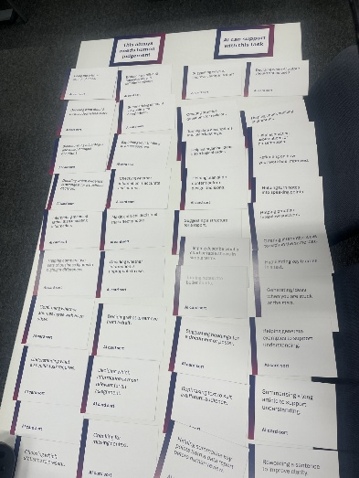
AI can support by generating examples helping practise interview answers, improving clarity of writing, comparing data and summarising key information. However, always review its suggestion, check the accuracy and use own judgement to make the final decision.
Generate clear examples to support understanding.
- Ai I can’t trust the fully information.
- Data Bias.
- Lack of Common Sense.
- Hallucinations.

.

Create a training Request charts.

For this project I use Microsoft Excel to enter and organise training request data. In class we created a chart , and I improved it to present the information clearly. ​
​
I learned how to organise data use formatting to make charts easier to understand and compare.​
​
Data Categorisation​
Visual Presentation​
Data organisation ​
Basic Data Analysis​
Chart creation on formatting ​
Customer communication​ | 18​
Digital Systems​ | 15​
Data protection​ | 9​
Time management​ | 7​

Conclusion
This portfolio demonstrates the progress I have made in developing my digital skills through creating professional emails, clear presentations and organised documents and charts.
Moving forwards, I am committed to challenging myself further and Using Excel and other tools more frequently to grow my confidence efficiency in my studies and professional career.

