Control System Design

Jordan Hayston

Instrumentation and Control

Wales Institute for Science and Art
University of Wales Trinity Saint David



Abstract
This report details the findings of a simulated control system for a Close in Weapon System using MATLAB and Simulink. Using a provided forward transfer function and a Proportional Integral Derivative (PID) controller, a closed loop (using feedback) control system was built to manage the speed and accuracy of the rotation of the turret to a desired target. The data produced by this was used to calculate the closed loop transfer function of the system as a whole, and results were compared to that of the initial simulation. An oscilloscope was used to measure the signal at various stages throughout the model. A Nyquist plot is used to measure the stability, showing phase and gain of the system. A pole zero plot of the closed loop transfer function was created to show where the transfer function tends to zero and infinity. Finally, a pole location waveform was plotted using information from the pole zero plot to show the displacement of the turret against time. The results demonstrated that the control system operated within the specified requirements.
Contents
1 Abstract 2
2 Introduction 4
3 Simulation Setup 6
4 Results 8
5 Discussion 12
6 Conclusions 13
7 References 14

Introduction
A CIWS (close in weapon system) is typically a turret mounted on a swivelling base. Models like the Phalanx (pictured below in Figure 1) are commonly used by the United States Navy on almost every class of surface combat ship. The Phalanx is computer-controlled and radar-guided. The control system allows for fast and accurate movement of the rotating base, and precise aiming of the turret. [1]

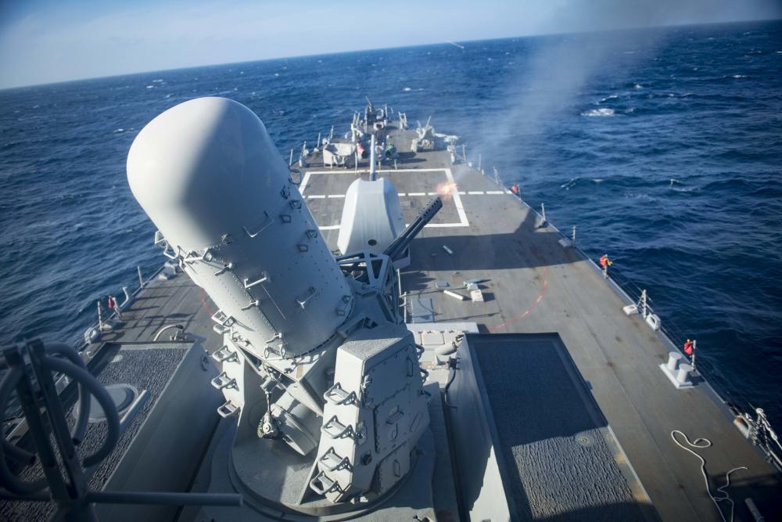
Figure 1, Phalanx CIWS turret

In simple terms, a control system manages, regulates, and commands other devices; it is a system which controls other systems using control loops to maintain process variables. Control systems are becoming more and more sought after as the demand for automation increases. Control systems can be categorised into open loop and closed loop. The sole difference is that an open loop system has no feedback element whereas a closed loop system does. The feedback loop in a closed system allows for accurate control of the output; both systems can be seen below in Figure 1 and Figure 2. [2]

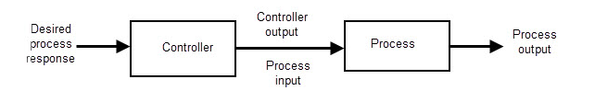
Figure 2, block diagram of an open loop control system [3]
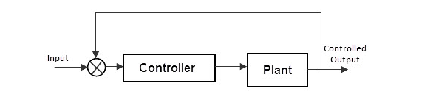
Figure 3, block diagram of a closed loop control system [4]
The control system used in this simulation setup is a Proportional Integral Derivative (PID) controller, which is effective for continuous processes unlike PLCs (programmable logic controllers). The proportional control corrects the deviation of a process back towards a set point; the correction is proportional to the amount of error. The integral control is also known as the reset control as it returns the flow to the original set point. Derivative control manages the correction rate of the proportional-integral system by producing a corrective signal. [5]

The PID controller has to manage the output of the provided forward transfer function, G(s). A transfer function is a mathematical representation of the relationship between the input and output of a control system. In this report, a closed loop transfer function is calculated using the provided forward transfer function and the function of the PID controller. [6]

Simulation Setup
The task was to design a closed loop control system capable of controlling the angular positioning system of an automatic CIWS turret. The system must be able to bring the process under control within 2 seconds with less than a 5% overshoot. The transfer function G(s) below was provided with assigned values for a, b, and c.

$$G\left(s\right)=\frac{1}{as^{2}+bs+c}$$ | a = 4  b = 2  c = 2

First a step input was created and setup to output a signal stepping from 0 to 1.

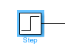 | 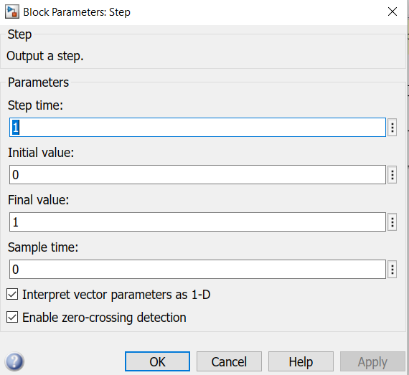

This signal was then put through a summing block which subtracts the feedback value from the step input.

Using a PID (Proportional Integral Derivative) controller, the system could then be tuned to achieve the performance requirements. The output of the controller is defined as s.
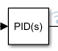

The PID uses the following function:

$$C\left(s\right)=Kp+Ki\frac{1}{s}+Kd\frac{s}{\frac{1}{N}s+1}$$

Following this, the values for a, b and c were substituted into the transfer function, and then this was put into a transfer function block which represents the turret’s angular positioning system.
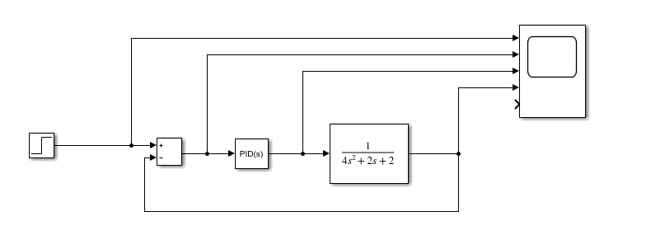0.
A scope was added to display the signal at various points of the control process.

The closed loop control system represented in Simulink can be seen below.
To find the transfer function of the entire closed loop system, G(s) and C(s) must be multiplied together.

Whole system transfer function = G(s) x C(s)

= ($Kp+Ki\frac{1}{s}+Kd\frac{s}{\frac{1}{N}s+1})$ x $(\frac{1}{as^{2}+bs+c})$

= $\frac{\left(Kp+NKd\right)s^{2}+\left(NKp+Ki\right)s+NKi }{as^{4}+\left(aN+b\right)s^{3}+\left(Kp+NKd+bN+c\right)s^{2}+\left(NKp+Ki+cN\right)s+NKi}$

This is then simplified as follows using the MATLAB command log:

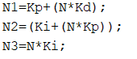 | 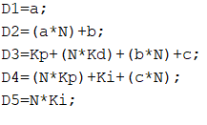
Using these simplified values, the forward transfer function was implemented as the following:

$$\frac{N1s^{2}+N2s+N3 }{D1s^{4}+D2s^{3}+D3s^{2}+D4s+D5}$$The stepped signal was input into this transfer function, and the outgoing signal was added to the scope.
Utilizing the data gathered, the MATLAB command log was used to plot several graphs. The graphs and diagrams plotted were: Nyquist plot of the forward transfer function (turret tf), pole zero plot of closed loop transfer function (whole control system tf) and a pole location waveform of the signal’s displacement over time, which was plotted using the values from the pole furthest from the origin.

Results
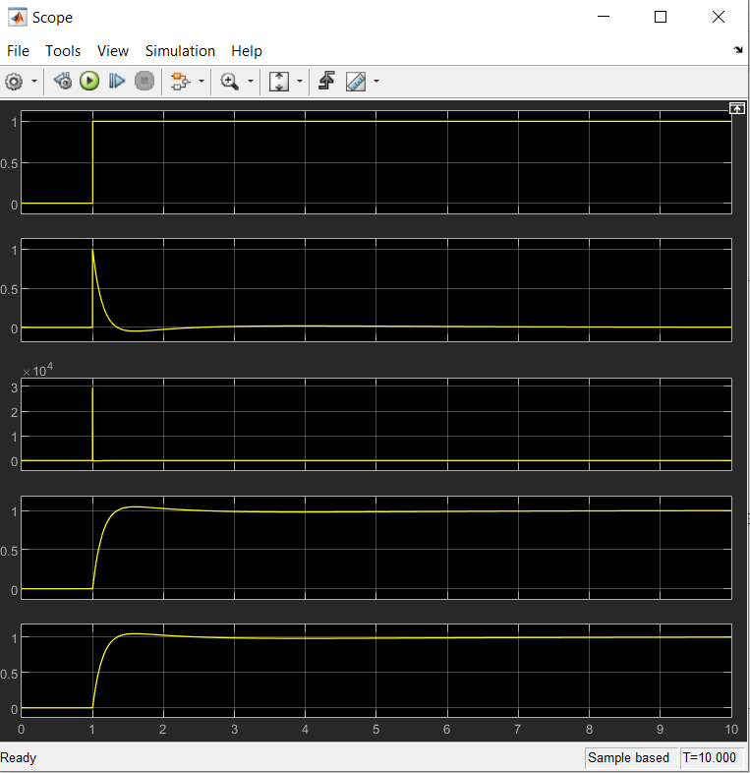
Figure 4, Scope of various signal stages throughout the system
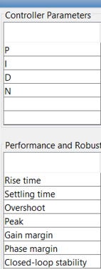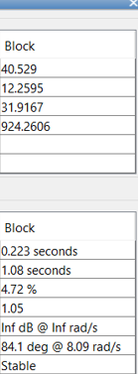
Figure 5, tuned parameters for PID controller
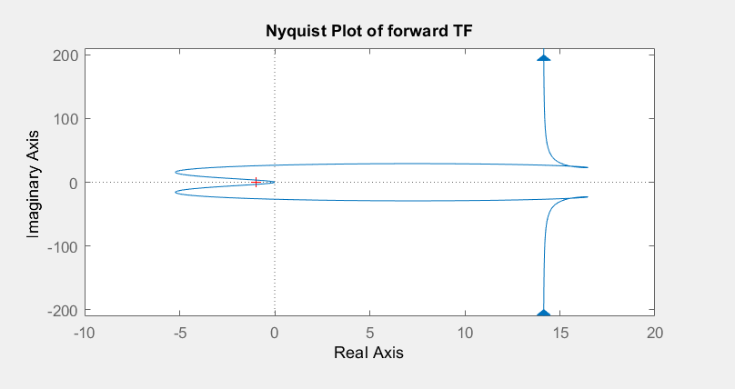
Figure 6, Nyquist plot of the forward transfer function
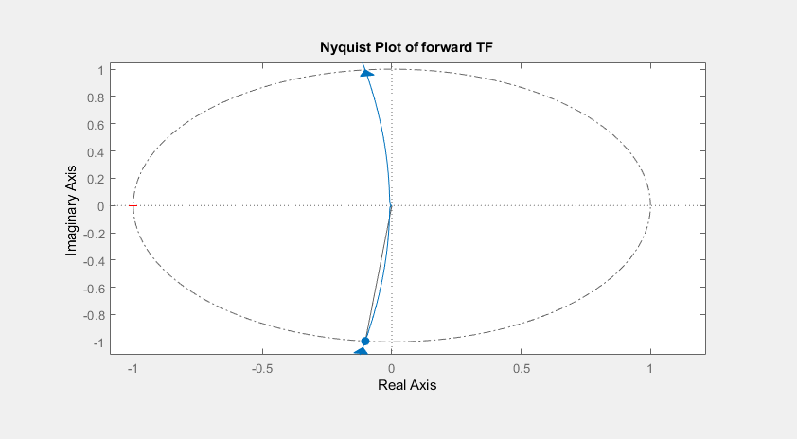
Figure 7, Nyquist plot of the forward transfer function zoomed with unit circle and phase margin annotation
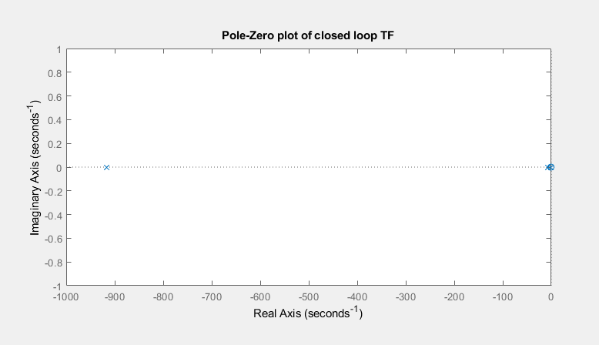
Figure 8, Pole Zero plot of the closed loop transfer function

Graph 1, a graph of the pole location waveform showing the turret’s displacement against time

Discussion
Figure 4 shows various stages of the signal throughout the control system. The first scope displays the step input going from a state of 0 to 1. The second scope is taken from the after the summation block, where the feedback signal is subtracted from the step input. Following this, Scope 3 shows the signal after it has been corrected by PID controller. The fourth scope is the final output of the control system after the signal (s) has been substituted into the transfer function G(s). Scope 5 displays the signal output from the closed loop transfer function, which matches that of scope 4.

The pole zero plot in Figure 8 presents multiple noughts and crosses, where the noughts represent a point at which the transfer function tends to zero and the crosses represent a point where it tends to infinity. The pole zero plot of the closed loop transfer function show that it is zero at locations s = -0.498 and s = -0.771, whilst the pole locations are at s = -0.425 and s = -1.02. There is also a third pole which is significantly further away from the origin, at s = -916. This pole represents a component that decays rapidly in the time domain due to its distance from the origin, whilst the other two represent slow-decaying components as they are closer.

Using the pole with the fastest time decay (real axis, sigma = -916, imaginary axis, omega = 0), the pole location waveform was calculated using the time domain response formula below. The pole location waveform provides a visual interpretation of the system response time and overshoot.

$$y_{h}\left(t\right)=\sum_{i=1}^{n}{C_{i}e^{P_{i}t}}$$

Figure 5 shows the values produced by the PID after tuning, including the proportional, integral, and derivative gain values. These are the values used to calculate the closed loop transfer function. The results of the tuned PID controller show that the system settles at the desired point in 1.08 seconds with an overshoot of 4.72%.

Graph 1 shows the displacement of s, produced by the closed loop transfer function, against time. It provides a visual interpretation of the system’s performance, showing that it acts within the design specification; the overshoot is less than 5% and the settle time is within 2 seconds. This information is secondary proof that the system works within the requirements.

Figure 6 shows the Nyquist plot of the forward transfer function. A Nyquist plot is a graphical representation of the stability of a system; it displays both frequency and phase response, where the frequency values are real, and the phase values are imaginary. Figure 7 is the same Nyquist plot zoomed in to where the graph meets the origin (0, 0). Using this, a unit circle of radius = 1 was plotted. To calculate the phase margin, a second annotation was made; a line was drawn from the origin to the point at which the plot meets the unit circle in the negative real axis. The phase margin was the angle between this line and the real axis, which was measured at 84.1 deg. Simulink also measures the gain margin from the Nyquist to be infinite (dB). As the gain margin is measured as infinite, this means that the system will never become unstable; ‘the greater the gain margin, the more stable the system’. [7]

Conclusions
A specification was detailed for a closed loop control system, capable of controlling the process of a Close in Weapon System (CIWS). The system was required to bring the process under control within 2 seconds and with less than a 5% overshoot on the rotation of the turret. The system needed to manage the output of the process transfer function, which was provided as G(s).

A model was built in Simulink with a step input going from 0 to 1, which represented the turret moving from one position to another. This signal was put through a Proportional Integral Derivative (PID) controller followed by the transfer function of the process. The output signal from this process was then sent through a feedback loop, which subtracted the output form the stepped input and out the resulting signal back through the controller. The PID controller was then tuned to meet the specification. The results of the tuning showed that the position settled in 1.08 seconds with an overshoot of 4.72%.

Following this, the closed loop transfer function of the whole system was derived by multiplying G(s) by the function of the PID controller. The gain values of the proportional, integral, derivative and the filter coefficient (N) were substituted into the closed loop transfer function using the MATLAB command log, and the output wad measured in a scope along with other stages of the original simulation. The results of this showed that the new transfer function gave the same result as the first simulation.

A pole location waveform was plotted using the time domain response formula which displayed the displacement of the signal against time. It showed the signal starting at 1 and rapidly decaying to settle at 0 in less than 2 seconds, overshooting by less than 5%. This proves that the system performs as it is required by the design specification.

Furthermore, a Nyquist plot was created which was used to calculate the phase and gain margin. The phase margin was calculated to be 84.1 degrees and the gain was infinite. The larger the gain measured from a Nyquist plot, the more stable the system is. Therefore, due to the gain being infinite, the system will never become unstable.

If this task was to be carried out in the real world, other factors and limitations would have to be considered, such as the mass of the turret and the operation of the components used to rotate it around its base. These could affect the speed and force at which the turret moves, making it more difficult for the control system to manage the settling time and the overshoot. A better understanding of the turret would produce more accurate and reliable results.

References

[1] | Raytheon Missiles and Defence, “Phalanx Weapon System,” Raytheon Missiles and Defence, 3 April 2020. [Online]. Available: https://www.raytheonmissilesanddefense.com/capabilities/products/phalanx-close-in-weapon-system. [Accessed 04 Jan 2022].
[2] | N. S. Nise, Control Systems Engineering 7th Edition, Wiley, 2014.
[3] | R. Teja, “Open Loop System,” Electronics Hub, 23 April 2021. [Online]. Available: https://www.electronicshub.org/open-loop-system/. [Accessed 2 Jan 2022].
[4] | Administrator, “Closed Loop System,” Electronics Hub, 17 July 2015. [Online]. Available: https://www.electronicshub.org/closed-loop-system/. [Accessed 2 Jan 2022].
[5] | J. W. Webb and R. A. Reis, “PID Control of Continuous Processes,” in Programmable Logic Controllers, Fourth Edition, National Instruments, 2006.
[6] | Electrical 4 U, “Transfer Function of Control System,” Electrical 4 U, 22 October 2020. [Online]. Available: https://www.electrical4u.com/transfer-function/. [Accessed 04 Jan 2022].
[7] | E. Cheever , “Determining Stability using the Nyquist Plot,” Swarthmore College, 13 October 2011. [Online]. Available: https://lpsa.swarthmore.edu/Nyquist/NyquistStability.html. [Accessed 4 Jan 2022].

