

MASTERS OF BUSINESS ADMINISTRATION
INTERNATIONAL BUSINESS CONCEPTS
MODULE CODE – LCMB7034
WEIGHINTING – 100%
ASSESSMENT COMPONENT: INDIVIDUAL REPORT
__________________________________
SUBMITTED
BY
STUDENT NAME:- NEEL MANISHBHAI KORAT
STUDENT ID – 2523741

TABLE OF CONTENTS
1. Organisational Classification and Global Strategy 3
1.1. Strategic Categorisation 3
1.2. Global Configuration and Value Creation 4
2. Macro-Environmental Appraisal and Market Attractiveness 6
2.1. Host Country Analysis 6
2.1.1. Political Direction and Institutional Risk 6
2.1.2. Economic Scale, Grocery Potential and Competitive Concentration 7
2.1.3. Price Sensitivity, Location Costs and Digital Expectations 8
2.1.4. Investment, Tax and Workforce Regulation 9
2.1.5. Food, Customs and Data Compliance 10
2.1.6. Cultural and Behavioural Fit 11
2.2. Market Entry 12
2.2.1. OLI Strategic Test 12
2.2.2. Ownership Advantages 13
2.2.3. Location Advantages in Demand and Market Access 14
2.2.4. Location Costs and Supply Constraints 15
2.2.5. Internalisation and Governance Boundary 16
2.2.6. OLI Synthesis and Entry Conditions 17
3. Entry Mode Strategy and Strategic Synthesis 18
3.1. Historical Pattern Recognition 18
3.2. Strategic Fit and Justification 20
3.3. Conclusion and Recommendations 22
4. Reflective Account Using Gibbs’ Reflective Cycle 24
4.1. Description and Initial Response 24
4.2. Evaluation of the Research Process 25
4.3. Analysis of Learning and Theory Application 26
4.4. Conclusion and Action Plan 27
5. References 29

1. Organisational Classification and Global Strategy

1.1. Strategic Categorisation
According to the integration-responsiveness model of Bartlett and Ghoshal, Costco is clearly operating a transactional strategy, where scale efficiency pressure outweighs pressure for full local autonomy (Hill and Hult, 2022). Its main formula is spread through paid membership, limited-line, bulk-pack, no-frills outlets, and low margins (Costco, 2026a). The company states that its business model is broadly similar in the US and Canada segments and internationally (Costco, 2025a). This standardisation supports centralised purchasing, faster business cycles, and supplier power, all of which are key advantages of global integration (Peng, 2022). The presence of private brands can add to the differentiation as they add value to the price, quality control, and retailer loyalty (McOuat et al., 2024).
In 2025, Costco had 81.0 million paid members, and worldwide renewal was 89.8%, indicating that its value proposition resonates internationally (Costco, 2025b). A global classification would be an exaggeration, however. Adjustment at the market level is required for food preferences, regulation, payment systems and warehouse services (Silva, 2025). International performance is also impacted by product adaptation mechanisms, which are context-dependent (Tsougkou et al., 2025). Costco thus adopts a global strategy with transnational elements rather than a transnational one, as efficiency continues to be the major criterion, and subsidiaries are not fully independent strategically (Cavusgil et al., 2025).
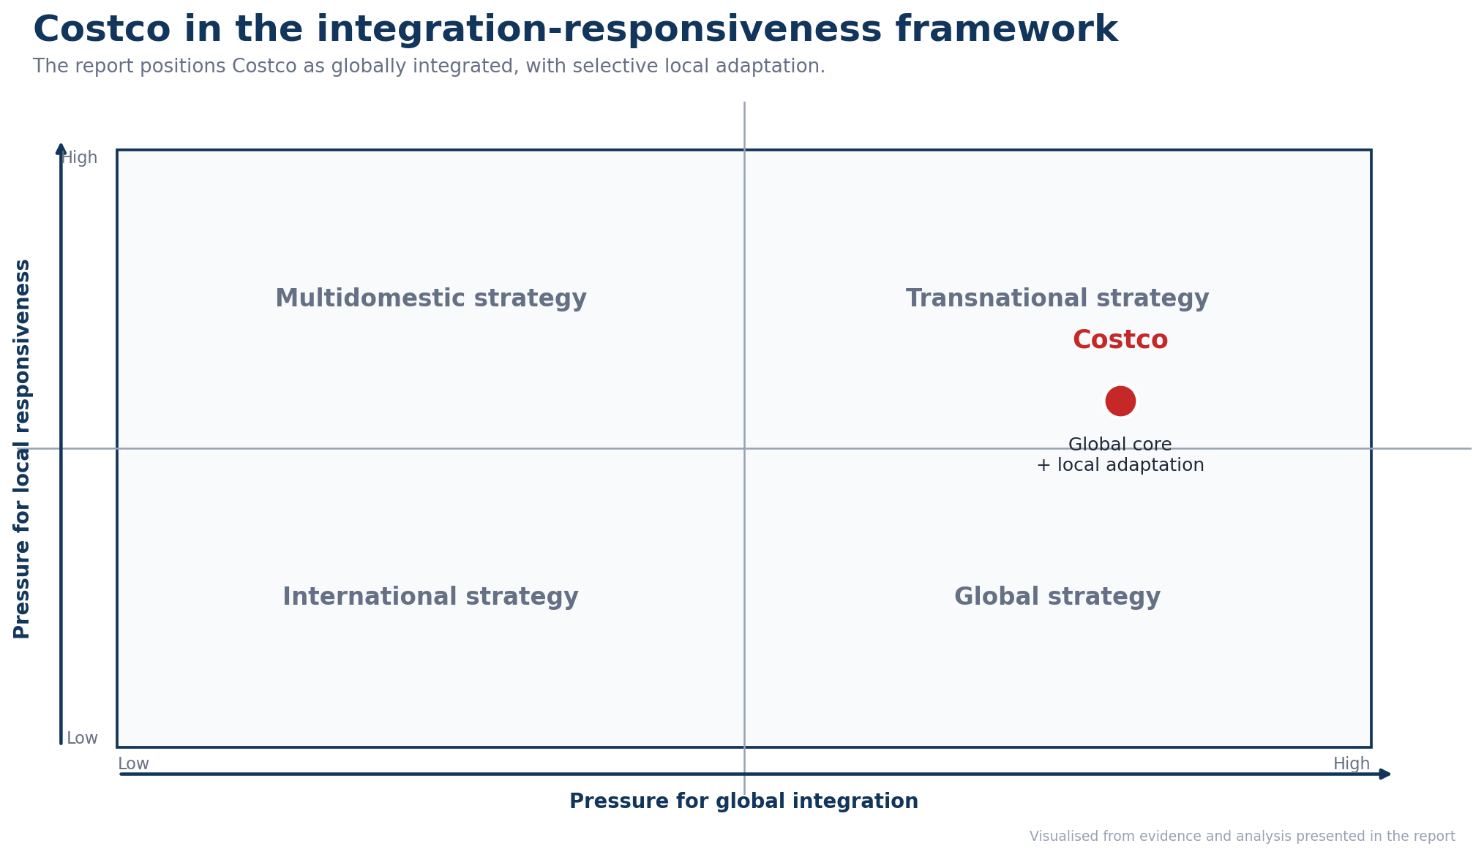
Figure 1. Integration-responsiveness positioning of Costco’s international strategy.
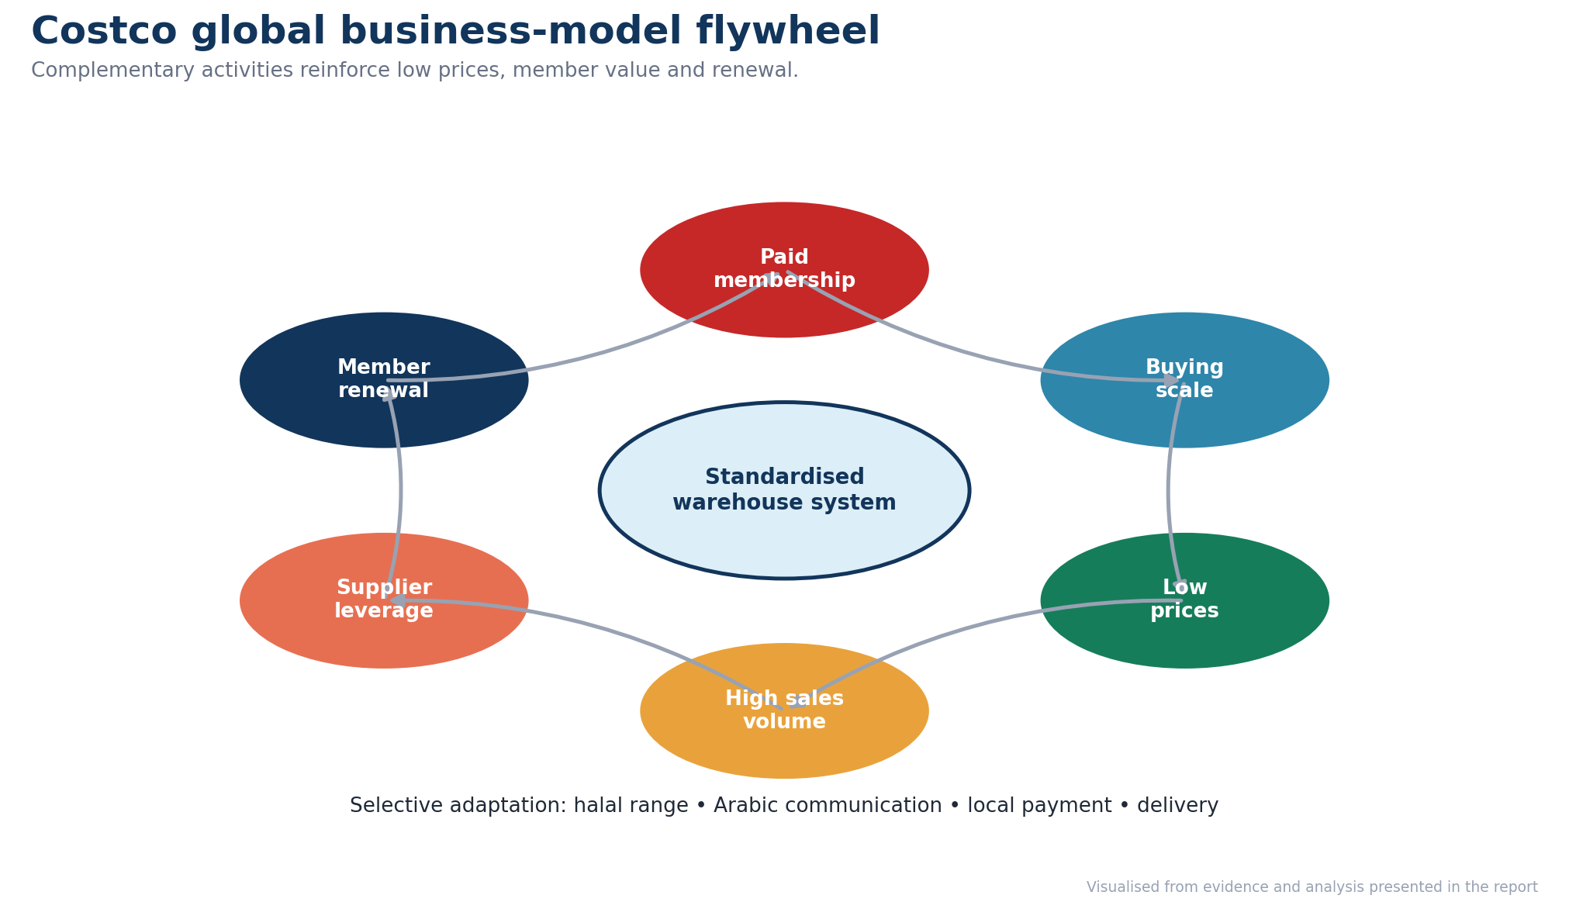
Figure 2. Costco’s global business-model flywheel with selective local adaptation.

1.2. Global Configuration and Value Creation
As of 28 May 2026, Costco operated 931 warehouses. Of these, 639 were in the US and Puerto Rico, 115 in Canada and 43 in Mexico. Thus, 85.6% of its network was still in North America. It operated in 14 markets, none of which were in the Middle East or Africa, which showed concentration risk and expansion potential. Net sales in the third quarter were US$69.15 billion, and adjusted other international comparable sales grew by 5.9% while digitally enabled sales grew by 20.8% (Costco, 2026b). Costco had confirmed its international scale by ranking fifth in the NRF and Kantar 2025 global retailer assessment, despite its geographic concentration (NRF, 2025). Foreign operations add value by increasing volumes, diversifying cash flows, and bringing warehouse knowledge. Digital integration provides additional convenience (Thaichon et al., 2024).
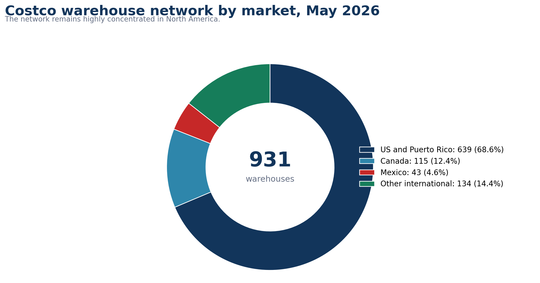
Figure 3. Geographic concentration of Costco’s 931 warehouses in May 2026.
Strong channel integration may also enhance the customer experience and perceived value (Balbín et al., 2024). The broader trend of private-label growth, which saw sales of U.S. grocery products rise 4.2% compared to 1.1% for national brands, further underscores Kirkland's strategic value (Financial Times, 2025). Costco has been moving its private-label sourcing closer to where its products are sold, minimising exposure to tariffs and showcasing its flexibility with the network (Hart, 2025). However, in North America, dependence restricts diversification. If Saudi Arabia comes in, it will be a vital territory for Costco in which to continue to operate with its repeatable platform.
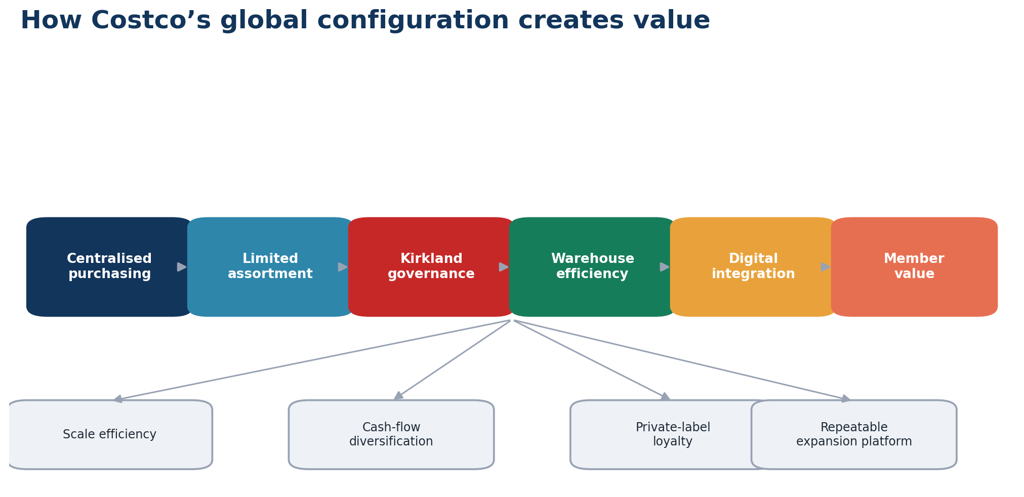
Figure 4. How Costco’s global configuration creates value across markets.

2. Macro-Environmental Appraisal and Market Attractiveness

2.1. Host Country Analysis

2.1.1. Political Direction and Institutional Risk
Costco would be served by a policy agenda aimed at attracting big foreign investors and greater demand for non-oil consumption. Saudi Arabia stated that non-oil activities accounted for 55% of GDP in 2025, which would decrease the retailer's reliance on petroleum-related demand alone (Saudi Vision 2020, 2026). Foreign direct investment inflows in the fourth quarter of 2025 totalled SAR50.6 billion, increasing by 90% from the previous year (GASTAT, 2026a). The updated Investment Law requires foreign investors to register before operating. It also offers a more transparent path to commercial registration and sector licences (MISA, 2024). This aligns with Costco's investment philosophy of controlled and long-term investment. But institutional risk is still applicable. Saudi Arabia scored 57 out of 100 and ranked 45th among 182 countries in the 2025 Corruption Perceptions Index. It lost two points compared to the previous year (Transparency International, 2026). Government spending also affects employment and consumer demand. The IMF estimated that in 2025, the fiscal deficit would be 4.3% of GDP, reflecting the impact of reduced oil income and substantial spending commitments (IMF, 2025). Therefore, Costco should dedicate itself to making investments and setting measurable expansion targets instead of treating political support as a permanent source of demand.
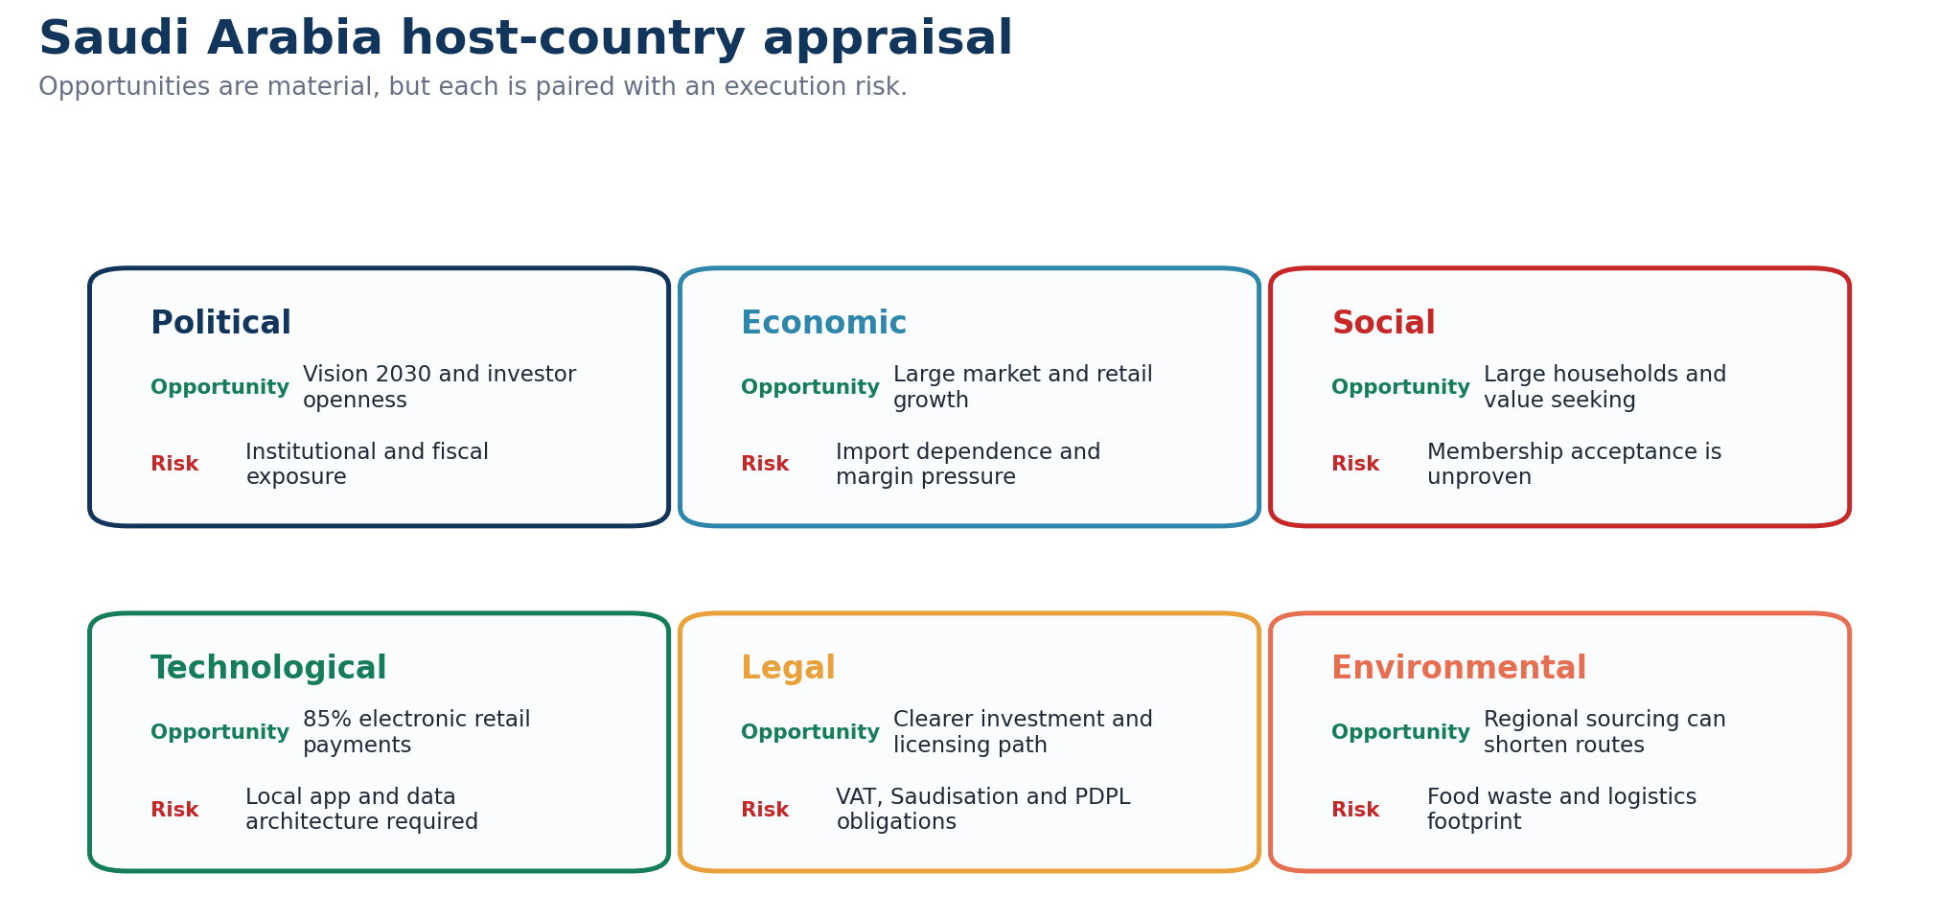
Figure 5. Saudi host-country opportunities and execution risks across PESTLE dimensions.
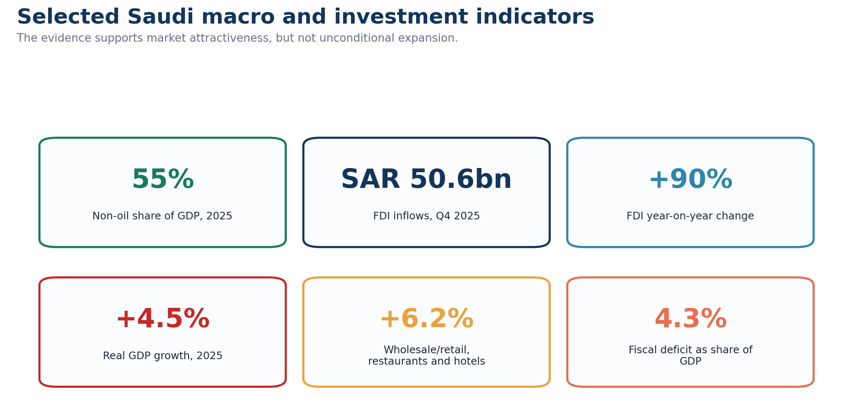
Figure 6. Selected Saudi macroeconomic and investment indicators relevant to entry.

2.1.2. Economic Scale, Grocery Potential and Competitive Concentration
Saudi demand can support Costco’s high-volume model, but retail concentration may restrict rapid market-share capture. Real GDP increased by 4.5% in 2025. Prices and income of wholesale/retail trade, restaurants and hotels increased by 6.2%, accounting for 12.3% of GDP (GASTAT, 2026b). The World Bank recorded a population of approximately 36.97 million and a GDP per capita of US$34,536.70, indicating a sizeable addressable market with substantial purchasing capacity (World Bank, 2026). Food retail sales reached approximately US$50 billion in 2024, and imports accounted for approximately 70% of food demand. However, LuLu, Tamimi, Panda, Danube and Othaim controlled more than 80% of retail revenue (USDA FAS, 2025). Costco might be able to take these companies on with its bulk and scale business. However, dependence on imports also exposes freight, customs and supply disruptions. Private consumption index rose 12.6% year on year in the third quarter of 2025, in line with its elevated spending momentum (SAMA, 2025). However, national purchasing power is not a guarantee of conversion. Costco has to demonstrate that the value of its limited selection outweighs the annual fee and travel expense to a warehouse.
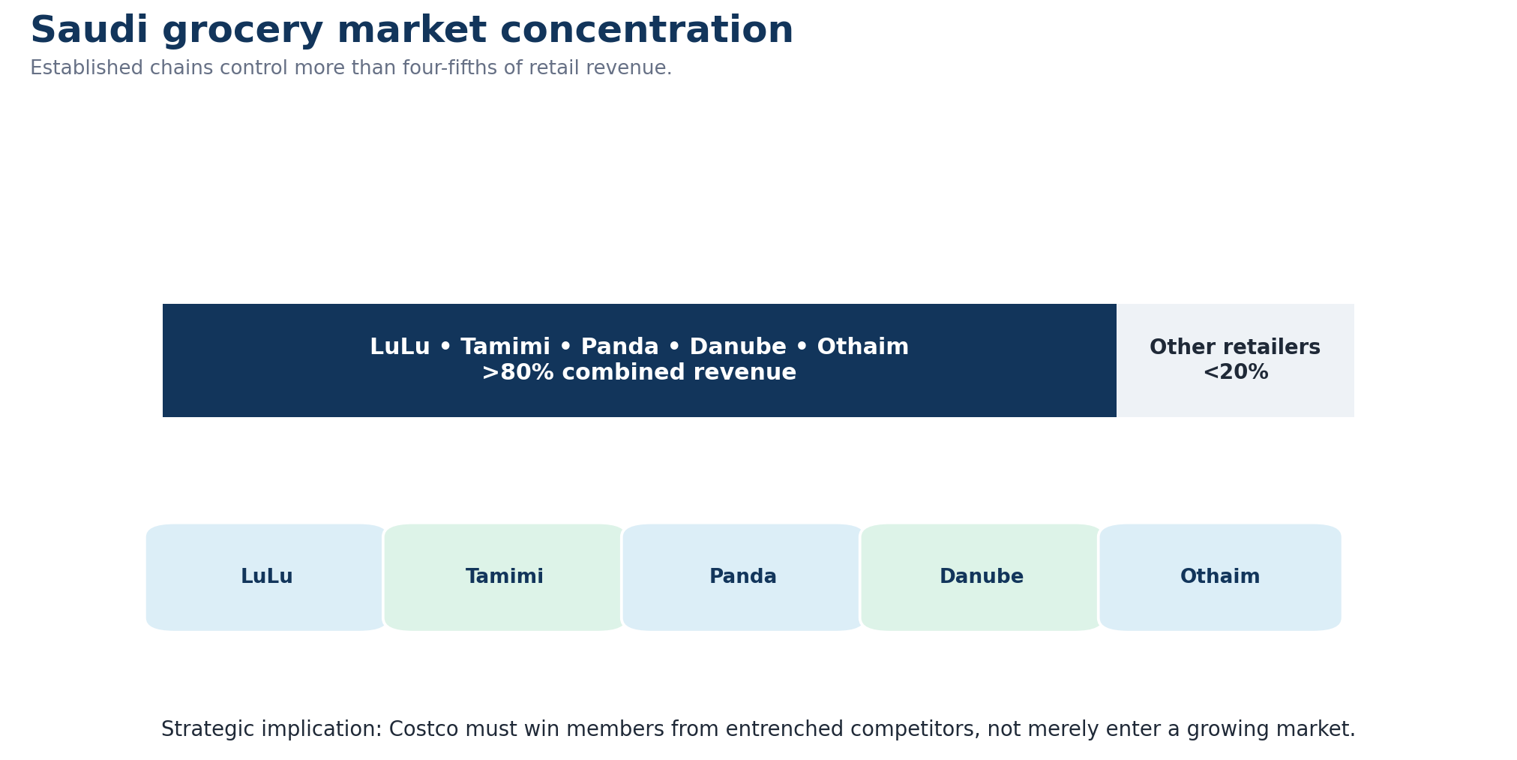
Figure 7. Saudi grocery-market concentration and the competitive challenge for Costco.

2.1.3. Price Sensitivity, Location Costs and Digital Expectations
Costco's value proposition aligns with rising price sensitivity, though urban costs may erode warehouse economics. In December 2025, consumer inflation was at 2.1%, and wholesale prices rose 3.1%, putting pressure on the low-margin retailer (GASTAT, 2026c). The results indicated that 14% to 21% of the surveyed customers in Riyadh and Jeddah plan to cut back on their grocery purchases, further supporting the idea of a value-driven warehouse store format (Abi Akl et al., 2025). Price is the primary food selection criterion for 47% of respondents in Saudi Arabia, according to PwC discovered. It also revealed that 49% bought food in bulk and 54% resorted to other stores to manage food costs (PwC Middle East, 2025). These behaviours will work in favour of Costco's bulk offering and as a caution against assuming automatic loyalty. Riyadh’s five-year freeze on commercial and residential rent increases may protect an initial lease. However, it also reveals how quickly prime-location costs became politically sensitive (Associated Press, 2025). In 2025, electronic payments accounted for 85% of retail payment transactions totaling 14.6 billion (SAMA, 2026). Costco would have to have app-based membership, local delivery and frictionless mada payments from the outset.
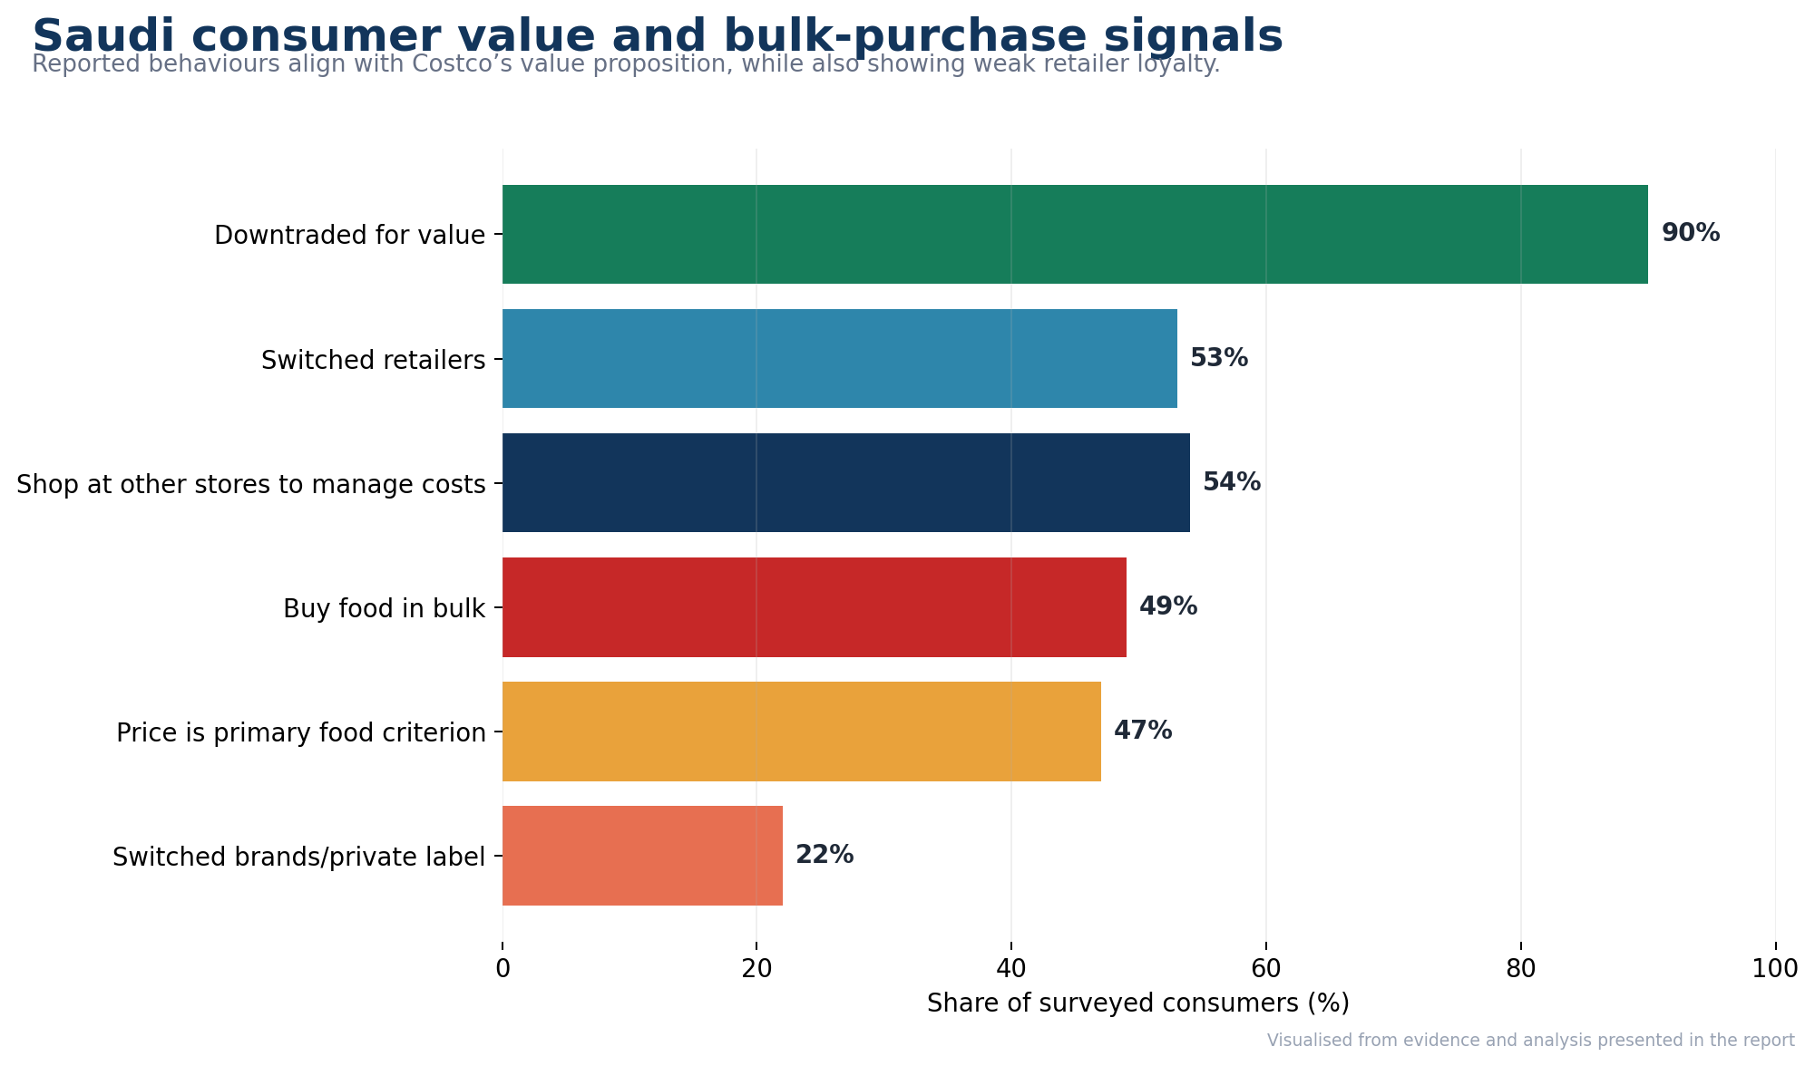
Figure 8. Saudi consumer value-seeking and bulk-purchase behaviours.
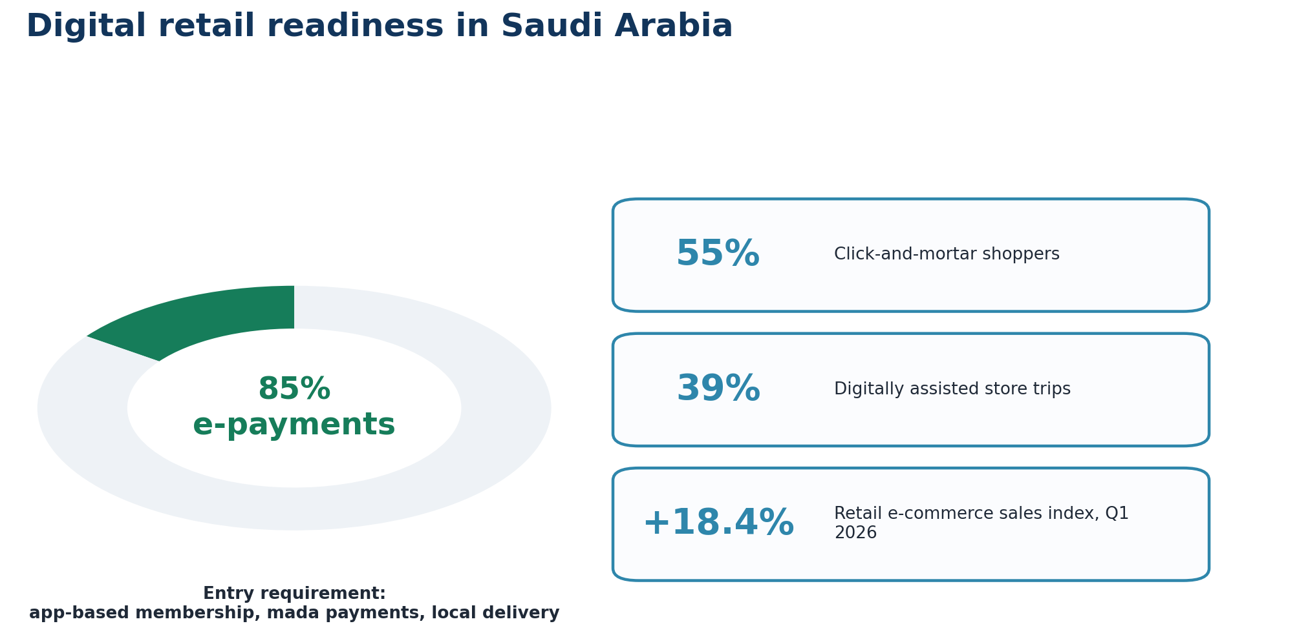
Figure 9. Digital retail readiness and payment expectations in Saudi Arabia.

2.1.4. Investment, Tax and Workforce Regulation
Formal establishment is manageable, but compliance would alter Costco's cost structure. MISA will require the foreign applicant's previous year's financial statements and authenticated corporate records. The estimated time for investment registration is 10 working days for approved activities (MISA, 2025). Saudi electronic government services can lower administrative friction, but Costco would still need individual commercial, municipal, food and operating approvals (Ministry of Commerce, 2024). Standard-rate transactions are subject to a rate of 15% VAT, whereas electronic invoicing would be applicable to membership fees, warehouse transactions and online sales (ZATCA, 2023). The regulation of labour has greater strategic importance. The marketing and sales sector was introduced to Saudisation starting from 19 April 2026 for qualifying businesses in this field at a rate of 60%. Marketing employees must earn at least SAR5,500 monthly to count towards the requirement (HRSD, 2026a). The new phase of Nitaqat also aims to generate over 340,000 jobs for Saudi nationals across three years, starting from 2026 (HRSD, 2026b). These rules increase recruitment and training costs for Costco’s labour-intensive format. However, Saudi staff might have improved in the areas of Arabic customer service and institutional legitimacy. Costco should, therefore, design structured local training programs, instead of relying on large numbers of expatriate managers.
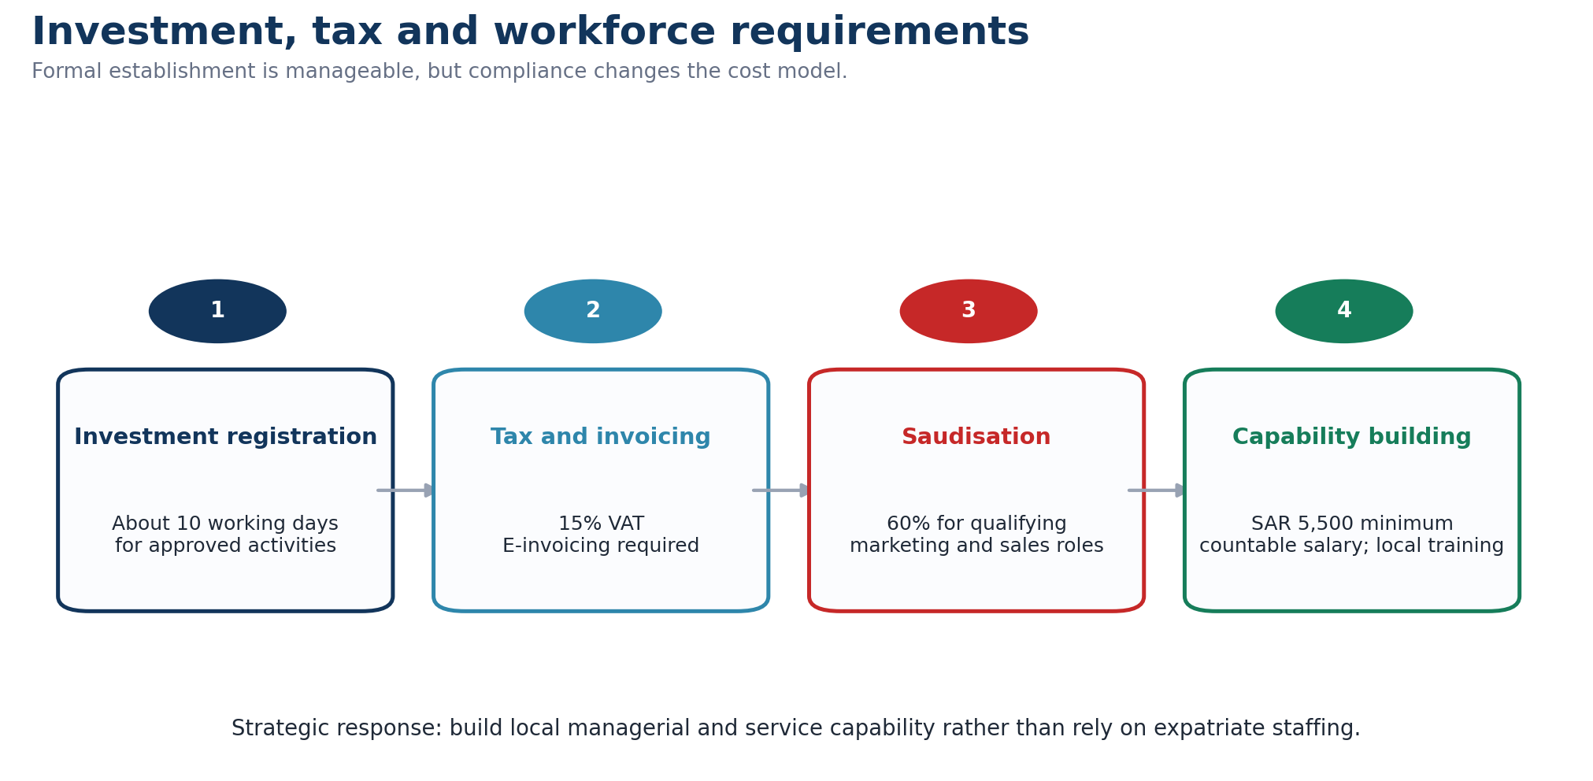
Figure 10. Investment, tax and workforce requirements affecting Costco’s cost structure.

2.1.5. Food, Customs and Data Compliance
While Costco's narrow selection might make compliance easier, product-level questions would still be applicable to Kirkland Signature imports. In January 2025, Saudi Arabia launched the 12-digit integrated customs tariff in the GCC for accurate classification and landed-cost calculation (ZATCA, 2025). Meat and poultry must be accompanied by recognised halal slaughter certificates for food clearance. Phytosanitary certificates are valid for applicable agricultural products; evidence is required for halal, organic and gluten-free claims (SFDA, 2025). All clearance requests have to go through government electronic platforms where documents and product conformity can be checked prior to clearance (SFDA, 2026). These controls may delay seasonal stock, which could undermine fast turnover unless Costco orders from regional suppliers and specifies the requirements beforehand. Membership operations are a source of exposure on their own. Saudi data law mandates obligations on organisations that process personal data such as personal member profiles, transaction history, and application data (SDAIA, 2023a). Cross-border transfers for central analytics may require safeguards such as standard contractual clauses or binding common rules (SDAIA, 2023b). Legal analysis confirms transfer compliance shall be integrated into a multinational data architecture and not a routine administration (Dentons, 2025). Costco must restrict the unnecessary transfers to American systems and have sensitive membership data localised.
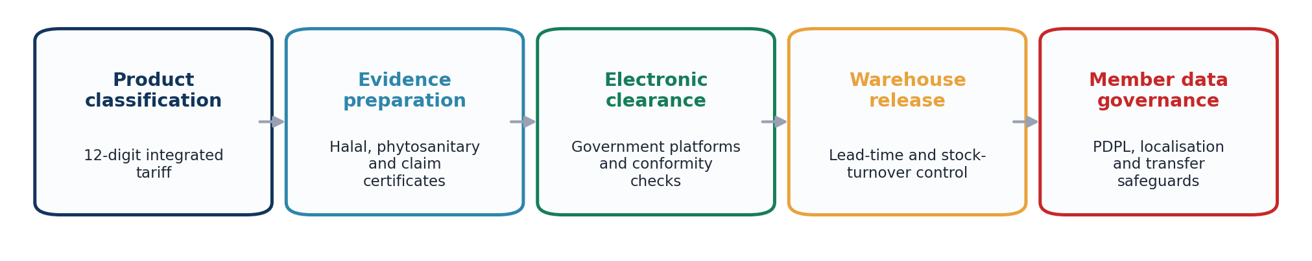
Figure 11. Food, customs and personal-data compliance pathway for Costco.

2.1.6. Cultural and Behavioural Fit
Saudi demographics offer a solid base of customers, but not all household purchases lead to customer loyalty. In 2024, non-Saudis accounted for 44.4% of the population, with 89.9% of non-Saudis in the working-age group (GASTAT, 2025). This generates a big expatriate population that could already be familiar with the retailing models used internationally. In 2024, the average size of each Saudi family was approximately five members, which facilitated bulk buying by Saudi families (Saudi Press Agency, 2025). McKinsey discovered that 90% of the Saudis surveyed had gone down in value. Among those consumers, 53% switched retailers, and 22% switched brands or bought private brands in order to get lower prices (Iftahy et al., 2025). This does not help Kirkland Signature, but it is a sign of a low level of retailer attachment. Research involving 189 Saudi respondents found that perceived benefits significantly increased e-grocery intentions, while the examined risk factors had no significant effect (Alsulaimani, 2024). According to a national study, 55% of shoppers travelled on click-and-mortar trips, with 39% of them taking some form of digitally assisted store trip (PYMNTS Intelligence, 2024). Costco should integrate halal products, Arabic communication and Ramadan planning in combination with digital fulfilment and adopt a locally tested membership price.
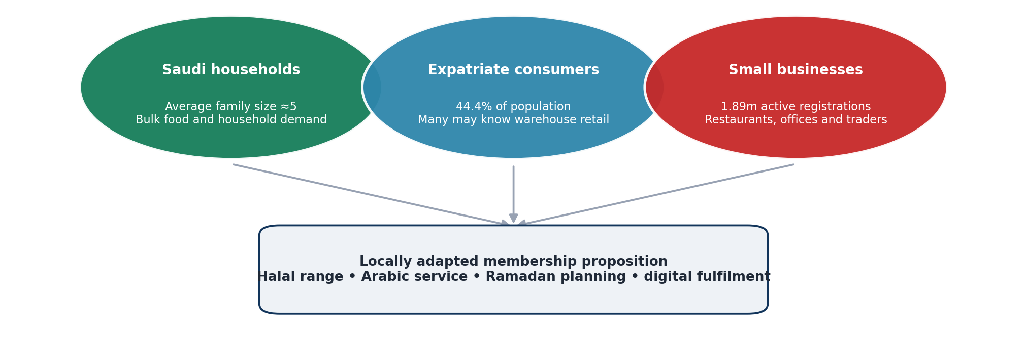
Figure 12. Priority customer segments for a Riyadh warehouse pilot.

2.2. Market Entry

2.2.1. OLI Strategic Test
Applied to Costco, Dunning’s eclectic paradigm justifies Saudi entry only if its ownership, location and internalisation advantages operate together, rather than as independent checklists. Costco has a system of warehouses that can be replicated, but it must be governed by a structure that ensures the retention of this capability in different institutions. Managers differentiate the controlled mode and the partnered mode based on their beliefs regarding competitive advantages abroad (Sharma and Klein, 2026). According to Asmussen and Petersen (2024), entry mode is not only the legal entry mode but also the first set of foreign activities. This is important because Costco requires a brick-and-mortar store and a digital membership. While virtual channels can diminish the necessity to dedicate resources, they do not replace local embeddedness in inventory-intensive retailing (Brouthers et al., 2022). The resources that Costco provide lower entry barriers, but financial slack is not a replacement for host-market managerial knowledge (Donnelly et al., 2024). Saudi Arabia is thus a tempting but qualified site. Access to sites, approvals and business networks (Saittakari et al., 2023) will be determined by political geography and institutional relationships. OLI should, therefore, evaluate if Costco can appropriate value after adaptation, not just simply if market conditions are attractive.
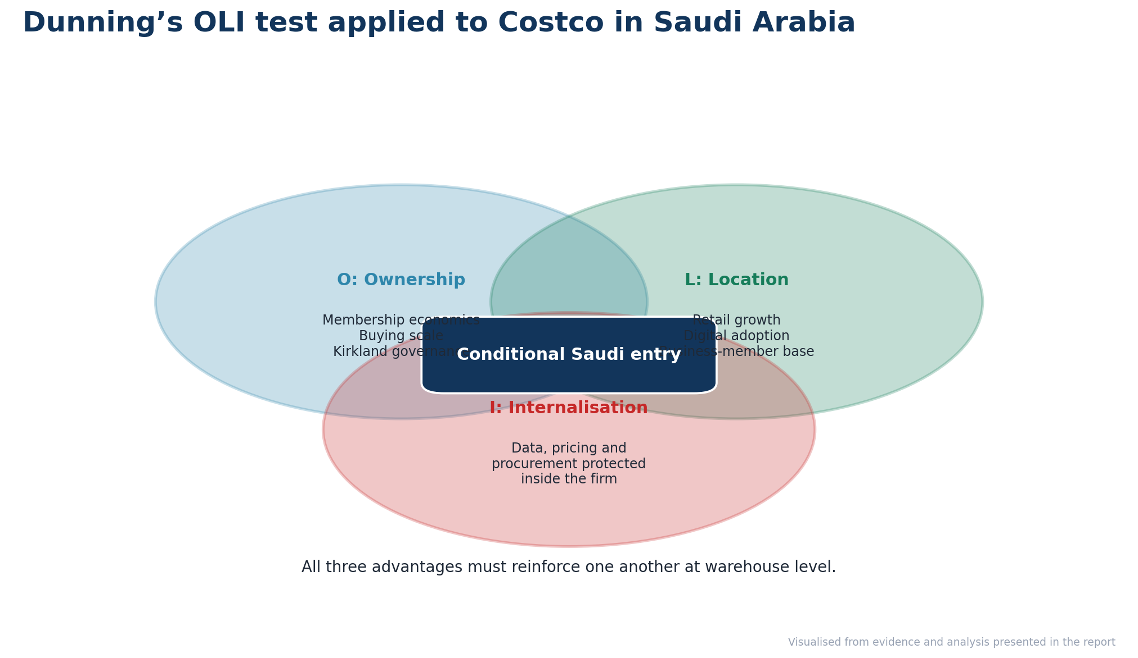
Figure 13. Dunning’s OLI framework applied to Costco’s proposed Saudi entry.

2.2.2. Ownership Advantages
The main ownership benefits in the Costco story are its membership economics, scale in buying, limited selection, and private-label governance and inventory discipline. As of 15 February 2026, Costco reported a cash balance of US$17.383 billion, revenue from membership fees of US$1.355 billion for the quarter, and a gross margin of just 11.02% (Costco, 2026). This shows investment capacity, and the business model is based on tight budget management. Value pricing can be supported by membership income, and cash reserves can allow a Saudi pilot to operate with no immediate pressure on local income. However, these resources are not automatically transferable. Reputational value does not exist unless the local resources and decision-making authority support it (Buckley et al., 2024). Costco must keep the world's best practices for Kirkland Signature, food safety and pricing, but adapt some products. Standards promote integration, but over-standardisation may undermine responsiveness to host institutions (Blind et al., 2025). While country of origin may be an indicator of quality, it can also create greater foreignness (Chwialkowska et al., 2026). Cleanliness, employee interaction and reliability of assortment supply the translation of the corporate brand into locally experienced service quality (Falatouri et al., 2024).
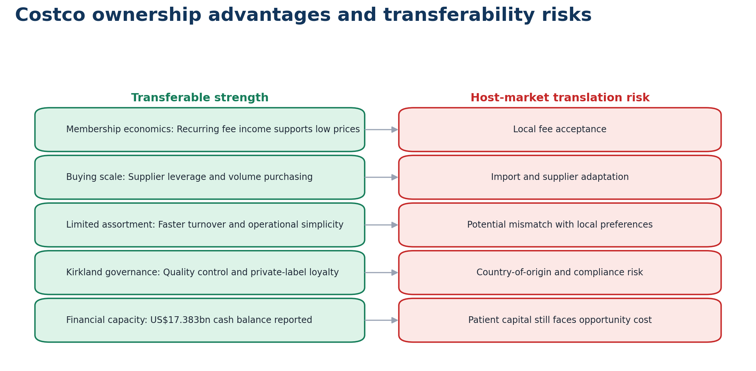
Figure 14. Costco ownership advantages and host-market transferability risks.

2.2.3. Location Advantages in Demand and Market Access
Saudi Arabia provides key geographic benefits for household and business membership. The retail operating-revenue index grew 9.6% year on year in Q1 2026, while the retail e-commerce sales index expanded by 18.4% year on year and the retail employee compensation index by 11.4% year on year (GASTAT, 2026a). This means the market momentum and increasing labour costs. Annual inflation was 1.7% in April 2026, and food and beverage price inflation was 0.6%, which means that purchasing conditions were relatively stable (GASTAT, 2026b). Saudi Arabia also had more than 1.89 million active commercial registrations as a result of issuing over 71,000 registrations in Q1, which could generate a business-member segment among restaurants, offices and independent traders (Saudi Press Agency, 2026). The registration base is strategically important because it is relevant for both small businesses and households that function within Costco’s warehouse logic. Digital growth props up the location case, but it is not a location unto itself. Increased local control is expected to enhance international e-commerce performance, for example, through delivery adaptation and supply-chain learning (Mueller and Swoboda, 2025). The last-mile selection should be convenient and cost-efficient for fulfilment (Risberg, 2026). Riyadh is well connected, which enables effective coordination; however, connectivity does not replace local relationships in logistics (Belderbos et al., 2024).
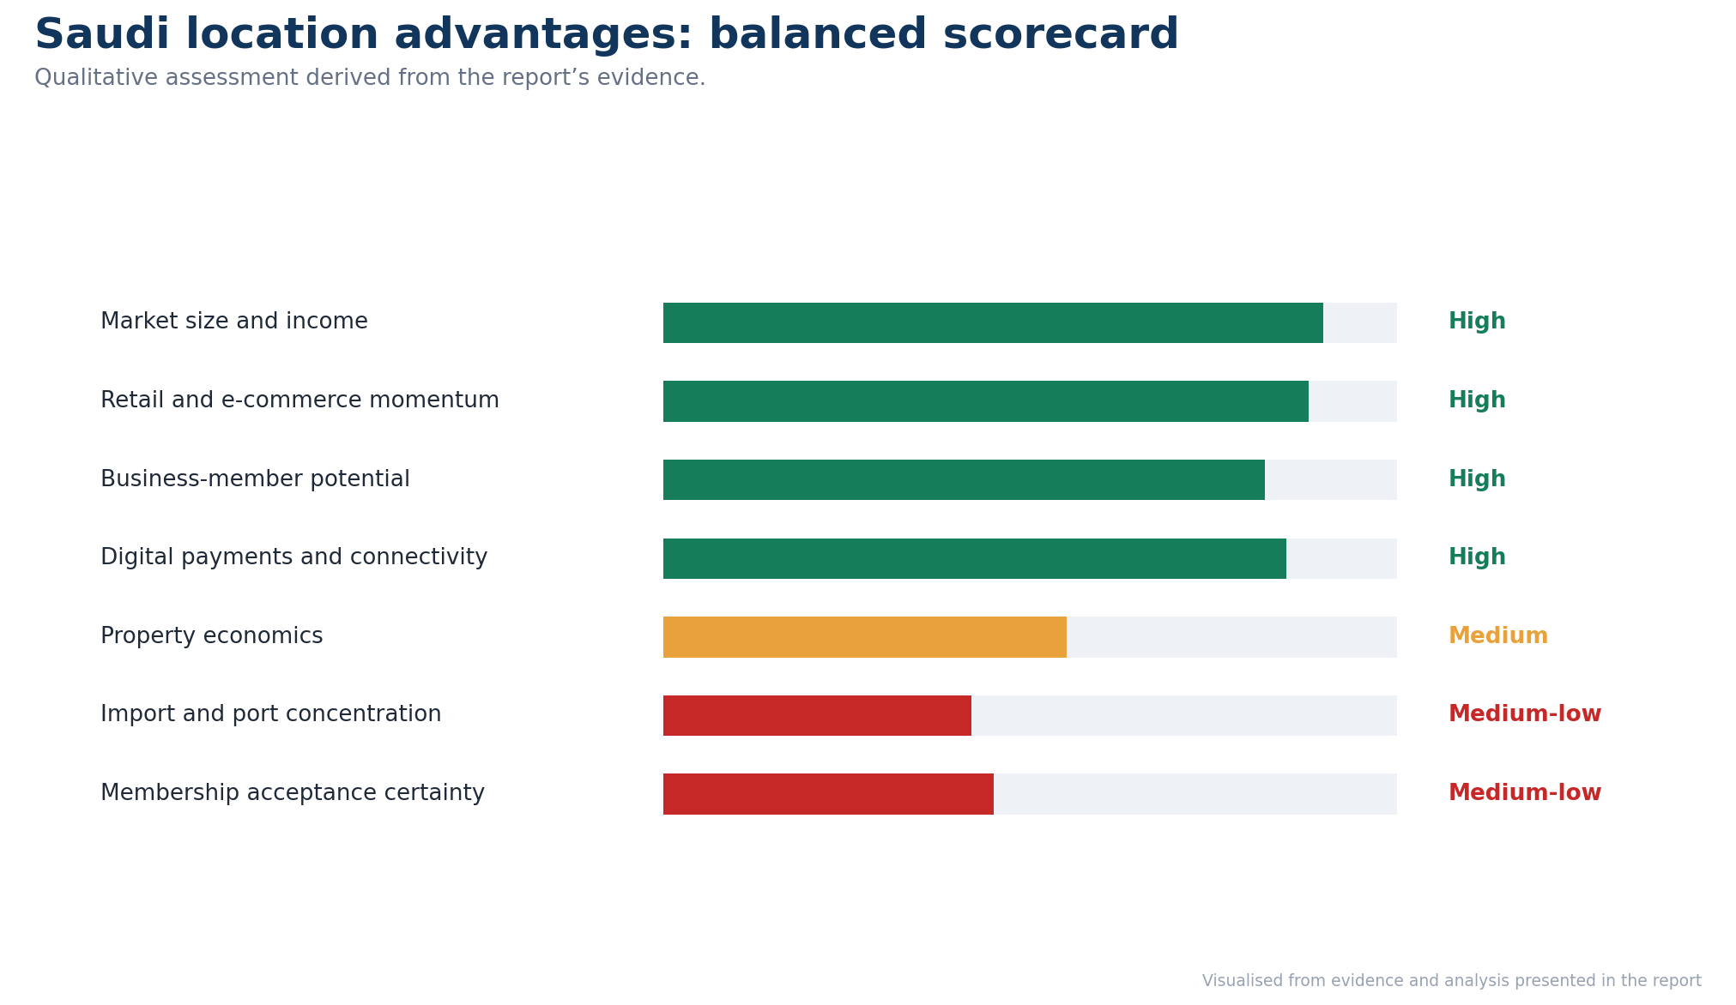
Figure 15. Balanced assessment of Saudi location advantages and constraints.

2.2.4. Location Costs and Supply Constraints
The location case weakens when import exposure, property economics and minimum scale requirements are considered. In March 2026, Saudi goods imports fell by 24.8% compared to the previous year. China accounted for 26.7% of imports, and Jeddah Islamic Seaport imported 29.8% (GASTAT, 2026c). Jeddah is a high-volume gateway, which could lead to disruption and lead-time exposure. Costco must regionalise certain sourcing and have other ways of sourcing from Dammam and Riyadh. The other limitation is property. However, as the overall property index (GASTAT, 2026d) fell, commercial real-estate prices rose 3.4% year on year in Q1 2026. Costco needs a big and convenient location, but not one that will make its low-cost business model unprofitable. While multinationals have more location flexibility than domestic firms, they still prefer areas with high population density and existing clusters of foreign businesses (Eriksson et al., 2025). Riyadh offers density, but it would be premature to roll out multi-city as fixed costs are high before membership behaviour is established. Retail exit research suggests that international failure is a result of the mismatches between firm resources and host-market conditions, thus endorsing the staged commitment (Schmid and Morschett, 2023). Expansion should then be pursued on the basis of Saudi unit economics (Verbeke et al., 2025), and not on global-scale goals.
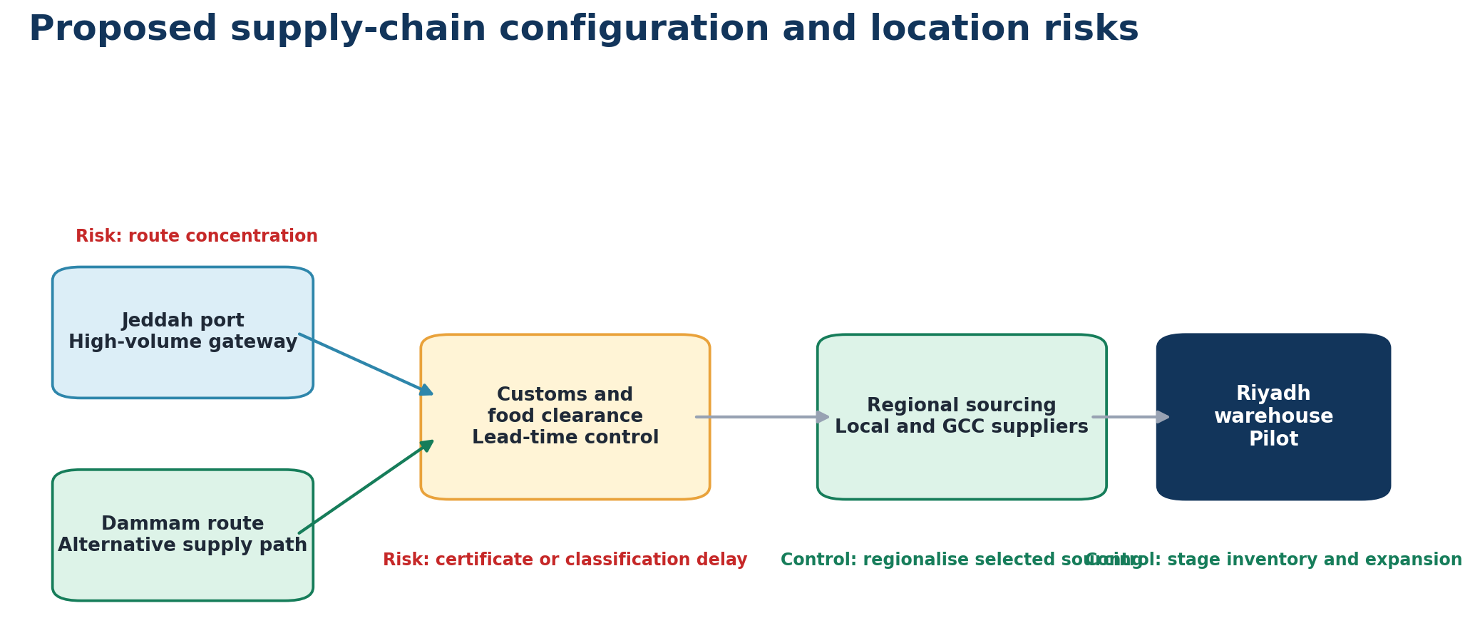
Figure 16. Proposed supply-chain configuration and location-related risks.

2.2.5. Internalisation and Governance Boundary
There are many internalisation benefits of Costco: membership data, supplier negotiations, Kirkland specifications, stock rotation, and price discipline all reinforce one another. It would face uneven implementation and jeopardise the low-margin offering of these activities via the franchise. However, it costs more to be familiar with every local activity if they are all internalised. Embeddedness and carefully managed dependence on host-country actors are ways of overcoming the issues of trust among foreign firms (Zhang et al., 2024). For effective interaction with host institutions, local participants who can translate regulation into practice are needed (Svystunova et al., 2024). Operating efficiency can't overcome foreign-firm discrimination resulting from political and social perceptions (Muratova et al., 2025). Costco should thus manage strategic assets within and acquire complementary capabilities through strategic contracts or via a minority stake. Existing studies on entry mode have focused on dynamic capability, uncertainty, and resources from partners as interrelated selection drivers (Mohammadi et al., 2026). Multi-criteria analysis is useful when there are conflicts between financial returns, control, risk and flexibility (Tanrıverdi et al., 2026). OLI also underestimates networks. The OLIN extension postulates that relationships will help to decrease outsidership and increase location value (Kaltenecker et al., 2026). Costco is in need of Saudi property, logistics and suppliers, but not a loss of control of its core operating system.
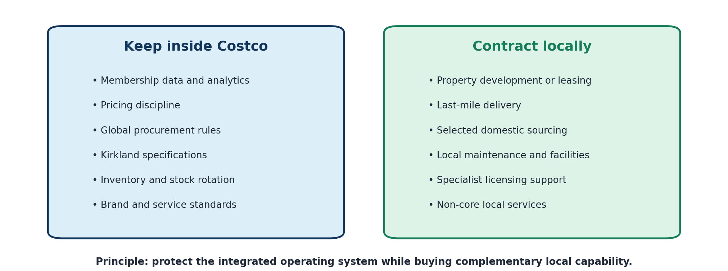
Figure 17. Recommended boundary between internalised core activities and local contracts.

2.2.6. OLI Synthesis and Entry Conditions
The assessment provides a favorable but qualified outlook on Saudi FDI. Costco has good ownership advantages, and these can be financed. Internalisation is essential for membership governance, purchasing, data management and brand standards. Saudi location advantages are medium to high due to the growth of retail activity, digital commerce, and business formation. Yet, import concentration and commercial property costs, as well as membership acceptance uncertainty, weaken confidence. Costco needs to have one warehouse in Riyadh, backed by an Arabic-language digital channel and a business-membership initiative. The rest of the capital should be dependent on acquiring paid members, renewals, average basket value, inventory turnover, and local sourcing reliability. Costco's pricing, procurement and governance of the Kirkland should stay in its hands. Saudi partners can be involved in last-mile delivery and selected domestic sourcing under performance-based contracts or in site development. A contractual option to buy partner-controlled assets later would give Costco optionality while giving it time to validate demand and increase ownership. This arrangement will bolster OLI's value by bringing its assets in-house, where contracting might have been destructive to value, and acquiring the assets Costco does not have. Success will depend less on aggregate Saudi market growth than on converting location benefits into warehouse-level economics without weakening the integrated system that constitutes Costco’s ownership advantage.
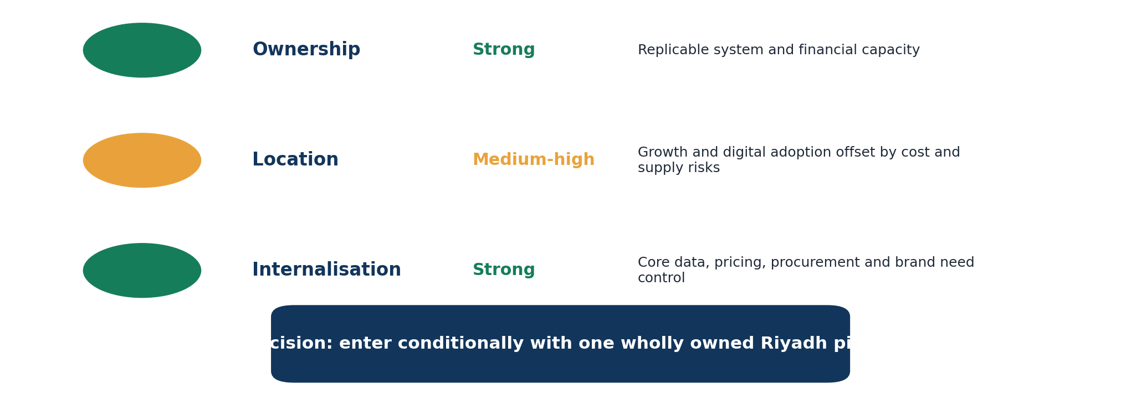
Figure 18. OLI synthesis and the resulting conditional market-entry decision.

3. Entry Mode Strategy and Strategic Synthesis

3.1. Historical Pattern Recognition
Costco's international strategy is characterised by a measured approach to ownership, but at times, partnerships have minimised initial market uncertainty. It entered the South Korean market in 1994, with a strategic partnership with Shinsegae, which provided local retail knowledge, before Costco took over (Daxue Consulting, 2024). Taiwan went through the same process. Costco entered through a joint venture and converted the operation into full ownership in 2022, confirming its preference to internalise proven platforms rather than remain partner-dependent (Reuters, 2022a). In 1999, Japan's first warehouse opened with a direct investment, indicating that Costco has been investing in greenfield sites and operating rights since then, without relying on an equity partner (Japan Today, 2025). There is local responsiveness within ownership control. Costco paid a minimum wage of ¥1,500 (US$9) an hour and received an estimated 2,000 applications for 300 jobs, and tweaked the methods used to prevent its warehouse formula from being leaked in Japan (Reuters, 2024). The membership fee, limited assortment and fast inventory rotations are complementary and not distinct functions at Costco (Mishra et al., 2025). Franchising has not taken over, since the division of the authority for buying, pricing, member data and Kirkland Signature might create a lack of coherence within the system.
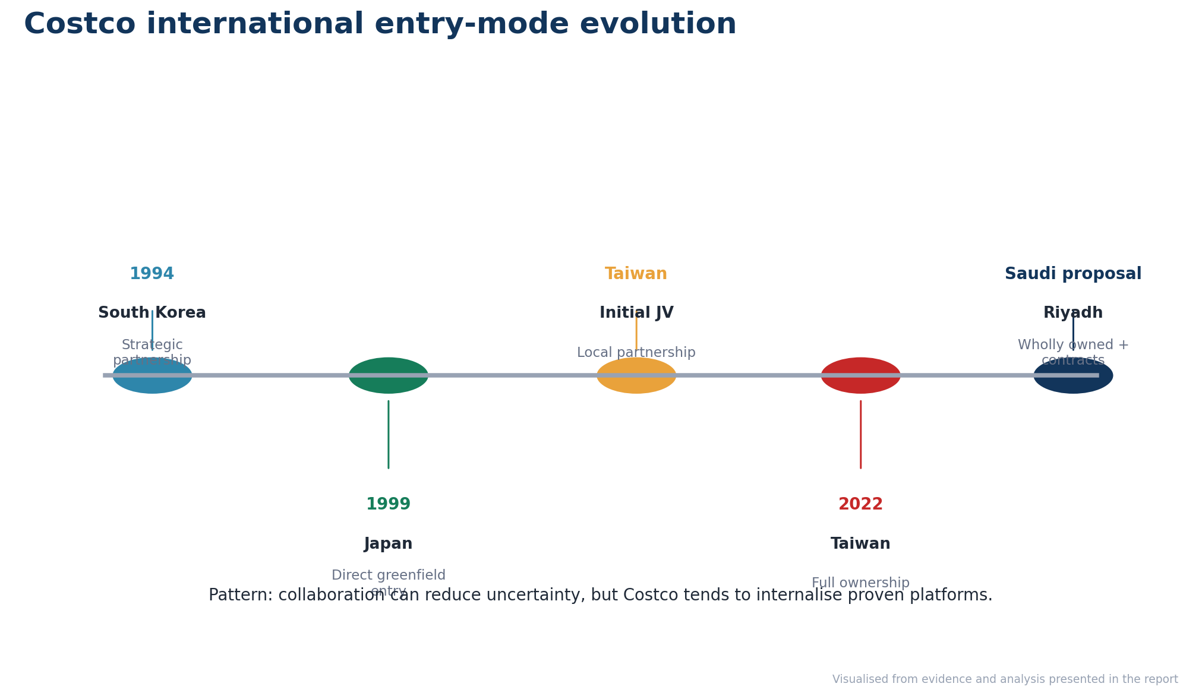
Figure 19. Costco’s historical evolution from partnership-based entry to ownership control.
The current trend is purely a pattern of greenfield expansion financed by patient capital. On average, Costco warehouses are approximately 147,000 sq. ft., which means that significant property and inventory commitments are required (TradingView, 2025). The power and the danger of this approach are illustrated in Spain. The business earned €544 million in revenue but still ended up at a loss of €7.7 million, which suggests that membership growth might come before profitability (Cinco Días, 2024). China reveals another weakness. By 2026, Costco had seven of its stores open, while Sam's Club had around 60, indicating that the standards appear to be protected through ownership but may be limiting competitive learning and rollout speed (WSJ, 2026). However, the first 39 weeks of Costco's fiscal 2026 resulted in US$221.19 billion in net sales. Other international comparable sales grew 10.9%, and digitally enabled sales grew 21.6%, allowing for sustainable growth (Costco, 2026). Research by entry mode confirms the importance of evaluating control, commitment and post-entry outcomes as a whole process, not just the automatic replication of past practices (Wan et al., 2023). The impact of learning is positive in regional expansion, but becomes negative once reaching excessive geographical spread (Ando, 2024). Costco's historical channel of distribution is thus more direct and is preceded by collaboration in areas of local uncertainty.
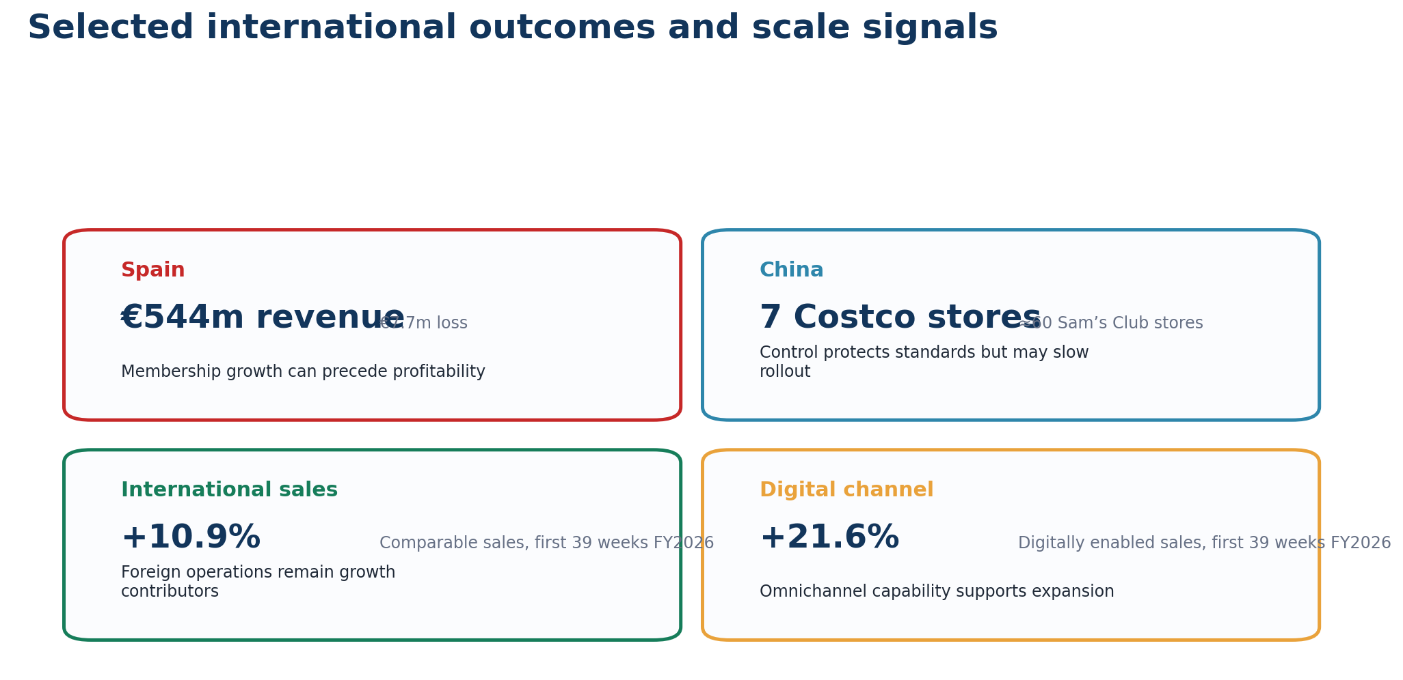
Figure 20. Selected international outcomes and scale indicators.

3.2. Strategic Fit and Justification
A Saudi partner could contribute relationships, but equity sharing is unnecessary to obtain those resources. Shared ownership can benefit from institutional distance, as local companies offer legitimacy and information (da Silva et al., 2024). Finally, when stakeholder support is critical, lower-control governance is fostered by the host country network (Bretas et al., 2024). The joint-venture stability is then undermined by the host risk and lack of country experience (AIB, 2024). While Saudi Arabia's policy openness continues, investors have not been at the forefront, with the net inflow of funds dropping by 2.4% YOY to SAR23.08 billion in Q1 2026 (Arab News, 2026a). Under the 2026 foreign real-estate regime, qualifying foreign companies are able to acquire commercial property rights in specific zones, without giving up an equity stake just to get warehouse rights (Bird and Bird, 2026). Additionally, Saudi Arabia announced on 1st February 2026 that all foreign investors will be allowed to participate in its capital market, further reinforcing its efforts on international capital participation (Reuters, 2026). They should, in the future, continue the historical, wholly owned greenfield strategy, which is adopted by Costco via a Saudi subsidiary. Local developers, logistics providers and food suppliers should be contracted rather than given ownership. This safeguards membership economics, data, private label quality, pricing discipline and enables Costco to change failed service partners.
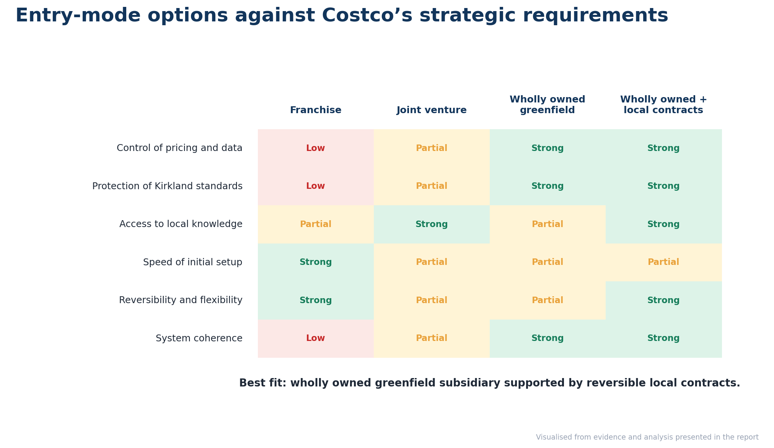
Figure 21. Entry-mode options assessed against Costco’s strategic requirements.
The financial and operational risk associated with direct ownership remains and thus needs to be staggered. Costco is spending around US$6.5 billion on capital expenditures each year and expects over 30 net new stores annually, demonstrating capacity but also competition for investment funds (Zacks, 2026). Port container throughput rose 20.89% year on year in February 2026, helping to facilitate and drive imports of stock flows, but not stemming the risk of customs and concentration of routes (Saudi Press Agency, 2026a). The sector of wholesale and retail had 1,816,403 jobs, and Saudi's unemployment rate was 6.4%, which offered recruitment depth as well as tasks of nationalisation (DataSaudi, 2026). Internal control is also one of the benefits of data governance. An examination of 100 Saudi e-commerce websites identified only 31% with all four of the items listed as part of the review, which indicated that the compliance of these websites was uneven (Alashwali and Alhuzali, 2026). By early 2026, over 700 multi-nationals had set up regional headquarters in Riyadh, enhancing business services but driving up competition for managers and sites (Arab News, 2026b). Modern theory argues that the integration of ownership and reversible contractual ties is preferable to a single approach (Shaheer et al., 2026). Costco should combine the wholly owned warehouse with the leased property, third-party logistics, and adapted local-sourcing contracts, and should place governance in line with host conditions (Agnihotri et al., 2023).
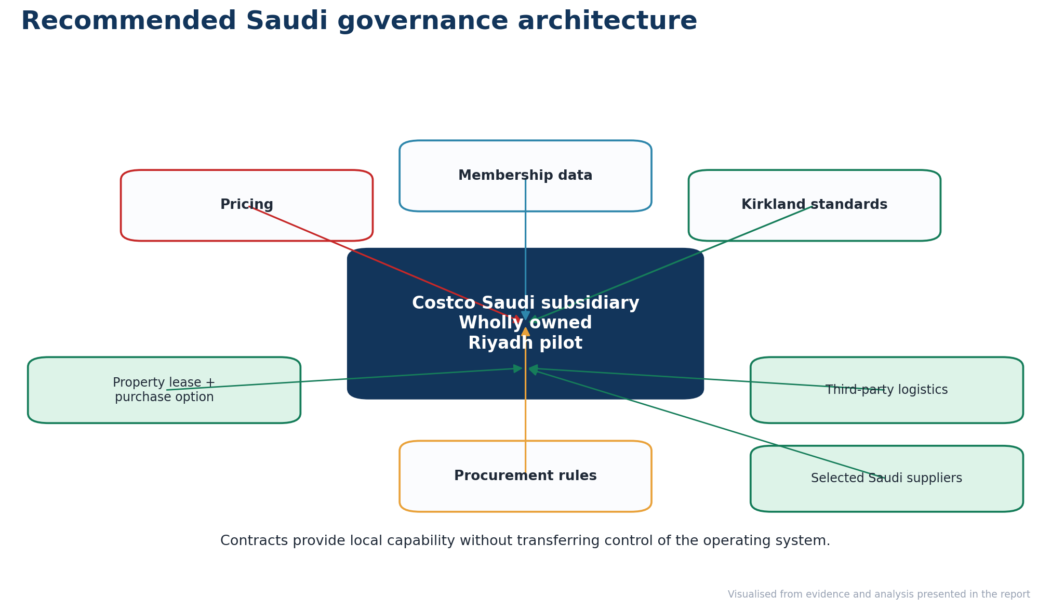
Figure 22. Recommended governance architecture for Costco’s Saudi subsidiary.

3.3. Conclusion and Recommendations
Costco should create a wholly owned Saudi greenfield subsidiary, beginning with one Riyadh warehouse and an Arabic digital membership channel. The pricing, data and Kirkland standards would be subject to agency risk if it were franchised. JVs would result in governance issues that would augur no additional capability that can be added through contractual agreements. Organic, acquisitive and collaborative growth should be chosen depending on market barriers, competition and prior experience (Ego and Pidun, 2025). There, Saudi institutional quality will be combined with subsidiary experience, where capable local management will be critical within headquarters control (Hassan et al., 2025). Under the new ownership model, the initial property should be leased with a purchase option to avoid sunk costs and provide flexibility (White and Case, 2025). The expansion of Jeddah should take place following a set of conditions that include paid membership, renewal, basket value, stock turnover, and local sourcing in Riyadh. The third stage should come from the Eastern Province entry. Service measures and termination rights are important elements of logistics, property and supplier agreements. When milestones are not met, such as licensing or staffing, Costco should not dilute its ownership; instead, it should delay the capital release. This helps retain Costco's historical control advantage, and staged investments reduce political, financial and operational risks. Saudi Arabia should be a platform for the GCC region following stability in local economics and compliance.
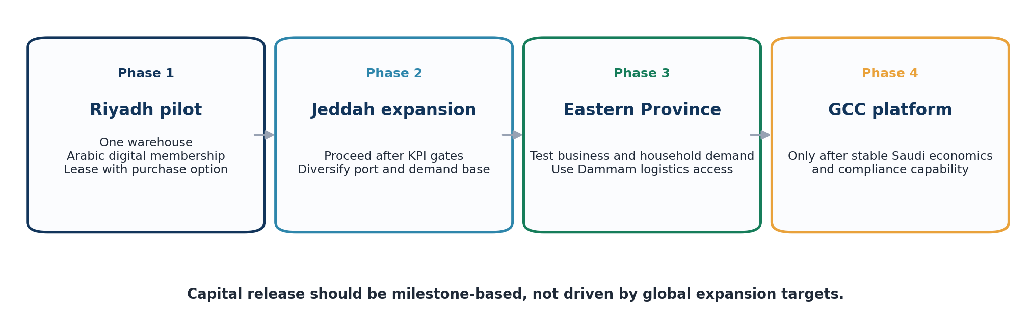
Figure 23. Phased Saudi market-entry roadmap from Riyadh to a potential GCC platform.
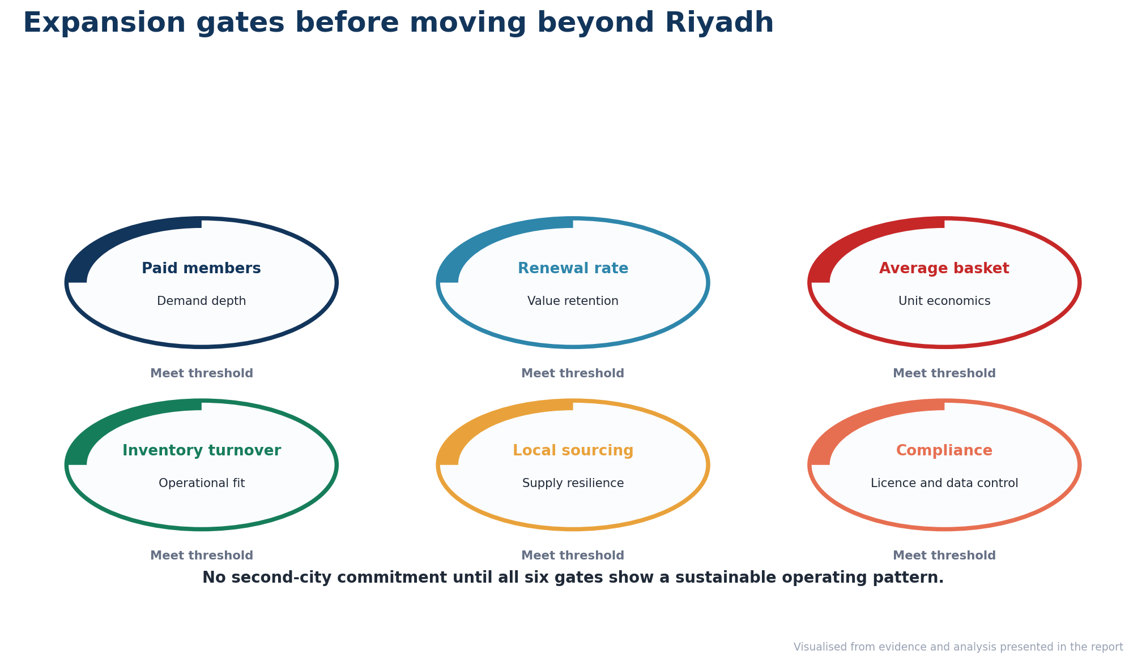
Figure 24. Performance gates required before expansion beyond Riyadh.
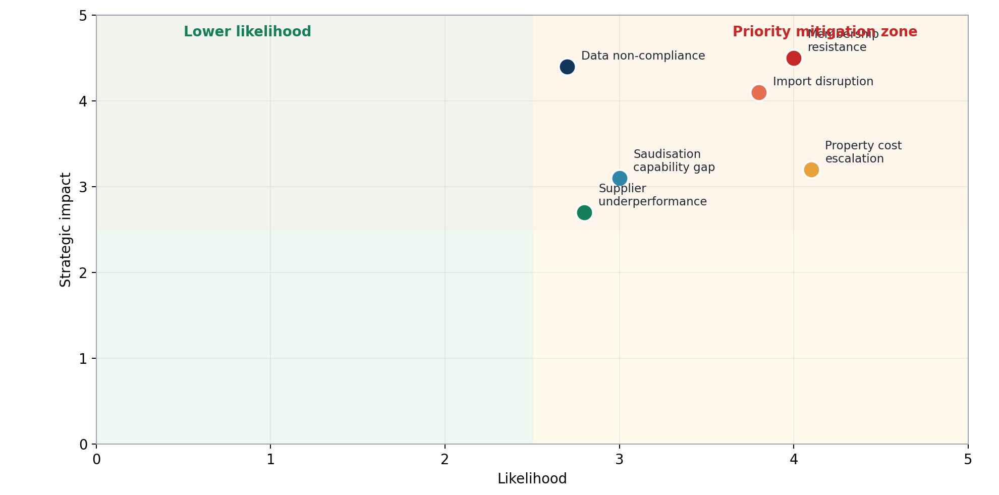
Figure 25. Priority strategic risks requiring mitigation during Saudi entry.

4. Reflective Account Using Gibbs’ Reflective Cycle

4.1. Description and Initial Response
I structured this reflection through Gibbs’ six stages because the model required movement from description towards evaluation, analysis and an action plan, rather than a narrative summary (University of Edinburgh, 2024). I started with four questions: How does Costco compete internationally? Why is Saudi Arabia attractive? Does OLI help to facilitate foreign direct investment? What entry mode is best for Costco's operating system? This question-led approach was reinforced in the module introduction as one where informed research and theory are applied towards complex international decisions (UWTSD, 2023a). I was initially confident because I felt that the model that Costco was using was quite easy. Early reading revealed a connection between membership economics, imported food, customer data and Saudisation, along with land access. I therefore saw the case as a complex decision, rather than a market growth opportunity. I used to rely on uncertainty as a vague explanation (UWTSD, 2023b), which I was able to break down into volatility, uncertainty, complexity and ambiguity during VUCA. Developed a source matrix that notes publication date, authority, evidence, relevance and limitations to the framework. This was done following a principle of business research which states that evidence should be collected based on the research question (Saunders et al., 2023).
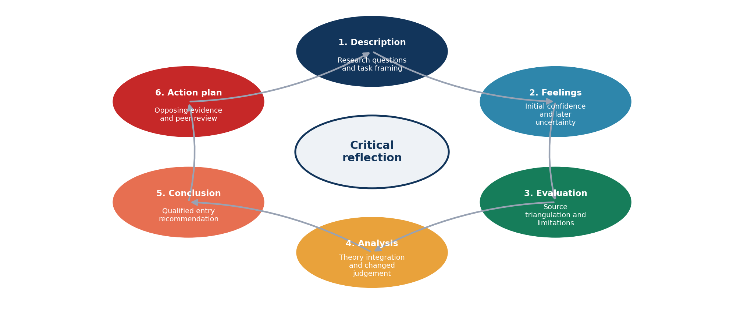
Figure 26. Gibbs’ reflective cycle applied to the assignment process.

4.2. Evaluation of the Research Process
The strongest part of my process was source triangulation. I focused on Costco filings, Saudi government publications, and recent academic literature, and then verified key claims with another source. This eliminated reliance on commercial reports and eliminated unsupported assumptions. The distinction between evidence collection and evidence interpretation was influenced by Bell et al. (2022) since a current statistic did not necessarily and immediately apply to Costco's strategic problem. I used the following themes to categorise evidence: political, economic, legal, cultural, ownership, location and internalisation. This was similar to reflexive thematic analysis, in which themes emerge from the material by active interpretation and not in a mechanical manner (Braun and Clarke, 2022). The Week 5 session improved my evaluation by requiring a benefit, cost and risk balance for political, economic and legal conditions (UWTSD, 2023c). Information overload was the most common limitation. Saudi reforms were rapid, and some websites simply regurgitated official releases without independent analysis. To accommodate this, I've taken the pages which don't have dates and traced statistics back to their original release, and used a clear information cut-off date. Lateral source checking further minimised the risk of accepting compelling but weak online proof (McGrew and Kohnen, 2024).
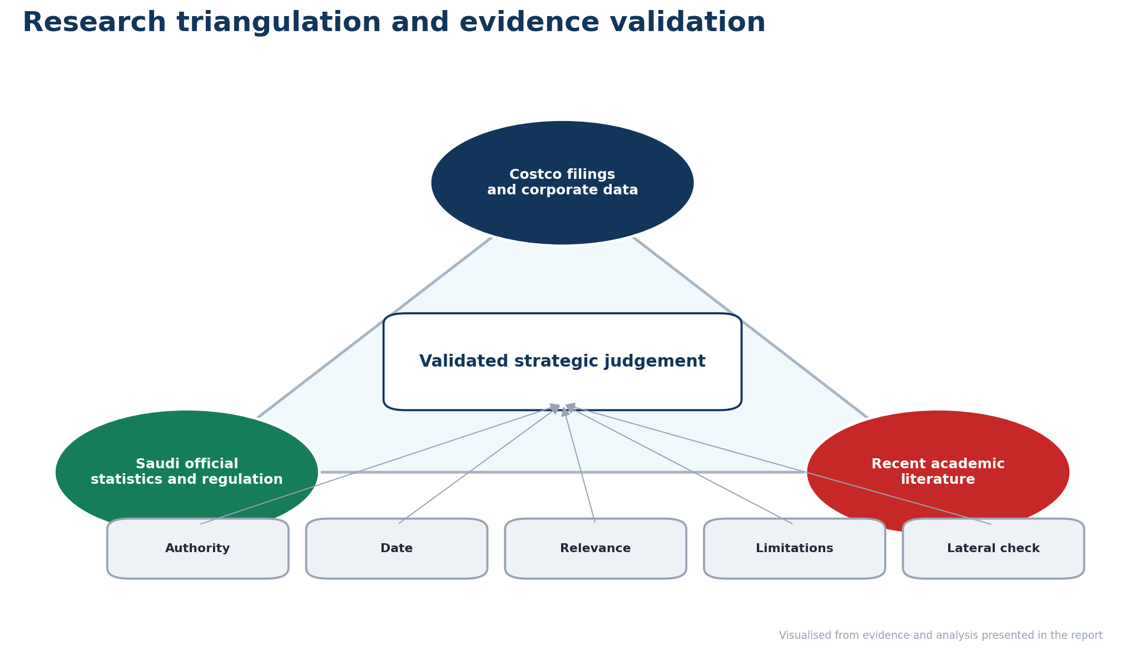
Figure 27. Research triangulation and evidence-validation process.

4.3. Analysis of Learning and Theory Application
My learning was most pronounced when I began to think of frameworks as a single component of the assignment. The entry-mode lecture demonstrated that licensing, joint ventures and wholly owned subsidiaries (UWTSD, 2023d) are impacted by control, cost pressure, and core competencies. I related this to the FDI lecture where it was explained that OLI involves ownership advantages, location advantages and the gains from internalisation of transactions (UWTSD, 2023e). I had initially recommended the integration, but this changed my mind. Initially, I preferred a Saudi joint venture, which seemed to minimise political and operating risk. Costco could be acquiring local property, logistics experience and regulation, and shared ownership could make it difficult to control the data on memberships, pricing, and Kirkland standards. I also wondered about the generalities of “Saudi consumers” during the culture session. It highlighted the importance of avoiding ethnocentric assumptions and that national averages may mask subcultures (UWTSD, 2023f). Instead of considering demand as homogeneous, I have treated Saudi families, expatriates and small-business members as different family groups. The marketing and supply-chain session clarified that legal, cultural and economic conditions may require selective adaptation without abandoning global standardisation (UWTSD, 2023g). This deeper analysis was supported by structured reflection, which was used to review the assumptions and formulate action plans (Hashim et al., 2023).
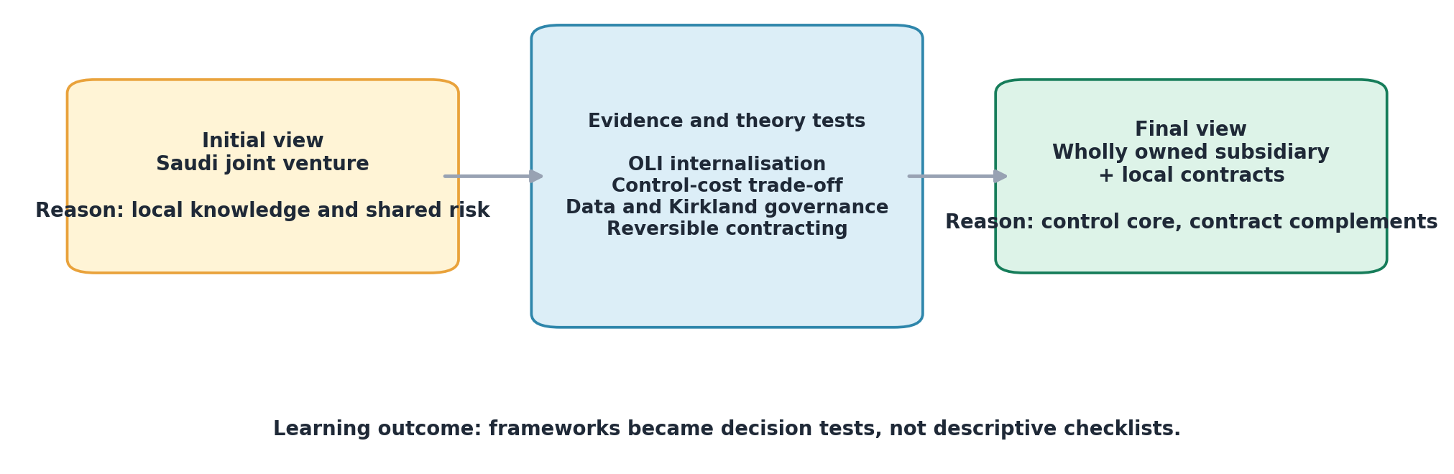
Figure 28. How theoretical analysis changed the preferred entry-mode recommendation.

4.4. Conclusion and Action Plan
The process taught me that critical international business analysis needs disciplined selection, rather than the quantity of material collected. My final judgment turned into an increasingly qualified. Saudi Arabia had legitimate demand and investment opportunities, and this would require a phased entry into Riyadh, local contractual partnering, and absolute control of ownership. Writing the reflection also brought to light that I had focused more on finding evidence for market attractiveness than on evidence that would invalidate entry. The reflective reports are useful if they expose weaknesses in the reasoning and relate to future improvements (Trimasse, 2025).
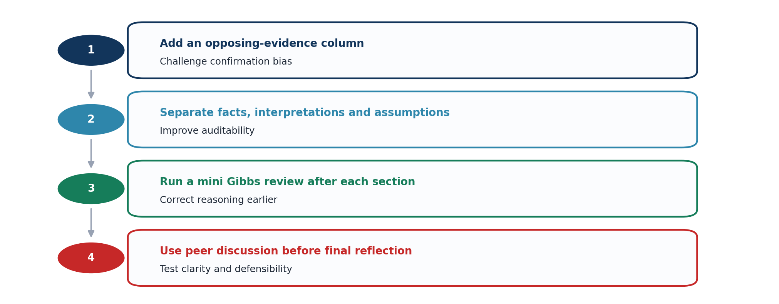
Figure 29. Action plan for improving future international-business analysis.
I will develop a column that has opposing evidence in my research matrix in future work and see how each recommendation stacks up against realistic evidence of failure. I will also distinguish facts, interpretations and assumptions when taking notes. Bolton and Delderfield (2026) state that reflective writing helps to facilitate critical enquiry by allowing professional thinking to be open to examination. I will therefore give a Gibbs review after each analytical section, not at the end of the assignment. Lastly, I will adopt peer discussion in advance of the reflection and collaborative learning to enhance analytical thinking (Guo et al., 2024). These actions should mitigate the influence of confirmation bias and will make future recommendations easier to explain and defend.

5. References
Abi Akl, J., Semaan, C. and Iftikhar, U. (2025) ‘The evolving spending habits of consumers in Saudi Arabia’, Oliver Wyman. Available at: https://www.oliverwyman.com/our-expertise/insights/2025/may/successfully-adapt-to-saudi-evolving-retail-consumer-trends.html (Accessed: 12 July 2026).
Agnihotri, A., Bhattacharya, S., Yannopoulou, N., and Thrassou, A. (2023). Foreign market entry modes for servitization under diverse macroenvironmental conditions: taxonomy and propositions. International Marketing Review, 40(4), 561-584.
Aib, H. (2024). Stability of international joint ventures: When experience and age overshadow host country risk. Journal of International Management, 30(6), 101205.
Alashwali, E., and Alhuzali, A. (2026). Evaluating PDPL Compliance in E-Commerce Websites: Insights and Lessons Learned from Human and LLM Analyses. arXiv preprint arXiv:2602.18616.
Alsulaimani, M. M. (2024). Factors affecting consumer intention to use e-grocery shopping in Saudi Arabia. International Journal of E-Business Research (IJEBR), 20(1), 1-17.
Ando, N. (2024). Multinationals’ intraregional geographic expansion and foreign subsidiary performance. International Business Review, 33(1), 102208.
Aneeis Hashim, S. N., Yaacob, A., Suryani, I., Mohd Asraf, R., Bahador, Z., and Supian, N. (2023). Exploring the Use of Gibbs’ Reflective Model in enhancing in-Service ESL teachers’ reflective writing. Arab World English Journal (AWEJ) Volume, 14.
Arab News (2026a) ‘Saudi FDI inflows rise 2.4% year-on-year in Q1’, 30 June. Available at: https://www.arabnews.com/node/2649113/business-economy (Accessed: 13 July 2026).
Arab News (2026b) ‘Saudi Arabia allows contracting exceptions for firms without regional headquarters’, 22 February. Available at: https://www.arabnews.com/node/2633989/business-economy (Accessed: 13 July 2026).
Asmussen, C. G., and Petersen, B. (2024). Foreign entry mode. In Encyclopedia of international strategic management (pp. 78-86). Edward Elgar Publishing.
Associated Press (2025) ‘Saudi Arabia’s crown prince freezes rents in Riyadh for five years after prices rapidly rose’. Available at: https://apnews.com/article/saudi-arabia-riyadh-rents-frozen-86dd4e5484a7f75a4f07b82a9efa35c9 (Accessed: 12 July 2026).
Balbín Buckley, J. A., and Marquina Feldman, P. S. (2024). Effects of channel integration on the omnichannel customer experience. Cogent Business and Management, 11(1), 2364841.
Belderbos, R., Castellani, D., Du, H. S., and Lee, G. H. (2024). Internal versus external agglomeration advantages in investment location choice: The role of global cities’ international connectivity. Journal of International Business Studies, 55(6), 745-763.
Bell, E., Bryman, A. and Harley, B. (2022). Business Research Methods. 6th edn. Oxford: Oxford University Press. Available at: https://global.oup.com/academic/product/business-research-methods-9780198869443
Bird and Bird (2026) ‘Saudi Arabia’s new foreign real estate ownership regime: Key issues for commercial real estate investors’, 29 June. Available at: https://www.twobirds.com/en/insights/2026/saudi-arabia/saudi-arabias-new-foreign-real-estate-ownership-regime-key-issues-for-commercial-real-estate-investo (Accessed: 13 July 2026).
Blind, K., Jastram, S. M., and Müller, J. A. (2024). Subsidiary strategy and importance of standards: An institutional development of the integration-responsiveness framework. European Management Journal.
Bolton, G. and Delderfield, R. (2026). Reflective Practice: Writing and Professional Development. 6th edn. London: SAGE. Available at: https://uk.sagepub.com/en-gb/eur/reflective-practice/book277204
Braun, V., and Clarke, V. (2022). Thematic analysis: A practical guide.
Bretas, V. P., Galetti, J. R., Alon, I., and Rocha, T. V. (2024). Do stakeholders matter in entry mode decisions? An investigation of international franchise governance mode choice. Journal of Business Research, 178, 114673.
Brouthers, K. D., Chen, L., Li, S., and Shaheer, N. (2022). Charting new courses to enter foreign markets: Conceptualization, theoretical framework, and research directions on non-traditional entry modes. Journal of International Business Studies, 53(9), 2088.
Buckley, P., Kandemir, D., Liu, S. Y., and Gençtürk, E. F. (2024). An internalization perspective on subsidiaries’ reputation and its impact on subsidiaries’ marketing advantage: The moderating roles of resources and autonomy. Journal of Business Research, 175, 114565.
Cavusgil, S. T., Knight, G., Riesenberger, J. R., Rammal, H. G., and Rose, E. L. (2014). International business. Pearson Australia.
Chwialkowska, A., Bhatti, W.A., and Servais, P. (2026). The influence of country of origin on branding processes in Born Global firms: An examination of the “liability of foreignness”. Journal of International Entrepreneurship , 1-22.
Cinco Días (2024) ‘Costco apunta a nuevas aperturas en España tras superar los 500 millones en ventas’, 6 September. Available at: https://cincodias.elpais.com/companias/2024-09-06/costco-apunta-a-nuevas-aperturas-en-espana-tras-superar-los-500-millones-en-ventas.html (Accessed: 13 July 2026).
Costco Wholesale Corporation (2025a) Annual Report on Form 10-K for the Fiscal Year Ended 31 August 2025. Available at: https://www.sec.gov/Archives/edgar/data/909832/000090983225000101/cost-20250831.htm (Accessed: 12 July 2026).
Costco Wholesale Corporation (2025b) ‘Costco Wholesale Corporation reports fourth-quarter and fiscal-year 2025 operating results’, 25 September. Available at: https://investor.costco.com/news/news-details/2025/Costco-Wholesale-Corporation-Reports-Fourth-Quarter-and-Fiscal-Year-2025-Operating-Results/default.aspx (Accessed: 12 July 2026).
Costco Wholesale Corporation (2026) ‘Costco Wholesale Corporation reports May sales results’, 3 June. Available at: https://investor.costco.com/news/news-details/2026/Costco-Wholesale-Corporation-Reports-May-Sales-Results/default.aspx (Accessed: 13 July 2026).
Costco Wholesale Corporation (2026) Quarterly Report on Form 10-Q for the Period Ended 15 February 2026. Washington, DC: US Securities and Exchange Commission. Available at: https://www.sec.gov/Archives/edgar/data/909832/000090983226000029/cost-20260215.htm (Accessed: 12 July 2026).
Costco Wholesale Corporation (2026a) ‘Corporate overview’. Available at: https://investor.costco.com/overview/default.aspx (Accessed: 12 July 2026).
Costco Wholesale Corporation (2026b) ‘Costco Wholesale Corporation reports third-quarter and year-to-date operating results for fiscal 2026’, 28 May. Available at: https://investor.costco.com/news/news-details/2026/Costco-Wholesale-Corporation-Reports-Third-Quarter-and-Year-To-Date-Operating-Results-For-Fiscal-2026/default.aspx (Accessed: 12 July 2026).
da Silva, F. M., Ogasavara, M. H., and Pereira, R. (2024). Institutional distances and equity-based entry modes: a systematic literature review. Management Review Quarterly, 74(3), 1723-1790.
DataSaudi (2026) ‘Labour market and sector employment indicators’. Available at: https://datasaudi.sa/en (Accessed: 13 July 2026).
Daxue Consulting (2024) ‘Costco in South Korea: Balancing success and controversies’, 12 January. Available at: https://daxueconsulting.com/costco-south-korea/ (Accessed: 13 July 2026).
Dentons (2025) ‘Saudi Arabia’s framework for cross-border data transfers’, 15 May. Available at: https://www.dentons.com/en/insights/alerts/2025/may/15/saudi-arabias-framework-for-cross-border-data-transfers (Accessed: 12 July 2026).
Donnelly, R., Purkayastha, S., Manolova, T. S., and Edelman, L. F. (2024). Institutional distance, slack resources, and foreign market entry. Journal of International Business Studies, 55(2), 194-211.
Ego, P., and Pidun, U. (2025). Roles of Market Characteristics and Experience in Ventures’ International Growth Mode Choice: A Conjoint Experiment. Management International Review, 65(2), 329-357.
Eriksson, M., Protsiv, S., Sölvell, Ö., and Tolstoy, D. (2026). The MNE versus the local firm: MNE relative location flexibility as a foreign firm advantage. Multinational Business Review, 34(1), 176-195.
Falatouri, T., Brandtner, P., Nasseri, M., and Darbanian, F. (2025). Service quality dimensions in Austrian food retailing–a text mining approach for physical retail stores. The International Review of Retail, Distribution and Consumer Research, 35(2), 127-162.
Financial Times (2025) ‘Aldi effect sweeps US supermarkets as shoppers embrace private label’, 16 November. Available at: https://www.ft.com/content/d70ff7b2-8096-45e4-829b-1de0ca321be9 (Accessed: 12 July 2026).
General Authority for Statistics (GASTAT) (2025) Population Estimates Statistics 2024. Available at: https://www.stats.gov.sa/documents/20117/2435273/Population%2BEstimates%2BStatistics%2B2024%2BEN.pdf/9b71e303-5fd9-19cb-9913-850a9d521639 (Accessed: 12 July 2026).
General Authority for Statistics (GASTAT) (2026a) Foreign Direct Investment, Quarter 4 2025. Available at: https://www.stats.gov.sa/documents/20117/2435267/Foreign%2BDirect%2BInvestment%2C%2BQuarter%2B4%2B2025-%2B%2BEN.pdf/4a05e896-63b3-ac5c-c516-3d3bc733f2c4 (Accessed: 12 July 2026).
General Authority for Statistics (GASTAT) (2026a) Wholesale and Retail Trade Statistics, Q1 2026. Available at: https://stats.gov.sa/en/statistics-tabs?category=123427andtab=436312 (Accessed: 12 July 2026).
General Authority for Statistics (GASTAT) (2026b) Consumer Price Index, April 2026. Available at: https://www.stats.gov.sa/documents/20117/2435267/CPI%2BApr%2B2026-EN.pdf/bde04884-dadd-e281-310c-2b262b578372 (Accessed: 12 July 2026).
General Authority for Statistics (GASTAT) (2026b) Gross Domestic Product for the Fourth Quarter of 2025. Available at: https://www.stats.gov.sa/en/w/gross-domestic-product-for-the-fourth-quarter-of-2025 (Accessed: 12 July 2026).
General Authority for Statistics (GASTAT) (2026c) ‘Saudi Arabia’s inflation rate records 2.1% in December 2025’, 15 January. Available at: https://www.stats.gov.sa/en/w/news/155 (Accessed: 12 July 2026).
General Authority for Statistics (GASTAT) (2026c) International Trade in Goods, March 2026. Available at: https://www.stats.gov.sa/documents/20117/2435267/ITR%2BMar2026-EN.pdf/0a0448bd-cf90-0d9e-691c-ba1f804b3a8c (Accessed: 12 July 2026).
General Authority for Statistics (GASTAT) (2026d) Real Estate Price Index, Q1 2026. Available at: https://www.stats.gov.sa/documents/20117/2435267/RPI%2BQ1%2B2026%2BEN.pdf/87b832df-68f6-bd48-5094-8738b19e6d24 (Accessed: 12 July 2026).
Guo, R., Jantharajit, N., and Thongpanit, P. (2024). Enhancing analytical and critical thinking skills through reflective and collaborative learning: A quasi-experimental study. Journal of Education and Educational Development, 11(2), 200-223.
Hart, C. (2025) ‘Costco to rely on advancing orders, production shifts to offset tariffs’, The Wall Street Journal, 29 May. Available at: https://www.wsj.com/business/earnings/costco-logs-higher-profit-sales-despite-declining-consumer-confidence-177cc293 (Accessed: 12 July 2026).
Hassan, H., Arshad, B., and Hoshino, Y. (2025). The interplay of the host country’s institutional environment and subsidiary characteristics in determining the performance of Japanese subsidiaries. Review of International Business and Strategy, 35(5), 689-707.
Hill, C.W.L. and Hult, G.T.M. (2022). International Business: Competing in the Global Marketplace. 14th edn. New York: McGraw-Hill Education.
Human Resources and Social Development Ministry (HRSD) (2026a) ‘Commencement of increased Saudization rates for marketing and sales professions’, 3 May. Available at: https://www.hrsd.gov.sa/en/media-center/news/%D8%A7%D9%84%D8%AA%D9%88%D8%B7%D9%8A%D9%86-%D9%81%D9%8A-%D9%85%D9%87%D9%86-%D8%A7%D9%84%D8%AA%D8%B3%D9%88%D9%8A%D9%82-%D9%88%D8%A7%D9%84%D9%85%D8%A8%D9%8A%D8%B9%D8%A7%D8%AA (Accessed: 12 July 2026).
Human Resources and Social Development Ministry (HRSD) (2026b) ‘Launch of a new phase of the Nitaqat Mutawar Program’, 19 February. Available at: https://www.hrsd.gov.sa/en/media-center/news/%D8%A5%D8%B7%D9%84%D8%A7%D9%82-%D9%85%D8%B1%D8%AD%D9%84%D8%A9-%D8%AC%D8%AF%D9%8A%D8%AF%D8%A9-%D9%85%D9%86-%D8%A8%D8%B1%D9%86%D8%A7%D9%85%D8%AC-%D9%86%D8%B7%D8%A7%D9%82%D8%A7%D8%AA-%D8%A7%D9%84%D9%85%D8%B7%D9%88%D8%B1 (Accessed: 12 July 2026).
Iftahy, A., Isherwood, T., Marcati, C. and Soni, K. (2025) Meet the New Saudi Consumer: Ten Trends Shaping a Fast-Evolving Market. McKinsey and Company. Available at: https://www.mckinsey.com/~/media/mckinsey/industries/retail/our%20insights/meet%20the%20new%20saudi%20consumer%20ten%20trends%20shaping%20a%20fast-evolving%20market/meet-the-new-saudi-consumer-ten-trends-shaping-a-fast-evolving-market.pdf (Accessed: 12 July 2026).
International Monetary Fund (IMF) (2025) ‘Saudi Arabia: Concluding statement of the 2025 Article IV mission’, 25 June. Available at: https://www.imf.org/en/news/articles/2025/06/25/saudi-arabia-concluding-statement-of-the-2025-article-iv-mission (Accessed: 12 July 2026).
Japan Today (2025) ‘How Costco succeeded in Japan: The story behind its 1999 market entry’, 20 January. Available at: https://japantoday.com/category/features/when-they-opened-in-japan/how-costco-succeeded-in-japan-the-story-behind-its-1999-market-entry-1 (Accessed: 13 July 2026).
Kaltenecker, E., Okoye, K., and Szymanski, M. (2025). From OLI to OLIN: understanding the internationalization process of elite business schools. International Journal of Emerging Markets, 1-23.
McGrew, S., and Kohnen, A. M. (2024). Tackling misinformation through online information literacy: Structural and contextual considerations. Journal of research on Technology in educaTion, 56(1), 1-6.
McOuat, A., Kuijpers, D., Ibáñez, P. and Drassinower, R. (2024) ‘A turning point for private brands: How retailers can seize the opportunity’, McKinsey and Company, 4 November. Available at: https://www.mckinsey.com/industries/retail/our-insights/a-turning-point-for-private-brands-how-retailers-can-seize-the-opportunity (Accessed: 12 July 2026).
Ministry of Commerce (2024) ‘E-services’. Available at: https://mc.gov.sa/en/eservices/pages/default.aspx (Accessed: 12 July 2026).
Ministry of Investment of Saudi Arabia (MISA) (2024) Updated Investment Law. Available at: https://misa.gov.sa/activities/laws-regulations-copy/ (Accessed: 12 July 2026).
Ministry of Investment of Saudi Arabia (MISA) (2025) Investor Guide. 12th edn. Available at: https://misa.gov.sa/app/uploads/2025/03/Investor-Guide.pdf (Accessed: 12 July 2026).
Mishra, S., Srivastava, S. and Jahan, T. (2025) ‘Costco Wholesale Corporation: A comprehensive business case study’, BSSS Journal of Commerce, 17(1), pp. 207–239. https://doi.org/10.51767/joc1715
Mohammadi, F., Zakery, A., Abdolhamid, M., Dincer, H., and Yuksel, S. (2026). Strategic entry mode selection for creative digital industries internationalization. Review of International Business and Strategy, 36(1), 129-154.
Mueller, M., and Swoboda, B. (2025). Effects of International E-commerce firms’ depth versus breadth of control on foreign sales performance and the role of market size and growth as context factors. Management International Review, 65(2), 275-304.
Muratova, Y., Dhanaraj, C., and Svystunova, L. (2025). Revisiting the liability of foreignness: political ideology, globalization, and discrimination. Journal of International Business Studies, 56(6), 739-755.
National Retail Federation (2025) ‘Top 50 global retailers 2025’. Available at: https://nrf.com/research-insights/top-retailers/top-50-global-retailers/top-50-global-retailers-2025 (Accessed: 12 July 2026).
Peng, M.W. (2022). Global Strategy. 5th edn. Boston: Cengage Learning.
PwC Middle East (2025) Voice of the Consumer 2025: Saudi Arabia Findings. Available at: https://www.pwc.com/m1/en/publications/voice-of-the-consumer-2025-saudi-arabia-findings.html (Accessed: 12 July 2026).
PYMNTS Intelligence (2024) The 2024 Global Digital Shopping Index: Saudi Arabia Edition. Available at: https://www.visaacceptance.com/content/dam/documents/campaign/shopping-index/global-digital-shopping-index-2024-saudi-arabia-edition.pdf (Accessed: 12 July 2026).
Reuters (2022a) ‘Costco buys remaining stake in Taiwan joint venture’, 30 June. Available at: https://www.reuters.com/markets/deals/costco-buys-remaining-stake-taiwan-joint-venture-105-bln-2022-06-30/ (Accessed: 13 July 2026).
Reuters (2024) ‘Costco’s Japan wages provide pathway to firing up nation’s low pay and economy’, 6 June. Available at: https://www.reuters.com/business/retail-consumer/costcos-japan-wages-provide-pathway-firing-up-nations-low-pay-economy-2024-06-06/ (Accessed: 13 July 2026).
Reuters (2026) ‘Saudi Arabia to open financial market to all foreign investors from February’, 6 January. Available at: https://www.reuters.com/world/middle-east/saudi-arabia-open-financial-market-all-foreign-investors-next-month-2026-01-06/ (Accessed: 13 July 2026).
Risberg, A. (2026). Last mile consumer steering in omni-channel retailing: an integrated delivery channel, mode, and partner steering study in Sweden. The International Review of Retail, Distribution and Consumer Research, 1-19.
Saittakari, I., Ritvala, T., Piekkari, R., Kähäri, P., Moisio, S., Hanell, T., and Beugelsdijk, S. (2023). A review of location, politics, and the multinational corporation: Bringing political geography into international business: Iiris Saittakari et al. Journal of International Business Studies, 54(6), 969-995.
Saudi Central Bank (SAMA) (2025) Key Economic Developments: Third Quarter 2025. Available at: https://www.sama.gov.sa/en-US/Publications/EconomicReports/DevelopmentReports/Key_Economic_Developments_Q3_2025-EN.pdf (Accessed: 12 July 2026).
Saudi Central Bank (SAMA) (2026) ‘E-payments account for 85% of total retail payments in 2025’, 12 April. Available at: https://sama.gov.sa/en-US/MediaCenter/News/pages/news-1139.aspx (Accessed: 12 July 2026).
Saudi Data and Artificial Intelligence Authority (SDAIA) (2023a) Personal Data Protection Law. Available at: https://sdaia.gov.sa/en/SDAIA/about/Documents/Personal%20Data%20English%20V2-23April2023-%20Reviewed-.pdf (Accessed: 12 July 2026).
Saudi Data and Artificial Intelligence Authority (SDAIA) (2023b) Regulation on Personal Data Transfer Outside the Kingdom. Available at: https://dgp.sdaia.gov.sa/wps/wcm/connect/e5bbede0-1119-4f70-b4ef-f043ce58d780/Regulation%2Bon%2BPersonal%2BData%2BTransfer%2BOutside%2Bthe%2BKingdom..pdf (Accessed: 12 July 2026).
Saudi Food and Drug Authority (SFDA) (2025) Conditions and Requirements for Food Clearance. Available at: https://www.sfda.gov.sa/sites/default/files/2025-04/ConditionsRequirementsFoodClearanceE.pdf (Accessed: 12 July 2026).
Saudi Food and Drug Authority (SFDA) (2026) ‘Electronic services’. Available at: https://www.sfda.gov.sa/en/eservices (Accessed: 12 July 2026).
Saudi Press Agency (2025) ‘GASTAT issues Saudi Family Statistics Report 2024’, 27 May. Available at: https://www.spa.gov.sa/en/N2327602 (Accessed: 12 July 2026).
Saudi Press Agency (2026) ‘Commerce Ministry reports significant growth in business sector for Q1 2026’. Available at: https://spa.gov.sa/en/N2554656 (Accessed: 12 July 2026).
Saudi Press Agency (2026a) ‘Mawani records 20.89% growth in container throughput for February 2026 year-on-year’. Available at: https://www.spa.gov.sa/en/N2531529 (Accessed: 13 July 2026).
Saudi Vision 2030 (2026) Vision 2030 Annual Report 2025. Available at: https://www.vision2030.gov.sa/media/ecdjfopq/vision2030_annual_report_2025_en.pdf (Accessed: 12 July 2026).
Saunders, M.N.K., Lewis, P. and Thornhill, A. (2023). Research Methods for Business Students. 9th edn. Harlow: Pearson. Available at: https://www.pearson.com/en-gb/subject-catalog/p/research-methods-for-business-students/P200000010080/9781292402727
Schmid, D., and Morschett, D. (2023). Retailers’ foreign market exits over time: A strategic management perspective. International Business Review, 32(5), 102164.
Shaheer, N., Li, S., Chen, L., Brouthers, K. D., Li, D., and Liesch, P. (2026). Moving beyond entry modes: toward a new paradigm of international involvement in an era of digitalization and global transitions. Journal of International Business Studies, 1-18.
Sharma, V. M., and Klein, A. (2026). Managerial decision-making: entry modes in global markets. Management Decision, 1-33.
Silva, S. C. (2025). Standardisation vs. adaptation dilemma in international retailing. In Elgar Encyclopedia of Retailing (pp. 806-808). Edward Elgar Publishing.
Svystunova, L., Muratova, Y., Fortwengel, J., and Edwards, T. (2024). Multinational corporations’ interactions with host institutions: taking stock and moving forward. Management International Review, 64(1), 3-33.
Tanrıverdi, Y., Kundakcı, N., and Ertuğrul, İ. (2026). International market entry strategy analysis with hybrid fuzzy multi-criteria decision-making methods. Review of International Business and Strategy, 36(1), 97-128.
Thaichon, P., Quach, S., Barari, M., and Nguyen, M. (2024). Exploring the role of omnichannel retailing technologies: Future research directions. Australasian Marketing Journal, 32(2), 162-177.
The Wall Street Journal (2026) ‘Sam’s Club is beating Costco at its own game in China’. Available at: https://www.wsj.com/business/retail/sams-club-china-success-4281a018 (Accessed: 13 July 2026).
TradingView (2025) ‘Costco Wholesale Corp new SEC 10-K report’, 8 October. Available at: https://www.tradingview.com/news/tradingview%3A82eefed3c0a05%3A0-costco-wholesale-corp-new-sec-10-k-report/ (Accessed: 13 July 2026).
Transparency International (2026) ‘Corruption Perceptions Index 2025: Saudi Arabia’. Available at: https://www.transparency.org/en/countries/saudi-arabia (Accessed: 12 July 2026).
Trimasse, N. (2025). The use of reflective reports in higher education. Reflective Practice, 26(1), 154-171.
Tsougkou, E., Cadogan, J. W., Boso, N., Hodgkinson, I. R., Oliveira, J. S., Laukkanen, T., ... and Story, V. M. (2025). International product adaptation and performance: A systematic analysis of the literature and agenda for future research. Journal of World Business, 60(1), 101597.
United States Department of Agriculture Foreign Agricultural Service (USDA FAS) (2025) Retail Foods Annual: Saudi Arabia. Report SA2025-0015. Available at: https://apps.fas.usda.gov/newgainapi/api/Report/DownloadReportByFileName?fileName=Retail+Foods+Annual_Riyadh_Saudi+Arabia_SA2025-0015 (Accessed: 12 July 2026).
University of Edinburgh (2024) ‘Gibbs’ reflective cycle’, Reflection Toolkit, 15 October. Available at: https://reflection.ed.ac.uk/reflectors-toolkit/reflecting-on-experience/gibbs-reflective-cycle (Accessed: 13 July 2026).
University of Wales Trinity Saint David (UWTSD) (2023a) Module Introduction: International Business Concepts. Week 1 lecture slides, LCMB7034
University of Wales Trinity Saint David (UWTSD) (2023b) VUCA Analysis and Adaptive Leadership. Week 2 lecture slides, LCMB7034.
University of Wales Trinity Saint David (UWTSD) (2023c) Political, Economic and Legal Systems. Week 5 lecture slides, LCMB7034.
University of Wales Trinity Saint David (UWTSD) (2023d) The Global Investment Environment and Market Entry Modes. Week 3 lecture slides, LCMB7034.
University of Wales Trinity Saint David (UWTSD) (2023e) Theories of Foreign Direct Investment. Week 7 lecture slides, LCMB7034.
University of Wales Trinity Saint David (UWTSD) (2023f) Cross-Cultural Business and the EPRG Model. Week 4 lecture slides, LCMB7034.
University of Wales Trinity Saint David (UWTSD) (2023g) International Marketing, Global Operations and Supply Chain Management. Week 9 lecture slides, LCMB7034.
Verbeke, A., Oh, C. H., and Jain, R. (2025). What is the future of regional multinational enterprises?. International Business Review, 34(4), 102442.
Wan, C., Sousa, C. M., Lengler, J., and Tan, Q. (2023). Entry mode choice: A meta-analysis of antecedents and outcomes. Management International Review, 63(2), 193-246.
White and Case (2025) ‘Saudi Arabia approves landmark real estate ownership law for non-Saudis’, 5 August. Available at: https://www.whitecase.com/insight-alert/saudi-arabia-approves-landmark-real-estate-ownership-law-non-saudis (Accessed: 13 July 2026).
World Bank (2026) ‘Saudi Arabia data’. Available at: https://data.worldbank.org/country/saudi-arabia (Accessed: 12 July 2026).
Zacks Equity Research (2026) ‘Costco targets $6.5 billion capital expenditure as expansion continues’, 29 May. Available at: https://finance.yahoo.com/markets/stocks/articles/costco-targets-6-5b-capex-121926070.html (Accessed: 13 July 2026).
Zakat, Tax and Customs Authority (ZATCA) (2023) E-Invoicing Detailed Guideline. Available at: https://zatca.gov.sa/en/e-invoicing/introduction/guidelines/documents/e-invoicing_detailed__guideline.pdf (Accessed: 12 July 2026).
Zakat, Tax and Customs Authority (ZATCA) (2025) ‘Integrated tariffs’. Available at: https://zatca.gov.sa/en/RulesRegulations/Taxes/Pages/Integrated-Tarrifs.aspx (Accessed: 12 July 2026).
Zhang, M. M., Lu, Y., Zhu, J. C., and Zhang, K. (2024). Dealing with trust deficit and liabilities of foreignness in host countries: Chinese multinational enterprises in Australia. Management International Review, 64(1), 35-58.

