Financial management


NAME | DESAI VIKASKUMAR HARISHBHAI
STUDENT ID | 1706369
SUBJECT | FINANACE MANAGEMENT
SUBJECT CODE | SBMA7100_LON
SUBMISSION DATE | 08-JANUARY-2018
DUE DATE | 09-JANUARY-2018
TUTOR NAME | JIA MIAO
REPORT TOPIC | BRITISH AIRWAYS

Table of Contents
Part A 3
Company history of British Airways (BA) 3
Part-B 6
Last five years BA’s operation analysis through financial key performance measures and its critical analysis 6
Ratios to measure the liquidity 6
Current ratio 6
Quick ratio 7
Profitability ratio 7
Margin for gross profit 8
Ratio for efficiency 8
Asset turnover 9
ROCE 9
Gearing ratio 10
Explaining the change in the ratios during these past years 11
Profit margin ratio 11
Liquidity ratio 13
Efficiency ratio 15
BA and Virgin Atlantic (VA) financial performance comparison 18
Future performance direction for BA 24
Financial ratio and its pros and cons 25
Reference 27

Part A

Company history of British Airways (BA)
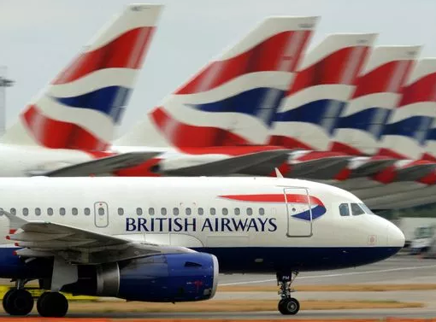
The route of the organisation can be found in the year 1919 when the organisation ‘Aircraft Transport and Travel Limited’ came into existence. In 1924 and 1936 the organisation called ‘Imperial Airways’ and ‘British Airways’ came into existence after some business merger process (British airways, 2017). Both the organisation was merged for the nationalisation process and become ‘British Overseas Airways Corporation’ (BOAC). BOAC then in the 70’s got merged with the “British European Airways’ to finally form the today’s BA. After this process the new entity became the flagship airways company for the British government. Over the years the process of merger and nationalisation helped the organisation to grow in the competitive aviation industry. Till 1987 the organisation is controlled by the government and the process of management was different compared to the recent operation after privatisation. The era of privatisation started in the BA in 1987 but in recent times the IAG or the ‘International Airlines Group’ took control of the organisation and made several changes to make it competitive and profitable (British airways, 2017). At the time of nationalised carrier the fund were provided by the government and the control provided the cost plus approach. The operational costs of the business were identified and then for the profitability the minimum expected return were added. These types of operational principles are the reason of loss making reason of BA before the privatisation. The heretical slow decision-making approach of the bureaucracy and no specific focus of the corporate also contributed in this process (Köthenbürger et al., 2006).The passenger amenities were not the priority but the welfare of the bureaucrats and staffs were the main focus.

Just before the process of the privatisation process Colin Marshall were given the change to change the organisational culture prepare the company for the privatisation process (Calder, 2012). In this turnaround story the perspective and culture of the organisation began to change. The staffs were asked to be customer centric through the tag line of ‘Putting people first’. The staffs of the organisation were specifically asked to follow this approach and spent time leading this new approach. This type of efforts that were introduced in the business helped to boost the confidence of the investors and at the time of privatisation and IPO release in the market the investors showed the confidence and the issues were oversubscribed (Calder, 2012).Different management approaches were also seen in involving the staffs of the organisation in this privatisation process where they were invited to participate in the process by investing.
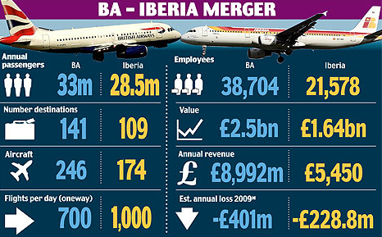
[Source: thisismoney.co.uk, 2010]
After the process of privatisation the organisation tried to expand its business and create competitive advantage in the market. In this process the preferred rout was the acquisition process. To expand the rout network the French ‘L’Avion’ and ‘British Caledonian airways’ were acquired (Tiernan et al., 2008). There were another significant challenge in the market and that is the low cost airlines as BA took the approach of premium service and premium pricing. In the year 2011 to significant merger announcement came with the Spanish low cost carrier ‘Iberia’ (Wearden, 2010). Now these two organisations operate in their separate brand name under the IAG group. This both premium and economic pricing approach oriented business targeting helped the business gain competitive advantage in the market. Another competitive advantage for the BA was the getting a base at the ‘Heathrow’ airport. As recent as up to 2008, BA used the terminal 4 of the airport for their base (London Heathrow Guide, 2017).In recent year Virgin Atlantic came up a one of BA’s strong competitor in the UK market as well as internationally. Before the process of privatisation BA was not focused on the customer service and there the Virgin Atlantic found out the opportunity and tried to address the customer needs in their operation. The competitive advantage of customer service helped Virgin Atlantic to gain market share first into the market. In the mean time the approach from BA to counter this bitter fight was unethical and that later cost the business financially and reputation wise also (Gregory, 2010).
In their operation and new growth approach BA was not successful all the time. For example, the acquisition of USAir resulted in selling in the year 1997 (Tiernan et al., 2008).But the push for the globalisation had seen significant changes in the market and one of them is the relaxation of the EU aviation market. These changes helped BA to further its expansion process. The financial crises of the 2008 were another significant change point in the history of BA. The bad economic time reduced the revenue and profitability position and there the business took the strategic step of more sustainable business approach (British airways, 2009). BA invested in their operation to further improve their position to become the top choice for the premium segment of the industry. BA shows more responsible approach in their business by improving their CSR approach with more focus on the staffs well fair, customer’s needs, less environmental impact generating and more fuel efficient operation, better waste management and so on. In the coming years the strategy helped the business and the growth customer number is the proof of that (Statista, 2016).

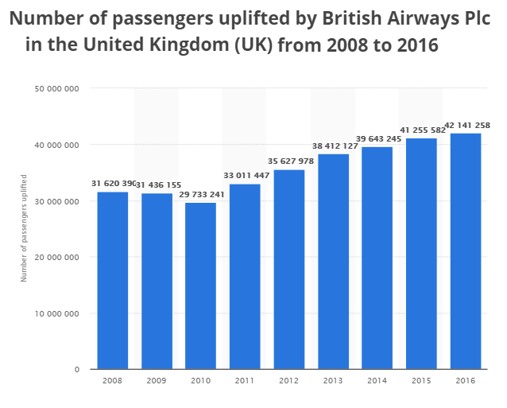
[Source: Statista, 2016]
In recent years the fuel cost has came down a lot through it is showing some upward movement now. In the aviation industry this aspect came as great boon. In 2016’s operation the IAG group shown around 65% up in their profit due to this advantage (Powley, 2016). BA is investing this easy profit for the customers. A £400m investment in the ‘Club world’ is one of that approaches. Other than that they are also investing lounge, security, technology like Wi-Fi and others (Media centre.british airways, 2017). All of this approach would improve the competitive position of the business in the market.

Part-B

Last five years BA’s operation analysis through financial key performance measures and its critical analysis

Ratios to measure the liquidity
There are different types of asset to the business organisation. Some are easily converted cash and some take times. The liquidity aspect of the business helps in understanding this position of the business as that enables the organisation to meet the obligations easily in the business (Chandra, 2011). BA is in the airlines industry. Here daily operation of the business needs lot of liquid type asset or cash. The liquidity ratios of the business show the information about the cash flow in the business and that helps in determining the solvency position.

Current ratio
The current liability of the business should get a balance from the current asset level of the business. This current ratio of the business is very usefull in that context to understand this position as this is the ratio of current asset and liability. The ratio can be expressed in term of percentage. The ratio shows a higher level of asset in the business when it is more than hundred percent as a ratio. Under this circumstance the business is able to fulfil the obligations which would have less than one year to meet (Madura, 2011). On the other hand the ratio less than hundred percent shows the opposite position of the business. The last five years of business operation of BA is showing a below the hundred percent current ratio. The figure is also showing a fluctuation where in one year it increase and the very next year drops. The best result is shown for the 2016’s operation. A further investigation shows that the liability of 2016 actually dropped from the previous year but the asset position has improved in contrast. So the improvement of 2016 much more significant not in term of ratio figure but also operationally.
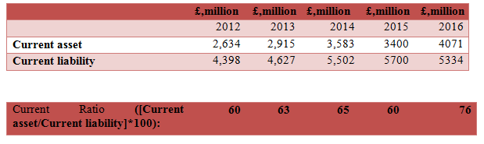

Quick ratio
This ratio provides more liquid position of the business. In this ratio the current asset position is further refined by subtracting the inventory position. Now the calculated asset is much more liquid and can be converted to cash easily. The quick asset ratio is supposed to drop from the current asset position. From the 60’s it dropped to 50’s as ratio percentage. Here also the ratio shows an improvement compared to current ratio (Higgins, 2012). But the ratio of 2016 did not dropped much and stands at 74%. The contrasting term in the year on year ratio improve can be justified from the declining inventory position of BA. So over the year the inventory management of BA improved and the business is able to keep more liquid level of current asset to meet the liability obligation.

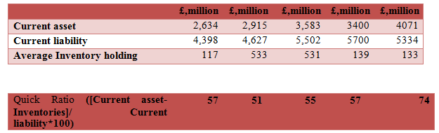

Profitability ratio
The profitability is one of the important aspects of any business. There was a time when the operations of business were not profitable in BA because of the business culture and priorities. After the privatisation process the customer centric, premium service quality approach made it profitable. In recent time the new long term business strategy and sustainable approach has improved the customer number in BA. The profitability ratio would help here to understand how the business is able to manage the expenses to make profit out of this improved customer position. Higher value of the ratios would be desirable for the business as it hows the higher profitability position of the business (Chandra, 2011). Ratios are not useful is only one figure is considered as it does not say much about the business and its operation. Here the comparison with the previous years of operation helps to understand the change and efficiency.

Margin for gross profit
This is profitable margin ratio at the gross profit level of the business. The basis calculation of this ratio is the net total revenue after subtracting the cost of goods sold and then dividing it by the total amount of revenue. In the revenue portion all the different type of incomes of the business is considered and not the only sales from the operation (Shapiro, 2008). Whereas the cost of goods sold takes the variable cost of the business into account. Here the fixed types of expenses in the aviation industry like the payment for new aircraft acquisition or other investment in the asset class. On the other hand the variable cost of the business is mainly the wages of the BA’s staffs, cost of material for the product and service delivery and so on. So a comprehensive picture may not come out of the gross profit margin but it would definitely show the profitability efficiency of BA at the operational level. The ratio can also be expressed through the percentage figure. The figures for the last five years operation of the business show a consistent improvement in the position year on year basis(Higgins, 2012). The margin for BA was lowest in the year 2012 at 3% level and highest in the year 2016 at 13% level. The reason of this efficiency can be further analysed from the analysis of the gross profit and the revenue figure of the business. The revenue over the year remained more or less stable around £11k ml mark but the gross profit figure of the business is increasing consistent manner with an average improvement of £300ml. It shows that business was able to improve its operational efficiency and able to control the variable cost of the business to increase the profit level over the years. There are two ways that the business can employ to improve the gross profit of the business one is the increase in revenue compared to cost structured and the improving the efficacy by reducing the cost of sales for a certain revenue number (Higgins, 2012). Here the efficiency approach is applied.
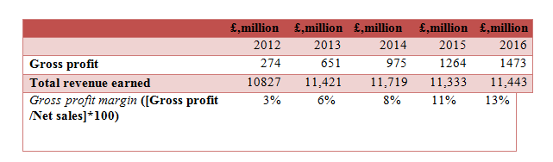

Ratio for efficiency
The efficiency ratio of any business shows how the business was able to manage its asset class for the generation of revenue in the business (Brigham and Houston, 2012). This is also termed as the activity ratio of the business. This ratio is strongly linked with the profitability of the business. More efficient business is able to generate more profit out of the operation. Aviation industry is highly capita intensive in nature and management of the business resources efficiently becomes important for the business.

Asset turnover
The ratio is arrived at by dividing the total revenue by total asset of the business. This ratio would provide the understanding of how BA is able to utilise its total asset classes in their business generate more revenue from the business (Madura, 2011). Higher the value of the ratio the better it is for the business. The ratio shows that over the years of operation the ratio gradually dropped. In the year 2012 it was at 0.91 and improved to 0.96 in the year 2013 but then began to drop. The lowest level is of the 2016’s 0.69. A further investigation would show that the revenue figure of the business did not improved much but remained the same. On the other hand the investment in the asset contentiously increased over the years but those were not able to produce more revenue for the business (Shapiro, 2008). This increasing investment in the asset creation and stagnant revenue level caused the decline of the ratio over the years for BA. New asset must have been created for the business competitive advantage development but that is taking time to generate more revenue for the business.
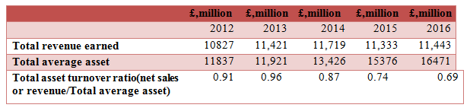

ROCE
This ratio is called the return of capital employed. The calculation of the ratio is done by dividing the EBIT by the capital employed in the business. Here the profitability of the business that is the EBIT (earnings before interest and tax) judged on the base of the total capital employed in the business. The ratio in the year 2012 was -0.01 and gradually improved from that position over the year and reached its highest position in the year 2015. The profit figure of the business through EBIT in the year 2012 negative for the business and brought down the ratio (Brigham and Houston, 2012). But from the next year onward the profit level of the business began to improve gradually and the ratio also improved. In 2016 the employed capital as well as the EBIT dropped from the 2015’s level but the profit dropped further than the employed capital and that reduced the ROCE to 0.10. The capital intensive sector like aviation demand more capital to be employed in the business for the operation and there the lower ratio cab ne expected but needs to be improved over the years.
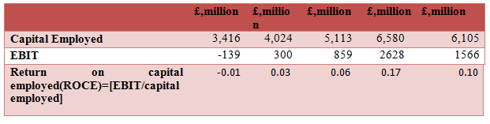

Gearing ratio
In this ratio the long term liability of the business is compared with the total employed capital. This ratio is very useful to understand the current capital structure of the business and the future requirements. This ratio provides a robust understanding about the debt finance of the business in comparison to the equity level in the business (Goel and Gangolly, 2012).The main focus of this ratio is the long term stability in the business finance through the liquidity aspect of the business is also analysed. The ratio dropped over the years. It started with 0.94 in the 2012 and reached to the lowest level of 0.57 of 2015 and that again rose in the 2016 to 0.73. The lower the number the better it is for the business. a detailed analysis reveals that the long term liability position of the business were increasing but dropped in the 2015 and rose again. But the ratio did not increased in similar fashion and the reason is that the increase in the retained earnings through the share capital of the business remains stable at £290ml. So in the business the role of debt fund increased but the overall dependency on the on debt capital reduced as the retained earnings increased (Brigham and Houston, 2012). This was a balanced approach form the BA and it made the business less leveraged. The lower leverage position of BA makes it more stable over the years and increases the sustainability and room for sudden requirement of using the debt instrument for the business operation. This approach is also less costly for the business also as the lower proportion of debt would attract lower level of interest payment (Goel and Gangolly, 2012).Low cost of capital would make the business more efficient. One the other hand the increase in the retained earnings is providing more strength to the business in term of the liquidity. All of these things is making the ratio favourable for the business in its five years of operation.
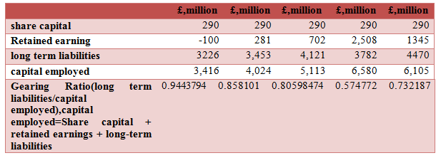

Explaining the change in the ratios during these past years

Profit margin ratio
The profit margin of the business has shown growth figure over the years. The gross margin of the business is understood from the cost of sale and the total revenue figure of the business (Chandra, 2011). In BA the success-based hub approach is followed where the travel rout increased by 33%. The increase in the customer number because of this approach is 40%, so the sales revenue one of the major part of the total revenue has seen steady growth in the business (Media centre.britishairways, 2017). This can explain the growth in the gross profit margin for the business is last 5 years of operation.

The net profit of the business is also showing a good growth in the business. In the year 2012 the negative net profit of the business are for different reason. In that year BA over all operation was good but other losses like the 13.5% loss share of the Iberia is added. £375 ml is the expenses incurred in the business because of the adverse pension charges (Investegate.co.uk, 2013). Loss in other associates was £66 ml. All of these things made a £139 ml loss even before the tax deduction. But in the same year the revenue of the business grown by 8.4% and the operating profit was at £233 ml(Investegate.co.uk, 2013). But because of the other circumstances the net profit of the business became negative. In the following year the situation were well managed. The net profit figure of the business again dropped from the 23% to the 13.5% in the year 2016 (Webcache.googleusercontent.com, 2016). The change can be explained from other factors. The gross profit has seen a improvement from the previous year’s figure. The fuel price were low in this years of operation and the rate of interest in the economy were also low that increased competition and scope for growth. But the impending referendum of Brexit was providing some uncertainty in the market (Busch and Matthes, 2016). The overall performance of the business actually was better than the 2015’s operation. Total revenue of the business is up by 1% and operational profit by 16.5%. But the net profit is down by 46%. In this part the gain of BA from the Avios group ltd deconsolidation is much higher in the year 2015 and that is almost by £1533 ml (Webcache.googleusercontent.com, 2016). This huge gain in the 2015’s operation has shifter the balance and the net profit margin of 2016 dropped compared to the2015’s operation. A close observation also revel the jump from the 2014’ operation to 2015’s and that 75 to 23% jump in the net profit margin is because of the additional gain from the Avios group ltd(Chandra, 2011).
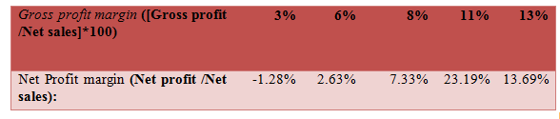

Liquidity ratio
The current ratio of the business is also showing a steady growth but the significant jump came in the year 2016. Here the current asset of the business has seen a significant jump through there is always a shortage of current asset in the business to meet its short term liability (Brigham and Ehrhardt, 2013). The businesses were in the expansion mode from the 2012’s operation as seen in the new route networking and more passenger inclusion. The entire needed fund to manage the working capital of the business, but the efficient management helped the business to keep the liquidity level of the business more or less the same. But the major improvement of the 2016 has some reason like the improvement in the cash and cash equivalent, interest bearing other current asset, trade receivables. On the other hand the current liability portion of the business has seen reduction in the ‘other and trade payable’, short term proportion in the long term borrowing, liability for financial derivative instrument (Chandra, 2011). The reduction in liability can be attributed to the lower fuel price and interest rate. All of these factors contributed in the improved current ratio figure for the business of 2016’s.

The quick ratio of BA also has the similar term but the jump in the year 2016 for the quick ratio is much significant. The primary reason for that is the much lower proportion of inventory in the current asset of the business (Higgins, 2012). The calculation inventory for BA includes the expendable for the aircraft, engine repairable part for the aircraft, spare part of the aircraft and the fuel component of the operation. So the overall current asset has increased in the 2016 but due to the lower fuel price the inventory value dropped from £139 to £133. On the other hand the 18 Boeing 747 aircraft interior refreshment program completions have also reduced the other inventory requirements for the business(Webcache.googleusercontent.com, 2016).This has helped in the improvement of quick ratio of the business in the 2016.
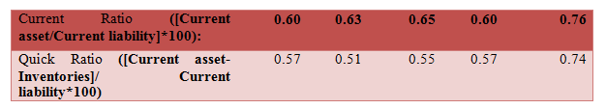

Efficiency ratio
In the ROCE the increase in the EBIT can be explained from the increment in the customer number that has happened during this five year period, as explained earlier. The improvement in the ratio is not significant for the business as the EBIT compared to the total employed capital figure of the business is very small (Brigham and Ehrhardt, 2013). The employed capital of the business is the investment done by the BA in their business operation for the desired functioning. The investment can be in the long term liability or the stocks. This is the valuation of total asset excluding the current asset of the business. The business in the five year period has invested in the new route network. The investment has also gone into the 4, 9, 15 and 19 numbers of Boeing 777s, A319s, A320s and Boeing 737s respectively (Media centre.britishairways, 2017). in the mean time BA has also under gone acquisition process where they acquired ‘bmi’ in 2011-2012 operation. All of these along with investment in the customer service and technology improvement investment have resulted in large investment in the business. All of these are the reason for the lower value of the ROCE.

On the other hand the ratio of asset to turnover were good at the beginning year of 2012 and 2013 but eventually dropped in the successive years. The earlier investigation showed that the stagnant revenue figure and increase in asset class is the reason. The above large size investment of BA for its sustainable business operation development has created large investment in the asset class. Over the years the drop in fuel price were slowly distributed to the customers. The increment in the customer number provided new source of revenue but that cannot balance the investment in business (Robinson et al., 2008).The significant drop of the 2016 is because of the unfavourable situation and business sentiment that reduced the business travel due to the Brexit referendum event and that slowed the revenue generation. The falling Pound has provided favourable situation for revenue generation (Busch and Matthes, 2016). The terrorist attract in the EU has also put pressure of the capacity of the market. All of these things impacted the revenue and that caused the further drop of 2016.

In the gearing ratio the long term liability figure is quite high because of the investment activity in the business (Higgins, 2012). Over the years the business was able to control the long term liability but that again increased in the 2016. Network development and investment in fleet increased in the 2016. 20 new destinations were added and also added 2 more Airbus A380s in the operation. 18 Boeing 747 aircraft refreshment programme also completed during this year. All of these things needed more fund in the form of long term liability. During this time the long term liability of interest bearing had increased from £4,020 to £4,745 (Webcache.googleusercontent.com, 2016). On the other hand the contribution to the employee benefit three folded from £602 to £1,960. Because of these reason the ratio of 2016 deteriorated further and the business became more leveraged during this year (Fraser et al., 2010).
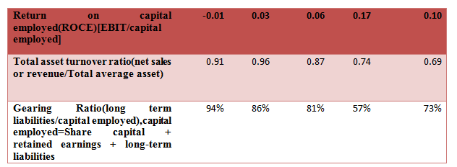

BA and Virgin Atlantic (VA) financial performance comparison

The comparison of the gross profit margin for these competitor companies provides two different pictures. In case of BA the trend is the gradual improvement whereas the figure for VA has seen initial up and then downward movement (Brigham and Ehrhardt, 2013). Here the size of operation for two competitors is different. The revenue figure for BA moves over the £10,000 ml figure whereas for VA the figure is above £2500ml to £4000ml. So considering the large size of the operation BA has better managed the gross profit of the business.

In case of net profit margin the performance of BA is much better in comparison to VA. The fluctuation in profitability is higher for VA. The profit level of BA has constantly risen over the years and in 2016 the EBIT reached to £1566mldropping from £2628ml level of a year ago. Comparing this with VA the peak profit was in 2016 at £385 ml. Drop for VA is sharp as in the 2016’s operation the EBIT is at £22ml level. So over the year VA improved the efficiency and cost control to show some improvement in the net profit margin in the midst of falling sale (Higgins, 2012). In case of BA the sales figure fluctuated but by one around 1% mark whereas the profitability improvement is significant over the years.

The current ratio is far better for VA compared to BA in the operation. For VA it reached highest level in 2013 then again dropped and came down to the BA’s level. BA was constantly improving the customer service, improving existing aircraft and so on. All of these were engaging lot more funds in the short term of the business and that kept the ratio below the 1. On the other hand the profitability was better for VA at the beginning years and that used to provide them good cash in their operation (Fraser et al., 2010).But the falling profit required more short term investment to improve customer service for revenue increment. So in the coming years the ratio dropped for VA.

The quick ratio also has shown the similar trend (Robinsonet al., 2008).But in the later years the improvement of quick ratio of BA improved much better. In the 2015’s to 2016’s operation, the ratio for BA changed from 0.57 to 0.74 and for VA from 0.68 to 0.77. Here BA managed their inventory much better and improved the current asset in comparison to current liability.

At the initial years the ratio of VA was much better than BA. But in the coming years of operation the ratio improved for BA much better (Fraser et al., 2010). Here the total asset position for both the organisation is significant. Over the years the total asset position of BA £11000ml to £16000ml whereas for VA it dropped from £4000ml to £1700ml and in the year 2014 it was at £196ml. On the other hand the EBIT figure gradually improved for BA and vice versa for VA. So total value and size wise also the management of BA is much better and the employed capital is much better used to generate profit from the operation.

The asset turnover ratio of VA is looking better compared to BA. Sudden drop in the average asset holding in the 2014’s operation of VA provided such 14.93 ratio. The average asset holding of VA dropped over the years. The sale figure has also dropped but that in comparison to the asset holding is much less (Robinson et al., 2008). The result is high value creation from the assets class hold by VA. On the other hand in case of BA the investment in business increased whereas the sales remained more of less the same. The ratio improved gradually but the efficiency of asset use is much better in case of VA.

The leverage position of the VA is having more fluctuation than the BA. The investment in the business for BA is much more for the long term sustainability of the business (Penman and Penman, 2007). Because of this reason more liability is incurred in the business but that figure never crossed the 100% mark. In case of VA it touched 100% mark once then again dropped to 13% level. Low level of gearing ratio for VA is providing lower risk for the business and room for future use of debt instrument for the business growth.

Future performance direction for BA
The above comparison of BA and VA shows different perspective of the sector. The volatility of the sector and high competitive environment can also be understood. In recent time the fuels price dropped and has limited chance of touching the last high in quick time. This fuel price advantage needs to be utilised in the future operation of the business (Healy and Palepu, 2012). The revenue growth of BA is sluggish and need to be improved as the business has invested lot in its customer service, technology improvement and business sustainability position. Considering this the revenue generation increment is necessary for the business. The world economic outlook is good under the current situation whereas the growth of UK is not reciprocating that. Considering this BA needs to put more emphasis on the internal operation for better return on its investment. On the other hand the initial uncertainty of the Brexit talk is over. The initial breakthrough of the talks appeared in the December 2017 and in the next step the trade agreement would go through (euronews, 2017). This situation would strengthen the Pound and that may take away the currency advantage for BA in their revenue figure (Busch and Matthes, 2016). On the other hand the trade negotiation needs to be monitored closely to take appropriate strategy in the business. VA is a customer focused company and tried to make that the main competitive advantage over the years. BA after privatisation also followed that approach and now provides premium service to the customer with premium pricing. Low fuel cost provide the unique opportunity to the business to attract customer from the below the premium segment with reduced cost of operation. All of the reasons are providing the higher revenue generation prospect for BA in their operation. The higher revenue with improved efficiency would increase the profitability prospect and better return from the employed capital and asset (Penman and Penman, 2007). The liquidity ratio of the business needs to be improved though the aviation industry needs more working capital to function.

Financial ratio and its pros and cons
The financial ratios are used to understand the business financial and operation positions. There are some advantage and disadvantage of these methods and those are discussed below.
Pros
The main financial information is developed from different account of the business to represent it with more clarity. The ratio helps in further simplification of that information. The approach is useful for the management of the businesses who have less time to engage deeply in the figures but have to take quick decisions in the business (Healy and Palepu, 2012). The ratios provides a quick glance and that helps in the decision making process. Mostof the personnel in the management would find this process easy to engage with. Like incase of BA the size and scale of operation is huge and that may overwhelmed people at the time of business financial health investigation. Under that circumstances the ratios parodies information in concise manner. But the ratio does not provide much value stand alone and there the benchmarking process helps (Whittington, 2008). Here the ratios of the business operation are compared with the competitors or the industry average. It could also be compared with the past years of business own operation to understand the change in the operation. The investigation of past five years of BA’s operation provided the image of the companies own activity financially. Further investigation of the business decisions revealed the change in the ratio and where the trend is going. On the other hand the comparison with the BA and VA provide a more comprehensive picture of BA’s operation with regard to market competition and environment. The size and scale of operation of the two organisations are different and that helped to understand how much efficient BA war in their operation (Subramanyam and Wild, 2009). After all of these analyses the understanding of future performance of BA is also projected and that will help in realising the full potential of the organisation.
Cons
The main disadvantage of the ratio analysis is the narrow vision of the process. Here the business functions, internal analysis, external analysis are not used at the time of operation in structured manner so the developed understanding is limited (Subramanyam and Wild, 2009). The approach may be highly useful for the investor to understand the business financial health and for the top management to take some quick decision. But developing the long term business strategy further investigation is required. The different in the accounting standard developed different type of result. Like the standard applied in VA and BA may not be the same and that would make fault in analysis. There are times when the information recoding is not done properly in the organisation and that provide false information (Whittington, 2008).So an in accurate information registration would make the process useless for the management and other stake holder for the understanding of the business.

Reference

Brigham, E. F., and Ehrhardt, M. C. (2013). Financial management: Theory & practice. Cengage Learning.
Brigham, E. F., and Houston, J. F. (2012). Fundamentals of financial management. Cengage Learning.
Britannica. (2017). British Airways PLC | History & Facts. [online] Available at: https://www.britannica.com/topic/British-Airways-PLC [Accessed 26 Dec. 2017].
Britishairways. (2009). Our strategy and objectives. [online] Available at: https://www.britishairways.com/cms/global/microsites/ba_reports0809/pdfs/Strategy.pdf [Accessed 26 Dec. 2017].
Britishairways. (2017). Explore our past | History & Heritage. [online] Available at: https://www.britishairways.com/en-gb/information/about-ba/history-and-heritage/explore-our-past [Accessed 26 Dec. 2017].
Busch, B., and Matthes, J. (2016). Brexit-the economic impact: A meta-analysis (No. 10/2016). IW-Report.
Calder, S. (2012). Lord Marshall: Executive who turned British Airways from a sleeping. [online] The Independent. Available at: http://www.independent.co.uk/news/obituaries/lord-marshall-executive-who-turned-british-airways-from-a-sleeping-giant-into-a-world-leader-7920614.html [Accessed 26 Dec. 2017].
Chandra, P. (2011). Financial management. Tata McGraw-Hill Education.
Chandra, P. (2011). Financial management. Tata McGraw-Hill Education.
euronews. (2017). Brexit talks breakthrough: What we know about the deal. [online] Available at: http://www.euronews.com/2017/12/08/brexit-breakthrough-what-we-know-about-the-deal [Accessed 15 Dec. 2017].
Fraser, L. M., Ormiston, A., and Fraser, L. M. (2010). Understanding financial statements. Pearson.
Goel, S., and Gangolly, J. (2012). Beyond the numbers: Mining the annual reports for hidden cues indicative of financial statement fraud. Intelligent Systems in Accounting, Finance and Management, 19(2), 75-89.
Gregory, M. (2010). Dirty Tricks: British Airways' Secret War Against Virgin Atlantic. Random House.
Healy, P. M., and Palepu, K. G. (2012). Business analysis valuation: Using financial statements. Cengage Learning.
Higgins, R. C. (2012). Analysis for financial management. McGraw-Hill/Irwin.
Higgins, R. C. (2012). Analysis for financial management. McGraw-Hill/Irwin.
Investegate.co.uk. (2013). FE Investegate |British Airways PLC Announcements | British Airways PLC: BA Annual Report and Accounts 2012. [online] Available at: https://www.investegate.co.uk/article.aspx?id=201303150900060517A [Accessed 27 Dec. 2017].
Köthenbürger, M., Sinn, H. W., and Whalley, J. (2006). Privatization experiences in the European Union. Mit Press.
London Heathrow Guide. (2017). Terminal 4 - London Heathrow Guide. [online] Available at: http://www.londonheathrowguide.com/terminal-4/ [Accessed 26 Dec. 2017].
Madura, J. (2011). International financial management. Cengage Learning.
Mediacentre.britishairways. (2017). British Airways - BRITISH AIRWAYS INVESTS TO BOOST CUSTOMER EXPERIENCE FOR ALL. [online] Available at: http://mediacentre.britishairways.com/pressrelease/details/86/2017-228/8421 [Accessed 26 Dec. 2017].
Mediacentre.britishairways. (2017). BRITISH AIRWAYS’ GATWICK GROWTH HITS DOUBLE FIGURES IN FIVE YEARS. [online] Available at: http://mediacentre.britishairways.com/pressrelease/details/86/2017-228/8454 [Accessed 26 Dec. 2017].
Penman, S. H., and Penman, S. H. (2007). Financial statement analysis and security valuation (p. 476). New York: McGraw-Hill.
Powley, T. (2016). Low fuel costs lift profits at British Airways owner IAG. [online] Ft.com. Available at: https://www.ft.com/content/38c54aea-dc68-11e5-98fd-06d75973fe09 [Accessed 26 Dec. 2017].
Robinson, T. R., Hennie van Greuning, C. F. A., Henry, E., and Broihahn, M. A. (2008). International financial statement analysis (Vol. 22). John Wiley & Sons.
Shapiro, A. C. (2008). Multinational financial management. John Wiley & Sons.
Statista. (2016). British Airways' UK passenger numbers 2008-2016 | Statistic. [online] Available at: https://www.statista.com/statistics/309349/british-airways-uk-passenger-numbers/ [Accessed 26 Dec. 2017].
Subramanyam, K. R., and Wild, J. J. (2009). Financial statement analysis. McGraw-Hill.
Tiernan, S., Rhoades, D., and Waguespack, B. (2008). Airline alliance service quality performance—An analysis of US and EU member airlines. Journal of Air Transport Management, 14(2), 99-102.
Wearden, G. (2010). British Airways and Iberia: How the merger partners stack up. [online] the Guardian. Available at: https://www.theguardian.com/business/2010/apr/08/british-airways-iberia-merger [Accessed 26 Dec. 2017].
Webcache.googleusercontent.com. (2016). British Airways Plc Year ended 31 December 2016. [online] Available at: http://webcache.googleusercontent.com/search?q=cache:-ttK5zPH7PcJ:phx.corporate-ir.net/External.File%3Fitem%3DUGFyZW50SUQ9NjYzMTY0fENoaWxkSUQ9MzcwNDUzfFR5cGU9MQ%3D%3D%26t%3D1+&cd=1&hl=en&ct=clnk&gl=in [Accessed 27 Dec. 2017].
Whittington, G. (2008). Fair value and the IASB/FASB conceptual framework project: an alternative view. Abacus, 44(2), 139-168.
thisismoney.co.uk. (2010). British Airways and Iberia confirm merger. [online] Available at: http://www.thisismoney.co.uk/money/markets/article-1692215/British-Airways-and-Iberia-confirm-merger.html [Accessed 28 Dec. 2017].

