Daniels Zelinskis (2104718)
Computer Networks and Cybersecurity
Network Programmability (ACCB5029)
Nitheesh Murugan Kaliyamurthy
University of Wales Trinity Saint David

Contents

1. Introduction 3
2. Task 1 4
2.1. What is Network programmability? 4
2.2. What is Network automation? 5
2.3. Automation frameworks and tools. 5
2.4. Automation of security and compliance policies 7
2.5. Application Programming Interface (API) 7
2.6. API Standards and architectures 8
2.7 API security and privacy 9
3. Task 2 10
3.1. Sandbox 10
4. Conclusion 11
References 12

1. Introduction

Network programming has grown in importance as a component of the network architecture in the modern digital world. Traditional manual network configuration, methods become inefficient and network programming becomes more popular due to benefits, such as reducing errors, simplifying, security, saving money and time. This report will focus on various aspects of network programmability, automation tools, API standards and architecture, and existing measures API security and privacy.

2. Task 1

2.1. What is Network programmability?

Network programmability is the ability to control, configure and manage networks using the software, and the software itself uses programming languages such as Python and JavaScript to combine such networking technologies as switchers, routers, firewalls etc. For automated and dynamic network, allowing administrators to quickly respond to changes and security threats. There are several different methods of methods of network programmability:
- Network Application programming interfaces (APIs): allows access and control network devices.
- Software Defined Networking (SDN): enables administrators to control their networks.
- Command Line Interface (CLI): Using command line tools to automating network configurations.
- Continuous Integration/Continuous Delivery (CI/CD): Set of automated processes such as Jenkins and DevOps.
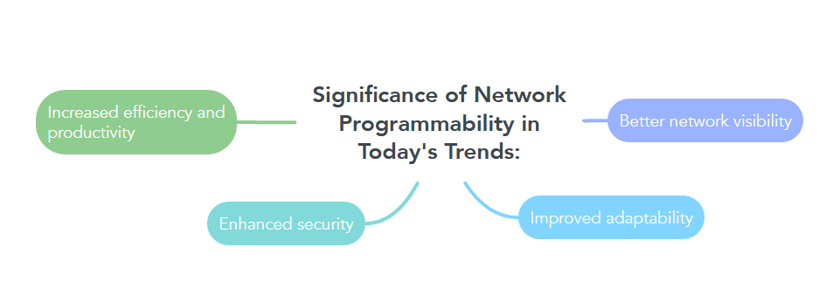
- To achieve network programmability and automation, these techniques may be used either separately or together.

2.2. What is Network automation?

Using software tools and frameworks to automate time-consuming and repetitive network processes is known as network automation. Basic network automation solutions transfer manual processes and activities to software programs that can repeatably and dependably finish them. The complexity of networks is one of the main forces for network automation.
Networks have grown more complicated because of the emergence of cloud computing, the Internet of Things (IoT), and other developing technologies, making manual configuration and maintenance practically unfeasible.

2.3. Automation frameworks and tools.

Automation frameworks give designers, developers, and maintainers a systematic way to create and manage automated testing.There are several kinds of automation frameworks, including hybrid, data-driven, and keyword-driven.

1.Data-Driven Testing Framework
Since the test data and script code are separated when using a data-driven framework, testers can store data externally. Very often, testers must repeatedly test the same application features using different groups of data.In such situations, it is important that test data is not difficult to encode in a script, as a linear or modular test system does.An external data source, such as Excel spreadsheets, tables, and other files, can be used to store and send input and output values to test programmes by setting up a data-driven test framework.
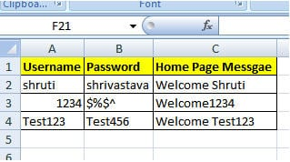
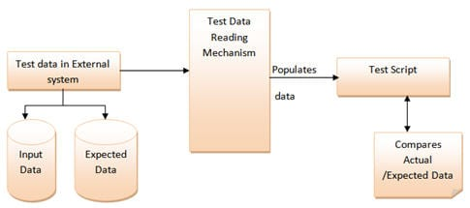
The test scripts are instructed to receive and update the required data when necessary and are linked to the external data source.
Fig.1. Data Driven Testing Framework Schema [1] Fig.2. Data Driven Testing Framework Example [1]

2. Keyword-Driven Testing Framework
The keyword-driven testing framework, which is frequently regarded as an outgrowth of the data-driven testing framework, collects your test data from an external source and securely keeps the set of codes.
These symbols, which are also known as "keywords," can be used to change the test routine and draw additional conclusions from the test framework.
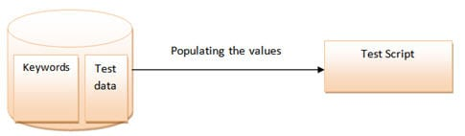
Additionally, these terms basically determine what tasks each application performs.
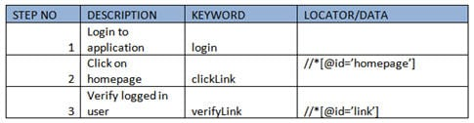
Fig.3. Keyword-Driven Testing Framework Schema [1] Fig.4. Keyword-Driven Testing Framework Example [1]

3. Hybrid Testing Framework
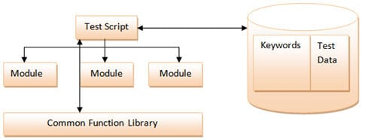
As the name suggests, hybrid framework connects platforms among themselves, overlapping them, taking advantage, and removing disadvantages for the best test results.
Fig.5. Hybrid Testing Framework Schema [1]
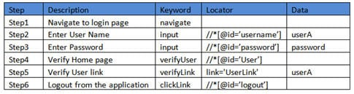
Fig.6. Hybrid Testing Framework Example [1]

A tool that will enable the tests to be executed is required when creating the tests in code. A testing framework provides a straightforward way to create and execute individual tests, though it is also possible to write all the tests as a single command-line program that runs them sequentially and shows the results. Then let you view the list of tests, run them, and determine which ones succeeded and which failed, either from a command line or a GUI tool. Normally, there is a choice of which tests to run: all, a selected set, or a filter by several characteristics.

Testing frameworks are frequently created with unit tests in mind, but they also perform well for integration and system testing. By "unittest framework," a phrase typically used to refer to various technologies. JUnit and TestNG for Java; MSTest, NUnit, and xUnit for.Net; the built-in unittest framework and py.test for Python; and the two most popular frameworks for JavaScript, Jasmine and Mocha.
The market is filled with both well-known and obscure automation test tools such as Puppet, Chef, Ansible, Selenium, Appium, Protractor, The Cucumber, Ranorex Studio etc. These tools contain a variety of common features as well as uniqueness for different types of users, although some of them might not be appropriate for all.

2.4. Automation of security and compliance policies

Securing the data plays an indispensable role in the management and enforcement of security and compliance. This process allows to ensure safety for various tools and not only, monitoring and identify possible risks. There are several advantages to automating security and compliance policies, including improved efficacy, reduce errors, reproduce activities with more accuracy and detect failures throughout relevant processes.
Data vulnerability issues can be avoided through SSH and TLS, it provides encryption and authentication between the source and target machines and VPN which stores all traffic on the network, also there is different Authentication types, single-factor (SFA), two-factor (2FA) and multi-factor (MFA)

2.5. Application Programming Interface (API)

An Application Programming Interface (API) is a set of defined rules that enable different applications to interact with each other. Uses common web-based interactions or communication protocols, allowing to request network services, such as routing, switching, and receiving responses. APIs are designed to be used by other applications programmatically.

To convert data structures to format, there are data serialization languages: JSON, YAML and XML. The most popular is JSON because human-readable text, which is lightweight, requires less coding, and processes faster.

2.6. API Standards and architectures

Simple Object Access Protocol (SOAP) is a way to transfer data in XML format between applications. The SOAP messages consist of an Envelope element, header, and body and use a request-response model, the client sends the request to the server, and the server processes the request and sends it back in the same fashion. The header itself provides extensions for processing the message information, and the body contains the payload for receiving and sending it.
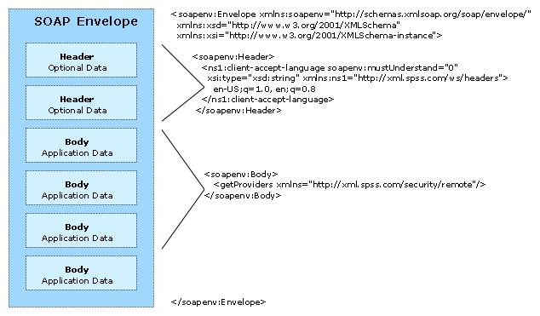
Remote procedure calls (RPCs) are what SOAP is and are sent via HTTP.
Fig.7. Hybrid Testing Framework Example

The software architecture known as Representational State Transfer (REST) lays out requirements for how an API must operate and is scalable, simple, and modifiable. In the beginning, REST was developed as a set of rules to control communication on a complicated network like the internet, but nowadays it communicates over HTTP, uses the same concepts protocols: requests, responses, verbs, status codes, headers/body which allows client to request the server functions.

REST API – Requests
- Uniform Resource Locater (URL)
- HTTP Method
- Header
- Body
REST API – Responses
- HTTP Status
- Header
- Body

2.7 API security and privacy

REST APIs need authentication to prevent unauthorised users from accessing, creating, updating, or deleting data. There are many ways to protect, API KEY, Bearer authentication and basic authentication by protecting data in the form of username:password encoded Base64. Also, there is a rate limit method that allows to control the number of requests to server to avoid congestion and protect against attacks like the Denial of Service attack (DoS

3. Task 2

3.1. Sandbox

What is a Sandbox?

Sandboxing works by isolating potentially harmful software or dangerous code from the organization's environment overall. It may be securely evaluated in this manner without endangering your operating system or host devices. Threats can be proactively eliminated if they are discovered. Security teams may do sophisticated malware analysis using a network sandpit by enabling suspect files to operate in a separate environment that mimics an actual end-user operating system.
The benefits of Sandbox:
- Allow to test software and do changes before posting.
- Does not have any risk to your operating system and devices.
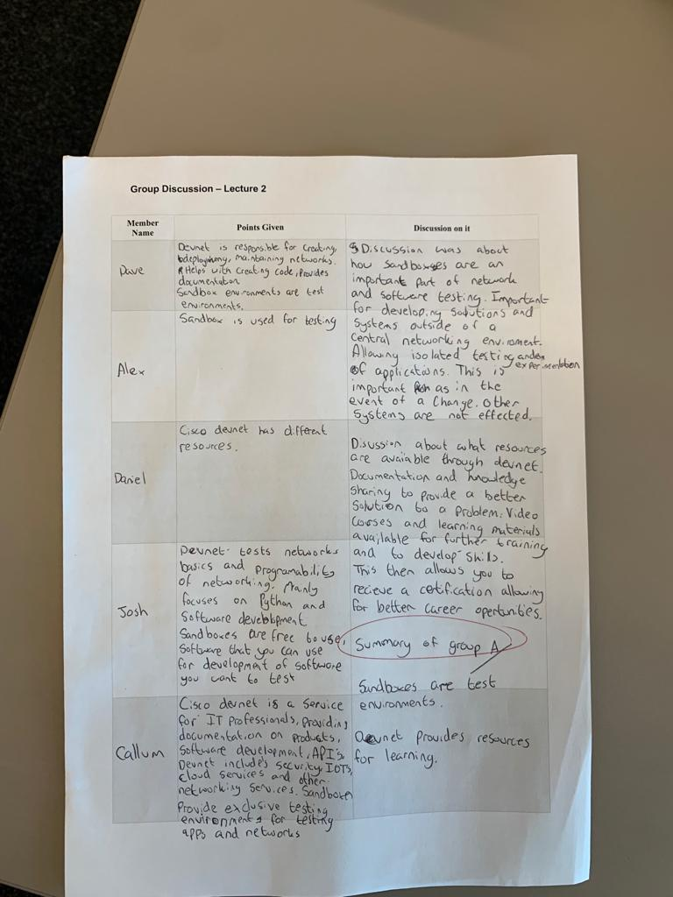
- Various Security.

4. Conclusion

In conclusion, network programmability shows evolving opportunities for structures and organisations to improve their network management procedures and compete in the automated world of today. Finding the appropriate automation tool is one of the crucial elements in any test automation project's success.

References
[1] Most Popular Test Automation Frameworks with Pros and Cons of Each – Selenium Tutorial #20. (2023, March 17). Retrieved from softwaretestinghelp: https://www.softwaretestinghelp.com/test-automation-frameworks-selenium-tutorial-20/
Badkar, G. a. (2023, 9 March). Popular Test Automation Frameworks. Retrieved from browserstack: https://www.browserstack.com/guide/best-test-automation-frameworks
Bajaj, H. (n.d.). CHOOSING THE RIGHT AUTOMATION TOOL AND FRAMEWORK IS CRITICAL TO PROJECT SUCCESS. Retrieved from infosys: https://www.infosys.com/it-services/validation-solutions/white-papers/documents/choosing-right-automation-tool.pdf
Froehlich, A. (2017, December 11). APIs and Networking: 3 Use Cases. Retrieved from networkcomputing: https://www.networkcomputing.com/networking/apis-and-networking-3-use-cases
Isreal, A. A. (2018). Complete Guide to Test Automation: Techniques, Practices, and Patterns for Building. Arnon Axelrod.
Jason Edelman, S. S. (2018). Network Programmability and Automation. Sebastopol: O’Reilly Media, Inc.
Lawitzke, J. (2019, August 20). Network Programmability: The Enabler of Innovation. Retrieved from tail-f: https://www.tail-f.com/network-programmability-the-enabler-of-innovation/
Ltd., C. P. (2003-2020). What Is Sandboxing? Retrieved from checkpoint: https://www.checkpoint.com/cyber-hub/threat-prevention/what-is-sandboxing/
Simple Object Access Protocol. (2021, 03 March). Retrieved from ibm: https://www.ibm.com/docs/en/sc-and-ds/8.1.0?topic=stack-simple-object-access-protocol
Singh, G. (2022, November 25). What is Network Programmability and Different Types of Methods for It? Retrieved from networkingsignal: https://www.networkingsignal.com/network-programmability-detail-explained/

