
October 16, 2022

Nikola Chakrakchiev
Student ID: 2029324
Course name: BA Business Management
Module: Management Economics (LCBB5003)
Lecturer: Vasilios Tavlaridis
Definitions and Evaluation
of
the Types of Market Structure
and
Their Effect on
Managerial Decisions

CONTENTS
INTRODUCTION 3
PERFECT COMPETITION 3
MONOPOLY 4
MONOPOLISTIC COMPETITION 5
OLIGOPOLY 7
DUOPOLY 8
CONCLUSION 8
REFERENCES 9

INTRODUCTION
There are different types of markets in respect of ease of entry and exit, freedom of operation, number of competitors, price setting, product variations, and freedom of access to information on the products. To clarify the term – “an industry, sector or market can be defined as a group of firms that produce close substitutes, whether goods or services” (Griffiths, 2011, p. 164)
There are five market structures. They are the Perfect competition market, Monopolistic competition, Oligopoly, Duopoly, and Monopoly. Figure 1 shows the various market structures as a spectre starting from the one that is defined by a big number of firms, free access, and ease of operation and ending with the monopoly of one firm, where the said firm is associated with the market itself (Griffith, 2011, p. 163).


Figure 1. Market structures on the scale from perfect to monopoly (Griffiths, 2011, p. 164)

PERFECT COMPETITION
A market has the structure of perfect competition where many buyers and sellers are participating, the firms in the sector produce identical products, all buyers and sellers have access to perfect information, transactions are performed with no additional cost and everyone is free to enter and exit the market (Baye & Prince 2016, p.230).
The fact that numerous sellers offer the same homogenous product and the participants in the market possess the perfect information about the product guarantees that no single market player can impact the product's price (Baye & Prince 2016, p.230). On the contrary, if one of the firms tries to sell at even a slightly higher price than the competitors, the customers will buy from the competition, where the price is lower because the customer is well informed and knows that the competitive firms sell identical products that can perfectly substitute each other. This defines one common price for the product by all sellers and this price is set by the interaction of all the participants in the market (Baye & Prince 2016, p.230).
Since there are no obstacles for companies to enter or exit the market, it is very easy for new firms to enter it if they receive economic benefits, and they are free to leave at any moment if they experience losses (Baye & Prince 2016, p.230).
The demand curve for this market is visualised in Figure 2. The higher the price, the lower the demand, i.e., the price is “perfectly elastic” (Baye & Prince 2016, p.231). The price defined at the point of interception between the demand and supply is constant (Figure 2 – left-hand side graphic). Firms must simply set the price at which everyone else is selling; after that, they must just calculate the output needed for the desired profit. The right-hand side of Figure 1 shows the demand curve from a firm’s perspective (Baye & Prince 2016, p.231).
In the long run, the profit for the companies in perfect competition is zero (Samuelson and Marks, 2014).
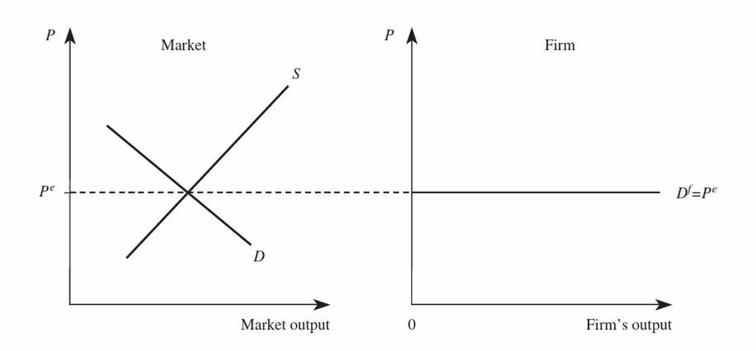
Figure 2 Demand and supply in the conditions of perfect competition (Baye & Prince 2016, p.231).

It is very hard to find examples of perfect competition markets in real life. One market that is as close as possible to perfect competition is the grain market in Ghana. In some regions the wholesalers do not cluster together to control the market, they, the assemblers, and the commission agents work separately and buy the crops from the farmers. There are many farmers and they are selling at relatively the same price as their competitor farmers. If they rise their price, the buyers will just go to the next producer. However, the market is often distorted by the collaboration among wholesalers (Langyintuo, 2010). This work will study this case study in the Monopolistic competition section.

MONOPOLY
On the opposite side of the spectre is Monopoly. This type of market is defined by only one company that Is synonymous with the industry (Samuelson and Marks, 2014). Usually, the lack of competition is a function of very high set bars for the entry of new players (Sloman, 2019, pp. 113).
Figure 3 visualises the relation between the demand, the output and the price of a monopolistic market. Since the industry is the firm, the industry demand curve falls into the company demand curve.
To maximise its profit, the company has to make sure that its marginal revenue matches the marginal cost of the product. It is shown in Figure 3 as Q_{m}, where the monopolist’s marginal revenue and marginal cost curves intersect. The industry demand curve sets the price at the level of P_{M}. The area between P_{M} and AC represents the excess profit of the monopolistic company in terms of price and volume (Samuelson and Marks, 2014).
As mentioned earlier, the monopoly is more often caused by high barriers of entry for new players, but it is sometimes caused by the economics of scale, where the market is so scarce that it cannot sustain more than one firm in it (Samuelson and Marks, 2014).
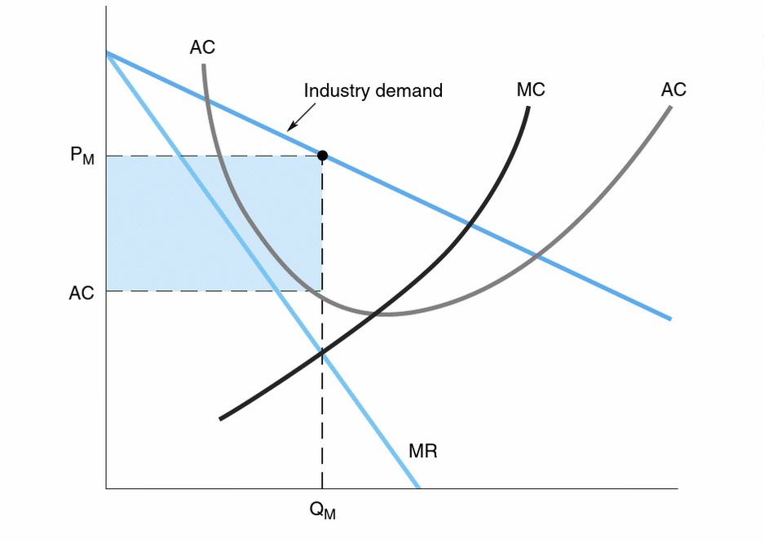
Figure 3. Optimal price and output of the monopolistic firm (Samuelson and Marks, 2014, pp. 245)
Other barriers before potential competitors are: requirements for certain initial capital (Samuelson and Marks, 2014); quality-to-price ratio unreachable by the newcomers (Samuelson and Marks, 2014); there is the option of an optimal product differentiation, when the only company on the market has marketed its product to the extent that it is associated with the industry (Samuelson and Marks, 2014) – in Bulgaria, “pampers” is the word for children’s absorption panties; another barrier may be that only one company has control over the resources required (Samuelson and Marks, 2014); other barrier is some kind of patent – the American Rexair LLC holds the patent for their “separator” that allows them to market their vacuum cleaners as the least air-pollutant vacuum-cleaners in the world (Rexair, 2022); strategic barriers is another obstacle for newcomers in the industry – the Bulgarian BDZ LTD was the only company performing railway transport of people in Bulgaria up until 2019, when the Bulgarian government accepted a change in the law and allowed other companies to compete with the state-owned transport company (Banker, 2019).
Another example of monopolies were the electric distribution networks, that in many countries were state-owned companies and therefore sanctioned as the sole and only providers of the services in their respective countries. However, during the last decades, these companies were privatised and the market was deregulated to create competition (Samuelson and Marks, 2014).

MONOPOLISTIC COMPETITION
This market structure type is also known as 'imperfect competition' (Griffiths, 2011). It resembles the competitive market structure to the extent that it consists of numerous small competitor firms and entering and exiting the industry is free of obstacles (Griffiths, 2011). However, this exhausts the resemblances to the perfect competition market. The other characteristics of this market structure are that the firms are developing more or less differentiated products, which renders them non-homogenous and thus – they do not appear the perfect substitution for the rivalling product (Griffiths, 2011). In other words, the new entries in the industry rather than merely increasing the output of a homogenous product, introduce a differentiated product and along with that, they draw some of the demand from the earlier firms to themselves (Griffiths, 2011). This process is visualised in Figure 4 (a) with the shift of the demand curve to the left (decrease in demand). While the demand defines the excess profit locked in the P_{S}VCW area (Figure 4 a), there will be an inflow of new firms in the market. Whenever the demand shifts right of D’ (Figure 4b), some of the firms in the market will leave it, and the entry of new firms will cease before the demand shifts back to the right. After that, the market will be open for new entries again (Griffiths, 2011).
In comparison to the perfect competition market structure, the imperfect competition supposes that if a seller lowers their price below the competitor’s price, they will draw some of the competitor’s buyers, but not all, and if they slightly increase their price, they will lose some buyers to the competition, but, again, not all. Here important role plays loyalty to the brand (Griffiths, 2011).
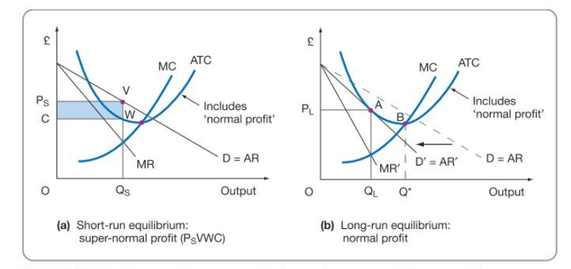
Figure 4. Equilibrium in monopolistic competition market structure (Griffiths, 2011, pp. 181)
In the long run, the monopolistic competition allows “only normal profits” (Griffiths, 2011). Griffiths (2011) argues that in respect of productive efficiency, imperfect competition does not allow productive efficiency (Figure 4b – at A ATC is higher than at B, where the lowest possible technical level is).
Unlike perfect competition, the price is higher and the output is lower (Griffiths, 2011). And since the output is lower than it should be for minimum ATC (Figure 4b), it is fair to say that the monopolistic competition market is characterised with excess capacity (Griffiths, 2011). Finally, Griffiths (2011) specifies that in the long run, allocative efficiency in imperfect competition is not achieved, too. The reason for that is that the marginal cost is lower than the price (Griffiths, 2011).
Examples of monopolistic competition can be found in several markets. One of them is the mentioned earlier Ghana maize market. Wholesalers in some regions in Ghana collaborate with each other and decide the distribution quantities of grain among the regions, thus controlling the price of the maize, and keeping it within higher limits (Langyintuo, 2010). Whenever they receive the information that some independent seller is about to reduce the prices in some region, they limit the distribution to that region, thus increasing the demand and the price, respectively (Langyintuo, 2010).

OLIGOPOLY
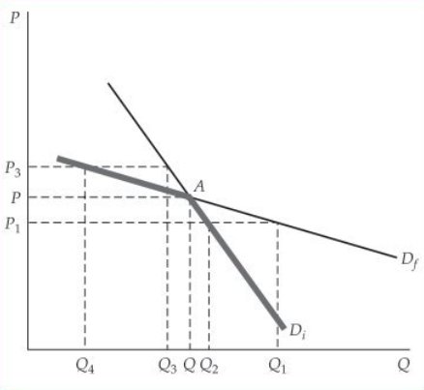
To consider a given market an Oligopoly it has to be composed of a few large companies. They must be more than one (otherwise it will be a monopoly) but don’t usually exceed ten (Baye & Prince, 2016, p.271). The products they sell don’t have to be identical, they may be differentiated. If the companies in the industry are only two (Baye & Prince, 2016, pp.271). The specific thing here is that if the oligopolistic industry is composed of only two competitors, the market structure is called a duopoly.

Figure 5. Change in demand in the conditions of Oligopoly at price increase/decrease (Keat, 2006, p. 394)
Scholars agree that the firms operating in an oligopoly are strongly interdependent (Baye & Prince, 2016, p.271; Caves & Porter 1978). Baye and Price (2016) make note that there are several models of oligopolies rather than a single one, and Caves and Porter (1978) argue that the reason for that is this same interdependence among the players.
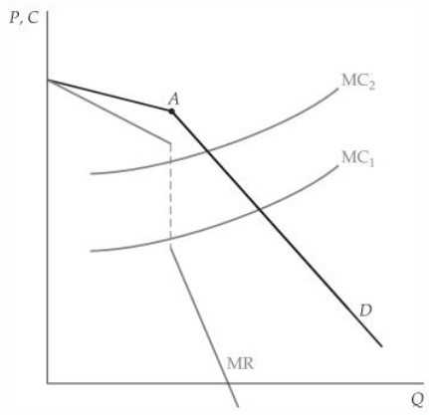
Figure 6. Kinked demand curve and a revenue curve (Keat, 2006, p. 395)

Any managerial decision reflects not only on the firm it was taken in but impacts the relevant market as well (Baye & Prince, 2016, p.271). Keat (2006) explains this with Paul Swezy’s kinked demand curve model. When one of the oligopolists on the market decides to lower the price aiming for higher sales – D_{f} on Figure 5. However, this price drop is usually followed by the other few companies on the market and instead of gaining more sales, the bold oligopolist who dropped the price first gains only lower profit, because the demand curve bends to D_{i} – sales are still higher, but not as expected. In contrast, if the oligopolist decides to increase the price and no competitor follows suit, the sales decrease, but not according to the D_{i} curve, but according to the D_{f} curve. The kinked demand curve is visualised in bold in Figure 5.
Having this information, it is possible to define the revenue curve. Figure 6 shows a change in marginal cost from MC1 to MC2, but the oligopolist will not change its price as long as the kink stays at point A.

DUOPOLY
Samuelson and Marks (2014) mention a Duopoly as an Oligopoly consisting of just two rival firms. Stigler (1940, p. 521) defined Duopoly as “the market situation in which there are two independent producers who do not explicitly agree on a common policy with respect to output, price, advertising, wages, and all other variables subject to their control.”
Stigler (1940, p.521) points out that the closest to maximum profit the duopolists can achieve is by being in agreement with their rival, i.e., to form a cartel organisation. Judging from the prices in duopolistic industries, American duopolists tend to avoid rivalry (Stigler, 1940, p. 521). However, the rivals are rarely able to achieve an agreement on all important policies (Stigler, 1940, p. 521). For example, if one of the rivals are producing a superior in quality product, thy are bound to be the first to suffer losses, in some cases, they even leave the industry at a price change, or change in quality with the rival firm (Crampes and Hollander, 1995, p. 71).
Google and Apple are duopolists in the mobile apps industry. Nuttall (2021) cites the Competition and Markets Authority of Britain: “Because Apple and Google control the way that browsers perform on their devices; and also set the terms for access to their app stores for native apps, they can limit competition from third parties in various ways,” (Nuttall, 2021)

CONCLUSION
In the spectre of market structures, there are five that highlight themselves. That are Perfect competition, Monopolistic competition, Oligopoly, Duopoly, and Monopoly. In this order, the market structures represent the transition from a free market with multiple participants, through more regulated markets with fewer and fewer players, up to a totally regulated monopolistic market. It is clear that even the most heavily regulated monopolistic markets have restrictions on profit created by the market demand. It is also clear that if the firms participating in the market have not illegally entered cartel agreements, they are still competitors and distance themselves from setting monopolistic margins.

REFERENCES
Banker (2019) ‘BDZ is set apart from its monopoly’, Banker, 22nd February. Available at: https://www.banker.bg/upravlenie-i-biznes/read/bdj-se-razdelia-s-monopola (Accessed: 13 October 2022)
Baye, M. & Prince, J. (2016), Managerial Economics and Business Strategy, New York: McGraw-Hill Higher Education. Available from: ProQuest Ebook Central. (Accessed: 29 September 2022).
Caves, R. and Porter, M. (1 978) Market structure, oligopoly, and stability of market shares. The Journal of Industrial Economics, pp.289-313.
Crampes, C. and Hollander, A. (1995) 'Duopoly and quality standards', European Economic Review, 39 (1), pp. 71-82
Griffiths, A. (2011) Economics for business and management. Third edition. Harlow, England :, Pearson Education Limited.
Keat, P. (2006) Managerial Economics: Economic Tools for Today's Decision Makers, 7th edn. Pearson Education.
Langyintuo, A.S. (2010) Grain distribution in Ghana under imperfectly competitive market conditions (No. 308-2016-4971, pp. 1-21).
Nuttall, C. (2021) ‘UK regulator tackles Apple and Google mobile duopoly’, Financial times, 21st December. Available at: https://www.ft.com/content/5ad7c6c2-3a57-4255-8aa5-0e3de00799b1 (Accessed: 15 October 2022)
Rexair (2022) Patents. Accessible at: https://rainbowsystem.com/patents/ (Accessed: 13 October 2022)
Samuelson, W. and Marks, S. (2014) Managerial Economics, New York: Wiley Textbooks. Available at: ProQuest Ebook Central. (Accessed: 13 October 2022).
Sloman, J. (2019) Economics for business [electronic resource] . 8th edn. Harlow: Pearson.
Stigler, G. (1940). Notes on the Theory of Duopoly. Journal of Political Economy, 48(4), 521–541. Accecible at: http://www.jstor.org/stable/1825484 (Accessed: 15 October 2022)

