Max Smith
1810364@student.uwtsd.ac.uk
True Word Count: 2613
Instrumentation and control
Control System Design
Abstract
In control law you start with a plant, this is the system that we are wanting to control, or the system whose behaviour we want to affect. The input into the plant is the actuated signal and the output is the controlled variable. Different industries refer to these signals by various names i.e. plant input and plant output. Regardless of the term used, the basic idea of a control system is to figure out how to generate the appropriate actuated signal so that the system will produce the desired controlled variable. In feedback control the output of the system is fed back and compared to the command variable to determine how far off the system is from where it needs to be. The difference between the two is the error term. If the output was exactly what was required then the error would be zero, which is what is wanted, zero error. A controller is used to convert the error term into suitable actuator commands so that over time the error can be driven to zero.
Table of Contents
1 Table of Figures 2
2 Abstract 3
3 Introduction 5
4 Method 7
4.1 Simulation 7
4.2 Experimental 7
4.2.1 PID Controller 8
4.2.2 PIDF Controller 10
4.3 Root Locus 14
4.4 Damping 14
4.5 Nyquist Plots 15
5 Results 16
5.1 Simulation Results 16
5.2 Experimental Results 17
5.3 Root Locus Results 18
5.4 Nyquist Results 22
6 Discussion 24
7 Conclusion 25
7.1 Summary 25
7.2 Recommendations 26
8 References 27
9 Appendix 28
9.1 Full Image of Figure 15 28

Table of Figures
Figure 1 - System Design for a Closed Loop System 7
Figure 2 - System Layout for PID Controller 8
Figure 3 - Forward Path Transfer Function Layout 9
Figure 4 - PID Transfer Function for Closed Loop System as a Whole 10
Figure 5 - System Layout for PIDF Controller 11
Figure 6 - Forward Transfer Function for PIDF Controller 13
Figure 7 - PIDF Transfer Function for System as a Whole 14
Figure 8 - MATLAB data for Nyquist Plot 15
Figure 9 - Untuned Response PIDF Steps 16
Figure 10 - Untuned Response PIDF Simulink 16
Figure 11 - Tuned Response of PIDF Steps 16
Figure 12 - Tuned Response PIDF Simulink 16
Figure 13 - Parameters of Tuned PIDF Controller 17
Figure 14 - PID Response from Transfer Function of System as a Whole 17
Figure 15 – Close-up of Original Tuned Trace and Whole System Trace for PID 17
Figure 16 - PID System with Transfer Function of System as a Whole 18
Figure 17 - PIDF Response from Transfer Function System as a Whole 18
Figure 18 - Close-up of Original Tuned Trace and System as a Whole for PIDF 18
Figure 19 - PIDF System with Transfer Function of System as a Whole 18
Figure 20 - MATLAB Character Definitions for Root Locus 18
Figure 21 - MATLAB Characteristic Equation for Root Locus 18
Figure 22 - Root Locus Plot for the Transfer Function of the Closed Loop System 19
Figure 23 - Pole-Zero plot of the Transfer Function for the Closed Loop System 20
Figure 24 - Close-up of Poles and Zeros nearest the origin 21
Figure 25 - Close-up on one of the Conjugate Pairs by the Imaginary Axis 21
Figure 26 - Nyquist Plot 22
Figure 27 - Nyquist Plot with Unit Circle applied 23
Figure 28 - Parameters of Tuned PIDF Controller 23
Figure 29 – Bode Plot for Transfer Function of the Closed Loop System as a Whole 24

Abstract
In control law you start with a plant, this is the system that we are wanting to control, or the system whose behaviour we want to affect. The input into the plant is the actuated signal and the output is the controlled variable. Different industries refer to these signals by various names i.e. plant input and plant output. Regardless of the term used, the basic idea of a control system is to figure out how to generate the appropriate actuated signal so that the system will produce the desired controlled variable. In feedback control the output of the system is fed back and compared to the command variable to determine how far off the system is from where it needs to be. The difference between the two is the error term. If the output was exactly what was required then the error would be zero, which is what is wanted, zero error. A controller is used to convert the error term into suitable actuator commands so that over time the error can be driven to zero. [1] [2]
An example would be designing an altitude controller for a quadcopter drone. The drone has four propellers and when they all spin up together, they produce a force that lifts the drone into the air. Let’s say the system is requires the drone to hover at 50m. The plant is the drone, the output is the altitude and the input is the propeller speed.
A proportional controller would see an error state of 50m, which means it would generate a high propeller speed causing the drone to lift and rise to reduce the error. Once the drone reaches 50m and the error is 0, the propellers would stop and the drone would fall, resulting in the error state increasing and the propellers spinning up to compensate.
There is a certain propeller speed where the lifting force is exact to the weight of the drone, at this point it would hover, this being dependant on the variable of the gain. Let’s assume the propellers need to spin at 100rpm to hover, and the gain was 2. Then the drone would hover at ground level. Since error x gain = propeller speed, the required rpm, would be met. However, if increased to a gain of 5, the drone would rise and stop at 30m, since the error at that point would be 20, and again the rpm would be met. A gain of 10 would produce an error of 10m and a gain of 100 would produce an error of 1m. No matter the increase in gain, the error won’t disappear, it will just get smaller with the system and a proportional controller. A proportional controller does not work in every situation, as it can create a steady state error.
To break the steady state error the controller needs to look at past information, or more specifically the addition of an integrator path alongside the proportional path in the controller. An integrator totals the input signal over time keeping a log of it, meaning it has memory of what has happened previously. If the drone gets to the steady state below the required altitude, the error term becomes nonzero and when a nonzero value is integrated the output increases. If there is error in the system, the integral output will continue to change, and this increased value from the integrator path will increase the speed of the propellers and the drone will continue to rise. The integral and proportional paths work together to drive the error state down to zero and get the drone to the desired altitude. The PI controller understands the present situation and past events; however, this is not always the best scenario. Just before the desired output is achieved a situation can occur, where the proportional path is near on zero because the error signal is so small, but depending on how the drone got to the height, the integrator path may have totalled a value greater than 100rpm. This would cause the drone to keep rising, and to remove the excess propeller speed the drone would have to go higher than the desired output resulting in a negative error being created. The negative error when summed up would lower the output of the integrator and slow down the propellers. This overshooting is not always desirable in a system.
To get over this issue another path needs to be added to the controller to predict the future and respond to the closing in on the required output. This is done with a derivative. A derivative produces a measure of the rate of change of the error, in that how fast the error increases or decreases. If the drone was rising quickly and fast approaching the target output, this means that the error is quickly decreasing, that decreasing error has a negative rate of change which produces a negative value through the derivative path. The negative value would be added to the controller output therefore reducing the propeller speed. In short it is looking at the current rate of change of error, determining the approach to the system target and acting in advance to prevent overshoot. This is a PID controller. It is a versatile controller that uses present error, the past error and a prediction of future error to calculate the appropriate actuator commands.
Each pathway contributes some amount to the overall output of the controller. Determination of contribution as the control system designer can be adjusted by changing the values of each path in terms of Ki, Kp and Kd, known as tuning the controller. PID is just one form of a feedback controller but is relatively easy to understand and implement, being the simplest controller, you can use that applies the three states of error. Its these primary features that are required to satisfy most control problems. PID is the most prevalent control for a wide range of real physical applications. [3] [4] [5]. Information on Cascade Controllers and Discrete Controllers can be found in sections 9.1 and 9.2.

Introduction
The aim of this assignment was to design a control system capable of controlling the process defined through the characteristic equation.$$G\left(s\right)=\frac{1}{as^{2}+bs+c}$$
The control system as per the requirements must be capable of bringing the process under control, thus achieving a settling time, within two seconds. The system must not overshoot the required output by more than 5%.
Using the software Simulink to design and build a control system implementing the process function as defined in the assignment brief, using set values provided, resulting with the transfer function for the system being: [6]
$$G\left(s\right)=\frac{1}{{4s}^{2}+3s+3}$$
Based on the control system designed via Simulink, the transfer function of the system was determined for the closed loop transfer function of the system as a whole. This was a mathematical process carried out using values taken from the tuned characteristics of the PID controller. So, using the values attained for the proportional, integral and derivative pathways.
This process eliminates the system requirements for separate entities within the system, meaning you do not need to have a controller function and a process function, they are one and the same. If successful, and the desired behaviour is achieved it means by carrying out this process you can reduce manufacture cost and make the system smaller, so less complex. It does however mean that should an error occur in the system; it would likely result in the full replacement rather than replacement of an individual component.
The results from the Simulink built system and the whole closed loop transfer function system were compared against one another to determine any variations in the responses and whether the design requirements were achieved. It will also be covering the stability of the system and determining how likely the system is to become unstable when functioning and analysing the performance in relation to the damping characteristics of the system.
Many tools and methods available when analysing the response of a system, some of which have been covered within this report.
Root locus is quite a powerful method of analysis and design for the stability and transient behaviour of a system, enabling compensation for errors in the design. It gives a qualitative description of a control systems performance as various parameters are altered and describes the movement paths of poles taken due to variations of the closed loop system gain. Root locus is a graphical representation of the closed poles of a control system. It is quite a powerful method of analysis and design for the stability and transient behaviour of a system, enabling compensation for errors in the design. It gives a qualitative description of a control systems performance as various parameters are altered and describes the movement paths of poles taken due to variations of the closed loop system gain. This method is not always used for gain and can be used for other parameters such as the integral constant and the derivative constant in a PID controller. This enables the determination of the stability of a system as the gain in the system is changed. In the case where it’s a PID control system, it can be analysed in terms of proportional, integral or derivative, though it is typical done in terms of proportional. [7] [8] [9]. Covered more in section 4.3.
A Nyquist plot is a graphical tool used to allow the determination of stability in a control system. It shows the frequency response and the phase response on a single plot, showing the real values of frequency for the control system. This tool enables you to find the phase margin and the gain margin of the system thus determining stability. This method is commonly used in conjuncture with Bode Plot graph which displays the magnitude (in dB) and phase of the transfer function versus frequency. Whilst these are similar, a Nyquist plot shows frequency response in the complex domain of the system. [10] [11]. Covered more in section 4.5.
The Ziegler-Nichols Method, also known as the Continuous Cycling Method. When using this process, you would initially have to shut of the integral function of the controller and the derivative control, essentially leaving you with a Proportional controller. If the oscillations are consistent then the system is undamped. If the oscillations are growing it means that the system is unstable, which basically means that the assessment of the gain is too high. If you see decaying oscillations it means that the system is underdamped, meaning that the controller gain is too low. The gain from the undamped system is known as the ultimate gain, with the period of this response being the ultimate period.
Limitations of this process are that it pushes the system top its stability limit, this can be an issue if the system you have naturally has an unstable process or safety issues. This is an issue if it is difficult to get the process back to its limit. This method is also a trial and error method which means it can be time consuming to carry out, for example if the process takes a matter of seconds then it’s not too bad, however if the process takes hours or days then this is the best method to apply to situation. Equally the decay ratio of a quarter is unacceptable in that this could be too high for the process and would be far better if lower or if the oscillations were eliminated. This method was devised in the 1940’s so is probably not the best method to apply to fine tune a system. However, this method does prove useful to attain an initial estimate of values to be used for the remaining fine-tuning process [12] [13].

Method

Simulation
Simulink allows you to create block diagrams of systems for simulation and modelling purposes. The following was carried out in order to determine the stability of the system.
Build the control system on Simulink using blocks from the library. Step which acts as the input to the system, add which is the error calculator block which lets the system know if any errors occur (the signs need to be amended), the PID controller block and the Transfer Function (TF) block.
The TF block was altered to have the desired TF equation as per the assignment brief. This was a closed loop system which doesn’t have a transducer in the system.
A Scope block was added to the system to provide a graphical representation of the occurrences within the system before pre and post tuning.
The controller was set up in parallel form, the filtered derivative set to 0 and the filter coefficient set to 1. This being done changed the PID controller to a PIDF controller. Though this was not clear until later, see section 3.2.
The Tune Controller option was selected, this provided a graphical representation of the tuned response of the controller and the block response of the controller, where the block response shows the plant output.

To achieve the requirements of less than 5% overshoot and a settling time of less than 2 seconds, the transient behaviour had to be adjusted either in a robust direction or aggressive direction. Due to need for a quick settling time, the transient behaviour was made for robust. If tuned aggressively the system would have become less stable and prone to oscillation.
To keep track of the changes being made to determine whether in tolerances or not the parameter window was opened. This part of the process could provide a challenge to get within the desired tolerances, though once achieved update the block and the run the scope again. Figure 1 shows the system that was built using the Simulink software.
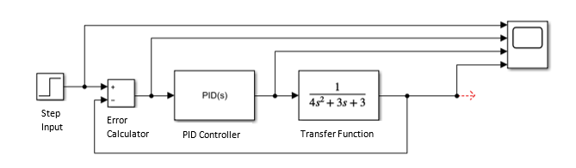
Figure 1 - System Design for a Closed Loop System
The pre and post results can be seen in section 4.1. [14] [15]

Experimental
This section covers the Mathematical processes which were required to calculate the TF of the system, by combining the controller function and the transfer function into an overall transfer function of the entire system. The first process seen is for a PID controller which was carried out based on a lecture provided by Dr Stephen Mosey [16]. The process after this one is for a PIDF controller, which was carried out based on a different lecture by Dr Stephen Mosey [17]. Both processes have been left in this report and will be explained in section 4.2.

PID Controller
$$G\left(s\right)=\frac{1}{as^{2}+bs+c}$$

Using the figures provided for the assignment a = 4, b = 3, c = 3 the transfer function now becomes:

$$G\left(s\right)=\frac{1}{4s^{2}+3s+3}$$

When drawn as a block diagram, the system now looks like this:
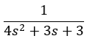
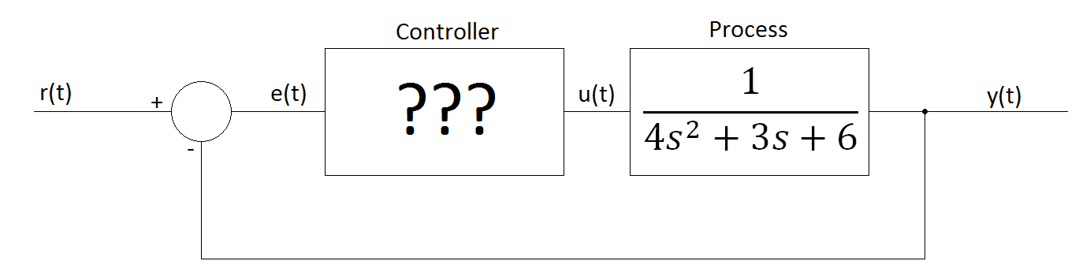
Figure 2 - System Layout for PID Controller
Using the PID tuner in MATLAB for task 1, the following values were obtained:

Kp: 53.7167
Ki: 20.1747
Kd: 35.2263

The following formula is for the transfer function of the PID controller:

$$\frac{K_{d}s^{2}+K_{p}s+K_{i}}{s}$$

$$\frac{35.2263s^{2}+53.7167s+20.1747}{s}$$

To calculate the forward path transfer function of the system, the controller’s transfer function must be multiplied by the transfer function of the process.
$$\frac{35.2263s^{2}+53.7167s+20.1747}{s}×\frac{1}{4s^{2}+3s+3}$$

$$\frac{35.2263s^{2}+53.7167s+20.1747}{4s^{3}+3s^{2}+3s}$$

The block diagram can now be redrawn as:

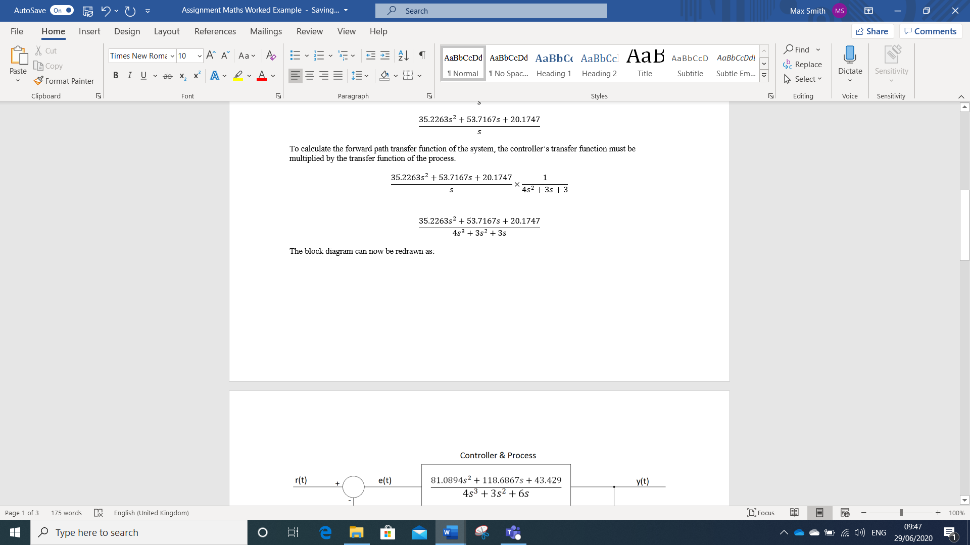
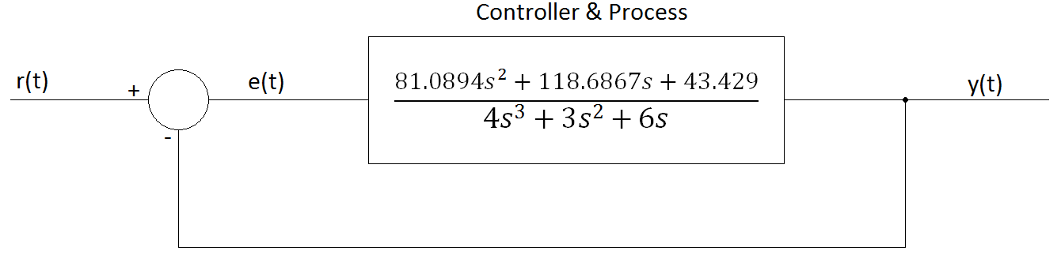
Figure 3 - Forward Path Transfer Function Layout

Now we remove the feedback loop and calculate the transfer function of the system as a whole.
Using:
$$TF=\frac{G}{1+GH}$$

Where TF is the transfer function of the whole system, G is the forward path transfer function, and H is the transfer function of the feedback loop, in this case $H=1$

$$TF=\frac{\frac{35.2263s^{2}+53.7167s+20.1747}{4s^{3}+3s^{2}+3s}}{1+\left(\frac{35.2263s^{2}+53.7167s+20.1747}{4s^{3}+3s^{2}+3s}\right)×1}$$

$$TF=\frac{\frac{35.2263s^{2}+53.7167s+20.1747}{4s^{3}+3s^{2}+3s}}{\frac{4s^{3}+3s^{2}+3s}{4s^{3}+3s^{2}+3s}+\frac{35.2263s^{2}+53.7167s+20.1747}{4s^{3}+3s^{2}+3s}}$$

$$TF=\frac{\frac{35.2263s^{2}+53.7167s+20.1747}{4s^{3}+3s^{2}+3s}}{\frac{4s^{3}+3s^{2}+3s+35.2263s^{2}+53.7167s+20.1747}{4s^{3}+3s^{2}+3s}}$$

$$TF=\frac{\frac{35.2263s^{2}+53.7167s+20.1747}{4s^{3}+3s^{2}+3s}}{\frac{4s^{3}+38.2263s^{2}+56.7167s+20.1747}{4s^{3}+3s^{2}+3s}}$$

$$TF=\frac{35.2263s^{2}+53.7167s+20.1747}{4s^{3}+3s^{2}+3s}×\frac{4s^{3}+3s^{2}+3s}{4s^{3}+38.2263s^{2}+56.7167s+20.1767}$$

$$TF=\frac{\left(35.2263s^{2}+53.7167s+20.1747\right)\left(4s^{3}+3s^{2}+3s\right)}{\left(4s^{3}+3s^{2}+3s\right)\left(4s^{3}+38.2263s^{2}+56.7167s+20.1747\right)}$$

$$TF=\frac{140.9052s^{5}+105.6789s^{4}+105.6789s^{3}+214.8668s^{4}+161.1501s^{3}+161.1501s^{2}+80.6988s^{3}+60.5241s^{2}+60.5241s}{16s^{6}+152.9052s^{5}+226.8668s^{4}+80.6988s^{3}+12s^{5}+114.6789s^{4}+170.1501s^{3}+60.5241s^{2}+12s^{4}+114.6789s^{3}+170.1501s^{2}+60.5241s}$$

Like terms collected:

$$TF=\frac{140.9052s^{5}+320.5457s^{4}+347.5278s^{3}+221.6742s^{2}+60.5241s}{16s^{6}+164.9052s^{5}+353.5457s^{4}+365.5278s^{3}+230.6742s^{2}+60.5241s}$$

Redrawn as:
Figure 4 - PID Transfer Function for Closed Loop System as a Whole

$$\frac{140.9052s^{5}+320.5457s^{4}+347.5278s^{3}+221.6742s^{2}+60.5241s}{16s^{6}+164.9052s^{5}+353.5457s^{4}+365.5278s^{3}+230.6742s^{2}+60.5241s}$$
y(t)
r(t)

PIDF Controller

$$G\left(s\right)=\frac{1}{as^{2}+bs+c}$$

Taking a = 4, b = 3, c = 3 the transfer function now becomes:

$$G\left(s\right)=\frac{1}{4s^{2}+3s+3}$$

When drawn as a block diagram, the system now looks like this:

Figure 5 - System Layout for PIDF Controller

Using the PID tuner in MATLAB, the following values were obtained:
Kp: 53.7167
Ki: 20.1747
Kd: 35.2263
N: 1021.2940

So, the transfer function of the PID controller will be:
$$K_{p}+K_{i}\frac{1}{s}+K_{d}\frac{s}{\frac{1}{N}s+1}$$

$$53.7167+\frac{20.1747}{s}+35.2263\frac{s}{\frac{1}{1021.2940}s+1}$$

To calculate the forward path transfer function of the system, the controller’s transfer function must be multiplied by the transfer function of the process.
$$\left(53.7167+\frac{20.1747}{s}+35.2263\frac{s}{\frac{s}{1021.2940}+1}\right)×\left(\frac{1}{4s^{2}+3s+3}\right)$$

$$\left(53.7167+\frac{20.1747}{s}+35.2263\frac{s}{\frac{s+1021.2940}{1021.2940}}\right)×\left(\frac{1}{4s^{2}+3s+3}\right)$$

$$\left(53.7167+\frac{20.1747}{s}+35.2263\left(s÷\frac{s+1021.2940}{1021.2940}\right)\right)×\left(\frac{1}{4s^{2}+3s+3}\right)$$

$$\left(53.7167+\frac{20.1747}{s}+35.2263\left(s\left(\frac{1021.2940}{s+1021.2940}\right)\right)\right)×\left(\frac{1}{4s^{2}+3s+3}\right)$$

$$\left(53.7167+\frac{20.1747}{s}+35.2263\left(\left(\frac{1021.2940s}{s+1021.2940}\right)\right)\right)×\left(\frac{1}{4s^{2}+3s+3}\right)$$

$$\left(53.7167+\frac{20.1747}{s}+\left(\frac{35976.4088s}{s+1021.2940}\right)\right)×\left(\frac{1}{4s^{2}+3s+3}\right)$$

$$\left(\frac{\left((s\left(s+1021.2940\right))×53.7167\right)+\left(s+1021.2940\right)20.1747+s\left(35976.4088s\right)}{s\left(s+1021.2940\right)}\right)×\left(\frac{1}{4s^{2}+3s+3}\right)$$

$$\left(\frac{53.7167s^{2}+54860.5434s+20.1747s+20604.3001+35976.4088s^{2}}{s^{2}+1021.2940s}\right)×\left(\frac{1}{4s^{2}+3s+3}\right)$$

$$\left(\frac{36030.1255s^{2}+54880.7181s+20604.3001}{s^{2}+1021.2940s}\right)×\left(\frac{1}{4s^{2}+3s+3}\right)$$

$$\frac{36030.1255s^{2}+54880.7181s+20604.3001}{\left(s^{2}+1021.2940s\right)\left(4s^{2}+3s+3\right)}$$

$$\frac{36030.1255s^{2}+54880.7181s+20604.3001}{4s^{4}+3s^{3}+3s^{2}+4085.1760s^{3}+3063.8820s^{2}+3063.8820s}$$

$$\frac{36030.1255s^{2}+54880.7181s+20604.3001}{4s^{4}+4088.1760s^{3}+3066.8820s^{2}+3063.8820s}$$

The block diagram was redrawn as:
$$\frac{36030.1255s^{2}+54880.7181s+20604.3001}{4s^{4}+4088.1760s^{3}+3066.8820s^{2}+3063.8820s}$$

Figure 6 - Forward Transfer Function for PIDF Controller

Now we remove the feedback loop and calculate the transfer function of the system as a whole.
Using:
$$TF=\frac{G}{1+GH}$$

Where TF is the transfer function of the whole system, G is the forward path transfer function, and H is the transfer function of the feedback loop, in this case $H=1$
[Note: From this point on the rounding will not be consistent due to the size of the numbers]

$$TF=\frac{\frac{36030.1255s^{2}+54880.7181s+20604.3001}{4s^{4}+4088.1760s^{3}+3066.8820s^{2}+3063.8820s}}{1+\left(\frac{36030.1255s^{2}+54880.7181s+20604.3001}{4s^{4}+4088.1760s^{3}+3066.8820s^{2}+3063.8820s}\right)×1}$$

$$TF=\frac{\frac{36030.1255s^{2}+54880.7181s+20604.3001}{4s^{4}+4088.1760s^{3}+3066.8820s^{2}+3063.8820s}}{\frac{4s^{4}+4088.1760s^{3}+3066.8820s^{2}+3063.8820s}{4s^{4}+4088.1760s^{3}+3066.8820s^{2}+3063.8820s}+\frac{36030.1255s^{2}+54880.7181s+20604.3001}{4s^{4}+4088.1760s^{3}+3066.8820s^{2}+3063.8820s}}$$

$$TF=\frac{\frac{36030.1255s^{2}+54880.7181s+20604.3001}{4s^{4}+4088.1760s^{3}+3066.8820s^{2}+3063.8820s}}{\frac{4s^{4}+4088.1760s^{3}+3066.8820s^{2}+3063.8820s+36030.1255s^{2}+54880.7181s+20604.3001}{4s^{4}+4088.1760s^{3}+3066.8820s^{2}+3063.8820s}}$$

$$TF=\frac{\frac{36030.1255s^{2}+54880.7181s+20604.3001}{4s^{4}+4088.1760s^{3}+3066.8820s^{2}+3063.8820s}}{\frac{4s^{4}+4088.1760s^{3}+39097.0075s^{2}+57944.6001s+20604.3001}{4s^{4}+4088.1760s^{3}+3066.8820s^{2}+3063.8820s}}$$

$$TF=\frac{36030.1255s^{2}+54880.7181s+20604.3001}{4s^{4}+4088.1760s^{3}+3066.8820s^{2}+3063.8820s}×\frac{4s^{4}+4088.1760s^{3}+3066.8820s^{2}+3063.8820s}{4s^{4}+4088.1760s^{3}+39097.0075s^{2}+57944.6001s+20604.3001}$$

$$TF=\frac{\left(36030.1255s^{2}+54880.7181s+20604.3001\right)\left(4s^{4}+4088.1760s^{3}+3066.8820s^{2}+3063.8820s\right)}{\left(4s^{4}+4088.1760s^{3}+3066.8820s^{2}+3063.8820s\right)\left(4s^{4}+4088.1760s^{3}+39097.0075s^{2}+57944.6001s+20604.3001\right)}$$

$$TF=\frac{144120.502s^{6}+{147297494.3s}^{5}+{110500143.4s}^{4}+{110392053s}^{3}+{219522.8724s}^{5}+{224362034.6s}^{4}+}{16s^{8}+16352.704s^{7}+{156388.03s}^{6}+{231778.4004s}^{5}+{82417.2004s}^{4}+{16352.704s}^{7}+16713183.01s^{6}+159835447.7s^{5}+{236887723.5s}^{4}+{84234005.17s}^{3}+}$$
$$⋯$$
$$\frac{+ 168312686.5s^{3}+{168148044.3s}^{2}+{82417.2004s}^{4}+{84234005.17s}^{3}+{63190957.1s}^{2}+63129144.2s}{+ 12267.528s^{6}+{12537953.39s}^{5}+{119905908.6s}^{4}+{177709251s}^{3}+{63190957.1s}^{2}+{12255.528s}^{5}+{12525688.86s}^{4}+{119788617.5s}^{3}+{177535417.2s}^{2}+63129144.2s}$$

Collecting like terms:
$$TF=\frac{144120.502s^{6}+147517017.2s^{5}+334944595.2s^{4}+362938744.7s^{3}+{231339001.4s}^{2}+6312944.2s}{16s^{8}+32705.408s^{7}+16881838.57s^{6}+{172617435s}^{5}+{369401738.2s}^{4}+{381731873.7s}^{3}+{240726374.3s}^{2}+63129144.2s}$$

Redrawn as:
Figure 7 - PIDF Transfer Function for System as a Whole

$$\frac{144120.502s^{6}+147517017.2s^{5}+334944595.2s^{4}+362938744.7s^{3}+{231339001.4s}^{2}+6312944.2s}{16s^{8}+32705.408s^{7}+16881838.57s^{6}+{172617435s}^{5}+{369401738.2s}^{4}+{381731873.7s}^{3}+{240726374.3s}^{2}+63129144.2s}$$
y(t)
r(t)

Root Locus
For this method based on the system for this assignment, the characteristic equation was defined as 1+KG(s)H(s), where K is gain in the system. This is the combination of the controller, the plant and the feedback.
G(s) was the transfer function equation and C(s) was the controller compensator equation based on the response of the tuned controller carried out in task 1.
H(s) was the transfer equation for the whole system which was defined as C*G/1+C*G.
This equation was used to plot a pole-zero diagram to visualise the variants of gain.
The plot shows the movements of all the poles within the system response. From the position of the poles you can determine whether the system will be critically damped and if the system will become unstable. Critical damping is where the system gets to where it needs to as quickly as possible and without an excessive oscillation. If the poles cross over to the positive side of the real axis it means the system will become unstable, as a result the gain of the system would need to be kept lower to prevent the system becoming unstable. [18]

Damping
The damping ratio is a dimensionless measure denoted by ζ, which describes how the oscillations in a system decay after a disturbance. After subject the system to a step input, the damping ratio will describe how the control system behaves towards the step and if any oscillations are present at the set value. Oscillatory behaviour is of key interest when designing a control system as you want a system which features speed, precision and an oscillation free response.
There are four states of damping. Undamped, underdamped, overdamped and critically damped. If undamped it would show as a sinusoidal waveform and would likely see the poles on the imaginary axis. If underdamped, where ζ is between 0 and 1, it would be shown as having a distinct overshoot and undershoot after the step response and would see a set of complex conjugate pair of poles on the left-hand side of the imaginary axis. If overdamped, where ζ is greater than 1, it would show no oscillations but would have a slower time response. You would see a pair of poles on the real axis. If critically damped, where ζ equals 1, you would see a good time response and little oscillation. This stage is borderline overdamped and underdamped. This is the desirable outcome and you would see double poles on the real axis. [19] [20]
The damping of a system can be found using the following equation, where PO is the percentage overshoot:
$$\frac{ln⁡(\frac{PO}{100})}{\sqrt{π^{2}}+\ln^{2}PO}$$

For this system, using the parameters of the tuned PIDF controller, the damping ratio was found to be 0.95. Meaning that the system is near on critically damped which is the desired outcome in a control system.

Nyquist Plots
A Nyquist plot is a graphical tool used to allow the determination of stability in a control system. It shows the frequency response and the phase response on a single plot, showing the real values of frequency for the control system. This tool enables you to find the phase margin and the gain margin of the system thus determining stability.
The gain margin is the change in open loop gain expressed in decibels, required at 180ᵒ of phase shift to make the closed loop system unstable. It can be applied as a safety margin, in that how much gain can be increased before the system becomes unstable. Once the Nyquist plot has been drawn, a unit circle can be incorporated into it to measure the gain margin. A unit circle is drawn from the origin and has a radius of 1. The gain margin is measured from where the plot crosses the negative real axis and the 180ᵒ point on the unit circle.
The phase margin is the change in open loop phase shift required at unity gain to make the closed loop system unstable. Unity gain on the plot is shown by the unit circle. It can be applied as a safety margin in that how much more phase shift would make the system unstable. Once Nyquist plot is done, the phase margin is measured by the angle between the 180ᵒ point on the negative real axis and the point at which the trace crosses the unit circle. The arrows depicted on a Nyquist plot show the change in value of ꙍ (omega). [10]
Using Matlab to attain the Nyquist plot for the control system, the following coding was used. This also incorporated the unit circle onto the plot. [21]

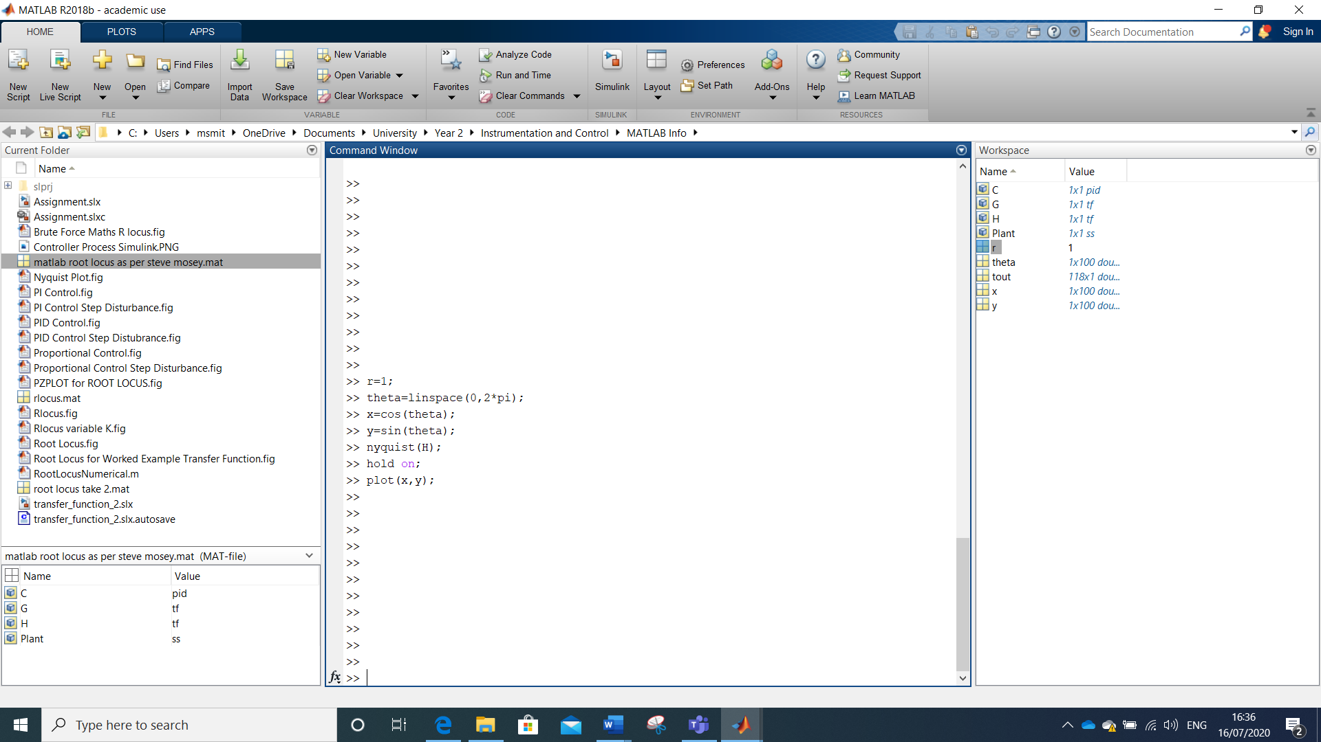
Figure 8 - MATLAB data for Nyquist Plot
Where:
- r determined the radius size
- theta was the angle for the circle
- x, y, plots determined the centre of the unit circle
- nyquist(H) was the plot for the transfer function for the whole system.

Results

Simulation Results
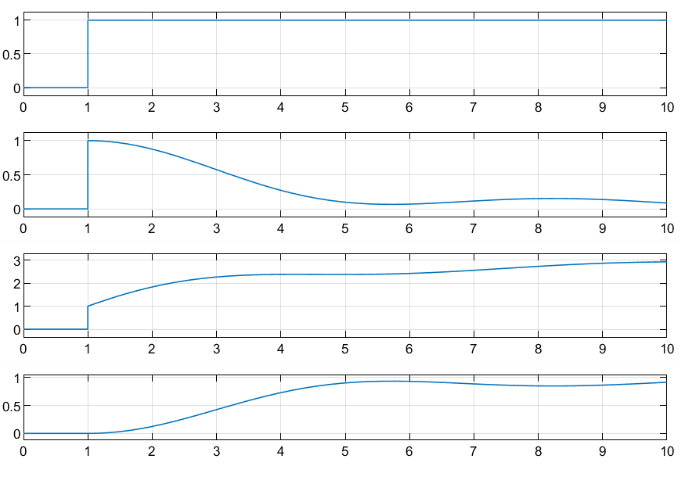  Figure 9 - Untuned Response PIDF Steps | 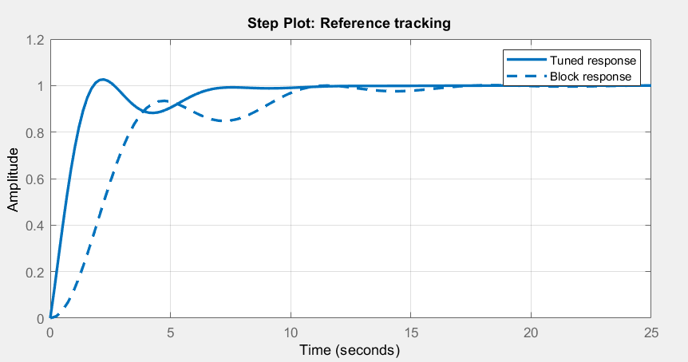  Figure 10 - Untuned Response PIDF Simulink
The above graphs show the PIDF controller prior to tuning. Figure 9 shows the responses at the different stages of the system. The top one is the step input where the controller output is switched on increasing the process value. The second one is the error signal. The third is controller effort and the fourth is the plant output.
Figure 10 shows that the system reacts sluggishly and has a slow response time. The block response is the response of the untuned controller, the oscillations occurring between ~4s and ~16s show that the system is not very stable, and the initial response does not meet the criteria of a settling time under 2s and a less than 5% overshoot. The response is like that of an underdamped system.
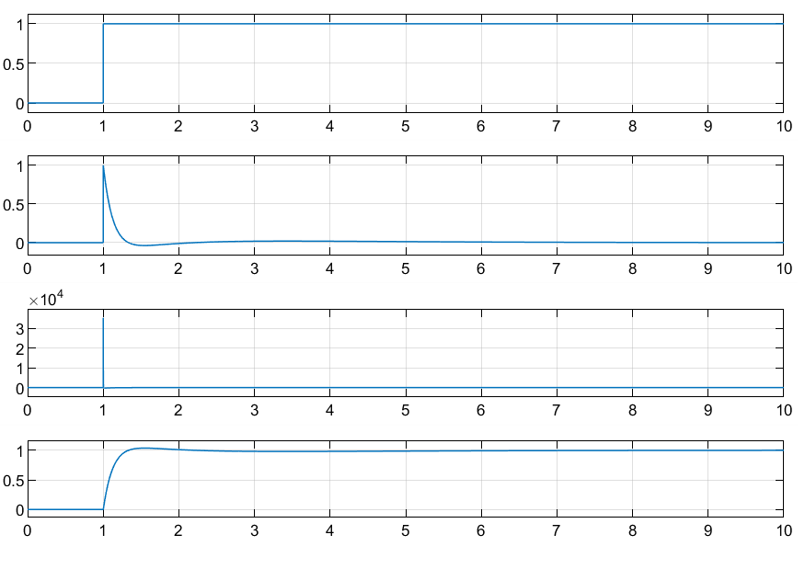  Figure 11 - Tuned Response of PIDF Steps | 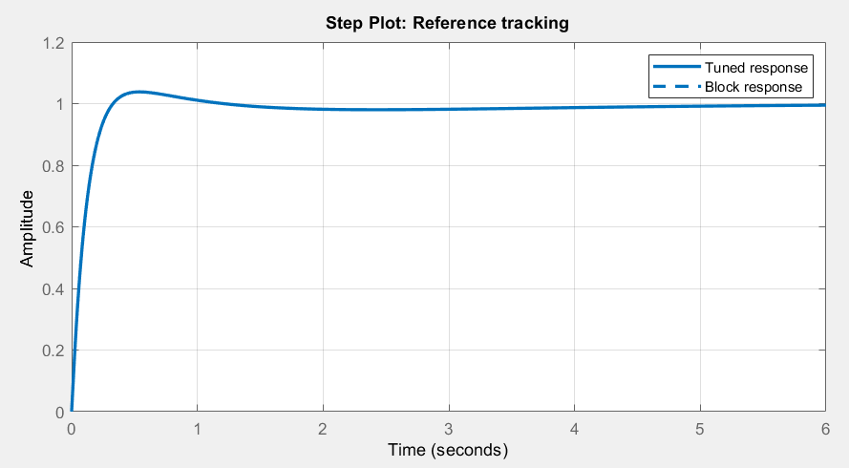  Figure 12 - Tuned Response PIDF Simulink
The above graphs represent the response of the PIDF controller once tuned via ZN process. Figure 11 shows the system response over the different steps, these appear much more dynamic in the response times. From Figure 12 shows there is minimal to no oscillation and response time is far quicker than the untuned response. The block response and the tuned response were the same and was representative of a critically damped system.

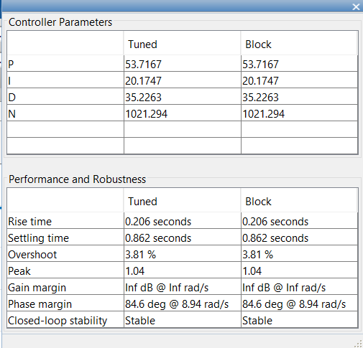  Figure 13 - Parameters of Tuned PIDF Controller | Figure 13 shows the parameters of the tuned PIDF controller. As can be seen there was a 3.81% overshoot and a settling time of 0.862 seconds which is within the design specifications. The figures provided in the controller parameters represent the values of the proportional response, integral response and the derivative response. The N is representative of the filter coefficient. These values were used in the mathematical processes carried out for the experimental section.

Experimental Results
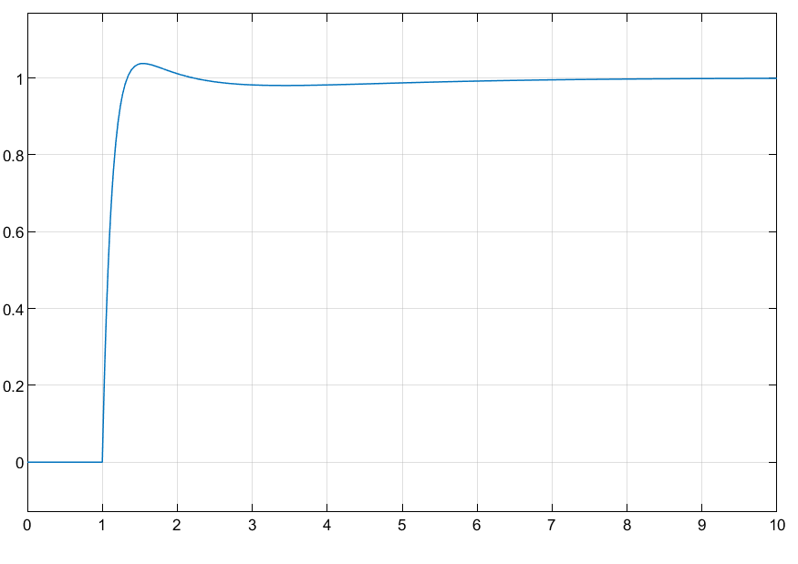  Figure 14 - PID Response from Transfer Function of System as a Whole | 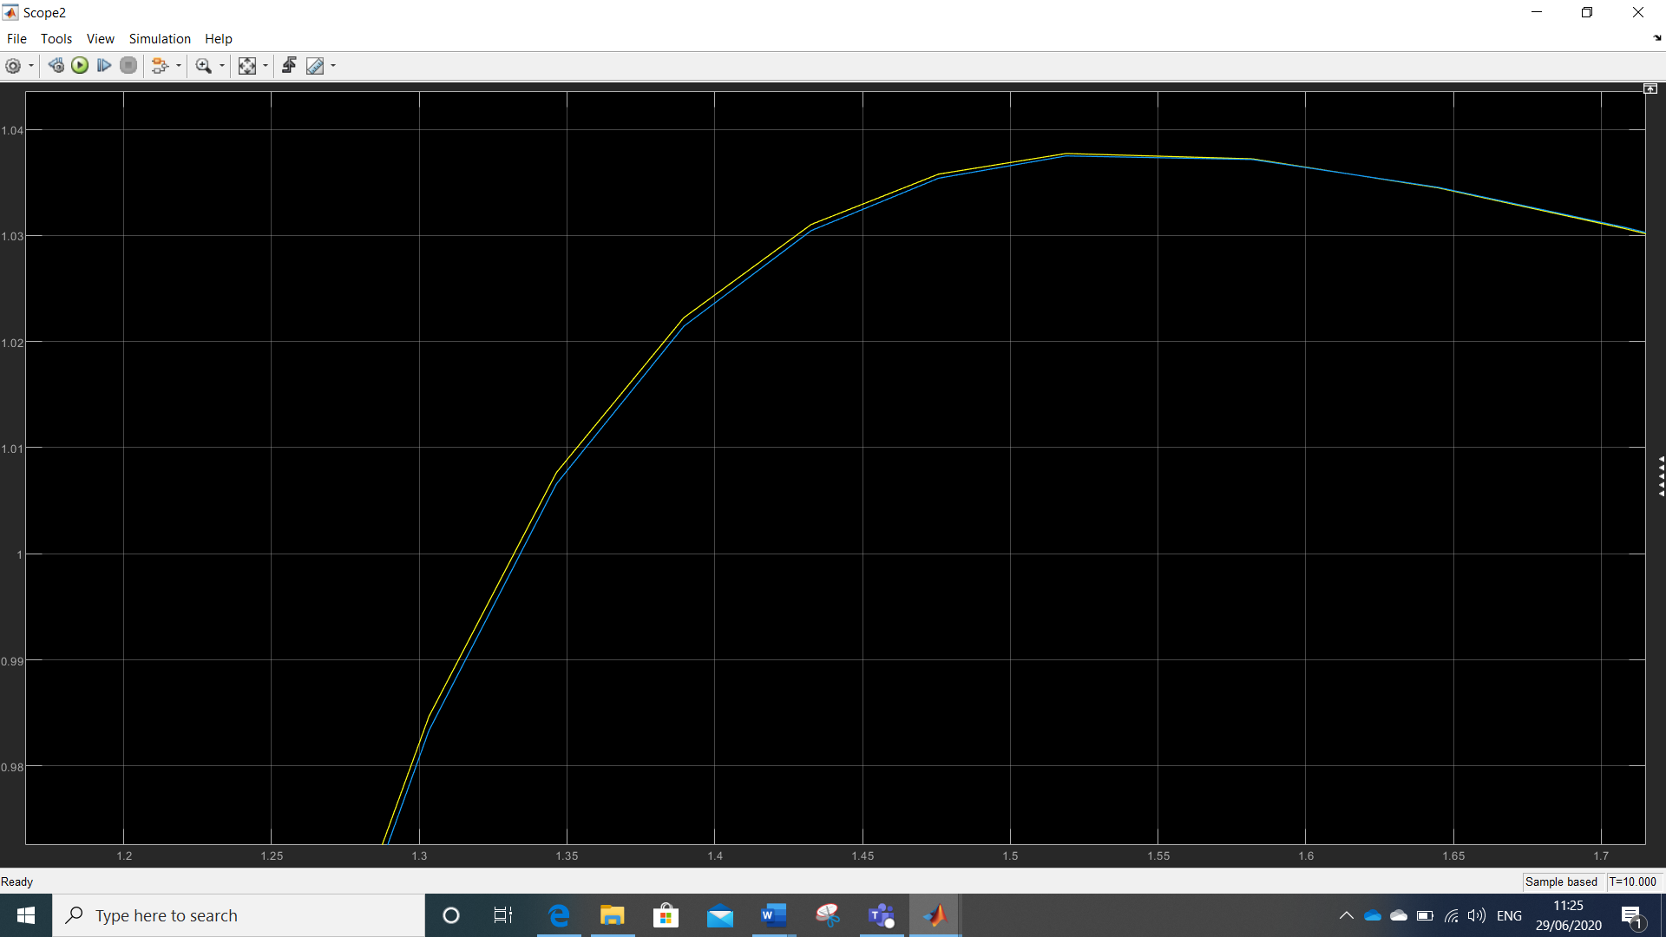  Figure 15 – Close-up of Original Tuned Trace and Whole System Trace for PID
Figure 14 shows the controller/transfer function response from the mathematical process carried out for a PID controller. The response was near identical to the response achieved from the tuning of the PID controller via Simulink. Figure 16 shows what the system looks like when built. Figure 15 shows a close-up comparison between the response from Process 1 and the Simulink Tuned response. There is a slight variation in the peak overshoot levels between the two responses. In Figures 14 and 17 the activation starts at 1 as opposed to 0, this was because of the step input in the system design.
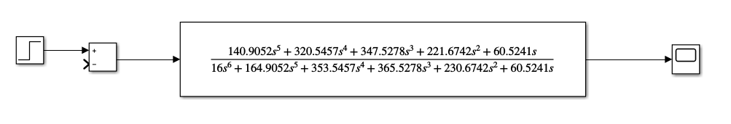
Figure 16 - PID System with Transfer Function of System as a Whole
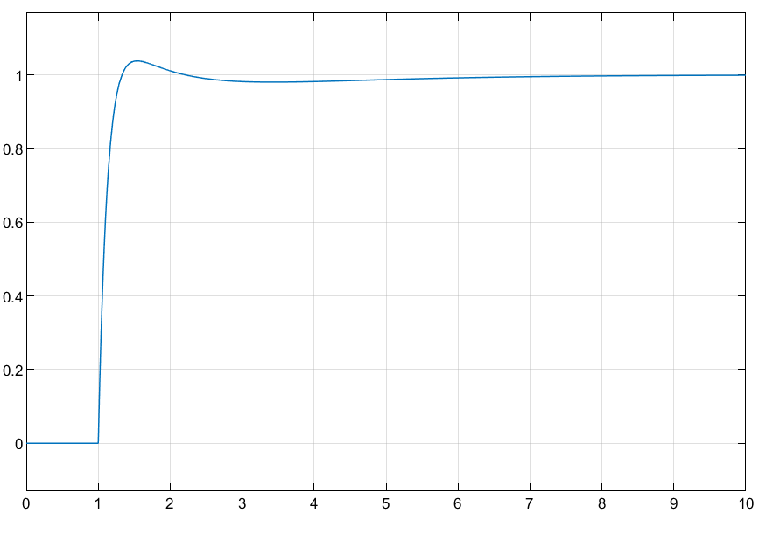  Figure 17 - PIDF Response from Transfer Function System as a Whole | 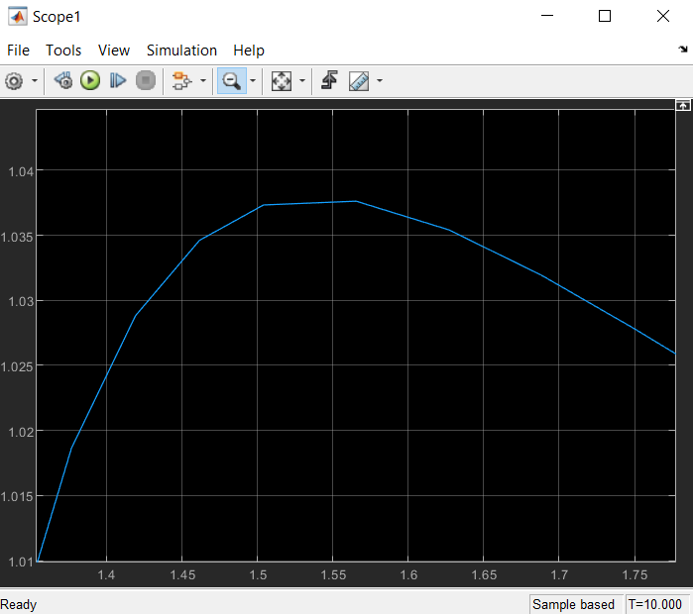  Figure 18 - Close-up of Original Tuned Trace and System as a Whole for PIDF
Figure 17 shows the controller/transfer function response from the mathematical process carried out for a PIDF controller. The response is near identical to the response achieved from the tuning of the PIDF controller via Simulink. Figure 19 shows what the system looks like when built. Figure 18 shows a close-up comparison between the response from Process 2 and the Simulink Tuned response. There was no deviation between the two responses.
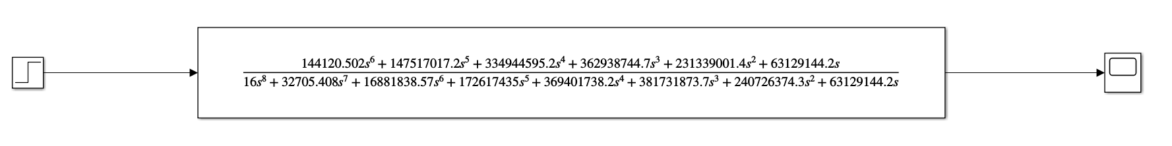
Figure 19 - PIDF System with Transfer Function of System as a Whole

Root Locus Results
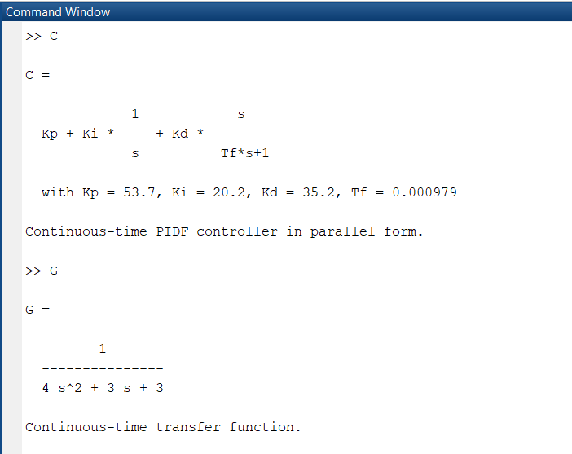  Figure 20 - MATLAB Character Definitions for Root Locus | 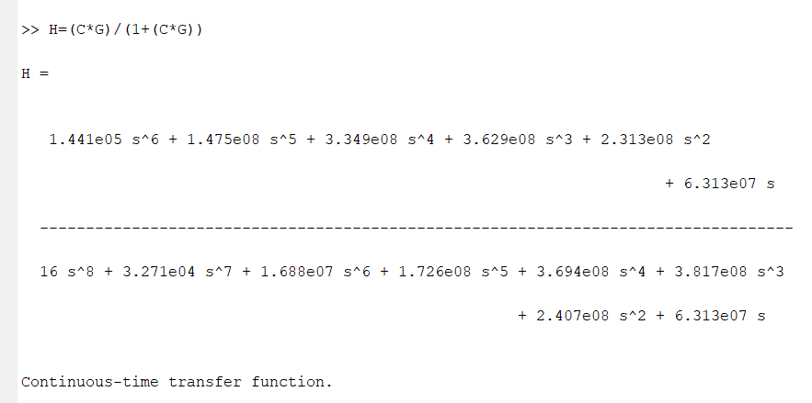  Figure 21 - MATLAB Characteristic Equation for Root Locus
For the root locus the characteristic equation was defined as 1+KG(s)H(s), where K is gain in the system. To carry this out, the parameters of the equation had to be defined.

Figure 20 shows the functions that define the characters.

To work out the root locus a function had to be applied to H.

Figure 21 shows the function worked out and applied in relation to the original characteristic equation. The equation represents the transfer function for the closed loop system response.

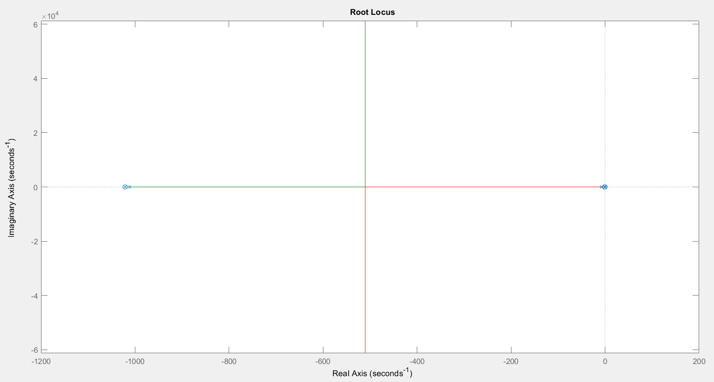
Figure 22 - Root Locus Plot for the Transfer Function of the Closed Loop System
Figure 22 shows the root locus plot of the transfer function for the closed looped system. It shows the time domains where the roots can move between and the system remain stable. From this it can be determined where the system can be critically damped to achieve the most efficient time response.
The insection where the green and red lines meet at ~-510 is representative of the centroid of the root locus. To confirm this the following equation can be done to calculate the centroid of the root locus:

$$\frac{\sum{Real Poles}-\sum{Real Zero's}}{Poles-Zero's}$$

$$\frac{\left(-1021+ -1012+ -7.914+ -1.182+ -0.5437+0\right)-\left(-1021+ -0.8519+ -0.6713+0\right)}{8-6}$$

$$\frac{-1020.1165}{2}$$

$$= -510.05$$

The calculated centroid and the graphical centroid are near identical.

The angles of asymptotes can be calculated for this system using the equation:

$$\frac{\left(2q+1\right)*180°}{Poles-Zeros}$$

The values for q for this system will be 0 and 1, this is because Poles-Zeros gives an answer of 2.

$$\frac{\left(2\left(0\right)+1\right)*180°}{2}=90°$$

$$\frac{\left(2\left(1\right)+1\right)*180°}{2}=270°$$

The angles of asymptotes are representative of the variables of gain (k) within the system. As can be determined from Figure 22, the lines go straight up and down to infinity at -510 on the real axis. From this it can be determine that the variables of ‘k’ before -510 it will be real and after -510, the variables of ‘k’ are imaginary. [22]
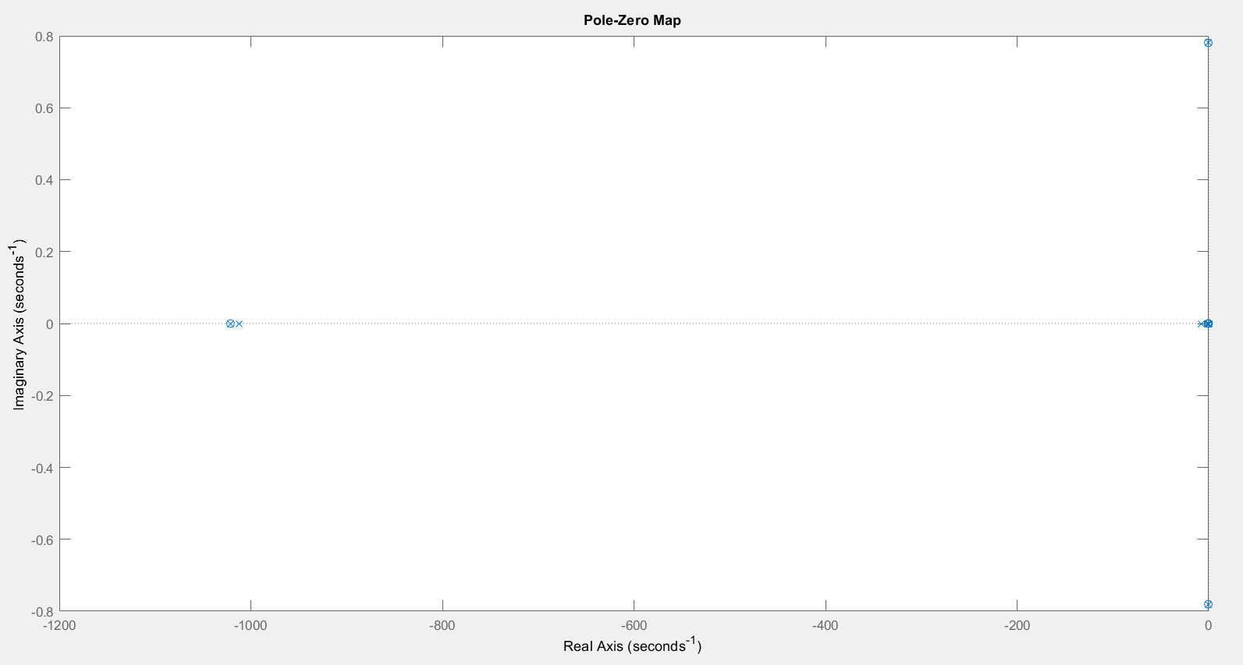
Figure 23 - Pole-Zero plot of the Transfer Function for the Closed Loop System
Using the transfer function for the characteristic equation, the above Pole-Zero graph (Figure 23) was generated using the function on Matlab ‘pzplot(H)’. It’s only the poles we are interested in. The ones closest to the imaginary axis are the dominant poles.
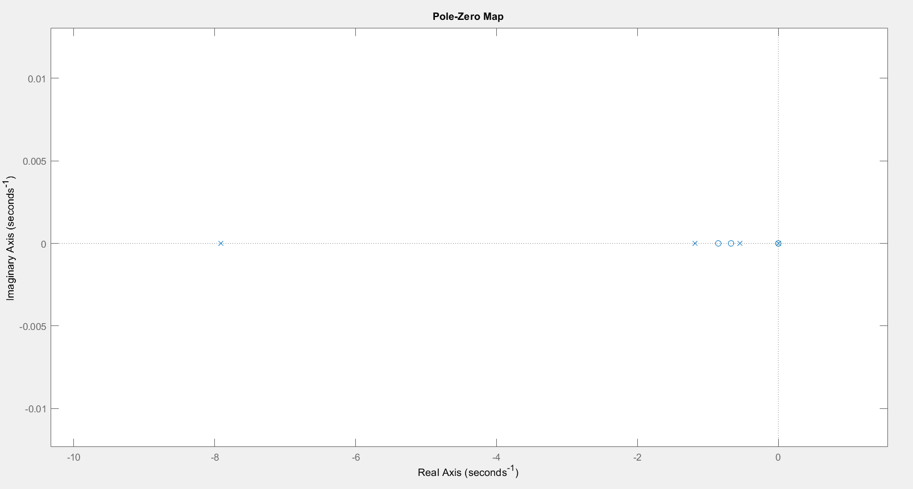
Figure 24 - Close-up of Poles and Zeros nearest the origin
Figure 24 shows a closer view of the poles and zeros as plotted via the Matlab function. This is missing some of the poles as shown in Figure 23, but this shows more clearly what we’re interested in.
There is a pole and a zero at the origin, a pole at -0.544 and -1.18. And a few further out. These are all on the negative real axis, this is important because it means that the system is stable.
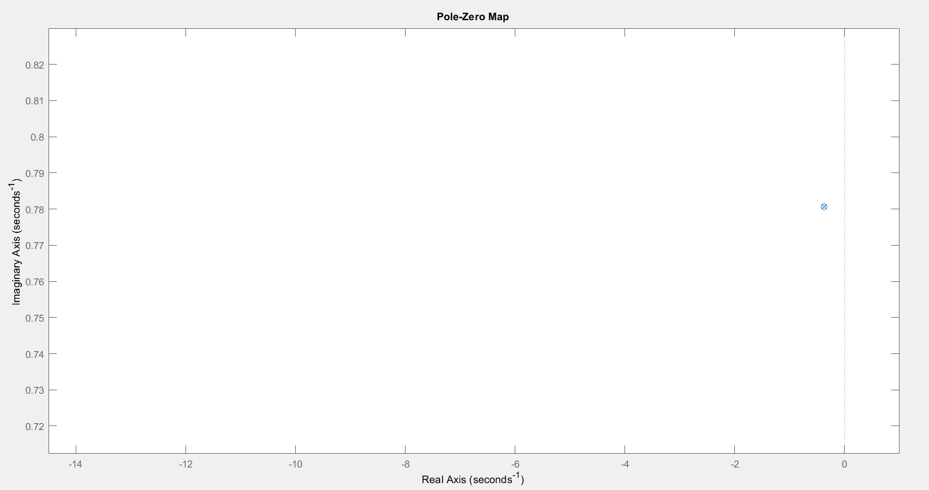
Figure 25 - Close-up on one of the Conjugate Pairs by the Imaginary Axis
Figure 25 shows one of the pole-zero conjugate pair. The position is good because it is inside of the imaginary axis, it means that the conjugate pair will decay meaning they aren’t going to be continuous oscillators. This demonstrates that the system will remain stable.

Nyquist Results
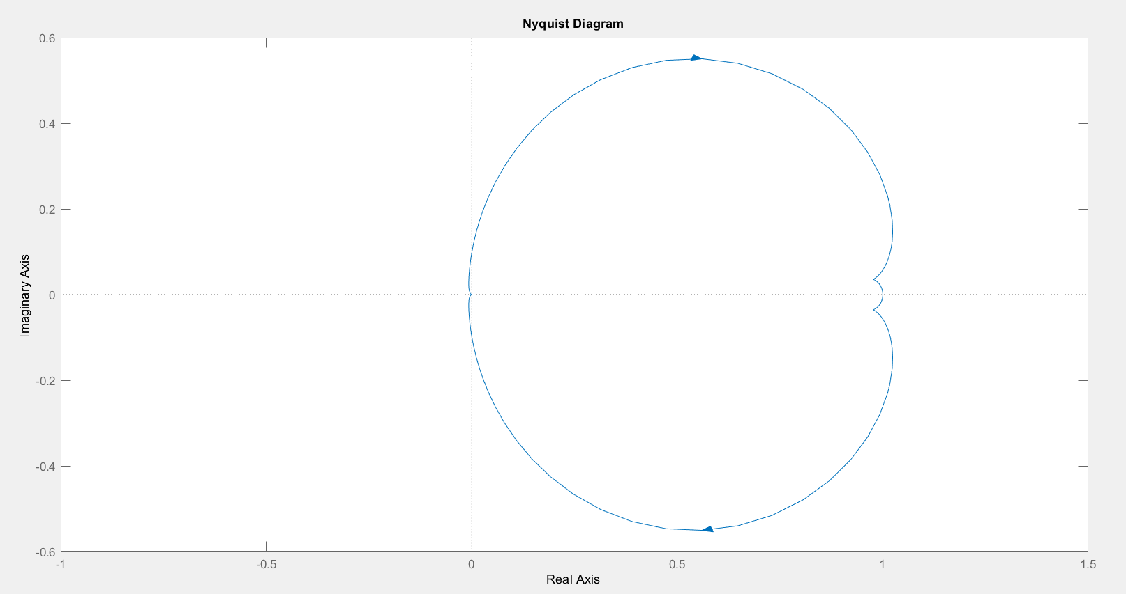
Figure 26 - Nyquist Plot
Figure 26 it shows the Nyquist plot for the transfer function for the control system as calculated in section 3.2.2.
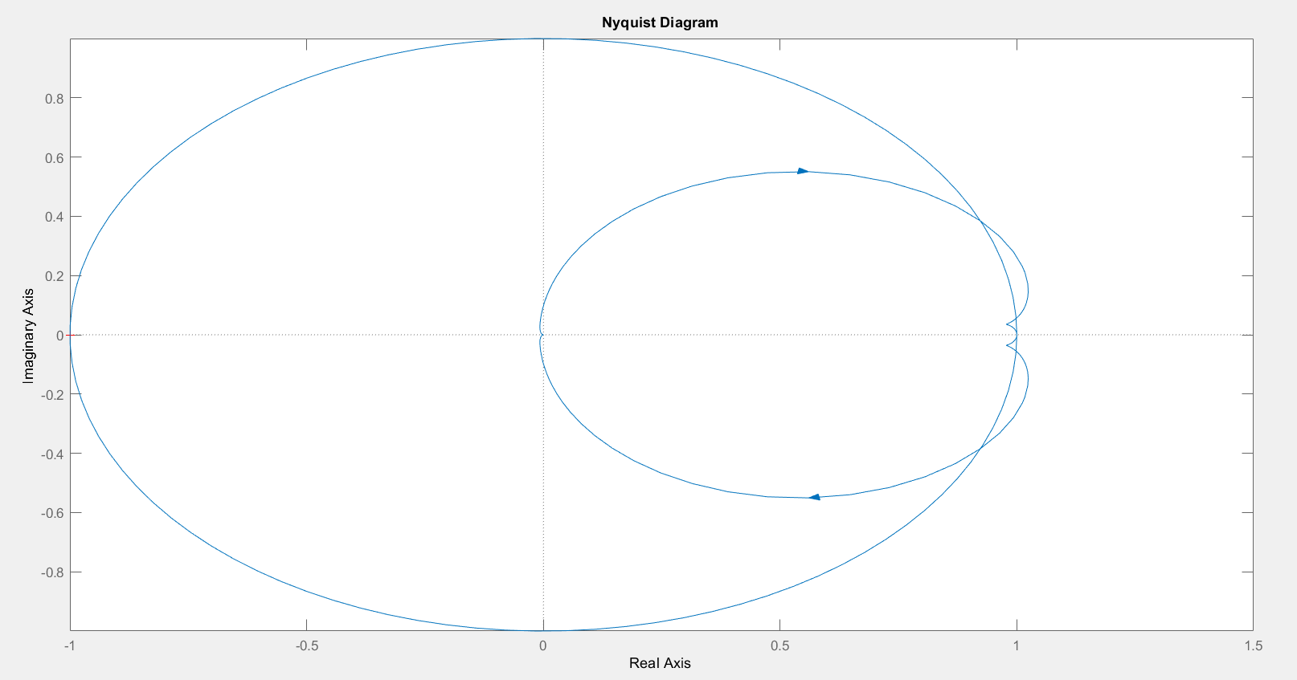
Figure 27 - Nyquist Plot with Unit Circle applied
Figure 28 - Parameters of Tuned PIDF Controller | Figure 27 shows the nyquist plot with the unit circle incorporated into the plot. Analysing this in comparison to the parameter fields form the tuned PIDF controller shows some similarities. The difference being that in Figure # on the left, the angle of phase margin has been taken from a different point on the axis and isn’t based on the nyquist plot theory. The phase margin as a result is 90ᵒ + 84.6ᵒ which totals in 174.6ᵒ. Meaning that the system would next to have a phase shift occurrence of 174.6ᵒ for the system to become unstable. The gain margin however is infinite. This can be seen on the nyquist plot as the trace doesn’t cross the negative real axis, meaning that the gain can be limitless, and the system will remain stable.
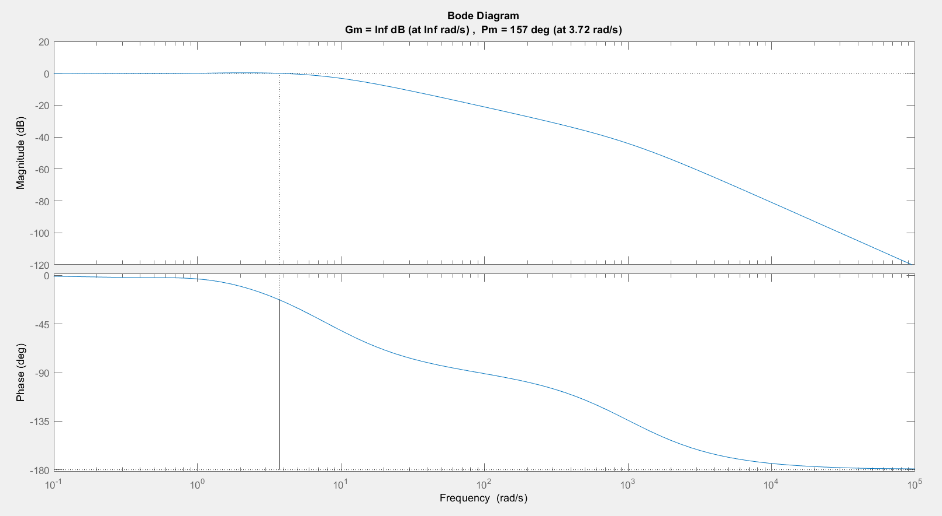
Figure 29 – Bode Plot for Transfer Function of the Closed Loop System as a Whole
Figure 29 depicts the bode plot for the transfer function of the control system. This shows gain and phase separately on two different graphs with gain being the top one and phase being the bottom one. With the application of the ‘margin(H)’ command in Matlab it shows the gain and phase crossover frequencies, and a graphical representation of these quantities on the Bode plot. At the lower frequencies the systems is going to handle it and there will be no appreciable phase change and no appreciable gain change. As the frequency increases the gain is going to drop off and will see more phase shift. As the gain drops to quite a low value the phase shift is not going to cause the system many issues, it just means the system will stop responding to higher frequency inputs. [23]

Discussion
In the first set of results, you saw the response of the controller in its original state and in its tuned state. In its original state the response was sluggish and had a slow response time. The dashed line on the graph was the untuned response, which demonstrated that the system would be unstable for the first 16s, this can be seen through the oscillations that occur, however from the initial peak of response, the output does not reach the required output for the system until ~16s. So, whilst prior to that point the system had overshoot, the system behaved underdamped, so the system threshold was never crossed. This controller in its untuned state did not allow the system to meet the design criteria. The tuned controller done via Simulink, was somewhat done using the ZN process but in an easier fashion. There was significantly better response from the tuned controller than the untuned controller. There was minimal to no oscillation in the initial response of the system, meaning the system was far more stable. There was an overshoot of the system of 3.81% which was within the design requirements, and the system swiftly corrected, achieving a settling time of 0.862s which met requirements. The graphical representation of the response was akin to that of a critically damped system. To which the damping ratio for the system had been calculated as being 0.95 which is 0.05 off being the perfect critically damped system.
The second set of results were from the mathematical processes that were carried out to convert the closed loop system into a closed loop transfer function for the whole system. There were too sets included in this assignment due to misinformation provided originally. The first lot have been retained to act as comparison for the actual calculations. The first comment on the response was that the activation of the system started after 1s as opposed to at 0s. This was simply due to the step feature in the system. The calculated transfer function for the system, which used the values determined through the digital tuning process, resulted in a trace response of the tuned response. This was most likely due to shear luck as the calculations used were for a PID controller as opposed to a PIDF controller. Comparing the two from afar, they were identical, however once a close up of the peak overshoot was done, it was clear there were differences between them. When using the correct calculations for the PIDF controller, the results were again near identical to the tuned response on Simulink. The two traces were plotted on the same graph and a zoom over the traces was carried out, no discernible deviations were observed between the two responses. The system through the conversion into a single closed loop transfer function was stable and met the design requirements.
The root locus method was applied to analyse the response times of the system, and to determine if the system would become unstable. All the poles for the system were on the negative real axis of the plane, which means that the system would be stable between all various values of gain. There was a pair of conjugate pole-zeros on the left-hand side of the imaginary axis of the plane, this means that the system will remain stable, as the conjugate pair will decay. The decay of the conjugate pair simply means they aren’t going to be continuous oscillators. If the any of the poles or the conjugate pair been on the right-hand side of the imaginary axis, i.e. on the positive real axis, then that would determine that between ‘x’ values of gain the system the would be unstable and as a result not suitable for the system required.
The phase and gain margins as determined by through the Nyquist plot and bode plots, show how much range the system has before becoming unstable. From both these plots it was found that the change in gain no matter how great or small would not affect system stability. Whether or not this is real behaviour for is system is another matter. As typically the gain in a system should have its limits where it would become unstable and thus not be suitable. The phase shift required to make the system unstable is nigh on 180ᵒ meaning that the system would have to receive a large amount of disturbance before becoming unstable. The Nyquist plot, bode plot and the root locus were based on the closed loop transfer function of the entire system as carried out in earlier processes.

Conclusion

Summary
This assignment covers the design of a control system capable of controlling the process as defined through the characteristic equation as specified in the brief. Using the values provided for the assignment, a system was designed using Simulink software to meet the required performance characteristics of under 5% overshoot and achieving a settling time within 2s of activation.
The system controller was defined using the tuning capabilities of the software and the mathematical processes as carried out in section 3.2 covering both a standard PID controller and a PIDF controller. With the mathematical procedures converting the closed loop system with separate control and process blocks, into a closed loop transfer function of the system as a whole incorporated the controller and process blocks as one.
The results were analysed and compared using the various methods of systems analysis tools available such as toot locus, Nyquist plots and bode plots, identifying the stable regions of the system and the likelihood of instability occurring. The results attained were in conjuncture with the damping style the system undertook.
The damping of a system is key to meeting the system requirements and retaining stability within the system, not wanting it to react too fast and vastly overshoot the mark, and not wanting it to react too slowly that the system would not be deemed applicable to the situation. In terms of systems a response time of seconds is a lifetime, especially with the technological advances being able to function in nanoseconds.
The benefit of converting the closed loop system into a singular entity would be the reduced manufacture cost and size of the system. However, the downside is if there was an error in the system it would be extremely difficult to identify the section at fault, whereas, like with the cascade loops, having singular parts of a system, it makes it more easy to identify deficient areas and solve any issues.
With the system that was designed being stable and meeting the performance criteria. The only issue that was found was when determining the gain margins when applying the Nyquist and bode plots to the data, as the result determined that infinite gain could be attained, and the system would not become unstable. As mentioned in the discussion, the author is unclear whether this system would be real world applicable or purely theoretical.
As a result the tuning process carried out initially to determine the character values of the proportional, integral and derivative controls would need to be readdressed, and the results re-run to determine any variation and to see if an actual value for gain could be attained for causing instability within the system.

Recommendations
To carry out a more thorough investigation into the comparisons between the behaviours of controllers and the various processes and methods used to tune and apply them, it would have been good to actually design the controllers and apply them to real world object like a drone to determine changes in behaviours when exposed and pushed to the various factors that would limit the performance of the system.
The author of the assignment was new to the use of the Matlab and Simulink software, having a better understanding and capability of use of these would have improved efficiency and competence when carrying out the investigation.
A more developed understanding of the instrumentation and control would have been more resourceful for carrying out an investigation like this, but due to real world situations the availability and time to develop this knowledge was somewhat capped, leaving little scope for self-development and time between final delivery of information to deadline.
For a more in-depth investigation of performance it would have been good to apply some more of the various tools out there to determine system stability, equally to go more in depth with some of the tools used within this assignment.
The control system would have been designed with the implementation of cascade loops, becoming a cascade controller for efficiency and ease of problem solving.

References

[1] | D. Lequesne, Predictive Control, Elsevier Ltd, 2017.
[2] | G. Ellis, Observers in Control Systems, Elsevier Inc., 2002.
[3] | B. Douglas, Composer, Understanding PID Control. [Sound Recording]. MATLAB. 2018.
[4] | C. Lum, Composer, Control Theory Playlist. [Sound Recording]. University of Washington. 2019.
[5] | N. S. Nise, Control Systems Engineering Sixth Edition, John Wiley and Sons, 2011.
[6] | D. S. Mosey, “Instrumentation and Control Assignment,” University of Wales Trinity Saint David, Swansea, 2020.
[7] | E. Cheever, “Why is Root Locus Important,” Swarthmore College, 2007. [Online]. Available: https://lpsa.swarthmore.edu/Root_Locus/RLocusAll.html. [Accessed 15th June 2020].
[8] | P. B. Messner and P. D. Tilbury, “DC Motor Position: Root Locus Controller Design,” MATLAB, 2017. [Online]. Available: http://ctms.engin.umich.edu/CTMS/index.php?example=MotorPosition&section=ControlRootLocus#19. [Accessed 20th June 2020].
[9] | D. M. F. Hamza, “Lecture for MCT5202,” ResearchGate, Online, 2018.
[10] | D. S. Mosey, “Nyquist Plot,” University of Wales Trinity Saint David, Swansea, 2020.
[11] | E. Editors, “Nyquist Plot: What is it? (And How To Draw One),” Electrical4u, 19th July 2019. [Online]. Available: https://www.electrical4u.com/nyquist-plot/. [Accessed 16th July 2020].
[12] | P. &. V. R. &. S. S. Parikh, “Velocity Analysis of a DC Brushed Encoder Motor using Ziegler-Nichols Algorithm: A Case of an Automated Guided Vehicle,” Indian Journal of Science and Technology, vol. 9, no. 10, p. 6, 2016.
[13] | M. Senra, Director, Continuous Cycling Method. [Film]. Colorado: Lafayette College, 2016.
[14] | D. S. Mosey, Composer, MATLAB/Simulink PID Controller Set-up guide. [Sound Recording]. University of Wales Trinity Saint David. 2020.
[15] | J. Dillon, Interviewee, Instrumentation and Control Design. [Interview]. 5th May 2020.
[16] | D. S. Mosey, Assignment Maths Worked Example, Swansea: Dr Stephen Mosey, 2020.
[17] | D. S. Mosey, Assignment Maths Worked Example 2, Swansea: Dr Stephen Mosey, 2020.
[18] | S. S. Kumar, “Design of PID Controller using Root Locus method,” Wordpress, 2016.
[19] | D. S. Mosey, “Root Locus,” in University of Wales Trinity Saint David, Swansea, 2020.
[20] | APMonitor.com, Composer, Second Order Systems. [Sound Recording]. APMonitor.com. 2015.
[21] | Unknown, “MATLAB-Nyquist Plot - Show the unit circle,” Develop Reference, 2018. [Online]. Available: https://ios.developreference.com/article/20195796/MATLAB+Nyquist+Plot+-+Show+the+unit+circle. [Accessed 16th July 2020].
[22] | T. P. Lecturers, “Construction of Root Locus,” Tutorials Learning, 2020. [Online]. Available: https://www.tutorialspoint.com/control_systems/control_systems_construction_root_locus.htm. [Accessed 15th June 2020].
[23] | B. York, “Frequency Response and Bode Plots,” New Jersey Institute of Technology, New Jersey, 2009.

Appendix

Cascade Controllers
Many systems implement cascade control. This is where there are multiple feedback loops in the system, using the quadcopter as an example, the inner loop controls the propeller motors and the outer loop controls the rest of the system, meaning there are separate comparators for each system within the system. The outer loop drives the set point of the inner loop and the inner loop affects the feedback path of the outer look. The implementation of cascade loops makes it easier to isolate any issues in the system and enables multiple teams to work on separate parts of the system. A more significant reason cascade loops are used is that you can run each at different speeds to address the different problems and sources of error in the system. The inner loop is generally tuned to respond quickly to local disturbance and the outer loop is tuned more conservatively to reject sensor noise and increase stability.

Discrete Controllers
There are several types of PID controllers, of which two are continuous time PID controllers and discrete PID controllers. A continuous time controller updates and reacts to situations continuously enabling reactive system control to keep the system stable. However not all controllers run continuously, this is because controllers are typically designed on digital computers, and digital computers don’t run continuously but rather, updates at each sample time. Digital systems have unique characteristics like quantisation, transport delay and sample times. If a sample time is short enough in comparison to the dynamics of the system it behaves similarly to that of a continuous time system because the controllers reads, updates and implements the changes so fast. However, as the sample time increases, the discrete controller results differ more and more from the continuous time controller results. If the sample time is fast, the controller sees everything and react like a continuous controller. If the sample time is slow, then the controller slows down to keep the system from crashing.
Continuous PID controllers are tuned using the formula in the S domain
$$Kp+Ki\frac{1}{s}+Kd\frac{N}{1+N\frac{1}{s}}$$
Discrete PID controllers are tuned using the formula in the Z domain
$$Kp+Ki\left(Ts\frac{1}{Z-1}\right)+Kd(\frac{N}{1+N\left(Ts\frac{1}{Z-1}\right)})$$
When tuning a discrete controller, it is done first in the S domain and then converted into the Z domain whilst ensuring that the sample time is fast enough to keep the same behaviour.
This is because starting in the continuous time domain makes solving the problems easier and there are more tools available to help, in addition often the plant requiring control operates in the continuous time domain, so modelling the plant and the controller in the same domain makes the problem simpler.

Full Image of Figure 15
In this image it is clearer to see the difference between the traces for the tuned PIDF controller and the calculated response for the PID controller.

