Marketing Fundamentals

Student Name: CRISTINA STEFANIA CIOBOATA – 1905391
ELENA CARMEN ANGHEL – 1905217
ELENA ONIGA - 1905210
OANA FLORENTINA DUMITRIU – 1909491
Module Title: LCBB4004
Assignment Title: Marketing Fundamentals – GROUP ASSIGNMENT
Lecturer’s Name: TUSHARA BALENDRAN
Table of Contents
Task 1A 3
Blog 1 3
Blog 2 5
Blog 3……………………………………………………………………………………….8
Blog 4……………………………………………………………………………………….9
Blog 5 11
Blog 6 13
Blog 7 15
Reference list 18

TASK 1A

Blog 1
Shop now to grab the best deal from Adidas and workout from home! Up to 40% off.
Hold your breath until your dreams come true! How long have you been waiting for your favourite Adidas pair? If you had to wait too long, be assured that what you receive would be worth the wait. Yes! It is true. We are holding a stock clearance sale, in the event if celebrating Easter and spreading joy amidst the dark hours of the COVID 19 pandemic. You will be getting an opportunity to shop not from the stores but online at up to 40% off throughout this weekend. So be prepared for the sale before the stock runs out.
Adidas is offering you a golden opportunity to be a better version of who you are. Adidas believes in the importance of being unique in a crowded world. If a budget has been a problem to hold on to your better personality, this is surely your time. Adidas takes your passions seriously. Starting with the Ultraboost 20 running shoes to the Adidas Terrex backpacks, everything would be offered for sale. If you love hiking, it is time that you also start planning your vacation with your hiking shoes and a backpack, after the coronavirus is gone.

There is a wide range of goods that would be up for sale this weekend—starting with sneakers, tops, sweatshirts, sweatpants, leggings, and shorts. These account for the wearables. Apart from these, there would also be a sale on sports equipment like footballs, gloves or other accessories like the backpacks, accounting for a wide range of styles with the trefoil logo.
The prime aim behind this huge sale is to keep up to the expectations of our core value, ‘passion, performance, integrity and diversity’. Even at the face of lockdown, and the difficulties of coping with the negativity, we find it very important to embrace individuality. Do not compromise on loving and embracing yourself. We are offering higher discounts on the work out commodities compared to the rest, as we want you to be empowered even by staying home. Do not just work from home, work out from home too!
We hope to see you this weekend. However, please note, delivery of merchandise might be affected based on the transport situation. But your product would surely be delivered later, and your money would be refunded otherwise. If you have any question, leave a comment below or call us at 11-820-301-52. We would do our best to reach out to you. Till then, stay safe, and be you!

Blog 2
We hear your passion screaming- Adidas cares about what you care
Are you panicking, or are you just bored? Don’t you feel that everything is so much quieter with the lockdown? No traffic, no horns, no basketball beats or soccer ball kicks, and no moving out had a deafening effect on you, didn't it? We want this to be over as much as you. But do you realise what had never been louder? The voice was screaming inside you!
Remember the days when you felt distant from yourself? Now you have the time to spend with yourself the most. Adidas wants to make your lockdown special, with the special offer of 40% discount! We know that amongst your readers, there are:
Dancers looking for ballerina or Hip hop shoes: Don’t you feel that the lockdown has made you want to break free? What better way to vent out your emotions than dance? Be it, ballerina or Hip Hop, we have all the softness and toughness with grippy socks and excellent sneakers that will help you move with confidence. The stage is where you stand. Now dance!
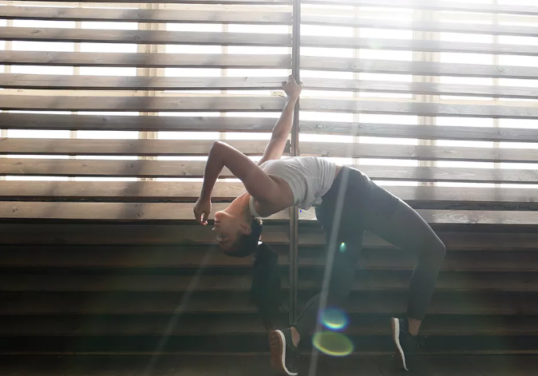

Fitness freaks looking for work out shoes and fitness trackers: Worried about putting on weight? Here’s presenting you with a range of socks and, shoes along with excellent fitness trackers. Eat well, sleep well, squat well and don’t forget to wear your Adidas while doing your jumping jacks. Done? How many calories did you lose? Download our fitness app Runtastic and sync it with your android or iPhone. Get fitter staying home and surprise your friends and family later.

And there is a list of things for all the dreamers:
DO you like looking at the stars, sun included? Do you read books? Do you overthink and fall in rabbit holes to end up in Wonderland every day? Don’t let anything chase away your comfort. There are an endless number of merchandises that you could put on the list, but if you are looking for it, you would definitely find it. Here are a few:
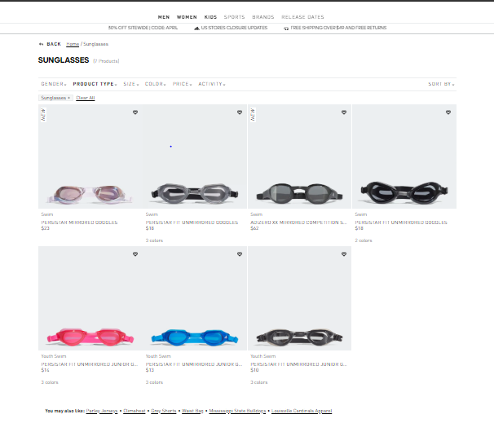
Sunglasses for looking at nature under the glaring sun!

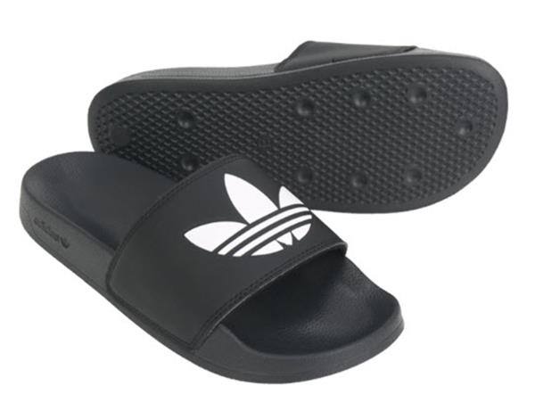
A special slipper for the place where you dream the most
Are you excited to grab the opportunity and meet yourself halfway, while we make an effort from the other side? Feel free to voice call or leave a message on 11-820-301-52. WE apologise in advance for the delay that would be caused due to the lockdown. Stay home.

Blog 3
You cannot get bored when you know how to dance– Dance your days away with exciting Adidas offers
What do you need to be a dancer, the right fitness, the right training or the right training? Well, none of these is true. All you need is a little bit of high spirit. A big shout out to all the dancers out there. You know who you are, staying home and protecting others. As a return gift of all the joys that we had received through the dancers during COVID lockdown and are still receiving through their online videos, Adidas is offering you big hearts a once in a lifetime offer of flat 40% discount on all merchandises that could be used for dancing.
Why is this offer special? There is a general offer going on with up to 40% off, that ends with the purchase. However, with the dancers' purchase, if you already possess videos on social media accounts, attaching the link of the video while proceeding with the purchase would act as a promo code for the merchandise. Irrespective of the degree of professionalism, your videos would have the chance to be selected and be used in a video promoting global dance movement later.
Who is it for?
The ballerina- Do you miss the long stage? Afraid that not you would turn out of practice by the time COVID 19 leaves? There is not much to worry, keep up with your practice with grippy socks being offered at low prices by none other than Adidas. So gear upright for you dancing sessions at home, with yoga pants, tank tops or casual tees.
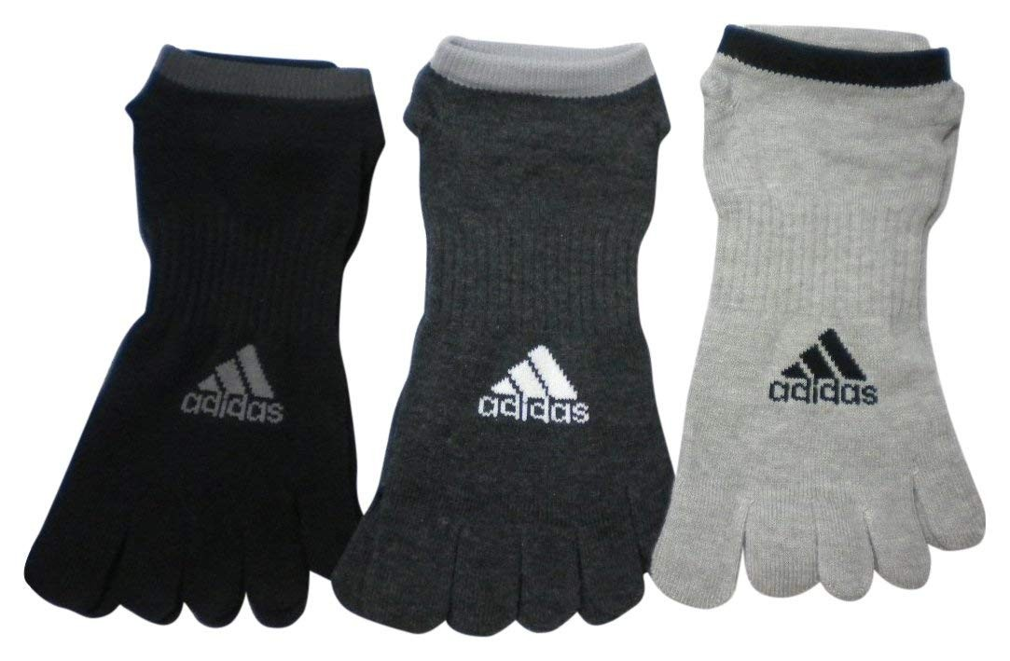

The hip hop: Is hip hop your forte? Well, you must see that you do not hurt yourself while making the moves inside your house. Dance in greater open space and watch out for corners. For gearing up, wear the right shoes that grab your ankle well and do not let it twist. You wear track pants that Adidas has its stock; they are soft and comfortable.

If you want to avail the offer this weekend, visit our homepage, www.adidashomepage.com and look for the merchandise that you want. For further query call us at 11-820-301-52. Till then, stay home and stay safe

Blog 4
The best deal of Adidas is here for all women so get ready to grab the offer and discount (50%)
Hurry up! Adidas is bringing exiting products to fill your wardrobe with trendy and latest clothes. We know that you are facing many problems and cannot purchase clothes for your future plans. For this reason, Adidas is coming with a range of women’s clothes. We are sure that these products will be the perfect addition to your wardrobe. We are going to surprise you by offering a discount of up to 50% on women’s clothes. We know that you guys cannot go outside for shopping due to coronavirus and lockdown. For this reason, we are going to reach the products up to you.
Adidas always takes care of your passion and dressing sense. Therefore, we are going to sale out our women exclusive products at a huge discount. The sale will start from this weekend and will go on till the end of this month. In this sale, many tracksuits, trefoil hoodies and sporty dresses and casuals will be available at a discount upto 50% so that you can choose what you want from these varieties of clothes. We are sure that this sale will be the most beneficial sale for all time in this vital situation.
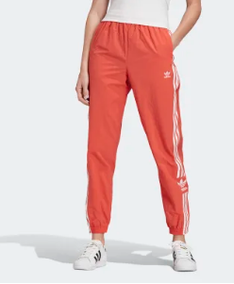
We know that your guys are not able to visit our retail stores due to lockdown until the infection of coronavirus disappears. That is the reason, Adidas is bringing the sale of women originals. The sale will be started on our official website as well as our social media accounts. If you think that the range of prices is still high, then you are wrong. We will enable a discount for all the products are available for women. So that you don't need to worry about it, just be ready to grab the items. The sale will be online so that you guys will get delivered with your product to home.
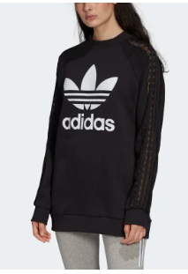
Due to lockdown, delivering process might be affected. There will be a delay for less availability of transportation. However, we will try our best. If you have any question, then you can post your question in the comment section of our post so we can solve it by replying you. Along with this, you can also leave your feedback on our official website so that we will be appreciated. Your feedback will encourage us. You can also contact us by calling our contact number to clear your doubts regarding the sale and offers.

Blog 5
Want to fill your wardrobe? The surprise is here for men from Adidas.
Are you bored with your old collection of the wardrobe? If yes, then Adidas has brought a surprise to you. During the lockdown, you are not able to go outside and shop from your nearest Adidas store. That’s why we are offering you a wide range of men clothing items. That’s it? No, we are coming with a huge discount on men’s clothing. You will be able to purchase stylish, sporty, comfortable and trendy outfits along with sneakers and slippers. All these will be available at a discount upto 35%. Can’t believe it, right? The sale will be started the day after tomorrow and will go on till the month-end.
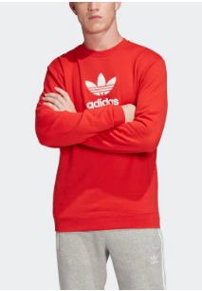
If you are thinking about the budget or you have a tight budget, then it is your time. Grab the deal and fill your wardrobe with the latest and attractive outfits. Adidas always takes care of your needs and values; that's why we present this surprise to you. The discount rate will be available for all the products that are on sale. We make all the payment options available for you. You can pay us with PayPal, internet banking, COD and many other digital payment methods.
Due to lockdown, the sale will be only available online. You will be able to purchase from our official website, which is ‘www.adidas.co.uk’ and Amazon as well. The discount is only available on these sites. Adidas always think about customer satisfaction so that we have another surprise for you. We also offer buy 3 get 1 free on your similar clothing items. If you purchase 3 T-shirts then you can choose another T-shirt for free; however, it should be the same price range. We wish it will be an effective deal for you in this situation.
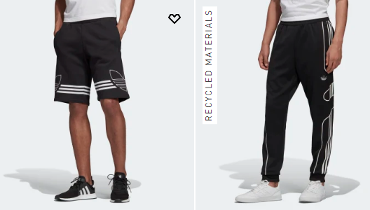
You can also ask your questions or queries by commenting on our posts. It will let us know your needs and how you accept our offers. It will encourage us to bring new offers for you. Due to lock down delivery might be delayed, so don't worry, it will not for a long time. We are hoping that we can fulfil your demands even at this crucial moment. Until the sale gets started, stay safe and stay at home.

Blog 6
Kids and teenagers are getting bored? Adidas brought 30% flat discounted sale for you.
Your kids are getting bored at home, right? Don’t worry! Adidas has brought some exciting deals for you in this lockdown period. Your kids might be bored at home because they cannot go outside. Here you can surprise your kids with some wearables specially made for kids. We are offering you guys, some exiting and valuable deals at a lower price. Adidas always gives you priority; that's why we don't forget your values. We are bringing this golden opportunity for you so that you can purchase these special items for your kids. The most exciting part is the discount that you will get while purchasing. There will be a 30% flat discount on all the products that are on sale.
We always care about you and your values. That’s why these products will be available on our official website as well as on our social media pages. We care about your budget so that it will not be the biggest issue for you anymore. 30% flat discount is available everywhere the sale will be going. So Hurry up! What you are waiting for, keep your money ready. This offer is only for this lockdown so be prepared for this sale. The offer will be visible to you at the end of this weekend. It will go on till the next weekend. It means the sale will be for 1 week. So you have a lot of time to think and grab these deals.
Are you thinking that we are just offering products in this sale for kids only? No friend that is not true. The surprise is not ended here. We are coming with a range of products for kids as well as for young adults. T-shirts, pants, shirts, sweatshirts and jackets, all these wearables will be available for both kids and young adults. We always care about your passion so that the products will be trendy and attractive. The exciting part is, the discount will be available for all the products on sale. You don’t need to go out to our stores and purchase; we can order online from our website and other social media platforms as well. We always have a prime motive to fulfil your expectation and passion even in this crucial time. You don’t need to compromise yourself because we are providing a huge discount for you.

We wish that you will be satisfied with our initiative during this crucial time. If you have any queries regarding the sale and the availability so you guys can let us know by leaving a comment on the comment section of our posts on social media, you can also appreciate our initiative by giving feedback on the review section of our official website. Due to lockdown and you might not get your delivery on time because of the transportation issue. For this reason, you can call us by clicking the option ‘contact us’ on our official website so that you can interact with our customer service representative. Stay safe and stay at home during this crucial period.
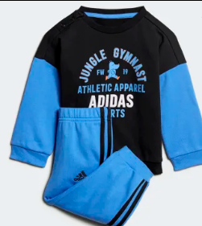

Blog 7
Can’t find any way to increase strength? The deal is for you fitness freaks and athletes.
Are you a fitness freak? Are you a sports person? Then this is the tough time for you guys during the lockdown. Now, Adidas is coming to make you tension free regarding your fitness. We know that you are not able to train yourself properly, as everybody knows that we are always fulfilling everyone's demands. That’s why we are going to offer you a huge discount on gym equipment so that you will be able to exercise at home. You will get upto 60% discount on gym equipment from this weekend. The sale will be going for 2 weeks from the end of this weekend. We know that freehand exercise is not enough for the weight lifters. That is the reason, we are bringing this attractive sale for you.
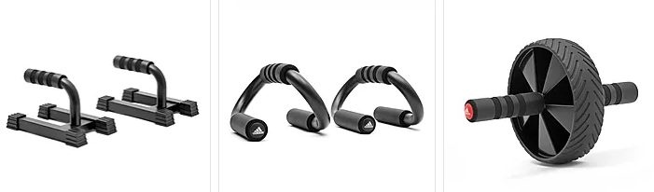
Adidas always care about you and always try to offer the best deal for you. Even we know that you are facing many issues during this lockdown because of coronavirus. It cannot be predicted when the virus disappears. For this reason, we are coming with a range of fitness equipment related to weight lifting and freehand. We are going to offer utility bench, ankle/wrist weights, AB wheels, Push up and pull up bars, skipping ropes including fitness belts. We will also offer health trackers such as sweat and waterproof fitness bands. All this equipment you will get at a discount upto 60%. We know how strength is essential for a sportsperson as well as a fitness freak. That's why we are coming with these exciting offers for you.


We always care about our customers and their values. Your passion and values are priorities for us. We wish that you can stick to your passion, even in this worse situation. The sale will be available on our official website as well as the social media platforms so that you can buy products as per your choice from the sites. We know the difficulties that you are facing during this lockdown. For this reason, we have another surprise for you guys. You can pay 50% of the total amount initially on your purchase and the rest 50% after a month. We think that it will make it easy and valuable to your purchase experience. For making the deal more valuable, we are providing these offers to you so you can continue your training and increase your strength even in staying at home.
We are hoping that these offers will be too much exiting for you. Even we are planning for new surprises for you when the situation gets under control, and the virus disappears. However, transportation is not good in this situation so there will be a delay in your delivery, but we will try our best. If you guys have any questions, then let us know by giving us feedback on our official website or our social media pages. You can also contact us by calling our customer service number to clear any query of yours. Keep your cash ready for the most valuable deal and stay safe till then.

Reference List
Abedi, G., Rahmani, Z., Abedini, E. and Rostami, F., 2015. Surveying the impact of services marketing mix components (7Ps) on patients’ disposition towards the public & private hospitals of Sari City. Journal of Hospital, 13(4), pp.63-71.
Arif, M.Z.U., 2016. Using the 7Ps of Booms and Bitner as Controllable Tactical Marketing Tools: An Exploratory Study on Selected Super Shops in Bangladesh. International Journal of Trade and Commerce-IIARTC, 5(1), pp.12-29.
Boonpradub, W. and Thechatakerng, P., 2015. Brand endorsement by celebrity in Thailand: 7Ps of marketing mix and the impact of brand alliance. International Journal of Trade, Economics and Finance, 6(1), p.8.
Kiessling, T., Isaksson, L. and Yasar, B., 2016. Market orientation and CSR: Performance implications. Journal of Business Ethics, 137(2), pp.269-284.
Kotler, P. and Armstrong, G. Parment, A, 2016. Principles of marketing: Scandinavian edition. Pearson Education Limited.
Michael, M., 2016. Actor-network theory: Trials, trails and translations. Sage.
Nuseir, M.T. and Madanat, H., 2015. 4Ps: A strategy to secure customers' loyalty via customer satisfaction. International Journal of Marketing Studies, 7(4), p.78.
Ryan, K., Communications Explored.
Seturi, M. and Urotadze, E., 2017. About Marketing Process Model and Relationship Marketing. In Proceedings of International Workshop, Model-Based Governance for Smart Organizational Future (pp. 169-171).
Widi Astuti, R.I.N.A., 2016. Pengembangan Social Media Marketing Dengan Pendekatan Sostac Model Untuk Meningkatkan Strategi Pemasaran (Studi Kasus Usaha Mikro Kecil Dan Menengah Waleu Kaos Lampung). Skripsi.
Wijaya, P.K. and Hermawan, A., 2018. E-Marketing Applications Based On Virtual Reality Using Sostac Planning Method On Sales Property. Tech-E, 1(2), pp.16-25.

