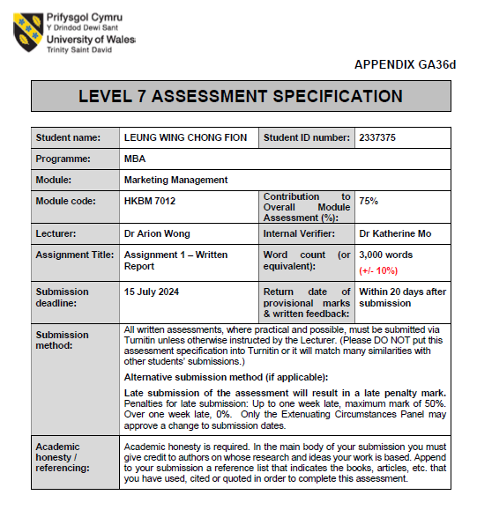


UWTSD MBA
HKBM7012 Marketing Management

Nestlé Hong Kong Limited – NESCAFÉ®

Student Name | ： | LEUNG WING CHONG FION
Student ID Number | ： | 2337375
Date of Submission | ： | 15 July 2024
Lecturer | ： | Dr. Arion Wong

Executive Summary

This study seeks to explore the marketing management of Nescafé, a prominent brand owned by Nestlé, within the Hong Kong market. Nescafé has long been an influential player in the coffee industry, and its global presence has positioned it as more than just a coffee brand, but rather as a facilitator of meaningful connections in consumers' lives. Upon entering the local Hong Kong market, an analysis of the macro and microenvironment will be conducted using the PEST framework, considering the impacts of local policies, political dynamics, global economic conditions, and changes in China's tourist policies on the company's strategies and operations. The newest global marketing slogan "Make Your World" reflects Nescafé's commitment to engaging with a broad customer base and building sustainability as commitment to the world. The study will also delve into the Segmentation, Targeting, and Positioning strategies for Nescafé in Hong Kong, with a focus on identifying competitive opportunities and challenges within the local market. Utilizing marketing mix tools will allow for an assessment of the current market situation, competitive envrionment in Hong Kong and the identification of potential areas for improvement. Further insights will be gained through a SWOT analysis, conduct to understand NESCAFÉ®’s internal strengths and weaknesses and external opportunities and threats that enabling the formulation of recommendations for feasible strategies to enhance customer engagement and drive sustainable sales growth for Nescafé in Hong Kong.

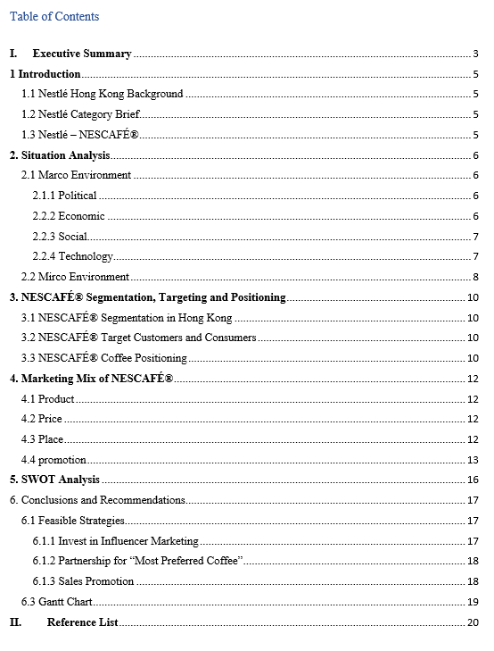

1 Introduction
Introducing Nestlé, the Swiss-based multinational food and beverage giant. With roots dating back to 1866, Nestlé has been expanding globally since 1990 and achieved organic growth 7.2% with 93 billion CHF in gross sales in 2023 (Nestlé, 2023).

1.1 Nestlé Hong Kong Background
Nestlé Hong Kong supplies a wide range of food and beverage products, including chilled and ice cream, coffee drinks, confectionery, cooking, pet foods, and healthcare nutrition items (NESTLÉ HK eShop, n.d.).

1.2 Nestlé Category Brief
Nestlé's global business includes 120 brands across 7 food and beverage categories. Powered and Liquid Beverages represent 24.8% of total Nestlé business, with NESCAFÉ® as the key contributor (Nestlé, 2023). Hong Kong is under Zone Grater China that representing 5.5 billion CHF ranked number 5 globally (Nestlé, 2023).
The coffee market is divided into whole-bean, ground coffee, soluble coffee, and capsules (www.linkedin.com, n.d.).

1.3 Nestlé – NESCAFÉ®
NESCAFÉ® is a flagship brand of Nestlé, it born by Morgenthaler created a powder rather than a cube that is convenience while a result much more like coffee bean, after 7 years development and the soluble coffee was launched (Nestlé, n.d.). Instant coffee is a beverage derived from brewed coffee beans that also called soluble coffee. NESCAFÉ®, from Nestlé, offers a wide range of coffee options for soluble coffee in Hong Kong, from Classic to Gold Blend in terms of premiumization, Sprays Dry, Freeze Dry to serve manufacturing process, and Premium White Coffee.

2. Situation Analysis
To identify the opportunities and challenges for both internal and external for Nestlé, it will further review on macro and microenvironment that impacting the company strategy formulation for local market (Guthrie, 2022).

2.1 Marco Environment
PEST analysis of NESCAFÉ® which review for Hong Kong business environment for political, economic, social, technological factors. It may impact on the decision for marketing mix set up and execution.

2.1.1 Political
NESCAFÉ® proudly holds the title for the largest global coffee footprint, with a presence in over 180 countries (Nestlé, 2023). It's crucial to recognize that any changes in regulations and policies can significantly impact the brand and its operations. Take, for example, the MSW charging implemented by the Hong Kong Environmental Protection Department, which is tied to legislative requirements and penalties, could potentially lead to increased costs for the Hong Kong office. These changes are directly linked to HKSAR policies or regulations updates, political stability, and other political forces that may impact the business environment. Just recently, Beijing raised the duty-free limit for mainland Chinese tourists in Hong Kong to HK$16,100 (SCMP, 2024a). It's essential to acknowledge that the policies from China also have a substantial impact on Hong Kong's business environment, while the limitation on tourists is critical.

2.2.2 Economic
Hong Kong's dynamic economy is underpinned by a free flow of capital, a robust legal framework, open trade policies, and competitive tax rates, creating an attractive environment for businesses to thrive. It is imperative to closely monitor the Consumer Price Index and GDP data to inform pricing strategies, particularly in light of reports indicating a reduction in the wealth gap in Hong Kong over the past 15 years (SCMP, 2024b). Furthermore, global raw material pricing significantly impacts procurement, resulting in heightened costs of goods sold and internal transfer prices, as evidenced by the coffee commodity market (as depicted in figure 2.1). These factors wield substantial influence over pricing strategies globally, significantly impacting the financial performance of businesses in Hong Kong.
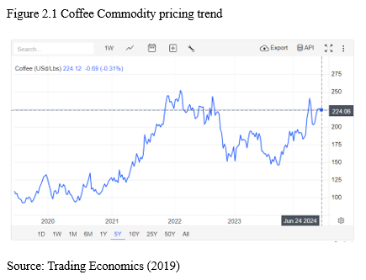

2.2.3 Social
While Nestlé is a global brand, NESCAFÉ® is tailored locally to appeal to the preferences of Hong Kong consumers. With the growing health consciousness in Hong Kong (Hong Kong, 2019), Nestlé is committed to unlocking the power of food to enhance the quality of life for everyone (Nestlé, 2023). Moreover, high pressure and its impact on health are pressing issues in Hong Kong, making it crucial for NESCAFÉ® to address these concerns in their promotional efforts (April International, 2022).

2.2.4 Technology
Nestlé is blazing a trail into the future with bold investments in innovation and entrepreneurship. By allocating resources to research and development on a global scale, we aim to enrich local markets with cutting-edge digital technologies, artificial intelligence (AI), and dynamic e-commerce development. These initiatives will be powered by the robust resources of Hong Kong, enabling us to swiftly bring new products to market, providing a significant advantage (Nestlé, 2023). There are some researches were on-going talking about coffee consumption will affecting health (Hu, 2021).
The PEST analysis of Nestlé offers invaluable insights into how this global food and beverage powerhouse successfully navigates its business landscape. On the political, Nestlé consistently adapts to changing regulations and trade policies, ensuring compliance and optimizing its supply chain in Hong Kong. Economically, the company's financial agility and pricing strategies remain finely tuned to navigate market fluctuations and diverse to local consumer spending habits.
Nestlé's unwavering commitment to understanding and catering to evolving consumer preferences and dietary trends in the social sphere underscores its relentless focus on innovation and consumer trust. Embracing technological advancements is pivotal for maintaining operational efficiency and competitive edge. Nestlé's strategic adaptability and showing commitment to long-term success Hong Kong.

2.2 Mirco Environment
Nestlé's commitment to "Good food, Good life" encompasses more than just nutritional values (Nestlé, 2023). The Value Chain Analysis offers valuable insights into Nestlé's operations and processes (Sloovi, 2023). Hong Kong, as part of Nestlé's Greater China Zone, accounts for a 6% share of the business (Nestlé, 2023). Consequently, Hong Kong may face challenges in developing its own unique product recipes.

Figure 2.2 illustrates how Nestlé Hong Kong receives robust support from the global organization to drive local business activities (Nestlé, n.d.).
Nestlé Hong Kong, as a multinational company, has established robust internal support activities aimed at unleashing the local market potential. This includes firm infrastructure, human resources management, technological development, and procurement. In the area of inbound logistics, Nestlé focuses on driving compliance and sustainability by sourcing coffee and cocoa from smallholder farmers. Maintaining high standards of food safety and quality is non-negotiable, and Nestlé is committed to fundamental engagement with consumers. For outbound logistics in Hong Kong, the company relies on 3PL suppliers to meet local demand. In terms of marketing and sales, NESCAFÉ® provides end-to-end marketing services tailored to the Hong Kong market, while the sales team focuses on enhancing the shopper experience and determining route-to-market strategies. Internally, Nestlé engages with employees, business partners, and community members, while externally, the company is dedicated to helping people lead better lives through its "Good Food, Good Life" objective (Nestlé, 2023).
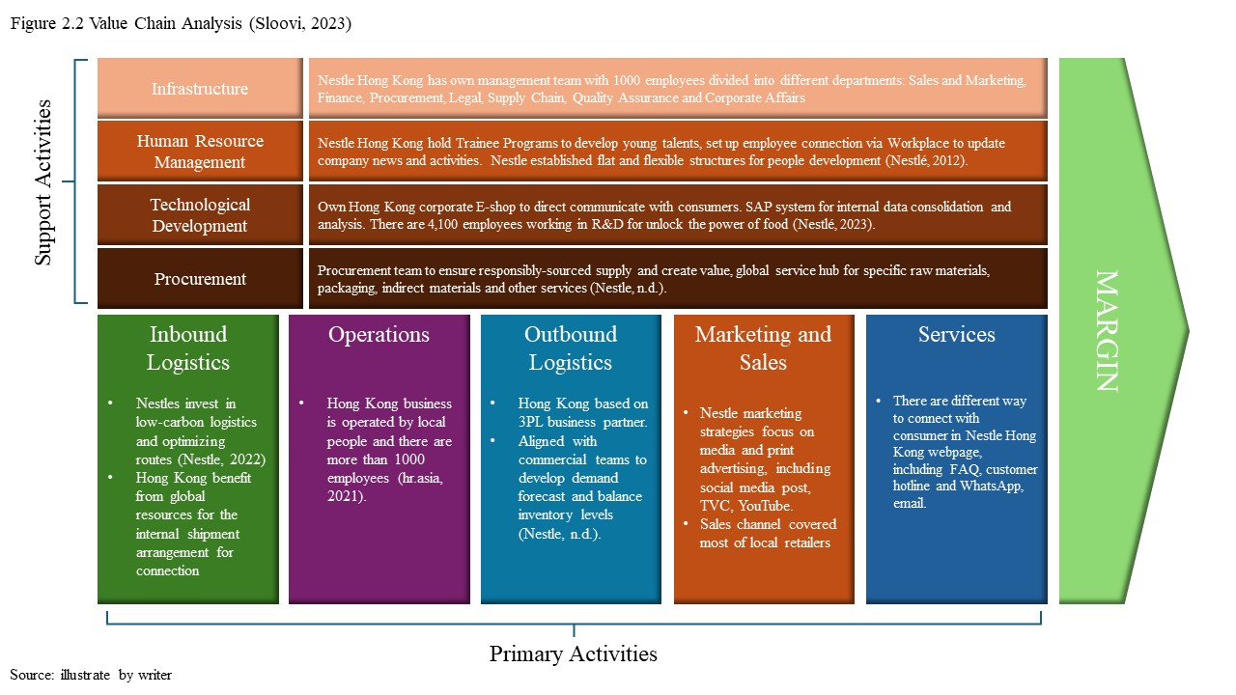

3. NESCAFÉ® Segmentation, Targeting and Positioning
The STP marketing model (Segmentation, Targeting, Positioning) is a powerful and widely recognized strategic approach that prioritizes commercial effectiveness. By carefully selecting the most valuable customers for a business, this model facilitates the development of targeted marketing mix strategies (Hanlon, 2024).

3.1 NESCAFÉ® Segmentation in Hong Kong
As a large market for coffee consumers, NESCAFÉ®'s segmentation in Hong Kong should consider all demographics, not just gender. It will only segment on age over 12, this is in line with the recommendations from the HKSAR Center of Food Safety, which advises special caution for vulnerable groups such as children, pregnant and lactating women, and individuals with lower caffeine tolerance (Center of Food Safety, 2013).

3.2 NESCAFÉ® Target Customers and Consumers
NESCAFÉ®'s main target customers are coffee enthusiasts looking for a quick and quality coffee solution for home consumption. NESCAFÉ® emphasizes product offer enjoy at one's convenience. Apart from the classic flavor, NESCAFÉ® offers a range of flavors to cater to diverse customer preferences, including options for both hot and cold energizing soluble beverages.

3.3 NESCAFÉ® Coffee Positioning
NESCAFÉ® Coffee differentiates its products to gain a competitive edge, holding the largest market share in instant coffee due to its product quality and the perceived value to the customer. Figure 3.1 showing that the price & quality in market. NESCAFÉ® with different product line to capture mid to high level customers.
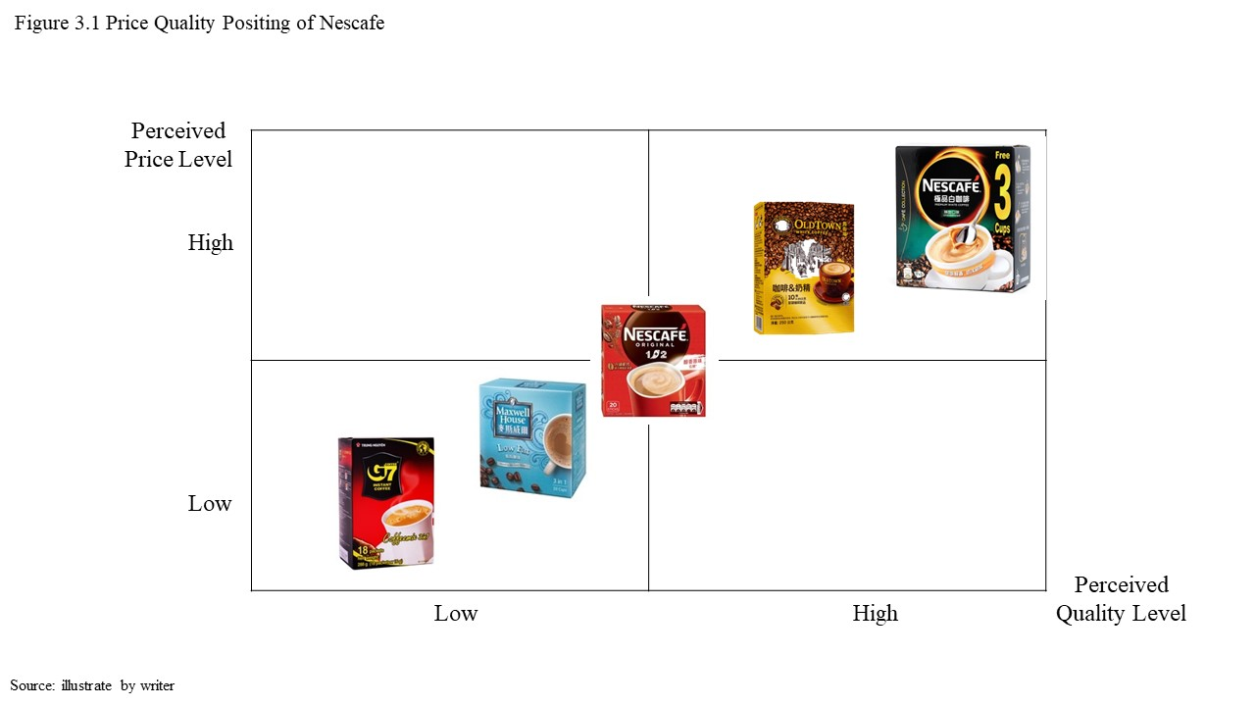

4. Marketing Mix of NESCAFÉ®
The marketing mix of NESCAFÉ® that analyzes the farmwork covers the 4Ps (Product, Price, Place and Promotion).

4.1 Product
In Hong Kong, NESCAFÉ® has extensive product portfolio to satisfy the consumer taste profile, offers a wide range of coffee blends, including NESCAFÉ® Original, Gold Blend, and Decaf. In addition to classic choices like Espresso and Latte, NESCAFÉ® also offers innovative trend coffee such as premium white coffee from ASEAN, catering to various preferences.

4.2 Price
NESCAFÉ®'s pricing strategy is designed to outperform competitors in various market segments (see Figure 3.1). NESCAFÉ® is positioned at a premium price point, ensuring strong perceived value compared to other brands in the same range. Same to other fast moving consumer goods (FMCG) products, it offers price discounts and promotions in retailers, current pricing strategy of NESCAFÉ® in market are consumer friendliness while maintaining a solid brand image.

4.3 Place
NESCAFÉ® in Hong Kong has strategically implemented the FMCG distribution approach, a highly effective channel for reaching a wide consumer base due to its visibility and availability. To ensure consumer access, NESCAFÉ® has secured partnerships with major supermarkets such as ParkNShop, Wellcome, AEON, APITA, and UNY. This distribution network has also been extended to include convenience stores, making sachet packs easily accessible and boosting overall consumption.

4.4 promotion
Nestlé has revolutionized its marketing strategy beyond traditional channels like TV commercials, print ads, bus-body, and in-store posters with the brand-new powerful slogan "Make Your World" (Nestlé, n.d.) embracing Figure 4.4.1. This encapsulates Nestlé's marketing campaign, focusing on the well-being of people and the planet. NESCAFÉ® has effectively utilized promotional strategies, establishing a strong presence in the minds of its vast consumer base. A common theme observed in these campaigns is storytelling, leveraging narratives that deeply resonate with the audience. At its core, Nestlé's strategy underscores sustainability and ethical sourcing, enhancing its image of social responsibility. Nestlé also actively empowers farmers by co-investing in their operations and providing essential equipment through strategic loans (Nestlé, 2023). In anticipation of new product launches, the company is set to harness the influence of celebrity endorsements for impactful communication, aligning these efforts with in-store visibility programs.

The recent marketing campaign strategically leveraged the influence of renowned personality Sean Lau to engage consumers with a preference for distinctive Malaysian flavors. This initiative effectively showcased the launch of the new 'Tarik' product (Figure 4.4.2) and secured a position among the top 3 advertisements on the NESCAFÉ Hong Kong page. Additionally, the campaign achieved notable visibility on YouTube (Figure 4.4.3).

Nevertheless, the lack of robust digital marketing data in Hong Kong poses a challenge for comprehensive evaluation. As a globally embraced brand, NESCAFÉ Hong Kong would benefit from enhancing its digital marketing strategy, notably across various social media platforms.

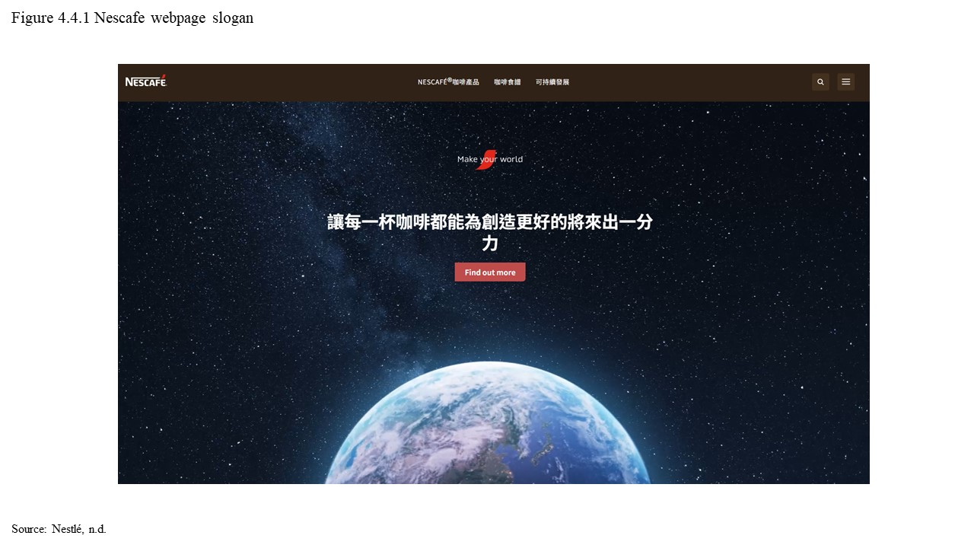
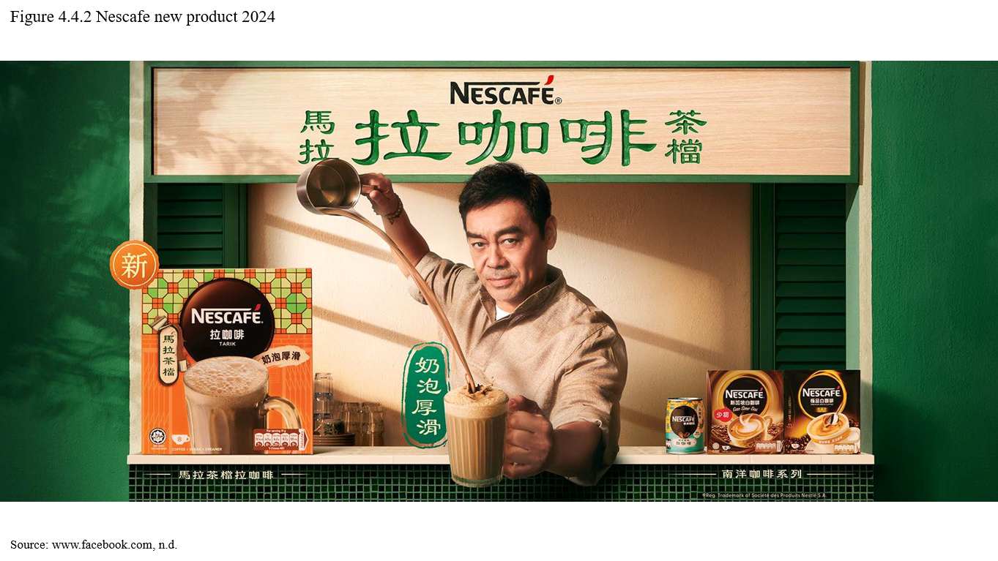
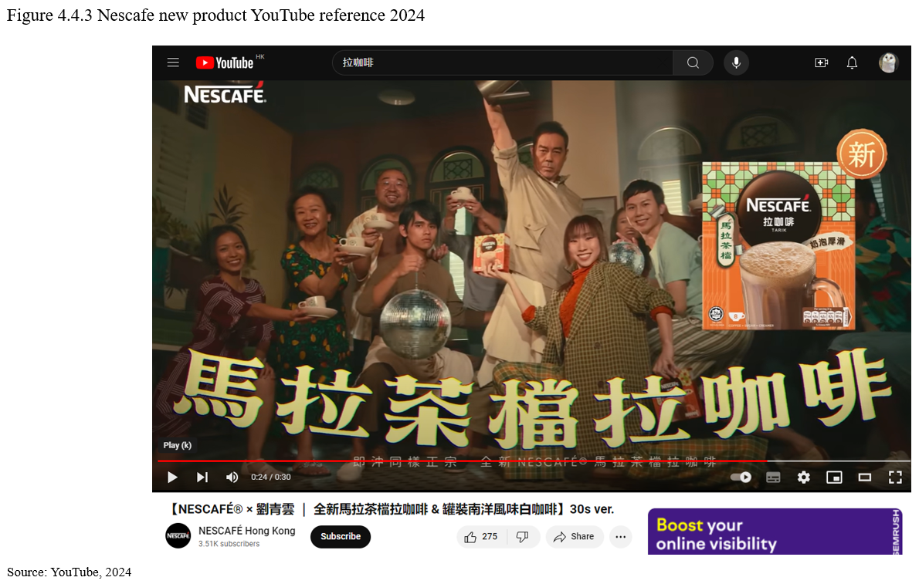

5. SWOT Analysis
"SWOT (Strengths, Weaknesses, Opportunities, and Threats) analysis is an influential and internationally recognized strategic tool. In academic spheres, SWOT analysis has withstood the test of time as a valuable approach for evaluating internal and external factors impacting an organization's strategic planning" (Puyt, Lie, and Wilderom, 2023).

Following an assessment of the macro environment, microenvironment, and marketing mix evaluations, NESCAFÉ® in Hong Kong has amassed robust global support and is positioned for further expansion in the local market. To mitigate its weaknesses, it is imperative for NESCAFÉ® to cultivate customer engagement in order to confer additional value to consumers and stimulate consumption, connect with customers by leveraging social media to enhance share of voice in market. Furthermore, with Hong Kong operating as a free trade region, competition from international counterparts or rival brands could swiftly encroach upon the market. Despite this, NESCAFÉ® possesses formidable brand equity and should concentrate on pioneering distinctive initiatives to foster consumer loyalty.
To Summarize the evaluation in PEST analysis, value chain analysis and marketing mix, figure 5.1 show the SWOT for NESCAFÉ® Hong Kong market.
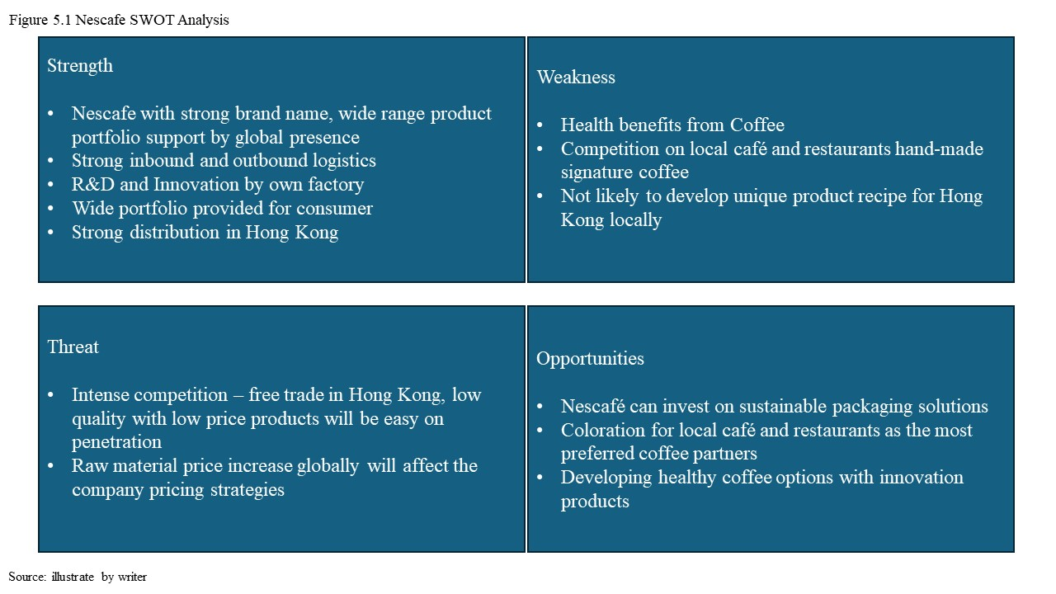

6. Conclusions and Recommendations
In conclusions, Nestlé is the world's largest food & beverage company, Nestlé Hong Kong can win in global supports especially on R&D. NESCAFÉ® with wide product portfolio to fulfill difference customer needs on coffee experience, instant coffee provides convenience and economy especially for Hong Kong people who are busy at work or studies.
To further strengthen market image and the customer loyalty, NESCAFÉ® can further explore the local corporation. Hong Kong boasts a bustling and diverse coffee culture. Many residents start their day with a cup of coffee, making it an integral part of their routine. NESCAFÉ®'s SWOT analysis highlights several key areas for potential development. To maximize engagement with customers and consumers, it is recommended to utilize differentiated above-the-line and below-the-line strategies.

6.1 Feasible Strategies
Influencing strategic decisions involves prioritizing the creation and delivery of superior value to customers in comparison to competitors. It is essential to recognize that customers are the ultimate arbiters of success in the marketplace. Leveraging the robust NESCAFÉ® brand necessitates the further development of partnerships and enhancing in-store visibility to impress consumers and build brand loyalty.

6.1.1 Invest in Influencer Marketing
In recent years, the e-commerce industry has experienced significant growth, especially in the coffee market. As a leader in this market, it is crucial to prioritize customer satisfaction. One effective strategy is to establish an E-shop and a YouTube channel that provides valuable and informative content (Bosch, 2023). By consistently updating customers about NESCAFÉ® activities, we can actively engage with our customer base. According to the report, 67% of consumers are willing to pay more for a superior experience, and 80% believe that the overall experience a company offers is just as vital as its products (Bosch, 2023).
In response to the increasing demand for healthier food options in Hong Kong, it is vital to enhance consumer engagement by leveraging NESCAFÉ®'s strong brand equity and highlighting the many benefits of coffee (Havrén, 2019). NESCAFÉ® can harness online platforms to effectively communicate the unique advantages of coffee and cultivate more opportunities for consumer usage, currently owning the morning moment and it can further build up the occasional including teatime, friend gatherings, and parties. By harnessing digital marketing channels such as Instagram and Twitter, NESCAFÉ® can establish a strong presence and influence among consumers.

6.1.2 Partnership for “Most Preferred Coffee”
Nescafé can explore to form some strategic partnerships with local cafes, Western restaurants, and hotels to showcase its products as the preferred coffee option on their menus. This initiative could significantly boost market penetration and elevate brand visibility. By collaborating with micro-influencers in the food and lifestyle categories and creating compelling content to entice consumers, Nescafé can generate excitement, drive trial, and stimulate word-of-mouth promotion across various social media platforms (Aaker and Moorman, 2023).

6.1.3 Sales Promotion
The effectiveness of a sales promotion can be examined by decomposing the sales “bump” during the promotion period into sales increase due to brand switching (Caughlin, 2022). Hong Kong presents itself as a sophisticated and mature market with a strong demand for gourmet products. While the majority of customers prioritize value for money, they are also open to investing in new and high-quality items.

Coupons
Coupons, as traditional advertising tools, are presented by consumers during payment. Considering the increasing prevalence of smartphones (Caughlin, 2022), Nescafé should contemplate the provision of digital coupons, which can be disseminated to customers through the company's website or direct email newsletter tailored for loyal consumers. Digital coupons serve as compelling incentives to prompt potential customers to patronize a business. Furthermore, the imminent expiration of a coupon can impart a sense of urgency to prospective clients.
Holiday Promotions
During the holiday season, many individuals seek the perfect gifts for their loved ones. Nescafé can play a significant role by promoting its products as ideal gifts for popular occasions such as Chinese New Year, Valentine's Day, Easter, Mid-Autumn Festival, and Christmas. This approach has the potential to boost sales revenue, while also attracting customers with enticing sales and promotions during these festive periods.

6.3 Gantt Chart
Gantt chart is one of the most common chart tools for illustrates graphic a project schedule (Teamgantt, 2019). For Nescafé project, there are some activities will be re-run such as sales promotions Coupons and Holiday promotions are depending on the result, occasions. For the long-term partnership such as build the “Most preferred Coffee” that will be work on preparation stage before start.

Reference List


