Master of Business Administration
Module: Marketing Management (LCMB7024)

Assessment Component 2: Marketing Portfolio

A Strategic Marketing Portfolio for the Launch of 'Patagonia Provisions Home'

Submitted to: | Dian Mayasari
Submitted by: | Jahangir khalaj savojbolagh
Student ID: | 2109914
Date of Submission: | 19 November 2025
Word Count: | 2,500

1.0 Introduction 2
2.0 Element 1: STDP Analysis for Patagonia Provisions Home 2
2.1 Introduction to Patagonia and the New Brand Concept 2
2.2 Market Segmentation 3
2.3 Target Market Selection 4
2.4 Positioning and Differentiation Strategy 4
3.0 Element 2: Patagonia Provisions Home Marketing Mix 5
3.1 Product Strategy 5
3.2 Pricing Strategy 6
3.3 Place (Distribution) Strategy 6
3.4 Promotion Strategy 7
3.5 People Strategy 7
3.6 Process Strategy 8
3.7 Physical Evidence Strategy 8
4.0 Element 3: Marketing Strategy Pitch Summary 8
5.0 Element 4: Reflection 9
5.1 Reflection on Brand Concept and Strategy Development 9
5.2 Pitch Preparation and Delivery Reflection 10
5.3 Key Skills Developed and Future Improvements 10
6.0 Conclusion 11
7.0 References 11
Appendix 14

1.0 Introduction
Today’s market environment is marked by a paradigm shift in consumerist values, shifting from materialistic to value-based consumerism, as customers increasingly tend to make buying decisions in consideration of social, moral, as well as environmental values (Pappas, 2022). The following portfolio entails an integrated marketing plan for creating, as well as launching, a brand, namely ‘Patagonia Provisions Home,’ by an already established brand, namely Patagonia, Inc.—an outdoor apparel brand.
Given the brand’s proud past in environmental activism and producing long-lasting products, it is only apt for Patagonia to carry this brand spirit into the home products industry. This report critically assesses the critical marketing mix strategies needed for leveraging this brand expansion strategy, which rests upon an analysis of Segmentation, Targeting, Differentiation, and Positioning (S-T-D-P)
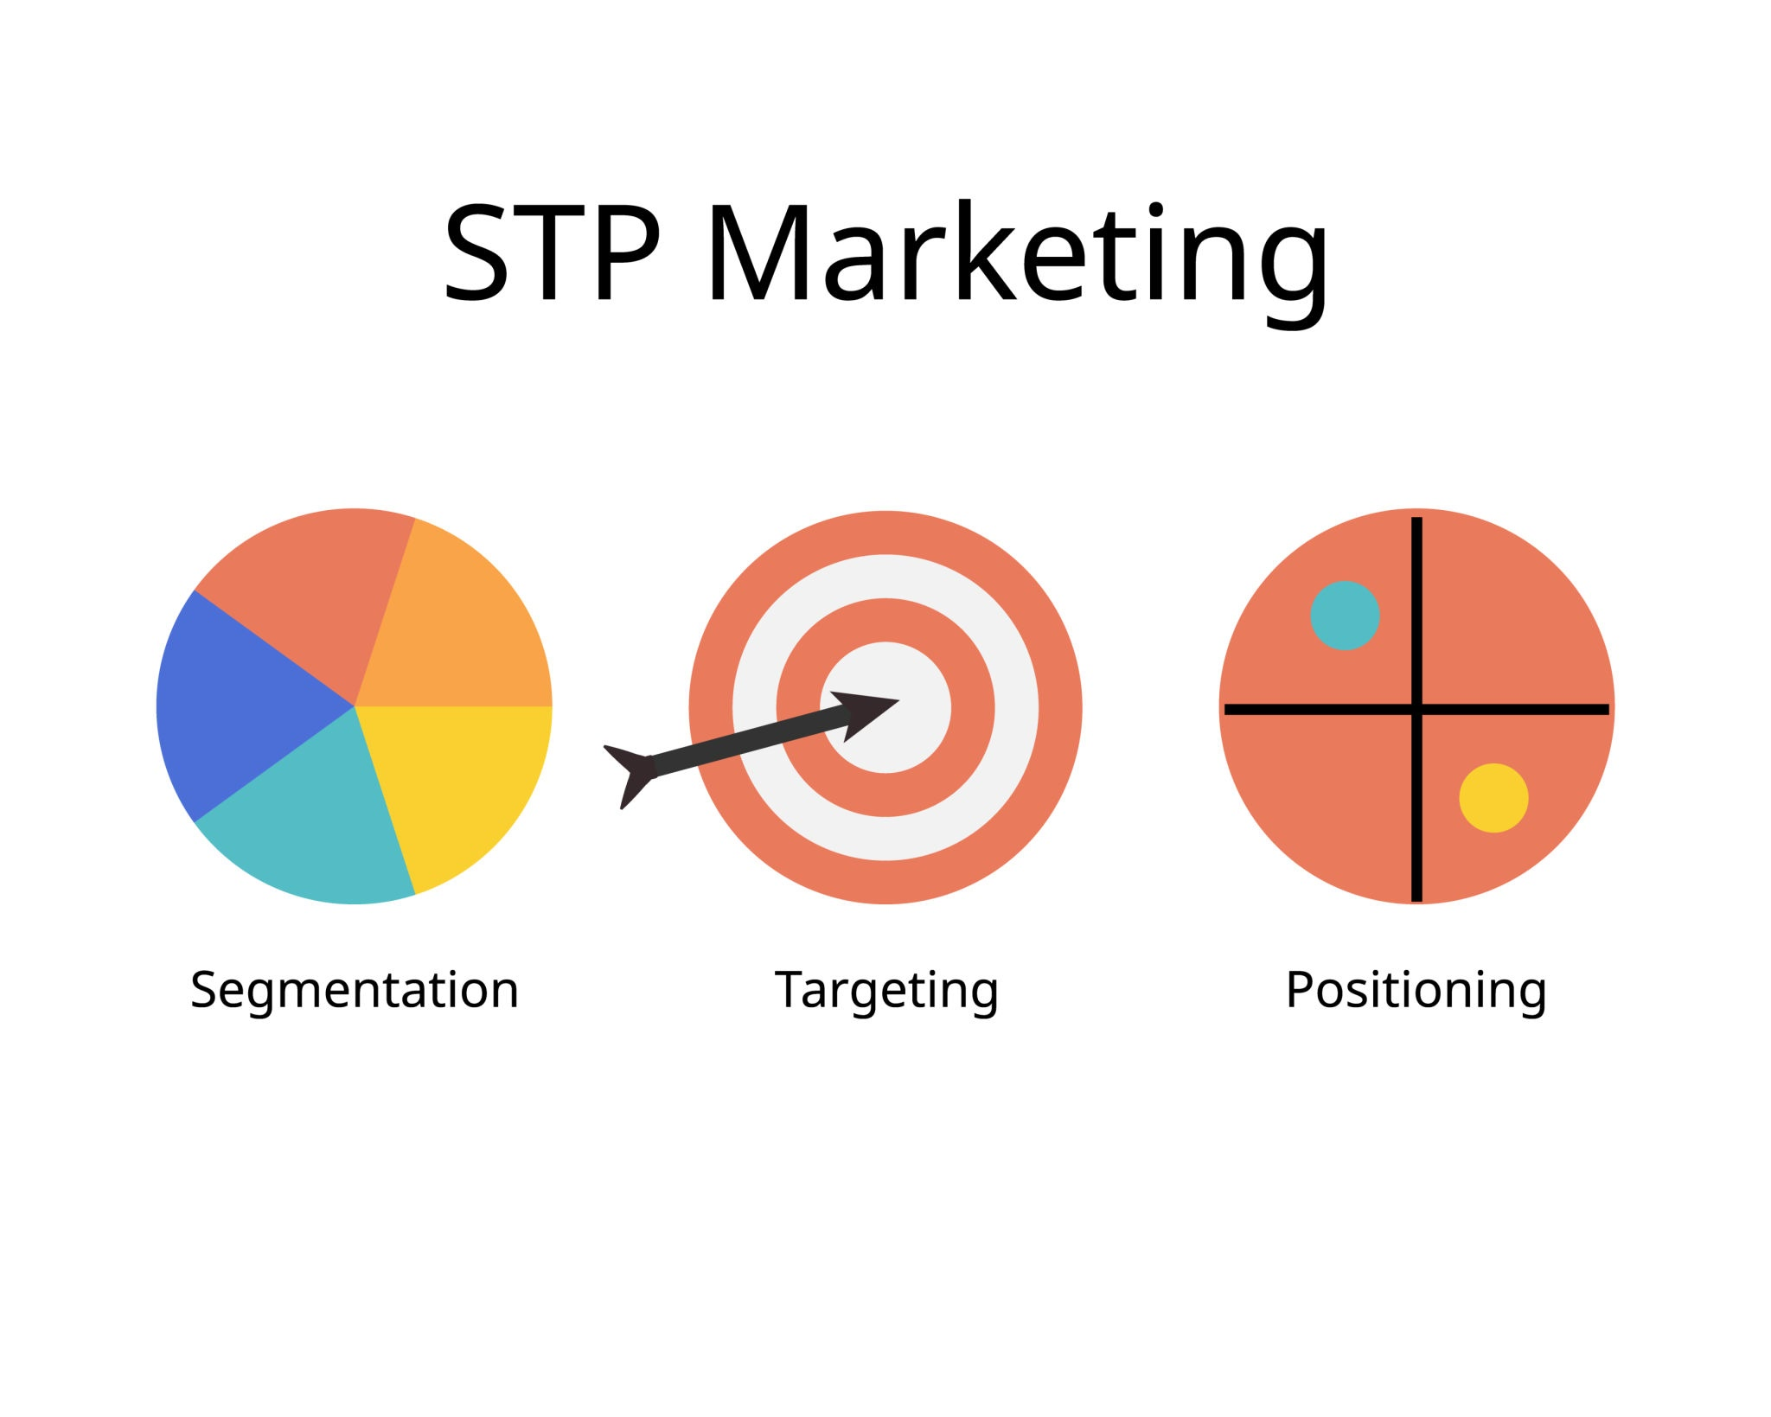
Figure: STP Marketing (Source: Shutterstock, 2025)
The portfolio contains an overview of a marketing persuasion presentation as well as a critical analysis of the STDP process, which incorporates the attainment of learning outcomes of analyzing marketing performance and analyzing future market development (University of Wales Trinity Saint David, 2024).

2.0 Element 1: Analysis of STDP for Patagonia Provisions Home

2.1 Introduction to Patagonia and the New Brand Concept
Patagonia
Yvon Chouinard’s company, Patagonia, Inc. established this strong brand identity for Patagonia based upon the slogan, "We’re in business to save our home planet" (Patagonia, 2023). The reason for Patagonia, Inc.’s existence stretches beyond corporate social responsibilities in order to form a platform for product development as well as marketing communications (Schoultz, [Year missing]).
The proposed brand concept, ‘Patagonia Provisions Home’, is an extension of success as well as an ideology of the established food brand, ‘Patagonia Provisions’ itself, as an endeavor of providing sustainable, responsibly produced, and long-lasting home commodities such as organic cotton home textiles, recycled glassware, non-toxic household cleaners, as well as sustainably harvested kitchenware.
This is meeting a demand for sustainability and transparency in the home, which reflects consumers who feel that it is a value they themselves express (Haller et al., 2021). The brand is leveraging the credibility that Patagonia has already established, which decreases risks known to result in expansion into a different market (Aaker, 2009).

2.2 Market Seg[mentation]
A segmentation strategy would also be critical in achieving success in targeting customers in the home products industry (Dibb & Simkin, 2010). In the case of Patagonia Provisions Home, a multi-variate segmentation strategy is deemed to be most appropriate, taking into consideration variables of both psychographic, demographic, as well as other behavioral variables.
Psychographic Segmentation
This is the most common basis for segmentation. The target consumer is part of what is known as LOHAS (Lifestyles of Health and Sustainability), which is a marketplace for people who both consume and sell products and services in relation to health, the environment, social justice, personal development, and sustainable living (Gleim et al., 2013). The customer is value-based, seeks information about products, as well as being prepared to pay more for ethically produced products.
Demographic Segmentation
This segment likely to include millennials (28-42 years of age) and older Gen X (43-55 years of age) who would be in the process of moving in, renovating, or have already completed this phase, who tend to have higher-than-average disposable income as well as an equal level of higher education, which is in sync with increasing environmental consciousness (Trivium Packaging, 2023).
Behavioural Segmentation
This type of segmentation is concerned with buying behaviour. The targeted consumers fall in to high involvement buyers who carry out in-depth research before they make a purchase. They are brand loyal customers of those brand’s which have prviously indicated dedication to customers' espoused values, whose prime interest in products lies in their usefulness rather than in low pricing (Keller, 2013).

2.3 Target Market Selection
Of those, a focused marketing strategy shall be employed for those who fit an overarching target market category, namely, the ‘Ethical Maximalist’ consumer, who seeks to maximize what they get from consuming in every possible way. This person is no minimalist; they enjoy good design, performance, but at no environmental, ethical expense (Carrington et al., 2014).
This category is also underserved by current home furnishings companies, who identify with only one attribute (e.g., using only organic materials) rather than an open system of production in total as a brand value. By positioning in this category, Patagonia Provisions Home also has the potential to create an intensely loyal customer community of brand ambassadors who spread the word about this brand as evangelists, which is an incredibly powerful catalyst for organic brand development (Grewal & Roggeveen, 2020).

2.4 Positioning and Differentiation Strategy
Differentiation involves creating both tangible and intangible differences between an organization’s offering and those of competitors (Kotler & Armstrong, 2021). Finally, differentiating Patagonia Provisions Home in this manner is based on three facets:
- Regenerative Sourcing: As if 'sustainably' sourced wasn’t communicative enough, this brand is also going to highlight regenerative organic methods (e.g., from recycled materials). This is a strong differentiator at a product level, which, quite obviously, communicates greatly about climate benefits (Rhodes, 2017).
- Radical Transparency: Each product shall be accompanied by a "Footprint Chronicle" tracing, in detail, every step of the supply chain, from material to end of life, in order to provide an unprecedented level of information for consumers.
- Functional Durability: Reflecting perfectly the essence of the Patagonia promise, all of this is going to be designed to last, as reflected in the brand’s Ironclad Guarantee, challenging headlong the increasingly popular concept of ‘fast fashion’ home furniture (Patagonia, 2023).
The brand positioning statement is:
For the conscientious consumer who feels that his home environment—indeed, his home itself—can provide a haven for his family as well as for the Earth, Patagonia Provisions Home is the only home products company that integrates uncompromising quality, clean design, values for regenerativity, and radical transparency because the products that fill his home should save his home itself.
This serves to place the brand in an upper quadrant of the market, in a niche positioned by a combination of strong moral values, as well as strong functional/aesthetic attributes, quite apart from, say, West Elm (aesthetic emphasis) or The Honest Company (toxic-free emphasis) (Ries & Trout, 2001).

3.0 Element 2: Patagonia Provisions Home Marketing Mix
The marketing mix for Patagonia Provisions Home will incorporate the expanded concept of 7Ps
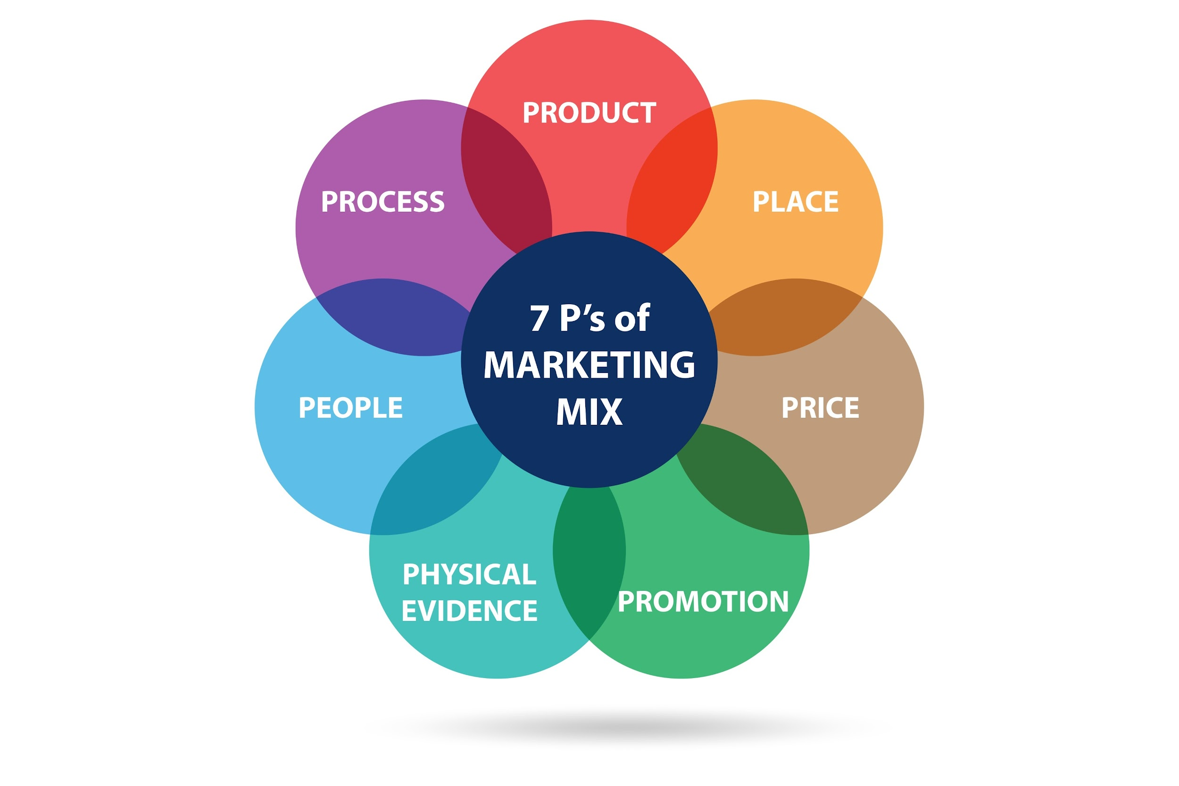
Figure: 7P’s of Marketing (Source: Shutterstock, 2025)
because this brand is more than products, as it also involves strong service aspects of shopping and e-commerce (Booms & Bitner, 1981).

3.1 Product Strategy
The product plays a pivotal role in this marketing mix. The marketing mix is planned using a three-level concept of products (Levitt, 1980).
- The central good is always the basic value, which in this case is creating a healthy, functional, comfortable home.
- The material good is represented by physical products—cleaning products, houseware, beddings—that embody minimalistic design, natural materials (regenerative organic cotton, recycled glass, for example), and sturdy construction. Branding, as in the subtler co-branding of products as "Patagonia Provisions Home", as well as green packaging, is an original aspect of this brand.
- The most powerful source of differentiation comes from the augmented good itself. These include things such as Patagonia’s Ironclad Guarantee for repair/replacement, tracing of "Footprint Chronicle" supply chain data available through QR code access, as well as an end-of-life reclaim program to recycle, which puts the product completely into a circular economy model (McDonough & Braungart, 2010).

3.2 Pricing Strategy
Value-based pricing, where pricing is calculated from customer value rather than production costs, would be used (Hinterhuber, 2008). The higher pricing is justified by quality, durability, sustainable sourcing, as well as the environmental mission of the organization. This pricing is in line with the positioning of the product as well as customer willingness to pay more for a product that fits into their values (D'Souza et al., 2007).
The price reflects quality research investments, supply chains, as well as good labor conditions in relation to costs. The costs will be clear, and explanations for how they help quality, employees, as well as environmental projects, shall be indicated on the website to further boost confidence.

3.3 PLACE (Distribution) Strategy
There would also be an omnichannel distribution strategy, which would result in a consistent brand experience regardless of where (Verhoef et al., 2015).
- Direct-to-Consumer (DTC) E-commerce - A department at Patagonia.com will be established as a flagship store to provide consumers with full product lines as well as high-quality usage, as well as sourcing information.
- Flagship Retail: A store-within-a-store concept is to be introduced in top flagship stores of Patagonia. These stores shall be experience-based, where customers get to touch, feel, and engage with employees.
- Strategic Wholesale Partnerships: A highly selective partnership strategy will be adopted, which features products in several like-minded retailers (e.g., independents for an ethical lifestyle, upmarket natural food stores) who support brand values and are capable of communicating them effectively.

3.4 Promotion Strategy
The promotion strategy would keep away from traditional marketing methods in order to adopt an inbound, content-led strategy, which would express the genuine voice of this brand (Halligan & Shah, 2014).
- Content Marketing: The actual strategy component itself. This would be in the form of documentary-style videos of the farmers and producers across the supply chain, regenerative living articles, and tutorials for making a home non-toxic. This is added value to what they consume, aside from, of course, the actual product itself.
- Public Relations & Earned Media: Reach targeted publications in sustainable living, design, and lifestyle in which to highlight the innovative, ethical aspects of the product line.
- Influencer Collaboration: Partnering with real figures in the sustainability community as well as people pursuing simple living, (micro-influencers versus celebrity ambassadors).
- Community Engagement: Organizing, sponsoring, or hosting workshops in community settings in areas of composting, natural dye, waste reduction, in order to build community, as well as emphasizing brand values.

3.5 People Strategy
As a component of a service offering, the "People" dimension is of critical value to this brand. Each front-line employee who is to deal directly with customers in stores as well as online will be fully trained, not only in terms of product benefit, but also in terms of the brand philosophy, sustainable sourcing, as well as environmental mission statements. Each employee will be selected because of his/her strong interest in sustainability, as well as his/her ability to function as a teacher-brand ambassador rather than merely as a salesperson (Grönroos, 2007).

3.6 Process Strategy
The "Process" is essentially those routine processes as well as streams of activity, which, when combined, provide a potential for value in the delivered service itself. For Patagonia Provisions Home, a customer experience needs to be clear, with no seams in it at all. The process of e-commerce shall be easy to use, easy to understand, providing clear information about the influence of freight costs as well as carbon-neutral freight available for consideration. One of the most important process innovations for this business shall be, in fact, providing customers using QR codes for "Footprint Chronicle" to know instantly in which manner they themselves, by purchasing this product, contributed to previous processes in the line of production (Zeithaml et al., 2009).

3.7 Physical Evidence
As indicated earlier, after understanding what S[ervice is], "Physical Evidence" also covers the surroundings in which consumption of the service takes place, as well as any physical products that help to provide it, such as (Bitner, 1992):
- In-store experiences—This means using natural, reclaimed, and recycled materials in display fixtures, creating a calming, well-lit atmosphere that communicates brand aesthetics/values.
- Packaging of products shall be minimal, using no plastic, completely compostable, or recycled.
- Website design shall be simple, intuitive, visually stunning, using first-class photography/videography as an equivalent of physical online proof of brand quality/values.

4.0 Element 3: Marketing Strategy Pitch Summary
(Pitch may be delivered in 3-5 minutes, accompanied by poster in Appendix A)
"Good morning. Our homes ought to be sanctuaries for us, but this $700 billion home goods industry is fueling a disposability epidemic, an environmental catastrophe, and hidden supply chains. Consumers feel as if they have to choose between fashion, quality, and sustainability. Why do they have to choose?"
The issue is obvious: an oversaturated products market that damages our planet. The answer is quite simple, really: "Patagonia Provisions Home."
"We’re bringing the legendary commitment to sustainable living from Patagonia’s mountains to people’s homes in a passionate celebration of what’s possible when people, products, and values connect in meaningful ways. Our brand is built upon three foundations: Sourcing, which is designed to bring healing to Mother Earth; Transparency; and Durability, which is protected by our Ironclad Guarantee."
"Our high-end client, known as the 'Ethical Maximalist,' is looking for us. Our customer is a value-conscious high-end segment who is willing to pay for those brands that speak to their values as well. Using an online-first, content-centric approach, we shall meaningfully connect with them, fostering a devoted community, rather than a mailing list."
"Patagonia Provisions Home solves the consumer’s dilemma. It offers guilt-free, high-performance products that are good, functional, and do something to save our home planet. It is not a brand extension; it’s a movement. A movement to make our homes resemble our values. Thanks."

5.0 Element 4: Reflection

5.1 Reflection of Brand Concept & Strategy Formulation
The development of Home by Patagonia Provisions is an overview of stealthy skill in which brand management is integrated into innovation in the industry. The biggest challenge is to create brand extension that resounds as well as value-added to the original brand purpose, which is neither commercially driven nor dilutive (Aaker, 2004). The use of this framework in STDP is beneficial in this respect.
Segmentation, in this case, focusing upon those of interest in LOHAS, led to a realization that a very in-depth exploration of targeted consumer motivations is necessary to ensure that, in creating this brand, they end up with more than a line of products, but also a statement of value for a certain worldview. The development of a positioning statement is an exercise in integration to distill higher-order ideals of regenerative sourcing, transparency, and durability into an integrated, consistent message, which also leads to an important realization—that for a brand such as Patagonia, achieving differentiation is a systems-level issue, meaning they shouldn’t promote it in advertising, but rather in what they’re doing in supply chains.

5.2 Reflection Regarding Pitch Preparation and Delivery
As [stated], shrinking this complex strategy down into a three-to-five-minute talk is an intense learning procedure in prioritization as well as in storytelling to persuade an audience. The key to this exercise is to get past the descriptive details (e.g., "we sell organic cotton sheets to consumers") to tell a strong story statement (e.g., "we resolve the consumer's choice dilemma in terms of values compromise").
The "problem-solution" template has played an important role in creating an instant engagement message that makes sense. The preparation of this message involves changing mindsets from an analytical strategist to an excellent storyteller. The emphasis placed on this is vital in ensuring that an "enemy" exists to present an individual in support of his/her brand as a "hero" in society, faced by this "enemy" known as "the culture of disposability." From this message delivery, for an ethical values brand, the message is clear, where how things are communicated is as vital as coming up with a justification for this message to make sense.

5.3 Key Skills Developed and Future Improvements
This project has greatly increased several important skills.
Firstly, by strategic analysis, meaning the structured use of either the STDP or the 7Ps models to a fictional but realistic scenario. Secondly, for creative synthesis, in formulating an executable brand extension, incorporating its marketing mix factors into an integrated unit. Thirdly, persuasive communication, as in the construction of the pitch.
In future projects, I would like to add value to the methodology in relation to two important areas.
- First, based on the initial quantitative market analysis, namely a survey to prove the assumption of the existence of the target group of ‘Ethical Maximalists,’ as well as willingness to pay premiums. Although secondary research is acceptable, having primary data would be more convincing in this respect.
- Second, I would create a more comprehensive financial analysis, including models of customer acquisition costs (CAC) and lifetime values (LTV), to better demonstrate the financial feasibility of inbound marketing approaches. This narrows down the differences between marketing strategy and financial outcomes.

6.0 Conclusion
In this marketing portfolio, a strong and genuine launch strategy for Patagonia Provisions Home has been established. The positioning of an extension of this brand, resting upon what Patagonia is all about, as well as a perceptive segmentation of this customer, known as an "Ethical Maximalist," provides an excellent positioning platform for this brand in the market place. The analysis of STDP provides a distinct strategic course, which, in turn, is complemented by the accumulated 7Ps of marketing mix to provide an inclusive guide to implement which ensures that all interfaces communicate a distinct value proposition for regenerative, transparent, and enduring home products. The success of this project also requires an errorless execution of this strategy, which expresses continued faith in the belief that a strong success at the level of commerce is also possible when accompanied by strong environmental sentiments at an equal level in our current economy.

7.0 References
Aaker, D.A. (2004) ‘Brand portfolio strategy and brand architecture’, California Management Review, 46(3), pp. 86–103.
Aaker, D.A. (2009) Managing brand equity. New York: The Free Press.
Bitner, M.J. (1992) ‘Servicescapes: The impact of physical surroundings on customers and employees’, Journal of Marketing, 56(2), pp. 57–71.
Booms, B.H. and Bitner, M.J. (1981) ‘Marketing strategies and organization structures for service firms’, in Donnelly, J.H. and George, W.R. (eds.) Marketing of Services. Chicago, IL: American Marketing Association, pp. 47–51.
Carrington, M.J., Zwick, D. and Neville, B. (2014) ‘The ideology of the ethical consumption gap’, Marketing Theory, 16(1), pp. 27–41.
D'Souza, C., Taghian, M., Lamb, P. and Peretiatkos, R. (2007) ‘Green decisions: demographics and consumer understanding of environmental labels’, International Journal of Consumer Studies, 31(4), pp. 371–376.
Dibb, S. and Simkin, L. (2010) ‘Targeting, segments and positioning’, International Journal of Retail & Distribution Management, 38(8), pp. 605–621.
Gleim, M.R., Smith, J.S., Andrews, D. and Cronin, J.J. (2013) ‘Against the green: A multi-method examination of the barriers to green consumption’, Journal of Retailing, 89(1), pp. 44–61.
Grewal, L. and Roggeveen, A.L. (2020) ‘Understanding the Power of Word of Mouth: A Review and Directions for Future Research’, Journal of Retailing, 96(3), pp. 297–299.
Grönroos, C. (2007) Service management and marketing: Customer management in service competition. 3rd edn. Chichester: John Wiley & Sons.
Hallagan, W.A., Menelly, N.E. and Anastas, P.T. (2021) ‘Green Chemistry, Green Chemical Engineering, and Sustainability’, in Handbook of Green Chemistry, Volume 10. Weinheim: Wiley-VCH, pp. 1–27.
Halligan, B. and Shah, D. (2014) Inbound marketing, revised and updated: Attract, engage, and delight customers online. Hoboken, NJ: John Wiley & Sons.
Hinterhuber, A. (2008) ‘Customer value-based pricing strategies: why companies resist’, Journal of Business Strategy, 29(4), pp. 41–50.
Keller, K.L. (2013) Strategic Brand Management. 4th edn. Harlow: Pearson Education.
Kotler, P. and Armstrong, G. (2021) Principles of marketing. 18th edn. Harlow: Pearson Education.
Levitt, T. (1980) ‘Marketing success through differentiation--of anything’, Harvard Business Review, 58(1), pp. 83–91.
McDonough, W. and Braungart, M. (2010) Cradle to cradle: Remaking the way we make things. New York: North Point Press.
Pappas, N. (2022) ‘The new era of conscious consumers: choosing sustainability in a pandemic world’, Current Issues in Tourism, 25(1), pp. 1–7.
Patagonia (2023) Our values / Our footprint. Available at: https://www.patagonia.com/our-footprint/ (Accessed: 19 September 2025). patagonia.com
Rhodes, C.J. (2017) ‘The imperative for regenerative agriculture’, Science Progress, 100(1), pp. 80–129.
Ries, A. and Trout, J. (2001) Positioning: The battle for your mind. 20th Anniversary edn. New York: McGraw-Hill.
Schoultz, H. (2020) Patagonia's marketing strategy: a deep dive into the iconic brand. Available at: https://www.linkedin.com/pulse/patagonias-marketing-strategy-deep-dive-iconic-brand-hannes-schoultz (Accessed: 21 September 2025).
Trivium Packaging (2023) 2023 Buying Green Report. Available at: https://buyinggreen.triviumpackaging.com/ (Accessed: 20 September 2025). buyinggreen.triviumpackaging.com+1
University of Wales Trinity Saint David (2024) LCMB7024 Marketing Management Assessment Specification. Carmarthen: UWTSD.
Verhoef, P.C., Kannan, P.K. and Inman, J.J. (2015) ‘From multi-channel retailing to omni-channel retailing: Introduction to the special issue on multi-channel retailing’, Journal of Retailing, 91(2), pp. 174–181.
Zeithaml, V.A., Bitner, M.J. and Gremler, D.D. (2009) Services marketing: Integrating customer focus across the firm. 5th edn. Boston: McGraw-Hill/Irwin. McGraw Hill

Appendix


