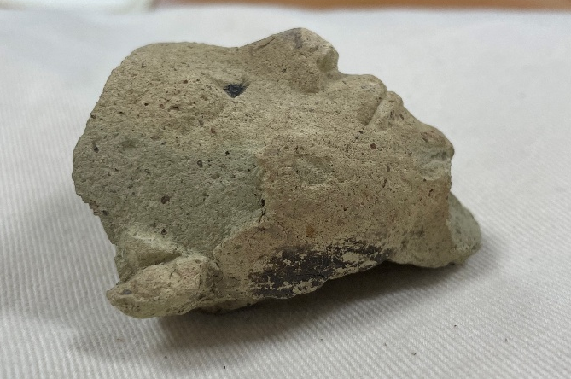
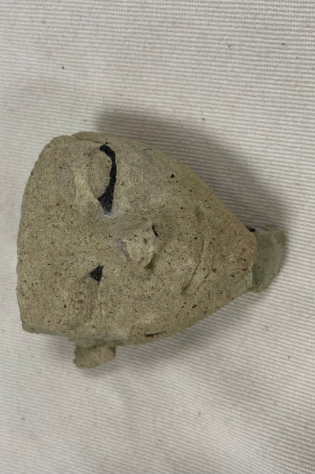

Human Head
Cyfarthfa Castle, Merthyr Tydfil CCM 175.996
Object Type: Funerary Mask
Material: Marl Clay
Period: Late Middle to New Kingdom (A3 to A4, 1550-1069 BC)
Provenance: Egypt
Dimensions: 5.7cm (height), 5.7 cm (width), 4.2 cm (depth)
Object Analysis By: Eleanor Woolston (2203257)

Description
Object 175.996 is believed to be a funerary mask made from Marl clay, spanning 5.7cm in width and 5.7cm in height. There are some remnants of black paint around the eyes and on the side of the object which suggests that the object would have been painted all over. There is an indent on the back of the mask which is roughly the width of a adult male pointer finger. The mask overall feels rough and there are layers of the clay peeling off to reveal at least three layers in total. The roughness is most prominent on the top of the head where it would have been broken away from the rest of the mask, similar to the texture of sandpaper in places. There is a rectangular shape protruding from the chin which would indicate that there was originally a beard which would have been attached, and suggested status of the person the mask was created for.
Information About Object
This object looks like something which we think would have been typically found within regions of Egypt, as the emphasis on the eyes and facial features would suggest which suggests a style possibly carried over from an earlier period or a mixing of styles from different times. This was typical of the Ptolemaic dynasty (305 BC - 30 BC) which also blended the styles of the Greek and Egyptian cultures, which also went into their literature and became much more prominent in the later Roman Empire.
Comparisons to other objects
This particular type of statue or mask was presumably made in order to fit into a larger mask that may have been on a coffin and inside a tomb for the deceased. These types of masks have been called “Rishi-style mummy masks”. “Rishi” means “feather” in Arabic, and would have been used to refer to the wings seen on the headdress part of the mask, referencing the “ba bird” or the person’s soul.
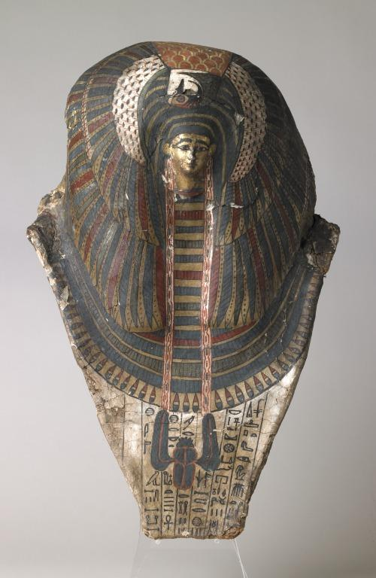
Figure 1: Liverpool Museum Rishi Mask (Second Intermediate Period; New Kingdom)
As seen in Figure 1; the head of the mask is very small when compared to how large the headdress is, and when compared to our original object we can see how the size compares and maybe even how it would have fitted in with the rest of the coffin, possibly even being able to slot over the head of a sarcophagus as there is hollow room underneath the mask for some purpose.
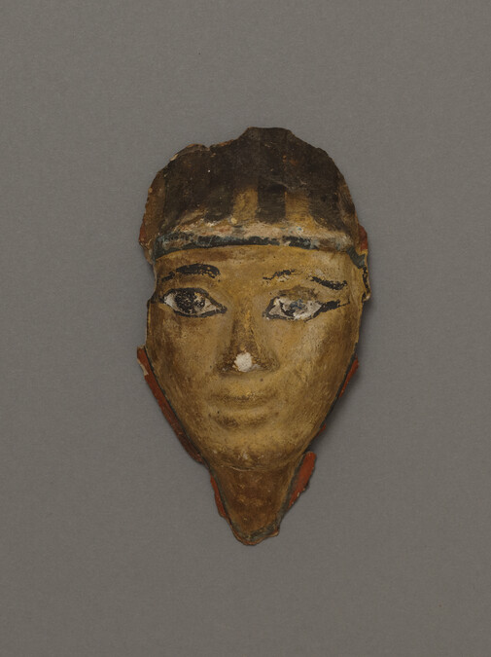
Figure 2: Face from a Rishi mask from Hood Museum of Art, 17th Dynasty (1650-1500 BCE)
As seen in Figure 2, our object is very similar as it shares a lot of the same qualities although is lacking paint and seems to be thicker in the way it was made. Figure 2 still retains its paint, so we can still see the facial features and the conventions with which it was made. Figure 2 is made a from a different material, plaster, so the process it went through would have been different and may have been easier to make for many different people.

Artistic Conventions
As seen on our original object, there are traces of paint around the eyes and some even on the side of the head. This could indicate that the head was, at one time, fully painted with possibly a depiction of the deceased in order to make them look more God-like. The artistic conventions, as I have mentioned previously, indicate that styles were being mixed from different eras and cultures during the Ptolemaic dynasty. Our original object looks far too smooth in some places to have been made by hand, so we presumed it may have been created in a mould as was the convention and as they were so closely intertwined with religious beliefs which helped align them with the Gods. There were other objects being made with the same material around the same time, such as amphoras which would have been used to hold both dry and liquid ingredients.
Place in funerary sphere
This object’s place in the funerary sphere as a whole is driven by looking at it; it seems too small to be of any use over a real person’s face and too intricate to be a toy, it aligns with every thing about the funerary aspects of the Ancient Egyptian world and what they believed in as there were significant religious beliefs and rituals that were performed when a person died in order to give them safe passage to the afterlife, including safe passage of the physical body (as can be seen with our original object clearly being to represent the deceased’s face). This object has its place in the funerary sphere because of the things that it would have symbolised to the people that made it, for example how it would have had the headdress with the wings symbolising the “ba bird” and how that meant freedom for the deceased’s spirit, including their individuality and personality, so it is not too different to the idea of the soul that we have in today’s age.

Bibliography
D. Arnold: Keramik. In: LÄ III, Sp. 399.
Rutherford, Ian (2016). Greco-Egyptian Interactions: Literature, Translation, and Culture, 500 BCE-300 CE. Oxford University Press. ISBN 978-0199656127.
Mummy mask, Liverpool Museum – https://www.liverpoolmuseums.org.uk/artifact/mummy-mask.
Hood Museum. (2015). Face From a Rishi Mask. [online] Available at: https://hoodmuseum.dartmouth.edu/objects/39.64.6629 [Accessed 30 Oct. 2025].
Team, E. (2025) Ancient Egyptian masks and their role in death, ritual, and resurrection. https://www.egypttoursportal.com/en-gb/blog/ancient-egyptian-civilization/ancient-egyptian-masks/.
Rembart, Laura; High-Steskal, Nicole; Ownby, Mary; Vessel: Syene 006-013-097-002-K022, Site: Aswan (Egypt/Upper Egypt), The Levantine Ceramics Project, accessed on 30 October 2025, https://www.levantineceramics.org/vessels/16160-syene-006-013-097-002-k022.
Pallis and A, C. (2025) Death | Definition, Types, Meaning, Culture, & Facts. https://www.britannica.com/science/death/Ancient-Egypt.
Ba Bird. https://egypt-museum.com/ba-bird/.
Christina, Riggs (2010-01-22). "Funerary rituals (Ptolemaic and Roman Periods)". UCLA Encyclopedia of Egyptology.
Harold, Hays (2010-01-22). "Funerary rituals (Pharaonic period)". UCLA Encyclopedia of Egyptology

D. Arnold: Keramik. In: LÄ III, Sp. 399.
Rutherford, Ian (2016). Greco-Egyptian Interactions: Literature, Translation, and Culture, 500 BCE-300 CE. Oxford University Press. ISBN 978-0199656127.
Mummy mask, Liverpool Museum – https://www.liverpoolmuseums.org.uk/artifact/mummy-mask.
Hood Museum. (2015). Face From a Rishi Mask. [online] Available at: https://hoodmuseum.dartmouth.edu/objects/39.64.6629 [Accessed 30 Oct. 2025].
Team, E. (2025) Ancient Egyptian masks and their role in death, ritual, and resurrection. https://www.egypttoursportal.com/en-gb/blog/ancient-egyptian-civilization/ancient-egyptian-masks/.
Rembart, Laura; High-Steskal, Nicole; Ownby, Mary; Vessel: Syene 006-013-097-002-K022, Site: Aswan (Egypt/Upper Egypt), The Levantine Ceramics Project, accessed on 30 October 2025, https://www.levantineceramics.org/vessels/16160-syene-006-013-097-002-k022.
Pallis and A, C. (2025) Death | Definition, Types, Meaning, Culture, & Facts. https://www.britannica.com/science/death/Ancient-Egypt.
Ba Bird. https://egypt-museum.com/ba-bird/.

