“Strategic Management”
“Nike”
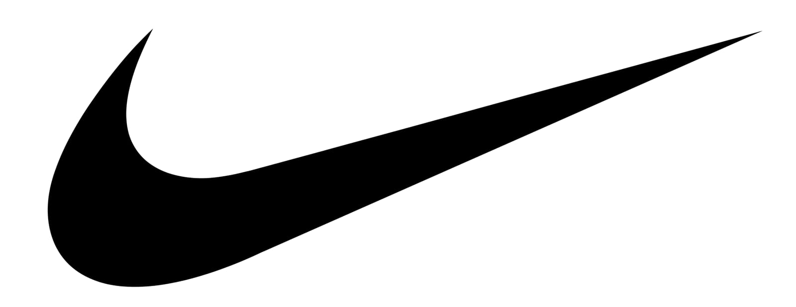
Student Name: Nizar Kasamali Charania
Student ID: 2132189
Course: Strategic Management (LCMB7003)

Executive Summary
According to market research company Mintel, Nike has a 20% share of the U.S. sports clothing industry. Nike's careful planning in product design and high-quality manufacturing help mitigate this threat to some extent. Focusing more on emerging markets like China's is good for the country's economy since it opens up more opportunities at lower costs. Particularly in developing countries, Nike's reputation for moral rectitude has been tarnished by allegations that the company avoids paying its fair share of taxes. Keeping every person at Nike confident in their own importance and contribution to the company is crucial to the company's continued success.
It has implemented a transparent approach for measuring productivity increases in the workplace and released ground-breaking new products. By working together with suppliers to optimise processes, businesses may save time and money. Leaders may learn the desired direction of their teams via the use of a strategic plan. Businesses may estimate how many items need to be sold in order to break even with the help of a fair assessment. Companies may keep their operating expenses in check with the use of budgeting breakdowns, quality audits, and other expense tracking methods.
For customers, the fact that Nike can and does charge higher prices for its items because of its recognisable brand is a point of frustration. Through a system of independent distributors and licensees, it distributes its products and services across the globe and attracts new customers to its website.

Table of Contents
Introduction 5
Objective 5
Strategic Management Framework 6
External Environment and Markets 6
Porter’s Five Forces 6
Threat of New Entrants 6
Bargaining Buying Power 6
Bargaining Supplier Power 7
Threat of Substitutes 7
Products 7
Nike’s Competitive Advantage 8
Resources 8
Capabilities 8
PESTLE Analysis 9
Political Factors 9
Economic Factors 9
Social Factors 10
Technological Factors 10
Environmental Factors 10
Legal Factors 10
SWOT Analysis 11
Strengths 11
A commanding market share and a solid holdings portfolio 11
Pay close attention to R&D efforts 11
Because of the multimodal strategies 11
Weaknesses 12
Over-reliance on third-party contract manufacturers 12
Opportunities 12
The industry for shoes across the world continues to grow 12
It has two parts to it. 12
The Three-Product Stream 12
Threats 13
Increasing numbers of people are buying counterfeit goods 13
Assaulting the Competition 13
Stakeholder Analysis 13
Organisational Culture 14
Strategy 14
Product Portfolio Internationalisation Strategy 14
Indicators of High-Quality Performance 16
Management Strategies tools 17
Internal Assessment 19
Partners 19
Essentials 19
It's basically this 20
Unique selling propositions 20
Customer Relationships 20
Clients 21
Value Proposition Canvas 21
Services and Goods 21
Profit Makers 21
Drugs to Ease Pain 21
Gains 21
Pains 22
Employment Requests from Customers 22
Recommendations and Conclusion 22
References 22

Introduction
Nike Inc., a global leader in athletic gear, was founded in the United States. The corporation has become the largest sportswear and equipment retailer in the planet. The company's major goal was to break Germany's stranglehold on the American shoe industry by producing high-quality footwear at low prices. The company's mission is to always be the one that people associate with the most authentic, connected, and original brand. When it comes to athletic apparel, Nike is in a league of its own. Nike is the undisputed leader in the American sports apparel market, with a 20% share according to research firm Mintel. The association with high-profile players like LeBron James of the Barcelona basketball team helps boost the brand's reputation. Here, we'll take a look at the bigger picture, the market, and the approaches that have been taken so far. It has a global customer base, including buyers in Europe, Asia, and the United States. Nike has a wide variety of sub-brands, including Nike Skateboarding and Nike Pro(Mahdi et al., 2015).

Objective
The management and tactics used by Nike, Inc. are the subject of this study. In conclusion, Nike's strong brand value is evidence that the corporation operates ethically. The external environment and market, the current strategy, and opportunities for improvement are all going to be covered in this study.
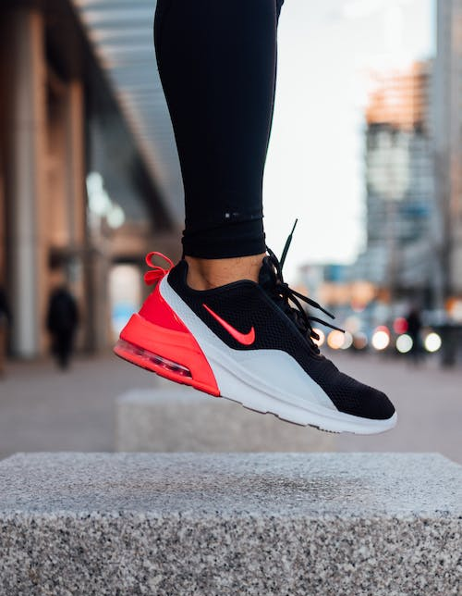
Figure 1 Nike(Knight et al., 2020)

Strategic Management Framework
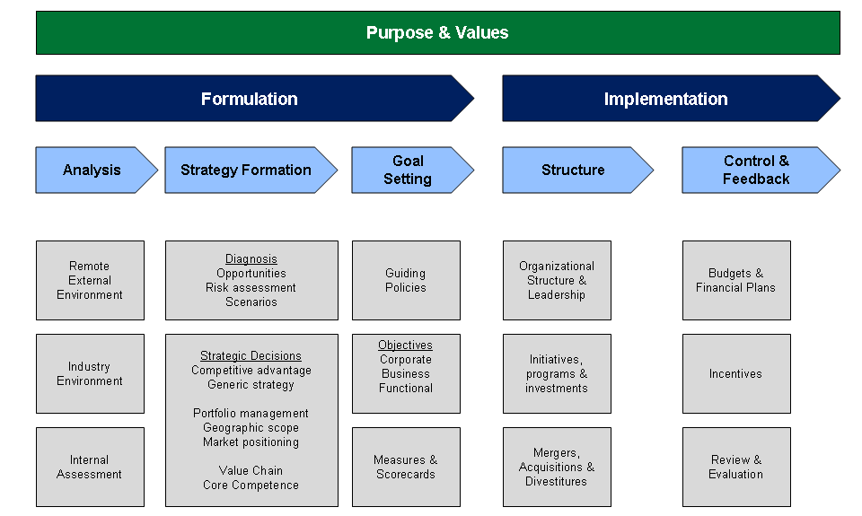

External Environment and Markets

Porter’s Five Forces

Threat of New Entrants
- Alternate-market rivalry.
- Threat from the established leaders.
- Considering the scale economy's first-mover advantage.
- The price of production is just too expensive.
- Too high of a price tag on the product.
- Due to its widespread business interests, Nike faces stiff competition.
Due of the difficulty of fulfilling the other requirements, new rivals face limited threats despite the modest starting expenditure. A new entrant may initially only be able to compete on a regional or niche market. Making goods is just one of the process; marketing, distribution, and managing suppliers are just as crucial(Zhu, 2022).

Bargaining Buying Power
- Very low switching expenses
- Reasonable Substitute Effort
- There is a limited pool of purchasers
Customers are free to move from Nike to any other brand of sports footwear due to the minimal switching barriers between brands. When alternatives are freely accessible, customers are able to do price comparisons and are more likely to try items from other companies. As a result of their small size and low volume, however, they have very little effect on the company's operations.

Bargaining Supplier Power
Pricey inputs
Large numbers of people actively trying to promote their products
Moderately sized individual vendors
When it comes to Nike's price, retailers don't have much control. Products from its 621 manufacturing facilities may be found in 42 different countries. They have a massive network of suppliers dispersed all over the world. Despite their scale, service providers face far less threat of rivalry from suppliers since they cannot assimilate incoming information via forwarding. The distributor, however, would stand to lose a substantial revenue in this case. Nike maintains a huge inventory in a big container(Meng et al., 2021).

Threat of Substitutes
The threat of cheaper alternatives to Nike is minimal. Because there is such a wide variety of rival brands selling essentially the same things. Several alternatives to Nike footwear are available at lower prices in both local and foreign markets. These factories produce low-quality imitations of Nike's products. Nike's attention to detail in product design and high-quality construction assist to reduce this risk to some degree. Replacement goods are not often a major security concern.

Products
Depending on the kind of sport they are designed for, Nike's plethora of items may be found in one of many different categories. One of Nike's first designs was a shoe specifically for use on a racetrack, but the company has subsequently expanded into making athletic footwear for a wide range of activities beyond running and track and field. Simply said, demand for the firm's wares is on the rise(Hadju et al., 2022). Their newest offering is a pair of athletic shoes called the air zoom Yorker. When compared to the Reebok counterpart, the Air Zoom Yorker is 30% lighter. Nike also just launched a brand new Air Jordan XX3 basketball sneaker. As part of their joint marketing effort, Apple Inc. and Nike have developed a radio device that can be placed inside the shoe and is connected to the iPod nano. Nike has also used innovations like Lunar light foam and Flywire to save weight from their footwear. Nike is a sportswear company that produces equipment that measures and logs steps taken, calories consumed, and time spent exercising. Product differentiation and positioning are at the heart of each successful advertising strategy. A primary focus for Nike has always been on delivering on customer needs and wants.

Nike’s Competitive Advantage
At this point in time, Nike has an edge over its rivals thanks to the efficacy of its dominating business strategy as a result of their talents and means.

Resources
One of the largest companies in the world, Nike has over 73,100 workers and more than a thousand retail locations globally. More than 700 factories in 42 different countries make Nike products. Products are sent from one of 57 warehouses to one of 18,500 clients or one of 140,000 storefronts. Although Nike designs and develops its own footwear and clothes, the company does not own any factories to produce these items. Moreover, Nike has a high value brand, which has propelled them to the forefront of their industry. Nike has established its (Jordan) line in collaboration with the legendary athlete Michael Jordan, as well as other fashion labels (like Off-white) and accessories (like the Apple Watch). In addition to a sizable and devoted client base, they have an excellent reputation as a result of the superior quality of their wares. Finally, Nike's Sport Research Lab is staffed by scientists and athletes who are eager to collaborate on their projects. Everyone who works there has at least a master's degree in the field of sports science. That's a big assistance to the creative process(Knight et al., 2020).
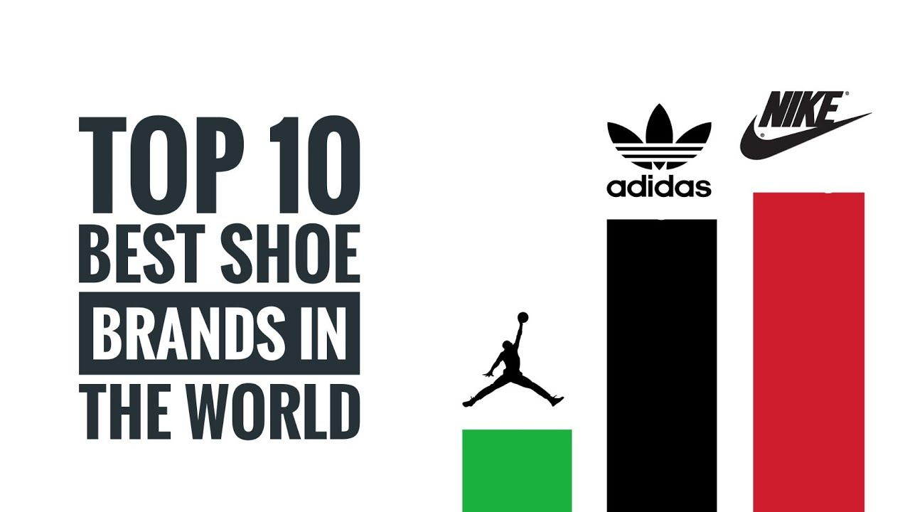
Figure 2 "Nike Top Range Shoe"(Knight et al., 2020)

Capabilities
The reduced management structure at Nike helps the firm to operate efficiently and reap more revenues. Furthermore, the company is increasing its investment in R&D to ensure that it can continue to provide excellent service and grow in line with the needs of its clientele. They also often spend money on advertising, which includes paying actors and sportsmen to promote their goods. Because of this, more people will want to purchase their sportswear rather than wear the clothing of a competitor(Distelhorst et al., 2017). Nike also has an excellent inventory management division and a human resources division that places a premium on employee training. There is a team of scientists and designers working in labs to assist Nike produce the ideal blend of performance, comfort, and fashion, and this is what has made Nike so successful. Nike is also well-known for its outstanding customer service. Nike may be said to use a resource-based perspective approach due to the abundance of resources at their disposal and the skill with which they put those resources to use. This establishes an indestructible market edge.
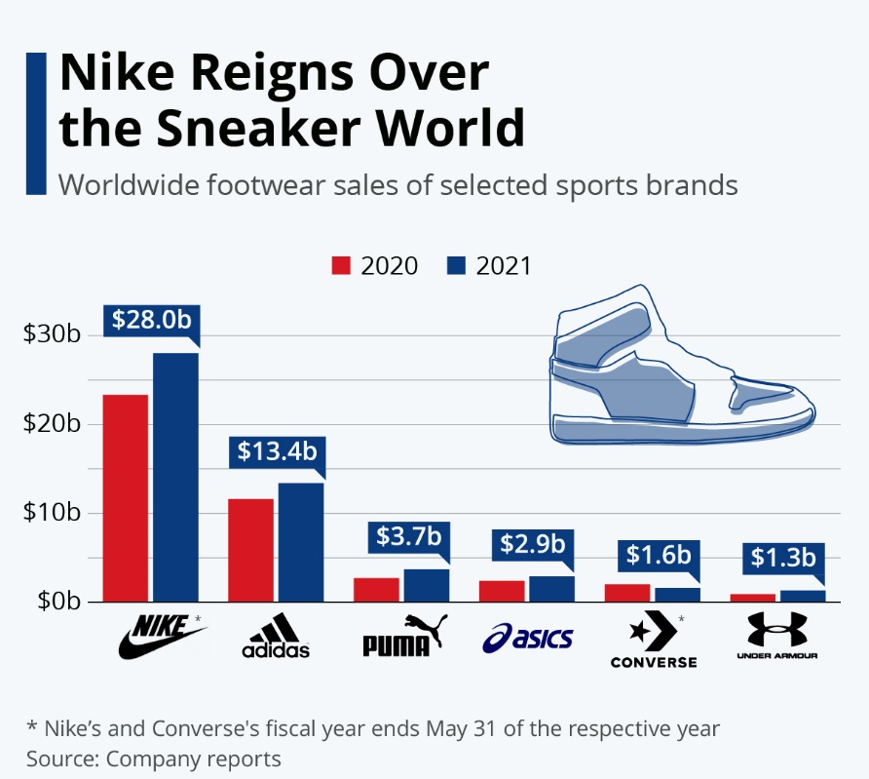
Figure 3 "Nike's Competitive Advantages"(Hunger, 2020)

PESTLE Analysis

Political Factors
The United States, Nike's home country, has advantageous development policies such as cheap borrowing rates and well-structured international tax agreements. Conversely, Nike's commerce and import/export agreements will be affected by political issues since the corporation operates on a worldwide scale. One example is how US sanctions on Iran have damaged Nike's reputation in Iran since the company is unable to fulfill its contract with the national football team. However, the corporation itself may run into issues with regulators. Such as when they posted the commercial featuring Colin Kaepernick, which angered the US government and Trump himself.

Economic Factors
The largest risk Nike faces now is the possibility of increased labour salaries or more costly materials as a result of an economic downturn in the nations where the business manufactures its goods, such as the United States and Asia. Moreover, Nike's increased emphasis on developing markets like China's benefits the country's economy by providing more possibilities at cheaper prices.

Social Factors
As a company, Nike has a high "health awareness," as seen by the fact that they care deeply about the health and safety of its customers. The Nike Lab team is always looking for new ways to improve their goods so that athletes can train with confidence and recover quickly. However, Nike often draws criticism for its allegedly poor working conditions. People now have a broader perspective on this issue because to social media, and there is a whole Wikipedia page on how Nike Inc. exploits its employees in sweatshops in Asia in order to keep its labour costs low(Hunger, 2020).

Technological Factors
Nike is often regarded as one of the most forward-thinking corporations of all time. Specifically, Nike employs scientists with doctorates or master's degrees in the subject to do research on how to improve the company's goods. They put elite athletes through extensive testing merely to come up with one new design for a shoe. Also, you can find Nike all over your favourite social networking sites. Social media has helped them grow their consumer base by presenting famous athletes endorsing their goods. They have 86.2 million people following their main account on Instagram, and they also have separate accounts for each major sport.
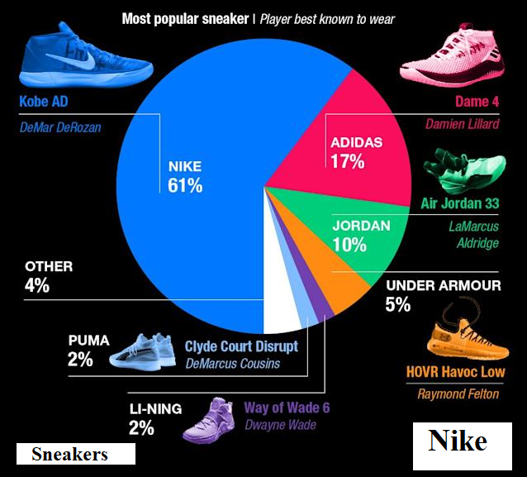
Figure 4 Most popular sneakers brands in NBA(Gamble et al., 2014)

Environmental Factors
Without a doubt, Nike's mass production plants do a lot of damage to the environment by contaminating the air and, in some cases, the rivers around the business.

Legal Factors
Considering the number of nations with which Nike interacts, the company must comply with a plethora of rules and regulations. As well as varying tariffs, each nation has its own rules for bringing goods into and out of the country. In addition, Nike's cheap labour costs and generous treatment of employees in Asia have gotten the company into a lot of controversy with that region's government. They had to deal with a lot of criticism in Vietnam due of allegations of unethical and illegal child labour. There are widespread suspicions that Nike engages in unethical behaviour by evading taxes, particularly in poorer nations(Simonson and Schmitt, 1997).
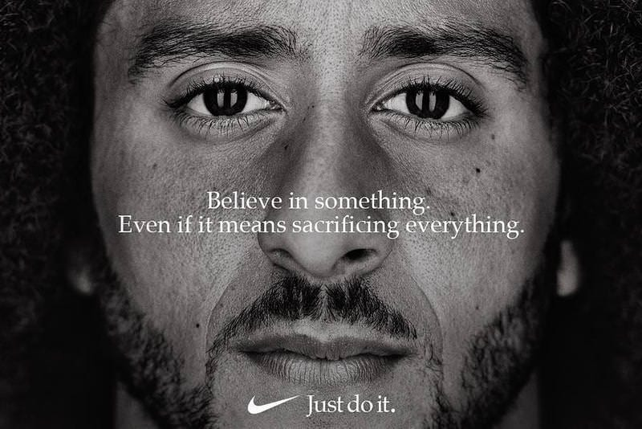

SWOT Analysis

Strengths

A commanding market share and a solid holdings portfolio
Without a doubt, Nike is one of the biggest manufacturers and retailers of athletic footwear in the world. In 2016, Nike has a 46% market share in the United States, making it one of the top 30 most valuable brands in the country. Their dominance in the industry may be attributed to the enduring popularity of household names like Nike, Jordan, Converse, and Hurley. While the Jordan brand is aimed squarely at professional basketball players, Converse is more like a street wear product.

Pay close attention to R&D efforts
Nike's continued dominance in the market depends on the company's ability to use technological advancements to make athletes' lives easier by reducing fatigue, danger, and the likelihood of injury. When designing new items, they consult 30 different sources, including coaching staff, tutors, and athletes themselves.

Because of the multimodal strategies
Nike sells their wares in a wide variety of ways, such as traditional retail storefronts, eCommerce, and supply chain management. In addition, they distribute their wares via a network of distributors and licensees, as well as their own extensive network of retail outlets throughout the globe. Customers may buy Nike products in one of 592 retail stores in 136 countries, or online at www.nike.com. They were able to reach and help a larger population because to their inter-oriented approach(Kiseleva et al., 2021).
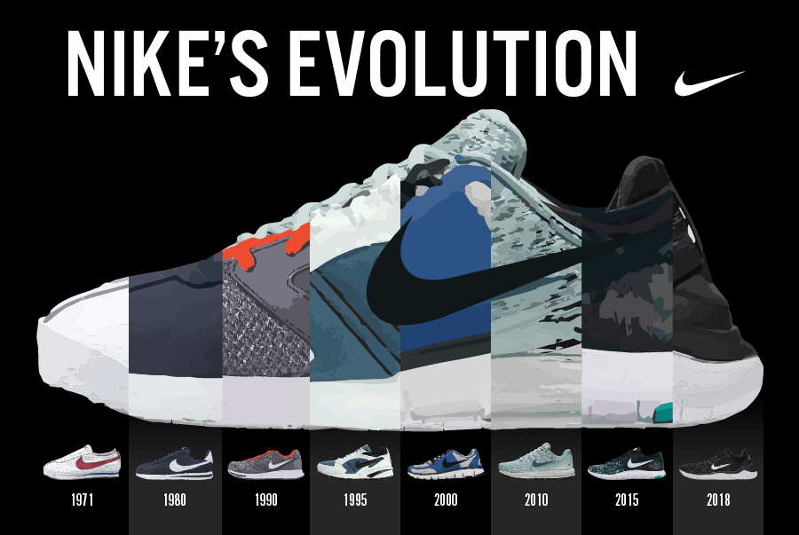
Figure 5 "Nike's Evolution"(Childs and Jin, 2018)

Weaknesses

Over-reliance on third-party contract manufacturers
Nike imports zero textiles from the United States. Manufacturers in Asia, India, and Vietnam, among others, so have minimal say over the reliability of their goods. It suggests that if manufacturing errors occur, more quality assurance personnel will need to be hired to address the issue.

Opportunities

The industry for shoes across the world continues to grow
The shoe industry's income has increased dramatically during the last several years. Between 2010 and 2014, income increased by 4.8%, and between 2014 and 2019, the same source projects a further 19.9% increase. The company is in a great position to take advantage of the rising demand for shoes thanks to its substantial brand investment.

It has two parts to it.
Many consumers now choose virtual stores over traditional ones. One indicator of this trend is the increasing share of consumer spending that goes to internet retailers in the United States. Even in Europe, people have seen these kinds of trends. Nike may use this to their advantage by increasing sales via their online stores at www.nike.com and www.converse.com.

The Three-Product Stream
Nike may expand their product offerings and increase their sales by entering the market for the many sports for which they now produce no related merchandise.
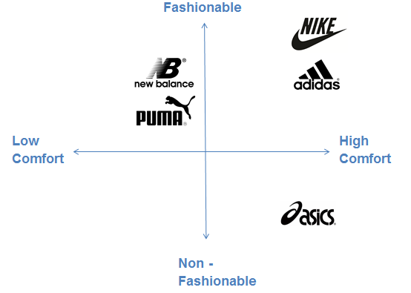
Figure 6 Strategic Positioning Map(Alsaffar, 2020)

Threats

Increasing numbers of people are buying counterfeit goods
Producing or selling knockoffs under a different brand name without permission is illegal. Without a doubt, the rising amount of time spent online will have certain unintended repercussions. In this way, it contributed to the globalisation of the counterfeiting industry. The massive entry of counterfeit products into the sector in the United States is causing copyright convulsions, which are expanding at a rate of around 25% annually.

Assaulting the Competition
Nike is a dominant force in the sportswear industry, which is one of the most cutthroat markets in the United States and the globe. Adidas and PUMA are two of the most formidable rivals in the industry. Since this is the case, Nike needs to constantly innovate in order to maintain its position as industry leader.

Stakeholder Analysis
Individuals that have a vested interest in a corporation are called "stakeholders." As a result, the first step of a stakeholder analysis is to catalogue the many interests at play. The Nike Foundation is at the centre of the company's corporate social responsibility strategy. Nike CSR looks after the company's stakeholders' best interests (Corporate Social Responsibility). Since Nike operates on a worldwide scale, there are a number of constituencies that may significantly impact the company's bottom line. For Nike, the CSR strategy's main objective is the company's end users. By purchasing shoes, clothing, and sporting equipment, customers have a direct impact on the company's bottom line. Nike is dedicated to continuing to provide cutting-edge, high-quality items. With the Nike Foundation, the company also helps local communities grow and thrive(Riwayadi et al., 2021). Nike's charitable organisation, for instance, has worked to increase the agency of young women in underdeveloped regions. Employees of Nike are also considered a stakeholder group since they have significant brand impact as the people who really make the items. Therefore, Nike employees benefit from a number of factors, including pay, benefits, and advancement potential. There is also the government to think about when thinking about stakeholders. The company's compliance with the law is impacted by the policies of various governments. Additionally, interest groups are considered a stakeholder group for Nike.

Organisational Culture
“One of my biggest concerns is that our organisation would get complacent in its success and become too large, sluggish, and bureaucratic to do anything about it”. CEO of Nike, Mark Parker (Fast Company, June 2013).
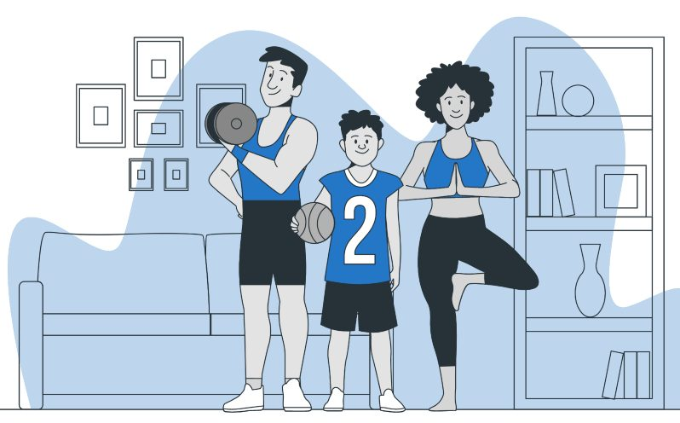
Nike is in the same league as other "cool culture" corporations like Apple, Google, Amazon, and Facebook. People are drawn to this culture because participating in its practises gives them a sense of community and meaning in their lives. 'We have the best-kept secrets' is ingrained in the Nike psyche. The key to Nike's success is maintaining the belief that each employee has in the significance and value of their job. A tiny group of women who felt excluded from Nike's corporate culture held a little demonstration a few years ago, and CEO Mark Parker apologised to them for allowing a "bro culture" to exist there. So Parker is making strides toward a future where all Nike workers are treated fairly and with dignity and respect(Knight and Greenberg, 2002).

Strategy

Product Portfolio Internationalisation Strategy
The company's marketing efforts are largely responsible for Nike's achievements. Customers have been attracted to purchase Nike goods with the tagline "Just Do It." Famous athletes have joined together with Nike for sponsorship agreements. While training for the New York City Marathon, Kennedy and Wieden had the idea for their first advertisement. And thus it is no surprise that Nike has also been honoured by the Emmys for their advertisements. The winning ad this year discussed the difficulties an athlete may encounter if the year 2000 was labelled Y2K. Woods' sponsors have helped amateur golfers like you, as well as pros like Michelle Wie and Tiger Woods(Orosová, n.d.). In addition to nikerunning.com, Nike also supports high school sports and the creation of online platforms for these competitions. Nike has tough competition in the business from companies like Adidas and Reebok, who provide items that are identical to Nike's. There are a lot of ladies that wear Reebok, however the brand's marketing is lacking when compared to Nike. It does not constantly place ads for its goods during news broadcasts, unlike many other corporations.
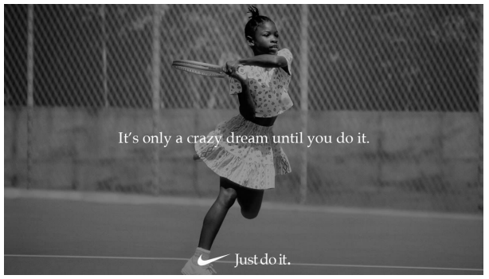
Figure 7 Nike's Slogan "Just do it"(Almazrouei et al., 2021)
To better understand how everything fits together, Nike has used no less than six distinct models. This paradigm has been useful in dealing with external factors including new competitors, alternatives to products or services, reducing the negative influence of customers and suppliers, and reducing rivalry amongst competitors. Nike has had to contend with competition from new entrants in the sports goods market since many other firms in the apparel and accessories industry are capable of producing such items if given the opportunity. New competitors have helped Nike lower some of its manufacturing costs. As a result, costs have changed as a result of this. But the risk has been mitigated thanks to regulations and consistent patronage. In addition, Nike does its best to stay out of direct competition with its main rivals, who pose a threat to the company's bottom line. The negotiating power of consumers is seen as a threat by Nike Inc. since it allows for price reductions and increases in expenses. Buyers may make significant profits from bulk purchases, while the business experiences substantial losses. By keeping production and costs in check, the company has reduced the leverage of its customers in negotiations. That means Nike is protected from suppliers' attempts to drive up the cost of their raw materials. Nike's reliable supply chain may warn the corporation about growing costs of key components far before the rest of the market(Liu et al., 2018).
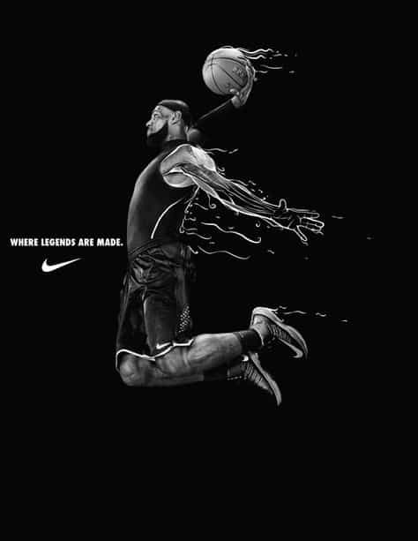

Indicators of High-Quality Performance
The organisation ensures that all levels of management are aware of each other's efforts by encouraging open lines of communication. Workers who get training are better able to contribute to the success of their organisation. Staff workers who are appreciated and rewarded are more inclined to give their all and seek out ways to better the company. Also, if a customer has an issue with a Nike product, Nike will replace it at no cost to the customer. The management does not need to sign off on any decisions made by the manager. Governance, which entails making the organization's objectives a reality and inspiring others to do the same, is another quality driver. Consumers' needs were met thanks to suggestions from both staff and customers. Institutional systems are pushed to improve when customers specify conditions, and when employees respond by providing goods that meet those needs. The results are beneficial for all parties. Customer-centricity, in the same vein, is fueled by the depth of a business's relationship with its clientele. Methods include gauging how customers feel about certain product lines and addressing their problems as soon as they arise. Positive interactions between a business and its customers are beneficial for both parties(Bonsu, 2019).
The Nike team has also employed procedure concentrate to boost their performance. The success of the game relies on it accomplishing the set objectives. One of the most important ways to increase output is via provider cooperation. Partnering with vendors to fine-tune processes allows for greater efficiency and better distribution of resources. Nike uses a variety of communication strategies to foster mutual understanding and trust across its many stakeholder groups. When there is open communication between different levels of a company, it is much simpler to take employee recommendations into account. Nike has been successful in part because of the company's dedication to encouraging a culture of invention and creativity among its employees.
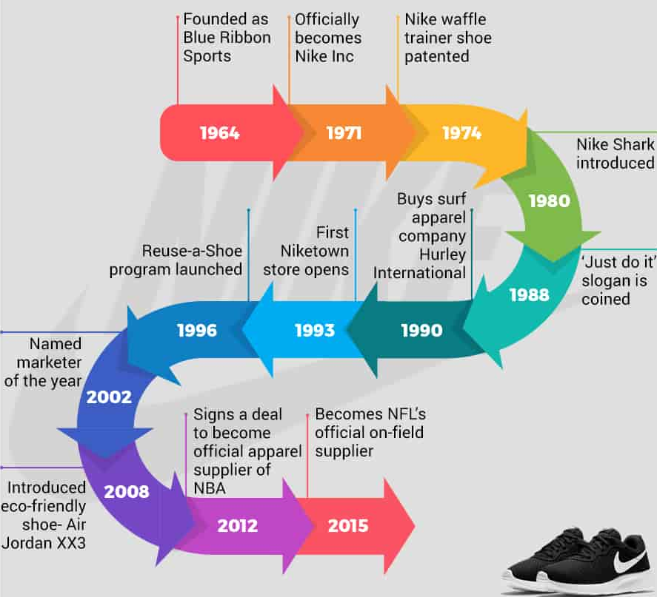
Figure 8 Nike's Timeline(Brohi et al., 2016)
This result is the result of a combination of factors, including a revised organisational structure and the introduction of innovative new goods. Nike has also been vigilant in its resource management. It is important to preserve the patient's unique qualities in order to optimise the patient's worth. To push themselves to new heights, Nike also analyses their past successes and performances. It has used a fair scoring system to monitor efficiency gains in the workplace. The company also collects information from existing and future consumers and monitors its rivals. It utilises the information to prepare for the future, establish objectives over a specified time frame, and assemble novel ideas from other organisations. Furthermore, Nike employs corporate citizenship as a primary mechanism for achieving high quality and engaging with the social order. Nike's distribution of branded jerseys to local youth athletic events is a great illustration of this philosophy in action.

Management Strategies tools
Strategic management has been used by Nike, Inc. to evaluate the company's present state and predict how it will do in the years to come. The resources available to management for determining the company's future direction have been vastly enhanced. The leaders of a company engage in strategic management practises such as formulating a plan, putting it into action, analysing its external context, and assessing its success. Strategic management was an invaluable tool for Nike as it formulated new business strategies and assessed many aspects of the company's operations. It opens the door for firms to develop novel methods of motivating their staff to perform better. Competitors' present and planned strategies are analysed to achieve this result. The company has used strategic management techniques to improve its knowledge of its present situation and forecast its future actions(Ahmed et al., 2016). Using a strategic plan, leaders may figure out where their teams want to go. Strategic management tools include a stated objective, SMART goals, a strengths and weaknesses analysis, and a comparison to industry standards. Mission and vision statements help stakeholders get insight into the organization's present and future priorities.
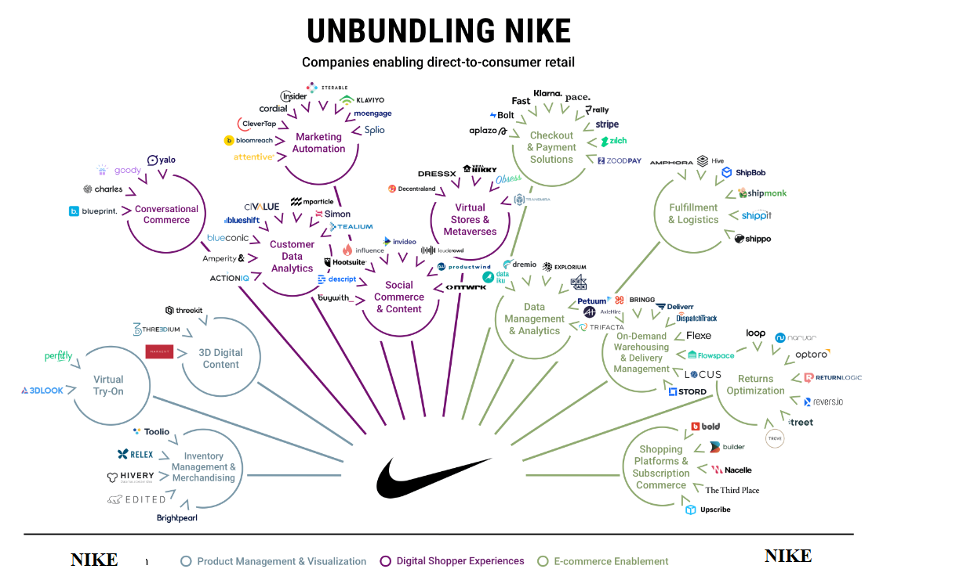
Figure 9 Unbundling Nike(Stonehouse and Minocha, 2008)
The corporation is trying to figure out how to set itself apart from rivals like Reebok. The company's SWOT analysis looks at its advantages, disadvantages, prospects, and dangers. With this help, the firm has capitalised on its strengths and reduced the impact of its weaknesses. In addition to the factors included in the SWOT analysis, the organisation has benefited by considering available positions and possible hazards. SMART goals are ones that are specific, measurable, evaluated in terms of attitude, achievable, and time-bound. Administration at Nike considers SMART objectives crucial because of how effectively they've eradicated the irritation that comes from setting goals that are unrealistically high. It will be clear that the leadership was effective if the desired outcomes are achieved. In addition to comparing ourselves to the finest in the business, we also take a look at the methods used by other organisations and modify our own methods as necessary(Thomas, 2022). It has been established that the company's management teams have been crucial in improving the company's performance to the point where it is meeting its goals and has an advantage over its rivals.
Assessment findings are used in project management as well, providing a complete picture of the project's success or failure for the company. As a result, upper management has a better idea of how much time is available to get everything done. Nike's success is contingent on the completion of these initiatives and projects. Break using an even evaluation, the corporation can forecast how many things need to be sold before it turns a profit. Marketers use gamification to foresee how consumers will react to price rises or the launch of new products. Using expenditures, quality audits, and budgetary breakdowns, businesses may better control and balance their operational costs. The organization's expenditures serve as a means of managing its revenue and expenditures and allocating its resources to different initiatives and activities(Li, 2022).
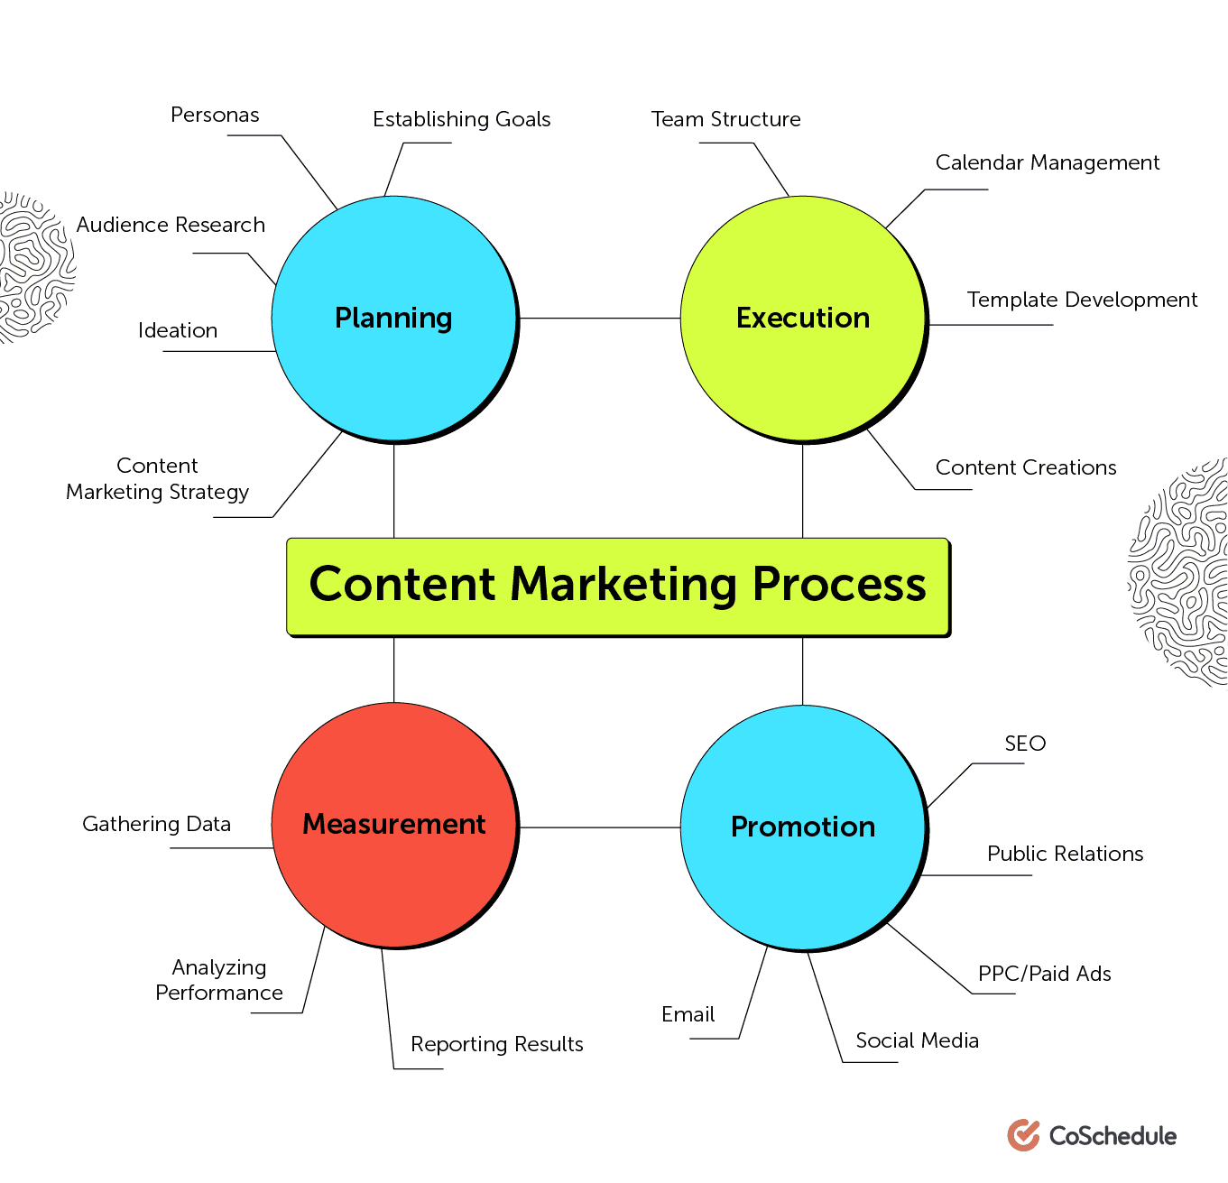
Figure 10 Nike's Marketing Strategy(Agha and Dixon, 2021)

Internal Assessment

Partners
Nike has strategic connections in dozens of nations. Nike's success depends on manufacturers and material suppliers. Freelancers produce. Nike has 150 shoe producers in Vietnam, China, and India and 400 clothing factories in China, Vietnam, Sri Lanka, Thailand, Indonesia, Malaysia, and Cambodia. Nike relies on EA Sports and Apple's AppStore. Nike partners with TomTom, Garmin, and Wahoo to provide more fitness trackers and GPS watches. Nike has also partnered with Michael Jordan and Rory McIlroy (with whom they developed footwear).

Essentials
Nike's assets are physical and human. Nike has 800 factories and one million workers in 50 countries, principally China and India. Because Nike is a leading sports brand, Nike's 65,000+ employees must enrol in a training programme to grasp the company's culture. Nike employees are ecstatic. Nike invests much on patents to commercialise its innovative technologies. Nike analyses business data to find ways to expand their lifestyle brand. Investors donate a lot to Nike since it's on the stock market and its business practises are transparent(Nica et al., 2021).

It's basically this
Nike focuses on branding, marketing, and product development. Nike markets culture, not products. Nike's branding promotes this lifestyle. Nike seeks to gain global followers and brand loyalty by appealing to people' heroes. The protagonist overcomes insurmountable challenges despite his terrible origins. "Just do it" was their catchphrase. It stirs emotions and is susceptible to interpretation. It connects the firm to customers. We use this motto regularly.

Unique selling propositions
Nike dominates sportswear. Because of its solid product quality and distribution network, and because it can demonstrate clients how much they are appreciated. Nike offers innovation, personalisation, brand/status, and a large range of footwear and gear, including Converse and Hurley. Nike valued creativity too. Nike Advanced Product Creation Center and Nike Explore Team Sport continue to create innovative products with cutting-edge technology. Nike ID also lets users choose a colour palette, a sport-specific design, and a shoe inscription. Nike's many honours, including 2010's "World's Most Innovative Company," demonstrate its brand-building prowess.
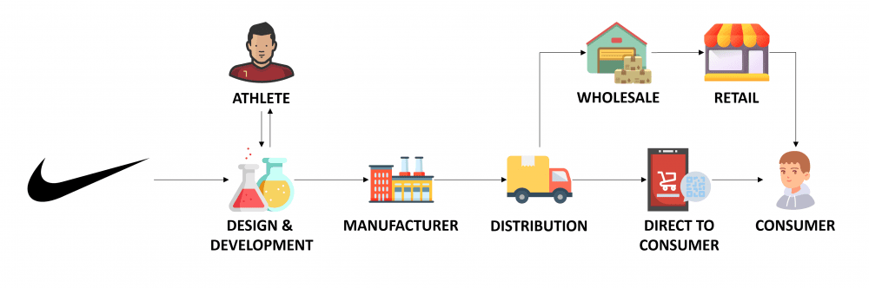
Figure 11 Business Model(Mahdi et al., 2015)

Customer Relationships
Nike Digital Sport (NDS) was founded in 2010 to develop technology and devices for self-monitoring. Nike documented customer preferences and patterns. Nike has improved their customer discussions after utilising NDS. Nike+, its social networking platform, promotes community relationships. Nike has built long-term market relationships through listening and reacting to customers. Nike employees know the company's products and can help unknown customers. The company's website also addresses typical inquiries. Phone, email, and live chat support are also available.

Clients
Nike is mass-market. The firm sells sports shoes and clothing. Nike sells sportswear and soccer shoes to younger customers, yet most of its customers are 18–40. Nike targets almost everyone. Nike targets highly driven, performance-focused athletes. Nike customers are usually well-off and interested in new workout gear. Nike targets Americans. Nike has stores in 190 countries on all seven continents. Nike distributes via its retail network. It sells its goods and services worldwide and drives visitors to its website via a network of independent distributors and licensees. Nike advertises mostly on TV. Nike also extensively promotes new products on social media, including Facebook, Instagram, Twitter, and Nike+. Nike's user-friendly website offers several resources. Most customers buy in the store therefore employees must be well-trained and friendly. Nike delivers internet purchases. Pricing Nike aims to increase retail sales and price its high-quality items to increase profitability by 0.4% yearly. The company's biggest expenditure is sales. NIKE's worldwide success lowers its effective tax rate. Taxes are generally lower elsewhere. The projected corporate tax rate is 24.5 percent.
Nike's revenue comes from footwear, clothing, equipment, and accessories sales. Nike sells more than soccer and basketball gear. With massive franchisees worldwide, the company's annual profits are largely from footwear sales. Nike's wholesale market sells its products via a broad retail network.

Value Proposition Canvas

Services and Goods
Nike is a company that provides consumers with top-notch sportswear, shoes, and accessories. Many Nike goods are identical to those worn by the world's finest athletes. Nike's shoes are designed to boost the wearer's efficiency.

Profit Makers
When it comes to sportswear and equipment, nothing beats Nike in terms of quality. Customers are influenced to purchase Nike products because they see their favourite players wearing them.

Drugs to Ease Pain
In order to boost public perception of the Nike brand, the company actively engages in contact with consumers through advertisements. They spend a lot of time and money on commercials using famous athletes like Michael Jordan, Serena Williams, and others to prove their point.

Gains
When it comes to sporting gear, Nike is at the top of the game. As a result, people end up staying for longer. Due of its good quality, it can survive with you for more than a year. The right pair of Nike soccer cleats, for instance, may significantly improve your game.

Pains
Nike's strong brand means that it must charge premium pricing for its products, which is a source of pain for consumers. The company's shoes are more expensive than those of its main rivals, putting them out of reach for many consumers throughout the globe.

Employment Requests from Customers
Nike's high-quality wares improve their owners' visual presentation. Clients like the added sense of safety it provides them when working out. The client feels safer and more secure in his Nike purchase since the athlete will have a higher sense of performance while wearing the brand's gear.

Recommendations and Conclusion
In conclusion, it's easy to see that Nike is a successful company with a powerful brand. They have seen significant performance gains after adopting a resource-based perspective approach. But Nike, like any other great corporation, isn't perfect. To help Nike in the future, consider these suggestions: The current state of their working circumstances reflects poorly on Nike. People are forced to labour in "sweatshops" for 9-15 hours per day, 6 days per week, for a pittance of pay. Companies have a duty to the communities surrounding their operations to provide a clean and healthy environment for employees and residents alike.
If Nike wants to steer clear of any political or social controversy, it would be wise for the company to tone down the substance of their commercials (see: the Colin Kaepernick commercial).
Aside from that, Nike is making remarkable strides and is on a sustainable path to success.

References
Agha, N., Dixon, J.C., 2021. The uniqueness of spectator sport from a strategic management perspective: The case for spectatoritis. Journal of Global Sport Management 6, 7–29.
Ahmed, R.R., Brohi, B., Bhutto, A.H., Prithiani, J., Khubchandani, R., Kumar, S., Abbas, Z., 2016. „Strategic Marketing Plan of Nike “. ResearchGate, Indus Institute of Higher Education.
Almazrouei, A., Yassin, A.M., Memon, A.H., 2021. Strategic Management Indicators for Sustainable Road Traffic Management. International Journal of Sustainable Construction Engineering and Technology 12, 88–95.
Alsaffar, H., 2020. Nike’s Marketing Mix and PES℡ analysis in China.
Bonsu, S., 2019. Strategic management: The concept of competing with self. Journal of Marketing and Management 10, 20–44.
Brohi, H., Prithiani, J., Abbas, Z., Bhutto, A., Chawla, S., 2016. Strategic Marketing Plan of Nike.
Childs, M., Jin, B., 2018. Nike: An innovation journey, in: Product Innovation in the Global Fashion Industry. Springer, pp. 79–111.
Distelhorst, G., Hainmueller, J., Locke, R.M., 2017. Does lean improve labor standards? Management and social performance in the Nike supply chain. Management Science 63, 707–728.
Gamble, J., Thompson, A., Peteraf, M., 2014. Essentials of Strategic Management 4e. McGraw Hill.
Hadju, Y., Salimi, Y.K., Bialangi, N., Ischak, N.I., 2022. Analysis Of Protein And Bioactivity Of Nike Fish (Awaous melanocephalus) Extract As Antioxidant. Jambura Fish Processing Journal 4, 103–112.
Hunger, J.D., 2020. Essentials of strategic management.
Kiseleva, M.A., Vasilev, K.V., Protopopova, P.A., Inin, A.A., Evtodev, M.D., 2021. NIKE SHOE REDESIGN, in: СТУДЕНЧЕСКИЙ НАУЧНЫЙ ФОРУМ 2021. pp. 48–51.
Knight, E., Daymond, J., Paroutis, S., 2020. Design-led strategy: how to bring design thinking into the art of strategic management. California Management Review 62, 30–52.
Knight, G., Greenberg, J., 2002. Promotionalism and subpolitics: Nike and its labor critics. Management communication quarterly 15, 541–570.
Li, Z., 2022. The Analysis of the Reasons for the Success of the Under Armour Brand Based on “SWOT” and Porter’s Five Forces, in: 2022 7th International Conference on Social Sciences and Economic Development (ICSSED 2022). Atlantis Press, pp. 676–680.
Liu, Y., Foscht, T., Eisingerich, A.B., Tsai, H.-T., 2018. Strategic management of product and brand extensions: Extending corporate brands in B2B vs. B2C markets. Industrial Marketing Management 71, 147–159.
Mahdi, H.A.A., Abbas, M., Mazar, T.I., George, S., 2015. A Comparative Analysis of Strategies and Business Models of Nike, Inc. and Adidas Group with special reference to Competitive Advantage in the context of a Dynamic and Competitive Environment. International Journal of Business Management and Economic Research 6, 167–177.
Meng, S., Wei, B., Xu, G., Zhang, R., 2021. Analysis of Enterprise Operation Under the Impact of COVID-19 Epidemic: A Case Study of Nike Inc., in: 2021 International Conference on Financial Management and Economic Transition (FMET 2021). Atlantis Press, pp. 137–145.
Nica, I., Chiriță, N., Ionescu, Ștefan, 2021. Using of KPIs and Dashboard in the analysis of Nike company’s performance management. Theoretical & Applied Economics 28.
Orosová, S., n.d. Social Media Marketing Strategies of Nike in Different Parts of the World-Dubai, Hong Kong and New York.
Riwayadi, E., Deliabilda, S.A., Panahatan, M.B., 2021. PESTLE ANALYSIS OF FINANCIAL TECHNOLOGY IN INDONESIA, in: International Conference on Innovations in Social Sciences Education and Engineering (ICOISSEE).
Simonson, A., Schmitt, B.H., 1997. Marketing aesthetics: The strategic management of brands, identity, and image. Simon and Schuster.
Stonehouse, G., Minocha, S., 2008. Strategic processes@ Nike—making and doing knowledge management. Knowledge and Process Management 15, 24–31.
Thomas, M.B., 2022. Swooshed: How Nike and the City of New York could potentially change the landscape of city branding through apparel licensing agreements. Public Administration Review 82, 1186–1191.
Zhu, X., 2022. A Comparative Study of Nike’s Marketing Strategies in China and the US, in: 2022 International Conference on Urban Planning and Regional Economy (UPRE 2022). Atlantis Press, pp. 467–470.

