Module- Academic and employability skills. Student name- Sean Ferguson Student number- 19166821 Lecturer name- Anita nan
Report index: Page 1a....introduction Page 1b....SWOT analysis Page 2a....Strengths Page 2b....Time management Page 3a....time management charts Page 3b....Effective verbal communication Page 4a....Weaknesses Page 4b.... Critical thinking Page 5a....Personal development plan page 5b....conclusion

Academic and employability skills

Introduction

The purpose of this report is to analyse my academic and employability skills and gain the ability to effectively recognise skills that will be used throughout my academic and professional career by creating a SWOT analysis that will allow me to identify and develop relevant skills. The analysis distinguishes between the stronger skills and compares them to the weaker, by analysing and reflecting on previous experiences and on future goals and expectations. Methods used to determine which skills furthermore my strengths and weaknesses have been used for many years and are still applied to this day. This report will be useful to reflect upon, analysing skills that will assist me to develop a professional career and academic studies.

SWOT Analysis

The analysis has four factors to consider, the internal factors [strengths and weaknesses]and the external factors [opportunities and threats] although some might argue that the categorisation of skills can be a distraction from the primary focus of achieving the main objectives, on the other hand personally this was a beneficial exercise to begin with as breaking down and categorisation of skills allowed me to compare and contrast between skill sets that would be useful in scholastic and working environments. The analysis shows the essential skills needed and others to be improved by dividing them into four sections, effective Academic skills are essential to learn effectively whilst employability skills are situation specific and acquired through experience, study and training. Creating a visual image of my skills, strengths and weaknesses of which need to be career orientated. Through this method of reflective analysis personal development progress will be easier to measure. This report will focus more about the internal factors [strengths and weaknesses] opposed to elaborating the opportunities and threats.

1

Strengths

Strengths These are the skills that need to be taken advantage of, developing abilities to competently and confidently Complete tasks more efficiently. Academic skills prioritise currently, they shall be the foundation for my employability skills to build on. The analysis made me focus on personal experiences that have greatly impacted me in the past and these skills have stood out to me as two skills that may already have practice.
• Time management skills
Time management is managing and prioritising time effectively, it is key for organisation and scheduling of studies and tasks. Dwight D. Eisenhower was the 34th President of the United States and creator of the Eisenhower matrix which he invented to plan each day through breaking down his duties into 4 categories of high and low importance and high and low urgency. this matrix that can sometimes be displayed in quadrants annotated by the important and relevant of the tasks at hand or needs to be done later. Urgent and important would be like going to work or cooking something as these are the tasks to hand therefore, they are prioritised. Whereas important but not urgent does not require the task to be done immediately but can be put off or scheduled to be done later.
Another popular method that was elaborated from Romanian born engineer, Joseph M.Juran that conceptualised upon the theory that he named the "pareto principle" after Vilfredo Pareto, which he had used to explain how the wealth is divided amongst the countrymen. His theory 80% cause comes from 20% of the effect, as an example he quoted that “80% of the wealth of the world was owned by only 20% of the nation”. Vilfredo Pareto.
Reflecting upon the valuable experience gained which gave me an insight as to what organisational skills are required to be able to learn and present evidence, this may be time consuming. Once taught these two strategies of time management they may develop my administrative skills which also need to be managed effectively. Researching these techniques and applying them to an academic course or work would demonstrate the ability to organise my time efficiently, for this course the Eisenhower matrix helped to implement a dynamic time schedule whereas with the pareto principle failed to give an effective method to prioritise and manage time in my situation The concept for example to say that “20% of my grades will come from 80% of studying?” Or compared to making an educated situation specific and achievable schedule of prioritised works that would have a necessity to complete under a timed pressure. The Eisenhower method in contrast to the pareto method, they have both been met with great acceptance to anyone that may of required help to guide them through the steps of time management.

2

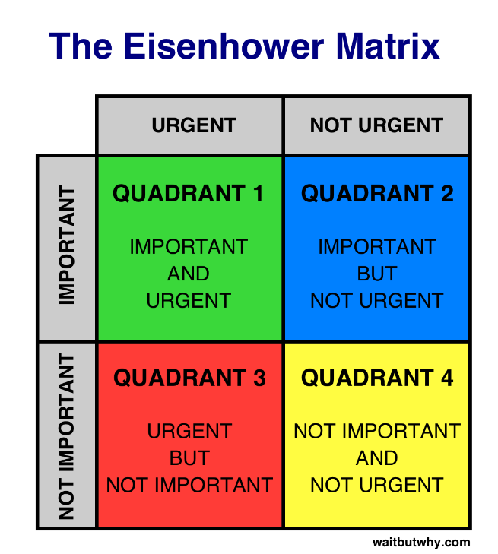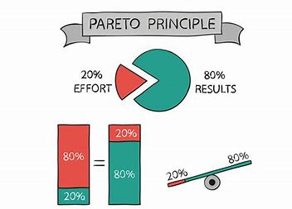
• communicational skills

Verbal communication or oral communication/speech is the process of sending a message either written or vocalised, a message for example on a board would be classed as verbal communication as the receiver would have to decode the written message. Verbal communication that does not require words to be spoken but rather the words that are being communicated are what is important as it’s the process of decoding and interpreting the words and making sense of the meaning and to show them here is a chart.

Verbal communication | non-verbal communication
Oral |Spoken language/words. | Laughing, crying, coughing,
|Video/phone calls. | sneezing, humming.
_______________________________________________
Non oral I writing memos and notes. | Body language and gesturing
| written messages or signing | signs, physical contact. Colours

Non-Verbal communication can be oral or non-oral. orally spoken language, written and sign language are both oral. Having travelled Argentina presented an opportunity to learn Spanish which I took advantage of also having two Italian children gave me the motivation to learn Italian. A common misconception is that some forms of non-verbal communication are verbal for example coughing, crying and laughing. University has improved my knowledge and given me a broader prospective of communication in general but specifically verbal communication. From my analysis of the academic skill that has developed through practice would be effective verbal communication. This would be used for conversing in person or even via phone passing and relaying a response from what message has been perceived by the receiver.
3

Weaknesses

To make an accurate reflective analysis the SWOT matrix requires self-criticism, fortunately this critique allows me to constructively integrate a system that tracks my progress. Short term goals can help prevent further skill fade, making my long-term goal to turn them into strengths.
Critical thinking. Making an effective analysis, reflection or argument that requires an inquisitive method of thinking to explore the subject from different aspects and views. According to Cottrell “working out whether we believe what we see or hear, taking steps to find out whether something is likely to be true, arguing our own case if someone doesn’t believe us”. Stella Cottrell. Macmillan International Higher Education, (2017) Inquisition is the direct route to information and knowledge, questioning a process or a thought for example would allow a greater deeper understanding of that subject keeping the questions relevant. Critical thinking has made an impact on university learning as critical thinking can be ambiguous. Imagination and curiosity can aid to asking relevant and otherwise overlooked questions. My short term goal is to attempt to approach situations, research methods and studying with inquisition scepticism that may improve overall projects and teach me how to look at something substantially and even be able to challenge a process that may be ineffective.

Adaptability. To be able to manage how you approach situations looking for the best outcome and being able to adjust to change of circumstances or environments. This is a useful skill to have as it allows a fluid transition between circumstance. Adapting to university life this year has proven to be more difficult than expected as my adaptability may have skill fade which is a problem that may happen if not used for some time. Not being adaptable has also caused or if not made worse an anxiety for me to cope with as a result of trying to maintain a balanced life between having a career, studying and home life which can be a full-time job. The world this year has been greatly impacted by a near complete global lockdown that has removed my routine also the opportunity to carry on improving my adaptability skills in a scholastic environment. The lock down itself has presented itself as a highly adaptable situation as everyone has had to adjust to the unforeseen circumstances. “It is not the strongest of the species that survives, nor the most intelligent. It is the one that is most adaptable to change.” Charles Darwin. (The father of evolution) To be able to work on improving adaptation effective goals will be set and managed to reach my objectives. My objectives are to improve my adaptability skills, to strengthen confidence in aspects of meeting new people or visiting new places and having the capacity to merge with the surrounding environment without stress. To be able to work on improving adaptation effective goals will be set and managed to reach the objective. My objectives are to improve my adaptability skills, to strengthen confidence in aspects of meeting new people or visiting new places and having the capacity to merge with the surrounding environment without stress. Adaptation has a huge connection to personality and generic thinking patterns, personality traits can either help or halt progress. Being adaptable is not about moving from place to place and trying to fit in, it is entering a situation and moulding yourself to the surrounds opposed to having a mentality to expect the world to fit them. It is easy to overlook a valuable lesson when attention is not being paid, so everyday starts with a "Can do" attitude and the willingness to learn. This year it is important to Practice improvisation, this is a valuable skill to have. Improvisation can be an exercise that can be practised and used to combat dealing with situations that may otherwise be more stressful.

4

My personal development plan

A personal development plan is an account for improvement and written self-reflection, furthermore this functions as a detailed action plan that will cover my personal and career-based goals. My short-term goals for this year are to use my time wisely, to sleep less and work more whilst seizing opportunities when possible, to develop further my communicational skills and to successfully integrate time management into daily life, the one most relevant for me and tailor it to my routine. How can my goals be prioritised? By creating a schedule of tasks the night before, be more aware of time to increase productivity. Invest my time into projects that can have productive effects on my academic and employability skills. How can I keep to my personal deadlines? keeping either an electronic or other type of schedule or diary can be an effective organisational tool, they may also note the measurement of progression
Conclusion
In conclusion, this report has discussed my academic and employability skills and made contrasts and comparisons to which would be my most effective skills, how they can be manageably integrated and have the progress measured by having realistic and achievable short- and long-term goals. Starting university can be daunting to someone that has not been to further education, this year begun with a basic knowledge of my personal skills and an idea of what to expect this year. Although there was a lack of preparation this analysis has aided me to learn more about myself and my strengths and weaknesses that would have gone otherwise unnoticed. My aim is to achieve over six months of practicing how to use my time effectively that a level of competency will have been achieved and by one year have a structured organised system of time management and be fully prepared for the next academic year. By this time new objectives will be made and the short-term goals will be beneficial to refer to when tracking overall progress. time management methods were adopted to give me an insight of how to prioritise my time throughout my academic period. The Eisenhower matrix has been thoroughly analysed and found to have one crucial problem that it focuses only on the tasks at hand and not so much on what the task requires or the task itself. Verbal communicational skills were discussed, this taught me about not just verbal abilities spoken orally but how communication can be displayed by expressions and body language Critical thinking and adaptability we two of my weaker areas that I would personally like them to evolve to a much stronger level. Thinking objectively and being inquisitive with a learning approach to the subject will understand weaker points in order to make progression.

References
References; Stella Cottrell. Macmillan International Higher Education, (2017) Charles Darwin in The Continuum Encyclopaedia of British Philosophy (1809-820) information for SWOT analysis from mindtools.com

)

5

References
References; Stella Cottrell. Macmillan International Higher Education, (2017)
Charles Darwin in The Continuum Encyclopaedia of British Philosophy (1809-820)
Eisenhower White House 1953 – 1961. www.whitehousehistory.org
Verbal communication “handbooks of communication science” published by Mouton. (2012) louis de Saussure and Andrea Rocci.
Information sourced on Vilfredo Pareto https://policonomics.com/vilfredo-pareto

