
Module Name: Academic Skills in the Digital Era
Module Code: BMSW4013
Assessment 1: E-Portfolio
Student Name: Hibah Harb
Student Number:2511464
Lecturer: Scott James
Deadline: Friday 21st November 23:59PM

AI Acknowledgement
statements if you have used AI.
I acknowledge the use of ChatGPT (https://chatgpt.com/) on 17 February 2026 to assist with paraphrasing and improving the clarity, grammar, and structure of my writing using the prompt(s):
- Please paraphrase the following paragraph while keeping the original meaning.
- Please shorten this paragraph without changing the main ideas.
I confirm that I have not presented AI-generated content as my own original ideas. The ideas and core content are my own work. I confirm that I have copies of my drafts, notes, and other resources used before and after the use of AI tools, which I may be asked to provide as evidence.
*You must provide an AI statement
Screenshot of proof and also have my own draft

Contents
Component 1 – Research and Planning Template 4
Source Exploration 4
Key Challenge for Students 4
Key Opportunity for Students 4
Planning Your Report 4
Timeline for Component 2 4
Component 2 – Answering the Question 5
Introduction 5
Challenges Students Face 5
Opportunities Digital Tools Provide 5
How Students Can Adapt 5
Conclusion 5
Component 3 – Reflective Presentation 6
Slide 1 (Overview) 6
Slide 2 (Research) 6
Slide 3 (Planning & Writing) 6
Slide 4 (Challenges) 6
Slide 5 (Successes) 6
Reference List 7

Component 1 – Research and Planning Template

Source Exploration
Choose one source and answer the following.
The selected source is Dadang Mulyana (2023), “Educational Management Innovation: Challenges and Opportunities in the Digital Era,” published in Jurnal Info Sains: Informatika dan Sains. The article examines how digital technologies—such as LMS, online collaboration platforms, and gamified learning environments—are transforming education and emphasizes the need for students and educators to adapt.
This source was chosen because it is recent, reliable, and directly relevant to my research on the challenges and opportunities students face in the digital age. Mulyana highlights obstacles like unequal access to technology and varying digital literacy, while also emphasizing opportunities for engagement and digital skill development.

Key Challenge for Students
Digital tools give students access to learning resources anytime and anywhere. According to Mulyana (2023), platforms like LMS, online libraries, and tutorials let students study independently and review material at their own pace. These tools also support online discussions and group work, helping students collaborate and improve communication skills. I appreciate this flexibility because it promotes self-directed learning, builds lifelong learning habits, and prepares students for careers requiring adaptability and tech skills.

Key Opportunity for Students
One major advantage of digital tools is the flexible access to educational resources anytime and anywhere. Students can learn at their own pace and review material as needed through learning management systems, online libraries, and video tutorials. Mulyana (2023) notes that this flexibility encourages self-organized learning and helps students take ownership of their development. For example, instead of waiting for the next lesson, students can access online tutorials or watch class recordings when they struggle with a topic. This flexibility allows me to learn according to my schedule and preferences, revisit missed material, and develop skills such as self-management and academic confidence, making learning more accessible and less stressful.

Planning Your Report
I will explore both challenges and opportunities in digital learning, as understanding difficulties shows the need for adaptation, while opportunities highlight its benefits. Using examples from Mulyana (2023), such as LMS platforms like Moodle and Google Classroom, and collaboration tools like Zoom and Microsoft Teams, I will show how students access information and communicate online. I may also draw on my own classroom experiences. The essay will cover key challenges, the advantages of digital tools, strategies for students to adapt, and a conclusion summarizing the main points.

Timeline for Component 2
Task | Date/ Deadline
Finish research | 14/10/2025
Draft first section | 1/11/2025
Complete first draft | 11/11/2025
Final editing | 24/02/2026

Component 2 – Answering the Question

Introduction
Technology plays a vital role in modern education, with students learning through digital tools, online platforms, and virtual collaboration. While these tools make learning more flexible and interactive, they also create new challenges and expectations. This study explores the opportunities and difficulties students face in digital learning and highlights the importance of developing the skills needed to succeed in a technology-driven environment.
I will explore both challenges and opportunities, as understanding difficulties shows the need for adaptation, while opportunities highlight benefits. Using examples from Mulyana (2023), such as LMS platforms like Moodle and Google Classroom, and tools like Zoom and Microsoft Teams, I will show how students access information and collaborate online. I may also draw on my own classroom experiences.

Challenges Students Face
Students face several challenges in digital learning. Unequal access to devices and reliable internet can limit participation. Developing digital literacy and managing online tasks requires effort, while self-discipline and time management are essential but difficult for many. Without support, these issues can increase stress and hinder learning.

Opportunities Digital Tools Provide
Despite challenges, digital tools offer clear benefits. Platforms like Moodle and Google Classroom give flexible access to lectures and assignments, while Zoom and Teams enable collaboration and skill development. Personalized learning tools adapt to student performance, and online libraries improve research and critical thinking (Mulyana, 2023). Overall, digital technologies enhance flexibility, teamwork, independent learning, and essential digital skills.

How Students Can Adapt
How Students Can Adapt to Digital Learning
Students need strong digital literacy and self-regulation skills to succeed in online learning. As Mulyana (2023) explains, the ability to manage learning independently is as important as access to technology. Regular use of digital tools—such as academic databases and learning platforms—builds confidence and efficiency.
Effective time management is also essential, as online learning requires independence and can lead to procrastination. Creating study schedules, setting deadlines, and breaking tasks into smaller steps help reduce stress and improve performance.
Finally, seeking academic and technical support—through tutors, workshops, and peer forums—enhances understanding and writing skills. Together, these strategies build resilience and help students adapt successfully to digital learning environments.

Conclusion
In conclusion, the digital age, students face both challenges—like unequal access, low digital literacy, and self-management issues—and opportunities, including flexible learning, personalized support, and enhanced collaboration. By developing skills, managing time, and seeking help, students can overcome obstacles and make the most of digital learning, preparing themselves for academic success and future careers.

Component 3 – Reflective Presentation
**Copy and paste your PowerPoint slides below. Start with Slide 1 under the heading ‘Slide 1’. Then do the same for each slide, using the correct slide number as the heading
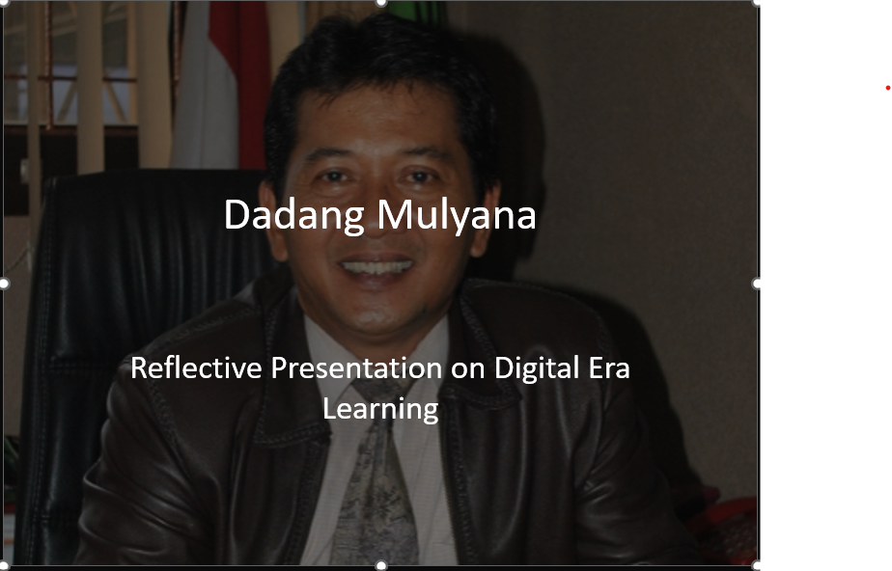
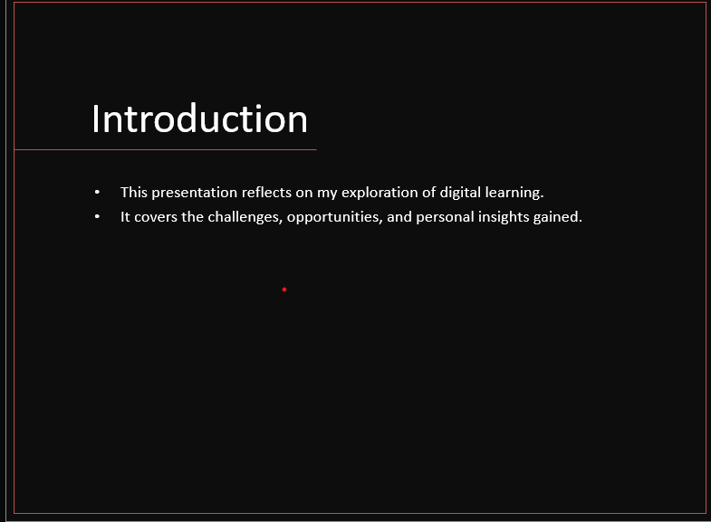
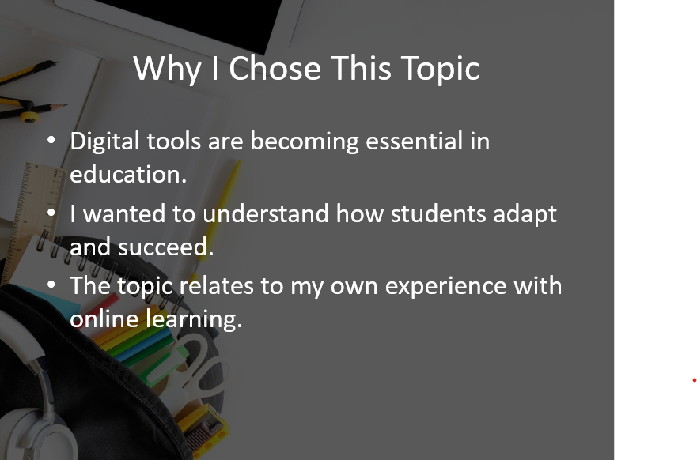
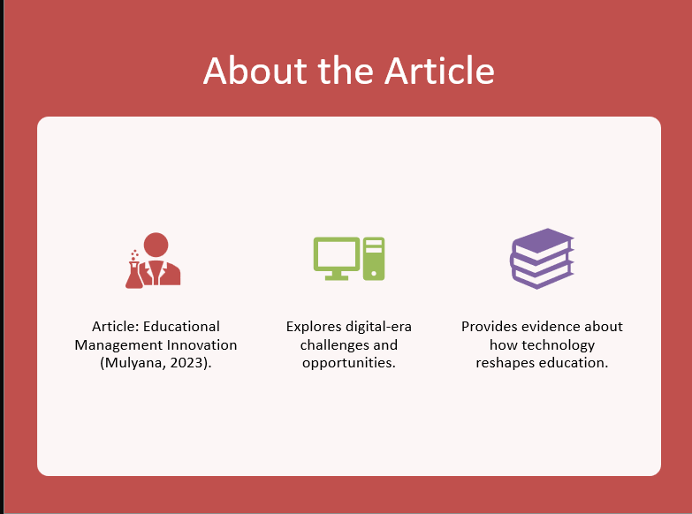

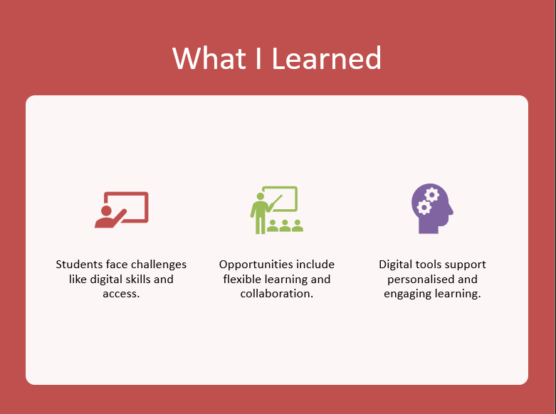
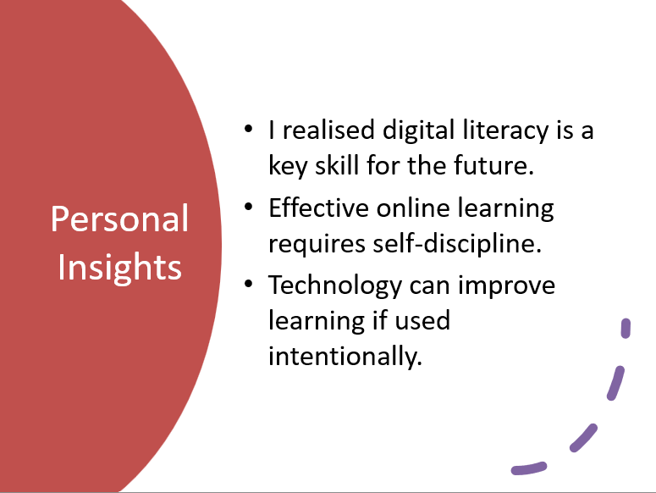
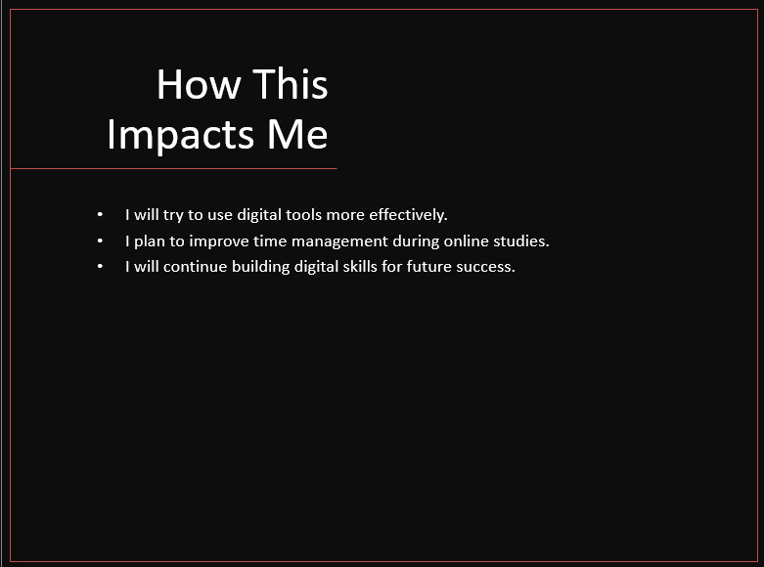
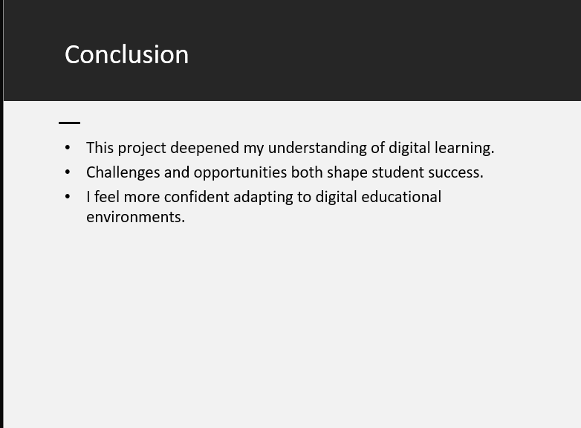

Reference List
**Include ten references, formatted in the Harvard Referencing style. List the references in alphabetical order.
Mulyana, D, (2023), educational management innovation: challenges and opportunities in the digital era. Jurnal Info Sains: informatika dan sains ,13(3),1201-1207: https://ejournal.seaninstitute.or.id/index.php/InfoSains/article/view/4082
AI-based writing and paraphrasing tools, including ChatGPT and Grammarly, were used to support drafting, editing, and improving academic language.

