University of Wales Trinity Saint David
Wales Institute of Science and Art


Kinetic energy recovery

Alternative propulsion systems ACHA5010

Alex Jones
2200239

Contents page:

- Introduction and vehicle characteristics……………………3
- WLTP cycle………………………………………………………….……4
- Cumulative tractive and braking energy plots…………..6
- Largest KERS recovery and storage requirements.......7
- Suitable KERS system……………….……………………………….7
- Kinetic energy recovered………………………………….………8
- System operation……………………………………………………...8
- Reference list………………………………………………………......9

Introduction

In this kinetic energy recovery analysis, I will be investigating the use of a Kinetic Energy recovery System (KERS) to reduce vehicle fuel consumption. To perform this analysis, I will be looking at the Worldwide harmonised Light vehicle Test Procedure (WLTP) and plotting spreadsheets for the cumulative tractive and braking energy required at the wheel over the cycle of the WLTP. Using these spreadsheets, the requirements for KERS energy storage, and the moments where the largest possible KERS power input is possible to maximise fuel savings will be identified. The optimal KERS will be selected with appropriately sized components to be efficient yet still able to fit and not add too much weight to the vehicle.
For this KERS analysis, the vehicle I have chosen to investigate is the Ducati Panigale 1299. It is a 1285cc superbike manufactured from 2015 until 2017. Being a superbike style of motorcycle, it has a full set of plastic fairings to increase aerodynamics and a windshield for the rider to tuck behind, further improving the aerodynamic drag which therefore improves fuel economy compared to a motorcycle with the same engine and gearing, but without fairings.
Ducati Panigale 1299 vehicle characteristics:
Engine | 1285cc naturally aspirated V Twin producing 205hp at 10500RPM and 144Nm at 8750RPM.
Kerb mass | 190.5kg
Frontal area | 0.48m^2
Co-efficient of rolling resistance | 0.02
Co-efficient of aerodynamic drag | 0.6

Frontal area was calculated using a scale picture in solidworks and tracing the outline of the bike. The picture was scaled using the known width of the handlebars, at 750mm.
The drag co-efficient of a motorcycle tends to range from 0.5-1 (Remmerie, 2018) which is double that of a modern car, due to the open wheels, many exposed components such as suspension and brakes and a constantly moving rider creates a disturbance in the airflow around it, detaching airflow. I was unable to find an exact co-efficient of aerodynamic drag for the Panigale, however values for other supersport styled bikes that I was able to find indicates the co-efficient is on the lower end of the range, so 0.6 will be used for the purpose of this analysis.

WLTP cycle

The Panigale 1299 produces 205hp which is equivalent to 152.86kW or 152868W, with a kerb mass as per ECE R83 of 190.5kg, giving the Panigale a power to weight ratio of 802.46W per Kg which puts it into WLTP class 3, version 5.

WLTP plots:
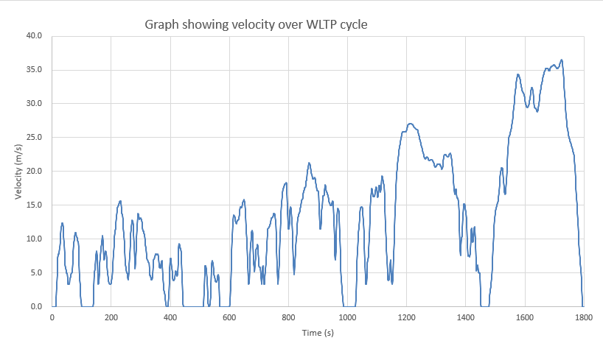
Looking at the velocity over time graph for the whole WLTP cycle it can be seen the WLTP class 3 cycle consists of a low speed, medium speed, high speed and very high speed sections with their maximum speeds reaching 15m/s, 21m/s, 27m/s and 37m/s respectively. The low (0-589s) and medium (590-1022s) speed sections consist of lots of accelerations and decelerations, coming to a complete stop 5 times. This is to best represent city driving conditions where you have to stop for traffic lights and pedestrians and accelerate and decelerate constantly between stops as you slow down for traffic and potential hazards. The high speed section from 1023-1477s has some accelerations and decelerations with 1 stop at the end of the section to replicate dual carriageway driving. The very high speed section from 1478-1800s has 1 large acceleration to motorway speeds, stays at that speed for some time then comes to a stop, replicating motorway driving.

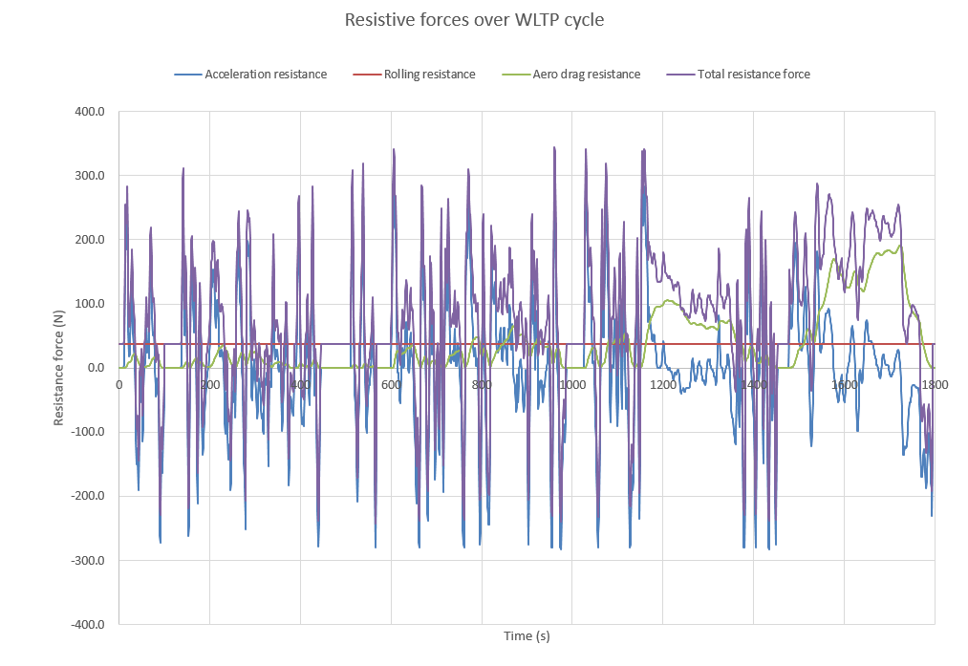
Assuming that the WLTP test is taking place on a flat road such that there is no gravitational resistance force, the remaining forces resisting the vehicles motion are acceleration resistance, rolling resistance and aerodynamic drag resistance.
Looking at the total resistive force, the sum of the 3 forces, in the low and medium speed sections, it closely resembles the acceleration resistance force as there is low aero drag at low velocities and rolling resistance only plays a small part in the total resistance, however in the high and very high velocity sections the drag resistance plays a bigger part than the acceleration resistance as aerodynamic drag increases exponentially as velocity increases. Regardless of this, the total resistance is lower at 254N max in the very high speed section, compared to 337N in high speed, 344N in medium speed and 320N in low speed. Due to the lower resistance in the high and very high speed sections, we can say vehicles are more fuel efficient as less energy needs to be used to overcome the resistive forces.

Accumulated tractive and braking energy
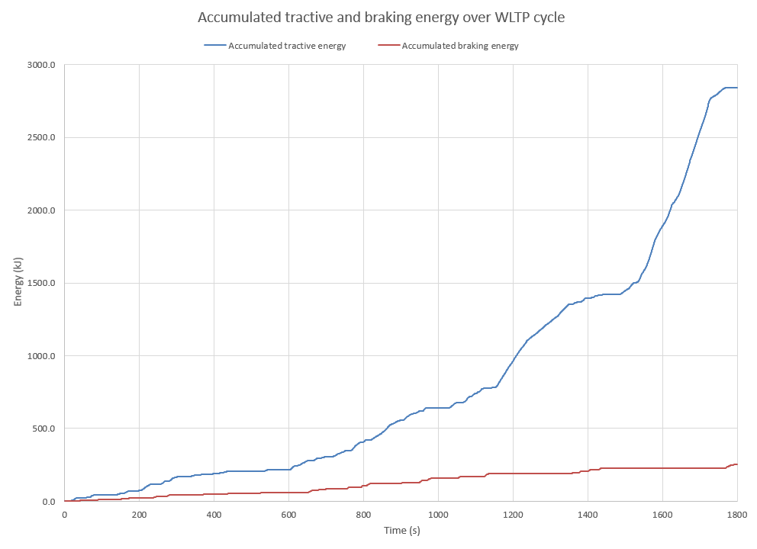
Looking at the above plot of cumulative tractive and braking energy, we can see that the total tractive energy and total breaking energy used. The tractive energy is used to propel the Panigale forwards against the resistance forces at the velocity required by the WLTP, so all this energy gets used up and cannot be recovered. The braking energy is the energy used by the brakes to slow the bike down against its own inertia. Due to the use of friction brakes on internal combustion engine vehicles, this braking energy gets turned into heat that is let off into the atmosphere so it is wasted energy from braking. A KERS system can be used to store this excess braking energy by turning the kinetic energy of the bike into stored electrical energy and can then re-deploy the stored braking energy as tractive effort by use of a motor when it is required. This will reduce the braking energy that is wasted into the atmosphere and reduce the tractive effort needing to be done by the engine as the re-deployed braking energy will aid the acceleration of the bike, therefore increasing the fuel efficiency as less work needs to be done by the engine.

Largest KERS energy recovery and storage requirements:

The total accumulated braking energy that can be recovered is 251.8KJ over the span of the WLTP with the largest braking zone occurring at the end of the very high speed section. This braking occurs over 26 seconds and accumulates 23KJ of braking energy that can be recovered. To store all 23KJ of energy, using a high energy density battery with a specific energy of 950KJ/kg, the battery will need to have a mass of 24.2 grams. Assuming all the energy recovered will be used at the next acceleration, the battery will only be required to store the energy for 90s. The maximum negative power over the WLTP cycle comes to 3.1KW, therefore the KERS system will need to deliver at least 3.1KW of power. For this purpose the motor will have 3.5KW of power to be able to overcome the maximum negative power.

Suitable KERS System:

An appropriate KER system for a motorcycle needs to be lightweight and compact to be able to fit into the bike and not be too bulky or heavy. Due to this, a battery powered system using a motor-generator (MGU) will be used.
The components of a battery powered system consist of an MGU, a PCU and a battery pack. The MGU and PCU have an efficiency of around 95% and the battery 99%. Once the energy has travelled through the MGU, PCU and battery and back to power to power the MGU, the overall efficiency of the KERS is 79.83%. This is greater than the thermodynamic efficiency of a Panigale 1299 engine, being a high revving, high compression naturally aspirated engine with an efficiency of 35-40%. This improved efficiency will result in an overall lower fuel consumption.

Kinetic energy returned to driving wheel:

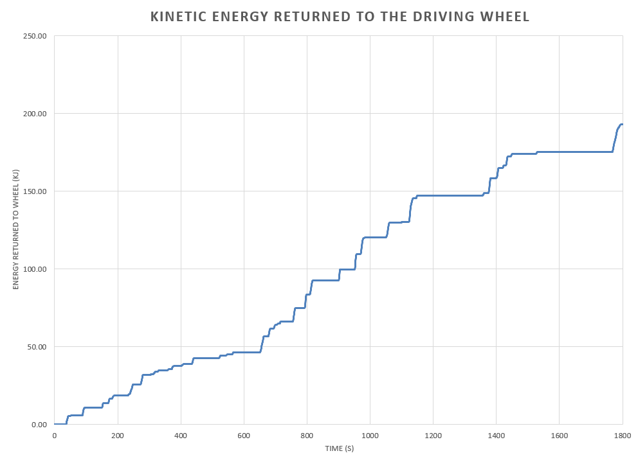
The accumulated kinetic energy that was returned to the driving wheel is 76.67% of the total energy going into the KER system. The total input energy of 251.84KJ*79.83% gives an output energy of 201.04KJ over the WLTP cycle. The difference in energy between input and output energy is lost as heat due to the efficiencies of the components in the KERS.

System operation and driver variation:

An MGU and battery powered KERS system operated by recovering and storing energy during deceleration that would otherwise be lost during braking, and then deploying this stored energy to provide additional power on acceleration. During deceleration, the MGU acts as a generator converting kinetic energy into electrical energy. The energy goes through the MGU into a PCU which controls the flow of electricl current between the battery and MGU and converts the current from AC to DC to be stored in a battery. The lithium-ion battery is used for its lightweight and energy dense storage, which contains the energy until the rider accelerates with the throttle. When this happens the energy is sent from the battery back through the PCU to be converted back to AC current and into the MGU which is now acting as a motor, using the energy to drive the bike forwards.

The difference that the rider may feel due to the addition of a KERS system is quicker deceleration when just letting off the throttle due to the energy regeneration, a faster acceleration from a stop due to the added power from the MGU however the handling and top speed will be affected negatively due to the added mass on the bike.

Reference page

Correia, A. (2015) Motorcycle specifications, 2015 Ducati 1299S Panigale. Available at: https://www.motorcyclespecs.co.za/model/ducati/ducati_1299S%20Panigale%2015.htm (Accessed: 12 January 2024).

Remmerie, W. (2018) How to improve motorcycle aerodynamics, AirShaper. Available at: https://airshaper.com/videos/motorcycle-aerodynamics/qrH_QBOrqbw (Accessed: 12 January 2024).

Preetha Roselyn, J., Mohamed Shuaib, Y. and Kubendran, V. (2022) (PDF) modelling of Vehicle Dynamics and determination of energy demand ..., ResearchGate. Available at: https://www.researchgate.net/publication/363595286_Modelling_of_Vehicle_Dynamics_and_Determination_of_Energy_Demand_for_Electric_Vehicle (Accessed: 13 January 2024).

Autobei Consulting Group (2016) Acceleration and climbing resistance, Autobei Consulting Group. Available at: https://www.autobei.com/autoanalysis/auto-guides/acceleration-and-climbing-resistance/#:~:text=Acceleration%20resistance%20is%20influenced%20by,over%20come%20the%20acceleration%20resistance. (Accessed: 13 January 2024).

LaClair, T. (2011) LARGE SCALE DUTY CYCLE (LSDC) PROJECT: TRACTIVE ENERGY ANALYSIS METHODOLOGY AND RESULTS FROM LONG-HAUL TRUCK DRIVE CYCLE EVALUATIONS. rep. Oak ridge national laboratory, pp. 1–7.

Collins, S. (2012) Developing Mercedes HPE KERS batteries, Racecar Engineering. Available at: https://www.racecar-engineering.com/articles/developing-mercedes-hpe-kers-batteries/ (Accessed: 18 January 2024).

Motor–generator (2023) Wikipedia. Available at: https://en.wikipedia.org/wiki/Motor%E2%80%93generator (Accessed: 18 January 2024).

Kinetic Energy Recovery System (2024) Wikipedia. Available at: https://en.wikipedia.org/wiki/Kinetic_energy_recovery_system#Motorcycles (Accessed: 19 January 2024).

Power Control Unit: Products & Services: What we do: Denso global website (no date) Products & Services | What we do | DENSO Global Website. Available at: https://www.denso.com/global/en/business/products-and-services/mobility/pick-up/pcu/ (Accessed: 20 January 2024).

Electric Power Control Unit (2023) DIYguru. Available at: https://diyguru.org/resources/article/electric-power-control-unit/ (Accessed: 20 January 2024).

