Student Name: Erin Nia Moran
Student Number: 1901829
Programme of Study: Ways of Thinking
Module: M4X01560

Tasks in the order I received them:
Task One: Semiotic Analysis (Ryan task) = 486 words
Task Two: Manifesto (Julia Task) = 480 words
Task Three. (Jon Task) = 488 words

Observational Writing: Identify an image and write a semiotic analysis
In our current day and age, we as humans are faced with many inequalities and unfair acts and because of this we protest. We protest through riots (Merthyr Riots, French Revolution, The Fall of the Berlin Wall etc.), we protest through campaigns (Global Warming campaigns), we even protest through public events, such as Merthyr Rising. A tribute to the Merthyr Riots and the protests of the working class.

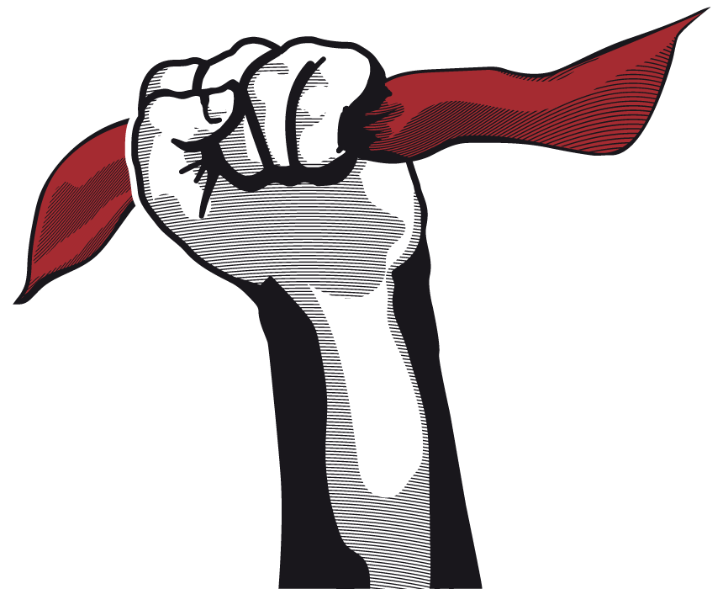
Image: http://www.merthyrrising.uk/ - Merthyr Rising 2018
This image of a clenched fist holding a red flag is the main symbol for the Merthyr Rising music festival. Despite this festival being a place for music it is also a celebration of the working class and the resistance to the upper class who hold us down. The reason why this festival is held is to remember the Merthyr Riots of 1831 where the workers of Merthyr Tydfil, who had been poorly treated for a very long time, rose up and began to cause chaos and anarchy around the town they lived in. This anger was directed mainly at the Iron Masters who owned the iron works and mines but paid the hard-working men and women (as well as children) next to nothing for their efforts.
The red of the flag is to symbolise the red flag the workers used during the riots, like the flags used by those in the French Revolution. The colour red, in western countries, is a symbol of anger, violence, gore and resistance. By using the colour red as the face of their cause the workers of Merthyr Tydfil could show the Iron Masters that they were not happy and that they were coming for blood. “Among the shouts were cries of Caws a bara (cheese and bread) and I lawr â'r Brenin (down with the king).” – John Davies – ‘The Welsh Academy Encyclopaedia of Wales. Cardiff: University of Wales Press 2008’ – accessed: 13/11/2019 These strong words link back to how the fist in this image is clenched tightly, signifying violence and resistance.
As it is widely known, all forms of representation are political and this image here is no acceptation as it portrays the strife between the working class and the upper class in many ways. This representation still holds strong today as Merthyr Tydfil is still a working town with many problems with pay and employment. A vast majority of houses in Merthyr were built as council houses for workers and their families to live in for no cost, but this shows clearly how poorly paid the people of Merthyr Tydfil are. But despite this, Merthyr Rising still brings hope to people and gives them joy despite a harsh reality of fighting between the upper class and the working class. As a side note, this red flag is the first recorded instance of the colour red being used for any kind of political resistance, long before it was used for causes like the Soviet Union.

Bibliography
- John Davies – ‘The Welsh Academy Encyclopaedia of Wales. Cardiff: University of Wales Press 2008’ – accessed: 13/11/2019
- http://www.merthyrrising.uk/ - Merthyr Rising 2018

Manifesto Writing: “What do I believe in?”
- Teamwork between all humans. We won’t get anywhere if we don’t work together. As a game development student, I’ve learned this with my other classmates.
- Treat others with respect and with equity. Being cruel and selfish will get you nowhere, as others will not want to be around you.
- Learn to make educated decisions. Think about what you are doing and what you decide to do next. Think about how it will affect other people.

When it comes to what I believe in, well I believe in a lot of things. I believe that as humans we must all work together, we did not get this far by being selfish, this is something shown in the Epic of Mwindo, an oral tale from the Congo told by the Nyanga people (N/A – 8/11/2019 – page 1 – Mwindo - https://www.encyclopedia.com/history/encyclopedias-almanacs-transcripts-and-maps/mwindo ). This tale tells exactly what I believe in when it comes to respect and equality, every human being is born differently, and this is not a reason for anyone to be treated any less than with respect. While treating others with respect is important, it is also important to think of others when making decisions.
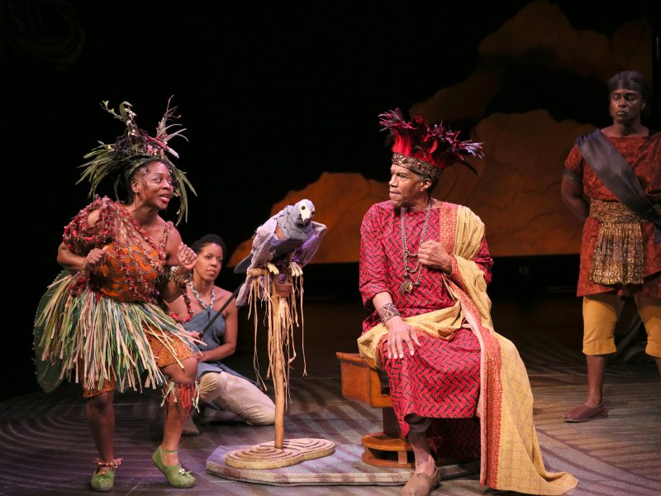
Image: https://playsforyoungaudiences.org/scripts/mwindo/ - A scene from a re-telling of ‘The Epics of Mwindo’
Yes, when you make decisions for yourself, you’re just doing that for yourself, but when it comes to things such as voting or how you treat someone you just met you must think deeply about what you will do or what you will say. These kinds of decisions will affect others in a big way and thus it is important for anyone to always think before they act. Working together also comes with a lot of things to consider as well. Not everyone is the same and no one will ever be exactly alike, so when we work together it is important to consider equity amongst our fellow human beings. Not implementing equity would only cause problems as equality only covers so much.
However, decision making is a skill and as humans we can be taught skills. As found in this video posted by The School of Life (posted 2/11/2017) called ‘How to Make a Decision’ (https://youtu.be/okdsAZUTJ94 - Accessed: 12/11/2019) how we make decisions varies on our skill levels with it. I believe that everyone should be taught properly how to make decisions, no matter their, age, gender, religion or social standing. Everyone deserves to know how to make a good and educated decision for anything they do.
To conclude, as a person I believe that every human being deserves to be treated with respect, kindness and equity while also being taught how to make honest, educated decisions that will not only benefit them but also the people around them. This is what I believe but beliefs are things that can and will change with time. Change is not always good but developing your beliefs is important.

Bibliography

- N/A – 8/11/2019 – Page 1 – Mwindo - https://www.encyclopedia.com/history/encyclopedias-almanacs-transcripts-and-maps/mwindo
- The School of Life – posted: 2/11/2017 – accessed: 12/11/2019 – How to Make a Decision - https://youtu.be/okdsAZUTJ94
- Image: https://playsforyoungaudiences.org/scripts/mwindo/ - A scene from a re-telling of ‘The Epics of Mwindo’ – Written by: Cheryl L. West

Reflective Writing: Do you know what you think?
What I think can be a struggle to fully comprehend. I know that the sky is blue, and the grass is green, but knowing what I think is hard. As a person I’ve been through a lot, being struck by lightning, falling down multiple stairs, bashed in the head a few times and the real kicker being my epilepsy. And as a student in game design and development I put my experiences and thoughts into my work.
Epilepsy has been a real pain for me for a very long time and to be quite honest I think it has made me stronger as a person. It’s provided me with the inspiration to create interesting characters and stories that reflect things that have happened to me. Expressing my pain and trauma through video games and character design is something I have seen many game developers do.
The Meatly
The creator of the game “The Binding of Isaac”; ‘The Meatly’ (Steam - https://store.steampowered.com/app/113200/The_Binding_of_Isaac/ ) created the game to reflect his childhood, growing up in a family of ‘born again’ Christians who were previously alcoholics and drug addicts. This kind of childhood trauma allowed him to create a game that made a huge impact on the indie-game community and to be quite honest it is a statement that for others who’ve been in the same situation, it gives them hope that their lives don’t have to be controlled by their family.
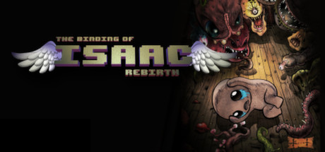
Image: https://store.steampowered.com/app/250900/The_Binding_of_Isaac_Rebirth/
I know I would very much like to be like him someday and give hope to others who are also suffering with different types of epilepsy. Taking my medical problem and turning it on its head to create something brilliant is the true mark of an artist and being able to use your pain to empower yourself really shows true inner strength and life.
Learning to see the good in my epilepsy
Ever since I was diagnosed with epilepsy it’s been a hard ride to get used to it. Taking so much medication to control it, so many MRI scans to find out what’s caused it and having to cope with micro seizures has really taken its toll on me. However, as the years have gone on, I’ve realised that I’ve become so much more resilient, so much stronger and so much more capable of looking after myself. I no longer feel fear about my seizures, in fact I feel confident that when I feel like I’m going to have a seizure I know what I have to do and I know I have good friends that’ll help me with them.
My epilepsy has created so many new paths for me, it’s boosted my strength as a person as well as my determination to achieve great things in my life. I know what I think about my epilepsy and that is, that I will never let it get me down.

Bibliography
- “The Binding of Isaac”; ‘The Meatly’ (Steam - https://store.steampowered.com/app/113200/The_Binding_of_Isaac/ )
- https://store.steampowered.com/app/250900/The_Binding_of_Isaac_Rebirth/

