

Student name: Robert Alexandru Merghisescu
Student number: 1907185
Module: LCBB5004
Managing People Assessment 1
Lecturer: Dr Mushfiqur Rahman
BA Business Management

December

Table of Contents
Task-1 1
Task-2 3
Introduction 3
Overview of Uber Inc. 3
Explaining the objectives of Uber Inc. that the HR functions are responsible for delivering 3
Workforce planning at Uber Inc. 3
Objectives regarding workforce planning and resourcing at Uber Inc. 3
HR functions to fulfil resourcing objectives at Uber Inc. 4
Recruitment and selection at Uber Inc. 4
Objectives regarding recruitment and selection at Uber Inc. 4
HR functions to fulfil recruitment and selection objectives at Uber Inc. 4
Considering the evolution of the objectives within resourcing activities along with the HR functions that deliver those 5
Conclusion 6
References 7

Table of Figures
Figure 1: CIPD Profession Map 1

Task-1

The term CIPD refers to the professional body awarding and crediting the professional human resource qualifications in the UK and is the abbreviation for Chartered Institute of Personnel Development (Younger, Brockbank and Ulrich, 2019). The HR training specialists working in various organisational sectors like private, public and charity use it as a professional standard to evaluate the current HR practices and needed qualifications in their organisations. This is considered as a very important tool by the professional, for which there have been periodical changes in the standards for keeping it updated and suitable for the modern business environment. Based on the recent modifications in the CIPD standards, the qualifications have been made even more specific so that HR officials can increase their career prospects (Lester, 2020). It will also help in their career growth by providing a more enriched knowledge base and required materials for them to excel in the business environment.

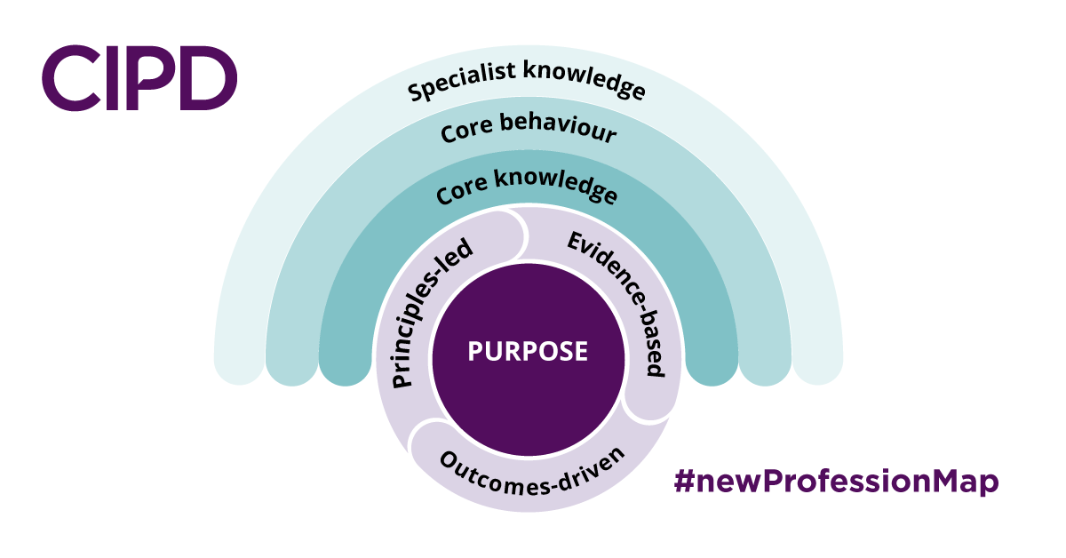
Figure 1: CIPD Profession Map
Source: (Jones and Fear, 2020)
As can be seen from the figure given, the CIPD map consists of the core element which is its purpose. An HR professional needs to keep the purpose as the base of career and all the other functions should be planned and designed while keeping the end goal of fulfilling that purpose in mind. Every HR professional should have their own set of principles to abide by along with following the company regulations to make various decisions throughout their career. They should also focus on many positive changes around them through various outcome-driven decisions which will be beneficial to the business, their selves and the general people as well. The collection and addition of various evidence can add more weight to the career of an HR professional because that indicates a more valid professional judgement from the professional. These are some of the core elements of CIPD that surround the purpose and help the professionals in making various decisions and plan their functions (Stewart, McGoldrick and Watson, 2019).
There are also various kinds of knowledge that HR professionals need to possess for making the right decisions, excel in their career and being able to develop over time. It also helps them in attaining in-depth knowledge about their sector and role for becoming an HR specialist qualified at his/her work. The core knowledge refers to the basic knowledge of HR professionals that include change management, people management, value creation through the employees and so on. The core behaviours are the set of behaviours essential for an HR professional to understand his/her job role properly and help in maintaining the job responsibilities with the appropriate behaviour. It can be learnt by collecting various feedback from the professionals and colleagues from academic and business researches. It includes how a specialist thinks, operates and acts to become qualified as an HR professional like passion for learning, giving value to people, decision-making ability based on the situation etc. The last element of the CIPD map is the specialist knowledge which is crucial for the HR specialists. There are various specialist areas of HR and the professionals should have a good idea regarding these to operate smoothly throughout their careers. Some of the specialist knowledge that HR professionals can possess are HR resourcing, employee relationship management, people analytics, talent management and employee experience management. So, an HR professional, according to the current CIPD map, is someone who can excel in his organisational role by following this guideline and acquire the required skill and behavioural set to maximise his/her potential and develop his/her career in an organisational environment.

Task-2

Introduction
The task focuses on the objectives related to resourcing in a company and its relationship with the HR functions conducted. For better understanding, Uber Inc. has been chosen in this study so that its organisational objectives related to resourcing and the corresponding functions can be explained and evaluated. The evolution of the issues in the corporate environment of Uber Inc. will also be explained so that the functions and its gradual changes to better fulfil the objectives can be understood.

Overview of Uber Inc.
Uber Inc. is an American company that provides mobile application connecting passengers with the drivers for hire. It also offers food delivery through Uber Eats, couriers, package delivery, electric bicycle, motorized scooter rental etc. The company operates in 900 metropolitan areas worldwide in more than 29 countries (Smith, 2019). The company became public in 2019 and raised $8.1 billion as its IPO. It is estimated to have more than 78 million active users around the world. It employs over 26,000 people throughout the whole world. The employee turnover rate is high in ride-sharing companies like Uber because many part-time drivers tend to casually join and leave the company in under a year or so (Moon, 2018). So the company puts great emphasis on its HR practices to focus on its full-time employees in various operational, technical, managerial and strategic positions.

Explaining the objectives of Uber Inc. that the HR functions are responsible for delivering

Workforce planning at Uber Inc.
Workforce planning used to be considered a secondary activity for Uber Inc. in the past, as the company heavily relied on its part-time and temporary drivers for their revenues. But this mindset changed over time as the company realised the importance of proper planning and management of its workforce as the temporary workers can leave the job anytime and a big decrease in employees can cause a lot of loss for the company (Jin, Kong and Sui, 2019).

Objectives regarding workforce planning and resourcing at Uber Inc.
The newly defined objectives of the company regarding this planning consist of structured planning for managing and retaining employees. Another objective is increased employee participation for higher satisfaction and lastly, to implement better forecasting methods to estimate possible employee shortages.

HR functions to fulfil resourcing objectives at Uber Inc.
The company has started using a team model in which a three-pronged leadership model is implemented in each city it operates on. It heavily relies on the culture of the area and even though the company welcomes diversity; it chooses most of the employees from among the local people who have a good knowledge regarding the people and culture of the place they will be working on. A general manager leads the team and focuses on the strategical aspects while keeping a balance among the demand and supply of the employees in an area. The community manager handles the local business communications and developments while guiding the other employees towards higher customer satisfaction and lastly a driver operations manager directly handles the drivers and also ensure proper communication between them and the company for employee satisfaction and participation (Gärtner, 2020).

Recruitment and selection at Uber Inc.
Recruitment and selection practices of Uber Inc. can be considered as a constantly developing activity. The company recruits and selects its employees based on some core aspects like skills, experience and behaviour that contributes to fulfilling the goals and objectives of Uber Inc. (Morris, 2019).

Objectives regarding recruitment and selection at Uber Inc.
The main objective of the company regarding its staffing policy is to choose the people with the right skills and temperament they need to succeed. Another objective is to select culturally-aware people to be able to suit the needs and taste of the local customers. Lastly, another objective is to select people with the right attitude and behaviour so that they can treat the customers properly and maintain the reputation of the company.

HR functions to fulfil recruitment and selection objectives at Uber Inc.
The recruitment and selection in Uber Inc. follow a structured and complex process where not only the skills and abilities of the candidates are assessed but their behaviours, attitudes and psychological condition is also evaluated. The company uses online modes of advertisement to attract candidates worldwide. And it is also known for having a very demanding interview process where candidates are asked to solve various real-world scenarios that they might face in their future work. It also offers a training session called “Uberversity” which helps a potential candidate develop his/her skills if the company can see potential in him/her but understands that he/she is not ready for the position yet (Kundu, 2019). The company also hires people based on their cultural awareness and openness because it greatly helps in attracting and retaining local customers and understanding their needs and wants better.

Considering the evolution of the objectives within resourcing activities along with the HR functions that deliver those
Even though the company Uber Inc. has been established only in the year 2009, it has already seen significant changes in its HR functions in that period. The objectives of the company have also changed for the better. The company had 14 core objectives, but later it was believed to be not so effective, for which reason they had been redesigned and brought down to only seven to eight. The objectives focus on making the company more customer-focused, introduces more engaging practices for its employees, provides better rewards and benefits to its employees for their retainment etc. (Lee, 2019).
The company had previously downplayed its HR activities as it didn’t realise the value of HR in fulfilling its business objectives. But later on, high turnover rates of employees and customer dissatisfaction made it realise the essentiality of properly planned HR functions. Now the company not only uses HR for staffing, but it also ensures the employee health, wellbeing and nurtures their talent. The company has also introduced better employee participation and feedbacks programs where employees can share their opinions and dissatisfactions.
One of the most recent changes in the company has been the work-from-home setting due to the global pandemic, which has decreased the employee communication drastically across the workplace. Uber has also started using some resourcing activities that will help it in facing such a challenge and help its employees feel connected (Cunningham-Parmeter, 2020). The recruitment and selection practices have also become limited to virtual interviews, assessment tests and CV screenings. But it must be noted that the company is still continuously improving its staffing policies, employee retention strategies, providing more training and development opportunities while also offering upgraded and unique rewards packages to maximise employee potential and keep them motivated and dedicated towards their work (Holm, 2020). The company has also introduced a multi-level workforce planning system which was previously non-existent in the company because it has realised the importance of employee forecast, the necessity of maintaining talent banks and the risks of possible employee shortage or high turnover.
All of these HR functions have changed the company for a lot better and are directly contributing to the fulfilment of the organisational objectives.

Conclusion
This task has been based on the organisational objectives of Uber Inc. in relations to its resourcing activities and the corresponding HR functions. An overview of the selected company Uber Inc. has been given for a better idea regarding the company. The objective relating to workforce planning in Uber and the related HR functions conducted has been explained. The recruitment and selection objectives and functions have also been described in the same way. Lastly, the evolution of the objectives and their relevant functions in Uber over the time have also been explained for a complete understanding of the HR functions and how it contributes to the goal-fulfilment in an organisational environment.

References
Cunningham-Parmeter, K. (2020). Newly designed HR practices at Uber Inc.: Defining employment in the modern economy. BUL Rev., 96, p.1673.
Gärtner, C. (2020). Smart human resource management: A case of Uber. Wiesbaden: Springer Gabler.
Holm, A.B. (2020). E-recruitment in Uber: towards an ubiquitous recruitment process and candidate relationship management. German Journal of Human Resource Management, 26(3), pp.241-259.
Jin, S.T., Kong, H. and Sui, D.Z. (2019). Uber, public transit, and urban transportation equity: The necessity of workforce planning. The Professional Geographer, 71(2), pp.315-330.
Jones, N. and Fear, N. (2020). Continuing professional development: perspectives from human resource professionals. Personnel Review.
Kundu, S.C., Rattan, D., Sheera, V.P. and Gahlawat, N. (2019). Recruitment and Selection techniques used in corporate Sector: a study on multinational companies like Uber Inc. Journal of Organisation and Human Behaviour, 4(4).
Lee, Z.W., Chan, T.K., Balaji, M.S. and Chong, A.Y.L. (2019). Why designing core values and HR functions correctly is essential: an empirical investigation of Uber. Internet Research.
Lester, S. (2020). Using the CIPD Map: Professional versus occupational models of work competence. Research in Post-Compulsory Education, 19(3), pp.276-286.
Moon, Y. (2018). Uber: Changing the way the world moves. Harvard Business School, Case, 101.
Morris, K.J.C. (2019). The role of right recruitment and selection practices in a company: a case study on Uber (Bachelor's thesis, University of Twente).
Smith, J.W. (2019). The Uber-all economy of the future. The Independent Review, 20(3), pp.383-390.
Stewart, J., McGoldrick, J. and Watson, S. (2019). Understanding human resource development using professional map: a research-based approach. Psychology Press.
Younger, J., Brockbank, W. and Ulrich, M.D. (2019). The state of the HR profession: the use of CIPD Map. Human Resource Management, 52(3), pp.457-471.

