  Component One:  What are the key skills required when working in the housekeeping team? 750 words (+/- 10%)  Contribution to Overall Module Assessment: 25% | Student No: | Syed Jakhan Ahmed  ID-2128160
 | Module Title: | Operating Hotel Facilities
 | Module Code: | BMIH4006
 | Lecturer: | Lisa-Marie Bassler
The cleaning team plays an essential part in ensuring visitors have a comfortable and enjoyable stay. Working on a housekeeping team requires a number of skills and characteristics, such as technical ability, communication skills, interpersonal skills, time management skills, and problem-solving capabilities (Hargie, nd).

In this article, we will investigate in detail the necessary skills for housekeeping teamwork. We will investigate how these skills improve the general performance of the housekeeping staff and guarantee that each visitor gets the highest level of care. This essay will cover the crucial role that housekeeping personnel play in the hospitality industry and how their skills and traits contribute to the achievement of the hotels and resorts they serve.

Technical Abilities: If you are a member of a housekeeping crew, you must possess technical abilities. These abilities include the knowledge and ability to clean, arrange, and maintain guestrooms and suites, lounges, and some other public spaces. The members of the housekeeping staff must be familiar with cleaning chemicals, materials, and equipment (Cobanoglu et al., 2020). They should be capable of dusting, vacuuming, wiping, and sterilizing surfaces, among other cleaning activities. Also, team members must be able to make a bed, change bedding, and wash laundry.

When in a housekeeping crew, one must have the ability to communicate with one another. The team members should be able to communicate effectively with their coworkers and other staff members. They ought to be able to follow instructions and instruct others. Effective communication is also essential while interacting with visitors since team members must be able to comprehend and answer the guests' requirements and concerns.

One must also be able to communicate well with other people while working on a cleaning crew. The team members must be able to get along, work well with each other, and have a positive attitude (Cobanoglu et al., 2020). They must be able to operate in a fast-paced, constantly-changing workplace, manage stress, and serve visitors with respect and civility.

The members of the cleaning staff must be able to pay great attention to the smallest of details. To ensure that each room is maintained to the greatest degree, they must be attentive to the smallest details. They must be mindful of stains on textiles, dust on tables, and filthy or smeared glass. When members of the team pay close attention to the smallest details, they are better able to identify areas that may need further care, such as the restroom or kitchen (JasiAAska & Hab, 2019).

As a member of a cleaning crew, one must be able to effectively manage your time. Members of the team need to be capable to collaborate effectively and complete duties on schedule (Cobanoglu et al., 2020). They would have to be able to establish priorities, organise their workdays, and multitask well. Ability to manage time are required to ensure that each room is cleaned thoroughly and that visitors are served promptly and efficiently. Individuals in the housekeeping staff must be adaptable and able to operate in a variety of locations (Firth, 2021). Workers may be reassigned to various rooms in the hotel or offered new employment in the final minute. They must be adaptable to new conditions and modifications to employment schedules and requirements.

Members of the cleaning staff must be physically healthy and able to do duties requiring physical strength, including such carrying and lifting heavy things, pushing heavy trolleys, and standing and walking for extended periods of time. They must be able to operate efficiently and effectively, as well as maintain their energy and attention throughout the day (Cobanoglu et al., 2020). As a member of a cleaning crew, one must be capable of resolving difficulties. Unanticipated stains or spills must be identified and remedied by team members as they clean the rooms. They ought to be capable of considering creatively and find innovative solutions to issues.

A variety of technical, communications, social, timekeeping, and problem-solving skills are required for work in a housekeeping team. The cleaning personnel must be attentive to detail, physically active, and able to perform in an unpredictable and dynamic environment. They must be able to communicate well, collaborate effectively, and have a good mindset. By having these skills and qualities, housekeeping staff members can guarantee that each hotel guest has a clean and pleasant stay.

Word Count | 698

Component Two:
Contribution to Overall Module Assessment: 25%
In this scenario – You have just been promoted to team leader for a floor within the hotel. A guest complains that on their arrival, their room had not been properly cleaned. Create an action plan and answer the following questions.

Problem | Why did it happen? | What are you going to do? | How will you prevent this from happening in the future? | What measures would you introduce to improve team effectiveness?
Inspect the room to confirm the guest's claims and identify any further issues that need to be addressed. | It is conceivable that the housekeeping staff made a mistake or missed certain places when cleaning the room, resulting in a subpar cleaning job. | Instruct the housekeeping staff to immediately address the guest's cleanliness issues and thoroughly clean the room in accordance with the hotel's guidelines. | Examine the rooms often to verify they meet the hotel's cleanliness and quality standards (Cobanoglu et al., 2020). | I would urge the team to regularly evaluate their work practises, find areas for development, and apply alterations to increase team performance.
Inform the housekeeping staff responsible for cleaning the room of the issue by calling them. | The housekeeping staff may not have gotten enough training on the hotel's cleaning procedures and standards, resulting in subpar cleaning work. | Ask the visitor for specifics about the cleanliness concerns they encountered. Notate the information and confirm it with the visitor. | Request that the housekeeping staff promptly report any issues or concerns they discover when cleaning the rooms. | I would encourage team members to communicate honestly and freely with one another and with me, the team leader.
Apologize for the inconvenience and assure the visitor that their concerns will be handled quickly. | While cleaning the room, the housekeeping staff may have been pressed for time, forcing them to overlook some areas or not clean the room as well as they should have (Cobanoglu et al., 2020). | Notify the housekeeping staff responsible for cleaning the room of the issue. | Regularly provide feedback and coaching to the housekeeping staff to reinforce best practises and ensure they are meeting the hotel's cleanliness and quality standards. | I would provide team members with opportunities for training and development in areas that would help them accomplish their responsibilities more effectively.
Ask the visitor for specifics about the cleanliness concerns they encountered. Notate the information and confirm it with the visitor. | Owing to a potential shortage of cleaning staff, hotel rooms may not be cleaned as thoroughly as they should be. | Inspect the room to confirm the guest's claims and identify any further issues that may need remedy. | Make that the housekeeping crew is well-versed in the hotel's cleaning procedures and standards, and emphasise the importance of paying special attention to the tiniest of details. | I would explain the team's goals and ensure that each member understands his or her role in achieving them.
Instruct the housekeeping staff to immediately address the guest's cleanliness issues and thoroughly clean the room in accordance with the hotel's guidelines. | There may have been a miscommunication between cleaning and the front desk, which resulted in the room not being marked as cleaned. | Apologize for the inconvenience and assure the customer that their concerns will be addressed quickly (Ahmed, 2013). | Verify that the hotel's cleaning procedures are current and effective. | I would want to create a healthy work environment by recognising and rewarding excellent performance, encouraging collaboration, and providing opportunities for team-building exercises.

Component Three:
Contribution to Overall Module Assessment: 50%
Your task is to create and prepare a presentation following the detailed scenario provided below.

As the floor housekeeping manager and given the recent guest complaints you need to put together a basic training presentation for your colleagues within the housekeeping team to get the best out of them, ensure that brand standard is being achieved and that Health and Safety procedures are also being followed.

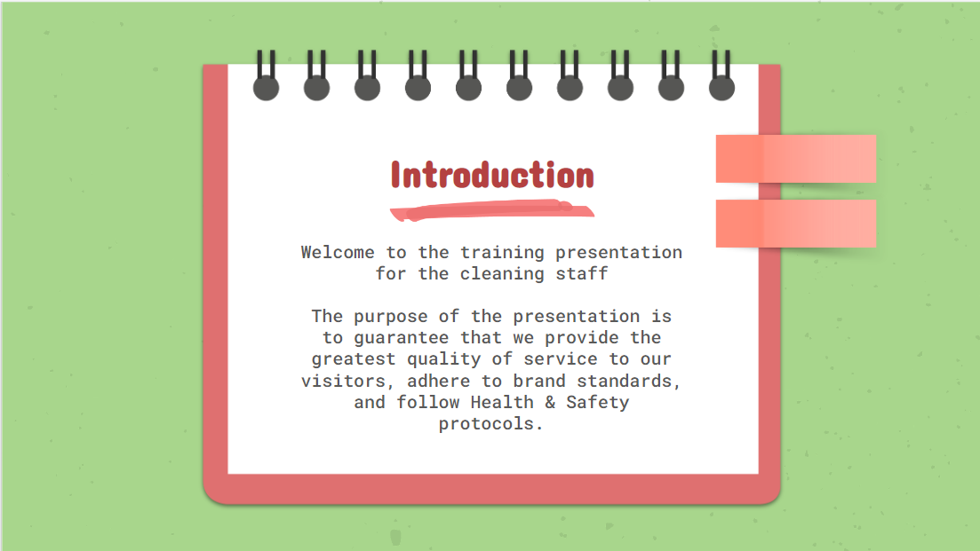

Training Notes:
- Introduce everyone to the presentation
- Talk about the outline of the presentation and what they will learn
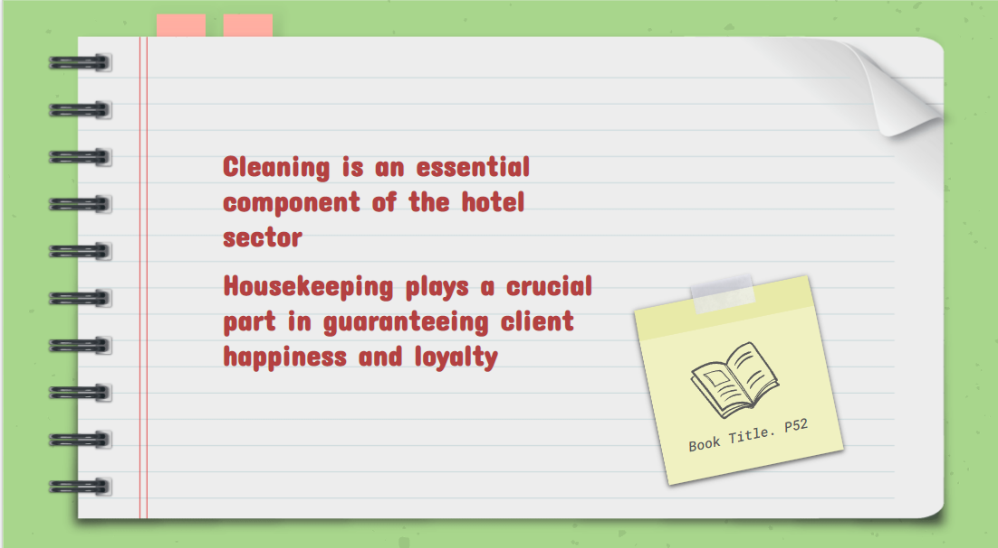

Training Notes:
- Talk about the importance of housekeeping
- The guidelines for housekeeping
- The significance of maintaining a clean and pleasant environment
- Sticking to brand guidelines to improve the client experience
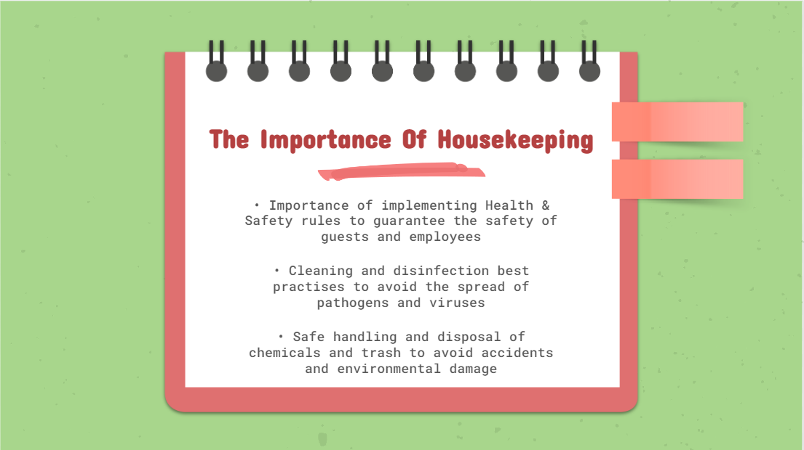

Training Notes:
- Importance of housekeeping
- Cleaning practices
- Safe handling of trash
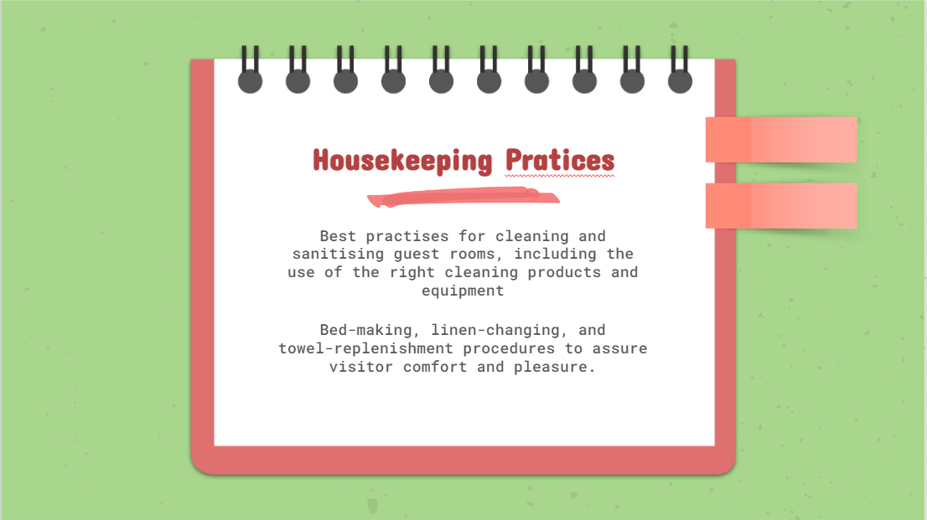

Training Notes:
- Practices for cleaning
- Practices for making beds and ensuring customer satisfaction
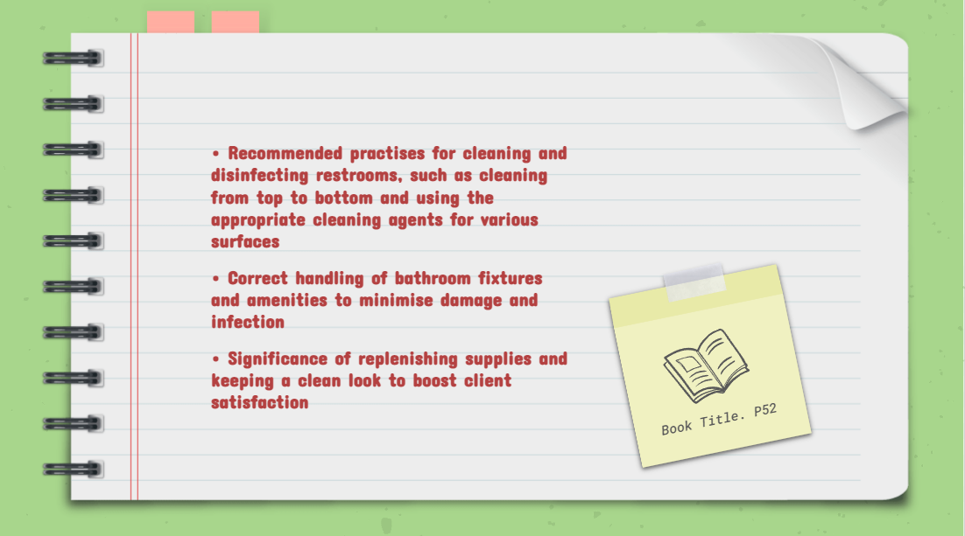

Training Notes:
- Best practices for cleaning and disinfecting bathrooms
- Proper handling of bathroom fixtures and amenities
- Importance of restocking supplies and maintaining a fresh and clean appearance

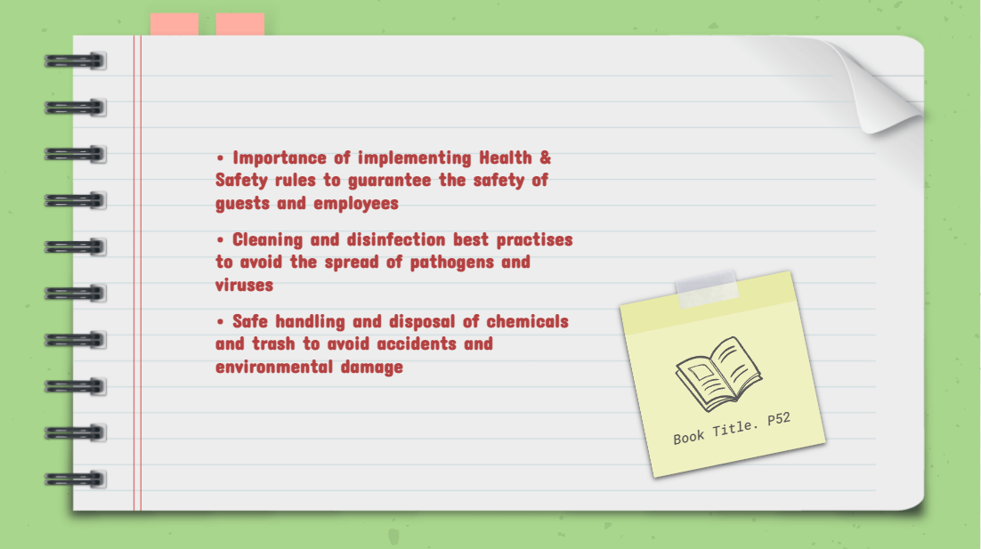

Training Notes:
- Cleaning public areas
- Ensuring safety and satisfaction among guests
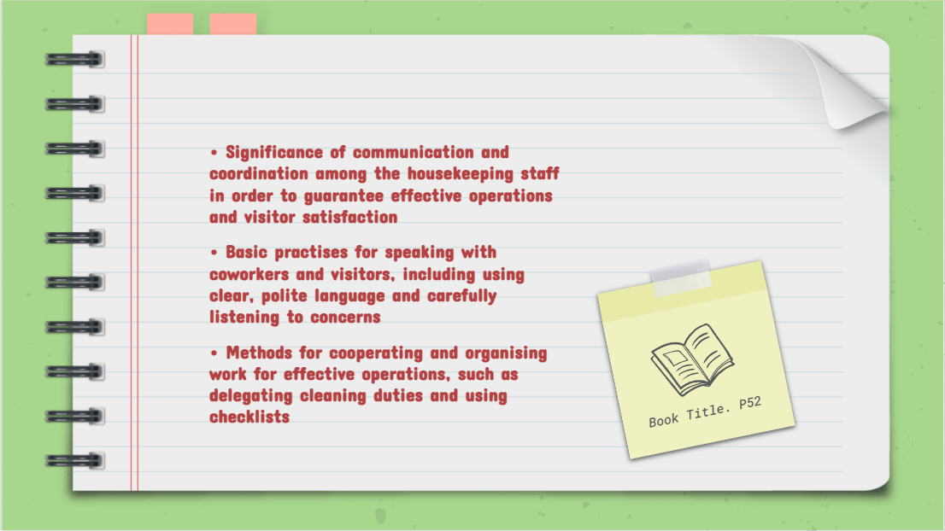

Training Notes:
- Effective communication
- How to speak with co-workers
- Operational methods regarding cleaning duties
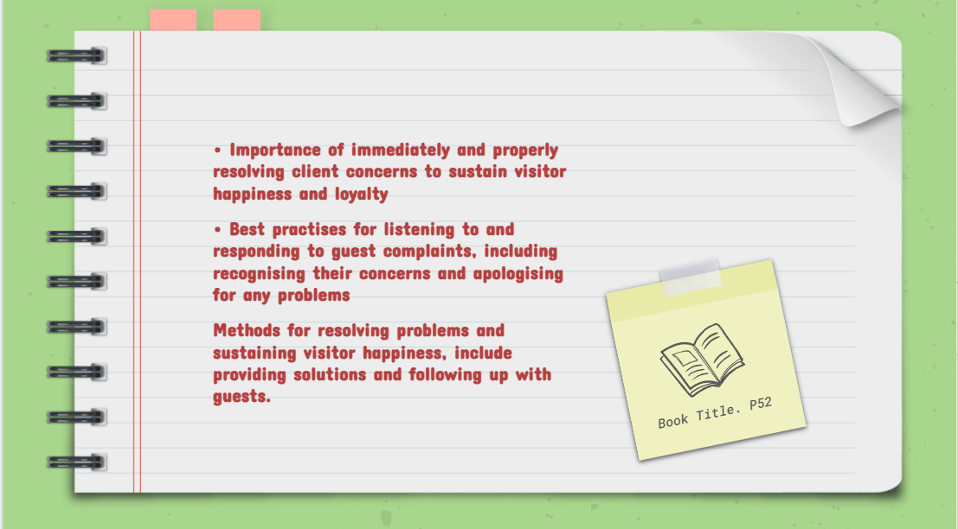

Training Notes:
- Managing guest complain
- Resolving issues
- How to respond to complaints
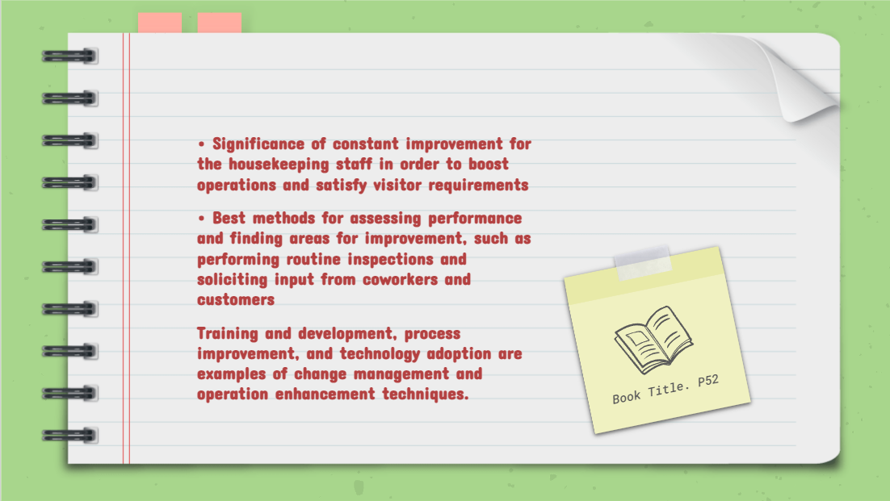

Training Notes:
- How to keep improving
- Methods to access and evaluate performances
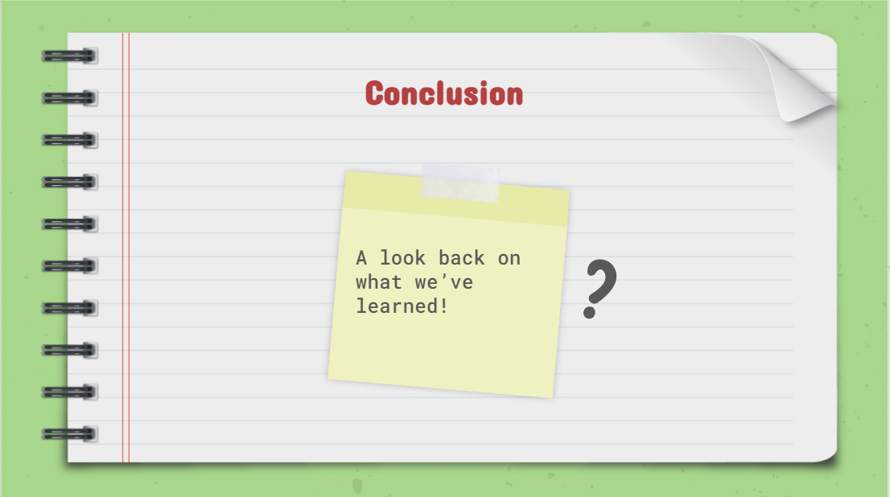

Training Notes:

- Summarizing the points of discussion and concluding the presentation

References
Ahmed, A.M. (2013) “Customer relationship and satisfaction,” Managing Customer Trust, Satisfaction, and Loyalty through Information Communication Technologies, pp. 20–36. Available at: https://doi.org/10.4018/978-1-4666-3631-6.ch002.
Cobanoglu, C. et al. (2020) “Gradebook for cleanliness in hotels: An analysis of housekeeping costs and hotel cleanliness as perceived by guests.” Available at: https://doi.org/10.5038/m3-htir.002.
Cunningham, W. (2021) “Guest editorial: Complaints: Their toll, why, and how we need the medical profession to act,” Journal of Primary Health Care, 13(3), p. 195. Available at: https://doi.org/10.1071/hcv13n3_ed2.
Firth, R. (2021) “Conditions of housekeeping,” Housekeeping among Malay Peasants, pp. 1–16. Available at: https://doi.org/10.4324/9781003135364-1.
Hargie, O. (no date) “Training in communication skills,” The Handbook of Communication Skills [Preprint]. Available at: https://doi.org/10.4324/9780203007037.ch20.
JasiAAska, J. and Hab (2019) “The process approach to manage changes in the organization,” Journal of Hotel and Business Management, 08(01). Available at: https://doi.org/10.35248/2169-0286.19.8.193.
Sherwyn, D.S. (2004) “Introducing the Hospitality Roundtable on Legal Issues,” Cornell Hotel and Restaurant Administration Quarterly, 45(2), pp. 170–171. Available at: https://doi.org/10.1177/0010880404263962.
Tantawy, A. and Losekoot, E. (2000) “An assessment of key hotel guest contact personnel in handling guest complaints,” Journal of Quality Assurance in Hospitality & Tourism, 1(4), pp. 21–43. Available at: https://doi.org/10.1300/j162v01n04_02.

