
DISSERTATION
MODULE: LCMB7035 – DISSERTATION

Exploring the Effect of Augmented Reality–Based Shopping Experiences on Online Purchase Intention: Evidence from the Fashion Retail Industry of Bangladesh

SUPERVISOR: FAIZU EDU

SUBMITTED BY: MD SAIFUL ISLAM (ID: 2413231)

SUBMISSION DATE: 01/02/2026

Declaration
I declare that this dissertation titled “Exploring the Effect of Augmented Reality (AR)–Based Shopping Experiences on Online Purchase Intention in Bangladesh’s Fashion E-Commerce Sector” is my own original work and has not been submitted previously for any academic award at this or any other institution.
All sources of information used in this dissertation have been acknowledged and referenced appropriately. Where the work of others has been used, it has been clearly cited in the text and included in the reference list. I confirm that I have complied with the University’s academic integrity and plagiarism regulations.

Student Name: Md Saiful Islam
Student ID: 2413231

Acknowledgements
I would like to express my sincere gratitude to my supervisor for his guidance, constructive feedback, and continuous support throughout the completion of this dissertation.
I also thank the academic staff at University of Wales Trinity Saint David for the knowledge and support provided during the programme, which contributed to the development of this research.
Finally, I am grateful to all the participants who took the time to complete the survey and share their experiences. Their responses made this research possible.

Abstract
This dissertation investigates how augmented reality (AR) shopping experiences influence online purchase intention (OPI) in Bangladesh’s fashion e-commerce sector. The study tests whether perceived usefulness (PU), perceived ease of use (PEU), interactivity and enjoyment (IAE), and trust and risk reduction (TRR) predict consumers’ intention to purchase fashion products online when AR features such as virtual try-on and 3D product views are available. A positivist, deductive design was used, applying a structured questionnaire with five-item Likert scales for each construct. Data were collected from Bangladeshi online fashion shoppers and screened to retain 160 valid responses. Reliability results indicated strong internal consistency across the scales, supporting the quality of the measures. Spearman correlation analysis showed positive, significant associations between each AR experience factor and OPI. Multiple regression analysis confirmed that the overall model significantly predicts OPI and explains 56.4% of its variance (R² = 0.564). All predictors had positive, statistically significant effects, with PU emerging as the strongest predictor, followed by PEU, TRR, and IAE. The findings suggest that AR is most effective when it clearly improves product evaluation and decision-making, remains simple to use on smartphones, builds confidence by reducing perceived risk through accurate and transparent visualisation, and keeps users engaged through interactive enjoyment. Practically, Bangladeshi fashion e-retailers should position AR as a decision-support tool, optimise usability, and prioritise realism to strengthen trust. Overall, it adds evidence from an under-researched emerging-market fashion context. Key limitations include convenience sampling, self-reported intention (not actual buying), and the cross-sectional design, which limits causal inference.
KEY WORDS: Augmented Reality, Online Purchase Intention, Perceived Usefulness, Perceived Ease of Use, Trust and Risk Reduction

Table of Contents
Declaration i
Acknowledgements i
Abstract ii
Table of Contents iii
List of Tables vi
List of Figures vii
List of Abbreviations viii
Chapter 1: Introduction 1
1.1 Chapter Overview 1
1.2 Background of the Study 1
1.3 Problem Statement 3
1.4 Research Aim 4
1.5 Research Objectives 4
1.6 Research Questions 5
1.7 Scope and Context of the Study 5
1.8 Justification and Contribution 5
1.9 Structure of the Dissertation 6
Chapter 2: Literature Review 8
2.1 Introduction 8
2.2 Augmented Reality: Definitions and Evolution 8
2.3 AR in Fashion E-Commerce 9
2.4 Online Purchase Intention 9
2.5 Theoretical Foundations 10
2.6 Key AR-Related Constructs in This Study 11
2.6.1 Perceived usefulness (PU) 11
2.6.2 Perceived ease of use (PEU) 11
2.6.3 Interactivity and enjoyment (IAE) 12
2.6.4 Trust and risk reduction (TRR) 12
2.7 Empirical Studies on AR and OPI 12
2.8 Research Gap and Justification 14
2.9 Theoretical and Conceptual Framework 15
2.10 Chapter Summary 19
Chapter 3: Methodology 20
3.1 Chapter Overview 20
3.2 Research Philosophy 20
3.3 Research Approach 21
3.4 Research Design 21
3.5 Population and Sampling 22
3.6 Data Collection Instrument 23
3.7 Data Collection Procedure 24
3.8 Data Analysis 24
3.9 Ethical Considerations 25
3.10 Methodological Limitations 26
Chapter 4: Data analysis and Findings 27
4.1 Chapter Overview 27
4.3 Demographic Analysis 28
4.4 Descriptive Analysis 32
4.5 Reliability Analysis 33
4.6 Correlation Analysis 33
4.7 Multiple Regression Analysis 34
4.8 Chapter Summary 35
Chapter 5: Discussion 36
5.1 Chapter Overview 36
5.2 Interpretation of Key Findings 36
5.3 Implications of the Study 40
5.4 Chapter Summary 41
Chapter 6: Conclusions & Recommendations 42
6.1 Chapter Overview 42
6.2 Conclusions 42
6.2.1 Objective 1: To investigate the impact of perceived usefulness and ease of use of AR applications on consumers’ OPI. 42
6.2.2 Objective 2: To evaluate the effect of interactivity and enjoyment in AR shopping experiences on OPI. 42
6.2.3 Objective 3: To analyse the influence of perceived trust and risk reduction of AR technology on OPI. 43
6.2.4 Objective 4: To provide recommendations for fashion retailers on how to effectively implement AR-based marketing strategies to enhance online consumer engagement and sales performance. 43
6.3 Recommendations 43
6.4 Limitations of the Study 44
6.5 Suggestions for Future Research 45
References 46
Appendices 50
Appendix – A 50
Appendix – B 62
Appendix – C 63
Appendix – D 64

List of Tables
TABLE 4.1: RESPONSE CLEANING SUMMARY | 27
TABLE 4.2: FREQUENCY TABLE OF RESPONDENT PROFILE | 28
TABLE 4.3: DESCRIPTIVE STATISTICS OF KEY CONSTRUCTS | 32
TABLE 4.4: RELIABILITY ANALYSIS (CRONBACH’S ALPHA) | 33
TABLE 4.5: SPEARMAN CORRELATION MATRIX | 33
TABLE 4.6: MODEL SUMMARY | 34
TABLE 4.7: ANOVA | 35
TABLE 4.8: REGRESSION COEFFICIENTS | 35
TABLE 5.1: SUMMARY OF HYPOTHESES TESTING | 40

List of Figures
FIGURE 1.1: ECOMMERCE SHARE GROWTH 2019-2024 | 1
FIGURE 1.1: ECOMMERCE SHARE GROWTH 2019-2024 | 1
FIGURE 2.1: TECHNOLOGY ACCEPTANCE MODEL | 16
FIGURE 2.2: S–O–R MODEL | 17
FIGURE 2.3: CONCEPTUAL FRAMEWORK | 18
FIGURE 4.1: AR EXPERIENCE PROFILE | 28
FIGURE 4.2: AGE GROUP DISTRIBUTION | 29
FIGURE 4.3: GENDER DISTRIBUTION | 29
FIGURE 4.5: EDUCATION LEVEL DISTRIBUTION | 30
FIGURE 4.5: OCCUPATION DISTRIBUTION | 30
FIGURE 4.6: MONTHLY HOUSEHOLD INCOME DISTRIBUTION | 30
FIGURE 4.7: ONLINE FASHION PURCHASE FREQUENCY | 31
FIGURE 4.8: AR USE FREQUENCY | 31
FIGURE 4.9: MAIN DEVICE USED FOR ONLINE FASHION SHOPPING | 32
FIGURE 4.10: MEAN SCORES ACROSS CONSTRUCTS | 33

List of Abbreviations
Abbreviation | Full form / Meaning
3D | Three-Dimensional
ANOVA | Analysis of Variance
AR | Augmented Reality
IAE | Interactivity and Enjoyment
IAEsummary | Composite score for IAE
MAR | Mobile Augmented Reality
OPI | Online Purchase Intention
OPIsummary | Composite score for OPI
PEU | Perceived Ease of Use
PEUsummary | Composite score for PEU
PU | Perceived Usefulness
PUsummary | Composite score for PU
R² | Coefficient of Determination
SD | Standard Deviation
S–O–R | Stimulus–Organism–Response
SPSS | Statistical Package for the Social Sciences
TAM | Technology Acceptance Model
TRR | Trust and Risk Reduction
TRRsummary | Composite score for TRR

Chapter 1: Introduction

1.1 Chapter Overview
The chapter introduces the study on how the factors of Augmented Reality (AR)-based shopping experience affect online purchase intention (OPI) in the fashion retail business in Bangladesh. It begins with the background of the study, by describing the global and national transformation of physical stores into digital ones and demonstrates how AR has become a valuable resource in order to make online shopping informative, immersive, and trustworthy. It then focuses on the Bangladeshi fashion e-commerce environment where online shopping is increasing yet the problem of trust and limited experience with the products are very severe. The chapter then provides the problem statement, research aim, objectives, and research questions that are used to conduct the study. It outlines the extent and setting of the research, outlines its theoretical and practical impacts, and simply outlines the way the rest of the dissertation is structured. Collectively, these sections form the basis and the orientation to the subsequent chapters particularly the literature review and empirical analysis.

1.2 Background of the Study
Retail has been moving from physical stores to digital channels over the last decade. Global e-commerce sales reached about US$6.8 trillion in 2024 and accounted for roughly 20.1% of total retail sales, up from around 16% in 2019 (Red Stag Fulfilment, 2024; Cramer-Flood, 2024). It is projected that the online market share will grow to approximately 2223 percent by 2027 (Red Stag Fulfilment, 2024). With the increased amount of shopping moving forward online, an increasing proportion of consumer buying decisions occurs in spaces where buyers are not able to touch or even feel products. Online Sales have grown as shown in Figure 1.1 and 1.2.
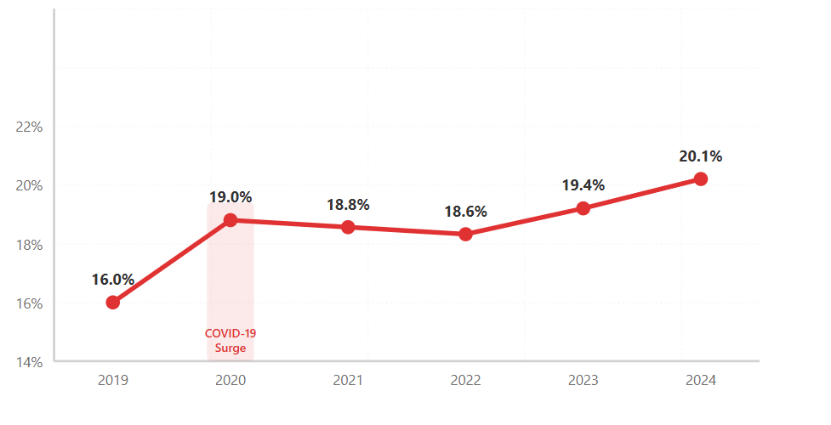 | 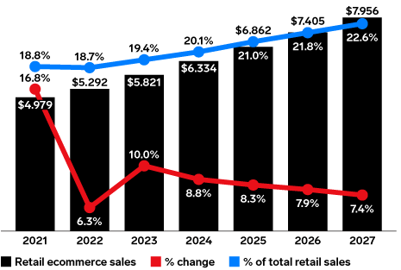
FIGURE 1.1: ECOMMERCE SHARE GROWTH 2019-2024  (SOURCE: RED STAG FULFILMENT, 2024) | FIGURE 1.2: RETAIL ECOMMERCE SALES WORLDWIDE, 2021-2027  (SOURCE: CRAMER-FLOOD, 2024)
The retailers are investing in technologies that will help to make online shopping more informative and immersive to overcome this deficiency in physical contact. AR has emerged as a key tool. It is projected that the AR in the retail market will increase to approximately US$19.5 billion by 2023 to 2028, and the compound annual growth rate will be nearly 58% (Technavio, 2024). More broadly, the global AR market is projected to expand at over 50% CAGR in the second half of this decade, with strong growth in Asia-Pacific (Technavio, 2024). These figures indicate that AR is now treated as a strategic investment rather than a niche experiment.
In retail settings, AR overlays computer-generated images or models on the real environment, typically through smartphones or tablets. Consumers can virtually try on clothes, shoes, or cosmetics, or place 3D furniture models in their homes. Academic reviews find that AR improves product visualisation, increases hedonic value, and supports decision confidence, which in turn raise OPI and can lower return rates (Hoffmann and Mai, 2022; Yitong et al., 2024). Studies in fashion, beauty, and furniture show that these effects work through both cognitive evaluations such as perceived usefulness (PU) and perceived ease of use (PEU) (Guo and Zhang, 2024; Hanna, 2023) and emotional responses such as enjoyment, immersion, and trust (Do et al., 2020; Voicu et al., 2023; Basari and Dewanti, 2024).
Fashion and beauty brands have been among the earliest adopters of AR. Global fashion labels use virtual try-on mirrors, interactive campaigns, and digital fitting rooms to reduce the “does it suit me” uncertainty of online fashion shopping (Hoffmann and Mai, 2022). Because fashion purchases rely heavily on appearance, style, and fit, which are difficult to judge from static images, AR’s richer visual and interactive cues can improve PU, make interfaces feel easier to use, increase enjoyment, and strengthen trust by reducing perceived risk.
There is also a rapid transition to digital commerce in Bangladesh but at a lower level. According to more recent industry data, the e-commerce market in Bangladesh had a worth of approximately US$7.5–9 billion in 2024 and is projected to increase to approximately US$9.75–13 billion in 20272028 with estimated annual growth rates ranging between approximately 7 and 12 percent (Research and Markets, 2024; PCMI, 2025). The increase is aided by the increasing internet penetration and smartphone ownership, government efforts in the frame of the Digital Bangladesh vision, and the growth of large platforms including Daraz (MCCI, 2022).
One of the drivers of this market is fashion. According to reports released by DHL Express Bangladesh, fashion products represent approximately 18.9% of the e-commerce revenue, so fashion is one of the most significant online categories (DHL, 2025). According to ECDB data, the online proportion of fashion sales in Bangladesh has reached approximately 15- 20% of total sales in 2024 and will increase to approximately 20- 25% in 2025 (ECDB, 2024). This proposes that much and increasing amounts of fashion consumption are already being done digitally.
Simultaneously, the overall online shopping adoption in Bangladesh is still lower than that of developed markets and there are a number of structural issues that continue to exist. Cash-on-delivery is prevalent, logistics and last-mile delivery are frequently unpredictable, and numerous customers are concerned with product authenticity and quality as well as fit (MCCI, 2022). The problems mentioned point to the pivotal importance of trust and perceived risk in online buying, particularly in the realm of fashion where doubts about how something will appear or fit may demoralize people to make a purchase or result in a refund.
AR-based fashion shopping tools can be considered a possible solution to these issues. AR can enhance PU and ease of use, make shopping more interactive and entertaining, and perceived risk minimized through trust-inducing product visualisation (realistic and virtual try-on) using smartphones, as well as improved size and appearance of products (Hoffmann and Mai, 2022; Yitong et al., 2024). However, although there is a lot of international attention to AR, its actual effect on OPI regarding e-commerce in Bangladeshi fashion remains unknown. There is limited empirical evidence on how Bangladeshi consumers respond to AR features and which aspects of the AR experience—PU, PEU, interactivity and enjoyment (IAE), or trust and risk reduction (TRR); are most important in shaping their intention to buy fashion products online.

1.3 Problem Statement
The rapid expansion of digital commerce and the spread of AR technology have created new opportunities for online fashion retailers. Global research shows that AR can improve product visualisation, add hedonic value, and strengthen trust, which in turn raises OPI and can reduce return rates (Hoffmann and Mai, 2022; Yitong et al., 2024). At the same time, the Bangladeshi e-commerce market is growing, with fashion emerging as a major online category and the online share of fashion sales expected to increase further in the coming years (ECDB, 2024; DHL, 2025). In principle, these developments make AR a promising tool for fashion e-retailers in Bangladesh.
In practice, however, most Bangladeshi online fashion platforms still rely on static product photos and short descriptions. Shoppers cannot try on garments, assess drape or fit, or see how colours look on their own body. In a market where cash-on-delivery is common and many customers remain sceptical about product authenticity and quality; this lack of rich product experience can amplify perceived risk and weaken OPI. Industry and policy reports repeatedly highlight trust, quality concerns, and delivery reliability as key barriers to e-commerce growth in Bangladesh, with fashion purchases especially exposed because of their visual and style-sensitive nature (MCCI, 2022).
From an academic viewpoint, there is substantial international evidence that AR shapes consumer attitudes and behaviour in categories such as cosmetics, furniture, tourism, and general online shopping (Do et al., 2020; Voicu et al., 2023; Hanna, 2023; Basari and Dewanti, 2024; Guo and Zhang, 2024). Yet empirical studies that focus on AR in fashion e-commerce in South Asian or Bangladeshi settings are scarce. As a result, fashion retailers in Bangladesh lack clear, context-specific evidence on whether AR features actually increase OPI and which aspects of the AR experience matter most for their customers.
The central problem this study addresses is therefore the absence of local empirical research that links key AR shopping experience factors, such as PU, PEU, IAE, and TRR, to OPI in Bangladeshi fashion e-commerce. Without this knowledge, managers must make decisions about AR investment based largely on foreign evidence or personal judgement rather than on robust data from their own market.

1.4 Research Aim
The main aim of this study is to examine the impact of AR-based shopping experience factors on OPI in the fashion retail industry of Bangladesh.

1.5 Research Objectives
To achieve the primary aim, the study has the following specific objectives:
- To investigate the impact of PU and PEU of AR applications on consumers’ OPI.
- To evaluate the effect of IAE in AR shopping experiences on OPI.
- To analyse the influence of perceived TRR of AR technology on OPI.
- To provide recommendations for fashion retailers on how to effectively implement AR-based marketing strategies to enhance online consumer engagement and sales performance.

1.6 Research Questions
In line with the research aim and objectives, this study seeks to answer the following questions:
- How does PU and ease of use of AR influence OPI?
- How do IAE in AR experiences shape OPI?
- How does AR technology build trust and reduce perceived risk in online fashion retail?
- Based on the influence of AR experience factors on OPI, what practical strategies can Bangladeshi fashion e-retailers adopt to use AR more effectively?

1.7 Scope and Context of the Study
This study focuses on online fashion consumers in Bangladesh who have experience with, or awareness of, AR shopping features such as virtual try-on, 3D product views, or AR filters. The sectoral scope is limited to fashion e-commerce, including clothing, footwear, and fashion accessories sold through online platforms. Other product categories that also use AR, such as furniture or tourism, are outside the scope of this research (Hanna, 2023; Do et al., 2020).
The geographical location of the study is limited to Bangladesh where e-commerce and mobile internet access are increasing at an alarming rate but the overall online shopping penetration is comparatively lower and the barriers to do business in the country are highly rooted in trust. Fashion is among the most significant online categories, as most of the platforms still operate through fixed images and general descriptions, which may not allow to understand the product and purchase confidence (Hoffmann and Mai, 2022; Yitong et al., 2024).
Methodologically, the study follows a cross-sectional quantitative survey design, where data are collected using structured questionnaires on the sample of online fashion buyers in Bangladesh. The study concentrates on the correlation between four independent variables, including PU, PEU, IAE, and TRR to the dependent variable, OPI. Firm-level outcomes such as sales growth or return rates, and technical implementation issues on the retailer side, are not directly examined. The findings therefore relate specifically to consumer perceptions and intentions, rather than to organisational performance measures.

1.8 Justification and Contribution
The study is justified by both theoretical and practical reasons. Theoretically, the AR and e-commerce literature shows strong interest in how AR shapes consumer experience and behaviour, but it is still fragmented across product categories and regions. Many studies investigate single product types (cosmetics, furniture, tourism) and mostly in developed markets (Do et al., 2020; Voicu et al., 2023; Hanna, 2023). There is limited empirical work that examines AR in fashion e-commerce within South Asian or Bangladeshi contexts. In addition, existing research often focuses either on cognitive technology acceptance factors (usefulness, ease of use) or on experiential and emotional aspects (enjoyment, immersion, trust), rather than testing a simple integrated model that includes both (Hoffmann and Mai, 2022; Yitong et al., 2024; Guo and Zhang, 2024).
This study contributes to theory by combining the Technology Acceptance Model (TAM) and the Stimulus–Organism–Response (S–O–R) framework into a single conceptual model that links PU, PEU, IAE, and TRR to OPI in fashion AR shopping. It thus extends AR and technology acceptance research to an emerging market and to a product category where visual appearance and fit are crucial.
In practice, the research provides the evidence-based advice to Bangladeshi fashion e-retailers. The results will assist managers in determining the probability of AR features enhancing OPI, and what features of AR experience should be given priority- functional value, usability, entertaining interaction, or perceived safety. Such information can be used in making more prudent choices regarding digital innovation, user interface design, and marketing communication within a competitive and fast changing online fashion market.

1.9 Structure of the Dissertation
The rest of this dissertation will be divided into 5 chapters. Chapter 2 constitutes an in-depth literature review of AR, OPI, and the primary theoretical foundations and elaborates the conceptual framework, as well as the hypotheses. Chapter 3 discusses the research methodology which involves research philosophy, research design, sampling, measurement, the data collection and the data analysis procedures. The empirical findings (descriptive statistics, reliability tests, and hypothesis testing) are reported in chapter 4. Chapter 5 explains the findings in terms of available literature and presents theoretical and practical implications of AR based fashion e-commerce in Bangladesh. Chapter 6 provides a conclusion of the study summarising the key findings, and contributions and limitations to the study, as well as recommendations to future studies.
1.10 Chapter Summary
The chapter has provided an introduction to the study by stating the trend of global retail moving to e-commerce and AR as a significant tool to enhance online shopping experience. It has demonstrated that AR can stimulate product visualisation, pleasure, and confidence, which is especially relevant in the context of fashion e-business when the purchases are determined by looks and fit. The chapter has also presented the progression and the difficulties of the Bangladeshi e-commerce, with the main roles of trust and perceived risk posing central influences to the online fashion purchases.
Based on this fact, the chapter pinpointed a definite research problem namely absence of context-specific evidence on how the same measures of AR experience PU, PEU, IAE, and TRR; influences OPI in Bangladeshi fashion e-commerce. It stated the purpose of the research, the objectives, questions, established the scope and context of the study and described the theoretical and practical implications of the research. These aspects form the basis of the second chapter will review the available literature in the details and identify the conceptual framework and hypotheses that they will be used in empirical testing.

Chapter 2: Literature Review

2.1 Introduction
This chapter reviews the theories and empirical studies related to Augmented Reality (AR) and online purchase intention (OPI) in the context fashion e-commerce. It aims to build a clear conceptual base for the study and to show how AR experience factors shape consumers’ OPI. The chapter is organised into several sections. The first part explains the definitions and evolution of AR. The next section discusses how AR is used in fashion e-commerce and related sectors. This is followed by a discussion of OPI and its cognitive and emotional drivers. The chapter then introduces the key theoretical foundations that explain consumer behaviour in AR environments, especially the Technology Acceptance Model (TAM) and the Stimulus–Organism–Response (S–O–R) framework, with brief reference to Flow Theory. After that, recent empirical studies on AR and OPI are reviewed across different product categories. The chapter then identifies the main research gaps and justifies the need for this study. Finally, it presents the conceptual framework and hypotheses that will guide the empirical analysis.

2.2 Augmented Reality: Definitions and Evolution
AR is generally described as a technology that combines digital content with the physical world in real time (Kazmi et al., 2021). Classic definitions explain that AR overlays computer-generated images, text, or other virtual elements onto the real environment so that they appear to coexist in the same space (Azuma, 1997; Azuma et al., 2001). In contrast to Virtual Reality (VR), which replaces the real world with a fully digital environment, AR enriches reality by adding an extra digital layer while the physical surroundings remain visible (Hoffmann and Mai, 2022; Hilken et al., 2018).
AR is a combination of real and virtual data and real-time interactive nature and three-dimensional object registration, which can assure precise digital locating of objects in the physical space (Zhou et al., 2008; Carmigniani et al., 2011). This enables users to touch and feel virtual products as they are in real life, and one of the features of AR is augmentation and interactivity (Javornik, 2016). The development of AR can be traced back to the 1950s, when Morton Heilig invented the name Sensorama and the concept of augmented reality was introduced in the industrial context in 1992 by Caudell and Mizell (Hanna, 2023). AR was initially expensive and focused on expert domains but the emergence of smartphones and mobile internet made it more affordable and created Mobile Augmented Reality (MAR) available to consumers (Do et al., 2020; Yitong et al., 2024). AR is used in the retail experience to visualize products, generate higher confidence in a decision, and perceived risk, especially in online shopping, where it has significant potential in fashion and beauty retail (Hoffmann and Mai, 2022; Yitong et al., 2024).

2.3 AR in Fashion E-Commerce
The problem experienced with fashion e-commerce is that customers have no physical contact with products, so it is hard to determine their fit, colour, fabric, and style, thus decreasing the willingness to buy and raising the number of returns. The gap has been filled with the introduction of Augmented Reality (AR) which provides virtual try-ons and more detailed visualizations of the products. Consumers can also use AR applications in beauty and cosmetics to try products such as lipstick and foundation on their own faces, which makes the shopping experience more engaging and better by increasing immersion, confidence in their fit, and sense of value (Voicu et al., 2023). AR in fashion serves the same purpose as informing, visualizing, try-on, and placing, which helps the customer visualize how the clothing, accessories, or footwear will appear before committing to one, eliminating uncertainty about fit and style (Hoffmann and Mai, 2022). Equally, in furniture and home decor, AR allows customers to see the things in their environment, which is a factor of purchase intent both rational and emotional (Hanna, 2023).
Across these categories, AR in fashion e-commerce provides three key benefits. First, it improves product visualisation by allowing realistic previews that reduce information gaps. Second, it increases engagement and enjoyment, creating a more playful and interactive experience (Voicu et al., 2023). Third, it builds trust and confidence by helping customers feel that what they see online will match what they receive (Hoffmann and Mai, 2022; Yitong et al., 2024). These benefits explain why AR is increasingly used by global retail brands and why it is expected to become an important part of online fashion shopping.

2.4 Online Purchase Intention
OPI refers to a consumer’s willingness or planned likelihood to buy a product through an online platform after considering available information and their experience with the website or app. It is widely seen as a strong predictor of actual online buying behaviour (Whang et al., 2021; Hanna, 2023; Liu and Napitupulu, 2020).
AR OPI is conditioned by a cognitive and emotional factor. Given their role in influencing purchase intentions, cognitively, perceived usefulness (PU) and perceived ease of use (PEU) are important. Guo and Zhang (2024) reveal that AR improves product knowledge and decision-making that stimulate the buying behaviour, and ease of use also promotes the intention. This is in line with the Technology Acceptance Model (TAM) in which these issues inform technology acceptance and behavioural intentions. Perceived enjoyment is also a significant factor in influencing online shopping behaviour, which Basari and Dewanti (2024) find to increase engagement and reduce perceived risk, increasing the likelihood of a consumer finishing the purchase. The immersion, satisfaction, and flow are also essential, as Do et al. (2020) prove that the interactive aspect of AR increases enjoyment and provokes impulse purchasing. On the one hand, OPI is also motivated by trust and decision confidence, and the researchers by Voicu and Hanna (2023) and Hanna (2023) conclude in their works that using AR, consumers become more confident in choosing a product and become less doubtful. The systematic reviews, including by Yitong et al. (2024) and Hoffmann and Mai (2022), also prove that AR positively affects purchase intention because it improves product visualization, hedonic value, and decision comfort. In such a way, OPI in AR is influenced by such cognitive evaluations as usefulness and ease of use, and emotional experiences such as enjoyment and confidence.

2.5 Theoretical Foundations
The literature employs a number of theoretical programs in explaining the effect of AR on consumer attitudes and behaviour. The TAM and the S-O-R framework are the most applicable in this work, although the flow theory adds some extra knowledge on the issue of experiential states.
TAM is one of the most popular models of technology and e-commerce studies. It states that two major beliefs PU and PEU define attitudes and behavioural intention of users towards a new system (Davis, 1989). TAM has been applied in the research of the influence of AR experience dimensions on usefulness, ease of use, and purchase intention in AR online shopping. According to Guo and Zhang (2024), information quality, entertainment, interaction, visualisation, and novelty have a strong impact on PU and PEU that contribute to the purchase intention. TAM is also employed by Hanna (2023) to study AR in online furniture shopping and the results reveal that the perception of ARs, including usefulness and enjoyment, has a significant impact on purchase intention.
The S-O-R model describes the influence of environmental stimuli on the internal states and consequently arrive at behavioural responses. Technological characteristics of interactivity, vividness, and information that reduces risk are perceived as stimuli in AR situations. They influence internal psychological conditions, including enjoyment, trust, and perceived risk reduced (the organism), which subsequently cause the response in the form of further AR use, purchase intention, and loyalty (Do et al., 2020; Voicu et al., 2023).
Flow Theory is concerned with a condition of deep involvement and absorption as individuals become engaged in a given activity. A flow-like condition can prevail in AR shopping when the application is interactive, engaging to look at, and simple to operate, the user loses their time and concentrates on the process. Do et al. (2020) suggest that such flow states strengthen positive emotions and behavioural intentions, including impulse buying. Although Flow Theory is not used as a separate model in this study, it helps explain why IAE are important aspects of the AR experience.
Systematic reviews by Yitong et al. (2024) and Hoffmann and Mai (2022) show that these frameworks are often combined in AR research. TAM is mainly used for cognitive evaluations of technology (usefulness and ease of use), while S–O–R and Flow Theory explain emotional and experiential aspects such as enjoyment, trust, and risk reduction. Together, they provide a strong base for building an integrated model of AR experience factors and OPI.

2.6 Key AR-Related Constructs in This Study
Based on the reviewed literature and the research proposal, this study focuses on four core AR-related constructs as independent variables: PU, PEU, IAE, and TRR. These constructs are derived from TAM and S–O–R and represent both cognitive and emotional aspects of AR-based shopping.

2.6.1 Perceived usefulness (PU)
PU refers to the degree to which a person believes that using a particular system will enhance their performance or decision-making (Davis, 1989). In AR shopping, PU relates to how much AR helps consumers evaluate products, understand features, and make better purchase decisions. Studies show that when AR provides realistic, diagnostic product information, consumers perceive it as more useful and are more willing to buy (Hanna, 2023; Guo and Zhang, 2024). Systematic reviews also highlight usefulness as a consistent predictor of purchase intention and AR adoption (Hoffmann and Mai, 2022; Yitong et al., 2024).

2.6.2 Perceived ease of use (PEU)
PEU is the degree to which a person believes that using a system will be free of effort (Davis, 1989). In AR apps, PEU covers how intuitive the interface is, how simple it is to navigate, and whether users can quickly understand how to activate and control AR features. When AR tools are easy to use, consumers are less likely to feel frustrated and more likely to accept the technology and consider purchasing (Guo and Zhang, 2024). However, some studies, such as Hanna (2023), suggest that in high-involvement product categories, the quality of visualisation and augmentation may matter more than interface simplicity. This indicates that while PEU is important, its influence can vary by context.

2.6.3 Interactivity and enjoyment (IAE)
IAE embrace the hedonic aspect of AR experiences. Interactivity is the extent to which users can manipulate, control, and react to the digital content, whereas fun, pleasure, and playfulness of the interaction are experienced via enjoyment (Do et al., 2020; Voicu et al., 2023). The responsive and vivid characteristics of AR can also produce the high engagement levels and even flow-like experiences, during which users are engaged with the activity. Empirical evidence shows that IAE increase satisfaction, loyalty, and purchase-related behaviours in AR shopping environments (Do et al., 2020; Voicu et al., 2023; Basari and Dewanti, 2024). In this study, IAE are combined into a single construct (IAE) because they are closely linked in the way consumers experience AR shopping.

2.6.4 Trust and risk reduction (TRR)
TRR relate to the degree to which AR helps consumers feel secure and confident about the product and the seller. Online shopping is often associated with uncertainty about product quality, fit, and the reliability of the retailer. AR can reduce perceived risk by offering realistic product visualisation, accurate try-on functions, and detailed information, which help customers judge whether a product suits them (Hoffmann and Mai, 2022; Hanna, 2023).
Several studies show that AR reduces perceived risk and enhances trust, which in turn support positive behavioural intentions (Basari and Dewanti, 2024; Mohanty et al., 2025; Jain and Kaur, 2024). For example, by seeing a realistic overlay of clothing or makeup on their own body, consumers feel more confident that the product will match their expectations, which reduces the fear of making a wrong purchase. In this study, TRR are combined into a single construct (TRR), capturing AR's role in building confidence and lowering uncertainty.

2.7 Empirical Studies on AR and OPI
Empirical research on AR and OPI has grown quickly in recent years, covering beauty, fashion, furniture, tourism, and general e-commerce.
In Indonesia, Basari and Dewanti (2024) examine the effect of AR and perceived risk on online shopping behaviour, with perceived enjoyment as a mediating variable. Using survey data from 100 respondents, they find that AR has a positive and significant effect on online shopping behaviour, and that perceived enjoyment also positively influences behaviour. Enjoyment mediates the effect of perceived risk, suggesting that a pleasant AR experience can reduce worries and support purchasing.
Voicu et al. (2023) explore consumers' experience with AR makeup apps. Their findings show that social value, fit confidence, immersion, and perceived hedonistic value all play significant roles in shaping satisfaction and continued usage intention. While the main outcome is continued use of AR apps rather than purchase intention, the results imply that when customers feel confident and enjoy the AR experience, they become more open to purchasing.
Hanna (2023) investigates the impact of AR technology on consumers' purchase intention of furniture in Egypt. The study finds that PU, PEU, perceived enjoyment, and perceived augmentation quality significantly influence purchase intention by improving the realism and diagnostic value of product information. This supports the view that both functional (usefulness, information quality) and emotional (enjoyment) aspects of AR are important drivers of OPI.
Do et al. (2020) examine mobile AR apps in tourism and their impact on impulse buying. They integrate TAM, S-O-R, and Flow Theory and show that PU, PEU, and interactivity affect perceived enjoyment and satisfaction, which then lead to stronger impulse buying behaviour. Although the context is tourism rather than fashion, the mechanism--AR features influencing internal states, which in turn drive purchase-related behaviour--is directly relevant for this study.
Guo and Zhang (2024) focus directly on AR online shopping experiences and purchase intention using a TAM-based model. They identify five types of AR experiences--information, entertainment, interaction, visualisation, and novelty--as antecedents. These experience factors significantly affect PU and PEU, which in turn influence purchase intention. Their study provides strong evidence that both functional and hedonic aspects of AR shape OPI.
At a broader level, Yitong et al. (2024) conduct a systematic review of 83 articles on AR in online shopping and conclude that AR mainly enhances user experience by improving product visualisation, hedonic value, and decision confidence. They also show that AR characteristics, functional factors, and hedonic factors are key drivers, while purchase intention and continued usage intention are common behavioural outcomes. Similarly, Hoffmann and Mai (2022) review 56 empirical papers on AR in retail and show that AR helps consumers visualise and evaluate products, increases engagement, and can reduce return rates by helping customers make better choices.
Other research highlights the importance of TRR. An Indian e-commerce study integrating TAM, UTAUT2, and Technology Readiness finds that PU, PEU, hedonic motivation, and trust all significantly predict AR adoption intentions, with PU being the strongest driver (Mohanty et al., 2025; Jain and Kaur, 2024).
These findings suggest that PU, ease of use, interactivity, enjoyment, trust, and risk reduction are robust determinants of consumers' responses to AR-enabled shopping and their OPI across multiple product categories, particularly in fashion, beauty, and furniture.
Overall, empirical studies consistently show that AR has a positive influence on consumers' attitudes and behavioural intentions, including OPI. AR works through both cognitive pathways (usefulness, ease of use, information quality, trust) and emotional pathways (enjoyment, immersion, confidence). Any conceptual model that aims to explain AR's impact on OPI therefore needs to capture both types of processes.

2.8 Research Gap and Justification
Although existing research clearly shows that AR improves user experience and can increase OPI, several important gaps remain, especially for the context of this study.
First, many studies are conducted in specific sectors such as makeup, furniture, or tourism, or in developed markets such as Europe, China, and the Middle East (Hoffmann and Mai, 2022; Yitong et al., 2024; Hanna, 2023). Research on AR in broader fashion e-commerce, and particularly in emerging markets, is still limited. Consumer behaviour in countries with different infrastructure, culture, and digital maturity may not follow the same patterns as in Western contexts.
Second, while many studies use TAM, S–O–R, or Flow Theory, fewer studies bring these perspectives together in a simple but integrated framework that includes both cognitive and emotional processes. Some work focuses mainly on usefulness and ease of use (Guo and Zhang, 2024), others emphasise enjoyment and immersion (Basari and Dewanti, 2024; Do et al., 2020), and others examine social and experiential factors such as fit confidence and social value (Voicu et al., 2023). The result is a fragmented picture of how AR experience factors jointly influence OPI.
Third, systematic reviews highlight that AR research is scattered across product types and outcome variables, with inconsistent attention to TRR, even though these constructs are central in online shopping (Hoffmann and Mai, 2022; Yitong et al., 2024).
Hecne, it is necessary to conduct more empirical studies that would help connect factors of AR experience in relation to perceived usefulness (PU), perceived ease of use (PEU), interaction anxiety (IAE), and trust-related risk (TRR) in a single model to online purchase intention (OPI). In particular, the literature regarding the effects of AR on OPI in South Asian fashion online markets, including Bangladesh, has a dearth of research on how fashion retailers in the country have utilized AR and how consumers have reacted to it. Since fashion online platforms in Bangladesh are developing at a rapid pace, but continue to use fixed images, it is not only timely but also important to recognize the impact of factors of the AR experience on OPI. This paper fills in these gaps by examining the impact of PU, PEU, IAE, and TRR on OPI in the Bangladeshi online fashion retail industry including the Technology Acceptance Model (TAM) and the Stimulus-Organism-Response (S -O -R ) model in a single empirical model applying survey data collected on the online shopper of Bangladesh.

2.9 Theoretical and Conceptual Framework
This study draws on two complementary perspectives to explain how AR-based shopping experiences influence OPI: the TAM and the S–O–R framework. Together, these models provide a coherent base for linking the cognitive and emotional aspects of AR use to consumers’ intention to buy fashion products online.
2.9.1 Technology Acceptance Model (TAM)
The TAM proposes that users’ behavioural intention to use a system is mainly driven by two beliefs, PU and PEU (Davis, 1989). PU is the degree to which using a system improves decision-making or performance, while PEU is the degree to which using the system requires little effort. These beliefs shape attitude toward the system and, in turn, behavioural intention.
In AR retail research, TAM has been widely applied and extended to capture AR-specific experiences. Studies show that AR features such as information quality, interactivity, visualisation and novelty strongly influence PU and PEU, which then drive purchase intention and continued use (Guo and Zhang, 2024). In online furniture shopping, for example, Hanna (2023) finds that when AR helps consumers better understand product size, style and fit, PU increases and so does purchase intention. Systematic reviews of AR in retail also highlight usefulness and ease of use as consistent predictors of positive consumer responses, including OPI (Hoffmann and Mai, 2022; Yitong et al., 2024).
In the context of this study, PU refers to the extent to which AR features help Bangladeshi online fashion shoppers evaluate clothing, footwear and accessories and make better purchase decisions. PEU reflects how easy it is for these shoppers to activate, control and interpret AR functions within mobile apps or websites. When AR is both useful and simple to operate, TAM predicts that consumers will be more likely to intend to buy through that channel.
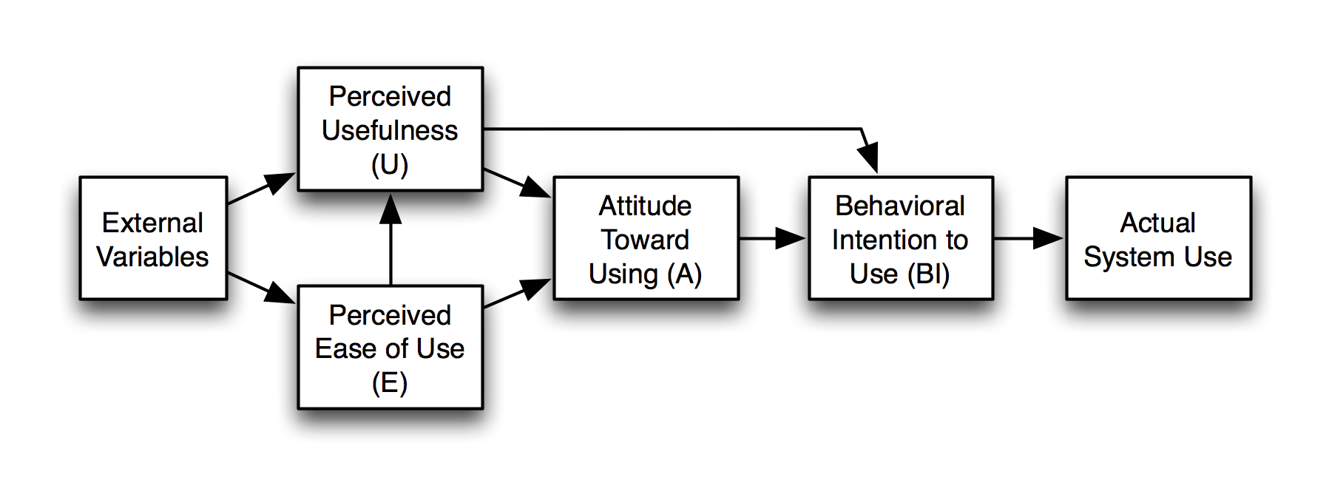
FIGURE 2.1: TECHNOLOGY ACCEPTANCE MODEL
(SOURCE: DAVIS, 1989)
2.9.2 Stimulus–Organism–Response (S–O–R) framework
While TAM focuses on cognitive beliefs about a system, the S–O–R framework explains how environmental cues shape internal states and, in turn, behaviour. Originally developed in environmental psychology, S–O–R describes how external stimuli (S) influence organismic states (O), such as emotions or cognitive evaluations, which then lead to behavioural responses (R) like approach, avoidance or purchase (Mehrabian and Russell, 1974).
In AR shopping contexts, technological features such as vivid 3D rendering, interactivity, virtual try-on and risk-reducing information operate as stimuli. These features influence internal states such as enjoyment, immersion, trust and reduced perceived risk, which then drive responses including OPI, impulse buying, continued use and loyalty (Do et al., 2020; Voicu et al., 2023). Do et al. (2020) show that in tourism AR apps, PU, ease of use and interactivity increase enjoyment and satisfaction, and these internal states stimulate impulse buying. Voicu et al. (2023) find that in AR makeup apps, immersion, fit confidence and hedonistic value shape satisfaction and continued usage intention, which are closely related to purchase decisions.
In this study, AR design elements such as visual realism, responsiveness and try-on capabilities are treated as underlying stimuli that are not measured directly. Instead, the research focuses on consumers’ perceptions of these stimuli, expressed through constructs such as IAE, and TRR. These perceptions represent organismic states that mediate between AR features and behavioural intention.
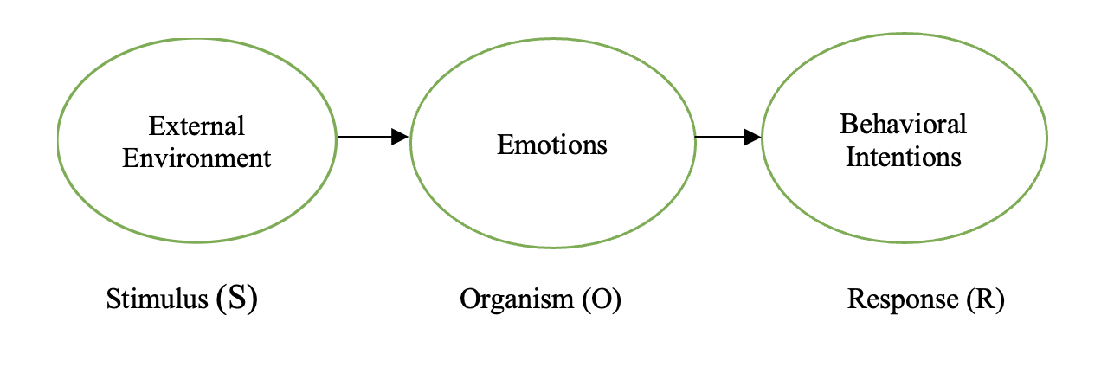
FIGURE 2.2: S–O–R MODEL
(SOURCE: MEHRABIAN & RUSSELL, 1974)
2.9.3 conceptual framework and hypotheses
For AR-based fashion shopping in Bangladesh, TAM and S–O–R are not competing explanations. They are complementary. TAM clarifies how cognitive evaluations of AR, particularly PU and PEU, influence behavioural intention, while S–O–R captures the experiential and affective side of AR use, especially enjoyment, immersion, trust and reduced risk (Do et al., 2020; Yitong et al., 2024). Recent AR studies often combine these perspectives, for example by treating AR characteristics as stimuli, PU and PEU as cognitive organismic states and purchase intention as the response (Guo and Zhang, 2024; Mohanty et al., 2025).
Building on this work, the present study develops an integrated conceptual framework in which four AR-related experience factors act as independent variables: PU, PEU, IAE and TRR. These constructs are derived from TAM and S–O–R and capture both cognitive and emotional aspects of the AR shopping experience. The dependent variable is OPI, defined as the consumer’s likelihood of buying fashion products online after using AR features (Whang et al., 2021; Hanna, 2023).
In this framework:
- PU is the extent to which AR enables shoppers to compare products and consider the fashion products accurately and feel more confident in their choice (Hanna, 2023; Guo and Zhang, 2024).
- PEU measures the level of intuitiveness and ease of use in using AR features on e-commerce used in fashion like the rotation of items, colour or size manipulation (Davis, 1989; Guo and Zhang, 2024).
- IAE is the hedonic aspect of the AR. It attributes interactivity, bound to the amount of control and responsiveness in the AR interface, with fun and pleasure of using AR, which is enjoyment (Do et al., 2020; Voicu et al., 2023; Basari and Dewanti, 2024).
- TRR measures the levels to which AR fosters trust in product appearance and fit and minimised perceived risk through providing real visualisation and credible information on fashion products (Hoffmann and Mai, 2022; Hanna, 2023; Jain and Kaur, 2024).
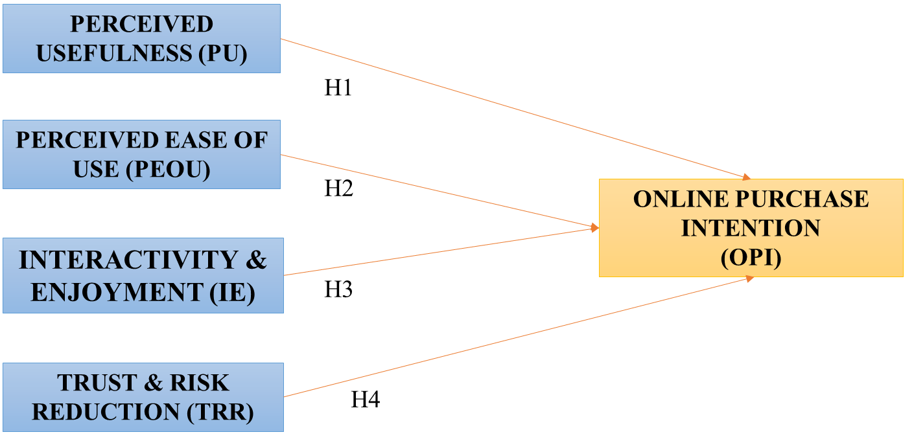
FIGURE 2.3: CONCEPTUAL FRAMEWORK
(SOURCE: SELF-CREATED)

Based on this framework and the empirical evidence reviewed in Sections 2.6 and 2.7, the study proposes the following hypotheses:
H1: Perceived usefulness of AR applications has a positive impact on OPI.
H2: Perceived ease of use of AR features positively influences OPI.
H3: Interactivity and enjoyment in AR shopping experiences positively affect OPI.
H4: Perceived trust and risk reduction associated with AR technology positively influence OPI.

2.10 Chapter Summary
This chapter, reviewed the main theories and empirical studies about AR and OPI especially when it comes to fashion e-commerce. It started by establishing the definition of AR and how it evolved according to specialised systems in industries to massively available mobile applications. The chapter then discussed the application of AR in fashion and other related industries and how it has been used in product visualisation, enjoyment, and trust enhancement. It also presented the concept of OPI and explained how the cognitive factors influenced by the PU and PEU and the emotional ones, including interactivity, enjoyment, trust and reducing risks influenced the purchase decision of the consumers. Based on the TAM and the S-O-R model, the chapter proposed four fundamental AR experience constructs (PU, PEU, IAE, TRR) and elaborated a series of hypotheses between them and OPI. The following chapter talks about the research methodology which is used to test these hypotheses in the Bangladeshi scenario of the fashion e-commerce.

Chapter 3: Methodology

3.1 Chapter Overview
This chapter explains how the empirical section of the study was designed and conducted. It outlines the research philosophy and the research approach, quantitative cross-sectional design, target population and sampling method, how the survey questionnaire was developed and how data were collected and analysed. It also describes the ethical protection that will be used to conduct the study and the principal methodological constraints. Collectively, these aspects demonstrate how the study confirms the interaction of augmented reality (AR) experience variables and online purchase intention (OPI) between online fashion customers in Bangladesh.

3.2 Research Philosophy
The research philosophy embraced in the study is positive research. Positivism presupposes that the social phenomena like the attitudes of consumers and their intention to buy products have an objective existence and can be quantified by applying systematic observation and statistical analysis (Saunders et al., 2019). In this perspective, the researcher will have an ideal distance with the participants and will not affect their answers, therefore, the findings will be perceived as objective and reproducible. This philosophy is applicable to the current study since the primary objective is to test certain relationships among variables that are well defined.
This paper is dedicated to four constructs of AR, such as perceived usefulness (PU), perceived ease of use (PEU), interactivity and enjoyment (IAE), and trust and risk reduction (TRR), and the effect that these constructs have on OPI. These constructs are measured on standardised items of questionnaires and analysed by use of statistical tools. This corresponds to the positivist concept that theories are testable through the collection of numerical data and verification on whether the evidence confirms or opposes the hypothesized postulates (Bryman and Bell, 2015).
The Technology Acceptance Model (TAM) as well as the Stimulus–Organism-Response (S-O-R) model according to which the study is guided also agree with positivism. An example of it is TAM that has its origins in a positivist tradition, where PU and PEU are seen as quantifiable beliefs that influence the intention to use a technology (Davis, 1989). Recent AR research that integrates TAM and S–O–R for online shopping also relies on quantitative survey methods within a positivist paradigm (Do et al., 2020; Guo and Zhang, 2024).

3.3 Research Approach
The research follows a deductive approach. In a deductive design, the researcher starts from existing theories and prior empirical evidence, develops hypotheses, and then collects data to test those hypotheses (Saunders et al., 2019). This approach is appropriate when there is already a strong theoretical base and the aim is to examine whether those relationships hold in a new context.
Chapters 1 and 2 reviewed existing work on AR in retail and fashion e-commerce and identified four key experience factors that are repeatedly linked to OPI: PU, PEU, IAE AND TRR (Hoffmann and Mai, 2022; Hanna, 2023; Voicu et al., 2023; Basari and Dewanti, 2024; Guo and Zhang, 2024; Yitong et al., 2024). From this literature and from the TAM and S–O–R frameworks, the study developed four hypotheses that predict positive effects of each AR factor on OPI.
The empirical part of the study then moves from these pre-defined hypotheses to data testing. Survey responses are collected from Bangladeshi online fashion shoppers and used to see whether the data support or do not support the expected relationships. If the findings match the predictions, they strengthen the existing theories in a new emerging-market context. If the findings are different, they suggest that the theories may need to be adjusted for this specific setting. This pattern of theory-driven hypotheses followed by empirical testing is typical of a deductive approach (Creswell and Creswell, 2018).

3.4 Research Design
The research design employed in this study is quantitative research design with a cross-sectional period. Quantitative design enables the measurement of the constructs of interest to be transformed into numeric measures by means of structured Likert-scale questions. It also facilitates the adoption of statistical methods, including correlation and multiple regression, which are required to examine the hypotheses related to testing the proposed relationship between the factors of AR experience and the OPI (Bryman and Bell, 2015). A cross-sectional design implies that the data will be collected at one point in time instead of being collected over time (Saunders et al., 2019). This fits a master dissertation, where there is limited time and resources available. It also suits well the present research purpose, which is to take a snapshot of the current perception of the Bangladeshi online shoppers who are interested in AR functions and how the perceptions are connected to their willingness to purchase fashion items over the internet.
The design focuses on individual consumers as the unit of analysis. Each respondent provides information on demographic characteristics, their use of online fashion shopping and AR tools, and their agreement with a set of statements measuring PU, PEU, IAE, TRR and OPI. These data are then combined to form scales for each construct and analysed at the aggregate level.

3.5 Population and Sampling
The target population for this study is online fashion consumers in Bangladesh who have experience with, or at least awareness of, AR shopping features. Fashion products include clothing, footwear, and accessories purchased through websites or mobile applications. The study focuses on individuals who either have used AR functions such as virtual try-on, 3D product views, or AR filters, or who have seen these tools and can imagine how they might use them. This focus reflects the research aim of understanding AR-based shopping experiences in fashion e-commerce rather than general online shopping.
In practice, it is not possible to obtain a complete list of all Bangladeshi online fashion shoppers who meet these conditions. For this reason, the study uses non-probability sampling. Specifically, a convenience sampling approach is adopted, supported by purposive elements. Convenience sampling involves selecting respondents who are easily accessible to the researcher, such as contacts reachable through social media platforms, university networks, and online fashion retail communities (Etikan et al., 2016). Purposive elements are introduced by targeting groups that are more likely to include people who shop for fashion items online and have seen or used AR features.
The planned sample size ranges from around 150 to 200 valid responses. This range is considered adequate for regression analysis with four independent variables, based on common rules of thumb that recommend at least 15 to 20 observations per predictor (Hair et al., 2019). A sample of this size offers enough statistical power to detect moderate relationships while remaining realistic within the time frame of the dissertation. The final number of responses and the response rate will be reported in Chapter 4, after data collection is complete and invalid entries are removed.
While non-probability sampling limits the ability to generalise the results to the entire population of Bangladeshi consumers, it is widely used in exploratory technology adoption research, especially in emerging markets where AR exposure is still relatively low and sampling frames are hard to construct (Hanna, 2023; Mohanty et al., 2025). The findings can still provide valuable insights into the attitudes of early users and AR-aware online fashion shoppers.

3.6 Data Collection Instrument
Data are collected using a structured self-administered questionnaire delivered through an online survey platform, specifically Google Forms. An online instrument is suitable because the target respondents are internet users who already shop for fashion products online. It also makes it easier to reach people in different parts of Bangladesh and to share the survey link through social media and messaging applications.
The questionnaire is structured into three major sections. The first section provide information and consent page, and then one screen question, which verifies the presence of AR shopping features, which the respondent has seen or used at least. The second part includes demographic and background data, including age, gender, education, occupation, household income, frequency of online fashion shopping, frequency of AR, and primary device of online shopping. These variables are further utilized in describing the sample and can be assumed as control variables in further analysis.
The third section measures the main constructs of the study: PU, PEU, IAE, and TRR, and OPI. Each construct is measured through five statements, giving a total of twenty-five Likert-scale items. Respondents are asked to indicate their level of agreement with each statement on a five-point scale, where 1 represents “strongly disagree” and 5 represents “strongly agree”. This format is commonly used in TAM and AR research and allows for relatively easy completion while still capturing variation in attitudes (Davis, 1989; Guo and Zhang, 2024).
The wording of the items is based on established scales from earlier studies on AR in retail, OPI, and technology acceptance, with adjustments to fit the fashion e-commerce context and Bangladeshi consumers. PU items reflect how far AR helps users evaluate fashion products and make better decisions, in line with previous work by Hanna (2023) and Guo and Zhang (2024). PEU items measure how simple and clear AR features are to operate, following the original TAM conceptualisation (Davis, 1989). IAE items capture the fun, engagement and sense of involvement that AR provides, drawing on S–O–R and flow-based AR studies (Do et al., 2020; Voicu et al., 2023; Basari and Dewanti, 2024). TRR items cover the confidence that AR builds in product appearance and fit and the reduction in perceived risk of a bad purchase, as highlighted by Hoffmann and Mai (2022), Hanna (2023) and related work. Finally, OPI items reflect the respondent’s likelihood of buying fashion products online after using AR features, consistent with AR and e-commerce research that treats purchase intention as a key behavioural outcome (Whang et al., 2021; Yitong et al., 2024).
Before the main data collection, the questionnaire will be pre-tested with a small group of respondents who resemble the target population. The aim of the pre-test is to check clarity of wording, length, and technical functionality on mobile devices, and to identify any confusing or overlapping items. Feedback from the pre-test will be used to refine the questionnaire. If feasible, a small pilot test will also be conducted to obtain preliminary reliability estimates for each scale, which will help ensure that the items work well in the local context.

3.7 Data Collection Procedure
The survey link will be distributed online over a defined period, for example three to four weeks. The link will be shared through social media platforms such as Facebook, WhatsApp, and other messaging or community groups where potential online fashion shoppers are present. The invitation message will briefly introduce the researcher, explain the purpose of the study, state that participation is voluntary and anonymous, and provide an estimate of the time needed to complete the questionnaire.
When respondents click the link, they first see the information sheet and consent statement. Only those who confirm that they are at least 18 years old, live in Bangladesh, and agree to take part are able to proceed to the survey questions. The screening question on AR experience appears early in the instrument. Depending on the final design, respondents who have never seen or heard of AR features may either be screened out or allowed to answer based on their expectations rather than direct experience, but this will be clearly recorded.
The Questionnaire will require the participants to answer it at their own pace, either using a smartphone, tablet, or a computer. No names or contact information is requested and the answers are automatically stored in the Google Forms system. The dataset will be exported to SPSS to be cleansed and analysed at the end of the data collection period. Any unanswered or plain inconsistent answers will be eliminated prior to the development of the finished dataset.

3.8 Data Analysis
The analysis of data shall be performed through the use of Statistical Package of Social Sciences (SPSS). The process starts with data preparation, i.e. checking presence or absence of values, identified and dropped incomplete values, and filtering of clear outliers or response patterns that may indicate the respondent is not engaged in the analysis, e.g. repeating a single answer across the items. After cleaning the dataset, the descriptive statistics will be generated to describe the information about the sample. Demographic variables will be described using frequencies and percentages, whereas means and standard deviations will be computed to every construct and the individual Likert-scale item.
Cronbach alpha will be used to determine the reliability of the multi-item scales. This statistic represents the measure of the consistency of the items in a construct in measuring the same underlying concept. The usually accepted alpha level is 0.70 or more, which is acceptable in exploratory research (Hair et al., 2019). If any item clearly reduces the reliability of its scale, it may be considered for removal, although such decisions will also take theoretical considerations into account. If the sample size allows, exploratory factor analysis may be used to check whether the items cluster into the expected constructs.
After reliability checks, bivariate correlation analysis will be carried out to explore the relationships between PU, PEU, IAE, TRR and OPI. Pearson correlation coefficients will show the strength and direction of these associations. The main hypothesis testing will then be conducted using multiple regression analysis, where OPI is the dependent variable and the four AR experience factors are the independent variables. This technique allows the study to examine the unique contribution of each predictor to purchase intention while controlling for the others, which is important because the constructs are likely to be interrelated. The regression model will report the overall fit (R² and F-statistic) and the standardised coefficients and significance levels for each predictor.
If appropriate, additional models that include selected demographic or behavioural variables as control variables may be tested to see whether the core relationships remain robust. The results of these analyses will be presented and interpreted in detail in Chapter 4.

3.9 Ethical Considerations
The research is conducted within ethical standards of the university and social research ethics whereby voluntary participation is observed. The purpose of the study, the nature of questions, time investment, and the rights of the respondents are explained to the participants, and it is ensured that they may leave the study anytime without any adverse effect. Informed consent is acquired by a mere agreement and no personal identifiers are recorded which makes it anonymous. The information is kept safe and is only utilized towards academic reasons, only the researcher and the supervisor have access to it. Data will be erased according to the retention policy within the university. The research, which deals with consumer perceptions of AR shopping, is a low-risk ethical study, which does not touch on vulnerable sections and sensitive issues.

3.10 Methodological Limitations
Although the selected methodology is appropriate in a master dissertation, it is limited to a certain degree. Convenience sampling can result in a biased sample consisting of younger, better educated and digitally savvy consumers, which will reduce the ability to make generalizations about the entire population of online fashion shoppers in Bangladesh. Moreover, self-reported data could be affected by the social desirability bias or incorrect recollections and respondents might oversell their intentions to purchase or enjoy AR functions. Cross-sectional design records the perceptions at one point in time and therefore, it does not allow one to make any conclusions concerning causal relations. Nevertheless, the methodology provides useful information about the association between the AR experience elements and online purchase intention of Bangladeshi fashion online shop, and opens the path to future research with bigger and more representative samples and more complicated designs.
3.11 Chapter Summary
This chapter has defined the methodological decisions that have been made in the research. It demonstrated the utilisation of a positivist philosophy and deductive approach, and it elucidated the quantitative cross-sectional survey design in order to determine the effects of AR-related experience factors on OPI. The chapter has described the target population, the convenience sampling methodology, how the online questionnaire was developed, and how the data collection and cleaning process is to be done. It also introduced the statistical procedures which will be incorporated in SPSS i.e. descriptive analysis, reliability testing, correlation as well as multiple regression. Lastly, it talked about the ethical protection and the primary methodological weakness. This methodology will be used in the following chapter and the empirical findings of the survey will be presented.

Chapter 4: Data analysis and Findings

4.1 Chapter Overview
This chapter presents the empirical findings from the survey of Bangladeshi online fashion shoppers (N = 160) and reports the statistical results used to test the study hypotheses. It begins with data preparation and screening, followed by a demographic profile of respondents. The chapter then reports descriptive statistics and reliability results for the key constructs: PU, PEU, IAE, TRR, and OPI. Finally, Spearman correlation and multiple regression analyses are presented to examine the strength of relationships between variables and to test the predictive impact of AR-based shopping experience factors on OPI.
4.2 Data Preparation and Screening
A total of 180 questionnaires were collected through the online survey. The dataset was then cleaned before analysis. Responses were removed if they were incomplete, showed low-quality patterns (such as straight-lining), or appeared duplicate/suspicious. After these checks, 160 responses were retained as valid for the final analysis.

TABLE 4.1: RESPONSE CLEANING SUMMARY
Cleaning step | Reason for removal | Frequency (n)
Incomplete / partially submitted responses | Missing key sections (demographics and/or scale items) | 11
Low-quality response patterns | Straight-lining or inconsistent answering | 6
Duplicate / suspicious entries | Repeated or highly similar submissions | 3
Total removed |  | 20
Total eligible submissions |  | 180
Responses used in analysis |  | 160
The survey started with a screening question, where it was ensured that only users of AU or respondents who have seen or heard about are AR are allowed to conduct the survey. Within the final valid sample (N = 160), 78.2% reported using AR fashion features and 27.9% reported having seen or heard of AR but not used it Figure 4.1.
For the main constructs, composite variables were created by calculating the mean score across five items for each scale (PU1–PU5, PEU1–PEU5, IAE1–IAE5, TRR1–TRR5, OPI1–OPI5). These composite scores were then used in the correlation and regression analyses.
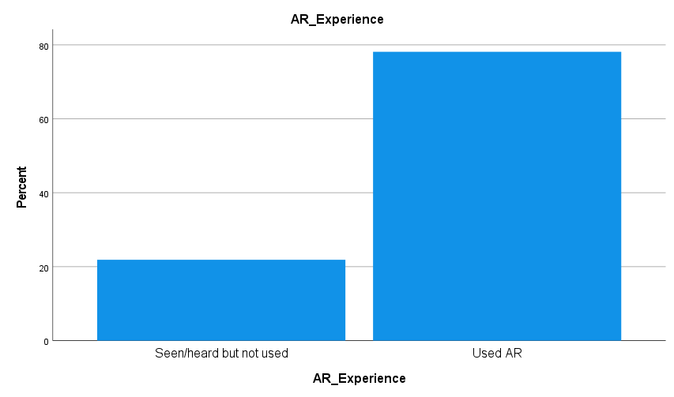

FIGURE 4.1: AR EXPERIENCE PROFILE

4.3 Demographic Analysis
This section summarises the demographic and online shopping characteristics of the final sample (N = 160) to provide context for interpreting later findings on AR experience factors and OPI in Bangladesh’s online fashion market. The full frequency and percentage breakdown is presented in Table 4.2, while Figures 4.2–4.9 highlight key distributions.

TABLE 4.2: FREQUENCY TABLE OF RESPONDENT PROFILE
Variable | Category | Frequency (n) | Percentage (%)
Age group | 18–24 | 85 | 53.1
 | 25–34 | 42 | 26.3
 | 35–44 | 17 | 10.6
 | 45–54 | 13 | 8.1
 | 55 or above | 3 | 1.9
Gender | Female | 84 | 52.5
 | Male | 75 | 46.9
 | Prefer not to say | 1 | 0.6
Education | SSC | 11 | 6.9
 | HSC | 25 | 15.6
 | Bachelor | 66 | 41.3
 | Master | 46 | 28.7
 | Doctorate/Other | 12 | 7.5
Occupation | Student | 64 | 40.0
 | Employed FT | 51 | 31.9
 | Employed PT | 5 | 3.1
 | Self-employed/Business | 22 | 13.8
 | Not employed | 9 | 5.6
 | Other | 9 | 5.6
Monthly household income (BDT) | <15,000 | 21 | 13.1
 | 15,000–30,000 | 53 | 33.1
 | 30,001–50,000 | 48 | 30.0
 | 50,001–70,000 | 24 | 15.0
 | >70,000 | 14 | 8.8
Online fashion purchase frequency | Once a week or more | 29 | 18.1
 | 2–3 times a month | 50 | 31.3
 | About once a month | 42 | 26.3
 | A few times a year | 27 | 16.9
 | Less than once a year | 12 | 7.5
AR use frequency | Seen/heard only | 35 | 21.9
 | Tried once or twice | 17 | 10.6
 | Occasionally | 39 | 24.4
 | Often | 39 | 24.4
 | Very frequently | 30 | 18.8
Main device used | Smartphone | 113 | 70.6
 | Laptop | 24 | 15.0
 | Tablet | 13 | 8.1
 | Desktop | 10 | 6.3

The sample is mostly young with 53.1% of the respondents being in the 18-24 age bracket and 26.3% in the 25-34 age bracket as indicated in Table 4.2 and Figure 4.2. These groups constitute 79.4 percent of the sample which is consistent with the active online fashion shopper in Bangladesh.
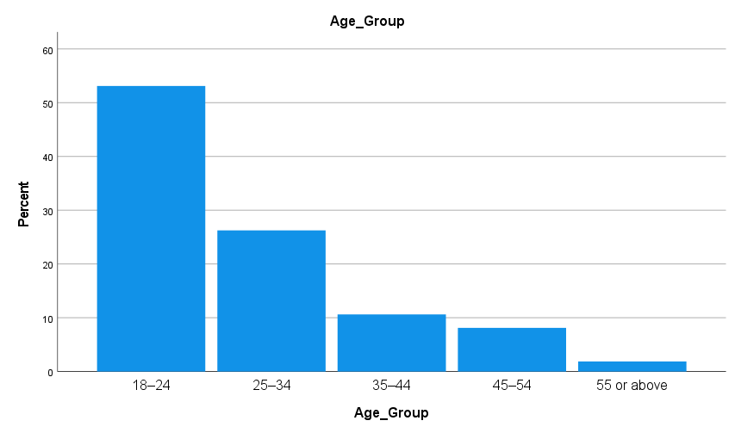
FIGURE 4.2: AGE GROUP DISTRIBUTION
The gender distribution is almost even with the 52.5 percent of females and 46.9 percent of males as the respondents (Figure 4.3) which makes gender views varied.
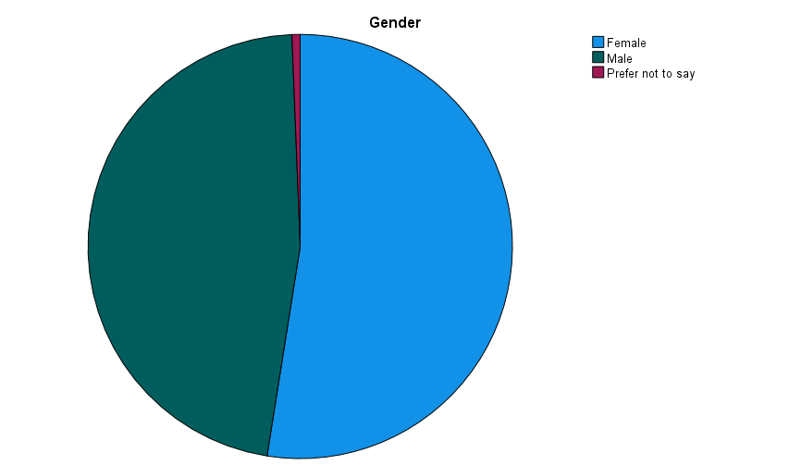
FIGURE 4.3: GENDER DISTRIBUTION
The level of education reveals the digital literacy level with most having a Bachelor's (41.3) or Master's (28.7) degree, which is applicable in determining the AR usability (Table 4.2, Figure 4.4).

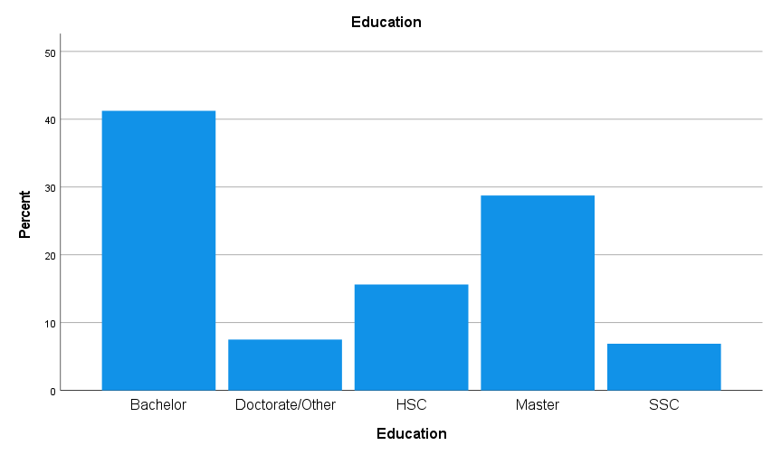
FIGURE 4.4: EDUCATION LEVEL DISTRIBUTION
In terms of occupation, the sample is comprised of a combination of students (40.0%), full-time employees (31.9%), and self-employed/business (13.8%) (Figure 4.5). This combination indicates customers in the early or middle career stage, and it may affect their purchasing behaviours in the Internet.
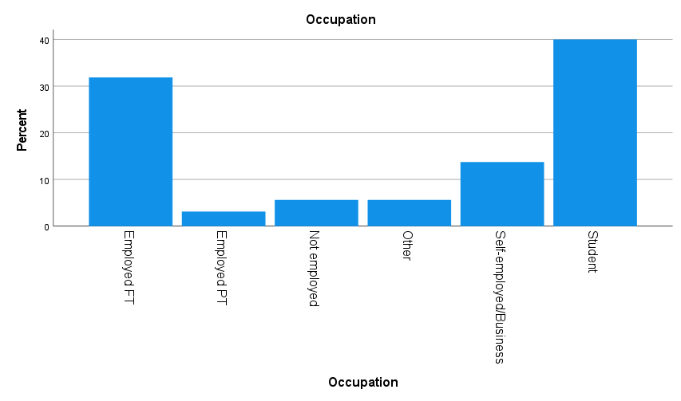
FIGURE 4.5: OCCUPATION DISTRIBUTION
Figure 4.6 indicates that 33.1% of households have incomes that are below BDT 15,000-30,000 and 30.0% between BDT 30,001-50,000, indicating that there is a difference in the purchasing power.
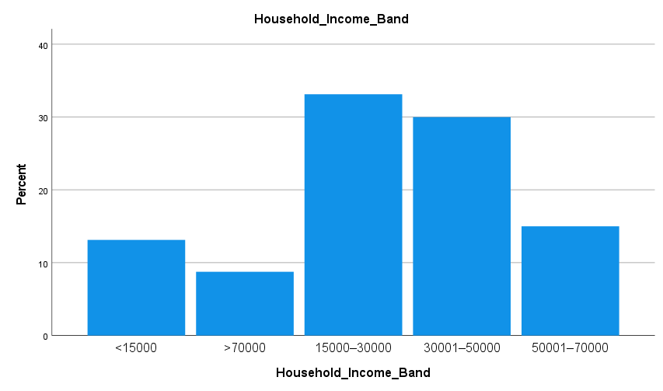
FIGURE 4.6: MONTHLY HOUSEHOLD INCOME DISTRIBUTION
The sample indicates active online shopping, as 31.3% of the customers buy fashion 2-3 times per month (Figure 4.7), which is why it is appropriate to analyse the perception of online fashion retail shopping and AR features.
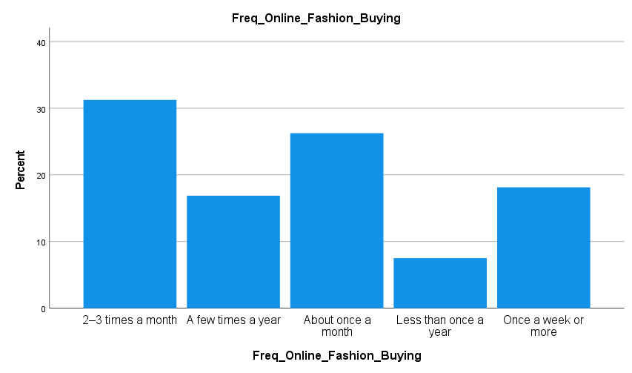

FIGURE 4.7: ONLINE FASHION PURCHASE FREQUENCY
AR use frequency indicates meaningful engagement among respondents. In Figure 4.8, most participants reported using AR occasionally (24.4%) and often (24.4%), or very frequently (18.8%), while fewer reported trying it once or twice (17.1%). However, 21.9% reported seen or only about AR.

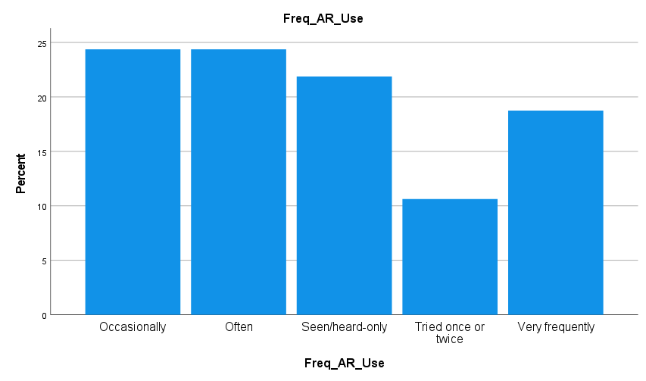
FIGURE 4.8: AR USE FREQUENCY
Finally, shopping is clearly mobile-first: smartphones dominate (70.6%) in Figure 4.9, reinforcing the practical relevance of mobile-based AR features in Bangladesh’s fashion e-commerce setting.
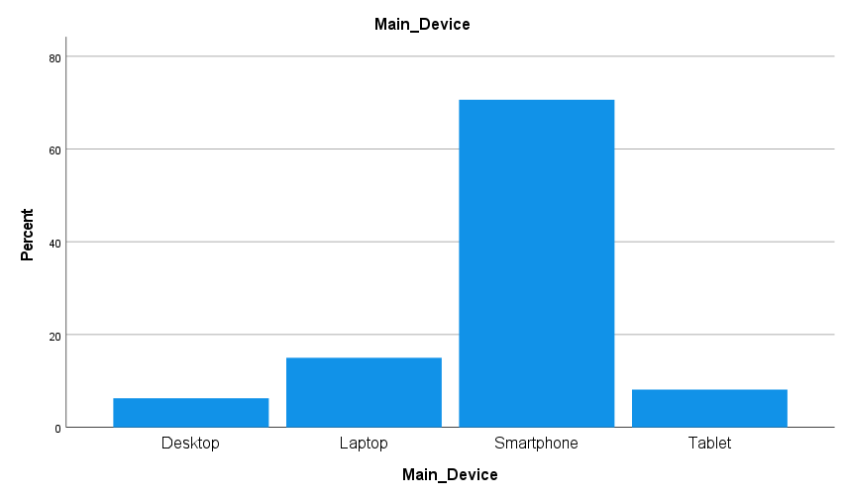
FIGURE 4.9: MAIN DEVICE USED FOR ONLINE FASHION SHOPPING

4.4 Descriptive Analysis
This section reports descriptive statistics for the study constructs. Composite scores were computed for each construct by averaging the five Likert-scale items (1 = strongly disagree, 5 = strongly agree): perceived usefulness (PUsummary), perceived ease of use (PEUsummary), interactivity and enjoyment (IAEsummary), trust and risk reduction (TRRsummary), and online purchase intention (OPISummary). Table 4.3 shows the minimum, maximum, mean, and standard deviation values provide an overall picture of respondents’ perceptions of AR-enabled fashion shopping and their purchase intention.

TABLE 4.3: DESCRIPTIVE STATISTICS OF KEY CONSTRUCTS
Construct | Minimum | Maximum | Mean | Std. Deviation
PUsummary | 1.00 | 5.00 | 2.9862 | 0.95565
PEUsummary | 1.00 | 5.00 | 3.0075 | 0.93966
IAEsummary | 1.00 | 5.00 | 3.0063 | 0.93443
TRRsummary | 1.00 | 5.00 | 3.0100 | 0.93265
OPISummary | 1.00 | 5.00 | 2.9988 | 0.90213
Overall, the experiences of AR-based shopping were rated by respondents as neither positive nor negative strongly. TRRsummary had the highest mean, highest mean (M = 3.0100) whereas PUsummary had the lowest mean, lowest mean (M = 2.9862). The construct means differences are however small and so the respondents had these AR experience dimensions at a fairly similar level.
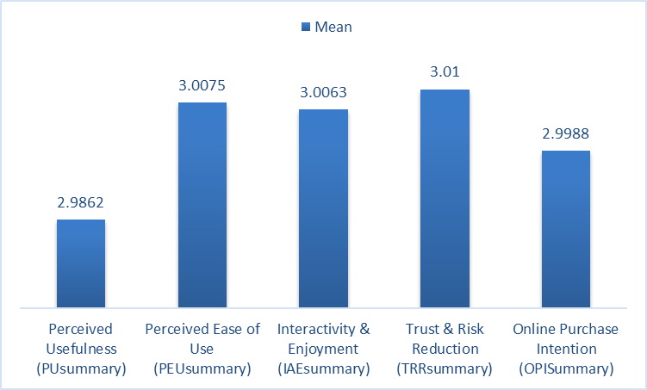

FIGURE 4.10: MEAN SCORES ACROSS CONSTRUCTS

4.5 Reliability Analysis
To test the internal consistency of the multi-item scales to measure each construct, reliability analysis was done. Cronbach alpha ( alpha) was computed of PU, PEU, IAE, and TRR, and online OPI. Five items (n = 5) were included in each construct. The results of reliability are described in Table 4.4.

TABLE 4.4: RELIABILITY ANALYSIS (CRONBACH’S ALPHA)
Construct | Items (n) | Cronbach’s Alpha (α) | Interpretation
Perceived Usefulness (PU) | 5 | 0.965 | Excellent
Perceived Ease of Use (PEU) | 5 | 0.954 | Excellent
Interactivity & Enjoyment (IAE) | 5 | 0.958 | Excellent
Trust & Risk Reduction (TRR) | 5 | 0.964 | Excellent
Online Purchase Intention (OPI) | 5 | 0.933 | Excellent
All scales demonstrated excellent internal consistency, with alpha values above 0.90. This confirms that the items within each construct are highly consistent in measuring the same underlying concept. Therefore, the use of composite mean scores (PUsummary, PEUsummary, IAEsummary, TRRsummary, and OPISummary) is justified for subsequent correlation and regression analyses.

4.6 Correlation Analysis
To examine the bivariate relationships between AR-based shopping experience factors and OPI, Spearman’s rank-order correlation (Spearman’s rho) was used. Spearman’s rho is appropriate for Likert-scale composite variables when the data are treated as ordinal or when normality assumptions for parametric correlation are uncertain (Field, 2018; Pallant, 2020; Saunders et al., 2019).

TABLE 4.5: SPEARMAN CORRELATION MATRIX
Construct | PUsummary | PEUsummary | IAEsummary | TRRsummary | OPISummary
PUsummary | 1.000 | -0.042 | -0.094 | 0.008 | 0.443**
PEUsummary | -0.042 | 1.000 | -0.047 | -0.031 | 0.344**
IAEsummary | -0.094 | -0.047 | 1.000 | 0.006 | 0.233**
TRRsummary | 0.008 | -0.031 | 0.006 | 1.000 | 0.327**
OPISummary | 0.443** | 0.344** | 0.233** | 0.327** | 1.000
As shown in Table 4.5, all four AR experience constructs are positively and significantly associated with OPI. PUsummary shows the strongest association with OPI (ρ = 0.443, p < .001), followed by PEUsummary (ρ = 0.344, p < .001), TRRsummary (ρ = 0.327, p < .001), and IAEsummary (ρ = 0.233, p = .003). This pattern indicates that stronger positive perceptions of AR, whether functional (usefulness, ease of use) or experiential (enjoyment, trust/risk reduction), tend to align with stronger purchase intention in Bangladesh’s online fashion context.
Correlations among the independent variables are very small (near zero), which suggests limited overlap between predictors at the bivariate level and reduces initial concern about multicollinearity (Hair et al., 2019; Field, 2018).

4.7 Multiple Regression Analysis
A multiple regression analysis was conducted to test the study hypotheses and assess the combined and individual predictive effects of PUsummary, PEUsummary, IAEsummary, and TRRsummary on OPISummary. Multiple regression is suitable when estimating how multiple predictors jointly and uniquely explain variance in a dependent variable and is widely used in technology adoption and consumer behaviour research (Hair et al., 2019; Saunders et al., 2019).
The regression model shows strong explanatory power. As presented in Table 4.6, the model produced R = 0.751 and R² = 0.564, meaning that the four AR experience factors jointly explain 56.4% of the variance in OPI. The Adjusted R² = 0.553 indicates the model remains strong even after accounting for the number of predictors. The standard error of the estimate (0.60328) reflects the average prediction error around the regression line.

TABLE 4.6: MODEL SUMMARY (DEPENDENT VARIABLE: OPISUMMARY)
R | R² | Adjusted R² | Std. Error of the Estimate
0.751 | 0.564 | 0.553 | 0.60328
The ANOVA results confirm that the model is statistically significant overall. As shown in Table 4.7, the regression model significantly predicts OPI, F(4, 155) = 50.136, p < .001, indicating that the set of AR experience variables explains OPI better than a model with no predictors.

TABLE 4.7: ANOVA
Model | Sum of Squares |  | df | F | Sig.
Regression | 72.987 |  | 4 | 50.136 | < .001
Residual | 56.412 |  | 155
Total | 129.400 |  | 159
The coefficients, as provided in Table 4.8, indicates that all four predictors have positive and statistically significant effects on OPI (all p < .001). As reported in Table 4.8, PUsummary is the strongest predictor in standardised terms (β = 0.483), followed by PEUsummary (β = 0.403), TRRsummary (β = 0.351), and IAEsummary (β = 0.328). This means that, holding the other AR factors constant, higher values on each predictor are associated with higher OPI.

TABLE 4.8: REGRESSION COEFFICIENTS
Model |  | Unstandardized Coefficients |  | Standardized Coefficients | t | Sig.
 |  | B | Std. Error | Beta | t | Sig.
1 | (Constant) | -1.499 | .327 |  | -4.592 | .000
1 | PUsummary | .456 | .050 | .483 | 9.045 | .000
1 | PEUsummary | .387 | .051 | .403 | 7.585 | .000
1 | IAEsummary | .317 | .052 | .328 | 6.140 | .000
1 | TRRsummary | .340 | .051 | .351 | 6.615 | .000
a. Dependent Variable: OPISummary

4.8 Chapter Summary
Chapter 4 presented the study’s quantitative results based on the completed survey responses. It reported the respondent profile and assessed the reliability of the measurement scales using Cronbach’s alpha. Descriptive statistics were used to summarise PU, PEU, IAE, TRR, and OPI. Spearman correlation analysis examined the direction and strength of relationships among the variables. Finally, multiple regression tested the proposed hypotheses and identified the most influential predictors of OPI. The findings provide the basis for the interpretation and implications discussed in Chapter 5.

Chapter 5: Discussion

5.1 Chapter Overview
This chapter discusses and interprets the findings in Chapter 4 concerning the study aim, objectives, hypotheses, and the theoretical basis of the study as discussed in Chapter 2. Based on the correlation and multiple regression findings, the chapter shows how the perceived usefulness (PU), perceived ease of use (PEU), interactivity and enjoyment (IAE), and trust and risk reduction (TRR) can affect online purchase intention (OPI) in online fashion customers of Bangladesh. The discussion correlates the statistical findings to the Technology Acceptance Model (TAM) and Stimulus Organism Response (S-O-R) framework demonstrating how cognitive and experience evaluations influence the purchase intention in AR-enabled retail. Another important theme identified in the chapter is the alignment, extensions, or deviations of the results with the previous study of AR and e-commerce within the context of fashion aspects. The chapter concludes with the description of the essential theoretical and operational implications of the research and fashion e-retailer in Bangladesh, and summarises the major points of discussion.

5.2 Interpretation of Key Findings
This part explains the empirical conclusions made in Chapter 4 through connecting the statistical results (Spearman correlation and multiple regression) to the study hypotheses and the theoretical foundations addressed in the Chapter 2. The findings indicate that the four factors of AR based shopping experience PU, PEU, IAE as well as TRR are all positively related to OPI. The direction and strength of the bivariate relationships are established by correlation analysis, whereas regression analysis illustrates the distinctive predictive value of each of the factors when they are controlled by the other ones (Hair et al., 2019; Field, 2018).
5.2.1 Perceived Usefulness and Online Purchase Intention
The discussion proves that PU is a major contributor of OPI. The findings of the correlation indicate that PU is moderately positively correlated with OPI ( 0.443, p <.001), i.e., consumers that find AR more helpful are more likely to state their intention to buy fashion products online. The regressions support this correlation. PU also exhibits the highest unique predictive value of the independent variables ( =.001). It means that, other factors of AR experience remaining unchanged, an increase in PU by one unit is correlated with the rise in OPI by 0.456. These findings confirm the Hypothesis 1 (H1) (PU of AR applications has a positive impact on OPI) as accepted.
This result appears to be as well consistent with the TAM which states that PU is one of the key predictors of behavioural intention since users embrace technologies they think improve decision-making performance (Davis, 1989). Usefulness in the case of AR-based fashion shopping denotes the level to which AR enhances product consideration, eliminates the ambiguity in portion to how things look and fit, and facilitates the ability to make purchase choices with greater certainty. Similar research findings indicate that PU is a stable and frequently controlling predictor of buying intention and adoption intention in AR stores (Hanna, 2023; Guo and Zhang, 2024). Systematic reviews also find that AR enhances purchase intention mainly by enhancing product visualisation and decision confidence, which are closely related to the usefulness perceptions (Hoffmann and Mai, 2022; Yitong et al., 2024).
Contextually speaking, the power of PU in Bangladesh is theoretically feasible. The e-commerce of Bangladeshi fashion is still influenced by information restraint and perceived product risk especially in terms of authenticity, quality, and fit. The increased diagnostic product cues offered by AR must be appreciated, therefore, not because of novelty per se but rather as having functional utility. The key implication of the given result is that AR investments have a higher chance of affecting the purchase intention when consumers believe that the technology will contribute to the quality of decisions made, rather than merely providing the visual value.
5.2.2 Perceived Ease of Use and Online Purchase Intention
PEU is also significantly positively related to OPI. Correlation outcomes show that there is a moderate, positive, relationship between PEU and OPI (rho = 0.344, p =.001). This implies that consumers are likely to demonstrate a high purchase intention when they feel that AR features are user friendly and user navigable. The results of regression prove that the independent PEU influence on OPI is statistically significant (B = 0.387; 0.403; t = 7.585, p < .001). This is to mean that one unit change in PEU is associated with a 0.387 change in OPI when other predictors are held constant. Thus, Hypothesis 2 (H2) (PEU of AR has a positive effect on OPI) is accepted.
This observation is aligned with TAM, which states that the perceived effortless systems have higher chances to be accepted due to the decreasing complexity has decreased cognitive load and increased favourable user assessments (Davis, 1989). Ease of use in AR fashion shopping means whether AR functions can be enabled, interpreted and manipulated easily, such as by easy interface navigation, consistent tracking, and reduced latency. The empirical literature also notes that the ease of use has a positive impact on AR-related behavioural intentions, such as purchase intention, particularly in mobile-based shopping areas where usability conditions may interrupt the shopping process (Do et al., 2020; Guo and Zhang, 2024). Also, reviews emphasize that user-friendliness facilitates the adoption and purchase outcomes of AR through the minimization of friction and reinforcing its acceptance among users (Hoffmann and Mai, 2022; Yitong et al., 2024).
Nevertheless, the results also indicate that PEU is poorly a little less influential in standardised terms than PU ( = 0.403 vs. = 0.483). This is an indication that consumers can be comfortable with a relative degree of usability complexity should AR offer apparent functional value. This trend is in line with the findings of TAM-based studies that usefulness usually prevails over ease of use when making decisions of higher involvement (Davis, 1989). Within the Bangladeshi fashion environment where the uncertainty in the evaluation of products is elevated consumers seem to place emphasis on the practicality of AR whereas level of ease of use seems to be an enabling factor that reinforces intention in case AR is perceived as both usable and supportive in decision making.
5.2.3 Interactivity and Enjoyment and Online Purchase Intention
The findings demonstrate that there is a positive and statistically significant relationship between IAE and OPI although the correlation is not as strong as functional predictors. Correlation analysis revealed that IAE and OPI have a small-to-moderate positive relationship ( ρ = 0.233, p =. 003). Regression analysis supports the fact that IAE is a major predictor at the expense of other variables (B = 0.317; 0.328 = 0.328; t = 6.140, p < 0.001). The first one is that a unit increasing in IAE will lower the OPI by 0.317. In this regard, Hypothesis 3 (H3) (IAE in AR shopping experiences positively influence OPI) is accepted.
This finding corresponds to the S-O-R model which suggests that the interactive technological stimuli influence the internal psychological state of enjoyment, engagement, and immersion which in turn precipitates the approach behaviour such as the purchase intention (Mehrabian and Russell, 1974). Hedonic value and experiences can be enhanced by AR functions that enable consumers to handle goods, interact with virtual trials, and enjoy using glamorous visual overlays. The previous research has shown that the AR interactivity can contribute to perceived enjoyment and satisfaction and consequently, purchase-related intentions (Do et al., 2020; Voicu et al., 2023). Basari and Dewanti (2024) also demonstrate that in AR setups, enjoyment is a key factor in determining the shopping behaviour and can mitigate the adverse influence of risk perceptions.
A critical interpretation of the comparatively less significant effect size that could be taken critically is that the consumers in Bangladesh might perceive AR as a decision-support option, but not as a hedonic or an entertainment capability. It is in line with the general principle of trust and product quality uncertainty in local e-commerce, where functional and risk-reducing benefits might prevail. However, the role of IAE suggests that the retailers cannot afford to overlook the experiential quality. Engagement time, exploration, and positive affect, which can be facilitated by enjoyment and interactivity, can be useful in purchase intention, and this is likely to happen when usefulness and trust-building mechanisms are involved.
5.2.4 Trust and Risk Reduction and Online Purchase Intention
TRR also show a great positive correlation with OPI. There is moderate positive correlation between TRR and OPI (Spearman correlation = 0.327, p =.001). Regression analysis also indicates that TRR significantly influences OPI in a positive way, independent or otherwise (B = 0.340; 2 = 0.351; t = 6.615, p <.001). This means that a unit change in perceived TRR is associated with a 0.340 change in OPI, all other things remaining constant. These findings prove that Hypothesis 4 (H4) (Perceived TRR related to AR technology positively affect OPI) holds.
The literature has a solid foundation on the importance of this finding and especially in the context of fashion e-commerce where uncertainty about product quality, fit and reliability of sellers may dampen the intention to purchase. AR could help to decrease the perceived risk because of the enhanced visualisation realism and tendency to form a stronger fit confidence, which leads to a heightened trust in the product expectations (Hoffmann and Mai, 2022; Hanna, 2023). The previous literature also reveals that the perceptions related to trust are large predictors of AR adoption and the intention to purchase, in particular, in situations where online shopping uncertainty is salient (Jain and Kaur, 2024; Mohanty et al., 2025). Similar conclusions are made by systematic reviews according to which one of the most reliable advantages of AR in retail is the confidence in decision-making and less uncertainty, which enhances the purchase intention (Yitong et al., 2024).
Critically, TRR is not significantly the most predictive in the regression model. This implies that lack of trust-building cannot be effective when AR fails to provide obvious usefulness and usability. That is, AR can have less risk perception, however, consumers tend to convert the reassurance into purchase intent more often when AR is also perceived as being useful and user-friendly in practical terms. This interpretation is consistent with integrated perspectives in AR research that combine TAM’s cognitive evaluations (usefulness, ease of use) with S–O–R’s internal states (trust, enjoyment) to explain purchase intention more comprehensively (Do et al., 2020; Guo and Zhang, 2024; Yitong et al., 2024). For Bangladesh’s fashion e-commerce sector, the implication is that trust effects may be strongest when AR experiences are accurate, stable, and clearly assist product evaluation rather than functioning as a superficial visual layer.

TABLE 5.1: SUMMARY OF HYPOTHESES TESTING
Hypothesis | Accepted or Not
H1: Perceived usefulness of AR applications has a positive impact on OPI. | Accepted
H2: Perceived ease of use of AR features positively influences OPI. | Accepted
H3: Interactivity and enjoyment in AR shopping experiences positively affect OPI. | Accepted
H4: Perceived trust and risk reduction associated with AR technology positively influence OPI. | Accepted

5.3 Implications of the Study
This study provides important implications for theory, practice, and future research on AR-enabled fashion e-commerce in Bangladesh. Theoretically, the findings support the combined use of the TAM and the S–O–R framework in explaining OPI. TAM is reinforced because PU and PEU significantly predict OPI, consistent with Davis (1989) and later AR adoption studies that show technology value and usability are key drivers of behavioural intention (Guo and Zhang, 2024; Hanna, 2023). At the same time, S–O–R is supported because IAE, and TRR also show significant positive effects on OPI, indicating that experiential and affective responses to AR shape approach behaviour in online shopping settings (Mehrabian and Russell, 1974; Do et al., 2020). By confirming that both cognitive and experiential mechanisms matter, the study strengthens the case for integrated models in AR retail research (Hoffmann and Mai, 2022; Yitong et al., 2024).
Practically, the results suggest that Bangladeshi fashion e-retailers should design AR primarily as a decision-support tool rather than a novelty feature. Since PU is the strongest predictor, AR functions should focus on improving product evaluation, such as clearer fit/size visualisation, more realistic colour rendering, and interactive product inspection. The importance of PEU signals the need for frictionless mobile interfaces, rapid loading, simple navigation and guidance especially since the market is dominated by smartphones. The positive effect of TRR suggests that AR should be able to serve as a trust-building mechanism in a situation where perceived risk and quality uncertainty remain major barriers so retailers should prioritise accuracy, transparency, and consistency between AR previews and delivered products (Hoffmann and Mai, 2022). Finally, the impact of IAE reveals that enjoyment adds value by keeping one engaged, but should not be used as entertainment, and should be paired with conversion outcomes (Voicu et al., 2023; Basari and Dewanti, 2024).

5.4 Chapter Summary
This chapter interpreted the study’s findings and connected them to the theories and empirical evidence reviewed in Chapter 2. Correlation and regression results indicate that PU, PEU, IAE, and TRR each have a significant positive relationship with OPI among Bangladeshi online fashion shoppers. Overall, the results support TAM and the S–O–R perspective by showing that both cognitive evaluations and experiential perceptions influence intention in AR-enabled fashion e-commerce.
The chapter also highlighted key implications. The study strengthens an integrated acceptance-and-experience framework and adds evidence from an under-researched emerging market. For practice, the findings suggest that Bangladeshi fashion e-retailers should focus on mobile-friendly AR that improves product evaluation, stays easy to use, builds trust through accurate visualisation, and increases engagement through interactive enjoyment. Chapter 6 concludes by summarising the study’s contributions, limitations, and future research directions.

Chapter 6: Conclusions & Recommendations

6.1 Chapter Overview
This chapter concludes the dissertation by summing up the purpose of the study, the main findings and how far the research has achieved its aim and objectives. It then offers practical recommendations to Bangladeshi fashion e-retailers on using AR features to enhance OPI. Finally, the chapter summarizes the limitations of the study and proposes the direction of future research to extend and expand current understanding of the AR-based shopping in the emerging markets.

6.2 Conclusions
The primary aim of study was to analyse the influence of the AR-based shopping experience factors on OPI in the fashion retail industry in Bangladesh. Using survey data of 160 Bangladeshi online fashion shoppers and by using spearman correlation, multiple regression analysis, the effects of PU, PEU, IAE, TRR, on OPI were tested. In addition to the primary aim the study also achieved its research objectives and answer the research questions.

6.2.1 Objective 1: To investigate the impact of perceived usefulness and ease of use of AR applications on consumers’ OPI.
This objective was achieved. Both PU and PEU were positively related to OPI in the correlation and regression analysis, confirming the fact that when AR is perceived to be helpful in finding help from products, easy to operate, the consumers express a stronger purchase intention. This directly answers the first research question and offers support for the TAM assumption that usefulness and ease of use are important determinants of behavioural intention (Davis, 1989). In the context of Bangladeshi fashion e-commerce, it seems that usefulness is an especially influential factor, which would imply that adoption of AR is more motivated by decision support value (mitigating uncertainty regarding product appearance/fit) rather than entertainment alone.

6.2.2 Objective 2: To evaluate the effect of interactivity and enjoyment in AR shopping experiences on OPI.
This objective was also achieved. IAE showed a positive association with OPI in the correlation and regression analysis, confirming AR experiences that feel engaging, fun, and interactive can increase consumers’ willingness to purchase fashion products online. The results align with S–O–R and flow-based arguments that enjoyable interactive environments create approach behaviour and strengthen buying intentions (Do et al., 2020). However, IAE was the weakest predictor among the four variables, suggesting that enjoyment supports purchase intention but is less influential than usefulness and ease of use in this context.

6.2.3 Objective 3: To analyse the influence of perceived trust and risk reduction of AR technology on OPI.
This objective was achieved. TRR were significantly related to OPI in the correlation and regression analysis, confirming that AR can work as a risk-reducing mechanism in online fashion shopping by increasing confidence in product appearance and fit, which is critical in Bangladesh where concerns about quality mismatch and reliability remain common. The finding supports prior AR research that emphasises trust-building and decision confidence as pathways to purchase intention (Hoffmann and Mai, 2022; Yitong et al., 2024).

6.2.4 Objective 4: To provide recommendations for fashion retailers on how to effectively implement AR-based marketing strategies to enhance online consumer engagement and sales performance.
This objective was met by converting the statistical results into practical recommendations that are provided in Section 6.3. Because of the fact that PU came out to be the strongest predictor of OPI, the study concludes that AR should be designed and communicated mostly as a tool to enhance product evaluation rather than strictly as a promotional novelty. The importance of PEU, TRR and IAE further states that retailers need to ensure that AR features are easy to use, trustworthy and interesting to maximise response and purchase intention from consumers.

6.3 Recommendations
Based on the findings, the following recommendations are made for the Bangladeshi fashion e-retailers and platform managers:
- Design AR around usefulness: Since PU is the strongest predictor of OPI, AR features should be aimed at increasing product understanding. For retailers, it should focus on virtual try-on, 3D product inspection and better guidance for size/fit to minimise the uncertainty about appearance and fit.
- Reduce user effort to improve ease of use: AR interfaces need to be simple and mobile-friendly. Retailers should minimise the number of steps involved to activate AR, make sure the loading times are fast, provide instruction, and make the experience stable across common smartphone devices.
- Strengthen trust through accuracy and transparency: Since TRR predicts OPI to a great extent, retailers should be better at making their AR previews and actual products realistic and consistent. They should also manage expectations by making clear what AR can and cannot perfectly replicate (lighting, device camera differences, etc.).
- Use enjoyment to sustain engagement, not as a substitute for value: Interactive features like rotation, zoom, mix-and-match styling, and easy sharing can increase enjoyment. However, these should support product evaluation and confidence rather than distract from purchase decisions.
- Integrate AR into marketing communication and customer journey: Retailers should promote AR as a practical tool (“check fit”, “see colour”, “try before you buy”) and embed it at key decision stages (product page, cart stage). Small incentives (discounts for using AR) may increase adoption among first-time users.

6.4 Limitations of the Study
This study has several limitations. First, the research involved non-probability convenience sampling, which means that the research sample may not represent the entire population of online fashion shoppers in Bangladesh. The demographics indicate a very high concentration of younger, educated and digitally active respondents, and so the results may reflect the views of early adopters and not necessarily older or less digitally confident consumers. Second, the research is based on self-reported answers to a survey, which might cause common method bias and social desirability effects, and on purchase intention, not actual buying behaviour. This is important in that intention does not necessarily translate into actual purchases, particularly in markets where constraints; such as price sensitivity, reliability of delivery and payment preference, can influence final decisions. Third, the research design is cross-sectional, capturing perceptions at one point in time, thus the results show associations but cannot prove causal relationships. Fourth, the model focuses on only four factors of AR experiences and does not consider other factors that may be influential such as price/value perceptions, brand trust, website/service quality, delivery experience, social influence, or previous satisfaction that could also influence OPI. Finally, the study is confined to the fashion e-commerce context in Bangladesh, so the study might not have generalisability for other product categories or countries where AR maturity, infrastructure and consumer expectations are not similar.

6.5 Suggestions for Future Research
Future research can take this study in a number of useful directions. First, researchers should consider use a larger and more diverse samples with probability based or stratified approaches to improve representativeness across age groups, regions and income segments in Bangladesh. Second, future studies should go beyond intention, by including behavioural outcomes such as actual purchase, conversion rates, return behaviour or repeat buying. Third, longitudinal or experimental designs would strengthen causal interpretation by testing whether exposure to AR features directly changes trust, confidence, and purchase decisions over time. Fourth, future models could test mediating mechanisms (for example, whether perceived trust or decision confidence mediates the impact of usefulness on purchase intention) and moderating effects (for example, whether AR experience level, product type, gender, or shopping frequency changes the strength of relationships). Finally, comparative research across platforms (brand-owned sites vs marketplaces) and across product categories (clothing vs footwear vs cosmetics) would help identify where AR creates the most value and whether the strongest drivers remain usefulness and ease of use or shift toward enjoyment and experiential factors as AR becomes more common.

References
Azuma, R. T. (1997) ‘A survey of augmented reality’, Presence: Teleoperators and Virtual Environments, 6(4), pp. 355–385. https://doi.org/10.1162/pres.1997.6.4.355
Azuma, R. T., Baillot, Y., Behringer, R., Feiner, S., Julier, S. and MacIntyre, B. (2001) ‘Recent advances in augmented reality’, IEEE Computer Graphics and Applications, 21(6), pp. 34–47. https://doi.org/10.1109/38.963459
Basari, A. S. A. and Dewanti, R. L. (2024) ‘The effect of augmented reality and perceived risk on online shopping behaviour with perceived enjoyment as mediating variable’, International Journal for Multidisciplinary Research, 6(2), pp. 1–10.
Bryman, A. and Bell, E. (2015) Business research methods. 4th edn. Oxford: Oxford University Press.
Carmigniani, J. and Furht, B. (2011) ‘Augmented reality: an overview’, in Furht, B. (ed.) Handbook of augmented reality. New York: Springer, pp. 3–46. https://doi.org/10.1007/978-1-4614-0064-6_1
Cramer-Flood, E. (2024) Worldwide retail ecommerce forecast 2024. eMarketer. Available at: https://www.emarketer.com/content/worldwide-retail-ecommerce-forecast-2024 (Accessed: 19 November 2025).
Creswell, J. W. and Creswell, J. D. (2018) Research design: qualitative, quantitative, and mixed methods approaches. 5th edn. Los Angeles: Sage.
Davis, F. (1989) ‘Perceived usefulness, perceived ease of use, and user acceptance of information technology’, MIS Quarterly, 13, pp. 319–340. https://doi.org/10.2307/249008
DHL (2025) Bangladesh e-commerce trends in 2025 – DHL Express BD. Available at: https://www.dhl.com/discover/en-bd/e-commerce-advice/e-commerce-trends/what-is-e-commerce-2025-blangladeshi-trends (Accessed: 19 November 2025).
Do, H. N., Shih, W. and Ha, Q. A. (2020) ‘Effects of mobile augmented reality apps on impulse buying behavior: An investigation in the tourism field’, Heliyon, 6(8).
ECDB (2024) Bangladeshi fashion ecommerce: Market size and growth. Available at: https://ecdb.com/resources/sample-data/market/bd/fashion#market-size-and-growth (Accessed: 19 November 2025).
Guo, C. and Zhang, X. (2024) ‘The impact of AR online shopping experience on customer purchase intention: An empirical study based on the TAM model’, PLOS ONE, 19(8), e0309468. https://doi.org/10.1371/journal.pone.0309468
Hanna, N. N. M. (2023) ‘The impact of augmented reality technology on consumers’ purchase intention of furniture through online stores: Applied on Chic Homz Store’, المجلة العلمية للدراسات التجارية والبيئية, 14(4), pp. 1588–1624.
Hilken, T., Heller, J., Chylinski, M., Keeling, D. I., Mahr, D. and de Ruyter, K. (2018) ‘Making omnichannel an augmented reality: The current and future state of the art’, J. Res. Interact. Mark., 12(4), pp. 509–523. doi:10.1108/jrim-01-2018-0023
Hoffmann, S. and Mai, R. (2022) ‘Consumer behavior in augmented shopping reality. A review, synthesis, and research agenda’, Frontiers in Virtual Reality, 3, 961236.
Jain, R. and Kaur, H. (2024) ‘Consumer trust and technology acceptance in Indian e-commerce: A study on augmented reality’, Indian Journal of Marketing, 54(1), pp. 18–27.
Javornik, A. (2016) ‘Augmented reality: research agenda for studying the impact of its media characteristics on consumer behavior’, Journal of Retailing and Consumer Services, 30, pp. 252–261. https://doi.org/10.1016/j.jretconser.2016.02.004
Kazmi, S. H. A., Ahmed, R. R., Soomro, K. A., Hashem E, A. R., Akhtar, H. and Parmar, V. (2021) ‘Role of augmented reality in changing consumer behavior and decision making: Case of Pakistan’, Sustainability, 13(24), 14064.
Liu, S. and Napitupulu, T. A. (2020) ‘Analyzing factors affecting satisfaction and purchase intention towards mobile augmented reality e-commerce applications in Indonesia’, Journal of Theoretical and Applied Information Technology, 98(22).
MCCI (2022) E-commerce in Bangladesh: Challenges and way forward. Metropolitan Chamber of Commerce and Industry, Dhaka. Available at: https://mccibd.org/wp-content/uploads/2022/09/Chamber-News-September-2022.pdf (Accessed: 19 November 2025).
Mehrabian, A. and Russell, J.A. (1974) An approach to environmental psychology. the MIT Press.
Mohanty, S. S., Nath, S. Ch., Sabat, D. R. and Baliarsingh, R. K. (2025) ‘Understanding the dynamics of augmented reality adoption in Indian e-commerce: A study on consumer perception and acceptance’, Advances in Consumer Research, 2(4), pp. 5423–5430.
PCMI (2025) Understanding Bangladesh’s e-commerce landscape. Available at: https://paymentscmi.com/insights/bangladesh-ecommerce-market-insights/ (Accessed: 19 November 2025).
Red Stag Fulfillment (2024) What share of global retail sales is ecommerce? Available at: https://redstagfulfillment.com/what-share-of-global-retail-sales-is-ecommerce/ (Accessed: 19 November 2025).
Research and Markets (2024) Bangladesh ecommerce market opportunities databook – 100+ KPIs on ecommerce verticals (shopping, travel, food service, media & entertainment, technology), market share by key players, sales channel analysis, payment instrument, consumer demographics – Q1 2024 update. Available at: https://www.researchandmarkets.com/reports/5648286/bangladesh-ecommerce-market-opportunities?srsltid=AfmBOoosT9j_7BwTWsu9podHUhDj8h6sOvOU1-qXcBQzOf9W7WVjxbHR (Accessed: 19 November 2025).
Saunders, M. N. K., Lewis, P. and Thornhill, A. (2019) Research methods for business students. 8th edn. New York: Pearson.
Technavio (2024) Augmented reality in retail market analysis: North America, Europe, APAC, South America, Middle East and Africa – US, China, Germany, UK, Canada – size and forecast 2024–2028. Available at: https://www.technavio.com/report/augmented-reality-in-retail-market-industry-analysis (Accessed: 19 November 2025).
Voicu, M. C., Sîrghi, N. and Toth, D. M. M. (2023) ‘Consumers’ experience and satisfaction using augmented reality apps in e-shopping: New empirical evidence’, Applied Sciences, 13(17), 9596.
Whang, J. B., Song, J. H., Choi, B. and Lee, J. H. (2021) ‘The effect of augmented reality on purchase intention of beauty products: The roles of consumers’ control’, Journal of Business Research, 133, pp. 275–284.
Yitong, W., Thoo, A. C., Lo, Y. T. and Huam, H. T. (2024) ‘Online shopping in augmented reality: Systematic literature review of consumer behavior’, Evolutionary Studies in Imaginative Culture, 8(2), pp. 1013–1025.
Zhou, F., Duh, H. B.-L. and Billinghurst, M. (2008) ‘Trends in augmented reality tracking, interaction and display: a review of ten years of ISMAR’, Proceedings of the 7th IEEE/ACM International Symposium on Mixed and Augmented Reality (ISMAR 2008), Cambridge, UK, 15–18 September, pp. 193–202. https://doi.org/10.1109/ISMAR.2008.4637362

Appendices

Appendix – A
Questionnaire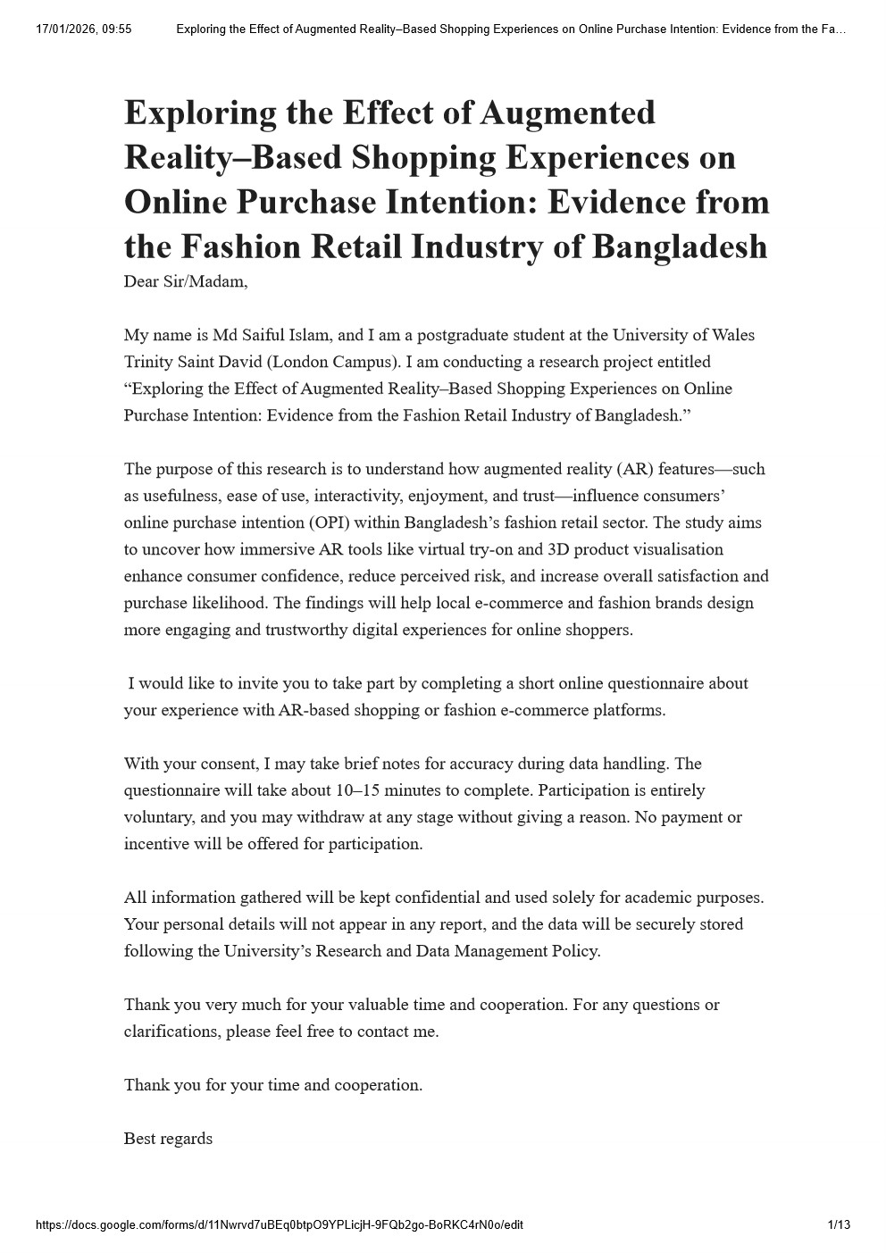
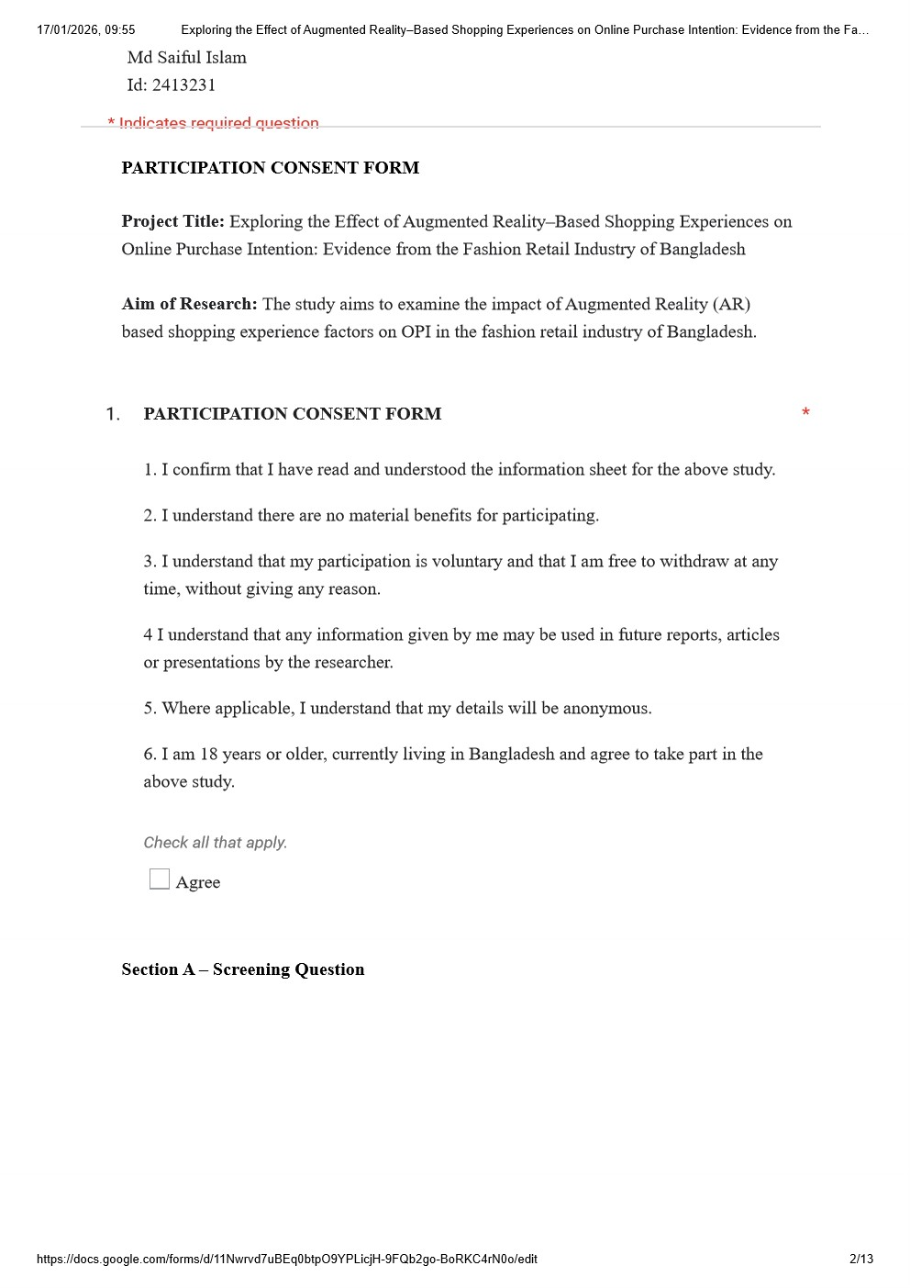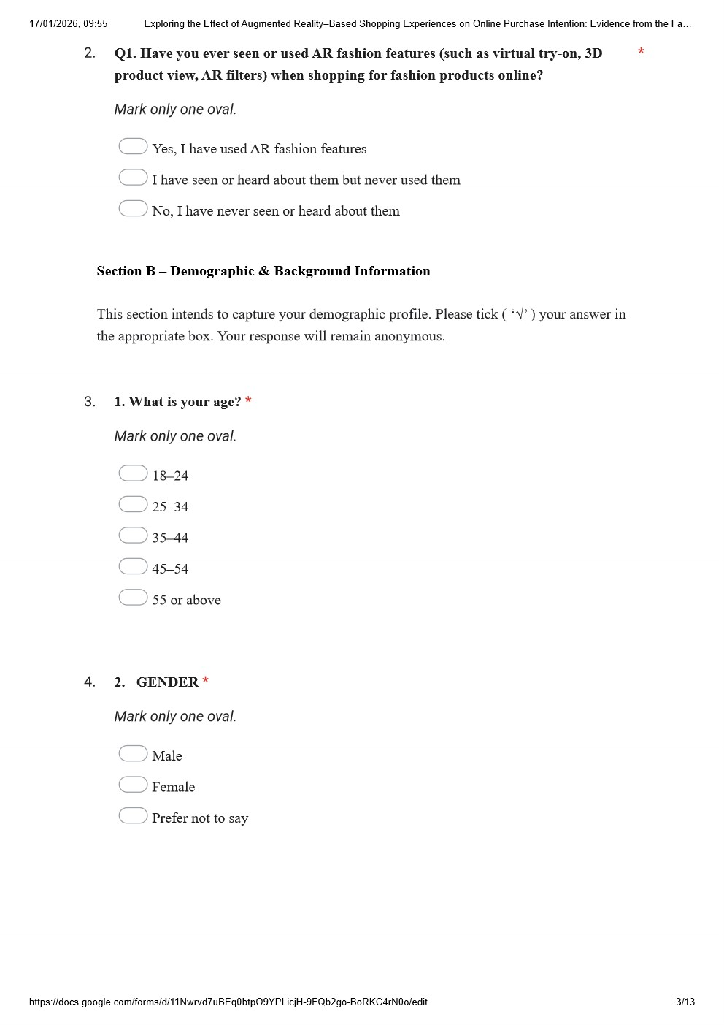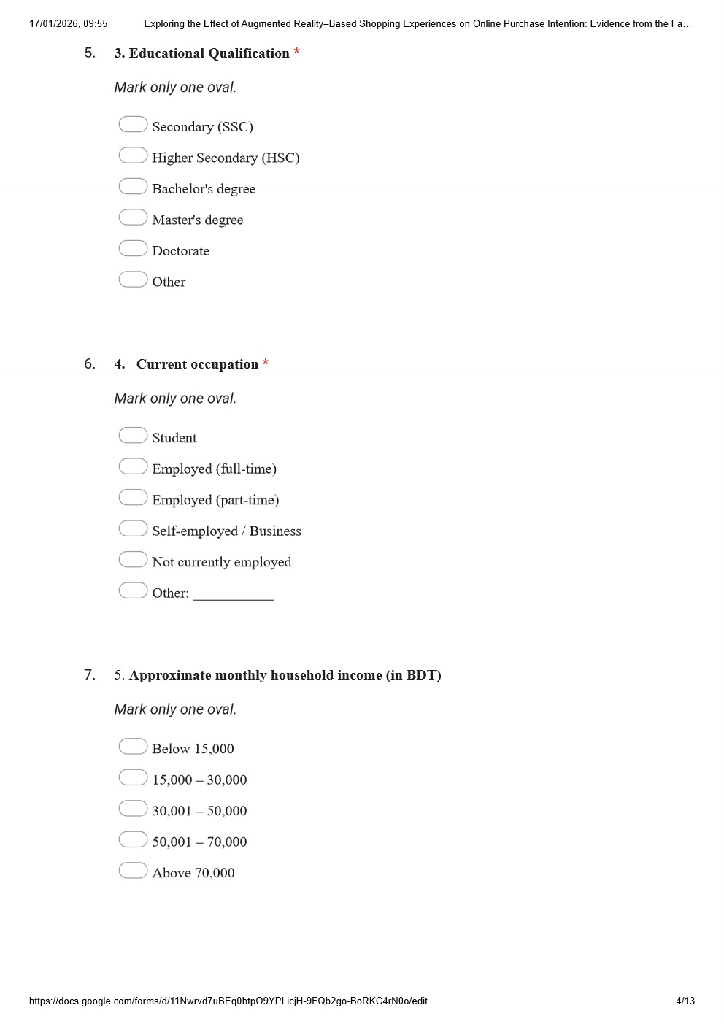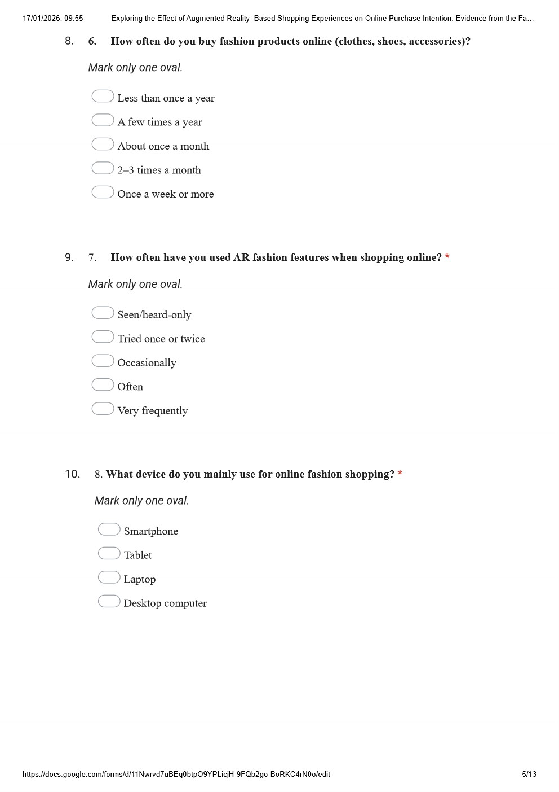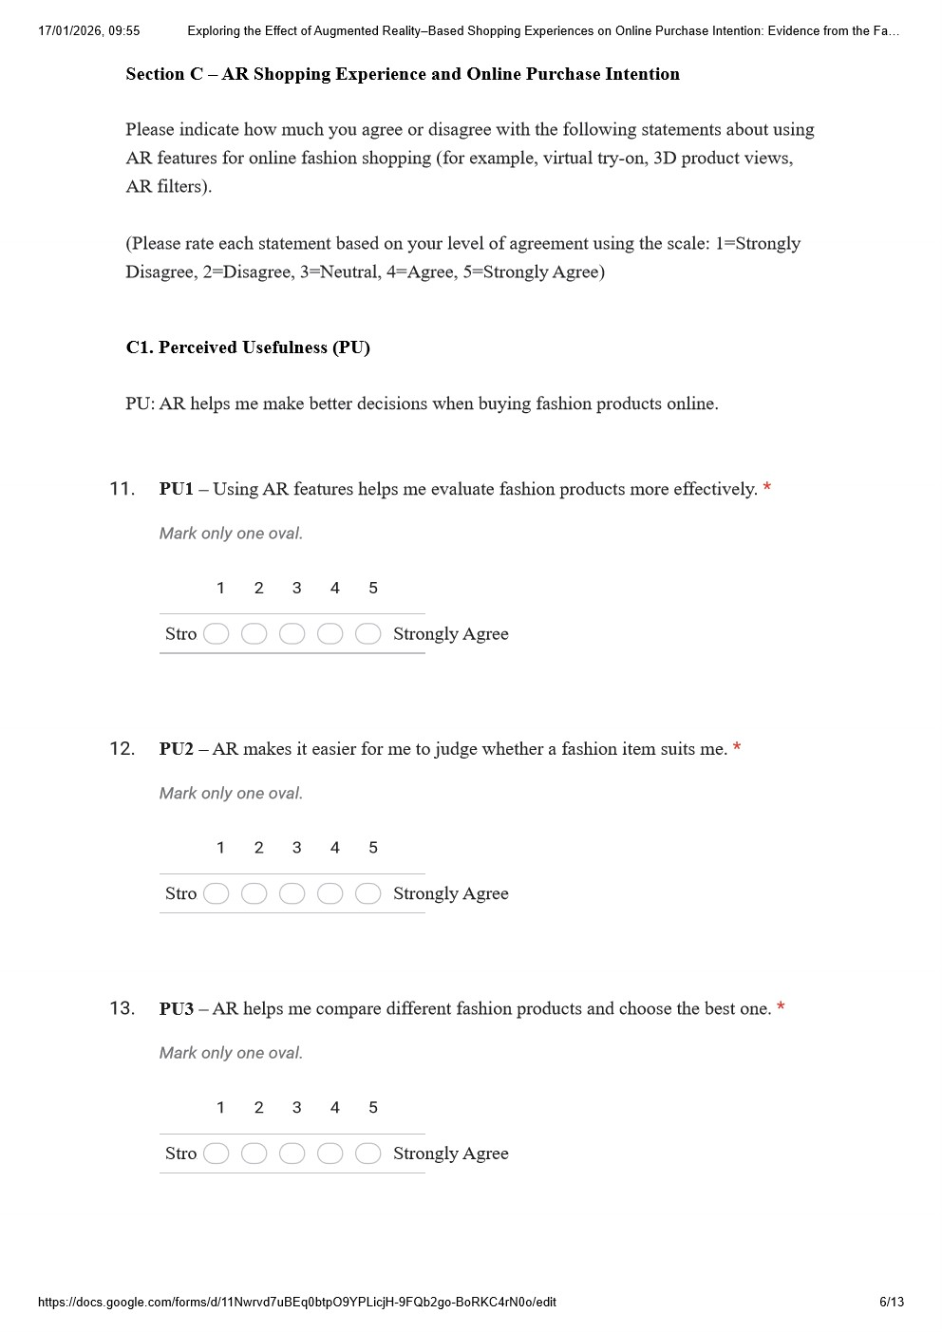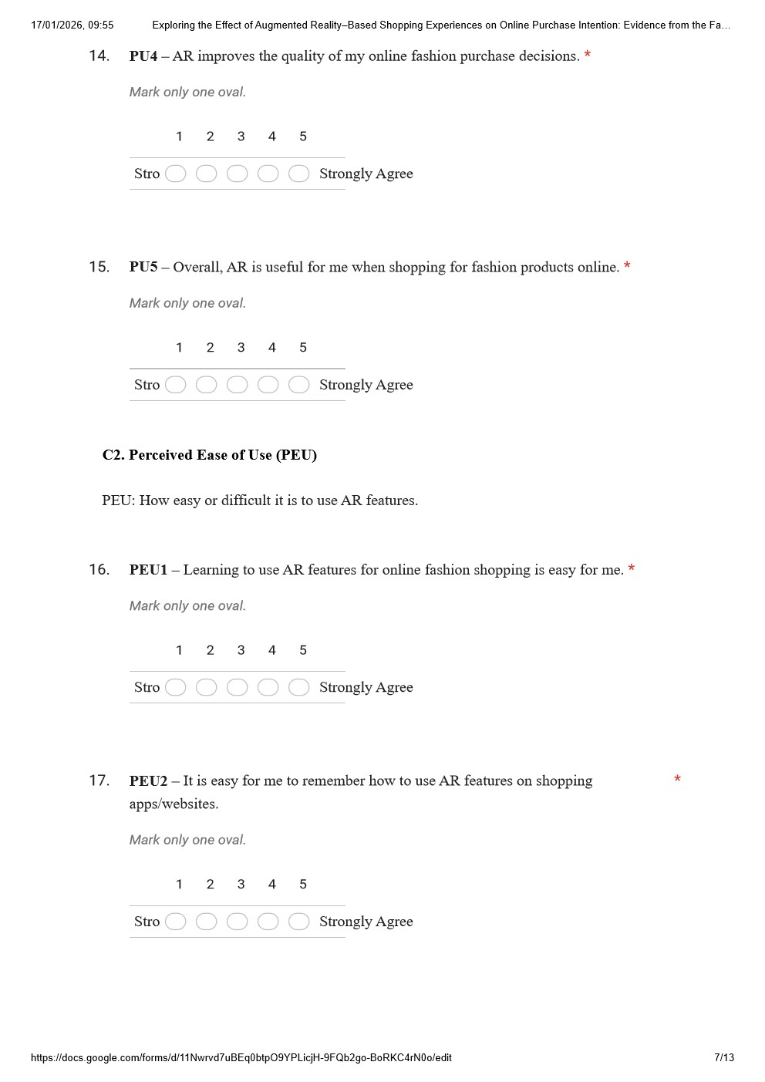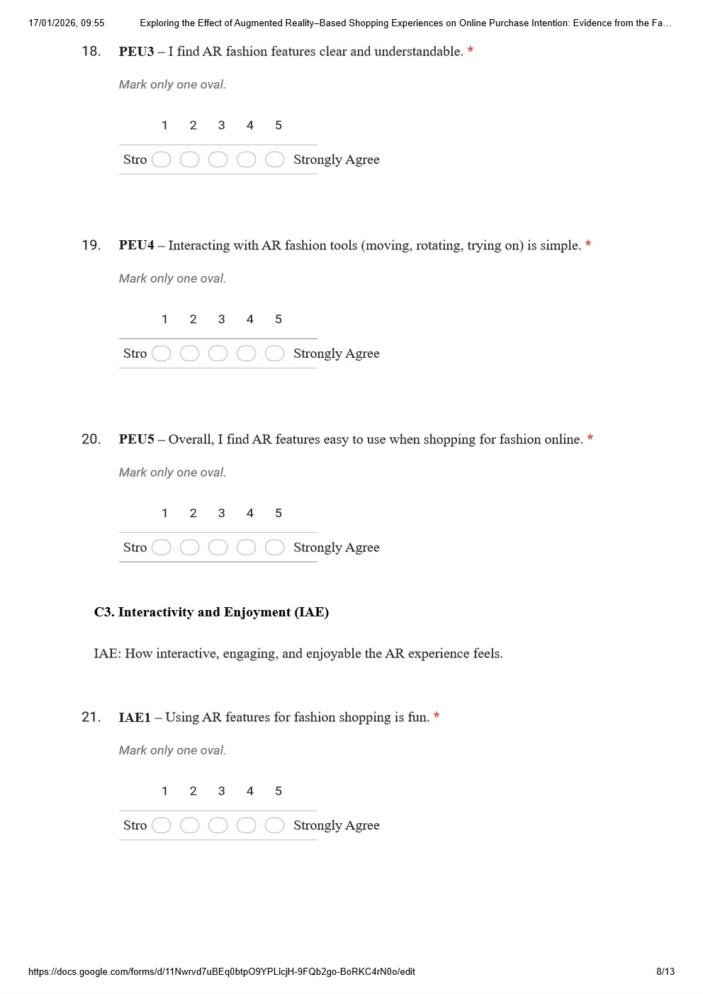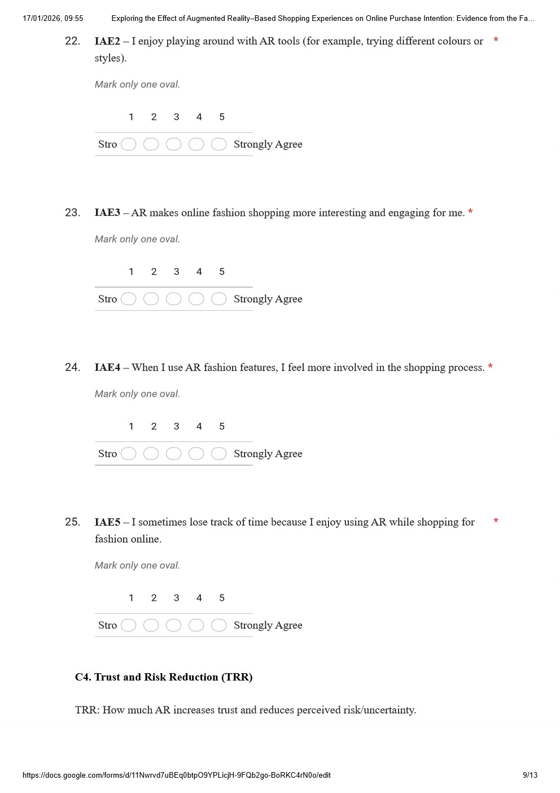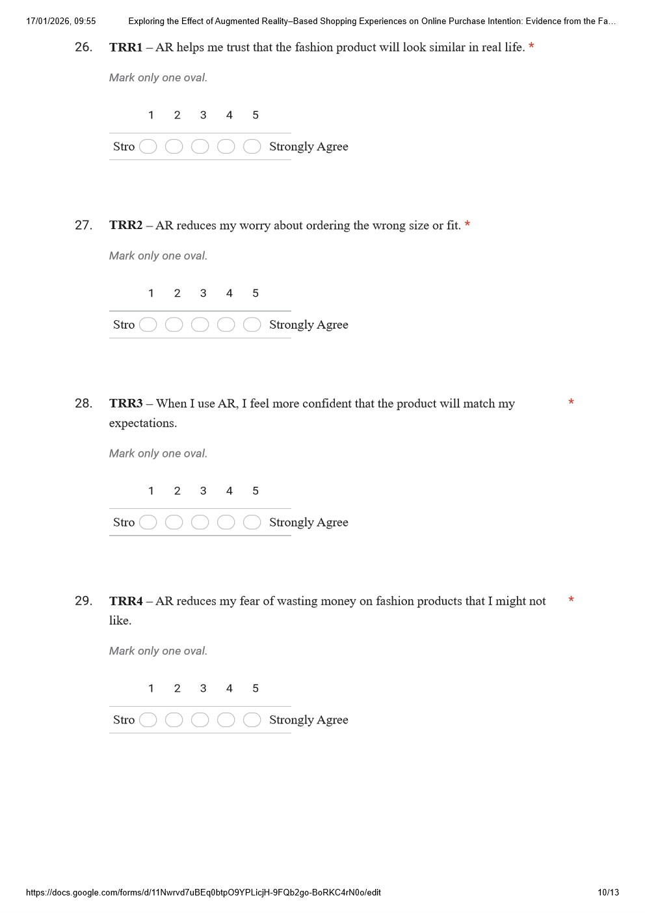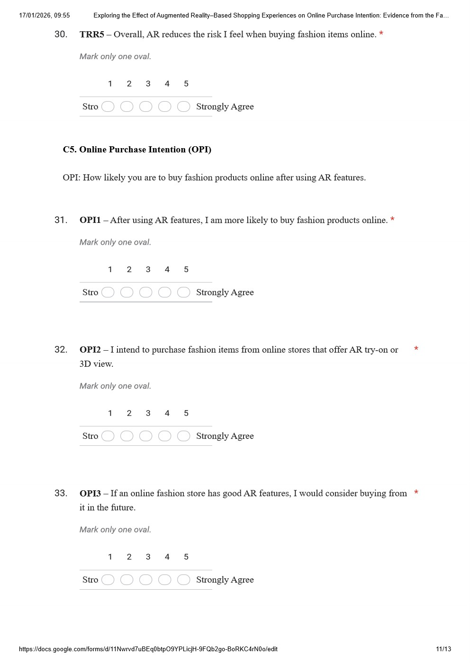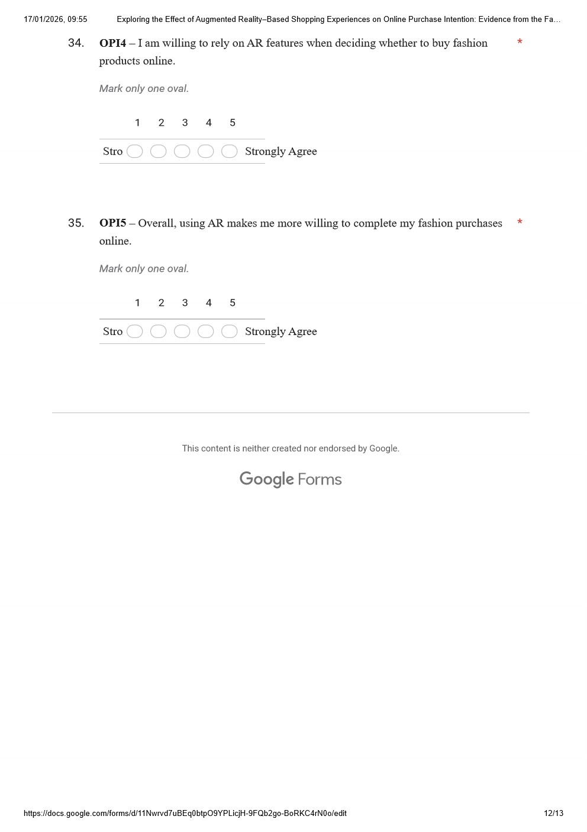

Appendix – B
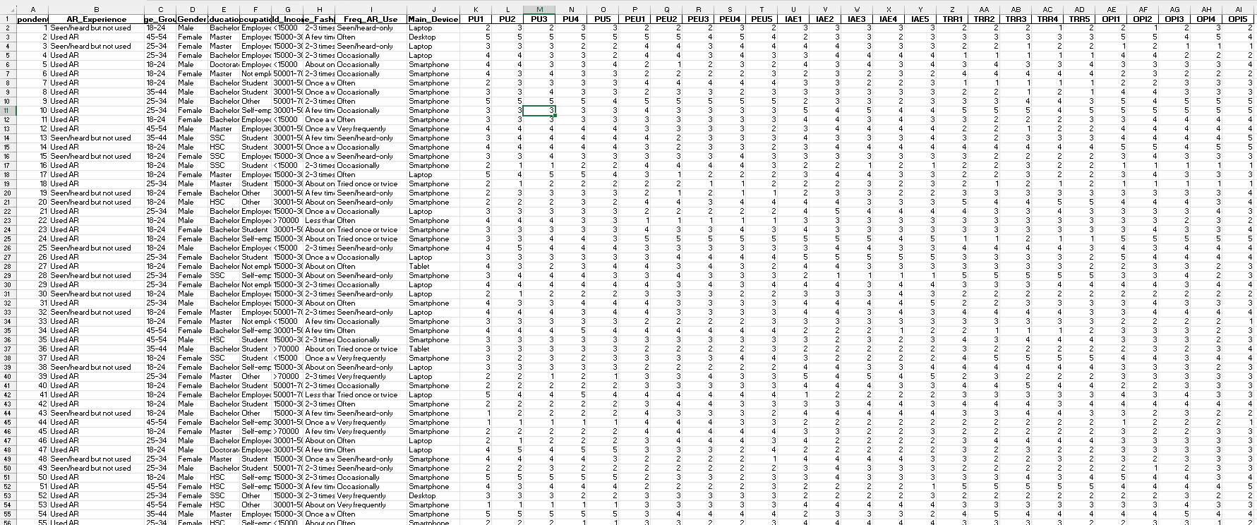
Data File (Excel)

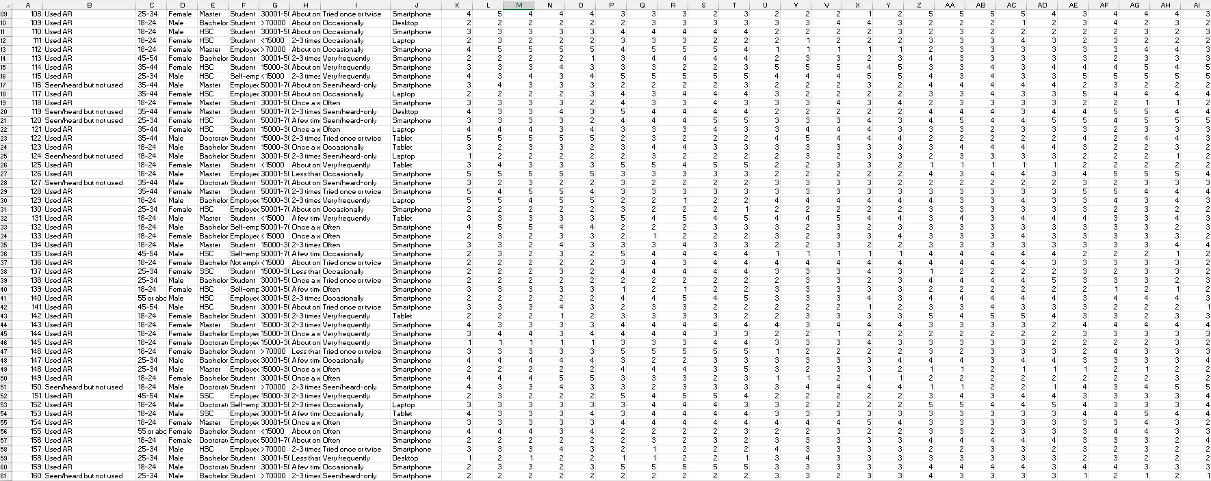

Appendix – C
Data File (SPSS)
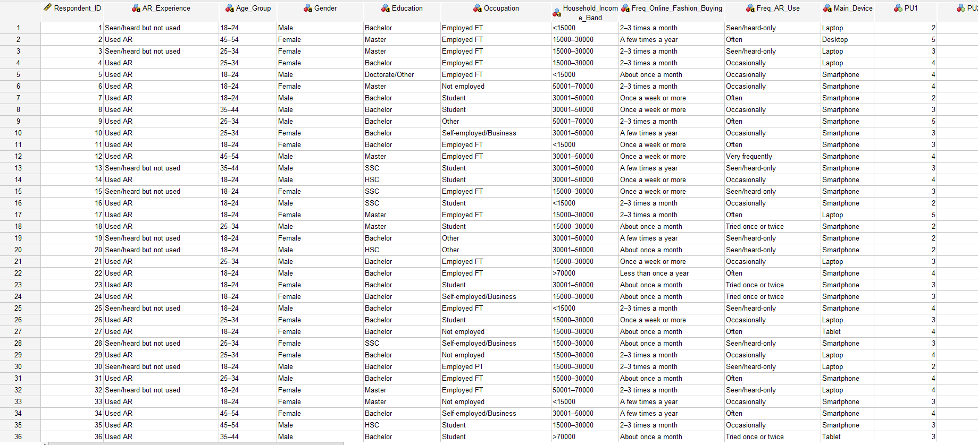
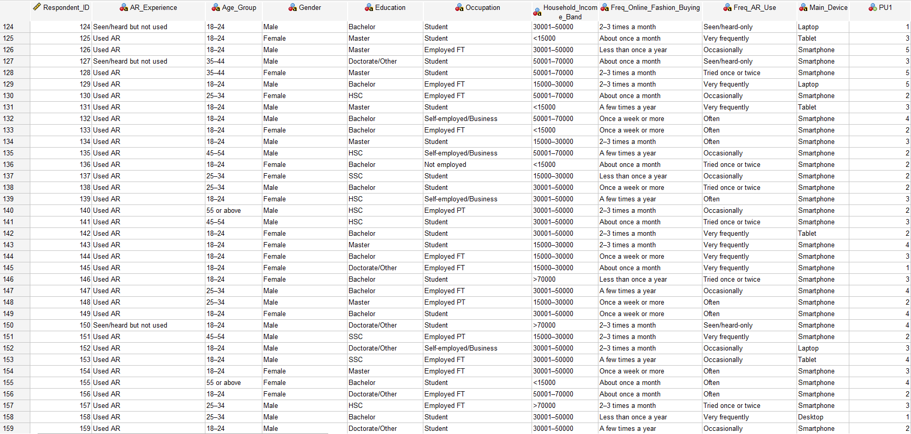

Appendix – D
Data Analys Output (SPSS)

