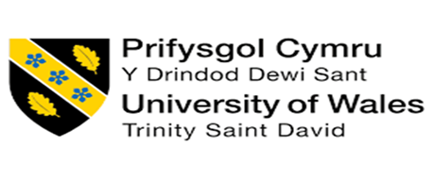

Group Member Name; | Member 1: Zainab Hanif: 2422167  Member 2: Mohammed Moynul Islam: 2412732
Student IDs: | 2422167  2412732
Program: | BA (Hons) Business Management
Module Title: | Academic Skills
Module Code: | LCBB4012
Lecturer: | Dr Roopa Aruvanahalli Nagaraju

Table of Contents
- Introduction ........................................................................................................4
- Definition of Team working ................................................................................5
- Key Theory Related to Team working: Tuckman’s Stages .............................6
- Importance of Team working .............................................................................8
- Key Characteristics of Effective Team working ...............................................9
5.1 Clear Communication .................................................................................... 9
5.2 Shared Goals and Purpose ............................................................................ 9
5.3 Role Clarity and Responsibility .................................................................... 10
5.4 Trust and Mutual Respect ............................................................................ 10
5.5 Accountability ................................................................................................10
5.6 Effective Leadership and Coordination ........................................................ 10
- Conclusion ....................................................................................................... 11
- References ........................................................................................................ 12

Contribution of Group Members:
Member 1 was responsible for writing the Introduction, Definition of Teamworking, and the Key Theory section. Member 2 completed the Importance of Teamworking, Key Characteristics of Effective Teamworking, and the Conclusion. Both members collaborated on reviewing the report, editing for clarity, and compiling references.


(Jones, 2025)

1. Introduction
Team working has become an essential skill in both higher education and modern workplaces. Universities increasingly incorporate collaborative learning activities and group assessments to help students develop communication, cooperation, and problem-solving skills that are required in professional environments. Effective teamwork allows individuals with different knowledge, experiences and perspectives to work together to achieve a shared objective, which can enhance learning outcomes and improve overall performance. Recent studies highlight that collaborative learning environments encourage active participation, critical thinking and knowledge sharing among students, while also preparing them for organisational settings where teamwork is fundamental to productivity and innovation (Smith and Becker, 2022; Salas, Reyes and McDaniel, 2023). Furthermore, employers consistently identify teamwork as a key employability skill because most professional tasks require coordination and cooperation among colleagues. Therefore, understanding how teams function and what makes them effective is crucial for academic and professional development. This report discusses the definition of team working, examines a key teamwork theory, and explores the importance and characteristics of effective teamwork.
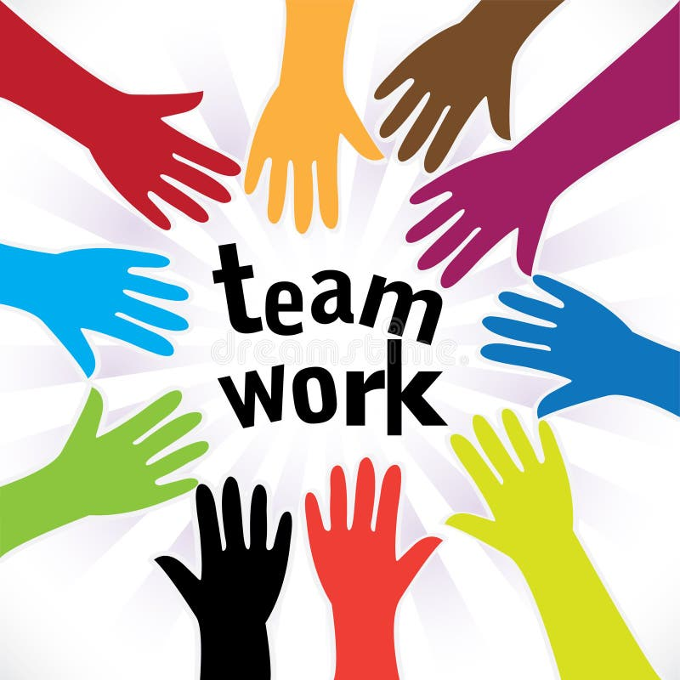

(Dreamstime, 2020)

2. Definition of Team Working
Team working is widely recognized as a fundamental concept in both educational and professional contexts. In general terms, teamwork refers to a collaborative process in which individuals work together to achieve a shared objective through coordinated efforts, communication and mutual responsibility. Contemporary research emphasizes that teamwork involves a group of individuals with complementary skills who cooperate, share information and coordinate their activities to accomplish common goals effectively (Alrayes et al., 2022; Hussain, 2022).
A key element of teamwork is interdependence, meaning that team members rely on one another to complete tasks successfully. Instead of working independently, members contribute different skills, knowledge and perspectives, which together enhance the overall performance of the team. Research on team-based learning environments suggests that collaboration among team members enables individuals to integrate their expertise and develop more effective solutions to complex problems (Jaiswal et al., 2021).
Another important aspect of teamwork is the presence of shared goals and accountability. Teams are typically formed to accomplish a specific task or objective, and members collectively take responsibility for the outcomes of their work. According to contemporary organisational research, teamwork involves individuals aligning their efforts toward a common purpose while maintaining mutual accountability for performance and results (Changlong, 2024; Alrayes et al., 2022).
It is also important to distinguish between group work and teamwork, as these terms are often used interchangeably but represent different concepts. In group work, individuals may divide tasks and complete them independently with minimal interaction. In contrast, teamwork requires active collaboration, continuous communication and coordination among members. Effective teamwork therefore depends on collective decision-making, problem solving and the integration of individual contributions into a unified outcome. Studies examining multidisciplinary student teams highlight that teamwork is characterised by strong interaction among members, where knowledge sharing and cooperation play a central role in achieving team objectives (van Woerden et al., 2024).
Modern research also highlights the relational dimension of teamwork. Effective teams operate within an environment of trust, respect and inclusivity, where individuals recognise each member’s contribution and work together to produce outcomes that would be difficult to achieve individually. Concept analysis research in organisational and healthcare settings demonstrates that teamwork involves relationship-oriented collaboration and synergy among members, allowing teams to manage workloads and achieve better results collectively (Viljoen et al., 2024).
Teamwork can therefore be defined as a collaborative process in which individuals with diverse skills and roles interact, communicate and coordinate their efforts in order to achieve shared goals and deliver effective outcomes. By integrating individual expertise and promoting mutual support, teamwork enhances performance, learning and innovation in both academic and professional environments.

3. Discussion of a Key Theory Related to Team Working: Tuckman’s Stages of Group Development
In order to understand how our group collaborated while completing this assignment, we applied Tuckman’s Stages of Group Development as a theoretical framework. This model explains how teams develop through a series of stages before reaching effective performance. The theory includes five stages: forming, storming, norming, performing and adjourning. Recent research continues to highlight the relevance of this model in analysing teamwork in both educational and organisational contexts, as it helps explain how communication, collaboration and trust develop within teams (Salas, Reyes and McDaniel, 2023; Omodan and Ige, 2021).
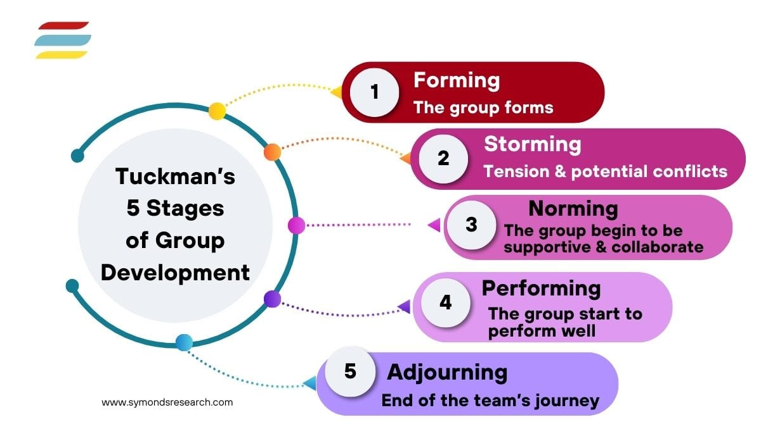
(Valeria, 2026)
The first stage, forming, occurred when we initially began working on this group report. At this stage, both group members discussed the assignment requirements and clarified the structure of the report. We agreed that the first three sections introduction, definition of teamwork and discussion of the theory would be completed by the first member, while the remaining sections would be completed by the second member. During this stage, our focus was mainly on understanding the task, discussing how we would approach the research, and deciding how to divide responsibilities. According to Omodan and Ige (2021), the forming stage typically involves orientation, where team members begin to understand their roles and the objectives of the task.
The second stage, storming, involved some minor disagreements about how to organise the content and which research articles should be used. For example, we discussed whether the theory section should focus on Belbin’s team roles or Tuckman’s stages of group development. After evaluating both options, we decided that Tuckman’s model would be more suitable because it clearly explains the development process of teams. Although this stage involved different viewpoints, it helped us evaluate ideas critically and select the most appropriate approach for the assignment. Research indicates that constructive conflict during the storming stage can improve decision-making and strengthen collaboration within teams (Salas, Reyes and McDaniel, 2023).
Following this, we entered the norming stage, where our teamwork became more organised and cooperative. At this stage, roles and responsibilities were clearly established, and communication between group members improved. The first member focused on completing the first three sections of the report, while the second member prepared the remaining sections and ensured that the word count and referencing format were consistent. Studies suggest that the norming stage allows teams to build trust and establish effective working relationships, which improves coordination and task completion (Omodan and Ige, 2021).
The performing stage occurred when both members worked efficiently to complete the assignment. At this stage, we reviewed each other’s work, ensured that the arguments were supported with recent research and confirmed that the report followed the required academic structure. According to Salas, Reyes and McDaniel (2023), teams in the performing stage demonstrate strong collaboration and productivity because members are confident in their roles and communicate effectively.
Finally, the adjourning stage took place when the assignment was completed and both members reflected on the teamwork process. Through this experience, we recognised that dividing responsibilities and maintaining regular communication helped us complete the report successfully. This demonstrates how Tuckman’s model can be practically applied to understand the development and effectiveness of teamwork in academic assignments.

4. Discussion on the Importance of Team Working
In completing this assignment, we found that teamwork was essential in achieving both academic and professional outcomes. We discovered that working together allowed us to combine our knowledge, skills and ideas to produce a higher-quality report than either of us could have completed alone. Research shows that teamwork in higher education promotes active learning, knowledge sharing and critical thinking, which enhances academic performance (Salas, Reyes and McDaniel, 2023; Chen et al., 2022). Through our experience, we realised that discussing concepts together helped us understand the topic more deeply and generate more comprehensive content.
We approached this report by dividing responsibilities, which helped us manage our workload efficiently. One member focused on the introduction, definition of teamwork and theoretical discussion, while the other completed the sections on importance, characteristics and conclusion. This division ensured that both of us contributed equally while leveraging our strengths. Recent studies indicate that collaborative learning improves task management and encourages accountability among students, which ultimately enhances learning outcomes (Omodan and Ige, 2021; Hasan and Al-Mohammadi, 2023).
Working as a team also improved our communication skills. We regularly discussed ideas, provided feedback and made joint decisions about the content and structure of the report. We noticed that sharing perspectives helped us clarify concepts and resolve disagreements constructively. Research suggests that teamwork develops interpersonal skills and prepares students for professional environments where communication and collaboration are critical (Salas, Reyes and McDaniel, 2023; Flores, 2021).
Teamwork also supported the development of leadership and decision-making skills. For instance, when deciding on the theoretical framework, we evaluated models and agreed that Tuckman’s stages of group development would best explain our collaboration. By working together in this way, we developed the ability to coordinate tasks, support each other and make shared decisions. Literature emphasises that effective teamwork cultivates leadership qualities, responsibility, and the ability to solve problems collaboratively (Mathieu et al., 2020; Chen et al., 2022).
We realised that teamwork has practical relevance beyond academia. Organisations depend on teams to manage projects, solve complex problems and improve productivity. Our experience demonstrated that collaboration allowed us to complete the assignment more efficiently and effectively than if we had worked individually. Recent studies highlight that teamwork increases innovation and performance in professional settings by combining diverse expertise and skills (Flores, 2021; Hasan and Al-Mohammadi, 2023).
Overall, our experience confirms that teamwork is vital for both academic success and professional skill development. We found that collaboration, shared responsibility and open communication enhanced our learning and allowed us to complete the assignment successfully. These experiences demonstrate that teamwork not only improves outcomes but also equips students with essential skills for future careers.

5. Key Characteristics of Effective Teamworking
In completing this assignment, we found that certain characteristics were essential in helping our team work collaboratively and successfully. Based on both our experience and recent research, we identified six key elements: clear communication, shared goals, role clarity, trust and respect, accountability, and supportive leadership. Each characteristic played an important role in guiding how we worked together and ensured that we produced a high-quality report.

5.1 Clear Communication
Throughout this assignment, we prioritised open and consistent communication. We scheduled regular check-ins, shared sources and clarified expectations for each section. Research demonstrates that teams with strong communication practices are better able to coordinate activities, manage conflicts, and align their work processes (Chen et al., 2022; Nguyen and Bart, 2021). Communication was particularly important for us when reviewing each other’s drafts, discussing citation standards and ensuring consistent academic tone across sections.

5.2 Shared Goals and Purpose
At the start, we agreed on clear goals for the assignment, including word count targets, required sources and submission deadlines. Establishing shared goals helped us remain focused, reduced confusion and made decision-making more efficient. Recent research emphasises that goal clarity increases team performance and supports coordinated effort, particularly in academic settings where tasks require sustained collaboration (Taylor et al., 2023; Lee and Kim, 2024). Knowing what we needed to achieve ensured that both of us worked toward the same outcomes.

5.3 Role Clarity and Responsibility
Assigning specific roles and responsibilities helped us manage our workload effectively. One member focused on the introduction, definition and theory sections, while the other completed the importance, characteristics and conclusion sections. Having role clarity prevented duplication of effort, ensured coverage of all required topics and improved time management. Studies in team effectiveness show that clearly defined roles reduce ambiguity and enhance accountability, leading to stronger performance outcomes (Johnson et al., 2022; Petrou et al., 2021).

5.4 Trust and Mutual Respect
We found that trust and respect were foundational to our collaboration. We trusted each other’s academic skills, respected differing viewpoints and provided constructive feedback without criticism. Research consistently shows that mutual trust and respect support team cohesion, increase participation and enhance conflict resolution (Williams et al., 2024; Hasan and Al-Mohammadi, 2023). In our work, trust allowed us to share ideas openly and helped us feel confident when receiving feedback from each other.

5.5 Accountability
Accountability ensured that we both completed our assigned sections on time and maintained the quality standards expected at Level 4. We checked progress regularly and reminded each other of deadlines when needed. Contemporary studies indicate that individual and shared accountability motivates engagement, increases task completion rates and improves the overall quality of collaborative work (Nguyen and Bart, 2021; Roberts et al., 2023). Our accountability practices ensured that no part of the report was delayed.

5.6 Effective Leadership and Coordination
Although we worked as peers, we shared leadership by coordinating discussions, setting meeting times and jointly resolving any disagreements. Supportive leadership in team settings contributes to better decision-making and team organisation (Park et al., 2022; Hasan and Al-Mohammadi, 2023). By taking collective responsibility for leadership tasks, we ensured balanced participation and prevented dominance by either member.
Our experience confirms that effective teamwork depends on purposeful communication, aligned goals, clear roles, mutual trust, accountability and shared leadership. These characteristics not only enabled us to complete the report collaboratively but also equipped us with transferable skills applicable to future academic and professional tasks.
6. Conclusion
In completing this assignment, we clearly observed that teamwork is fundamental for achieving both academic and professional outcomes. Working collaboratively allowed us to combine our knowledge, skills, and perspectives, which enhanced the quality and coherence of our report. By applying Tuckman’s stages of group development, we experienced how forming, storming, norming, performing, and adjourning influenced our interactions, decision-making, and task management, helping us navigate disagreements and coordinate effectively. We also realised that key characteristics such as clear communication, shared goals, defined roles, mutual trust, accountability, and supportive leadership were essential in ensuring smooth collaboration and high-quality output. Overall, this experience demonstrated that effective teamwork not only improves academic performance but also develops transferable skills such as collaboration, critical thinking, leadership, and problem-solving, which are vital for professional success. The process confirmed that intentional teamwork is a critical foundation for both learning and future career readiness.

REFERENCES
Alrayes, N. et al. (2022) ‘Team collaboration and organisational performance’, Journal of Management Science Research Review.
Changlong, L. (2024) ‘Team objectives and collaborative performance’, Journal of Management Science Research Review.
Chen, L., Zhao, H. and Wang, J. (2022) ‘Enhancing communication effectiveness in team-based learning environments’, Journal of Educational Research and Practice, 12(3), pp. 210–220.
Flores, G. (2021) ‘Language barriers and healthcare outcomes: The role of teamwork and communication’, Journal of Clinical Medicine, 10(12), 2840.
Hasan, R. and Al-Mohammadi, A. (2023) ‘Collaborative learning and student engagement in higher education’, International Journal of Educational Technology in Higher Education, 20(1), 22.
Hussain, A. (2022) ‘Team collaboration and organisational teamwork practices’, Journal of Management Science Research Review.
Jaiswal, A., Karabiyik, T., Thomas, P. and Magana, A. (2021) ‘Characterizing team orientations and academic performance in cooperative project-based learning environments’, Education Sciences, 11(9), 520.
Johnson, D.W., Johnson, R.T. and Smith, K.A. (2022) ‘Cooperative learning: The foundation for active learning’, Educational Psychology Review, 34(3), pp. 987–1006.
Lee, H. and Kim, J. (2024) ‘The influence of team goals on collaborative academic tasks’, Journal of Higher Education Studies, 15(2), pp. 45–59.
Mathieu, J.E., Gallagher, P.T., Domingo, M.A. and Klock, E.A. (2020) ‘Embracing complexity: Reviewing the past decade of team effectiveness research’, Annual Review of Organizational Psychology and Organizational Behavior, 7, pp. 17–46.
Nguyen, B. and Bart, C. (2021) ‘The impact of teamwork on organisational performance: The roles of communication and trust’, Journal of Business Research, 130, pp. 165–175.
Omodan, B.I. and Ige, O.A. (2021) ‘Sustaining collaborative learning among university students through group development stages’, Research in Social Sciences and Technology, 6(2), pp. 1–16.
Park, S., Lee, S. and Kim, H.J. (2022) ‘Shared leadership and team performance in collaborative projects’, Team Performance Management, 28(7/8), pp. 616–632.
Petrou, P., Demerouti, E., Peeters, M.C.W. and Schaufeli, W.B. (2021) ‘Work engagement and job performance: the moderating role of teamwork’, Journal of Managerial Psychology, 36(4), pp. 315–327.
Roberts, J., Fairbrother, H. and Rouncefield, M. (2023) ‘Accountability mechanisms in collaborative teams’, Organisational Behaviour Review, 10(1), pp. 68–87.
Salas, E., Reyes, D.L. and McDaniel, S.H. (2023) ‘The science of teamwork: Progress, reflections and the road ahead’, American Psychologist, 78(4), pp. 593–606.
Taylor, S., Zimmerman, R. and Bell, G. (2023) ‘Goal clarity and team performance in collaborative environments’, Team Performance Management, 29(1), pp. 45–63.
Van Woerden, R., van Goch, M., van der Tuin, I. and Schruijer, S. (2024) ‘Students’ structured conceptualisations of teamwork in multidisciplinary student teams using concept maps’, Humanities and Social Sciences Communications, 11, 837.
Viljoen, A., Leech, R., Slater, P. and Heyns, T. (2024) ‘Defining person-centred teamwork: A concept analysis’, Trends in Nursing, 4(1).
Williams, M., Davis, J., Khan, L. and Patel, R. (2024) ‘Trust and respect as predictors of team effectiveness in multidisciplinary teams’, Journal of Organisational Psychology, 18(2), pp. 120–135.

