Changemakers: Creativity and Value Creation – ACCA5033
Assignment 2: Project Management.
Applied Cyber Security
25/07/2023 (Diff Dead)
Joshua James Harries (2021807)

Table of Contents
DIFFERENTIATED DEADLINE 2
e-Portfolio Link 3
Task 1 3
Task 2 4
Task 3 4
Appendix 1 – Confirmation Screens 5
Unit 3 Topic 1 5
Unit 3 Topic 2 5
Unit 3 Topic 3 6
Unit 3 Topic 4 6
Unit 4 Topic 1 7
Unit 4 Topic 2 7
Unit 4 Topic 3 8
Unit 4 Topic 4 8

DIFFERENTIATED DEADLINE

In accordance with paragraphs 10.11.1 and 10.14.1. of the Mitigating Circumstances Policy, a differentiated deadline has been agreed for the particular assessment components noted below:
Student: Joshua Harries - 2021807
Module Code | Module Name | Component | Original (undifferentiated) deadline | Differentiated deadline
ACCB5033 | Changemakers | Assignment 2: Project Management. | 18th July 2023 | 25th July 2023

The differentiated deadline has been applied as part of the compensatory measures as set out in the Statement of Compensatory Measures approved for this student.

e-Portfolio Link
Main Link: https://2021807.wixsite.com/changemakers
https://2021807.wixsite.com/changemakers/assignment-two
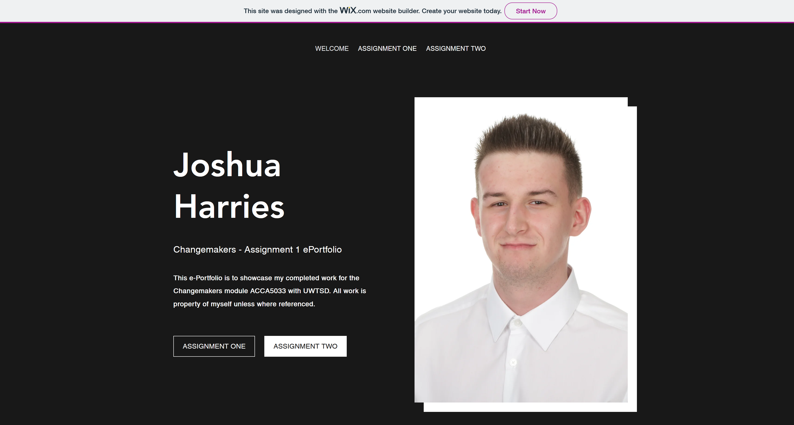

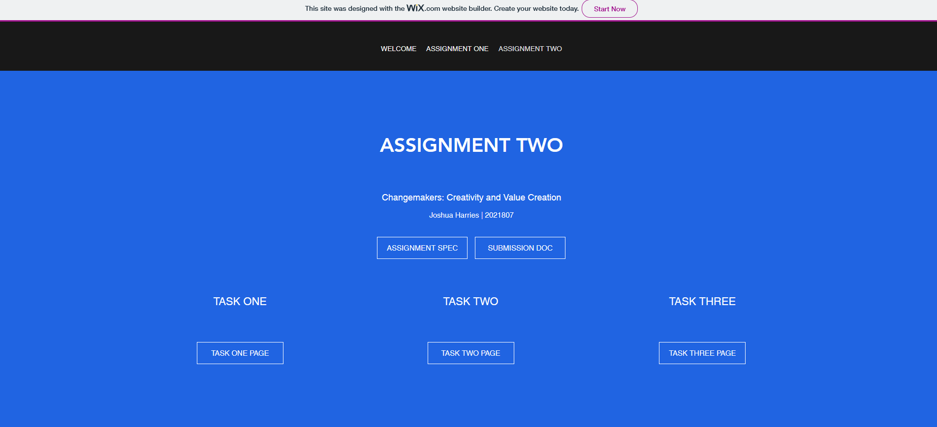
Task 1
e-Portfolio Link: https://2021807.wixsite.com/changemakers/a2-task-1


Task 2
e-Portfolio Link: https://2021807.wixsite.com/changemakers/a2-task-2

Task 3
e-Portfolio Link: https://2021807.wixsite.com/changemakers/a2-task-3
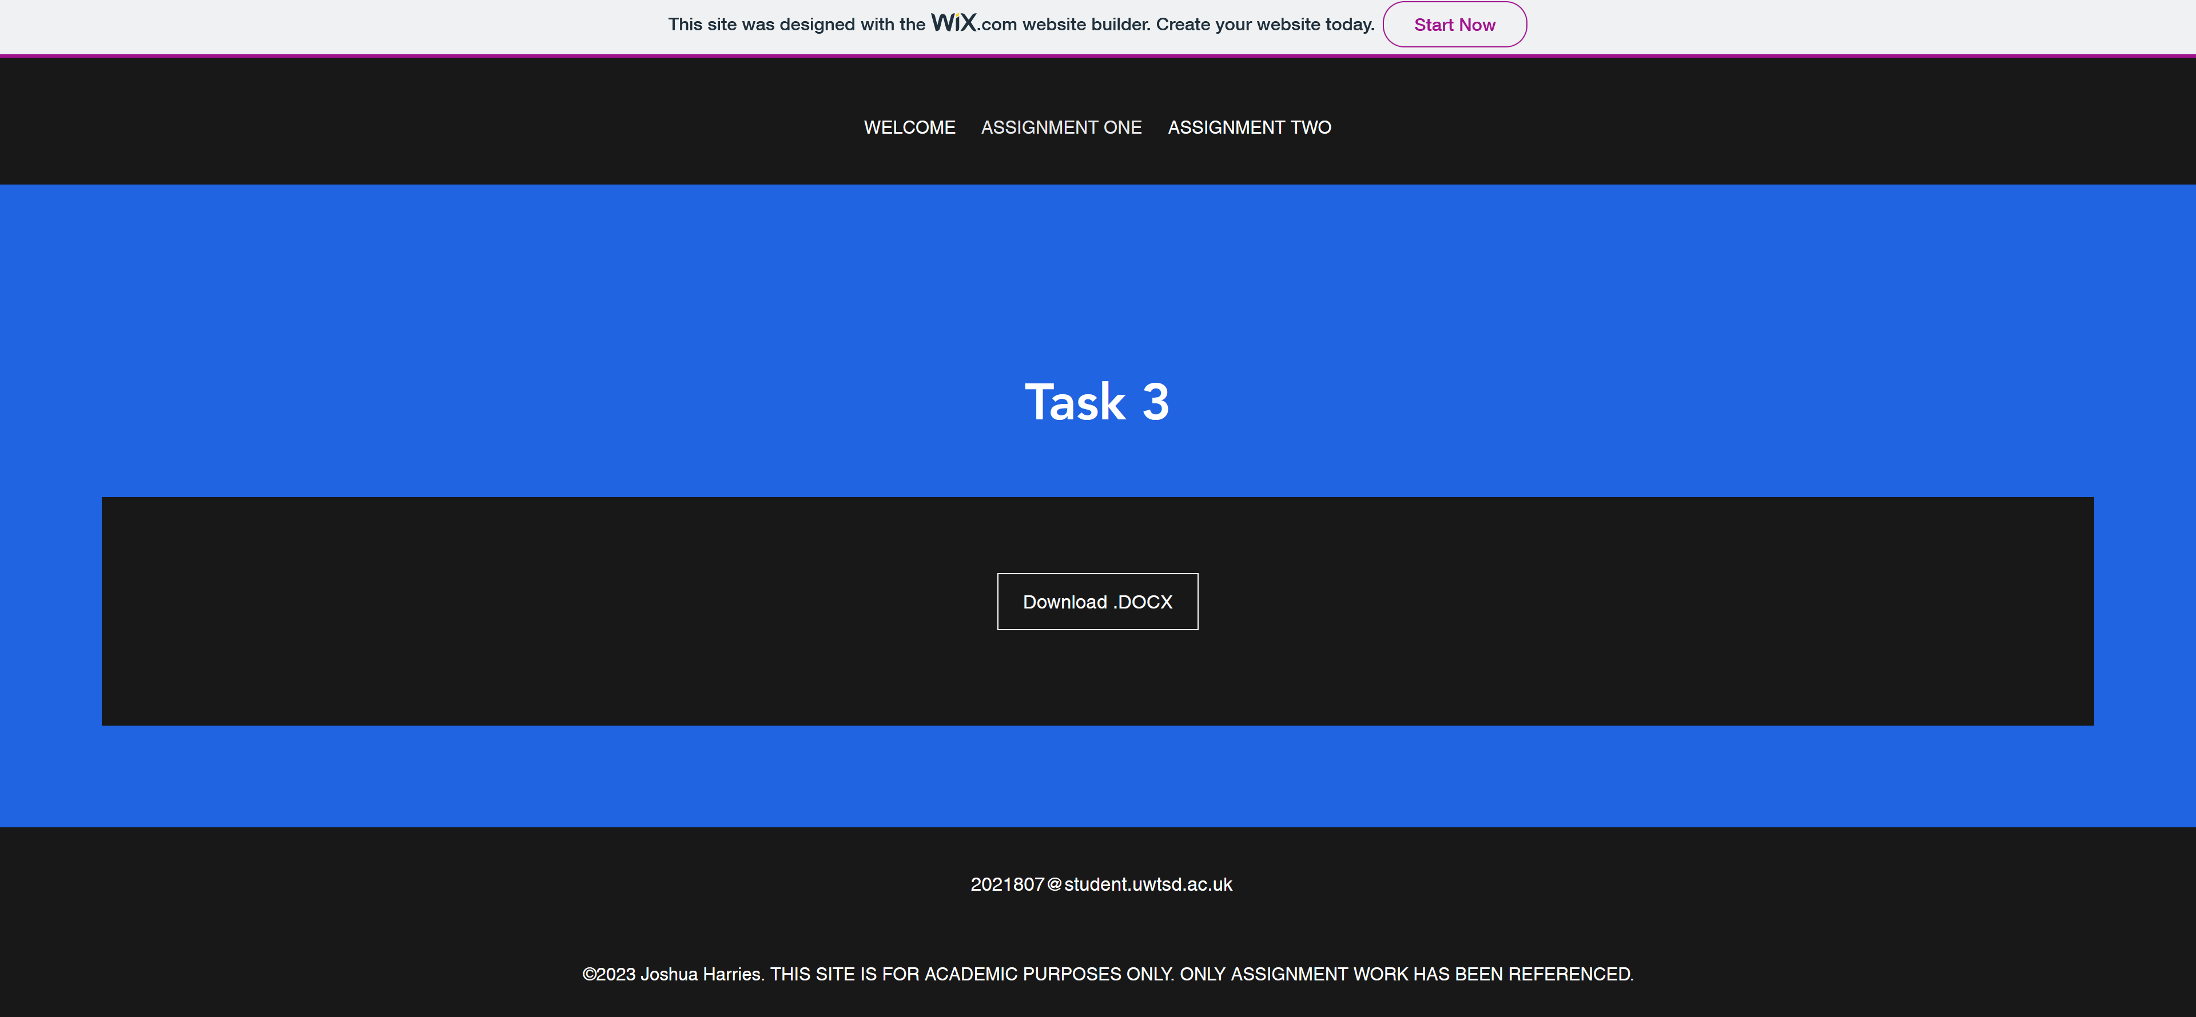

Appendix 1 – Confirmation Screens

Unit 3 Topic 1
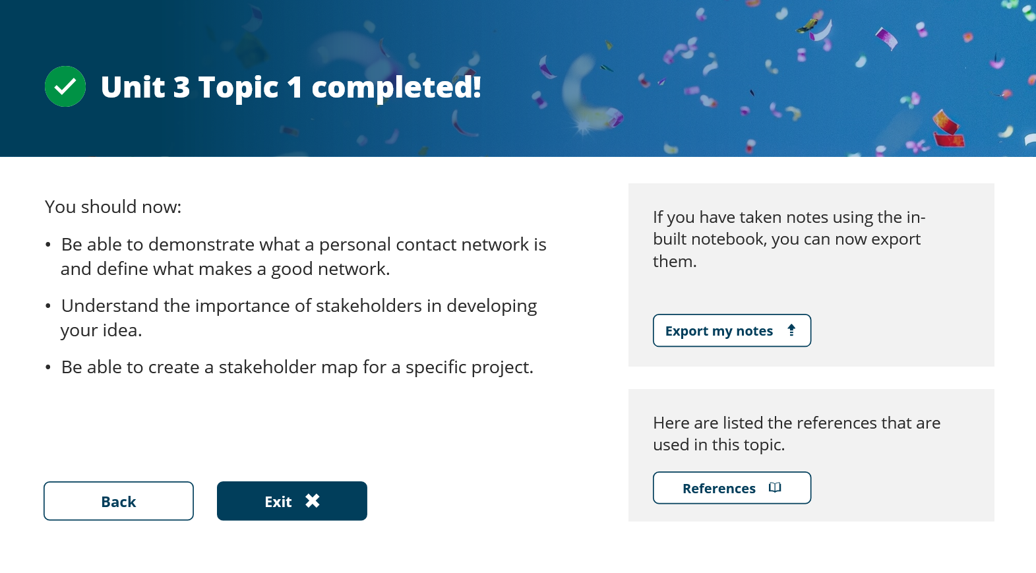

Unit 3 Topic 2
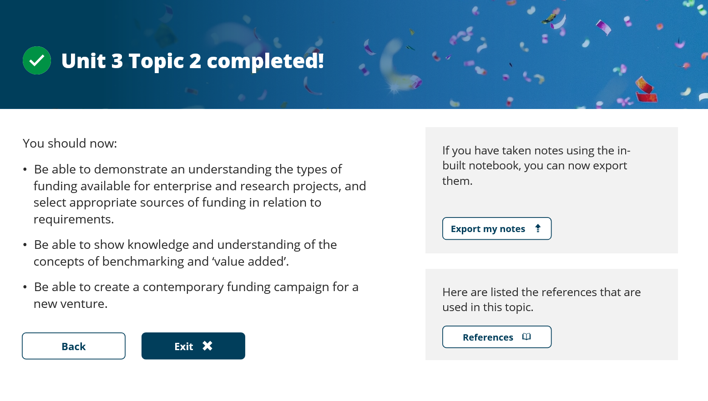

Unit 3 Topic 3
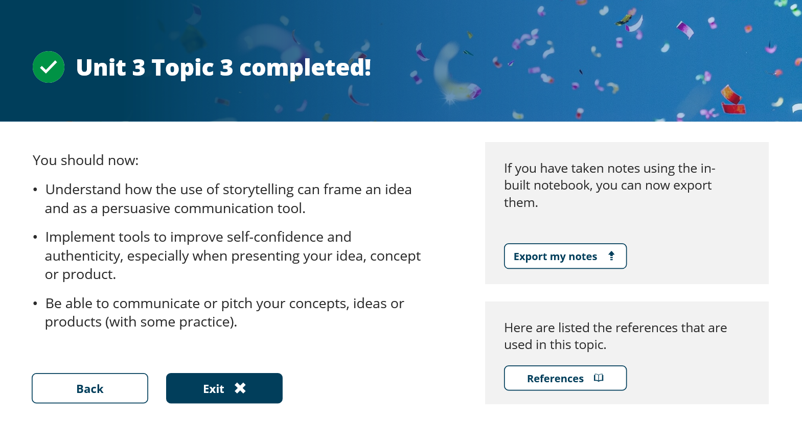

Unit 3 Topic 4
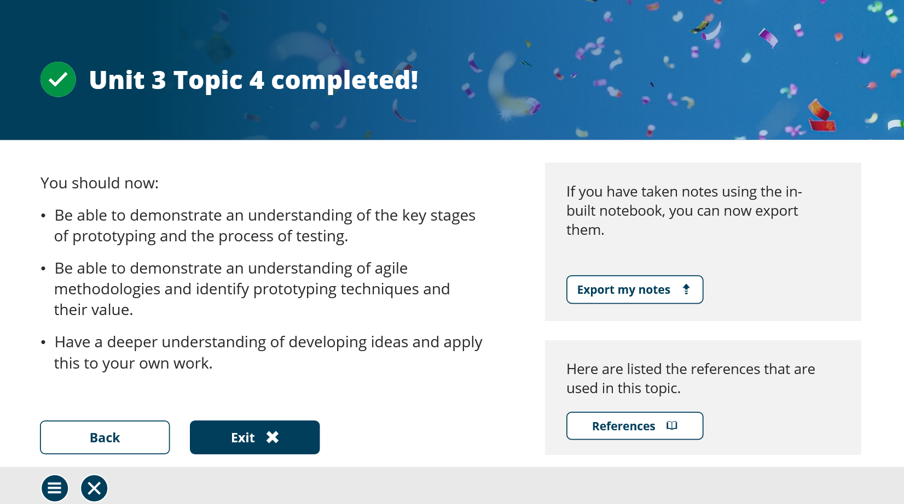

Unit 4 Topic 1
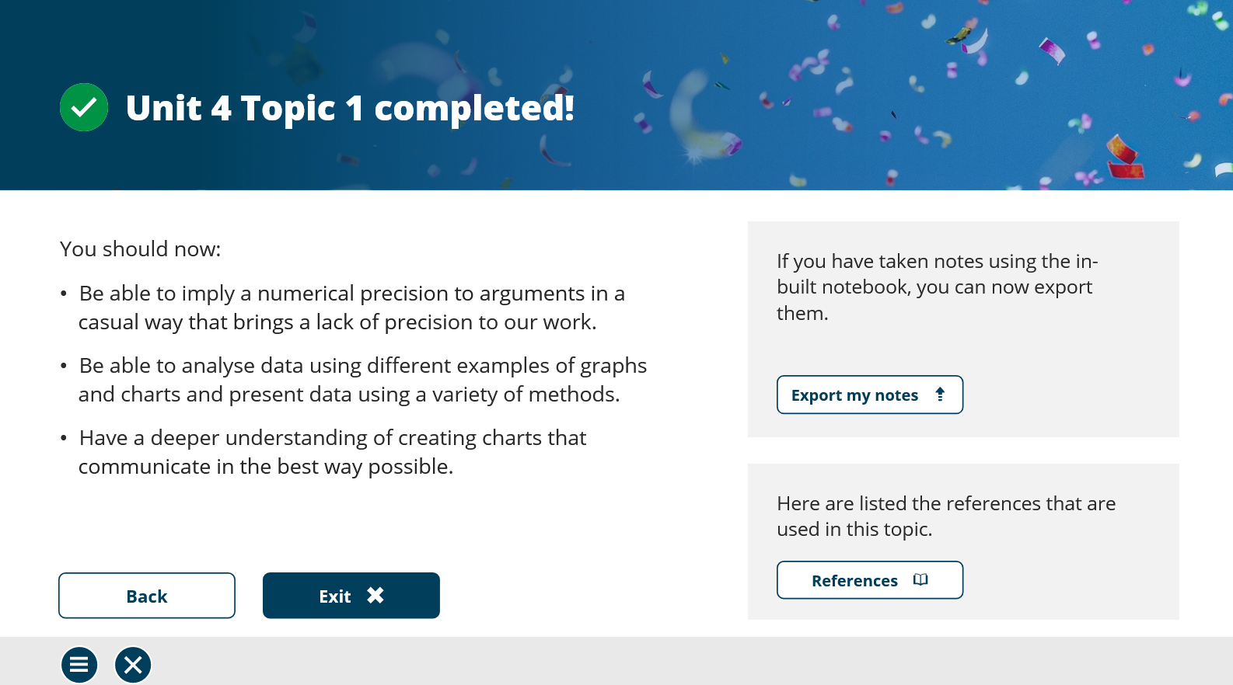

Unit 4 Topic 2
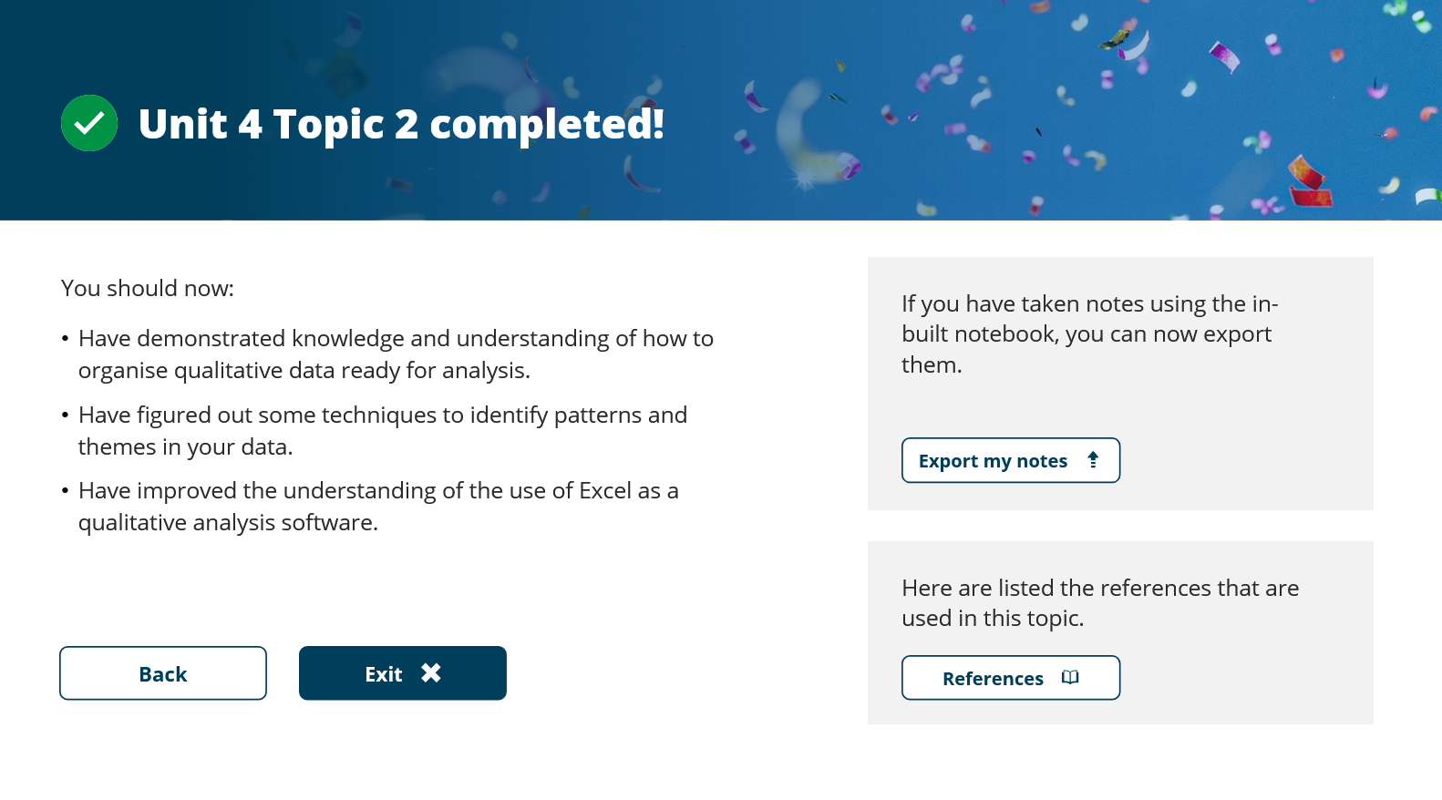

Unit 4 Topic 3
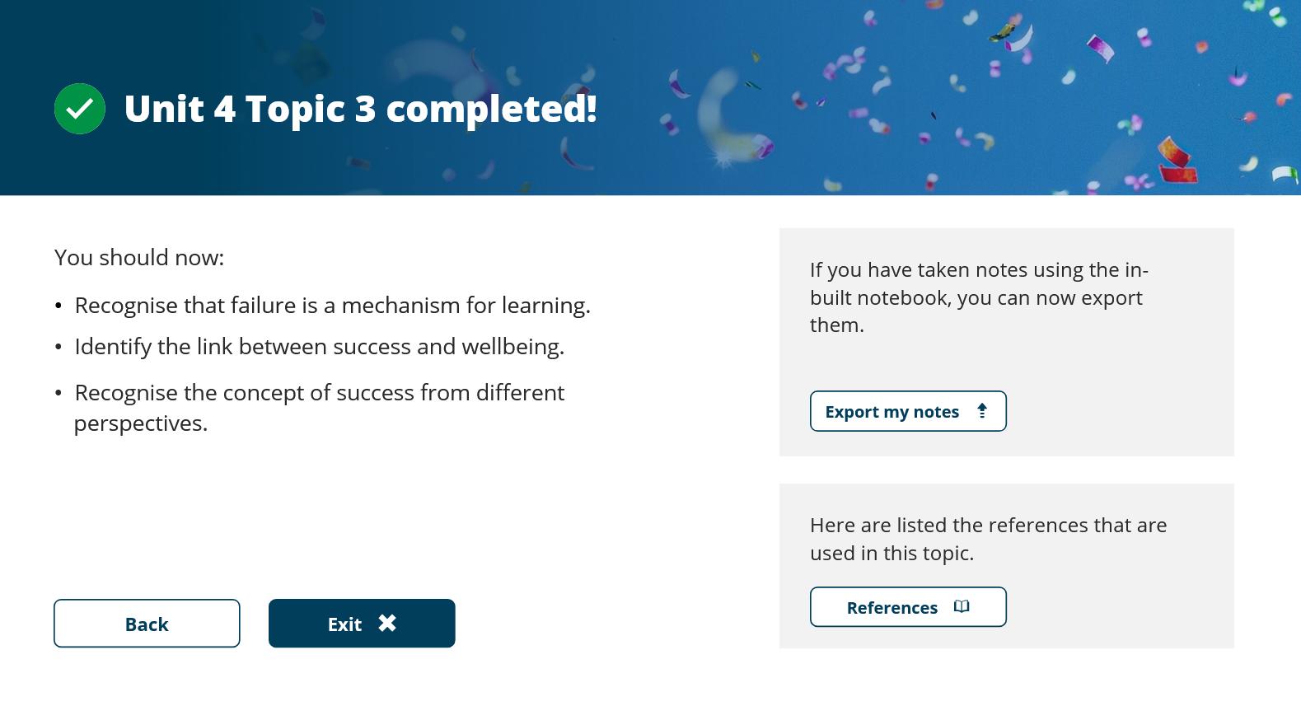

Unit 4 Topic 4


