Generative AI-Based Real-Time Scene Description and Navigation Assistance for Visually Impaired Individuals

1. Abstract
Visually impaired individuals often face difficulties when navigating unfamiliar environments. Traditional assistive tools such as white canes and guide dogs help users avoid obstacles, but they cannot provide detailed information about the surrounding environment [1]. Recent developments in Computer Vision and Generative Artificial Intelligence (AI) have created new opportunities to improve navigation assistance for visually impaired people [4], [7].
This research proposes a safe real-time navigation assistance system that combines fast object detection with Generative AI-based scene description. The proposed system uses a wearable camera and a local YOLOv8 model to continuously detect nearby obstacles and provide immediate safety warnings [2], [3]. A cloud-based Generative AI model is used to generate detailed descriptions of the surrounding environment when requested by the user through a voice command or button press [6], [14].
To improve reliability, this research introduces a Double-Check Safety Guardrail that compares the AI-generated description with the objects detected by YOLOv8. Generative AI systems can sometimes produce inaccurate or hallucinated information, which may create safety risks in navigation applications [9], [13]. If the generated description fails to mention a critical obstacle, the system blocks the response and provides a safety warning instead.
The proposed system will be evaluated based on detection accuracy, response time, safety performance, and user experience. The expected outcome is a reliable, affordable, and user-friendly navigation tool that improves independence, confidence, and mobility for visually impaired individuals.

2. Introduction

2.1 Background
Visual impairment affects millions of people worldwide and can significantly reduce an individual's ability to move independently and safely. According to the World Health Organization (WHO), more than 2.2 billion people globally live with some form of vision impairment or blindness [1]. For many of these individuals, everyday activities such as crossing roads, finding building entrances, locating seats, and avoiding obstacles can be challenging and sometimes dangerous.
Traditional mobility aids such as white canes and guide dogs have been widely used to support visually impaired individuals. White canes help users detect obstacles on the ground, while guide dogs assist with navigation and obstacle avoidance. However, these solutions have several limitations. White canes can only detect objects within a short distance and cannot provide information about the surrounding environment. Similarly, guide dogs cannot explain what is happening around the user or describe nearby objects and locations [7].
Recent developments in Artificial Intelligence (AI), Computer Vision, and wearable technologies have created new opportunities for improving navigation assistance systems. Modern computer vision models can identify and locate objects in real time, while Generative AI models can provide detailed descriptions of complex scenes using natural language [4], [6]. These technologies have the potential to provide visually impaired users with a better understanding of their surroundings and support safer navigation.

2.2 Research Problem
Although AI-based navigation systems have improved significantly in recent years, several challenges remain. Object detection systems such as YOLO can accurately identify nearby objects and obstacles at high speed [2], [3]. However, these systems usually provide only simple object labels and cannot explain the relationships between objects within a scene.
On the other hand, Generative AI models can produce detailed scene descriptions and provide contextual information. Despite their impressive capabilities, these models can sometimes generate incorrect or misleading information, a phenomenon known as AI hallucination [9]. In navigation applications, inaccurate descriptions may create safety risks for visually impaired users. Furthermore, most Generative AI models require cloud-based processing, which can introduce delays that are unsuitable for real-time navigation [6].
Another important challenge is audio overload. Many assistive systems continuously provide spoken feedback to users. Excessive audio information can interfere with environmental sounds such as traffic noise, footsteps, and conversations, which visually impaired individuals often rely on for navigation and situational awareness [8], [16].

2.3 Motivation for the Research
The increasing availability of powerful mobile devices, wearable cameras, and Generative AI technologies creates an opportunity to develop more intelligent and user-friendly navigation systems. However, safety and reliability remain major concerns when using Generative AI in real-world applications [13].
This research is motivated by the need to develop a navigation assistance system that combines the speed and reliability of object detection with the rich contextual understanding of Generative AI. The proposed system aims to provide meaningful scene descriptions while ensuring that safety-critical information is never missed.
In addition, reducing cognitive load is an important consideration. Instead of continuously speaking to the user, the proposed system allows users to request detailed descriptions only when needed. This approach helps users remain aware of their surroundings while still receiving useful information when required.

2.4 Research Gap
Existing research has investigated object detection systems for navigation assistance [2], [3] and Generative AI-based scene understanding systems separately [6], [14]. However, there is limited research on integrating these technologies into a single framework that prioritizes user safety.
Most current systems do not include a mechanism to verify whether AI-generated descriptions accurately reflect the actual environment. As a result, users may receive incomplete or incorrect information. Furthermore, many existing solutions provide continuous audio feedback, which may increase mental workload and reduce usability [8].
Therefore, a research gap exists in developing a navigation assistance framework that combines real-time object detection, user-triggered Generative AI descriptions, and an automated safety verification mechanism.

2.5 Proposed Solution
To address these challenges, this research proposes a safe Generative AI-based navigation assistance system for visually impaired individuals. The system combines a local YOLOv8 object detection model with a cloud-based Generative AI model. The YOLOv8 model continuously monitors the environment and provides immediate warnings about nearby hazards, while the Generative AI model generates detailed scene descriptions when requested by the user.
A key contribution of this research is the development of a Double-Check Safety Guardrail. This mechanism compares the objects detected by YOLOv8 with the generated scene description before it is delivered to the user. If a critical obstacle is detected but not mentioned in the AI description, the system blocks the response and issues a safety warning instead.
By combining fast local processing, detailed scene understanding, and safety verification, the proposed framework aims to improve navigation safety, reduce cognitive load, and increase the independence of visually impaired individuals.

3. Research Aim and Objectives

3.1 Research Aim
The main aim of this research is to develop and evaluate a safe real-time navigation assistance system for visually impaired people using Computer Vision and Generative AI.
The specific aims of this research are:
- To develop a YOLOv8 object detection system that can identify obstacles and hazards in real time.
- To integrate a Generative AI model that can provide clear and simple scene descriptions for users.
- To create a user-triggered system using a voice command or button so users can request descriptions only when needed.
- To develop a Double-Check Safety Guardrail that compares detected objects with AI-generated descriptions to reduce incorrect or hallucinated information.
- To test and evaluate the system based on accuracy, response time, safety, cognitive workload, and user satisfaction.
- To examine whether the proposed system can provide safer and more reliable navigation support for visually impaired individuals compared to traditional assistive methods.

3.2 Research Objectives
To achieve the research aim, the following objectives will be completed:
- To review and analyse existing research on AI-based navigation assistance systems for visually impaired individuals.
- To develop a real-time object detection module using YOLOv8 for identifying obstacles and hazards in the user's environment.
- To integrate a Generative AI model capable of producing simple and understandable scene descriptions.
- To design and implement a user-trigger mechanism using a voice command or button press to activate scene descriptions only when required.
- To develop a Double-Check Safety Guardrail that verifies AI-generated descriptions against detected obstacles before providing feedback to the user.
- To evaluate the proposed system in terms of detection accuracy, response time, navigation safety, cognitive workload, and user satisfaction.
- To determine whether the proposed framework can improve navigation assistance while reducing the risks associated with AI hallucinations.

4. Importance of Research

4.1 Academic Importance
This research contributes to the growing field of Artificial Intelligence (AI) for accessibility and assistive technologies. Recent studies have shown that object detection models and Generative AI can improve environmental understanding for visually impaired individuals [2], [6]. However, concerns about AI reliability and hallucinations remain significant challenges in safety-critical applications [9], [13].
The proposed research introduces a Double-Check Safety Guardrail that combines a deterministic object detection model with a Generative AI model. This approach contributes to current research on trustworthy and explainable AI by exploring methods to verify AI-generated outputs before they are delivered to users. The findings may provide useful knowledge for future research on safe human-AI interaction and real-time assistive systems.

4.2 Practical and Social Importance
From a practical perspective, this research aims to improve the independence, confidence, and mobility of visually impaired individuals. Existing assistive tools such as white canes and guide dogs provide important support, but they cannot offer detailed information about the surrounding environment [1], [7].
The proposed system can provide both immediate safety warnings and detailed scene descriptions using affordable and widely available technologies such as smartphones, wearable cameras, and cloud-based AI services. The user-triggered design also reduces unnecessary audio feedback, helping users remain aware of important environmental sounds [8], [16].
If successful, the proposed framework could support safer navigation, improve daily accessibility, and contribute to the development of more reliable AI-based assistive technologies for visually impaired communities.

5. Literature Review

5.1 Traditional Assistive Technologies for Visually Impaired Individuals
Assistive technologies have been developed for many years to help visually impaired individuals navigate safely and independently. The most common traditional mobility aids are white canes and guide dogs. White canes help users detect nearby obstacles and changes in ground level, while guide dogs assist users in following safe routes and avoiding hazards. Although these solutions remain effective and widely used, they have several limitations. They cannot provide detailed information about the surrounding environment, identify objects, or explain spatial relationships between objects [1], [7].
To overcome these limitations, researchers introduced Electronic Travel Aids (ETAs). Early ETAs used ultrasonic sensors, infrared sensors, and laser-based systems to detect nearby obstacles and alert users through vibration or audio feedback [1]. These systems improved obstacle detection but lacked environmental understanding. They could warn users that an obstacle existed but could not identify the type of object or describe its location in a meaningful way.
GPS-based navigation systems were later developed to provide route guidance for visually impaired individuals. These systems are useful for outdoor navigation but often struggle with indoor environments and short-range obstacle avoidance. GPS signals may also be inaccurate in crowded urban environments, making them unsuitable for real-time micro-navigation tasks [10], [12].
Although traditional assistive technologies provide valuable support, they generally focus on obstacle detection rather than environmental understanding. This limitation has encouraged researchers to explore Artificial Intelligence and Computer Vision solutions.

5.2 Object Detection and YOLO-Based Navigation Systems
Recent advances in deep learning have significantly improved computer vision applications. Object detection models can identify and locate multiple objects within an image or video stream. Among these models, the YOLO (You Only Look Once) family has become one of the most popular due to its high speed and accuracy [2].
YOLO performs object detection in a single processing stage, making it suitable for real-time applications. Several studies have applied YOLO models to navigation assistance systems for visually impaired users. Wang et al. [3] developed a YOLO-based navigation assistant capable of detecting pedestrians, vehicles, and traffic signs in real time. Their system demonstrated high detection accuracy and fast response times.
Similarly, Zhang et al. [2] showed that improved YOLO architectures can provide reliable obstacle detection while maintaining low computational requirements. These characteristics make YOLO suitable for mobile devices and wearable systems.
Despite these advantages, object detection systems have important limitations. Most systems provide only object labels and locations. For example, a system may report "chair," "table," and "door" without explaining the relationships between these objects [5]. As a result, users must mentally reconstruct the scene themselves, which can increase cognitive workload.
Furthermore, object detection systems focus primarily on identifying individual objects rather than understanding the broader context of an environment. Therefore, while YOLO-based systems are effective for safety monitoring, they often provide limited situational awareness.

5.3 Generative AI and Scene Understanding
The emergence of Generative AI and Large Multimodal Models (LMMs) has transformed scene understanding capabilities. Unlike traditional object detectors, these models can generate natural language descriptions that explain relationships between objects and provide contextual information about an environment [6].
Modern multimodal models such as GPT-4o, Gemini, and other vision-language systems can analyse images and produce detailed descriptions. These systems can identify objects, describe spatial layouts, read text from signs, and answer user questions [14]. Such capabilities make them attractive for assistive applications involving visually impaired individuals.
Several recent studies have explored the use of Generative AI for accessibility support. Research has shown that AI-generated scene descriptions can improve users' understanding of unfamiliar environments and help them perform daily tasks more independently [5], [13].
However, Generative AI introduces significant challenges. One major concern is AI hallucination, where the model generates information that is incorrect or unsupported by the input image [9]. In navigation applications, hallucinated descriptions can be dangerous because users may rely on inaccurate information when making movement decisions.
Another limitation is latency. Large multimodal models require substantial computational resources and are typically hosted on cloud servers. As a result, images must be transmitted over the internet and processed remotely before a response is returned. This process introduces delays that may reduce the effectiveness of real-time navigation support [6], [9].
Therefore, while Generative AI provides richer environmental understanding than object detection systems, concerns regarding reliability and response time remain important research challenges.

5.4 Human-Centered Design and Cognitive Load
User experience is a critical factor in the success of assistive technologies. Visually impaired individuals depend heavily on hearing to understand their surroundings. Environmental sounds such as vehicle movement, footsteps, and conversations provide important information for safe navigation.
Many assistive systems use continuous audio feedback to inform users about detected objects and hazards. Although this approach can increase awareness, excessive audio information may create cognitive overload and reduce the user's ability to hear important environmental sounds [8], [16].
Ortiz-Escobar et al. [8] reported that user acceptance of assistive technologies is strongly influenced by usability and mental workload. Systems that provide excessive or unnecessary information are often perceived as frustrating and difficult to use.
Recent research suggests that user-controlled interaction mechanisms can improve usability. Allowing users to request information only when needed can reduce cognitive load and improve overall satisfaction [16]. Therefore, modern assistive systems should balance information delivery with user comfort and safety.

5.5 Research Gap
The literature demonstrates that object detection systems and Generative AI systems each offer important advantages for navigation assistance. YOLO-based systems provide fast and reliable obstacle detection but limited contextual understanding [2], [3]. In contrast, Generative AI systems provide detailed scene descriptions but may suffer from latency and hallucination problems [6], [9].
Although previous studies have investigated these technologies separately, limited research has focused on integrating them into a single safety-oriented framework. Existing systems rarely include a mechanism that automatically verifies whether AI-generated descriptions accurately represent detected obstacles. In addition, many systems continue to rely on continuous audio feedback, which may increase cognitive load and reduce usability [8].
Therefore, a clear research gap exists in developing a navigation assistance framework that combines real-time object detection, user-triggered Generative AI descriptions, and an automated safety verification mechanism. This research aims to address this gap by introducing a Double-Check Safety Guardrail that improves the reliability and safety of AI-generated navigation assistance for visually impaired individuals.
6. Research Questions and Hypotheses
6.1 Research Questions
The main purpose of this research is to investigate how Generative AI and computer vision can be combined to create a safe and practical navigation assistance system for visually impaired individuals.
The primary research question is:
- How can a real-time assistive system combine fast object detection and Generative AI scene description to provide safe and effective navigation support for visually impaired users?
To answer this main question, the study will investigate the following sub-questions:
- Can a locally deployed YOLOv8 model detect navigation-related obstacles accurately and in real time on a mobile device?
- Can a Double-Check Safety Guardrail reduce the risk of incorrect or hallucinated information generated by a multimodal AI model?
- Does a user-triggered description mechanism reduce cognitive load compared to systems that continuously provide audio feedback?
- Does the proposed system improve navigation performance, obstacle avoidance, and user confidence compared to traditional assistive approaches?
These research questions are directly linked to the identified research problem, which is the lack of a safe and reliable AI-based navigation system that combines real-time obstacle detection with detailed scene understanding.
6.2 Research Hypotheses
Based on the literature review and research objectives, the following hypotheses will be tested:
H1: Real-Time Detection Performance
The YOLOv8-based object detection module will achieve an F1-score greater than 85% while maintaining real-time performance of at least 20 frames per second on a mobile device.
This hypothesis evaluates whether the system can provide fast and accurate obstacle detection for navigation tasks.
H2: Safety Guardrail Effectiveness
The proposed Double-Check Safety Guardrail will successfully identify and block more than 90% of AI-generated descriptions that contain safety-critical omissions or hallucinations.
This hypothesis measures the effectiveness of the safety verification mechanism in reducing the risks associated with Generative AI outputs.
H3: Cognitive Load Reduction
Users of the trigger-based description system will report significantly lower cognitive workload scores than users of a continuous audio feedback system.
This hypothesis investigates whether user-controlled information delivery improves the overall user experience.
H4: Navigation Improvement
Participants using the proposed system will complete navigation tasks with fewer collisions and higher walking efficiency than participants using a traditional white cane alone.
This hypothesis evaluates the practical benefits of the proposed framework during navigation activities.
H5: User Trust and Acceptance
Participants will report higher trust and satisfaction scores when using the proposed system compared to traditional object-label-based assistive systems.
This hypothesis examines whether combining Generative AI descriptions with safety verification improves user confidence and acceptance.

7. Research Design and Methodology
This research will follow an experimental and prototype-based methodology. The study aims to design, develop, and evaluate a real-time navigation assistance system for visually impaired individuals by combining object detection, Generative AI, and a safety verification mechanism.
The research will be conducted in five main phases: system design, model development, system integration, testing, and evaluation. The proposed framework uses a wearable camera to capture the environment, a local YOLOv8 model to detect obstacles, and a cloud-based Generative AI model to generate scene descriptions. A Double-Check Safety Guardrail will verify the AI-generated descriptions before they are delivered to the user.

7.1 Research Framework
The overall workflow of the proposed system is shown below.
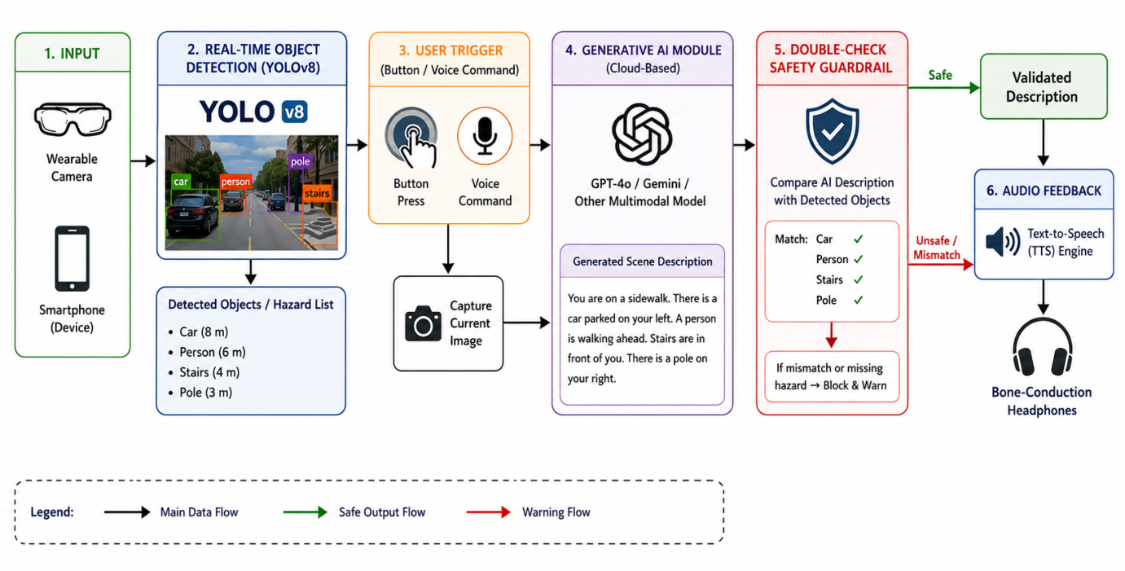

7.2 System Development
The proposed system consists of four main modules:
1. Object Detection Module
A YOLOv8 model will be implemented on a smartphone or edge device. The model will continuously analyse video frames and detect navigation-related objects such as:
- Cars
- Pedestrians
- Stairs
- Curbs
- Doors
- Poles
- Potholes
The model will provide real-time warnings whenever a dangerous obstacle is detected within a predefined distance.
2. Generative AI Scene Description Module
When the user activates the system using a button or voice command, a captured image will be sent to a multimodal Generative AI model such as GPT-4o.
The model will generate a short and simple description of the environment. For example:
"You are standing in a hallway. A closed door is directly ahead. There is a chair on your right side."
The description will help users understand the overall scene rather than only individual object names.
3. Double-Check Safety Guardrail
The Double-Check module is the main innovation of this research.
The module compares:
- Objects detected by YOLOv8
- Objects mentioned in the AI-generated description
If a dangerous object detected by YOLOv8 is missing from the generated description, the system will block the response and issue a warning message instead.
This mechanism aims to reduce the impact of AI hallucinations and improve user safety.
4. Audio Feedback Module
Validated information will be converted into speech using a Text-to-Speech (TTS) engine and delivered through bone-conduction headphones.
This approach allows users to hear both system feedback and environmental sounds simultaneously.

7.3 Data Collection and Testing
The study will use publicly available datasets containing indoor and outdoor navigation scenes. Additional videos and images will be collected in controlled environments such as university corridors, classrooms, and walkways.
The prototype will be tested using approximately 15 volunteer participants under three different conditions:
Condition A
White cane only.
Condition B
White cane with continuous object detection announcements.
Condition C
White cane with the proposed Generative AI navigation system.
The following performance measures will be recorded:
- Object detection accuracy
- Response time (latency)
- Number of collisions
- Navigation completion time
- NASA-TLX cognitive workload score
- User trust and satisfaction score

7.4 Data Analysis
The collected data will be analysed using descriptive statistics and comparative analysis.
The following metrics will be calculated:
- Precision
- Recall
- F1-score
- Average latency
- Mean collision rate
- Mean NASA-TLX score
Statistical comparisons between the three testing conditions will be performed to determine whether the proposed system provides significant improvements in safety, usability, and navigation performance.
The findings will then be used to evaluate the effectiveness of the proposed framework and determine whether the research objectives and hypotheses have been achieved.

8. Research Limitations
Every research project has certain limitations that may affect the results. Understanding these limitations helps ensure that the findings are interpreted correctly and provides opportunities for future improvements.

8.1 Dependence on Internet Connectivity
The proposed system uses a cloud-based Generative AI model to generate detailed scene descriptions. Therefore, a stable internet connection is required when the user requests a description. In locations with weak or unavailable network coverage, such as tunnels, underground stations, or remote areas, the response time may increase or the description service may become unavailable.
To reduce this problem, the YOLOv8 obstacle detection module will continue to operate locally on the smartphone and provide safety warnings even when the internet connection is lost.

8.2 Hardware and Battery Constraints
Running real-time computer vision algorithms continuously can consume significant processing power and battery life. Smartphones may experience reduced battery performance and increased device temperature during long periods of use.
To address this limitation, a lightweight and optimized version of YOLOv8 will be used to reduce computational requirements while maintaining acceptable detection accuracy.

8.3 Limited Participant Testing
Due to time constraints and ethical approval requirements, the study may not initially involve a large number of visually impaired participants. Instead, preliminary testing will be conducted with sighted volunteers wearing blindfolds in a controlled environment.
Although this approach is commonly used in early-stage assistive technology research, it may not fully represent the experiences and behaviours of actual visually impaired users.

8.4 AI Hallucination Risk
Although the proposed Double-Check Safety Guardrail is designed to reduce AI hallucinations, it may not completely eliminate all errors. There is still a possibility that some incorrect descriptions could pass the verification process, especially in complex or unfamiliar environments.
Future research could explore more advanced verification techniques and additional sensor fusion methods to further improve reliability.

8.5 Environmental Conditions
The performance of computer vision models can be affected by environmental factors such as poor lighting, heavy rain, shadows, or crowded scenes. These conditions may reduce object detection accuracy and affect the quality of generated descriptions.
Additional training data and adaptive image enhancement techniques may be required to improve system performance under challenging real-world conditions.

Summary of Limitations
Despite these limitations, the proposed framework provides a practical and realistic solution for improving navigation assistance for visually impaired individuals. The identified limitations will be considered during system design, testing, and evaluation to ensure that the research findings remain reliable and meaningful.

9. Timeline with Professional Practice
This research project is planned to be completed within six weeks . The timeline is designed to ensure that all research objectives are completed systematically, from literature review and system development to testing and thesis writing.
The timeline also demonstrates professional project management practices by dividing the research into manageable phases with clear deliverables and milestones.

9.1 Gantt Chart

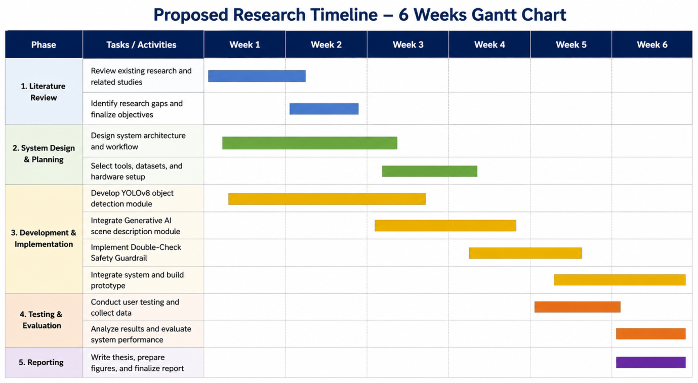

10. Expected Findings
This research is expected to demonstrate that combining real-time object detection with Generative AI can provide a safer and more useful navigation assistance system for visually impaired individuals than existing solutions.
First, it is expected that the YOLOv8 object detection model will successfully detect common navigation hazards such as stairs, curbs, poles, vehicles, and pedestrians with high accuracy and low latency. The model is expected to achieve an F1-score greater than 85% while maintaining real-time performance of at least 20 frames per second on a mobile device. This would ensure that users receive immediate warnings about nearby obstacles.
Second, the proposed Double-Check Safety Guardrail is expected to improve the reliability of Generative AI descriptions. By comparing detected objects with AI-generated scene descriptions, the guardrail should be able to identify and block most safety-critical hallucinations. It is anticipated that the system will successfully detect and prevent more than 90% of dangerous omissions or incorrect descriptions generated by the AI model.
Third, the trigger-based interaction design is expected to reduce cognitive load and audio fatigue. Unlike systems that continuously announce detected objects, the proposed system allows users to request detailed information only when needed. As a result, participants are expected to report lower NASA-TLX workload scores and higher satisfaction levels during testing.
In terms of navigation performance, participants using the proposed system are expected to complete navigation tasks more efficiently than those using a traditional white cane alone or a continuous object-announcement system. The number of collisions is expected to decrease, while navigation speed and confidence are expected to improve.
Overall, the findings are expected to show that integrating YOLOv8, Generative AI, and a safety verification mechanism creates a practical, reliable, and user-friendly navigation assistance framework. The study will also contribute to the growing field of trustworthy and explainable AI by demonstrating how a verification layer can improve the safety of Generative AI in real-world applications.

11. References
[1] G. I. Okolo, T. Althobaiti, and N. Ramzan, “Assistive Systems for Visually Impaired Persons: Challenges and Opportunities for Navigation Assistance,” Sensors, vol. 24, no. 11, p. 3572, 2024.
[2] Y. Zhang, X. Li, and H. Wang, “Real-Time Object Detection for Assistive Navigation Using Improved YOLO-Based Models,” IEEE Access, vol. 11, pp. 112345–112356, 2023.
[3] H. Wang, Z. Liu, and J. Chen, “YOLO-Based Obstacle Detection and Navigation Assistance for Visually Impaired Individuals,” Applied Sciences, vol. 13, no. 8, pp. 1–15, 2023.
[4] M. M. Valipoor and A. de Antonio, “Recent Trends in Computer Vision-Driven Scene Understanding for Blind and Visually Impaired Users: A Systematic Mapping Study,” Universal Access in the Information Society, vol. 22, pp. 983–1005, 2023.
[5] R. Gonzalez, J. Collins, S. Azenkot, and C. Bennett, “Investigating Use Cases of AI-Powered Scene Description Applications for Blind and Low Vision People,” in Proceedings of the CHI Conference on Human Factors in Computing Systems, 2024.
[6] J. He, S. Pundlik, and G. Luo, “Can Large Multimodal Models Assist Visually Impaired People with Navigation Tasks?,” arXiv preprint, 2024.
[7] A. Lavric, C. Beguni, E. Zadobrischi, A. M. Căilean, and S. A. Avătămăniței, “A Comprehensive Survey on Emerging Assistive Technologies for Visually Impaired Persons: Lighting the Path with Artificial Intelligence Innovations,” Sensors, vol. 24, no. 15, p. 4834, 2024.
[8] J. Ortiz-Escobar, F. Alghamdi, and M. Alshammari, “User-Centered Design Considerations for AI-Based Assistive Technologies,” IEEE Access, vol. 12, pp. 44567–44581, 2024.
[9] J. He, S. Pundlik, and G. Luo, “Evaluating Large Language Models for Micro-Navigation Assistance in Visual Impairment Applications,” arXiv preprint arXiv:2408.08321, 2024.
[10] C. Cai, D. Liu, and Z. Liu, “A Spatial Data Model of Blind Outdoor Navigation for Path Optimization,” Humanities and Social Sciences Communications, vol. 11, no. 1323, 2024.
[11] F. Yao, W. Zhou, and H. Hu, “A Review of Vision-Based Assistive Systems for Visually Impaired People: Technologies, Applications, and Future Directions,” arXiv preprint, 2025.
[12] R. Quinn, S. Murtough, H. de Winton, B. Ellis-Frew, and A. J. Spiers, “A Shape-Changing Haptic Navigation Interface for Vision Impairment,” Scientific Reports, vol. 14, p. 29223, 2024.
[13] C. Bennett, R. Gonzalez, and S. Azenkot, “Artificial Intelligence and Accessibility: Opportunities and Challenges for Blind and Low Vision Users,” ACM Computing Surveys, vol. 57, no. 2, pp. 1–28, 2025.
[14] A. Ahmetovic, C. Bernareggi, and S. Mascetti, “Assistive Technologies for Blind and Visually Impaired People: Current Trends and Future Directions,” ACM Computing Surveys, vol. 58, no. 1, pp. 1–35, 2025.
[15] D. Gunning and D. Aha, “DARPA's Explainable Artificial Intelligence (XAI) Program,” AI Magazine, vol. 40, no. 2, pp. 44–58, 2019.
[16] L. Martinez, “Voice-Activated Accessibility Tools: Minimizing Cognitive Load in Audio-Based Assistive Technology,” Accessibility and Assistive Technology Studies, vol. 12, no. 2, pp. 89–102, 2025.

