
Programme name: Master of Business Administration
Name and code of the module: Dissertation LCMB7035
Name and title of the assessment item: Leadership Effectiveness During Digital Transformation: Evidence from UK Technology Firms
Supervisor’s name: Dr Ghulam Mujtaba
Student Name : Vishal Choudhary
Student ID: 2412600
Word count: 12,608
Submission date: 09/sep/2026
Abstract
Purpose: This study aims in particular to investigate the effectiveness of leadership during digital transformation in technology firms in the UK, relating this to behavioural, relational and digital skills, and their links to employee engagement and digital transformation success. It also explores the mediational role of employee engagement, which is proposed for this study.
Methods: A positivist philosophy, deductive approach and cross-sectional research design methods were used. The primary data collection was conducted via an SEO website using a five-point Likert scale questionnaire with 200 technology workers within UK-based technology companies, directly involved in or affected by digital transformation. A convenience sampling method was employed. SPSS was used for data analysis to estimate the proposed relationship between the constructs of the study by descriptive statistical analysis, Cronbach's alpha, Pearson correlation and multiple regression. It has been identified will also be problems which are statistically significant and the level of comparative predictive ability to determine which leadership competency was most predictive for each organisational outcome.
Findings: The findings demonstrate statistically significant and strong positive relationships across the three leadership competencies, employee engagement and digital transformation success. The strong model accounted for 55.4% of the variance in employee engagement (R² = .554), and all Three Competencies were found to be significant for this measure. The most important predictor was relational competence (β = .306), followed by digital competence (β = .289) and behavioural competence (β = .231). Leadership skills also significantly explained the variance of digital transformation success (R² = .679). The strongest predictor was digital competence (β = .395), followed by behavioural competence (β = .270), and finally by relational competence (β = .249). There was a strong correlation between successful digital transformation and employee engagement (r = .689). Thus, the H1 and H2 were supported. Formal mediation analysis was not developed; however, the relationship between involvement and the transforming success should be referred to as an association instead of in terms of mediation or causality, and H3 was not confirmed.
Conclusion: The conclusions of the study are that the one-dimensional view according to sufficient leadership capability, which can be both applied in the organisation and in certain contexts, is not adequate for successful digital transformation. Relational competence becomes even more crucial when it comes to engaging employees, and digital competence when it comes to successfully generating transformation. Digital transformation is a leadership and people challenge as well as a technical one, so UK technology companies should treat it as such. This comprehensive approach can enhance organisational agility, staff engagement, innovation, resilience and outcomes for long-term transformation for the sector.

Acknowledgement
I would like to express my gratitude to my supervisors, Hoang Nguyen and Masud Ibrahim, for their guidance, constructive feedback and support during this dissertation. I also wish to express my appreciation for the challenging and enriching opportunity of having the MBA faculty and staff provide the resources for this research. Many thanks to all of the respondents who were willing to spare their time and offered their opinions, which allowed this study. Lastly, I express my appreciation to my family, friends and colleagues for the support and encouragement that they provided throughout this journey, especially when I finished this dissertation.

Table of Contents
Chapter 1: Introduction 6
1.1 Introduction 6
1.2 Background of the Study 7
1.2.1 Digital Transformation 7
1.2.2 Digital Transformation in UK Technology Firms 8
1.2.3 Leadership During Digital Transformation 9
1.3 Research Problem 9
1.4 Research Aim 10
1.5 Research Objective 10
1.6 Research Questions 10
1.8 Significance of the Study 11
1.9 Scope and Delimitations of the Study 11
1.10 Dissertation Structure 12
Chapter Two: Literature Review 14
2.1 Introduction 14
2.2 Conceptualising Leadership Effectiveness: Divergent Theoretical Lenses 14
2.4 Leadership Theories in Digital Transformation: A Comparative Theoretical Evaluation 16
2.5 Leadership Behaviours, Challenges and Digital Transformation Outcomes: Reconciling Conflicting Evidence 19
2.6 Leadership Effectiveness, Digital Leadership and Employee Engagement 20
2.7 Critical Synthesis, Research Gap and Conceptual Framework 22
2.8 Research Hypothesis 23
Chapter 3: Research Methodology 25
3.1 Introduction 25
3.2 Research Philosophy 26
3.3 Research Approach 26
3.4 Research Method and Design 27
3.5 Population and Sampling 27
3.6 Questionnaire Development 28
3.7 Data Collection 28
3.8 Data Analysis Using SPSS 28
3.9 Validity and Reliability 29
3.10 Ethical Considerations 29
3.11 Methodological Limitations 30
3.12 Chapter Summary 30
Chapter 4: Analysis and Discussion 31
4.1 Introduction 31
4.2 Demographic Analysis 31
4.3 Reliability Test 33
4.4 Descriptive Analysis 34
4.5 Correlational Analysis 35
4.6 Regression Analysis 36
4.6.1 Regression Test 1: Leadership Competencies and Employee Engagement 36
4.6.2 Regression Test 2: Leadership Competencies and Digital Transformation Success 41
4.7 Discussion 45
4.7.1 Overall Discussion of the Findings 45
4.7.2 Leadership Effectiveness and Employee Engagement 48
4.7.3 Leadership Effectiveness and Digital Transformation Success 49
4.7.4 Employee Engagement and the Proposed Mediating Relationship 50
4.8 Chapter Summary 51
Chapter 5: Conclusion and Recommendations 53
5.1 Overall Conclusion and Achievement of the Research Aim 53
5.2 Conclusion on Leadership Effectiveness and Employee Engagement: Objective 1 and H1 54
5.3 Conclusion on Leadership Effectiveness and Digital Transformation Success: Objective 2 and H2 55
5.4 Conclusion on Employee Engagement and Digital Transformation Success: Objective 3 and H3 55
5.5 Practical Recommendations for UK Technology Firms 56
5.5.1 Strengthen Integrated Relational and Digital Leadership Capability 56
5.5.2 Embed Employee Participation and Continuous Digital Learning 57
5.6 Limitations 57
5.7 Future Research Directions 58
5.8 Final Conclusion 58
References 60
Appendix 71
Appendix A: Questionnaire 71
Appendix B: SPSS Outputs 77

Chapter 1: Introduction

1.1 Introduction
Digital transformation can be defined as the strategic incorporation of digital technologies into an organisation's processes, business models and decision-making, which aims at improving competitiveness, process efficiency and value creation in the long term (Shao, 2025). In the past decade, Artificial Intelligence (AI), cloud computing, big data analytics, machine learning, and automation have been used in business to transform the way organisations develop value, interact with customers, and adapt to the rapidly changing market (Machucho and Ortiz, 2025). But despite the significant investment in technology, evidence strength appears to suggest that technology is not an adequate enabler for successful change. Research shows that about 70% of digital transformation programs are unsuccessful, and a lack of organisational culture, a lack of executive buy-in, and resistance to digital transformation from employees are cited as bigger hurdles to transformation than technology. This is clear proof that digital transformation is not about technology alone, but is a process of organisational change. In this context, UK technology companies offer a suitable research environment that accounts for around 1.8 million jobs in the UK and about £170 billion of the UK economy (Consultancy.uk, 2018) (See Figure 1.1). This Chapter therefore introduces the background of the study, the research gap and sets out the research aim, objectives and research questions.
Figure 1.1: Bullish UK Technology Sector Worth
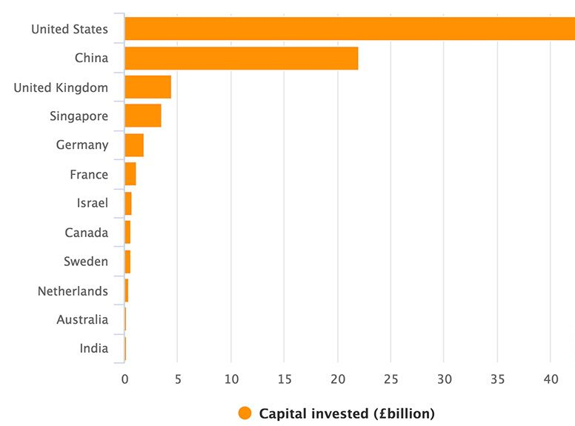
Source: Adapted from: Consultancy.uk (2018)

1.2 Background of the Study

1.2.1 Digital Transformation
Digital transformation, from digitising business processes to a strategy for organisations that has embraced artificial intelligence (AI), cloud computing, machine learning, big data analytics, cybersecurity and digital innovation, has evolved from a mere business process digitisation initiative to a broader strategy for organisations to become more competitive (Alabi, 2024). But researchers have different views among themselves regarding what is a key factor in the success of transformation: technology or skills/abilities (Zhang, Xu and Ma, 2022; Chirumalla et al., 2025). While technology improvement and cloud platforms can boost operational effectiveness and data-driven decision-making, research shows that over three-quarters (74%) of digital transformation projects are at risk of failure due to organisations' lack of cultural change, leadership or skills (Vărzaru and Bocean, 2024). Moreover, the return on investment for digital transformation is expected to become greater than $3.9 trillion globally by 2027, so digital transformation should be considered a change of the organisation, not only investing in the best technologies (Henkin, 2025).

1.2.2 Digital Transformation in UK Technology Firms
There is no doubt that the digital economy has become a vital and important pillar of the UK economy, accounting for around 7.2% of the UK economy and creating around 1.8 million jobs through over 180,000 technology businesses in the UK (S&P Global, 2026) (Refer to Figure 1.2). While start-ups and scale-ups, and innovation ecosystems have gained strength from government support and private investment, firms are still facing intense pressure from competition and ever-changing customer demands to change. Furthermore, the prevalence of remote/hybrid workstyles has been driving digital collaboration up and up, but also cybersecurity and operational risks are increasing (Maity and Lee, 2025). Therefore, investment in technology alone cannot be relied upon to give the business an edge; having an agile organisation based upon adaptive management and ongoing innovation is more essential than ever before.
Figure 1.2 State of the UK digital economy

Source: Adapted from: S&P Global (2026)

1.2.3 Leadership During Digital Transformation
The extent to which leaders enable a digital culture and continuous learning while dealing with employee resistance and articulating a digital vision and strategic goals is widely recognised as a key factor in driving successful digital transformation. But there is evidence that technological capability is not enough; almost 70% of digital transformation efforts fail because of factors other than poor technology: it is poor culture and leadership (Demirel, 2024). The key differences between transformational leadership and digital leadership are in the emphasis given to inspiration and change, while digital leadership gives emphasis to the use of digital capabilities, and adaptive leadership gives emphasis to organisational flexibility for an uncertain environment (Ly, 2023). This issue of their relative effectiveness is still in debate and is discussed in detail in Chapter Two.

1.3 Research Problem
The success rate of digital transformation amongst organisations is very dismal, even after a lot of investment in digital technology. Despite a global investment projected to hit US$3.9 trillion by 2027, evidence shows that only around 70% of digital transformation projects are able to meet expectations (World Bank, 2023). This implies that financial investments and technological capacities are not enough to make this transformation a success. However, in UK tech businesses, barriers such as employee reluctance, ineffective communication, scarce digital leadership skills, and a general “business as usual” attitude persist in this area and are impacting transformation outcomes (Hržica, 2025). While existing research has already been conducted in many areas around technology adoption, artificial intelligence, cloud computing and digital innovation, comparatively less has been done in determining the impact of leadership effectiveness on digital transformation success, especially in the technology industry in the UK (Chen, Wang and Park, 2026). Therefore, it is still lacking in the literature and in empirical research to evaluate the contextual and empirical relationships between leadership behaviours and employee engagement and organisational adaptability in the digital transformation phase. This study aims to address this gap by examining leadership effectiveness as a critical capability of an organisation within UK technology companies.

1.4 Research Aim
The aim of the research is to investigate the impact and effectiveness of leadership in digital transformation in technology companies and how it is affecting employee engagement and organisational transformation in the UK.

1.5 Research Objective
- RO1: To identify and evaluate the key dimensions of leadership effectiveness, including behavioural, relational and digital competencies, during digital transformation within UK technology firms.
- RO2: To examine the relationship between leadership effectiveness and employee engagement during digital transformation within UK technology firms.
- RO3: To assess the relationship between leadership effectiveness and digital transformation success within UK technology firms.
- RO4: To examine the mediating role of employee engagement in the relationship between leadership effectiveness and digital transformation success within UK technology firms.

1.6 Research Questions
RQ1: What are the key dimensions of leadership effectiveness during digital transformation within UK technology firms?
RQ2: What is the relationship between leadership effectiveness and employee engagement during digital transformation within UK technology firms?
RQ3: What is the relationship between leadership effectiveness and digital transformation success within UK technology firms?
RQ4: To what extent does employee engagement mediate the relationship between leadership effectiveness and digital transformation success within UK technology firms?

1.8 Significance of the Study
The purpose of this study is to make an academic contribution by delving into the sparse empirical research focused on fostering effective leadership in the context of technological change in digital transformation in technology firms in the United Kingdom. It offers insights specific to the sector that can inform future research around leadership and digital transformation (Government of UK, 2025). The results are also relevant to Technology companies, HR managers and project managers to understand the leadership practices that could enhance the implementation of digital strategies, innovation, organisational performance and adaptability (Daud, 2024). Study employees' communication levels, leadership practices, continuous learning, building digital skills, adapting to organisational changes, and resisting organisational changes. Lastly, digital transformation and workforce development policies and strategies can benefit from the findings, as they can help technology leaders grow, upskill and innovate, making the UK technology sector more competitive and sustainable in the long-term (OECD, 2024).

1.9 Scope and Delimitations of the Study
This study aims to explore the impact of leadership effectiveness during digital transformation in technology companies in the UK on employee engagement and the successful completion of the digital transformation within the organisations. This research aims to gather data from employees who are directly engaged in digital transformation initiatives to uncover key leadership practices and organisational outcomes. However, the study only addresses the technology sector in the UK, reflecting the findings within that specific industry and country, to other sectors and other countries. Also, a cross-sectional quantitative research approach and convenience sampling method are used, where primary data are gathered via structured questionnaires, where statistical analysis is possible, but causal inferences and changes in the effectiveness of leadership over time are not possible.

1.10 Dissertation Structure
This dissertation is organised into five chapters. Chapter One introduces the study, outlining the research background, problem statement, aims, objectives, research questions, significance, scope, and overall structure. Chapter Two critically reviews existing literature on digital transformation and leadership theories, identifies research gaps, develops a conceptual framework, and formulates hypotheses. Chapter Three explains the research methodology, including philosophy, approach, design, sampling, data collection, questionnaire development, data analysis, validity, reliability, and ethical considerations. Chapter Four presents data analysis, findings, and hypothesis testing. Finally, Chapter Five concludes the study, discusses implications, limitations, recommendations, and directions for future research.
Figure 1.3. Dissertation Structure
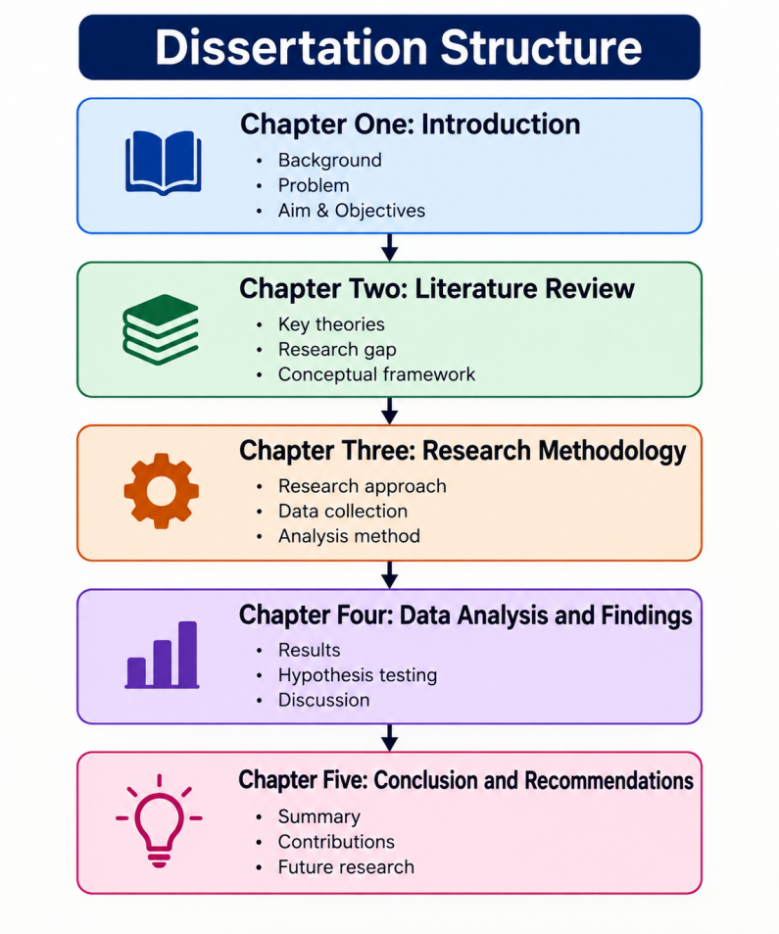
Source: Self-Created

Chapter Two: Literature Review

2.1 Introduction
The chapter is not a summative description of what has been written thus far on leadership effectiveness and digital transformation (DT); it critically considers and compares the scholarly literature to determine where it overlaps, conflicts, and has gaps. The review is organised against the backdrop of the objectives outlined in Chapter One: it explores leadership conceptions and digital transformation, juxtaposes the various leadership theories used to analyse digital transformation environments, assesses the leadership-behaviour and employee-behaviour relationships in empirical studies, and looks at the leadership/employee engagement relationship. The chapter concludes by putting together these ideas and themes to identify what role this research will fulfil, namely that it will uncover a gap in the UK-based research landscape in relation to the link between leadership and the outcomes of digital transformation in the technology sector, and that such work is missing in empirically based evidence.

2.2 Conceptualising Leadership Effectiveness: Divergent Theoretical Lenses
Effective leadership is a dynamic, fluid construct, and there are at least three conflicting aspects to it that form competing claims about what effective leadership means. Behavioural accounts see effectiveness in terms of what leaders do, relational accounts through how leaders build trust, work collaboratively, and commit with followers, and strategic accounts in terms of the contribution of effectiveness to organisation competitiveness and transformation outcomes. Each lens has a unique methodological bias: the behavioural approach is easiest to measure by means of a survey instrument, but is most likely to contain measurable elements that are irrelevant to leadership effectiveness; the relational approach is harder to measure, but the interpersonal component of leadership is better captured. Leadership definitions that are strategic often will take the approach of measuring performance in terms of a firm's strategic goals, which are compounded by issues of market competition and macroeconomic factors other than leadership itself. This is because, although this has been a widely shared claim, it comes from a business-press publication rather than a peer-reviewed empirical study, and thus the causal direction of the relationship is not surreptitiously reported with very high confidence (Power, 2024).
The peer-reviewed essays provide a more guarded depiction, but they do not consistently concur. As effective digital leaders, Türk (2023) identifies a discretion: Being inspired, having a vision, being adaptable, absorbing uncertainty and being innovation-oriented. In contrast, Sacavém et al. (2025) suggest that leadership and DT are reinforcing each other; thus, digital leadership is the independent variable and the long-term employee engagement variable the moderating variable between the two in achieving an organisational digital transformation, meaning that digital leadership's effectiveness is not only dispositional but process-oriented as well. The latter view is not necessarily exclusive of the former and is hardly confirmed by empirical models that integrate the two accounts; both points are still mainly of the theoretical description, and rarely are they confirmed by longitudinal or comparative data. Another common limitation in the leadership effectiveness literature was that studies claimed that there were reciprocal or dispositional links between leadership and organisational outcomes; however, they lacked designs that allow one variable to be controlled if directionality was assessed and that allow tests between competing causal explanations. The design of this study, with its quantitative approach, is aimed at closing this gap in the literature.
The other source of conceptual ambiguity is the definition of digital transformation. Schilirò (2024) lacks a subtle focus on digital technologies and considers DT primarily as the implementation of digital technologies in decision-making, business models and organisational processes, focusing on the adoption of digital technologies. By contrast, the informational and relational benefits of DT, such as network effects, the external use of knowledge, and internal innovation, have been highlighted by Kraus et al (2021), resulting in a more capability- and knowledge-centred account. These aren't just a matter of style; having a technology-adoption definition suggests that DT is measured based on the presence of digital tools, and a capability-centric definition suggests that DT should be measured by the outcomes of organisational learning and knowledge, and these are not always synonymous for measuring purposes.
This argument is continued in another direction by Szymon Cyfert et al. (2025), who state that Digital Maturity is based on organisational culture, leadership and competence, not only on the organisation's technology (and implicitly that this is a criticism of the definitions of digital maturity that focus on technology alone, such as those proposed by Schilirò). This cultural reading is further supported by Cao, Duan and Edwards (2025) who link organisational culture directly to the outcome of DT and product innovation, implying that organisational culture is an antecedent condition determinant of DT success, not an incidental correlate. This places the DT literature across a spectrum ranging from Schilirò's technology-centric account at one end, through the many works that were followed up which, though not necessarily as explicitly as these two, stand nearer to the technology end than the DT end, to Szymon Cyfert et al.'s orientation toward a culture-and-competence account at the other.
In addition to this conceptual fragmentation, there is an inconsistency in quantifying the DT phenomenon in secondary data sources. All these estimates are of a similar magnitude but actually reflect different constructs, ranging from a small DT-services market to the entire technology market, and should not be considered a contradiction of the phenomenon itself. Grand View Research (2026) estimates the market for digital transformation in the UK at $77.0 million in 2026, while IMARC (2025) separately estimates the UK technology market at $1.4 trillion in 2025. The values of GVA can also differ between sources as different definitions of what is defined as digital activity are used (Vailshery, 2025). Such uncritical use of figures in industry and academic publications reflects a general issue in the DT literature: Market sizing can often include multiple different definitions, thereby creating definitional ambiguity in the data used to explore and define DT as a measurable construct. The present study is specifically motivated by this instability through adopting a specific, bounded definition of DT centred on leadership behaviours and outcomes, instead of linking it to market-level indicators.

2.4 Leadership Theories in Digital Transformation: A Comparative Theoretical Evaluation
The literature reviewed included various leadership theories that explain outcomes of DT, with none dominating, and that have also been individually tested and confirmed in validity in a digital context, even if some have received some interest (Henderikx and Stoffers, 2022; Dickson, 2023; Malik et al., 2024). Each of those mentioned theories has its theoretical restrictions that narrow its capacity for explaining outcomes of DT.
This trait theory, which has focused on the individual aspects of what constitutes an effective leader, has been challenged because of its lack of situational and technological aspects of leaders that are demanded in DT (Dickson, 2023). Behavioural theory builds on this by shifting the emphasis from subtle or unseen characteristics or agency to more observable and teachable behaviours, but, compared with approaches that recognise the termed 'change and adaptation', it is relatively unchanging and less able to account for the complexity and constant fluidity characteristic of the digital dimension. It is argued that in DT situations the contingency approach pushes top-down individual leadership while neglecting bottom-up organisational culture and sticks with a bottom-down goal-setting approach that conflicts with the exploratory and boundary-pushing nature of a successful DT process. In other words, servant leadership, which focuses on supporting followers both professionally and personally to embrace change, and transactional leadership, which is characterized by directive exchanges between leader and follower, exist on opposite ends of another spectrum: Servant leadership is suitable for buy-in but not equally effective at achieving transformational scope, while transactional leadership is effective in an incremental operating mode but is expected to be weaker in addressing a vision-setting and culture change context of technological uncertainty (Henderikx and Stoffers, 2022).
Transformational leadership is the most widely used theory in the DT literature, and this is mainly because its focus on vision and inspirational and intellectually stimulating tools suggests that it will naturally fit with the disruptive nature of DT. However, this popularity cannot take the place of the empirical consensus. According to Lee (2014), these very behavioral characteristics which contribute to the effectiveness of a transformational leader – charisma, persuading others beyond self-interest and having a strong vision – can prove to be an organisational problem if applied in excess; the dependent nature of employees on the capability of one single transformational leader, and the potential use of personal values to abuse the position of influence in cases of weaker leaders. This is a critique that dims the general praise that is given to the body of literature on transformational leadership and suggests an application of this concept to DT to be considered with caution. There is also another level of fragmentation to be found within the literature on pro-transformational, digital-leadership that focuses on organisational design as the main levers, on the development of individual digital skills, and on the alignment of resources with strategic goals, three different prescriptions under the one umbrella of a theoretical label, with the consequence that it suggests something more of an umbrella than a precisely specified model.
The focus has been shifted from individual leader characteristics to the institutional or neo-institutional perspective, as discussed by Malik et al. (2024), who explained how the dominant organisational norms and cognitive frames affect digital leadership. This macro-level orientation is less usable, however, for practitioners and provides relatively little guidance for those seeking to understand what specific behaviours to engage in among the firm's leaders, limiting its utility for this work, like the present study, that seeks actionable recommendations for leadership.
All of the academic readings indicate a move away from simple contingency and behavioural theory implementations, and towards a hybrid style framing that encompasses a blend of both approaches, while not advocating for any single leadership style, with competency portfolios being flexible to context, firm size and even sector, not necessarily set as a recipe for a specific style of leadership. In this respect, the theoretical direction is very similar to the direction of the current study, which is the study of leadership within a specific context – UK technology organisations, compared to general leadership.
Another comparison that could be made is in terms of the analysis level at which these theories are working. As for trait theories and behavioural and transformational theories, they are almost exclusively focused at the personal level; they consider DT success to be a result of the personal characteristics or behaviour of one person. Institutional theory, on the other hand, is situated at the field or sector level, and considers leadership behaviour the result of structural norms rather than a variable under consideration. Followers of Individual and Organisational approaches are mainly focused either on the Individual level or on the Organisational level, not on both, which is what the Contingency approach or the competency-portfolio approach focuses on. This is a structural problem that makes direct comparisons of results at the level of individual theories that have been reviewed in the literature difficult: When one study is based in the context of trait theory and the other on institutional theory, in effect they are actually answering different questions even if they both focus on "effective leadership in digital transformation. The present study tackles this by putting the conceptual lens on the organisational level of the research, where the definition of leadership effectiveness is a set of measurable behaviours and competencies conducted within, and bounded by, a particular UK technology firm context rather than either the individual level or the institutional level of theory abstractly.

2.5 Leadership Behaviours, Challenges and Digital Transformation Outcomes: Reconciling Conflicting Evidence
The findings from real-world studies around the relationship between leadership and DT outcomes are actually quite divergent, and this divergence is itself of analytical importance. In contrast to the findings of PwC's (2024) study, which found 61% of business leaders do not believe a lack of digital skills is the biggest issue in achieving DT, Weiser et al. (2023) found that almost 70% of all failed DT projects in their research result from cultural resistance and insufficient leadership rather than skills deficiencies. These findings, read together, are not necessarily in opposition to each other instead they can be interpreted along two lines: either (1) they refer to different definitions of what constitutes a 'skill'—digital skills versus practical skills which involve the transfer of digital capability to organisational change—and, (2) they can be seen to demonstrate technical skills alongside the applied leadership skill of making wonderful use of the skills of information and communication technologies for organisational change (which is often not clearly distinguishable in the literature). This is a methodological weakness typical of reports on industry made from surveys, which present single-item statistics, rather than those clearly understood by scientifically tested instruments.
The leadership-deficit picture is confirmed by other UK-centred surveys, if their conclusions are somewhat contradictory; in his review of the literature on STEM education, Ahres (2023) reports the views of a majority of his respondents, who felt that senior leaders were digitally literate in principle but not managing to create an operating model or vision based on this literacy, while in Weston (2020) about two-thirds of UK organisations saw a digital skills gap as a threat to DT, which is a different focus than used by Deloitte in their leadership-deficit work. Musaigwa (2023) broadens this understanding of successful change management with a focus on the relationship between change management and leadership; Tagscherer and Carbon (2023) summarise the previous studies and articulate a transition of expectations of leadership from a hierarchical character to adaptive, collaborative and cross-functional leadership models. But as this contribution is in fact a text about general change management and not about DT, integrating the latter's challenges into reviewed literature demands some inference which can be drawn from the application of change-management theory in DT contexts as described in the literature.
Tuyen et al. (2025) provide one more layer of detail as they demonstrate that this association between leader attributes and DT can be nuanced with compliance pressure, which is relatively under-researched in the UK context. The generalisability of Tuyen et al.'s results to a more established and rigorously regulated market like the UK is open to question given their context of the emerging market, as this is where the present study aims to address the contextual differences. Likewise, pre-pandemic statistics like those of Alsop (2018), which revealed that 51% of UK IT leaders don't get boardroom buy-in for DT, were dated and may be outdated with the advent of DT's technologies and their acceleration during the Covid-19 pandemic (Consultancy.uk, 2020). The tendency for the literature to repeat these figures from pre-incident is another example that a need for fresh primary information, specific to the UK, not secondary industry reports, exists at this time.
Digital Leadership and Employee Engagement (2.6) provides an opportunity to study the role of a digital leader and how this can enhance leadership effectiveness in today's digital landscape.

2.6 Leadership Effectiveness, Digital Leadership and Employee Engagement
While there is a strong theoretical understanding of the link between leadership and employee engagement during DT, it receives less evidence than it deserves. Of that literature, Li et al. (2024) draw upon the theory of Social Exchange Theory and conduct interviews with 559 employees from across 11 listed organisations in Southwest China and show that the relationship between digital leadership and employee work engagement is mediated by empowerment and affective commitment, while emotional intelligence, as a moderator, has a conditional effect in its own right. This is in sharp contrast with the "almost purely conceptual/literature-synthesis" results presented by Sacavém et al. (2025) and Henderikx and Stoffers (2022), who theorise leadership-engagement-DT linkages without providing concrete statistics to support these theories. Maye (2026) comes to reasonably broad conclusions, saying that digital leadership is indeed linked to both employee engagement and organisational innovation and provides convergent evidence for the argument that it is effective on DT outcomes through engagement, but not directly. Shonubi (2025) complicates that somewhat by noting legacy organisational structures as a source of innovation challenges rather than just linear organisational models involving the dyad of leader and followers, suggesting that engagement-mediated models may need to take into account legacy structures that lie outside the individual leader's control.
Another conceptual approach to the subject is to directly see digital competency as the independent variable - directly predicting the outcomes at the employee level - rather than digital leadership behaviour. Results of Tiong et al. (2024) in their study on digital competency of Indonesian SME workers reveal that digital competency, leadership style and engagement would all predict SME performance and that innovation capability would mediate between digital competency and SME performance; whereas, organisational culture would moderate between digital competency and SME performance. This indicates that there are at least two, somewhat connected, explanatory chains in the literature: the first starts with leadership behaviour and leads to levels of engagement, and the second begins with the individual's digital competence and leads to their innovation competence, mediated along the way by organisational culture. Due to the cross-sectional design of this study, the empirical question of the substitution/complementation of leadership effectiveness for digital competence of the individual has not been answered, but this study is suitable for discussion within the context of the UK technology-firm context.
But the overall validity of this existing evidence should not be taken blindly over to the context of the present study. The same geographic area is used for listed companies in China (Li et al. 2024), and the authors themselves cautioned the limitations in generalisability because they studied only one geographic area and within the specific sample of listed companies in China. None of the empirical studies reviewed in this chapter create a UK sample of MTs and link specific MT leadership behaviours to employee engagement and specific DT outcomes, as happens in almost all of the emerging-markets work (Tuyen et al., 2025) and the non-sector-specific UK survey work (PwC, 2024; Ahres, 2023; Weston, 2020). Whilst not a focus of the present study's aims, Li et al. (2024) also point out that the focus of the majority of existing research in DT is on the senior or C-suite level of leadership, and thus middle-management leadership is not investigated as much.

2.7 Critical Synthesis, Research Gap and Conceptual Framework
This review highlights three cross-cutting failings. First of all, leadership effectiveness and the concepts of digital transformation still remain in doubt, with varying measures taken, either in a behavioural or relational dimension, in a strategic dimension or simply on the technological side and on the capability side, making it difficult to make findings on them comparable across studies. Second, there is no empirical evidence of any one leadership theory dominating in explaining the success or failure of DT: trait/behavioural theories fail to account for context and contingency; institutional leadership theories are too abstract to be practically applied to explain DT outcomes; and transformational leadership is known to have some problems, namely leader dependency (Lee, 2014). Thirdly, the empirical evidence on leadership behaviours, challenges, and employee engagement does not come from single region, UK or technology industry samples and/or industry survey findings that fail to align fully with respect to the constructs of the actual survey items (Li et al., 2024; Tuyen et al., 2025; PwC, 2024; Deloitte, 2023), creating unresolved tension between skills-deficit and leadership-deficit explanations of why DTs are failing.
Taken together, these gaps provide a compelling justification for the research problem that was set in Chapter One: no previously investigated study has used a sample of UK technology firms, primary quantitative data and a model that explicitly examines the relationship between leadership effectiveness and (DT) success and employee engagement. The reviewed literature informed this study's conceptual approach, which was structured to have leadership effectiveness (including the independent variables of behavioural competence, relational competence and digital competence) as the independent variable, followed by employee engagement as the mediating variable, and digital transformation success as the dependent variable in a particular leadership context that is specific to the organisational and regulatory climate of UK technology organisations. This framework is a theoretical foundation for the methodological choices set out in Chapter Three and is directly informed by the critical gaps identified above.

2.8 Research Hypothesis
The hypotheses for this study are formulated based on the theory and empirical studies reviewed in this chapter. Transformational Leadership Theory suggests that a successful leader would instil their employees with inspiration, motivation and intellectual stimulation in order to enhance their involvement and dedication toward their organisation's change. Leaders who are more effective at digital transformation are those who communicate a clear vision, are open to innovation, and are available to support employees every step of the way to increase employee engagement. Previous research has also shown that leaders' actions have a positive effect on employee motivation and commitment to digital initiatives and participation (Li et al., 2024; Maye, 2026). Hence, the impact of employee engagement on leadership effectiveness in a UK-based tech company can be expected to be positive.
H1: Leadership effectiveness has a significant positive relationship with employee engagement during digital transformation within UK technology firms.
Moreover, Transformational Leadership Theory and Digital Leadership Theory are concerned that one of the main factors in a successful digital transformation is great leadership. Leaders with behavioural, relational and digital competencies can define a digital vision, foster innovation, sustain the necessary change management and colleagues, and find ways to connect pieces together and meet the transformation objectives. It is consistently found in the literature that leadership is integral to outcomes of digital transformation and organisations' adaptability. As a result, positive leadership behaviours are expected to positively influence digital transformation success.
H2: Leadership effectiveness has a significant positive relationship with digital transformation success within UK technology firms.
Employee engagement is theorised to be a mediator of relationships between the Social Exchange Theory and positive psychosocial consequences. The theory is based on the idea that positive leadership fosters positive responses from employees in the form of commitment, involvement, and engagement. When workers are involved, they're more likely to accept tech change, acquire new digital skills, and actively participate in transformation efforts. In previous studies, leadership had been shown to impact organisational outcomes via employee engagement, highlighting the critical role of employee engagement in the connection between leadership effectiveness and digital transformation success.
H3: Employee engagement significantly mediates the relationship between leadership effectiveness and digital transformation success within UK technology firms.

Chapter 3: Research Methodology

3.1 Introduction
The aim of this chapter is to provide the methodology for investigating the effectiveness of digital transformation leadership in UK technology firms. It gives an account of the philosophy and approach, design, sampling, questionnaire, data collection, SPSS analysis, validity, reliability and ethics. The methodology is directly connected with the research purposes and conceptual framework formulated in the previous chapter. Leadership effectiveness is defined across the three areas of behavioural competencies, relational competencies and digital competencies, and employee engagement is the mediator variable, whereas the dependent variable is defined as the successful or unsuccessful digital transformation. The fit of this alignment enables the theoretical relations identified in the literature to be tested in a sample of technology companies in the UK.
Figure 3.1 Research Onion
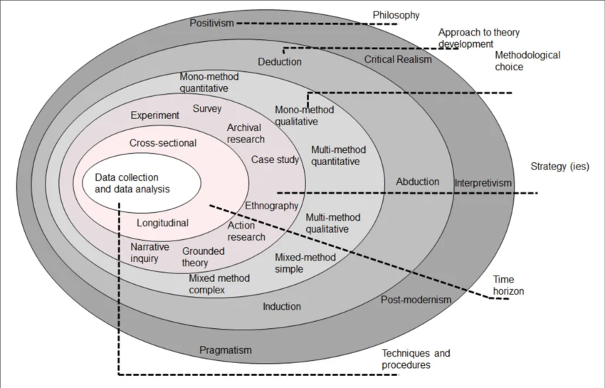
Source: Adapted From: Seuring, Stella and Stella, 2021

3.2 Research Philosophy
A positivist philosophy is used because the study aims to get objective, measurable evidence from the correlation among leadership effectiveness, employee engagement and digital transformation success. These constructs can be made feasible with the use of questionnaires to measure them and statistically test them (Churchman, Pangbourne and Dekker, 2026). The quantitative results are in line with the purpose of this study. The limitations of positivism are that there are other contextual, interpersonal and cultural factors that influence the effectiveness of leadership which may not be numerically explained. They say leadership is a multi-dimensional concept and have found four identifications from the literature, namely behavioural, relational, strategic and Spiritual. This study will therefore be highly focused on leadership behaviour and skills which are discernible and measurable so as not to encompass all elements of leadership. This helps to ensure consistency with the quantitative objectives, yet it acknowledges that results are subjective and based on respondents' perceptions.

3.3 Research Approach
The study is of a deductive nature, from literature identification of relationships to testing. In terms of leadership, behavioural competence, relational competence and digital competence are evaluated, and in terms of employee engagement, it is seen as a mediator: digital transformation success is seen as the dependent variable (Orkamo et al., 2025). This allows for proposed relationships to be tested systematically. In a deductive approach, the study is able to test relationships that have been determined based on previous literature that have been created and not created during the study (Kim, 2021). This certainly fits the theme of the study since three guiding hypotheses of leadership effectiveness, employee engagement and success in digital transformation are presented. While the findings may be limited by deduction, this is fine as the findings are mainly for the purposes of hypothesis testing, not theory construction.

3.4 Research Method and Design
To capture similar numerical data from employees who are exposed to digital transformation, the quantitative design type of cross-sectional design is used. The cross-sectional design enables a practical snapshot of the organisational conditions, but quantitative measurement is used for the statistical examination of relations between variables (Kotronoulas, 2023). One-point data collection, however, does not affect the assessment of changes throughout transformation and weakens strong causal inference, which is consistent with the study's delimitations. While a cross-sectional approach provides a useful snapshot of organisations at a particular time, there is no way it is able to measure whether the effectiveness of leadership is different during various phases of organisational digital transformation (Orkamo et al., 2025). It is also not ideal for making robust inferences, as data is gathered at a single time period. Thus, in the definition of significant relationships, there is no requirement for causation. This is important because literature on leadership and transformation has previously confirmed reciprocal relationships between the two but not necessarily the directionality of the relationship.

3.5 Population and Sampling
Those working in technology companies within the UK in roles directly involved in, or exposed to, digital transformation projects are the target audience for the report. The competent person/s need enough organisational experience to analyse leadership and engagement. Within the limitations of the dissertation, it is feasible to access the participants of the study, and it is called convenience sampling (Memon et al., 2025). However, it is capable of introducing selection bias and reducing representativeness, and so results should not be extrapolated to all UK technology workers. While convenience sampling may be accessible and convenient in reaching employees engaged in digital transformation, it may result in selection bias if those that are reached do not necessarily represent those that are not reached (Golzar, Tajik and Noor, 2022). However, because of this, the sample is not a representative sample of the entire UK technology workforce. The findings should, therefore, be viewed as evidence from selected individuals that participated in the study and not as generalisable findings. The scope of this study is as described, and this is a limitation.

3.6 Questionnaire Development
The primary data were collected using a self-administered structured questionnaire with the relevant items on a 5-point Likert scale. This instrument examines behavioural and relational competences and digital competence as aspects of leadership effectiveness, as well as employee engagement as the hypothesised mediator and success of digital transformation as the dependent variable. They are similar to the constructs that emerged from the literature search. The development of questionnaires is carried out referencing literature and a conceptual framework to increase content validity. The items represent the attributes of leadership like vision, adaptability, innovation and support for organisational change; employee engagement is represented as the proposed process linking leadership and transformation outcomes.

3.7 Data Collection
The survey is carried out using Google Forms and can be distributed and responses returned to the eligible technology workers in the UK efficiently and online. Before the participants respond to the questionnaire, they are given information about the study and an informed consent statement. No pressure is put on respondents to participate in the survey, and participation is voluntary. A link to the Google Form is shared with the people who qualify for participation. Completed responses are then sampled and screened for eligibility and completeness and then exported for SPSS analysis. This process ensures consistent data collection and enables access to geographically spread respondents.

3.8 Data Analysis Using SPSS
IBM SPSS is used to analyse the data. Data on respondent attributes are represented in terms of descriptive statistics (frequencies, percentages, means and standard deviations) to establish patterns. The internal consistency is assessed by Cronbach's alpha. The strength and direction of the association between leadership effectiveness, employee engagement and the success of digital transformation is measured using Pearson correlation (Adamu et al., 2025). There are two types of analyses performed: regression analysis tests the predictive relationships hypothesised in the research model, and hypothesis testing determines whether the relationships are statistically significant. For those who can be accommodated, a mediation analysis is conducted to determine if employee engagement is a mediator between the relationship of leadership effectiveness and digital transformation success. These procedures provide a structure for assessing the literature model. Summarising statistics are used to develop the descriptions of the respondents' characteristics and response patterns, and then the internal consistency is evaluated with Cronbach's alpha (Pretorius and Padmanabhanunni, 2025). The strength and direction of the relationships are tested through the use of a Pearson correlation, and the predicted relationships presented by the conceptual relationships are tested through regression.

3.9 Validity and Reliability
Content validity is achieved if questionnaire dimensions are obtained from the literature of similar studies as well as the conceptual framework. Construct validity is enhanced if all items are so connected to each of the variable(s) they are put to measure (McGrath, 2025). Cronbach's alpha (IC test) is used to examine the reliability for internal consistency. Errors are also minimised due to incomplete forms by screening the data. Validity and reliability go hand-in-hand, as both cannot be demonstrated by Cronbach's alpha. Construct validity is supported by the variable scales with identical scale items to these defined variables (Flake et al., 2022). This is very important as conceptual differences in definitions and measurements of leadership effectiveness and digital transformation were identified in the literature review.

3.10 Ethical Considerations
Informed consent, voluntary participation, and confidentiality and anonymity are required for an ethical practice. There is no unnecessary collection of identifying data from respondents, and the data is properly and securely handled and is employed solely for academic purposes. Consent is not the only aspect that falls under ethical practice. The data may come from employees' perceptions of their leaders, so respondents can fear that there might be repercussions to a critical response. Identifying irrelevant data is thus eliminated, and results are presented as averages (Saidu et al., 2023). Academic intent of research, voluntary participation, and confidentiality are explained to participants and responding materials are appropriately handled and stored.

3.11 Methodological Limitations
The method has its limitations of convenience sampling, self-report, cross-sectional measurement and limited generalisability. These factors can lead to bias and limit possible causal considerations. Responses to a teacher effectiveness survey might be influenced by social desirability and one's notion of successful leadership. Common-method bias can again result from measuring all the main variables with the same questionnaire (Kock, Berbekova and Assaf, 2021). Additionally, the quantitative measurement offers less understanding of how a leader is viewed from a contextual perspective. These limitations are accepted since the research specifically focuses on testing the proposed relationships in a statistical fashion.

3.12 Chapter Summary
Overall, the methodology offers a systematic quantitative approach to measure leadership effectiveness, employee engagement and digital transformation in UK technology companies. The general methodology used was coherent in tying up the theoretical framework with the empirical investigation. Systematic testing of H1, H2 and H3 was facilitated with a positivist philosophy, a deductive approach, a quantitative cross-sectional design, and a structured questionnaire design. SPSS was used to perform descriptive, reliability, correlation, regression and mediation analyses. However, these findings must be viewed in the context of convenience sampling, self-reported data and cross-sectional measurement.

Chapter 4: Analysis and Discussion

4.1 Introduction
In this chapter, the quantitative study analysis and findings of the effectiveness of leadership, employee engagement, and digital transformation success in the UK technology companies are presented. 200 respondents were used to analyse the data using frequency analysis, reliability analysis, descriptive statistics, Pearson correlation and multiple regression. The demographic analysis determined the sample characteristics, and Cronbach's alpha was used to examine the internal consistency of the constructs used in the study. Descriptive statistics were used to investigate the pattern of responses, and correlation analysis was used to establish relationships between the variables. The predictiveness of these competencies (behavioural, relational and digital) for the success of digital transformation and employee engagement was then evaluated using regression analysis.

4.2 Demographic Analysis
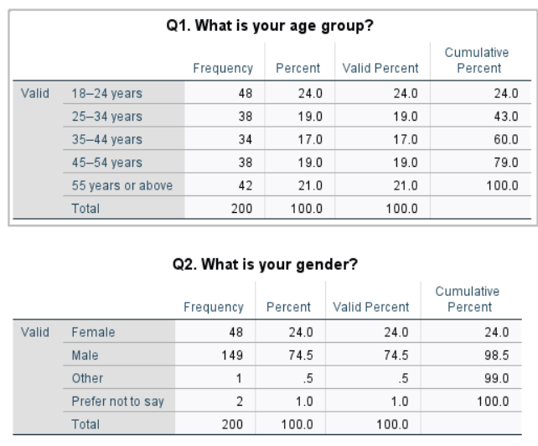
Figure 4.1: Age and Gender Distribution of Respondents
The age and gender distribution of the 200 respondents is shown in Figure 4.1. The age group with the highest number of respondents (24.0%) was 18-24 years, and 55 years and over had 21.0%. As far as gender was concerned, 74.5% of the sample were male, 24.0% female, and 0.5% other, with 1.0% deciding against stating their gender.
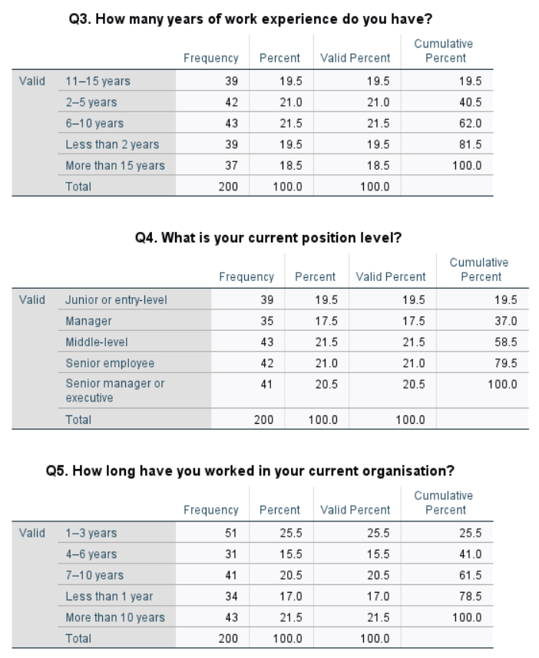
Figure 4.2: Work Experience, Position Level and Length of Service

Figure 4.2 shows that most respondents were working in their current role, and indicated that they had worked in their position for a long time. The top work experience group (6–10 years) accounted for 21.5% of the total number. 21.5% of middle-level employees worked for their current organisation for 1-3 years, and 25.5% for 4-5 years. Overall, the sample represents a diverse range of professions and levels of experience in organisations.

4.3 Reliability Test
Table 4.1: Reliability Analysis of Study Constructs
Construct | Items | Cronbach's Alpha | N
Behavioural Competence | 3 | 0.672 | 200
Relational Competence | 3 | 0.699 | 200
Digital Competence | 3 | 0.719 | 200
Employee Engagement | 3 | 0.652 | 200
Digital Transformation Success | 3 | 0.663 | 200
The internal consistency is satisfactory for all five constructs, according to reliability analysis. The Cronbach's alpha coefficient for Behavioural Competence was found to be 0.672 and 0.699 for Relational Competence. Digital Competence had the highest reliability at 0.719. Employee Engagement had an alpha of 0.652, while Digital Transformation Success was at 0.663. Three questionnaire items were used for each construct with 200 respondents. Some of the alpha values are slightly below the generally accepted threshold of 0.70, but still close to the acceptable alpha value for an exploratory study. Overall, the results suggest that the items have a good degree of uniformity for later description, correlation and regression analyses.

4.4 Descriptive Analysis
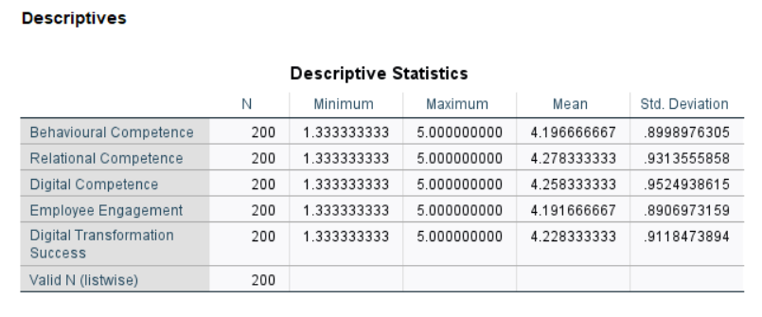
Figure 4.3: Descriptive Statistics of Study Variables
Descriptive statistics for the five study variables with 200 respondents are shown in Figure 4.3. The range of all variables was from a minimum of 1.33 to a maximum of 5.00. The mean scores for Digital Competence (4.2583) and Relational Competence (4.2783) came next, and Digital Transformation Success (4.2283) was the lowest. The mean score for Behavioural Competence was 4.1967, and the score for Employee Engagement was the lowest at 4.1917. There was little variation in responses, as standard deviations were a maximum of 0.9525 and a minimum of 0.8907. The overall mean scores indicate mostly positive perceptions with respect to all five study constructs.

4.5 Correlational Analysis
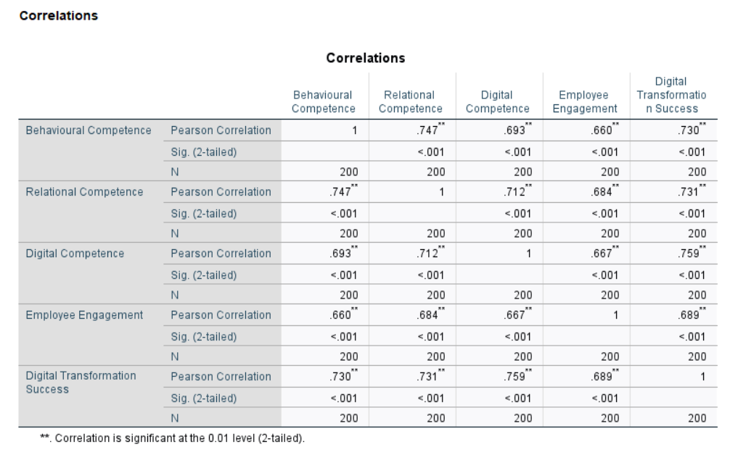
Figure 4.4: Pearson Correlation Analysis of Study Variables
The Pearson correlation values obtained for the five study variables with 200 respondents are shown in Figure 4.4. The relationships between all variables were positive and statistically significant at the 0.01 level. Strong correlation results were achieved between Behavioural Competence and both Relational Competence (r = .747) and Digital Transformation Success (r = .730). There was a positive correlation between Relational Competence and Digital Transformation Success (r = .731). Digital Transformation Success (r = .759) was the strongest relationship with Digital Competence. Additionally, Employee Engagement was positively related to Digital Transformation Success (r = .689). On a general level, the results show strong positive correlations between the leadership competencies and the success in digital transformation and employee engagement.

4.6 Regression Analysis

4.6.1 Regression Test 1: Leadership Competencies and Employee Engagement
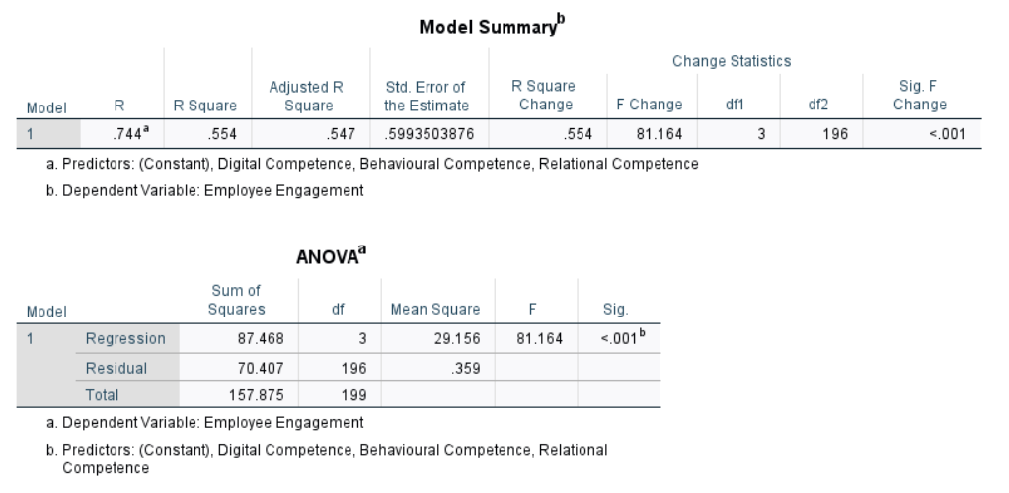
Figure 4.5: Regression Model Summary and ANOVA for Employee Engagement
Figure 4.5 shows the multiple regression model testing the prediction of Employee Engagement by Behavioural Competence, Relational Competence and Digital Competence. The model resulted in an R value of .744 with an R² of .554, which means that the three leadership competence dimensions explain 55.4% of the variance in Employee Engagement. The adjusted R² was .547. The results of the ANOVA indicate that the overall regression model was statistically significant, F(3,196) = 81.164, p < .001. Thus, the overall leadership competence variables statistically significantly predict employee engagement among the respondents.
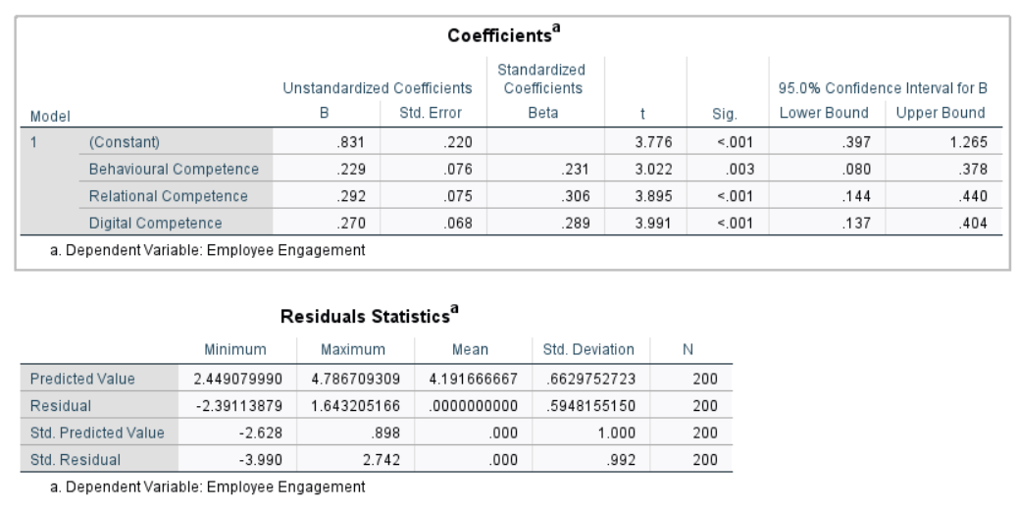
Figure 4.6: Regression Coefficients and Residual Statistics for Employee Engagement
The regression coefficients and residual statistics are shown in Figure 4.6 for Employee Engagement. All three predictors were significant and positively related to Employee Engagement. The standardised beta values for Behavioural Competence, Relational Competence and Digital Competence were .231 (p = .003), .306 (p < .001) and .289 (p < .001) respectively. The standardised contribution of the three predictors was the highest for Relational Competence. Residuals have a mean of around zero and a standard deviation of .595. The results are supportive of the positive predictive relationships of the leadership competence dimensions and employee engagement.

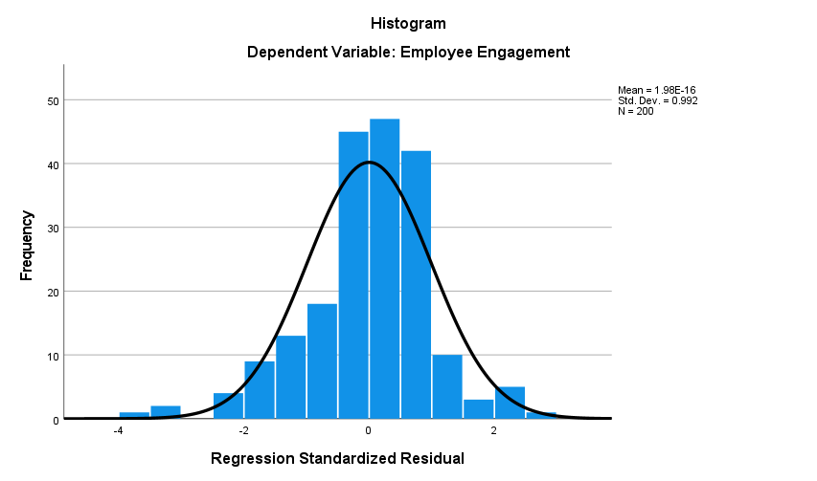
Figure 4.7: Histogram of Regression Standardised Residuals for Employee Engagement
The histogram of the standardised residuals for the Employee Engagement model is shown in Figure 4.7. The residual values are centred around the line of zero with a wide normal distribution curve. Most of the residuals lie close to the middle of the range, suggesting that they are close to being normally distributed. Thus, it is reasonable to assume that the normality assumption holds.
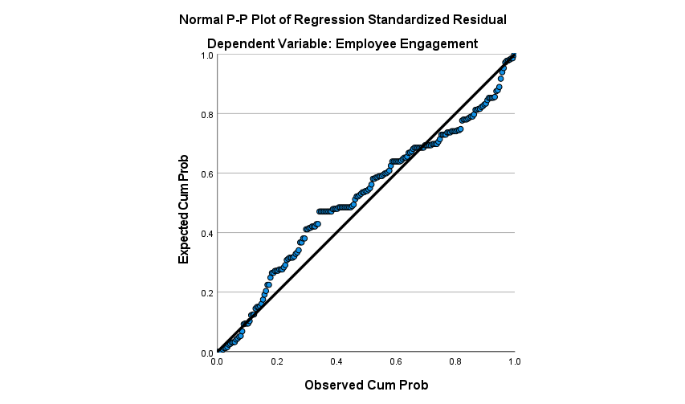
Figure 4.8: Normal P-P Plot of Regression Standardised Residuals
The Normal P-P Plot of the standardised residuals for employee engagement is shown in Figure 4.8. The majority of the observations are on the diagonal line, with some variation in the middle. The residuals are roughly normally distributed overall, and do not show signs of being skewed from normality within the regression analysis.
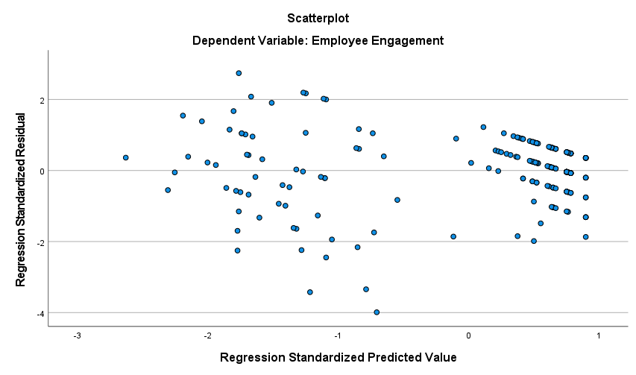
Figure 4.9: Scatterplot of Standardised Predicted Values and Residuals
Figure 4.9 is the scatterplot of Employee Engagement. The residuals do not have any clearly systematic pattern or funnel shape around the zero line. This means that the conditions of linearity and homoscedasticity are relatively met and that this regression model is appropriate.

4.6.2 Regression Test 2: Leadership Competencies and Digital Transformation Success
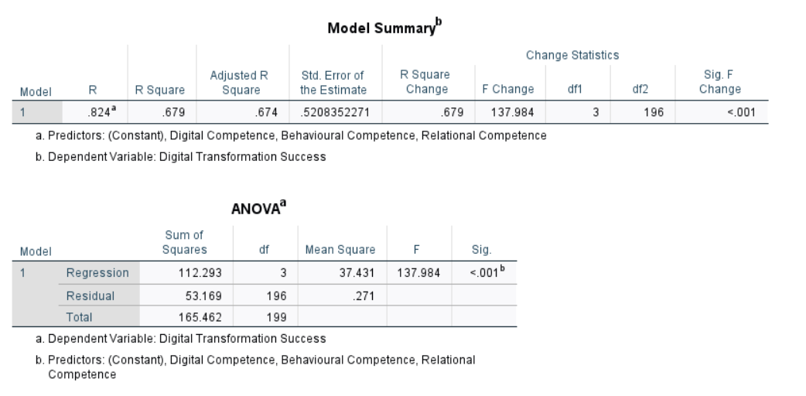
Figure 4.10: Regression Model Summary and ANOVA for Digital Transformation Success
The multiple regression model to test the effect of Behavioural Competence, Relational Competence and Digital Competence on Digital Transformation Success is presented in Figure 4.10. The model achieved an R value of .824 and an R² value of .679, which means that the three dimensions of leadership competence explain 67.9% of the variance in Digital Transformation Success. The adjusted R² was .674. The results of the ANOVA support the statistical significance of the overall regression model, F(3,196) = 137.984, p < .001. Thus, the three competence dimensions of leadership taken together make a strong prediction of digital transformation success.

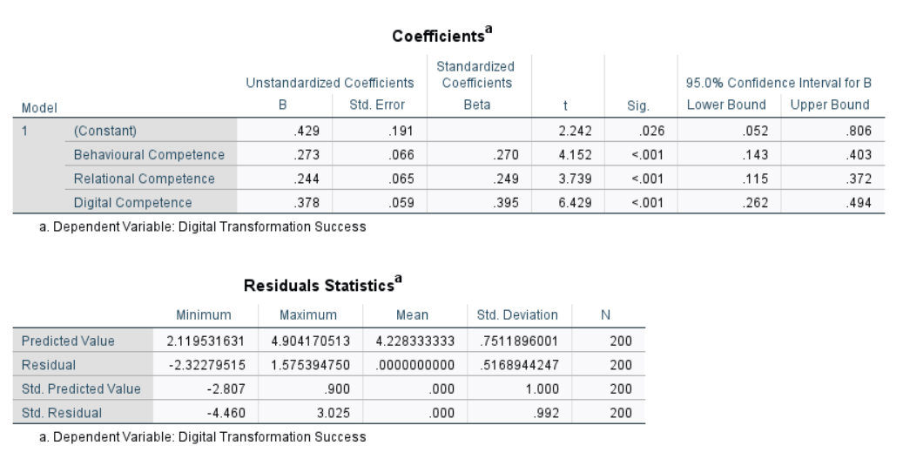
Figure 4.11: Regression Coefficients and Residual Statistics for Digital Transformation Success
The regression coefficients and residual statistics for Digital Transformation Success are shown in Figure 4.11. The three dimensions of the leadership competency were statistically significant and positively impactful. The standardised beta for Behavioural Competence was .270 (p < .001), Relational Competence was .249 (p < .001), and Digital Competence recorded the highest beta of .395 (p < .001). Thus, Digital Competence contributed the greatest relative to Digital Transformation Success. Residuals indicate a mean of about 0 and a standard deviation of .517. The overall results show that all three leadership competences have a significant positive effect on digital transformation success.
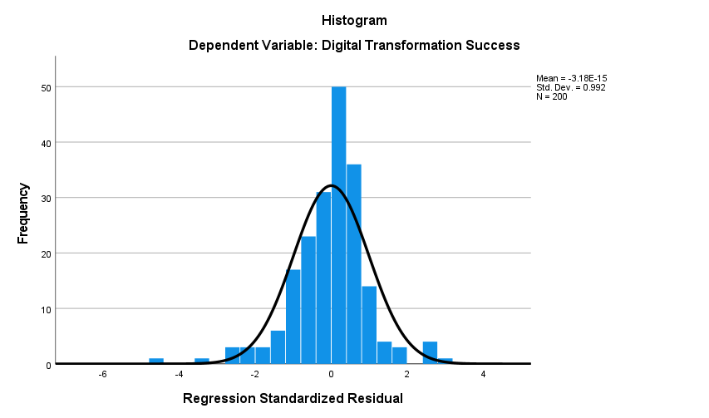
Figure 4.12: Histogram of Regression Standardised Residuals for Digital Transformation Success
The histogram of standardised residuals for Digital Transformation Success is shown in Figure 4.12. The residuals are normally distributed with a mean of 0 and a wide distribution. The majority of observations are focused on an intermediate region with residuals being approximately normally distributed. The normality assumption is thus fairly met.

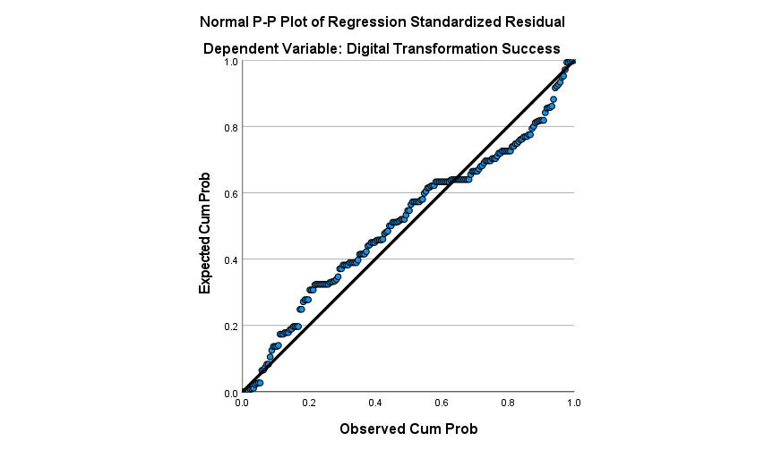
Figure 4.13: Normal P-P Plot of Regression Standardised Residuals for Digital Transformation Success
The following figure (Fig. 4.13) shows the Normal P-P Plot for Digital Transformation Success. The majority of observations are aligned along the diagonal reference line, with some variations in certain regions. The residuals seem to be normally distributed with a mean of zero, which is consistent with the assumption that the regression analysis is valid.
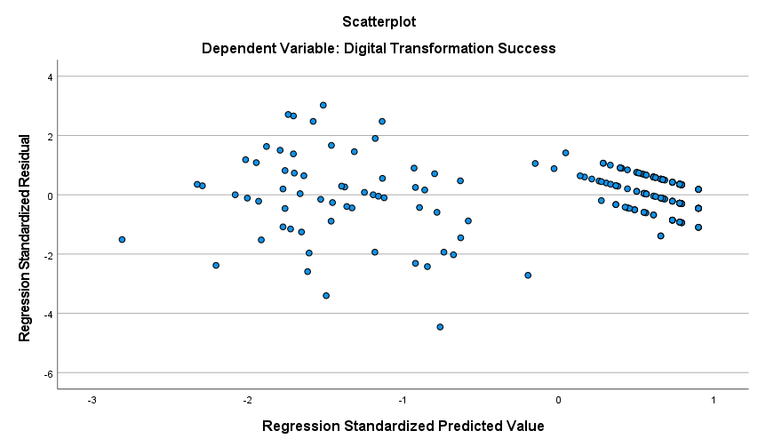
Figure 4.14: Scatterplot of Standardised Predicted Values and Residuals for Digital Transformation Success
The scatterplot of predicted values and residuals for Digital Transformation Success is shown in Figure 4.14. Residuals are randomly arranged about the zero line with no obvious systematic pattern or funnel. This suggests that the regression model is reasonably satisfactory: the assumptions of linearity and homoscedasticity are reasonably met.

4.7 Discussion

4.7.1 Overall Discussion of the Findings
The results of this research support the argument which emerged from the literature that good leadership has a significant role in the successful implementation of employee engagement and digital transformation in technology companies. The study focused on three aspects of leadership effectiveness, which are defined as behavioural competence, relational competence and digital competence. The findings indicate positive relationships between all three dimensions and employee engagement, as well as between digital transformation success and all three dimensions. This aligns with the literature employed in the literature review, which showed that digital transformation does not simply rely on investments in technology, as leadership capability, employee involvement, organisational culture and digital competence also relate to the success or failure of digital transformation. In the literature study, leadership and competence were also found to be important aspects of digital maturity.
The descriptive results revealed positive perceptions of all five constructs with a mean score ranging from 4.1917 to 4.2783. The mean for Relational Competence was the highest, and the lowest mean was for Employee Engagement. These results are consistent with the literature review that highlighted the following as important for digital transformation: adaptability, innovation, digital knowledge and effective leadership. Türk (2023) also focused on vision, adaptability and innovation in the field of Digital Leadership.
The Pearson correlation of the proposed relationships in the research framework is supported very strongly. Employee Engagement and Digital Transformation Success were found to be positively correlated with Behavioural Competence at .660 and .730, respectively. The relationship with Employee Engagement was positive (r = .684), and Digital Transformation Success (r = .731) was also positively related to Relational Competence. There were significant positive relationships between Digital Competence and Employee Engagement (r = .667) and Digital Transformation Success (r = .759). All relationships were statistically significant at a level of p < .001. The results show that the better the leadership competences, the more engaged employees are and the more positive the digital transformation outcomes. This reflects the argument of the literature review, which suggested that leaders who are able to communicate effectively, support employees and foster innovation are able to help employees to participate and to change organisational practices.
The regression results support this as well because they analyse the impact of the three leadership dimensions together. The regression model for Employee Engagement was statistically significant, F(3,196) = 81.164, p < .001, and had an R² of .554. Thus, the three components of Behavioural Competence, Relational Competence and Digital Competence combined accounted for 55.4% of the variance of Employee Engagement. All three predictors were statistically significant. Behavioural Competence had a standardised beta of .231, Relational Competence had a beta of .306 and Digital Competence had a beta of .289. The relative contribution of Relational Competence to Employee Engagement was the highest. The findings are in line with the literature review, which highlighted communication, trust, leadership support and cooperation as key leadership behaviours in digital transformation. It also aligns with Li et al. (2024), who explored the concept of digital leadership and employee work engagement and found that leadership practices have an impact on employee engagement.
The results for Digital Transformation Success were even more impressive. The regression model produced an R² of .679 and was statistically significant, F(3,196) = 137.984, p < .001. The three leadership competence dimensions thus accounted for 67.9% of the variance in Digital Transformation Success. Digital Competence was the strongest predictor with a standardised Beta of .395, followed by Behavioural Competence with a standardised Beta of .270 and Relational Competence with a standardised Beta of .249. This means the capacity of leaders to understand, support and leverage digital technologies might be a critical success factor in the successful digital transformation. The finding is aligned with the discussion of the literature review that digital leadership is not just traditional leadership in the digital age, as leaders have to adapt their leadership skills to the digital world and understand the changes that it brings. Malik et al. (2024) also investigated the link between digital leadership and business model innovation and organisational change, stressing the importance of the role of leaders in leading the digital change.
The higher impact of Digital Competence on Digital Transformation Success is especially applicable to the research problem. The literature search revealed that concerns could arise with organisations investing in digital technologies but failing to deliver on the anticipated outcomes of the transformation. The results indicate that leadership capacity could be a potential resolution to this issue, as technological shifts demand leaders who can grasp the digital technologies and drive their application within the organisation. The outcome also corroborates the findings of Szymon Cyfert et al. (2025) that digital maturity is not only about technology, but also about leadership and organisational culture and competence. The present results thus underscore the need to invest in the right technology along with the proper leadership skills.
Results further help answer the research gap from the literature. Previous studies have explored digital leadership, employee engagement and organisational change and digital transformation in various contexts. The literature review, however, revealed relatively little empirical research specifically on the linkages between the effectiveness of leadership, employee engagement, and the successful implementation of digital transformation in technology companies in the UK. This study makes a significant contribution to this field by applying quantitative evidence based on 200 respondents, as well as analysing 3 dimensions of leadership competence under a single analytical framework.
The results should, however, be taken with a grain of salt. The study employed cross-sectional quantitative data, which showed a statistical relationship/associative relationship but not a causal relationship. So, the regression results are not to be taken as direct proof of the causal relationship between leadership competency and employee engagement and digital transformation success. This restriction is similar to what is found in the literature, where challenges to directionality in the study of leadership are identified. Furthermore, the correlation between Employee Engagement and Digital Transformation Success was strong (r = .689), but a formal mediation analysis needs to be conducted before it is possible to draw a conclusion that Employee Engagement is a mediating variable between leadership effectiveness and the success of the digital transformation.
In general, the results endorse the main thesis of the research. There was a strong link between behavioural, relational and digital competencies and employee engagement and digital transformation success. Relational Competence was the strongest predictor of Employee Engagement, and Digital Competence was the strongest predictor of Digital Transformation Success. The results indicate that good leadership, employee relationships, and employee digital skills are key to successful digital transformation.

4.7.2 Leadership Effectiveness and Employee Engagement
The results showed that the hypothesis H1, which asserts the positive relationship between the effectiveness of leadership and the involvement of employees in digital transformation, is supported. All three competencies contributed to engagement significantly; however, relational competence, with its contribution of β = .306, best, followed by digital competence with its contribution of β = .289, and behavioural competence with its contribution of β = .231. This ranking is significant because it points toward leadership effectiveness being multi-faceted, rather than being related to one predominant capacity.
The discovery corroborates the findings of Li et al. (2024), which reveal that there is a positive linkage between digital leadership and employee work engagement. The current study, however, builds on this by finding that relational competence had a stronger association with engagement than digital competence. This is in contrast to technology-focused conceptualisations of digital leadership, which indicate that the involvement of employees is more dependent on communication, trust and support than on the technical expertise of the leader. The outcome is also in line with the literature reviewed, which targeted a focus on leadership support and cooperation during a transformational process.
This discovery aligns in part with the vision, adaptability and innovation principles Türk (2023) highlights, but indicates that this may still not be enough without managing employee relationships. Likewise, the outcome corroborates that of Sacavém et al. (2025), who consider leadership and transformation as reinforcing processes. But the cross-sectional study design does not allow causality to be attributed to the relationship. In sum, while H1 is supported overall, it highlights the value of relational competence as a key component in maintaining employee engagement as they shift to a digital experience.

4.7.3 Leadership Effectiveness and Digital Transformation Success
The results subsequently support the second Research Objective – to link successful DT with effective leadership – and H2, which explored how leadership and effectiveness are associated with successful DT. Digital competence (β = .395), followed by behavioural competence (β = .270) and relational competence (β = .249), all contributed significantly, with digital competence making the greatest contribution. Contrast this with the employee engagement results, which reflect that relational competence is stronger than the other leadership abilities -- and it can change based on the organisational outcome you are looking at.
A greater emphasis on digital competence reinforces the view of digital leadership put forward by Malik et al. (2024) that connects with business model innovation and organisational changes. It is also closely related to the Szymon Cyfert et al. (2025) article, which states that Digital Maturity is more about leadership and competence than technology. But behavioural and relational competency is important, and not just a matter of technology. The result thus challenges a skill deficit view of transformation and offers some confirmation of a blended competency view.
The finding is in line with the literature review finding that there is no one single theory to explain digital transformation. The emphasis from Türk (2023) is on adaptability and innovation, and the literature is generally in agreement with this, in connection with the capabilities of behaving and relating. The emerging evidence combined these insights by indicating digital competence as crucial to the success of transformation, and other leadership attributes are also important. However, the cross-sectional study design only allows an association and not causation to be concluded. Hence, while having H2 support is important, leadership must not be seen as the sole pathway to success in achieving transformation.

4.7.4 Employee Engagement and the Proposed Mediating Relationship
The results support the mediation of the proposed factor, employee engagement, in relation to the satisfaction of Research Objective Three and H3. The three leadership competencies also significantly predicted employee engagement, and digital transformation success was positively and strongly related to employee engagement (r = .689). The results are aligned with the literature that claims that involved employees can make significant contributions to successful transformation. For instance, Li et al. (2024) revealed that digital leadership has relationships with engagement and, through the mediating factor of empowerment, with commitment; and Maye (2026) showed digital leadership to have been linked with engagement, and through the mediator of organisational innovation with commitment.
The results presented here are not, however, strong enough for statistical mediation to be inferred. If there is a high correlation between engagement and successful transformation, this does not mean that the relationship between engagement and the impact on transformation is necessarily mediated. Hence, this study differs from those that explicitly identify the mediating mechanisms and agrees with the literature review conducted in the study, which argued that some studies are still predominantly conceptual. For instance, Sacavém et al. (2025) theorise positive links between leadership and transformation such that no directionality is established on the basis of longitudinal evidence.
Therefore, the results help to build the case for employee engagement as a possible organisational mechanism, but not as definitive for H3. This view aligns with Tiong et al. (2024), who found potential pathways in which organisational outcomes might be linked together and involve areas of leadership, competence, engagement, and organisational conditions. The cross-sectional design also does not enable inferences regarding temporal direction. Thus, only part of Objective Three is met: engagement is strongly correlated with transformation success, but if it proved to be mediating, then formal mediation testing would be needed to confirm that mitindeed mediate between the two.
This version provides three, well-balanced portions of approximately equal length and leads smoothly from H1 to H2 to H3 without the use of citations outside the framework of your literature review or some other changes from the existing in 4.7.1. The three objectives/hypotheses and the UK technology sector research gap that have been identified are explicitly laid out in the literature review itself.

4.8 Chapter Summary
The empirical data obtained from 200 respondents were analysed in this chapter. Overall, the perceptions were good for behavioural competence, relational competence, digital competence, employee engagement and digital transformation success. The results of the reliability analysis showed that the internal consistency of the five constructs was good. Pearson correlation showed strong positive correlations between the leadership competencies and employee engagement and digital transformation success. The results from these findings lay the foundations for the next chapter: interpretation of the results with respect to the research objectives, a theoretical discussion and recommendations for the application of the findings in practice in the context of UK technology companies. The regression results also confirmed that leadership competencies have a significant impact on successful digital transformation and employee engagement. Relational competence had the greatest impact on employee engagement, and digital competence the greatest on the success of digital transformation. These findings will be explored in the next chapter in light of the literature review conducted and the research objectives set.

Chapter 5: Conclusion and Recommendations
The chapter ends with a review of the study's research objectives and recommendations to enhance and optimize the effectiveness of leadership in the digital transformation process for UK technology-based companies. The results showed that there is a positive relation between employee engagement and digital transformation success with the effectiveness of leadership. But not all the behavioural, relational and digital capabilities are equally understood for such outcomes. Of the 4 competences, relational competence was the strongest indicator of employee engagement, indicating the importance of communication, trust, cooperation and employee support. Digital competence was identified as the most important predictor of digital transformation success and behavioural competence also played an important role in the digital transformation by contributing in three aspects: adaptability, appropriate leadership behaviour, and effective direction setting. The outcomes clearly suggest that a one-firestone-fits-all concept for digital transformation is not likely to work, as it's about integrated leadership that will make the difference. The results of the study suggest this conclusion—H1 is confirmed as leadership competencies have a significant positive relationship with employee engagement, accounting for variance in the model is 55.4%. Additionally, the six leadership competencies accounted for 67.9% of the variance in the success of digital transformation, and H2 was also supported. There was a strong positive relationship between employee engagement and transformation success (r = .689, p < .001); however, an H3 test (formal mediation analysis) was not conducted. As such, it is acceptable to say the findings indicate association and not mediation or causation.
As a result, there is a need for UK technology companies to increase the focus on integrated leadership development; the fusion of digital knowledge, behavioural and relational skills. To increase employee participation, organisations should also be using feedback mechanisms, consultation, transformation workshops and ongoing digital learning. These can enhance employee readiness and engagement in times of technological transitions. The limitation of the study is use of 200 respondents convenience sampling, self-reported data and cross-sectional design of the study. Additional studies should be conducted using larger random samples, longitudinal and/or mixed method designs, and formal mediator models, and organisational performance measures should be used. Therefore, digital transformation needs to be considered as a leadership, employee, and organisation challenge, rather than an IT transformation challenge.

References
Adamu, A., Kolo, J. and Kagara, A.B. (2025). Impact of employee engagement on organizational performance. Journal of Management Science and Entrepreneurship. [online] Available at: https://www.researchgate.net/publication/390909822_IMPACT_OF_EMPLOYEE_ENGAGEMENT_ON_ORGANIZATIONAL_PERFORMANCE [Accessed 10 Aug. 2026].
Ahres, Y. (2023). New research: How organisations achieve digital transformation. [online] Elsewhen.com. Available at: https://www.elsewhen.com/blog/achieve-digital-transformation/.
Alabi, M. (2024). Digital Transformation and Business Innovation: A Comprehensive Review of Strategies and Best Practices. [online] researchgate.net. Available at: https://www.researchgate.net/publication/385008897_Digital_Transformation_and_Business_Innovation_A_Comprehensive_Review_of_Strategies_and_Best_Practices [Accessed 1 Aug. 2026].
Alsop, P. (2018). Half the UK's IT leaders believe lack of consensus from the c-suite is holding back digital transformation. [online] Digitalisation world. Available at: https://digitalisationworld.com/news/325-half-the-uks-it-leaders-believe-lack-of-consensus-from-the-c-suite-is-holding-back-digital-transformation.
Asa, A.R., Nautwima, J.P. and Johannes, H.N. (2026). The Transformative Impact of Digital Technology on SME Performance: A Review and Framework for Digital Transformation. Cogent Business &amp; Management, [online] 13(1). Available at: https://www.tandfonline.com/doi/full/10.1080/23311975.2026.2643949 [Accessed 1 Aug. 2026].
Cao, G., Duan, Y. and Edwards, J.S. (2025). Organizational Culture, Digital Transformation, and Product Innovation. Information & Management, [online] 62(4), p.104135. Available at: https://www.sciencedirect.com/journal/information-and-management/vol/62/issue/4.
Chen, Z., Wang, Y. and Park, J. (2026). Research on the Impact of Digital Transformational Leadership on Digital Innovation Performance. Scientific Reports. [online] Available at: https://www.nature.com/articles/s41598-025-34966-5?utm_source=chatgpt.com [Accessed 1 Aug. 2026].
Chirumalla, K., Oghazi, P., Nnewuku, R.E., Tuncay, H. and Yahyapour, N. (2025). Critical Factors Affecting Digital Transformation in Manufacturing Companies. International Entrepreneurship and Management Journal, [online] 21(1). Available at: https://link.springer.com/article/10.1007/s11365-024-01056-3 [Accessed 1 Aug. 2026].
Churchman, P., Pangbourne, K. and Dekker, T. (2026). Purposivism: A critical realist research approach for purposive system change. Energy Research &amp; Social Science, [online] 136, p.104731. Available at: https://www.sciencedirect.com/science/article/pii/S2214629626002021 [Accessed 10 Aug. 2026].
Consultancy.uk (2018). Bullish UK Technology Sector Worth Over £180 Billion. [online] Consultancy.uk. Consultancy.uk. Available at: https://www.consultancy.uk/news/17376/bullish-uk-technology-sector-worth-over-180-billion [Accessed 1 Aug. 2026].
Consultancy.uk (2020). Covid-19 has accelerated digital transformation by seven years. [online] Available at: https://www.consultancy.uk/news/26372/covid-19-has-accelerated-digital-transformation-by-seven-years (Accessed: 30 June 2026).
Daud, M. (2024). The effect of digital transformation on organizational performance: A meta analysis. Deleted Journal, [online] 15(1), pp.50–65. Available at: https://www.researchgate.net/publication/380203887_THE_EFFECT_OF_DIGITAL_TRANSFORMATION_ON_ORGANIZATIONAL_PERFORMANCE_A_META_ANALYSIS [Accessed 1 Aug. 2026].
Deloitte (2023). Measuring value from digital transformation. [online] Available at: https://www.deloitte.com/uk/en/services/consulting/research/measuring-value-from-digital-transformation.html (Accessed: 30 June 2026).
Demirel, H.G. (2024). Why Do Digital Transformation Initiatives Fail? Digital Mindsets as an Invisible Strategic Component. Yönetim Bilimleri Dergisi. [online] Available at: https://www.researchgate.net/publication/384475250_WHY_DO_DIGITAL_TRANSFORMATION_INITIATIVES_FAIL_DIGITAL_MINDSETS_AS_AN_INVISIBLE_STRATEGIC_COMPONENT [Accessed 1 Aug. 2026].
Dickson, R.K. (2023). Analysis of The Traditional Leadership Theories: A Review of Contemporary Leadership Approaches and Management Effectiveness. Information and Knowledge Management, 13(5). https://doi.org/10.7176/IKM/13-5-02.
El, A. (2026). Hr digital transformation: Enhancing Human Resource Management Through Technology. Future Business Journal, [online] 12(1). Available at: https://link.springer.com/article/10.1186/s43093-025-00703-7 [Accessed 1 Aug. 2026].
Financial Times (2019). 70 per cent of transformation projects fail – and everyone’s ignoring the same fix. [online] Ft.com. Available at: https://www.ft.com/partnercontent/teamviewer/70-per-cent-of-transformation-projects-fail-and-everyones-ignoring-the-same-fix.html [Accessed 1 Aug. 2026].
Flake, J.K., Davidson, I.J., Wong, O. and Pek, J. (2022). Construct validity and the validity of replication studies: A systematic review. American Psychologist, [online] 77(4), pp.576–588. Available at: https://www.researchgate.net/publication/359335447_Construct_validity_and_the_validity_of_replication_studies_A_systematic_review [Accessed 18 Aug. 2026].
Golzar, J., Tajik, O. and Noor, S. (2022). Convenience sampling. [online] ResearchGate, pp.72–77. doi:10.22034/ijels.2022.162981.
Government of UK (2025). The Wider Economic Impacts of Emerging Technologies in the UK (HTML). [online] GOV.UK. Available at: https://www.gov.uk/government/publications/the-wider-economic-impacts-of-emerging-technologies-in-the-uk/the-wider-economic-impacts-of-emerging-technologies-in-the-uk-html [Accessed 1 Aug. 2026].
Grand View Research (2026). UK digital transformation market size & outlook, 2030. [online] Grandviewresearch.com. Available at: https://www.grandviewresearch.com/horizon/outlook/digital-transformation-market/uk.
Guenther, C., Lehnen, S. and Rilke, R.M. (2024). Formalization of annual performance feedback and employees’ job satisfaction in the SME context. Journal of small business management, [online] 63(2), pp.1–32. Available at: https://www.tandfonline.com/doi/full/10.1080/00472778.2024.2326576 [Accessed 28 Aug. 2026].
Hariyani, D., Hariyani, P. and Mishra, S. (2025). The role of leadership in sustainable digital transformation of the organization. Sustainable Futures, [online] 10, p.101130. Available at: https://www.sciencedirect.com/science/article/pii/S266618882500694X [Accessed 28 Aug. 2026].
Henderikx, M. and Stoffers, J. (2022). An exploratory literature study into digital transformation and leadership: Toward Future-Proof middle managers. Sustainability, [online] 14(2), p.687. Available at: https://doi.org/10.3390/su14020687.
Henkin, D. (2025). How a new wave of digital innovation is reshaping global enterprises. Forbes. [online] 25 June. Available at: https://www.forbes.com/sites/davidhenkin/2025/06/25/how-a-new-wave-of-digital-innovation-is-reshaping-global-enterprises/ [Accessed 1 Aug. 2026].
Hržica, R. (2025). From fragmented criteria to a structured decision support mode: designing a DEX-based DSS for assessing organizational readiness for co-creation. Systems, [online] 13(9), p.806. Available at: https://www.mdpi.com/2079-8954/13/9/806 [Accessed 1 Aug. 2026].
IMARC (2025). UK technology market forecast 2033. [online] Imarcgroup.com. Available at: https://www.imarcgroup.com/uk-technology-market.
Kim, S.M. (2021). Inductive or deductive? Research by maxillofacial surgeons. Journal of the Korean Association of Oral and Maxillofacial Surgeons, [online] 47(3), pp.151–152. Available at: https://pmc.ncbi.nlm.nih.gov/articles/PMC8249189/ [Accessed 18 Aug. 2026].
Kock, F., Berbekova, A. and Assaf, A.G. (2021). Understanding and managing the threat of common method bias: Detection, prevention and control. Tourism Management, [online] 86(1), p.104330. Available at: https://www.sciencedirect.com/science/article/pii/S0261517721000492 [Accessed 18 Aug. 2026].
Kotronoulas, G. (2023). An overview of the fundamentals of data management, analysis, and interpretation in quantitative research. Seminars in Oncology Nursing, [online] 39(2), p.151398. Available at: https://www.sciencedirect.com/science/article/pii/S0749208123000293 [Accessed 10 Aug. 2026].
Kraus, S., Jones, P., Kailer, N., Weinmann, A., Banegas, N.C. and Tierno, N.R. (2021). Digital transformation: An overview of the current state of the art of Research. SAGE open, [online] 11(3), pp.1–15. Available at: https://doi.org/10.1177/21582440211047576.
Lee, M. (2014). Transformational Leadership: Is It Time For A Recall? International Journal of Management and Applied Research, 1(1), pp.17–29. Available at: https://www.ijmar.org/v1n1/14-002.html.
Li, Z., Yang, C., Yang, Z. and Zhao, Y. (2024). The impact of middle managers' digital leadership on employee work engagement. Frontiers in Psychology, 15, 1368442. Available at: https://doi.org/10.3389/fpsyg.2024.1368442.
Ly, B. (2023). The Interplay of Digital Transformational Leadership, Organizational Agility, and Digital Transformation. Journal of the Knowledge Economy, [online] 15, pp.4408–4427. Available at: https://link.springer.com/article/10.1007/s13132-023-01377-8 [Accessed 1 Aug. 2026].
Machucho, R. and Ortiz, D. (2025). The impacts of artificial intelligence on business innovation: A comprehensive review of applications, organizational challenges, and ethical considerations. Systems, [online] 13(4), p.264. Available at: https://www.mdpi.com/2079-8954/13/4/264 [Accessed 1 Aug. 2026].
Maier, C., Thatcher, J.B., Grover, V. and Dwivedi, Y.K. (2023). Cross-sectional research: A critical perspective, use cases, and recommendations for IS research. International Journal of Information Management, [online] 70(70), p.102625. Available at: https://www.sciencedirect.com/science/article/abs/pii/S0268401223000063 [Accessed 10 Aug. 2026].
Maity, R. and Lee, K.L. (2025). The Impact of Remote and Hybrid Work Models on Small and Medium-Sized Enterprises Productivity: A Systematic Literature Review. SN Business & Economics, [online] 5(10). doi:10.1007/s43546-025-00931-7.
Malik, M., Raziq, M.M., Sarwar, N. and Tariq, A. (2024). Digital leadership, business model innovation and organizational change: Role of leader in steering digital transformation. Benchmarking, 32(5). doi:10.1108/bij-04-2023-0283.
Maye, C.G. (2026). The Effectiveness of Digital Leadership in Promoting Employee Engagement and Organizational Innovation. OALib, 13(02), pp.1–16. Available at: https://doi.org/10.4236/oalib.1113907.
McGrath, R. (2025). Construct validity in action: A case-based method for model testing in sovereign investment and health systems. International Journal of Qualitative Methods, [online] 24. Available at: https://journals.sagepub.com/doi/10.1177/16094069251378862 [Accessed 10 Aug. 2026].
Memon, M.A., Ramayah, T., Ting, H. and Cheah, J.-H. (2025). Convenience sampling: A review and guidelines for quantitative research. Journal of Applied Structural Equation Modeling, [online] 9(2), pp.1–15. Available at: https://www.researchgate.net/publication/393264653_CONVENIENCE_SAMPLING_A_REVIEW_AND_GUIDELINES_FOR_QUANTITATIVE_RESEARCH [Accessed 10 Aug. 2026].
Musaigwa, M. (2023). The Role of Leadership in Managing Change. [online] ResearchGate. Available at: https://www.researchgate.net/publication/375562628_The_Role_of_Leadership_in_Managing_Change.
Nanda, S., Khurana, J., Alhuwalia, N., Jain, K., Vinil, B. and Pattanayak, S. (2025). The influence of digital transformation on employee engagement and organizational commitment. Multidisciplinary Science Journal, [online] 7, p.2025ss0216. Available at: https://www.researchgate.net/publication/396201034_The_influence_of_digital_transformation_on_employee_engagement_and_organizational_commitment [Accessed 28 Aug. 2026].
Nastase, C., Adomnitei, A. and Apetri, A. (2025). Strategic human resource management in the digital era: Technology, Transformation, and Sustainable Advantage. Merits, [online] 5(4), pp.23–23. Available at: https://www.mdpi.com/2673-8104/5/4/23 [Accessed 1 Aug. 2026].
Nguyen, T.-H. (2025). Research on factors influencing the employees’ digital transformation engagement and job performance in logistics companies. SAGE Open, [online] 15(3). Available at: https://journals.sagepub.com/doi/10.1177/21582440251353391 [Accessed 28 Aug. 2026].
OECD (2024). The United Kingdom’s holistic approach to digital development. [online] OECD. Available at: https://www.oecd.org/en/publications/2021/03/development-co-operation-tips-tools-insights-practices_d307b396/the-united-kingdom-s-holistic-approach-to-digital-development_87d35e33.html [Accessed 1 Aug. 2026].
Oguntade, A.F., Japinye, A.O., Alenoghena, R.O. and Osanebi, C. (2025). Importance of training on organisational performance: A review of literature. South Asian Research Journal of Business and Management, [online] 7(03), pp.256–265. Available at: https://www.researchgate.net/publication/392308696_Importance_of_Training_on_Organisational_Performance_A_Review_of_Literature [Accessed 28 Aug. 2026].
Orkamo, M., Ukko, J., Rantala, T. and Saunila, M. (2025). Leadership behaviours to promote organisational performance in private sector digital transformation – A systematic literature review. Digital Business, [online] 5(2), p.100155. Available at: https://www.sciencedirect.com/science/article/pii/S266695442500050X [Accessed 10 Aug. 2026].
Perifanis, N.-A. (2023). Investigating the Influence of Artificial Intelligence on Business Value in the Digital Era of Strategy: A Literature Review. Information, [online] 14(2). doi:https://doi.org/10.3390/info14020085.
Power, R. (2024). Employees in action: Unlocking profit through an engaged workforce. Forbes, 21 July. Available at: https://www.forbes.com/sites/rhettpower/2024/07/21/employees-in-action-unlocking-profit-through-an-engaged-workforce/ (Accessed: 27 June 2026).
Pretorius, T.B. and Padmanabhanunni, A. (2025). Reliability generalization of the problem solving inventory: A meta-analysis of cronbach’s alpha with a varying-coefficient model. SAGE Open, [online] 15(3). Available at: https://journals.sagepub.com/doi/10.1177/21582440251361978 [Accessed 18 Aug. 2026].
PricewaterhouseCoopers (PwC) (2024). UK Workforce Hopes and Fears Survey 2024. Available at: https://www.pwc.co.uk/services/human-resource-services/insights/uk-hopes-and-fears-survey/2024.html (Accessed: 30 June 2026).
Qiao, G., Li, Y. and Hong, A. (2024). The Strategic Role of Digital Transformation: Leveraging Digital Leadership to Enhance Employee Performance and Organizational Commitment in the Digital Era. Systems, [online] 12(11), p.457. doi:https://doi.org/10.3390/systems12110457.
Röth, L. (2023). Pathway analysis, causal mediation, and the identification of causal mechanisms. Springer eBooks, [online] pp.123–151. Available at: https://link.springer.com/chapter/10.1007/978-3-031-12982-7_6 [Accessed 28 Aug. 2026].
S&P Global (2026). State of the UK Digital Economy, 2026. [online] S&P Global Market Intelligence. Available at: https://www.spglobal.com/market-intelligence/en/news-insights/research/2026/02/state-of-the-uk-digital-economy-2026 [Accessed 1 Aug. 2026].
Sacavém, A., Machado, A. de B., Santos, J.R. dos, Palma-Moreira, A., Belchior-Rocha, H. and Au-Yong-Oliveira, M. (2025). Leading in the digital age: The role of leadership in Organizational digital transformation. Administrative sciences, [online] 15(2), pp.43–43. Available at: https://doi.org/10.3390/admsci15020043.
Saidu, M., Shagari, S.L., Kabir, M.A. and Abubakar, A. (2023). Improving University Students’ Data Analysis Outputs through Effective Data Collection, Cleaning, Screening and Normalisation. Applied Quantitative Analysis, [online] 3(2), pp.32–45. Available at: https://journals.researchsynergypress.com/index.php/aqa/article/view/1951 [Accessed 18 Aug. 2026].
Schilirò, D. (2024). Digital Transformation and its Impact on Organizations. International Journal of Business and Management, [online] 19(6), p.71. Available at: https://doi.org/10.5539/ijbm.v19n6p71.
Seuring, S., Stella, T. and Stella, M. (2021). Developing and publishing strong empirical research in sustainability management—Addressing the intersection of theory, method, and empirical field. Frontiers in Sustainability, [online] 1(1), pp.1–9. Available at: https://www.researchgate.net/publication/349083776_Developing_and_Publishing_Strong_Empirical_Research_in_Sustainability_Management-Addressing_the_Intersection_of_Theory_Method_and_Empirical_Field [Accessed 10 Aug. 2026].
Shao, W. (2025). The role of digital transformation in enhancing organizational agility and competitive advantages: A strategic perspective. Advances in Economics Management and Political Sciences, [online] 154(1), pp.115–120. Available at: https://www.researchgate.net/publication/387806349_The_Role_of_Digital_Transformation_in_Enhancing_Organizational_Agility_and_Competitive_Advantages_A_Strategic_Perspective [Accessed 1 Aug. 2026].
Shonubi, O. (2025). Innovation Challenges of Digital Transformation: Transitioning Legacy to the Future. Sustainable Futures, [online] p.100971. Available at: https://doi.org/10.1016/j.sftr.2025.100971.
Szymon Cyfert, Dyduch, W., Szumowski, W. and Prause, G. (2025). Are we ready for digital transformation? The role of organizational culture, leadership and competence in building digital advantage. Central European Management Journal. Available at: https://doi.org/10.1108/CEMJ-11-2024-0346.
Tagscherer, F. and Carbon, C.-C. (2023). Leadership for Successful digitalization: a Literature Review on Companies' Internal and External Aspects of Digitalization. Sustainable Technology and Entrepreneurship, [online] 2(2), pp.1–15. Available at: https://www.sciencedirect.com/science/article/pii/S2773032823000032.
Tiong (2024). The Influence of Digital Competency, Employee Engagement, and Leadership Style on SME Employee Performance in Indonesia: Innovation Capability as A Mediator and Organizational Culture as A Moderator in the Society 5.0 Era. STI Policy and Management Journal. Available at: https://www.stipmjournal.org/index.php/stipm/article/view/405
Türk, A. (2023). Digital leadership role in developing business strategy suitable for digital transformation. Frontiers in psychology, [online] 13(1). Available at: https://doi.org/10.3389/fpsyg.2022.1066180.
Tuyen, B.Q., Anh, P., Hung, T.H. and Lan, M.T. (2025). Leadership characteristics and digital transformation in an emerging market: The moderating effect of compliance pressure. International review of Economics & finance, [online] pp.103944–103944. Available at: https://www.sciencedirect.com/science/article/pii/S1059056025001078.
UK Parliament (2026). Rewiring the State: Delivering Digital Government. [online] Parliament.uk. Available at: https://publications.parliament.uk/pa/cm5902/cmselect/cmsctech/61/report.html [Accessed 1 Aug. 2026].
Vailshery, L.S. (2025). Topic: Digital economy in the UK. [online] Statista. Available at: https://www.statista.com/topics/7208/digital-economy-in-the-uk/.
Vărzaru, A.A. and Bocean, C.G. (2024). Digital transformation and innovation: The influence of digital technologies on turnover from innovation activities and types of innovation. Systems, [online] 12(9), p.359. doi:https://doi.org/10.3390/systems12090359.
Weston, S. (2020). Two thirds of UK organisations facing digital skills gap. [online] ITPro. Available at: https://www.itpro.com/business/357879/two-thirds-of-uk-organisations-facing-digital-skills-gap.
World Bank (2023). Digital Progress and Trends Report. [online] Available at: https://documents1.worldbank.org/curated/en/099031924192524293/pdf/P180107173682d0431bf651fded74199f10.pdf [Accessed 1 Aug. 2026].
Xiao, H. (2024). Employee role transformation and adaptation in digital transformation: Barriers, misalignments, and solutions in digital tool application. Journal of Applied Economics and Policy Studies, [online] 13(1), pp.33–38. Available at: https://www.researchgate.net/publication/388108496_Employee_Role_Transformation_and_Adaptation_in_Digital_Transformation_Barriers_Misalignments_and_Solutions_in_Digital_Tool_Application [Accessed 28 Aug. 2026].
Zhang, X., Xu, Y. and Ma, L. (2022). Research on Successful Factors and Influencing Mechanism of the Digital Transformation in SMEs. Sustainability, [online] 14(5), p.2549. Available at: https://www.mdpi.com/2071-1050/14/5/2549 [Accessed 1 Aug. 2026].

Appendix

Appendix A: Questionnaire
Section 1: Demographic Information
Q1. What is your age group?
- 18–24 years
- 25–34 years
- 35–44 years
- 45–54 years
- 55 years or above
Q2. What is your gender?
- Male
- Female
- Other
- Prefer not to say
Q3. How many years of work experience do you have?
- Less than 2 years
- 2–5 years
- 6–10 years
- 11–15 years
- More than 15 years
Q4. What is your current position level?
- Junior or entry-level
- Middle-level
- Senior employee
- Manager
- Senior manager or executive
Q5. How long have you worked in your current organisation?
- Less than 1 year
- 1–3 years
- 4–6 years
- 7–10 years
- More than 10 years
Section 2: Behavioural Competence
Q6. Leaders in my organisation communicate a clear direction during digital transformation.
- Strongly Disagree
- Disagree
- Neither Agree nor Disagree
- Agree
- Strongly Agree
Q7. Leaders in my organisation demonstrate flexibility when digital transformation requirements change.
- Strongly Disagree
- Disagree
- Neither Agree nor Disagree
- Agree
- Strongly Agree
Q8. Leaders in my organisation make timely decisions when dealing with digital transformation challenges.
- Strongly Disagree
- Disagree
- Neither Agree nor Disagree
- Agree
- Strongly Agree
Section 3: Relational Competence
Q9. Leaders in my organisation listen to employees' views about digital transformation.
- Strongly Disagree
- Disagree
- Neither Agree nor Disagree
- Agree
- Strongly Agree
Q10. Leaders in my organisation provide appropriate support to employees during digital transformation.
- Strongly Disagree
- Disagree
- Neither Agree nor Disagree
- Agree
- Strongly Agree
Q11. Leaders in my organisation build trust with employees during periods of digital change.
- Strongly Disagree
- Disagree
- Neither Agree nor Disagree
- Agree
- Strongly Agree
Section 4: Digital Competence
Q12. Leaders in my organisation understand the digital technologies used in the organisation.
- Strongly Disagree
- Disagree
- Neither Agree nor Disagree
- Agree
- Strongly Agree
Q13. Leaders in my organisation support the adoption of new digital technologies.
- Strongly Disagree
- Disagree
- Neither Agree nor Disagree
- Agree
- Strongly Agree
Q14. Leaders in my organisation use digital information and data to support decision-making.
- Strongly Disagree
- Disagree
- Neither Agree nor Disagree
- Agree
- Strongly Agree
Section 5: Employee Engagement
Q15. I feel motivated to contribute to digital transformation activities in my organisation.
- Strongly Disagree
- Disagree
- Neither Agree nor Disagree
- Agree
- Strongly Agree
Q16. I am actively involved in activities related to digital transformation.
- Strongly Disagree
- Disagree
- Neither Agree nor Disagree
- Agree
- Strongly Agree
Q17. I feel committed to helping my organisation achieve its digital transformation goals.
- Strongly Disagree
- Disagree
- Neither Agree nor Disagree
- Agree
- Strongly Agree
Section 6: Digital Transformation Success
Q18. Digital transformation has improved the efficiency of processes in my organisation.
- Strongly Disagree
- Disagree
- Neither Agree nor Disagree
- Agree
- Strongly Agree
Q19. Digital transformation has improved the organisation's ability to achieve its business objectives.
- Strongly Disagree
- Disagree
- Neither Agree nor Disagree
- Agree
- Strongly Agree
Q20. Digital transformation initiatives in my organisation have achieved their intended outcomes.
- Strongly Disagree
- Disagree
- Neither Agree nor Disagree
- Agree
- Strongly Agree

Appendix B: SPSS Outputs
Demographic Analysis
Reliability Test
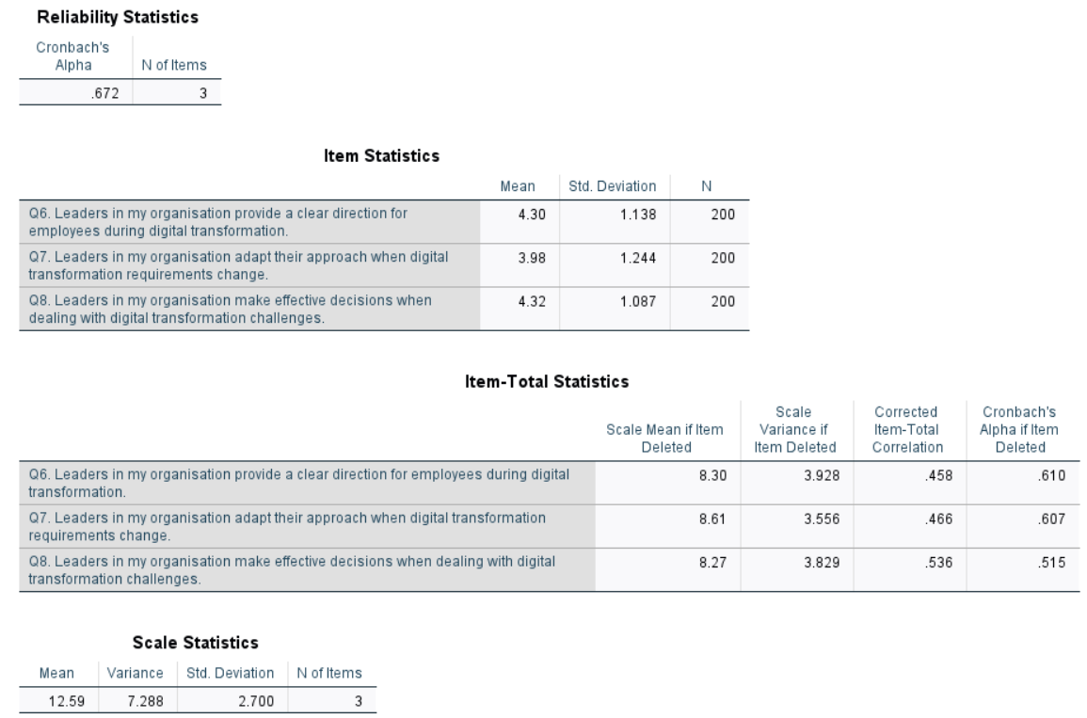
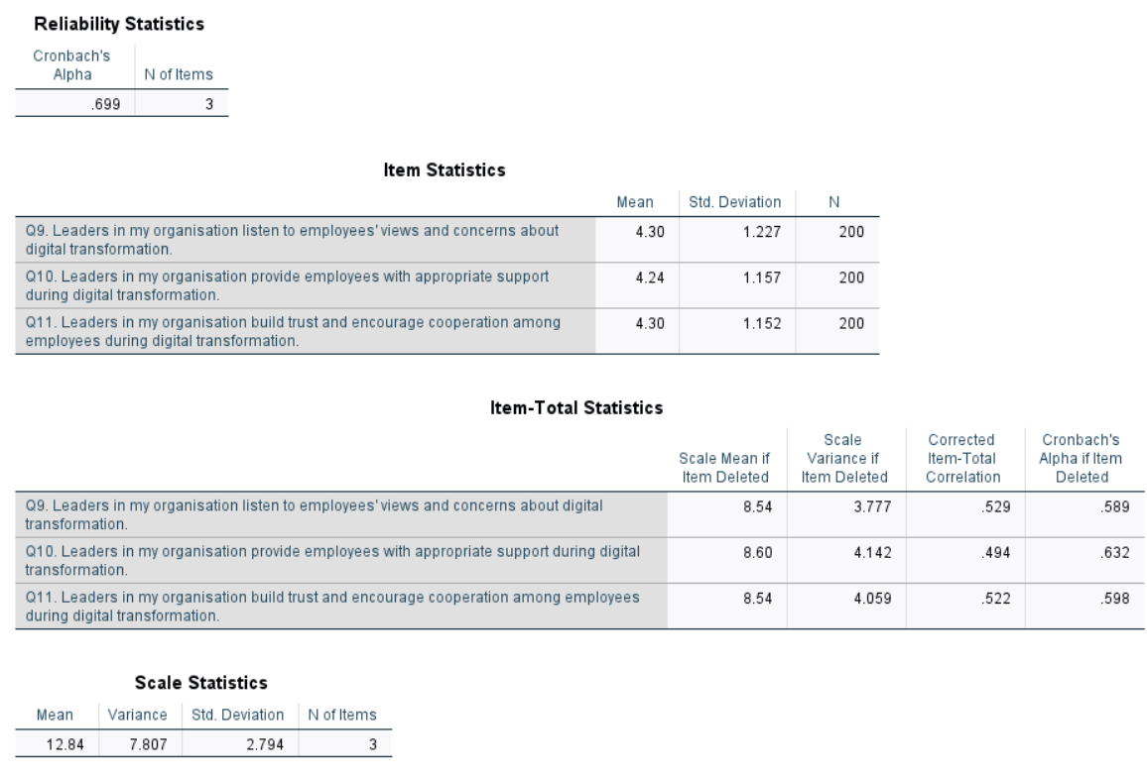
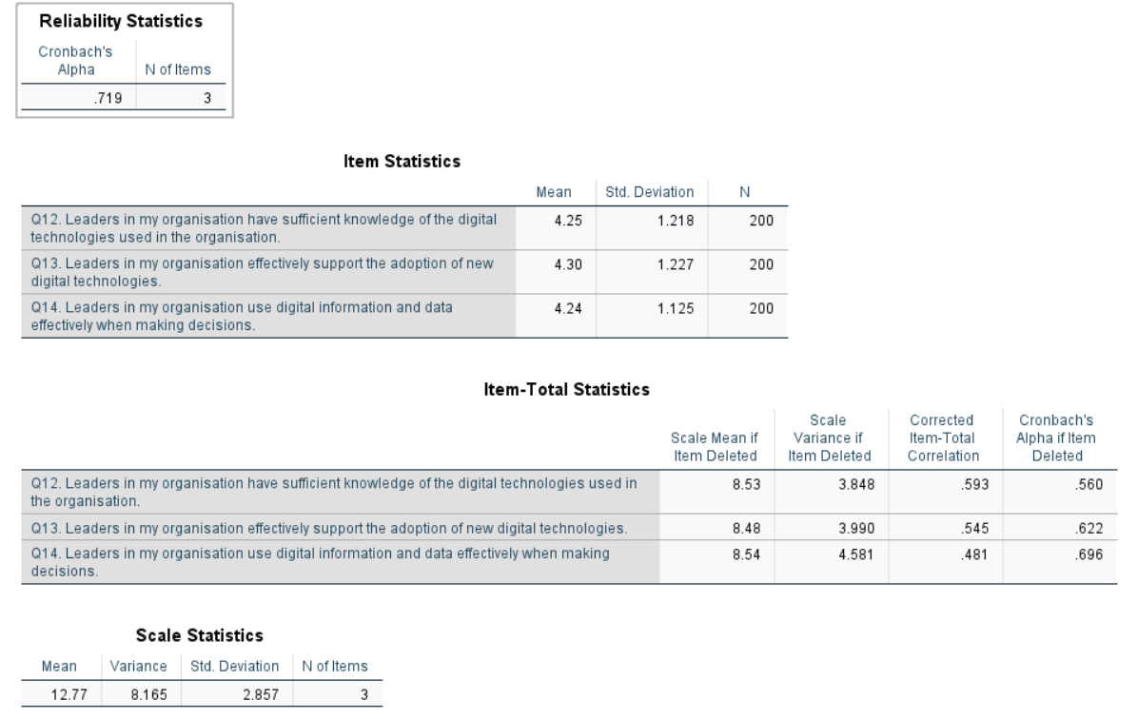
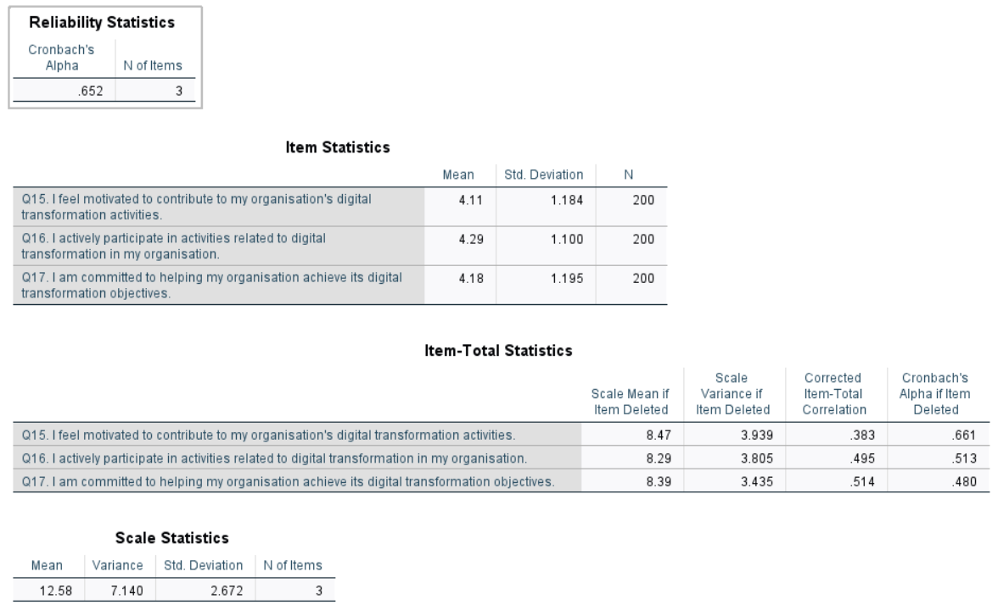
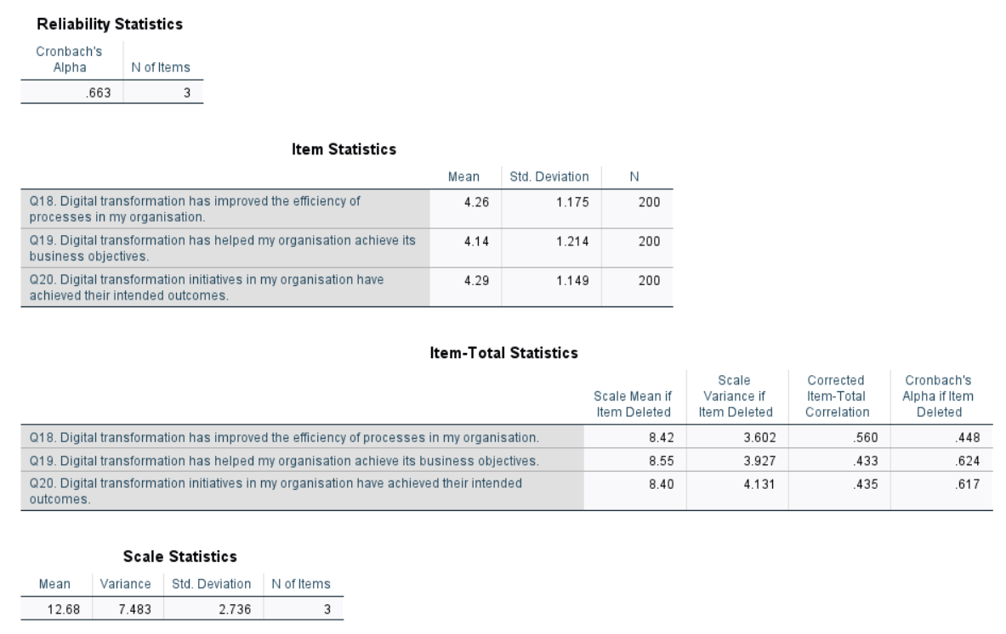
Descriptive Analysis
Correlational Analysis
Regression Analysis
Regression Test 1: Leadership Competencies and Employee Engagement
Regression Test 2: Leadership Competencies and Digital Transformation Success

